After logging in the text box can be used to inject commands. The text is not read as a string and can be used to manipulate the site. For example, when “print()” is entered, it attempts to print the page.

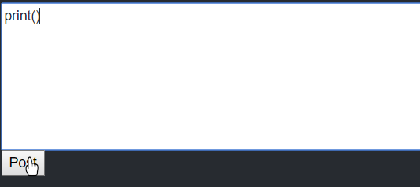

The user is prompted to enter printer details and the site is shown in black and white, losing some of its formatting during the print preview.

