## Installing VirtualBox

Go to <https://www.virtualbox.org/wiki/Downloads> and download the installer corresponding to your system:  
  
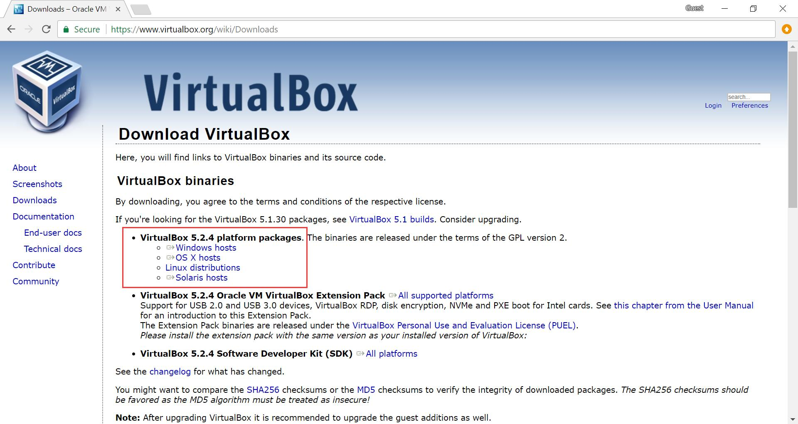

Open the downloaded file and finish the installation. There should be no need to change any settings.

## Installing Vagrant

Go to <https://www.vagrantup.com/downloads.html> and download the installer corresponding to your system.

Run the installer, keep the settings default.

## Setting up the VM

Download the provided VM image.

Start [Command Prompt](https://www.lifewire.com/how-to-open-command-prompt-2618089)(Windows) or [Terminal](https://www.wikihow.com/Open-a-Terminal-Window-in-Mac)(Mac) and enter the following command where <name> is a placeholder for the name you want to name the machine, and <path> should be replaced with the path to the downloaded image, which usually means your downloads folder:

vagrant box add <name> <path>cs1122.box  
vagrant init <name>  
vagrant up

You should see something like this:

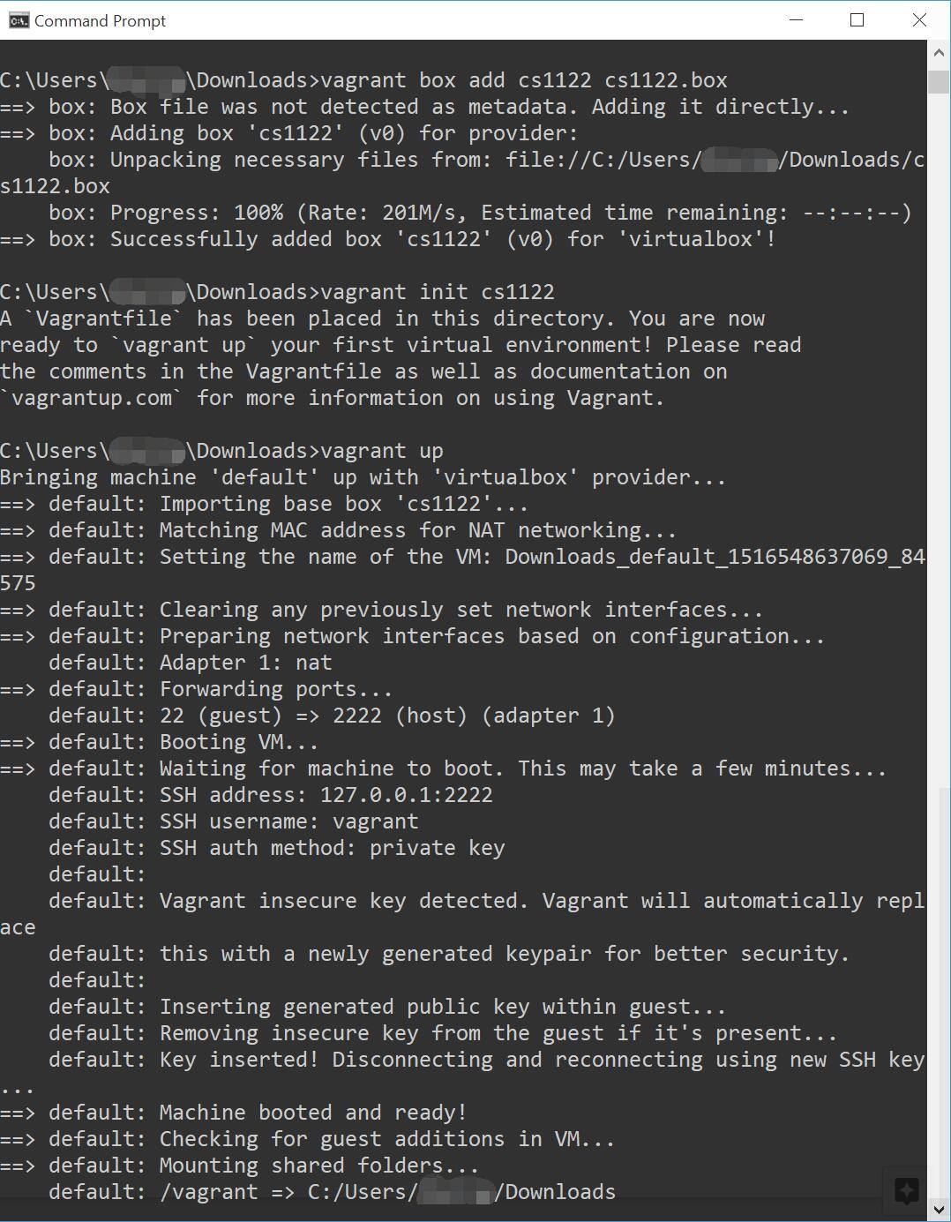

Here a relative path to the VM image was used. Read about [absolute vs relative paths](https://phpdelusions.net/articles/paths), it will also be helpful for web development.

The VM image comes with many tools pre-installed, but if you need to install additional Python packages, use:

pip install <package-name>