Mapping The S Drive

JinZhao Su

Table of Contents

The S drive 3
Accessing the S drive 4
How to map the S drive on a Windows 10 Operating System: 5
How to map the S drive on a Mac Operating System: 7

The S drive

The network drive created for CS-UY 2204 Digital Logic & State Machine Design, also known as the S drive, was created for students to save their course work. The S drive or CSE001-WFP will be located on the ad.nyu.edu domain along with all the other 26 computers located in RH227.

Accessing the S drive

The S drive can only be accessed when the device is connected via any NYU network. If you are not near any NYU buildings or campuses then you can connect via the NYU VPN client. More information about the NYU VPN can be found on this link.

How to map the S drive on a Windows 10 Operating System:
- Click on MY PC and select the computer button
- Now select the Map Network Drive icon

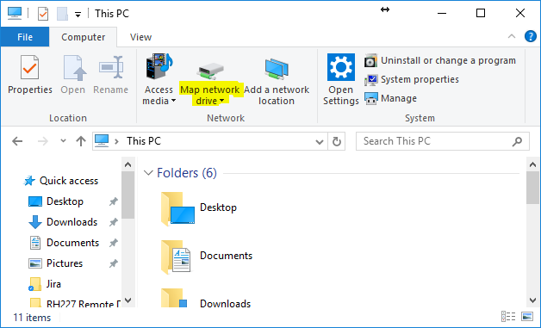

- To map the S drive, put \\CSE001-WFP.ad.nyu.edu\home$\NETID, where the NETID is the netid of the student. In the case where CSE001-WFP.ad.nyu.edu is not found, use the following instead: \\192.168.237.115\home$\NETID.
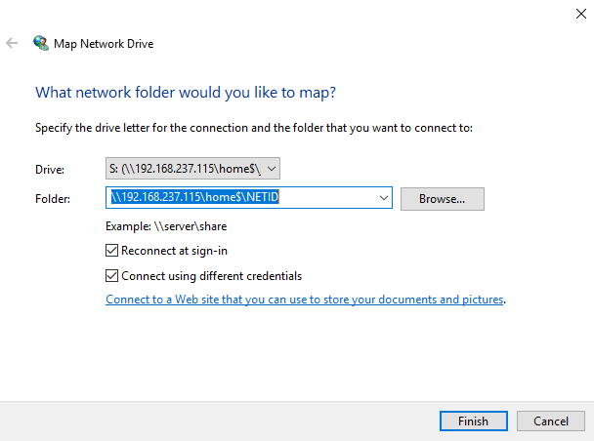
Once you enter your NYU credentials, the S drive will now be mapped.

Reminder: Your NYU credentials to enter after you click “Finish” are of the following :

Username : [Insert AD\NetID]
Password : [Insert your password, the one you use for your email]

You must include “AD\” next to your NetID

How to map the S drive on a Mac Operating System:
- Click on Finder, and under the Go tab, click connect to Server
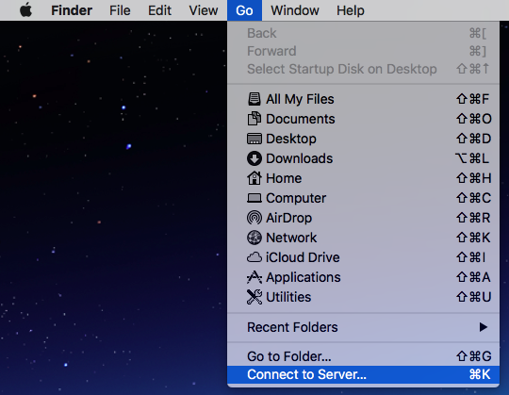

- In the Server Address field put //CSE001-WFP.ad.nyu.edu/home$/NETID, where the NETID is the netid of the student. In the case where CSE001-WFP.ad.nyu.edu is not found, use the following instead: //192.168.237.115/home$/NETID.

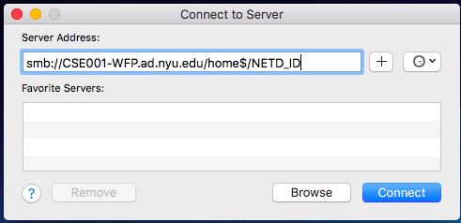

- Once you click Connect and enter your credentials, you will then be mapped to the S drive.

Reminder: Your NYU credentials to enter after you click “Connect” are of the following :

Username : [Insert AD\NetID]
Password : [Insert your password, the one you use for your email]

You must include “AD\” next to your NetID

