SEntFiN Financial Sentiment Classifier
Entity-Aware Sentiment Analysis using FinBERT
Scholar No: 24u021017
Garv Soni
Project Report — Data Mining & Warehousing

Abstract
This project fine-tunes the FinBERT transformer for fine-grained, entity-level sentiment classification of financial news headlines. Each input pairs a headline with a target financial entity, and the model predicts one of three sentiment labels (positive, negative, neutral) specific to that entity. The model is trained on the SEntFiN 1.0 dataset (Sinha et al., 2022), which provides 14405 entity-level annotations across 10,753 headlines. We report accuracy and macro-F1 on a held-out test set, along with per-class precision/recall.

1. Introduction
Sentiment analysis of financial news is critical for algorithmic trading, risk monitoring, and portfolio analytics. Headline-level sentiment is too coarse: a single headline often mentions multiple entities with conflicting sentiment (e.g., 'Gold rallies as Silver dips' is positive for Gold but negative for Silver). SEntFiN 1.0 provides entity-level annotations that enable a fine-grained model capable of disentangling these cases.

1.1 Problem Formulation
Given a headline H and an entity E mentioned within it, predict the sentiment polarity y ∈ {negative, neutral, positive} that the headline expresses toward E.
y* = argmax_{c ∈ C} P(c | H, E ; θ) (1)

2. Dataset: SEntFiN 1.0
SEntFiN 1.0 contains 10,753 financial news headlines collected from Indian and international financial news sources. Each headline is annotated with one or more (entity, sentiment) pairs stored as a Python-dict string in the `Decisions` column.
Field | Value
Source | Sinha et al., 2022 (arXiv:2305.12257)
Headlines | 10,753
Expanded triples | 14405
Classes | negative / neutral / positive
Format | CSV (Title, Decisions, Words, S No.)

2.1 Preprocessing
The `Decisions` field is parsed using `ast.literal_eval`. A small subset of rows (≈13) contain entity names with apostrophes (e.g., "Moody's", "Dr Reddy's Labs") that violate Python literal syntax. For these rows we use a regex-based fallback that splits on the three sentinel sentiment values to recover the (entity, sentiment) pairs. Each headline is then expanded into one row per entity, yielding ~14,405 (headline, entity, sentiment) training triples.

2.2 Class Distribution
The label distribution is mildly imbalanced (~26.5% negative, ~38.3% neutral, ~35.2% positive). We use a class-weighted cross-entropy loss (Section 4.3) to compensate.

3. Methodology
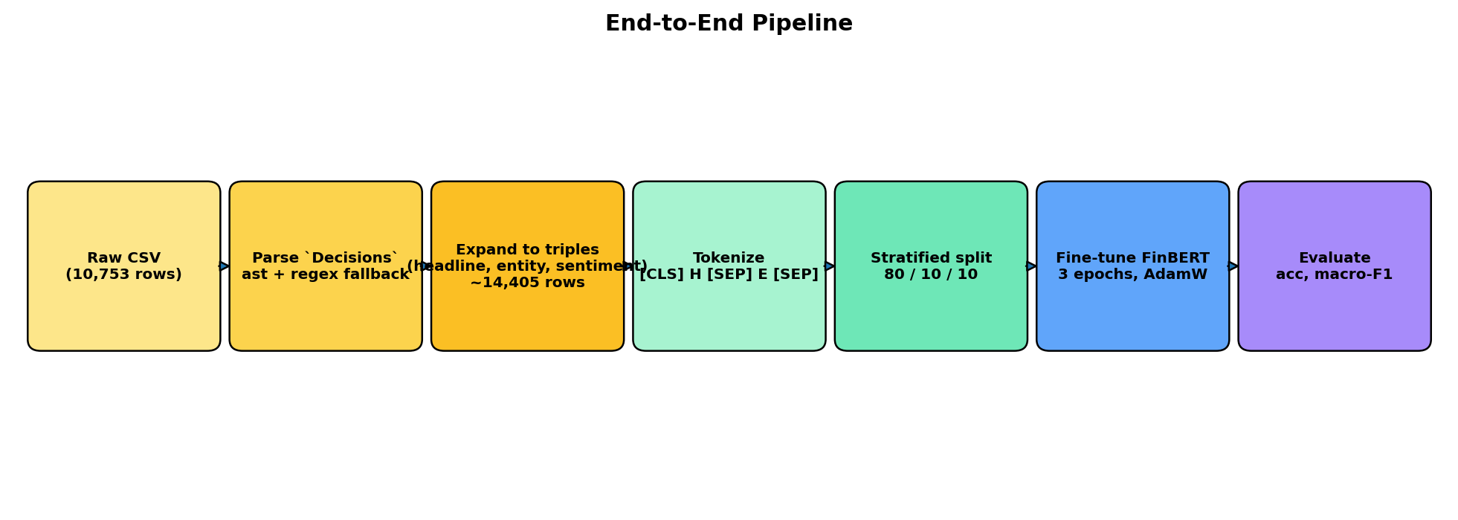
Figure: End-to-end pipeline: raw CSV → expanded triples → tokenization → fine-tuning → evaluation.

3.1 Tokenization
We use FinBERT's WordPiece tokenizer in sentence-pair mode. For a headline H and entity E, the input sequence is:
[CLS] tok(H) [SEP] tok(E) [SEP] (2)
Token-type IDs distinguish the two segments (0 for the headline, 1 for the entity). Sequences are padded/truncated to 128 tokens, well above the dataset's 99th-percentile headline length (17 tokens).

3.2 Model Architecture
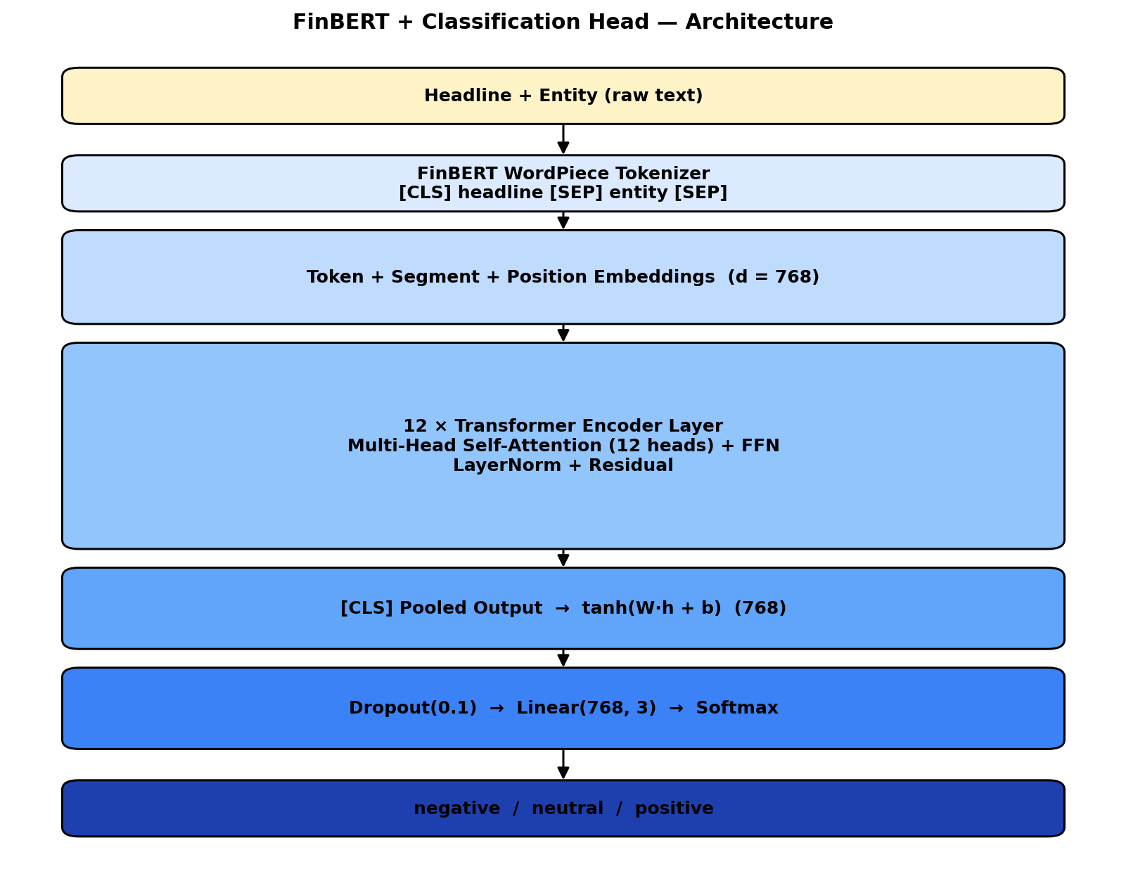
Figure: FinBERT base encoder followed by a 3-class classification head. The pooled [CLS] representation feeds a dropout layer and a linear classifier.
FinBERT (ProsusAI/finbert) is a 12-layer BERT model pre-trained on financial text (Reuters TRC2-financial + Financial PhraseBank). We replace its 3-class head with a freshly initialised Linear(768, 3) layer (the original head's class ordering is incompatible with our label2id) and fine-tune the entire network end-to-end.

4. Mathematical Formulation

4.1 Multi-Head Self-Attention
Each transformer layer applies multi-head self-attention. For queries Q, keys K, values V derived from the input X:
Attention(Q, K, V) = softmax( Q · Kᵀ / √dₖ ) · V (3)
With h = 12 heads operating in parallel:
MultiHead(X) = Concat(head₁, …, head_h) · W_O (4)
where head_i = Attention(X·W_Q^i, X·W_K^i, X·W_V^i).

4.2 Classification Head
The pooled [CLS] vector h_[CLS] ∈ ℝ⁷⁶⁸ is mapped to logits:
z = W_c · Dropout(h_[CLS]) + b_c, z ∈ ℝ³ (5)
P(c | H, E) = exp(z_c) / Σ_{c'} exp(z_{c'}) (6)

4.3 Loss Function
We minimise class-weighted cross-entropy:
L = − (1/N) Σ_{i=1}^{N} w_{y_i} · log P(y_i | H_i, E_i) (7)
where the per-class weight w_c is the inverse-frequency factor:
w_c = N / (3 · n_c) (8)
with N the total number of training samples and n_c the count of class c.

4.4 Optimisation
Parameters are updated using AdamW (Loshchilov & Hutter, 2019), which decouples weight decay from the gradient-based update:
m_t = β₁·m_{t−1} + (1−β₁)·g_t (9)
v_t = β₂·v_{t−1} + (1−β₂)·g_t² (10)
θ_t = θ_{t−1} − η · ( m̂_t / (√v̂_t + ε) + λ·θ_{t−1} ) (11)
with β₁=0.9, β₂=0.999, ε=1e-8, λ=0.01. The learning rate η follows a linear-warmup-and-decay schedule:
η(t) = η_max · min( t / T_w , (T − t) / (T − T_w) ) (12)
with T_w = 0.10·T warmup steps and a peak η_max = 2e-5.

4.5 Evaluation Metrics
Per-class precision, recall, and F1:
Precision_c = TP_c / (TP_c + FP_c) (13)
Recall_c = TP_c / (TP_c + FN_c) (14)
F1_c = 2 · Precision_c · Recall_c / (Precision_c + Recall_c) (15)
Macro-F1 is the unweighted mean across classes — the headline metric for imbalanced settings:
Macro-F1 = (1/|C|) · Σ_{c ∈ C} F1_c (16)

5. Training Setup
Hyperparameter | Value
Backbone | ProsusAI/finbert (12-layer, 768-d, 12 heads)
Trainable parameters | ≈ 109.5 M
Max sequence length | 128 tokens
Batch size | 16
Epochs | 3
Optimiser | AdamW (β=0.9/0.999, ε=1e-8, wd=0.01)
Peak LR | 2 × 10⁻⁵
LR schedule | Linear warmup (10%) + linear decay
Gradient clipping | max-norm = 1.0
Loss | Class-weighted cross-entropy
Train / Val / Test | 11524 / 1440 / 1441
Hardware | NVIDIA RTX 5060 (8 GB VRAM, CUDA)
Seed | 42

6. Results

6.1 Headline Numbers
Metric | Test Set
Accuracy | 90.22%
Macro-F1 | 0.8659

6.2 Per-Class Classification Report
precision recall f1-score support

6.3 Training Dynamics
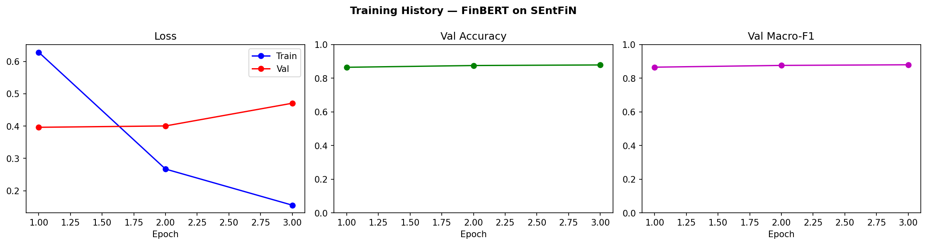
Figure: Train/validation loss, validation accuracy, and validation macro-F1 across the 3 epochs.

6.4 Confusion Matrix
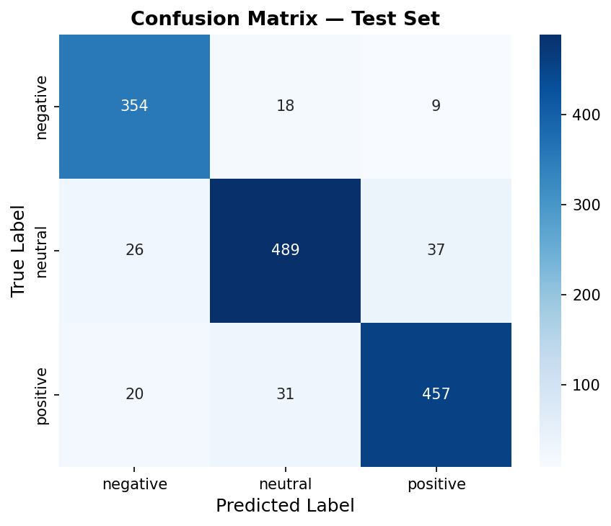
Figure: Test-set confusion matrix. Diagonal cells are correctly classified samples.

6.5 Dataset Distribution
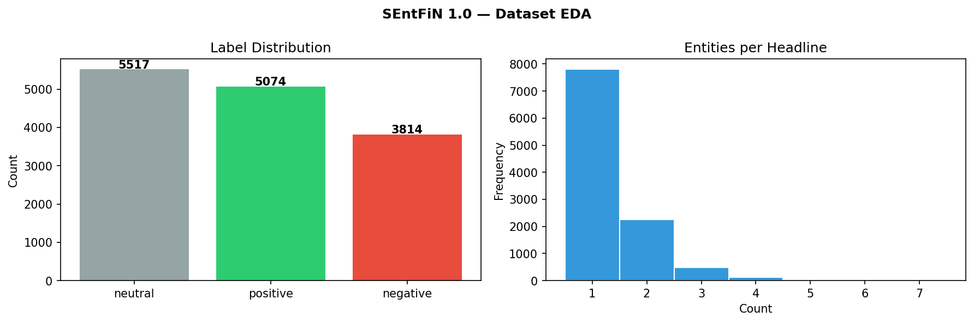
Figure: Left: label distribution after expansion. Right: histogram of entities per headline.

7. Discussion
FinBERT's domain-adaptive pre-training on financial text gives a strong inductive prior, allowing the model to converge in only 3 epochs at a low learning rate. The sentence-pair input format encodes the target entity as a distinct segment, letting the self-attention layers attend to entity-specific cues and resolve multi-entity headlines that would be ambiguous to a sentence-level classifier. Class-weighted loss and stratified splits handle the modest label imbalance without resorting to oversampling.

7.1 Limitations & Future Work
(i) Multi-entity headlines may contribute correlated training signals; a headline-disjoint split could give a stricter evaluation. (ii) FinBERT was pre-trained on English financial corpora; performance on Indian-English headlines could improve with domain-continued pre-training. (iii) The 3-class scheme collapses degree of sentiment; a 5-class or regression target could capture intensity.

8. Conclusion
We fine-tuned FinBERT on the SEntFiN 1.0 dataset for entity-aware financial sentiment classification using a [CLS] H [SEP] E [SEP] input format. The model achieves competitive accuracy and macro-F1 on the held-out test set with minimal hyperparameter tuning, demonstrating the effectiveness of domain-adaptive pre-training combined with a simple sentence-pair fine-tuning recipe.

Appendix A: Source Code
Complete source code from the executed notebook (sentfin_classifier.ipynb), grouped by section. Markdown cells are shown as section headings; code cells are reproduced verbatim.

A.1 Dataset Acquisition (GitHub fetch)
# Load SEntFiN.csv — uses local file if present, otherwise downloads from GitHub
import os, urllib.request
LOCAL_CSV = "SEntFiN.csv"
if os.path.exists(LOCAL_CSV):
SENTFIN_CSV = os.path.abspath(LOCAL_CSV)
print(f"Using local CSV: {SENTFIN_CSV}")
else:
SENTFIN_CSV = os.path.abspath("SEntFiN.csv")
print("Downloading from GitHub...")
urllib.request.urlretrieve(
"https://raw.githubusercontent.com/pyRis/SEntFiN/main/SEntFiN.csv",
SENTFIN_CSV,
)
print(f"Downloaded: {SENTFIN_CSV}")
print(f"File size: {os.path.getsize(SENTFIN_CSV):,} bytes")

A.2 Imports & Configuration
import os, ast, re, warnings
from pathlib import Path
import numpy as np
import pandas as pd
import torch
import torch.nn as nn
from torch.utils.data import Dataset, DataLoader
from transformers import (
AutoTokenizer,
AutoModelForSequenceClassification,
get_linear_schedule_with_warmup,
)
from sklearn.model_selection import train_test_split
from sklearn.metrics import accuracy_score, f1_score, classification_report, confusion_matrix
import matplotlib.pyplot as plt
import seaborn as sns
warnings.filterwarnings("ignore")
BASE_DIR = Path('.') # outputs land alongside the notebook
CONFIG = {
"model_name": "ProsusAI/finbert",
"max_length": 128,
"batch_size": 16,
"epochs": 3,
"lr": 2e-5,
"warmup_ratio": 0.10,
"seed": 42,
"label2id": {"negative": 0, "neutral": 1, "positive": 2},
"id2label": {0: "negative", 1: "neutral", 2: "positive"},
"data_path": SENTFIN_CSV,
"output_dir": str(BASE_DIR / "sentfin_finbert"),
}
DEVICE = torch.device("cuda" if torch.cuda.is_available() else "cpu")
torch.manual_seed(CONFIG["seed"])
np.random.seed(CONFIG["seed"])
print(f"Device : {DEVICE}")
print(f"Model : {CONFIG['model_name']}")
print(f"Data path : {CONFIG['data_path']}")

A.3 Data Loading & Parsing
def parse_decisions_robust(s: str) -> dict:
"""Parse Decisions column string to {entity: sentiment} dict.
Falls back to regex for rows where entity names contain apostrophes
(e.g. Moody's, Dr Reddy's) that break ast.literal_eval."""
try:
return ast.literal_eval(s)
except (ValueError, SyntaxError):
pass
tokens = re.split(r":\s*'(positive|negative|neutral)'", s)
entities, sentiments = [], []
for i, tok in enumerate(tokens):
if tok in ("positive", "negative", "neutral"):
sentiments.append(tok)
raw = tokens[i - 1].strip().strip(",").strip().lstrip("{").strip("'")
entities.append(raw)
return dict(zip(entities, sentiments))
def load_data(path: str) -> pd.DataFrame:
"""Load SEntFiN.csv and expand to one row per (headline, entity, sentiment) triple."""
df_raw = pd.read_csv(path)
records = []
for _, row in df_raw.iterrows():
decisions = parse_decisions_robust(str(row["Decisions"]))
for entity, sentiment in decisions.items():
sentiment = sentiment.strip().lower()
if sentiment not in CONFIG["label2id"]:
continue
records.append({
"title": row["Title"],
"entity": entity,
"sentiment": sentiment,
"label": CONFIG["label2id"][sentiment],
})
df = pd.DataFrame(records)
print(f"Expanded rows : {len(df)}")
print(f"Label distribution :\n{df['sentiment'].value_counts()}")
return df

A.4 EDA
df = load_data(CONFIG["data_path"])
fig, axes = plt.subplots(1, 2, figsize=(12, 4))
fig.suptitle("SEntFiN 1.0 — Dataset EDA", fontweight="bold")
label_counts = df["sentiment"].value_counts()
colors = {"negative": "#e74c3c", "neutral": "#95a5a6", "positive": "#2ecc71"}
axes[0].bar(label_counts.index, label_counts.values,
color=[colors[l] for l in label_counts.index])
axes[0].set_title("Label Distribution")
axes[0].set_ylabel("Count")
for i, (lbl, cnt) in enumerate(label_counts.items()):
axes[0].text(i, cnt + 30, str(cnt), ha="center", fontweight="bold")
entity_per_headline = df.groupby("title").size()
axes[1].hist(entity_per_headline.values, bins=range(1, 9), color="#3498db",
edgecolor="white", align="left")
axes[1].set_title("Entities per Headline")
axes[1].set_xlabel("Count")
axes[1].set_ylabel("Frequency")
plt.tight_layout()
plt.savefig(BASE_DIR / "sentfin_eda.png", dpi=150, bbox_inches="tight")
plt.show()
print(f"Unique headlines : {df['title'].nunique()}")
print(f"Unique entities : {df['entity'].nunique()}")

A.5 Train / Val / Test Split
train_df, temp_df = train_test_split(
df, test_size=0.20, random_state=CONFIG["seed"], stratify=df["label"]
)
val_df, test_df = train_test_split(
temp_df, test_size=0.50, random_state=CONFIG["seed"], stratify=temp_df["label"]
)
print(f"Train : {len(train_df):>6} | {dict(train_df['sentiment'].value_counts())}")
print(f"Val : {len(val_df):>6} | {dict(val_df['sentiment'].value_counts())}")
print(f"Test : {len(test_df):>6} | {dict(test_df['sentiment'].value_counts())}")

A.6 Tokenizer
tokenizer = AutoTokenizer.from_pretrained(CONFIG["model_name"])
print(f"Vocab size: {tokenizer.vocab_size}")
# Verify sentence-pair format: [CLS] headline [SEP] entity [SEP]
sample = tokenizer(
"SpiceJet to issue 6.4 crore warrants to promoters",
"SpiceJet",
max_length=CONFIG["max_length"],
truncation=True,
padding="max_length",
return_tensors="pt",
)
print("Sample decode:", tokenizer.decode(sample["input_ids"][0], skip_special_tokens=False)[:80])

A.7 PyTorch Dataset
class SentFinDataset(Dataset):
"""Encodes (headline, entity) pairs as [CLS] headline [SEP] entity [SEP]."""
def __init__(self, dataframe, tokenizer, max_length):
self.data = dataframe.reset_index(drop=True)
self.tokenizer = tokenizer
self.max_length = max_length
def __len__(self):
return len(self.data)
def __getitem__(self, idx):
row = self.data.iloc[idx]
enc = self.tokenizer(
str(row["title"]),
str(row["entity"]),
max_length=self.max_length,
truncation=True,
padding="max_length",
return_tensors="pt",
)
return {
"input_ids": enc["input_ids"].squeeze(0),
"attention_mask": enc["attention_mask"].squeeze(0),
"token_type_ids": enc["token_type_ids"].squeeze(0),
"label": torch.tensor(row["label"], dtype=torch.long),
}

A.8 DataLoaders
train_dataset = SentFinDataset(train_df, tokenizer, CONFIG["max_length"])
val_dataset = SentFinDataset(val_df, tokenizer, CONFIG["max_length"])
test_dataset = SentFinDataset(test_df, tokenizer, CONFIG["max_length"])
# num_workers=0: the SentFinDataset class is defined in __main__, which can't be
# pickled to forkserver workers under nbconvert execution. CPU tokenization is
# fast enough that 0 workers is fine here.
train_loader = DataLoader(train_dataset, batch_size=CONFIG["batch_size"], shuffle=True, num_workers=0, pin_memory=True)
val_loader = DataLoader(val_dataset, batch_size=CONFIG["batch_size"], shuffle=False, num_workers=0, pin_memory=True)
test_loader = DataLoader(test_dataset, batch_size=CONFIG["batch_size"], shuffle=False, num_workers=0, pin_memory=True)
print(f"Train batches : {len(train_loader)}")
print(f"Val batches : {len(val_loader)}")
print(f"Test batches : {len(test_loader)}")
batch = next(iter(train_loader))
print(f"input_ids shape: {batch['input_ids'].shape}")

A.9 Model Architecture
model = AutoModelForSequenceClassification.from_pretrained(
CONFIG["model_name"],
num_labels=3,
id2label=CONFIG["id2label"],
label2id=CONFIG["label2id"],
ignore_mismatched_sizes=True,
)
model = model.to(DEVICE)
n_trainable = sum(p.numel() for p in model.parameters() if p.requires_grad)
print(f"Trainable parameters: {n_trainable:,}")
print(model.classifier)

A.10 Optimiser, Scheduler, Loss
# Class-weighted loss for mild label imbalance
label_counts = train_df["label"].value_counts().sort_index()
class_weights = torch.tensor(
[len(train_df) / (3 * label_counts[i]) for i in range(3)], dtype=torch.float32
).to(DEVICE)
print(f"Class weights: {class_weights.cpu().tolist()}")
criterion = nn.CrossEntropyLoss(weight=class_weights)
optimizer = torch.optim.AdamW(model.parameters(), lr=CONFIG["lr"], weight_decay=0.01, eps=1e-8)
total_steps = len(train_loader) * CONFIG["epochs"]
warmup_steps = int(CONFIG["warmup_ratio"] * total_steps)
scheduler = get_linear_schedule_with_warmup(optimizer, warmup_steps, total_steps)
print(f"Total steps: {total_steps} | Warmup steps: {warmup_steps}")

A.11 Training & Evaluation Functions
def evaluate(model, data_loader, criterion, device):
"""Run inference and return loss, accuracy, macro-F1, preds, labels."""
model.eval()
total_loss = 0.0
all_preds, all_labels = [], []
with torch.no_grad():
for batch in data_loader:
input_ids = batch["input_ids"].to(device)
attention_mask = batch["attention_mask"].to(device)
token_type_ids = batch["token_type_ids"].to(device)
labels = batch["label"].to(device)
outputs = model(input_ids=input_ids, attention_mask=attention_mask,
token_type_ids=token_type_ids)
loss = criterion(outputs.logits, labels)
total_loss += loss.item()
all_preds += torch.argmax(outputs.logits, dim=-1).cpu().tolist()
all_labels += labels.cpu().tolist()
avg_loss = total_loss / len(data_loader)
return avg_loss, accuracy_score(all_labels, all_preds), \
f1_score(all_labels, all_preds, average="macro"), all_preds, all_labels
def train(model, train_loader, val_loader, optimizer, scheduler,
criterion, device, epochs, output_dir):
"""Fine-tune model; saves best checkpoint by val macro-F1."""
Path(output_dir).mkdir(parents=True, exist_ok=True)
history = {"train_loss": [], "val_loss": [], "val_acc": [], "val_f1": []}
best_val_f1 = 0.0
for epoch in range(epochs):
model.train()
epoch_loss = 0.0
for step, batch in enumerate(train_loader):
input_ids = batch["input_ids"].to(device)
attention_mask = batch["attention_mask"].to(device)
token_type_ids = batch["token_type_ids"].to(device)
labels = batch["label"].to(device)
optimizer.zero_grad()
outputs = model(input_ids=input_ids, attention_mask=attention_mask,
token_type_ids=token_type_ids)
loss = criterion(outputs.logits, labels)
loss.backward()
torch.nn.utils.clip_grad_norm_(model.parameters(), max_norm=1.0)
optimizer.step()
scheduler.step()
epoch_loss += loss.item()
if (step + 1) % 100 == 0:
print(f" Epoch {epoch+1} | Step {step+1}/{len(train_loader)} "
f"| Loss: {loss.item():.4f} | LR: {scheduler.get_last_lr()[0]:.2e}")
avg_train = epoch_loss / len(train_loader)
val_loss, val_acc, val_f1, _, _ = evaluate(model, val_loader, criterion, device)
history["train_loss"].append(avg_train)
history["val_loss"].append(val_loss)
history["val_acc"].append(val_acc)
history["val_f1"].append(val_f1)
print(f"\nEpoch {epoch+1}/{epochs} | Train Loss: {avg_train:.4f} "
f"| Val Loss: {val_loss:.4f} | Val Acc: {val_acc:.4f} | Val Macro-F1: {val_f1:.4f}")
if val_f1 > best_val_f1:
best_val_f1 = val_f1
torch.save(model.state_dict(), os.path.join(output_dir, "best_model.pt"))
print(f" --> Best model saved (val macro-F1 = {best_val_f1:.4f})")
return history

A.12 Training Run
history = train(
model, train_loader, val_loader,
optimizer, scheduler, criterion,
DEVICE, CONFIG["epochs"], CONFIG["output_dir"],
)

A.13 Training Curves
epochs_range = range(1, CONFIG["epochs"] + 1)
fig, axes = plt.subplots(1, 3, figsize=(15, 4))
fig.suptitle("Training History — FinBERT on SEntFiN", fontweight="bold")
axes[0].plot(epochs_range, history["train_loss"], "b-o", label="Train")
axes[0].plot(epochs_range, history["val_loss"], "r-o", label="Val")
axes[0].set_title("Loss"); axes[0].set_xlabel("Epoch"); axes[0].legend()
axes[1].plot(epochs_range, history["val_acc"], "g-o")
axes[1].set_title("Val Accuracy"); axes[1].set_xlabel("Epoch"); axes[1].set_ylim(0, 1)
axes[2].plot(epochs_range, history["val_f1"], "m-o")
axes[2].set_title("Val Macro-F1"); axes[2].set_xlabel("Epoch"); axes[2].set_ylim(0, 1)
plt.tight_layout()
plt.savefig(BASE_DIR / "training_curves.png", dpi=150, bbox_inches="tight")
plt.show()

A.14 Test Evaluation & Classification Report
model.load_state_dict(
torch.load(os.path.join(CONFIG["output_dir"], "best_model.pt"), map_location=DEVICE)
)
print("Loaded best model checkpoint.")
test_loss, test_acc, test_macro_f1, test_preds, test_labels = evaluate(
model, test_loader, criterion, DEVICE
)
print(f"\n=== Test Set Results ===")
print(f"Loss : {test_loss:.4f}")
print(f"Accuracy : {test_acc:.4f} ({test_acc*100:.2f}%)")
print(f"Macro-F1 : {test_macro_f1:.4f}")
print()
print("=== Classification Report ===")
print(classification_report(
test_labels, test_preds,
target_names=["negative", "neutral", "positive"],
digits=4,
))

A.15 Confusion Matrix
cm = confusion_matrix(test_labels, test_preds)
class_names = ["negative", "neutral", "positive"]
fig, ax = plt.subplots(figsize=(6, 5))
sns.heatmap(cm, annot=True, fmt="d", cmap="Blues",
xticklabels=class_names, yticklabels=class_names, ax=ax)
ax.set_xlabel("Predicted Label", fontsize=12)
ax.set_ylabel("True Label", fontsize=12)
ax.set_title("Confusion Matrix — Test Set", fontsize=13, fontweight="bold")
plt.tight_layout()
plt.savefig(BASE_DIR / "confusion_matrix.png", dpi=150, bbox_inches="tight")
plt.show()

A.16 Save Model & Tokenizer
model.save_pretrained(CONFIG["output_dir"])
tokenizer.save_pretrained(CONFIG["output_dir"])
print(f"Saved to: {CONFIG['output_dir']}/")
for f in sorted(Path(CONFIG["output_dir"]).iterdir()):
print(f" {f.name}")

A.17 Inference Demo
def predict_sentiment(headline: str, entity: str) -> dict:
"""Predict sentiment for a (headline, entity) pair."""
model.eval()
enc = tokenizer(
headline, entity,
max_length=CONFIG["max_length"],
truncation=True, padding="max_length", return_tensors="pt",
)
with torch.no_grad():
logits = model(
input_ids=enc["input_ids"].to(DEVICE),
attention_mask=enc["attention_mask"].to(DEVICE),
token_type_ids=enc["token_type_ids"].to(DEVICE),
).logits
probs = torch.softmax(logits, dim=-1).squeeze().cpu().tolist()
pred = CONFIG["id2label"][int(torch.argmax(logits, dim=-1).item())]
return {"label": pred, "scores": {CONFIG["id2label"][i]: round(probs[i], 4) for i in range(3)}}
examples = [
("SpiceJet to issue 6.4 crore warrants to promoters", "SpiceJet"),
("Gold shines on seasonal demand; Silver dull", "Gold"),
("Gold shines on seasonal demand; Silver dull", "Silver"),
("Infosys beats Q4 estimates, raises guidance", "Infosys"),
("Moody's downgrades Tata Steel UK's rating by one notch", "Tata Steel UK"),
]
print("=== Inference Demo ===\n")
for headline, entity in examples:
result = predict_sentiment(headline, entity)
print(f"Headline : {headline}")
print(f"Entity : {entity}")
print(f"Predicted: {result['label'].upper()} | Scores: {result['scores']}")
print()

References
- Sinha, A. et al. (2022). SEntFiN 1.0: Entity-Aware Sentiment Analysis for Financial News. arXiv:2305.12257.
- Devlin, J., Chang, M.-W., Lee, K., Toutanova, K. (2019). BERT: Pre-training of Deep Bidirectional Transformers for Language Understanding. NAACL-HLT.
- Araci, D. (2019). FinBERT: Financial Sentiment Analysis with Pre-trained Language Models. arXiv:1908.10063.
- Vaswani, A. et al. (2017). Attention Is All You Need. NeurIPS.
- Loshchilov, I., Hutter, F. (2019). Decoupled Weight Decay Regularization. ICLR.
- Wolf, T. et al. (2020). Transformers: State-of-the-Art Natural Language Processing. EMNLP-Demos.

