# Summary Tables

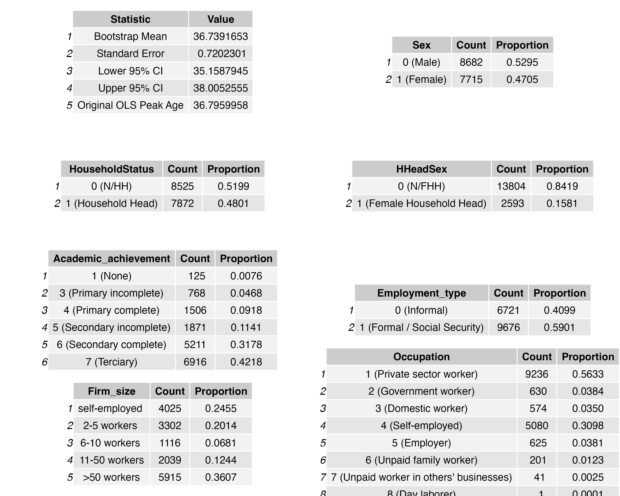

This figure displays the summary tables for continuous and categorical variables.