PINOUT:

Schemat Boarda:

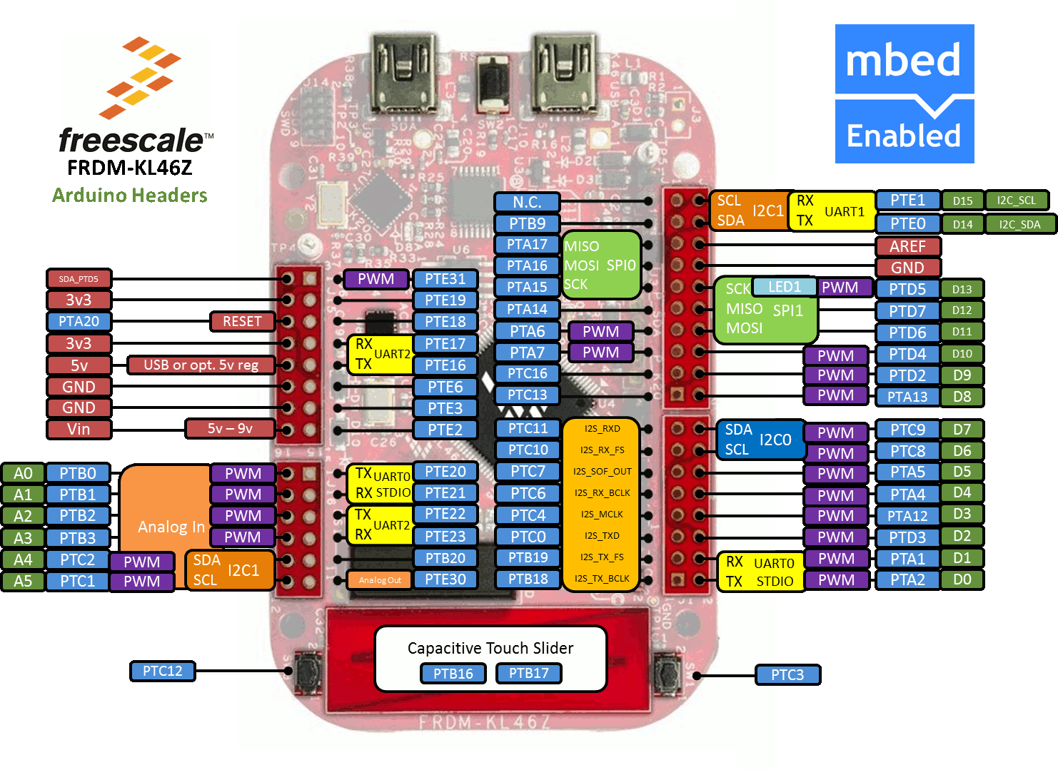

|  |  |  |
| --- | --- | --- |
| **Device** | **Device pins** | **BOARD** |
| ADT7410 - addr8bit(0x90)  A0 and A1 PIN are conected to GND | ADT7410_PIN_SDA  ADT7410_PIN_SCL | PTE0  PTE1 |
| MAX44009 - addr8bit (0x97)  A0 PIN is conected to VDD | MAX44009_PIN_SDA  MAX44009_PIN_SCL | PTE0  PTE1 |
| BMP180 - addr8bit (0xEF) | BMP180_PIN_SDA  BMP180_PIN_SCL | PTE0  PTE1 |
| MAX9611 - addr8bit (0xE1) | MAX9611_PIN_SDA  MAX9611_PIN_SCL | PTC9  PTC8 |
| DS2782 - addr8bit (0x68) | DS2782_PIN_SDA  DS2782_PIN_SCL | PTC9  PTC8 |
| SI7020 - addr8bit (0x81) | SI7020_PIN_SDA  SI7020_PIN_SCL | PTE0  PTE1 |
| AS3935 - addr8bit (0x06) | AS3935_PIN_SDA  AS3935_PIN_SCL  AS3935_PIN_INTERRUPT | PTC9  PTC8  PTA7 |
| GTS-4E-60 (GPS) |  |  |
|  |  |  |

Other STUFF:

<http://www.environmental-expert.com/monitoring-testing/weather-stations/products/location-china>

gotowa stacja na części od chinczyków

<http://www.ebay.com/bhp/wind-speed-sensor>

<http://www.alibaba.com/product-detail/Rain-Gauge-Weather-Sensor-Wind-Sensor_1189348626.html>

<http://www.gillinstruments.com/products/anemometer/windsonic.htm#windsensor>

<http://www.analog.com/en/mems-sensors/digital-temperature-sensors/adt7320/products/product.html>

Ze względu na obudowę zamawiamy na końcowy bord

<http://www.analog.com/en/mems-sensors/digital-temperature-sensors/adt7420/products/product.html>

Kwieciński czujniki temp.

<http://www.analog.com/en/mems-sensors/digital-temperature-sensors/adt7410/products/product.html>

za mała obudowa

<http://www.analog.com/en/mems-sensors/mems-inertial-sensors/adxl345/products/product.html>

radio

<http://www.analog.com/en/rfif-components/rfif-transceivers/adf7023-j/products/product.html>

kwieciński

<http://www.analog.com/en/digital-to-analog-converters/da-converters/ad5666/products/product.html>

dds Kalicki obudowa chujowa

<http://www.analog.com/en/digital-to-analog-converters/high-speed-da-converters/ad9106/products/product.html?src=ad9106.pdf>

potencjometr cyfrowy zajebisty I2C

<http://www.analog.com/en/digital-to-analog-converters/digital-potentiometers/ad5175/products/product.html>

niezły opamp tylko od 5zł startuje

<http://www.analog.com/en/precision-op-amps/precision-rail-to-rail-amplifiers/ad8639/products/product.html>

pompeczka -5V

<http://www.analog.com/en/power-management/switched-capacitor-converters/adm8829/products/product.html>

LDO adjust

<http://www.analog.com/en/power-management/linear-regulators/adp7104/products/product.html>

metex energii rycie duże

<http://www.analog.com/en/analog-to-digital-converters/energy-measurement/ade7816/products/product.html>