**MIS611 - Information Systems Capstone**

**(Assessment 1)**

**Stakeholder Requirements Document**

**Reinventing Money**

**Developing a CDBC for 2050**

|  |  |  |
| --- | --- | --- |
| Student Name | Student ID | Contribution % |
| Jessica Arango Castrillon | A00021154 | 100% |
| Ignacio Carreon Carrasco | A00045758 | 100% |
| Noman Tahir | A00033748 | 70% |
|  |  |  |
|  |  |  |
|  |  |  |
|  |  |  |

Learning Facilitator/Lecturer:

**Elizabeth Mulhall**

**2021 (Trimester 3)**

Table of Contents

1. Introduction 6

2. The Brief 7

The problem area/scope of the project 7

The objectives of your project are defined using SMART goals 7

Objective 1: Offer our clients a cashless option 7

Objective 2: Create products and services tailored to farmers 8

The target audience for whom your solution is being defined 9

Critical Success Factors 9

3. A description of the project 10

4. A stakeholder map 11

5. The data collection strategy 13

6. Appropriately documented functionality 15

FUNCTIONAL REQUIREMENTS 15

Savings account 15

Credit 16

Insurance 16

Investment 16

Foreign exchange 17

Payroll 17

7. A clear problem statement 17

7.1 What is the problem that your solution will resolve 17

8. Next steps 18

9. Appendices – Data Collection Strategy and Evidence 19

10. References according to the APA style 22

**Checklist**

**Assessment 1 Content checklist**

|  |  |  |
| --- | --- | --- |
| **Number** | **Section to be completed** | **Completed (please tick)** |
| 1 | Introduction | X |
| 2 | The Brief | X |
| 3 | A description of the project | X |
| 4 | A stakeholder Map | X |
| 5 | The Data Collection Strategy | X |
| 6 | Appropriately document functionality | X |
| 7 | A clear problem statement | X |
| 8 | Solution Evaluation | X |
| 9 | Next steps | X |
| 10 | Appendix 1 – Data Collection strategy output (including method toolkits) | X |
| 11 | References according to APA 7th style | X |

**Signature of each group member confirming all group members have checked and completed all the assessment sections :**

**1 ___Ignacio Carreon Carrasc___________**

**2____Noman Tahir___________________**

**3______** **Jessica Arango Castrillon ______**

**4___________________________________**

**5___________________________________**

**6___________________________________**

**7___________________________________**

**8___________________________________**

## Introduction

The aim of the report is to provide the detail description of capstone case study that is reinventing money in Colombia. The case is based on urban and rural farmers living in Colombia who still depend on cash and lack the knowledge or tools to be able to make the transition to digital financial methods. Although they are able to sale the products but not able to gain much profit. The comparison is provided of urban farmer and rural farmer of Colombia. Urban farmer age 40, location outskirts of biggest cities, products tomato, flowers and lettuce, exports include US/South America/Europe and equipment tools include automated irrigation, drones, sensors, advanced computers climate, facilities include primarily greenhouses and vertical farms. On the other hand, it also includes technologies used such as automated processes health. Family of urban farmers include small family 2 or 3 members.

Rural farmers age 55, location include small cities, products produced by rural farmers include coffee/banana and potato. The exports include south America equipment/tools tractors. Facilities include land, few greenhouses. The technology used by the rural farmers include drones. Family includes medium family 4 or 5 members.

Further, Columbia government has decided to start reinventing money so that farmers can earn more money. They decided to develop the block chain strategy that would help the farmers to gain income and earn more money. It has been determined that design thinking strategy is also helpful to attain the valid income for the urban farmers in Colombia.

The country Colombia has predicted up to 2050 to have more people living in cities as compare to rural areas that is 80% urban and 20% rural. Further financial technologies will be adopted by more than 70% people. There will be wide adoption of technology in general and it would include cheaper technologies more accessible to population.

## The Brief

## The problem area/scope of the project

We are in Colombia in the year 2050. Cash is about to disappear, however, farmers in both the city and rural areas are not 100% prepared for the change. The IMF requires that we reinvent the way money will be handled from now, so, we will continue to develop a cashless solution trying to solve the needs of farmers. We will focus on the new needs that they will face without forgetting the pillars that make up a solid financial system, so accompanying them in the transition by offering products and services relevant to their sector will be crucial.

## The objectives of your project are defined using SMART goals

The objectives of the project are as under:

### Objective 1: Offer our clients a cashless option

**Specific**

A prototype will be developed over 6 weeks in which the use of cash in transactions carried out by farmers will not be taken into account.

**Measurable**

Progress in each area of the project will be monitored weekly.

**Achievable**

It is year 2050 and the use of cash is decreasing considerably, however it is still used in some regions so the leap to a new technology that gets rid of it is feasible, this complements the wide penetration of financial services that already exist.

**Relevant**

Cash transactions almost disappeared and the use of new technologies that facilitate their management and improve their administration is more efficient.

Governments are beginning to pass laws that encourage and intensify the non-use of cash.

**Time bound**

The prototype will be ready in 6 weeks with the necessary functionalities.

### Objective 2: Create products and services tailored to farmers

**Specific**

**F**armers needs will be considered according to their particular circumstances, a thorough analysis of their profiles (personas) will be essential.

**Measurable**

Through the implementation of satisfaction surveys, the level of acceptance among users will be measured.

**Achievable**

Current users already manage digital accounts so they will be complemented with these products.

**Relevant**

The financial services to be provided will be designed for the agricultural sector.

**Time bound**

The prototype will be ready in 6 weeks with the necessary functionalities.

## The target audience for whom your solution is being defined

Our work will focus on solving the needs of 2 types of farmers that we believe in the future will become the predominant ones in Colombia, urban and rural farmers.

With urban farmers, we refer primarily to individuals or organizations with high purchasing power that, making use of the latest advances in technology (vertical farming/greenhouses/automation), are dedicated to the production of specialized food in areas close to large cities.

In the year 2050, it is projected that around 80% of the population of Colombia will live in urban areas, so it was concluded that taking advantage of technology and following new trends in agriculture plus technology, the installation of greenhouses in strategic points would be more profitable.

In relation to farmers in rural areas, we will focus on individuals of average purchasing power who do not have the latest production techniques but who, by making use of available technology, obtain an attractive return on their investment.

## Critical Success Factors

We will put special emphasis on these 4 factors that we believe will be essential for the successful development of a solution that encompasses everything necessary to make our consumers satisfied.

**Identify right customers**

Selecting and choosing carefully our target is crucial to be successful

**Correct analysis of customers**

An exhaustive analysis of the habits of our consumers will help to cover any shortage

**Customers' Needs**

Having carried out the analysis of our clients, with this information we will be able to detect what they really need.

**The easy and practical solution**

Deploying an easy-to-use solution will be decisive for success.

## A description of the project

As the project is focused on Colombian farmers living in both urban and rural areas, it was vitally important to detect the habits that, as productive agents, repeat every day as well as to make an analysis of the financial characteristics of their businesses. During the project, it was decided to make 2 profiles of different farmers that coincide in specific points to create a solution that benefits a greater number of people.

By 2050, according to different projections, financial inclusion in the country will have reached significant levels within the population, which means that a large majority of people will have a higher level of financial education, which will facilitate the adoption of our products.

As an organization, we intend to develop financial products and services around the main productive activities of farmers, adding options such as credits, insurance, investment, group purchases, etc., to a universal account in which our clients can find solutions to suit everything. this in the comfort of their home and with the guarantee that the transactions carried out will be protected with blockchain technology and without involving cash during the entire process.

All these initiatives designed to satisfy farmers would not be possible without extensive and powerful development of the technology as a whole over the next 30 years. It is expected that computational power will increase exponentially in the following years, which will promote the innovation and creation of new products that will replace and update the current ones, for this reason, our idea revolves around a powerful technological platform that can support the technical needs of planned products. Added to this, according to different sources, it is projected that the price of electronic devices will continue to fall, which will help middle-income countries to have more access to more advanced technology.

## A stakeholder map

A **map** showing key stakeholders, stakeholder interests and influences and how will the project address those interests.

**Answer:** The stakeholder map will help to solve the problems of Colombian farmers who are living in urban and rural areas. The stakeholder map gets a visual representation of all the people who influence that how the stakeholders will connect with the given project. All the stakeholders such as the community, government, investors, employees, suppliers and farmers urban and rural will help to complete this project.

**Keep completely informed**

**Manage most thoroughly**

**Regular minimal contact**

**Anticipate and meet needs**

Interest of stakeholders

Influence of stakeholders

Government

Community

Supplier

Investors

Farmers

Employees

Figure 1: Stakeholder mapping

(Source: Created by Author, 2021)

## The data collection strategy

In order to develop the project requested, it will be used the Agile approach is aligned with many methods and tools for requirements elicitation. After analysing, the most suitable for this particular case study was chosen the following that is explained below.

Before addressing the requirements elicitation techniques, group members made sure of having a clear understanding of the problem to solve in the case study that is reinventing money for the management of the agriculture industry in Colombia in 2050.

Design Thinking is an approach for emerging human-centred innovation focused on the user or customer experience. Design thinking is done through the understanding of the needs, pains, and gains of the customer through the empathise, define, solution ideate, and prototype phases. For this project the empathise with the customer phase was mainly done through researching regarding the agriculture industry in Colombia nowadays and factors around it such as economy, politic, social, environmental, health, and technology. Its affections or impacts in the future, the people involved in the project as customers, which in this case are farmers and people around them, and the vision of the industry, farmers, and technology in future obtaining a better understanding of the client, and the industry within which they are operating. Additionally, the defining the insights phase was done by analysing the findings through the empathy map, brainstorming and the definition of personas, and understanding the alignment of the customer needs with the problem by answering from the research key questions that help to clarify the insights. The solution brainstorming, and building prototype phases are out of the scope of this paperwork for which are not explained in deep. Furthermore, the Design Thinking methodology is suitable for issues that cannot be easily described and to which the solution is difficult to be found (Przybilla et al., 2018). There is a variety of models the deliver a Design Thinking process. However, one of the most known is the Double Diamond in which the Design Thinking for this project is based on.

The Double Diamond technique surely help us to discover the problem and define the insight by exploring the issue deeply, and obtaining the answer to those specific questions raised which gave a clear understanding of the problem, customer and insights instead of assuming theories or possible fake scenarios.

Moreover, Empathy Map is another tool used for gathering information for this project. An empathy map is a tool developed for teams that focuses on developing collective and profound understanding and empathy for people. This tool is frequently used to enhance customer experience, navigate organizational politics, design better work environments and a host of other things. The Empathy Map comprises a set of specific questions and it suits as a structure to complement an exercise in developing empathy (Gray, 2017). It represents what you know about a specific user or user group in order to build empathy for them (Stockwell, 2020). In the case study were analysed and brainstorming the feel and think, hear, see, do, say and do pains, and gains areas that help to have a sense and vision from the farmers perspective, expanding the spectrum of the current situation of the farmers and the industry, and gains.

Finally, the use of Personas was also implemented to create a shared understanding of who is the customer in this particular case study. The Persons are the fictitious but realistic description of a product user, which is believed to be a common or target user and should be described as a real person. The description of the persona should be clear in the wants, objectives and concerns, and should narrate the background of the persona such as gender, age, location, likes and dislikes. The description should centre on those characteristics that affect the product that is being created (Nodder, 2026). In the case study, two Personas were defined to cover different aspects of the target audience. We focused on the size of the farmer and location as they might have different huge differences in their needs and wants.

## Appropriately documented functionality

## FUNCTIONAL REQUIREMENTS

The system will be compatible with all technological platforms of 2050.

* Login.
* Double authentication process.
* Optional use of authentication with biometric data (facial, fingerprints or voice recognition).
* User data may be updated by meeting certain authentication requirements.
* Users will be informed by email of changes made to their account (optional and configurable).
* The home page will include a control panel with different types of accounts, credits, investment insurance, payroll, as well as a section on promotions.

### Savings account

* There will be a savings recommendation system based on monthly expenses managed by artificial intelligence.
* The system will create weekly expense reports.
* The weekly sales report will include a current monthly sales forecast.
* Expense notifications may be included each time a payment is made.
* Contact lists (clients) will be kept to streamline payment management.
* Transfers backed by blockchain technology.

### Credit

* Credits will be offered based on the history of each user.
* Status of each credit and information (payment date, payment limit, amount).
* Credit payments may be customizable, that is, adjust the time in which the discount of the payment of the main account will be made.
* A payment reminder will be sent 3 days before the deadline (configurable).
* Statistics related to credit will be available at all times.

### Insurance

* Insurance quote.
* Insurance payment through accounts.
* Policy visualization available in system.
* Discounts according to claims history.
* Recommendations for agricultural insurance according to the needs of each client.
* Claims and doubts via chatbot.
* Modifications to policy conditions.

### Investment

* Option to establish a recurring investment.
* Generation of monthly investment reports.
* Disposition of money invested in 24 hours.
* Investment tips and advice.
* Access to the stock exchange and information on public companies from the platform.
* Investment instrument finder.

### Foreign exchange

* Creation and implementation of a real-time currency exchange system
* Currency calculator.
* Option to transfer money in different currencies to accounts other than ours.

### Payroll

* Internal control panel with visualization of the profile of each employee of the company.
* Basic financial data for each employee.
* General and individual statistics of each employee account.

## A clear problem statement

## 7.1 What is the problem that your solution will resolve

**Answer:** The main problem is that the cash is not available that is the major problem to the farmers where they offer the products but cash is not enough to satisfy their needs. The cash related problem will be solved by taking the right actions.

To guide the solution process in the following format :

**Clients Name** :

Urban and Rural Farmers

**Needs a way to**

Make payment other than cash

**Because**

Cash has become almost obsolete in year 2050

## Next steps

Steps to be taken in progressing to your solution prototype.

8.1 The project manager will use ideas and design the process for applying this project.

8.2 block chain technology will be adopted to reduce the cash problem to the farmers in future.

8.3 The project manager should focus on elicitation techniques, human-centred innovation, stakeholder mapping and design thinking methodology, empathy map and two personas to solve the issues.

## Appendices – Data Collection Strategy and Evidence

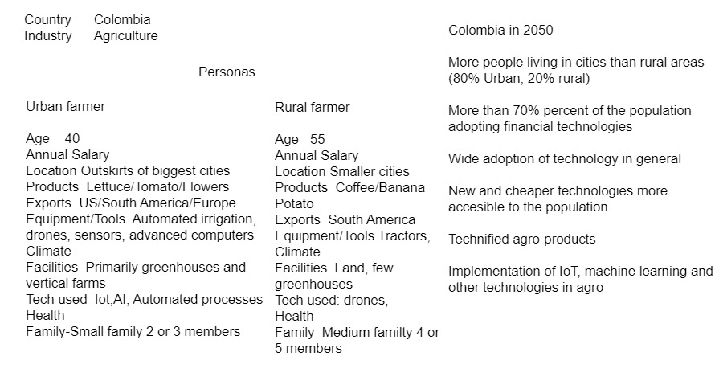

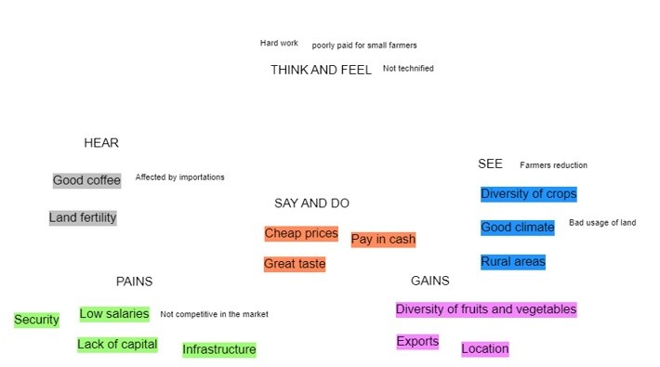

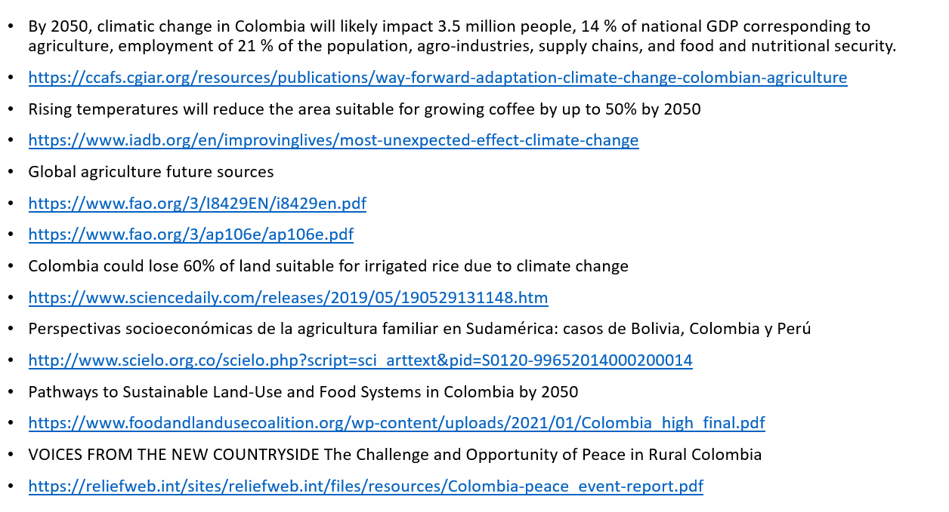

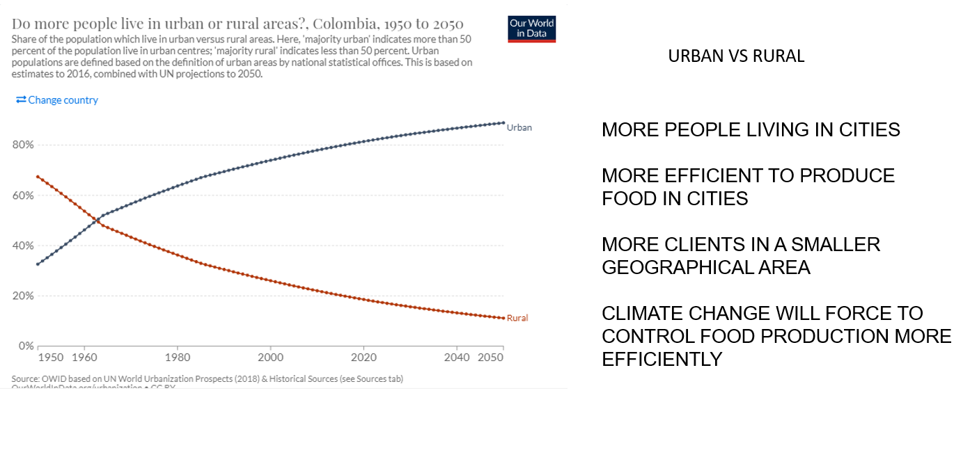

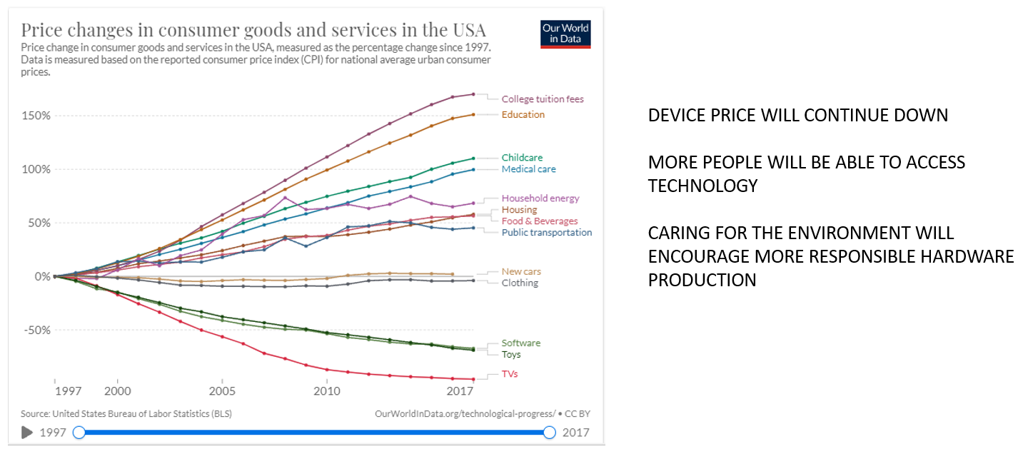

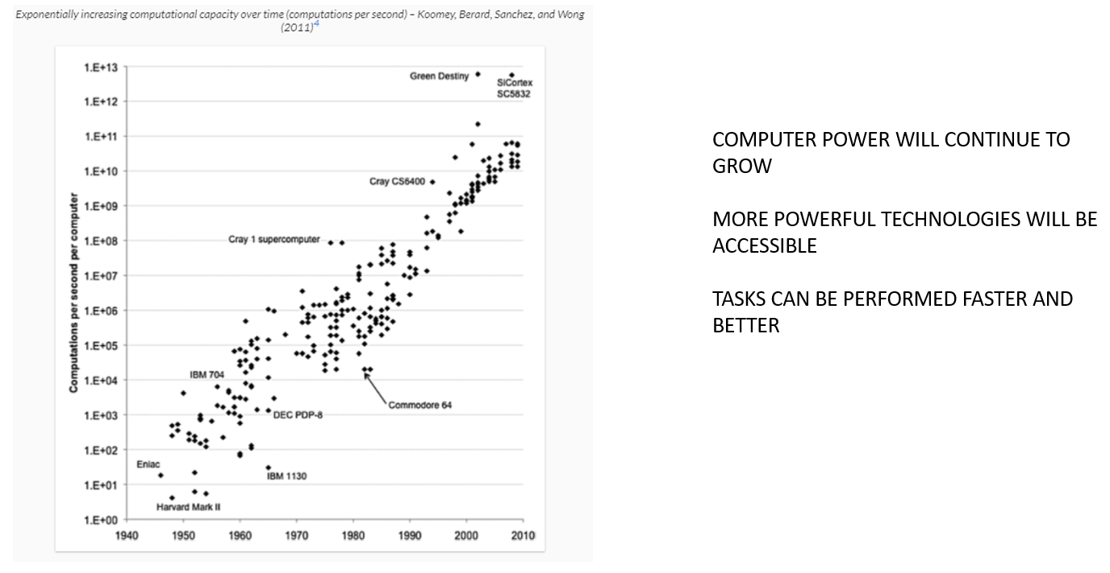

## References according to the APA style

Gray, D. (2017, July 16). Updated Empathy Map Canvas. https://medium.com/the-xplane-collection/updated-empathy-map-canvas-46df22df3c8a

Nodder, C. (2016, September 23). UX Design: 3 Creating Personas [Video files]. https://www.linkedin.com/learning/ux-design-3-creating-personas/what-is-a-persona?u=56744473

Przybilla, L., Schreieck, M., Klinker, K., Pflügler, C., Wiesche, M., and Krcmar, H. (2018). Combining Design Thinking and Agile Development to Master Highly Innovative IT Projects. Projektmanagement und Vorgehensmodelle 2018-Der Einfluss der Digitalisierung auf Projektmanagementmethoden und Entwicklungsprozesse. https://dl.gi.de/handle/20.500.12116/18905

Stockwell, A. (2020, April 24). Empathy Map Usage [Video file]. https://www.linkedin.com/learning/ux-deep-dive-mapping/empathy-map-usage?u=56744473

Stockwell, A. (2020, April 24). Building an Empathy Map [Video file]. https://www.linkedin.com/learning/ux-deep-dive-mapping/building-an-empathy-map?u=56744473