**FLYWHEEL MANUFACTURING FOR HIGH VOLUME PRODUCTION:**

Model Snapshot:  
Drawing Snapshot: Will add later  
I will also add references later.

1. Introduction

**Overview of the Project:**

This report details the manufacturing process for the flywheel of a vertical Stirling engine. The flywheel will be produced using a casting process with stainless steel as the raw material.

**Purpose of the Report:**

The purpose of this report is to outline the design specifications, manufacturing process, cost analysis, and quality assurance measures for the flywheel.

**Step 1: Choosing a stainless-steel alloy for flywheel considering following: -**

* Strength: Alloy should have adequate strength to withstand the mechanical stresses and loads experienced by the flywheel.
* Corrosion Resistance: Depending on the operating environment (e.g., marine, industrial), alloy should have corrosion resistance to ensure longevity and reliability of the flywheel.
* Machinability: Alloy should allow some machinability for additional machining operations required to produce final part.
* Cost: Need to balance the performance requirements with the cost of the stainless-steel alloy, including considerations for casting, machining, and any necessary post-processing treatments.

As this flywheel is part of an air engine, we can choose 316 stainless steel alloy

* Strength: Grade 316 stainless steel offers good strength properties suitable for high-speed applications. It has a tensile strength of around 580 MPa and a yield strength of about 290 MPa.
* Corrosion Resistance: Grade 316 is known for its excellent corrosion resistance, particularly in marine and chloride environments due to the addition of molybdenum. This makes it suitable for air engines that may be exposed to varying environmental conditions.
* Machinability: While not as easily machinable as some lower-alloyed stainless steels, Grade 316 can be machined effectively with appropriate tools and techniques.

**Step 2: Choosing a manufacturing process considering following: -**

As the shape of flywheel is unique, it will need some type of a mold in which molten stainless steel is poured and allowed for solidification. This process is called casting; there are multiple types of casting processes that can be considered for stainless steel: -

* Investment Casting (Lost Wax Casting):
  + Known for producing parts with excellent surface finish, intricate details, and tight tolerances.
  + Well-suited for stainless steel due to its ability to handle high melting temperatures and produce complex shapes.
* Sand Casting:
  + Versatile and can handle a wide range of sizes and shapes, making it suitable for large parts.
  + Can be used for 316 stainless-steel may require higher molding temperatures and careful handling to prevent oxidation.
* Shell Molding (Shell Casting):
  + Offers good dimensional accuracy, surface finish, and can handle higher production rates than traditional sand casting.
  + Can provide smoother surfaces and better dimensional control compared to sand casting.
* Die Casting (for certain stainless-steel alloys):
  + Can achieve high production rates and tight dimensional tolerances, suitable for mass production of smaller, more intricate parts.
  + Possible for stainless steel but less common due to the higher melting temperatures and more demanding process requirements.

Considering above casting options and taking into account their pros and cons, it would be beneficial to go ahead with investment casting. Sand casting would have been another good choice but it is comparatively a slower process and is more suitable for limited size batch production and less suitable for high volume production. Assuming that flywheel (part of air engine) would be a high-volume part, sand casting would not be a good choice. Finally, for die casting, given the high costs and technical challenges associated with die casting stainless steel, this method is rarely used in practice. Therefore, investment casting seems to be the best feasible choice considering high melting point of 316 stainless steel (~1399°C).

**Step 3: Investment Die Casting Process Flow: -**

1. **Pattern Creation:** A wax pattern is made, replicating the final product's shape. These patterns are typically produced using injection molding. Dies, molds & injection machines are used.
2. **Pattern Assembly:** The wax patterns are attached to a central wax gating system (sprue) to form a tree-like assembly. This allows multiple parts to be cast in a single mold.
3. **Shell Building:** The wax assembly is repeatedly dipped into a ceramic slurry and coated with fine sand (stucco) to build a ceramic shell around the wax pattern. This process is repeated several times to achieve the desired thickness and strength of the shell.
4. **Wax Removal:** The ceramic-coated wax assembly is placed in an autoclave or furnace to melt and drain out the wax, leaving a hollow ceramic shell. This step is also known as dewaxing.
5. **Preheating:** The ceramic shell is preheated to remove any residual wax and moisture, and to prepare it for the molten metal. This also strengthens the ceramic mold.
6. **Pouring:** Molten metal (such as 316 stainless steel) is poured into the preheated ceramic shell through the gating system. The high temperature ensures that the metal fills all intricate details of the mold. Induction/electric furnaces & pouring equipment is used.
7. **Cooling:** The molten metal is allowed to cool and solidify within the ceramic mold.
8. **Shell Removal:** The ceramic shell is broken away using mechanical vibration, water jets, or chemical processes to reveal the metal casting.
9. **Cutting and Finishing:** The individual cast parts are cut from the central gating system. The castings are then cleaned, ground, and machined as needed to meet final specifications.
10. **Inspection:** The finished parts undergo inspection for quality assurance, including dimensional checks and non-destructive testing methods to detect any defects.

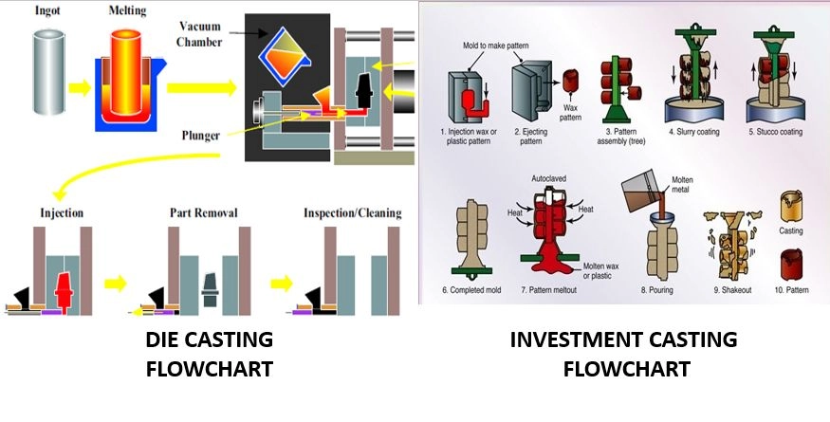

**Step 4: Quality Assurance and Inspection: -**

Inspecting critical-to-function dimensions of a flywheel is essential to ensure its performance, safety, and reliability in its application. The inspection process typically involves several steps and uses a variety of measurement techniques. Here’s a detailed overview:

1. Visual Inspection

* Purpose: Identify any obvious defects or irregularities.
* Methods: Check for cracks, surface imperfections, and overall condition of the flywheel. Use magnification if needed to inspect small details.

1. Dimensional Inspection

* Purpose: Verify that all critical dimensions are within specified tolerances.
* Tools and Methods:
* Calipers and Micrometers: Measure diameter, thickness, and other critical dimensions. Ensure accuracy within tight tolerances.
* Gages and Fixtures: Use specialized gages and fixtures to measure features like keyways, mounting holes, and balancing surfaces.
* Coordinate Measuring Machine (CMM): Provides high precision for complex geometries and can measure multiple dimensions in one setup.

1. Balancing Inspection
   * Purpose: Ensure the flywheel is properly balanced to avoid vibrations during operation.
   * Methods:
     + Dynamic Balancing: Use a balancing machine to check and correct any imbalance. This is critical for flywheels to ensure smooth operation and reduce wear on connected components.
2. Surface Finish Inspection
   * Purpose: Confirm that surface finishes meet requirements for function and longevity.
   * Methods:
     + Surface Roughness Tester: Measure surface texture to ensure it meets specified roughness values. Important for areas that come into contact with other components or require a specific finish.
3. Geometric Inspection
   * Purpose: Verify that geometric features like concentricity, runout, and flatness are within tolerance.
   * Tools and Methods:
     + Dial Indicators: Check for runout and concentricity of the flywheel’s rotational axis.
     + Flatness Gages: Measure the flatness of surfaces to ensure proper fit and function.
4. Material Inspection
   * Purpose: Ensure that the flywheel material meets the required specifications and properties.
   * Methods:
     + Hardness Testing: Verify material hardness to ensure it meets strength requirements.
     + Non-Destructive Testing (NDT): Techniques like ultrasonic testing or magnetic particle inspection to detect internal flaws or defects.
5. Functional Testing
   * Purpose: Ensure the flywheel performs correctly under operational conditions.
   * Methods:
     + Operational Testing: Mount the flywheel on a test rig or engine to check its performance under simulated operating conditions.
     + Dynamic Testing: Evaluate the flywheel’s behavior during dynamic loading and operation to ensure it performs as expected.

**Step 5: Documentation and Reporting: -**

* Recording Measurements: Document all measurements, test results, and inspection findings. Ensure traceability to the specific flywheel and its manufacturing lot.
* Quality Control Reports: Prepare detailed reports summarizing the inspection process, results, and any corrective actions taken.
* Proper inspection of critical dimensions ensures that the flywheel will function reliably and meet safety and performance standards. Regular and thorough inspections help in maintaining high-quality standards and preventing issues in operation.

**Cost Analysis – This is a general overview. Will likely go deeper into analysis.**

Let's assume the following data for a flywheel production:   
MOQ (Minimum Order Quantity) = 10,000 units

#### Material Costs

* **Material Required**: (0.111 kg/unit * 10,000) * 1.1 = 1221kg
  + **Note**: Added 10% extra material for buffer/wastage
* **Material Cost per kg**: $7.72 per kg (assumed as per values found online)
* **Total Material Cost**: 1221kg * $7.72/kg = $9,426

#### Labor Costs

Assuming team of 10 production team members are required to support this production for a duration of 3 months. Considering 25 working days per month.

* **Labor Hours**: 25days/month * 3months * 8 hours/day * 10 workers = 6000 man-hours
* **Labor Rate**: $25 per hour
* **Total Labor Cost**: 6000 man-hours * $25/hour = $150,000

#### Machine Time Costs

Assuming half of man hours are consumed in machine operations.

* **Machine Hours**: 3000 hours (combined machine/equipment hours ; will need to define rate per machine/setup)
* **Machine Rate**: $32 per hour (assumed rate ; considering constant rate for now)
* **Total Machine Time Cost**: 3000hours * $32/hour = $96,000

### Total Costs

* **Total Direct Costs**:

Total Direct Costs = Total Material Cost + Total Labor Cost = $159,426

* **Total Overhead Costs**:

Total Overhead Costs = Total Machine Time Cost = $96,000

* **Total Cost**:

Total Cost = Total Direct Costs + Total Overhead Costs = $255,426

Total Cost per unit = $255,426 / 10,000 = $25.54/unit

This analysis provides a basic overview. Additional factors would be considered in detailed cost analysis like quality control, setup costs, and other overheads that may affect the total cost.