

CSC 431  
  
Dashboard  
  
Software Requirements Specification (SRS)

**<Team number>**

|  |  |
| --- | --- |
| Izzy Geller |  |
| Rebecca Wagner |  |
| Emmett Steven |  |
| Alessio |  |
| Joran Rodriguez |  |
| Raul Diaz |  |

Version History

|  |  |  |  |
| --- | --- | --- | --- |
| Version | Date | Author(s) | Change Comments |
| 1.0 | 02/17/20 | ProjectU | Added project name |
|  |  | Julio Perez | General Comment about writing use cases and how to detail the Basic Flow |
| 1.2 | 2/16/18 | Dashboard | Added the UML |
| 1.3 | 2/24 | Izzy | Updated the UML |
| 1.4 | 2/24 | Dashboard | updating the tables to completeness and fixed the diagram |

Table of Contents

Version History 2

Table of Contents 3

Table of Tables 5

Table of Figures 6

1. System Requirements 7

1.1. Functional Requirements 7

1.1.1. Sign up page 7

1.1.2. Login page 7

1.1.3. Calendar 7

1.1.4. Task Creation Modal 8

1.1.5. Task Tracker 8

1.1.6. Task Tracker Timer 8

1.1.7 Settings 9

1.2. Non-Functional Requirements 9

1.2.1. Alert Badge 9

1.2.2. Password Recovery 9

1.2.3. Fill Out Email Prompt 9

1.2.4. Login Failure Prompt 9

2. System Constraints 11

2.1. Tool Constraints 11

2.1.1. Requirement Title 11

2.2. Language Constraints 11

2.2.3. Requirement Title 11

2.3. Platform Constraints 11

2.3.1. Requirement Title 11

2.4. Hardware Constraints 11

2.4.1. Requirement Title 11

2.5. Network Constraints 11

2.5.1. Requirement Title 11

2.6. Deployment Constraints 12

2.6.1. Requirement Title 12

2.7. Transition & Support Constraints 12

2.7.1. Requirement Title 12

2.8. Budget & Schedule Constraints 12

2.8.1. Requirement Title 12

2.9. Miscellaneous Constraints 12

2.9.1. Requirement Title 12

3. Requirements Modeling 13

3.1. Dashboard Diagram 13

4. Evolutionary Requirements 14

4.1. Functional Requirements 14

4.1.1. Requirement Title 14

4.2. Non-Functional Requirements 14

4.2.1. Requirement Title 14

Table of Tables

<Generate table here>

Table of Figures

<Generate table here>

1. 1. System Requirements

1.1. Functional Requirements

1.1.1. Sign up page

|  |  |
| --- | --- |
| ID | FR1 |
| Title | Sign up page |
| Description | A form to allow new users to create an account and then access the task tracker |
| Priority | 0 |
| Precondition(s) | Navigate to the website to the login/register landing page |
| Basic Flow | User clicks sign up button to open form  User enters desired email and password for account  User presses submit and their information is saved to the account database  User directed to login page |
| Postconditions(s) | User directed to login page and can access task tracker |
| Use Case Diagram | 3.1 |

1.1.2. Login page

|  |  |
| --- | --- |
| ID | FR2 |
| Title | Login page |
| Description | A form for users to enter their existing account information and log in to their personalized task tracker. The activity has options for company login or personal, but it is personal by default. |
| Priority | 0 |
| Precondition(s) | User account has already been created |
| Basic Flow | Navigate to landing and login page  User enters email and password to login  Password forgotten, click link and it will send the option to reset the password to the email filled in in the login form  User clicks login button  Username and password are checked against the database  Redirects to task tracker dashboard |
| Postconditions(s) | The user will have access to create and manage tasks |
| Use Case Diagram | 3.1 |

1.1.3. Calendar

|  |  |
| --- | --- |
| ID | FR3 |
| Title | Calendar |
| Description | Tasks in a calendar view. The calendar can be shown by week or month and on each day displays what task is due. The tasks will be colored according to their respective category color. |
| Priority | 0 |
| Precondition(s) | User is logged in |
| Basic Flow | User clicks to toggle to calendar view.  User can select to view the tasks for the week or the month  can also choose to jump forward or backward a week or month  Click on plus to add task to a specified date  Click on an existing task to modify its details (change due date, category, title, etc) |
| Postconditions(s) | The user will be able to add and track his tasks |
| Use Case Diagram | 3.1 |

1.1.4. Task Creation Modal

|  |  |
| --- | --- |
| ID | FR4 |
| Title | Task Creation Modal |
| Description | Modal where users will create their task and add necessary details. The user will be able to create the task with a title and default settings that can be customized later(category, due date, priority, description, and timer). |
| Priority | 0 |
| Precondition(s) | User must be logged in and on the calendar or list view of the tasks. |
| Basic Flow | Render task creation modal  Fill out task title, description, due date, etc.  Button to click submit  Save task to database  Redirect to previous view (list or calendar) |
| Postconditions(s) | A task will be created |
| Use Case Diagram | 3.1 |

1.1.5. Task Tracker

|  |  |
| --- | --- |
| ID | FR5 |
| Title | Task Tracker |
| Description | Ultimate view for the calendar that shows the tasks in a list which are sorted depending on the category, priority, and due date. When you click on a task, it will give you more details. |
| Priority | 2 |
| Precondition(s) | User must be logged in to see their tasks |
| Basic Flow | Render task tracker widget as list  Set sorting criteria  Sort tasks  Click on a task  Load modal with information from database  Update and add information as needed  Close/ save the task  Show details for specified task in the main tracking list view |
| Postconditions(s) | The user will be able to get details on tasks |
| Use Case Diagram | 3.1 |

1.1.6. Task Tracker Timer

|  |  |
| --- | --- |
| ID | FR6 |
| Title | Task Tracker Timer |
| Description | It allows the user to set a designated time frame for the task. You can start and stop the timer while you are working on it. |
| Priority | 3 |
| Precondition(s) | Having created a task |
| Basic Flow | Render timer creation form  Link to specific task  Set time frame for task  Button to submit  Save timer to database section related to specified task |
| Postconditions(s) | A timer will be created to track a specific task |
| Use Case Diagram | 3.1 |

1.1.7 Settings

|  |  |
| --- | --- |
| ID | FR7 |
| Title | Settings |
| Description | Allow users to personalize the calendar (such as changing the color) and manage their profile (such as change the username, email, and/or password) |
| Priority | 0 |
| Precondition(s) | Having an account |
| Basic Flow | User selects the settings tab  The settings windows is opened, listing different options for the user (change appearance, manage profile)  The user can change their username, email, and/or password information, or modify the appearance of the calendar, and press save to confirm the change  The changes are applied to the account |
| Postconditions(s) | The account settings will be modified accordingly |
| Use Case Diagram | 3.1 |

1.2. Non-Functional Requirements

1.2.1. Alert Badge

|  |  |
| --- | --- |
| ID | NFR1 |
| Title | Alert Badge |
| Description | After the user logs in, it will display a badge of the number of tasks that are due in the webpage tab. |
| Priority | 5 |
| Applicable FR(s) | Task tracker (1.1.5) and task tracker timer (1.1.6) |

1.2.2. Password Recovery

|  |  |
| --- | --- |
| ID | NFR2 |
| Title | Password Recovery |
| Description | After the user selects that they have forgotten their password, an email will automatically be sent to the email on file allowing an option to reset the password. |
| Priority | 2 |
| Applicable FR(s) | Login Page (1.1.2) |

1.2.3. Fill Out Email Prompt

|  |  |
| --- | --- |
| ID | NFR3 |
| Title | Alert Window |
| Description | The email box will flash red if the email box has not been filled when pressing the forgot password button |
| Priority | 5 |
| Applicable FR(s) | Login Page (1.1.2) |

1.2.4. Login Failure Prompt

|  |  |
| --- | --- |
| ID | NFR1 |
| Title | Alert Window |
| Description | After the user attempts to log-in and fails validation, a text prompt will appear asking the user that they have been unable to log-in and to check that their information has been inputted correctly |
| Priority | 5 |
| Applicable FR(s) | Login Page (1.1.1) |

1. 2. System Constraints

2.1. Tool Constraints

< List all tool constraints in the following example format >

2.1.1. Requirement Title

|  |  |
| --- | --- |
| ID | <a unique ID for the constraint, e.g., C1)> |
| Title | <Insert title> |
| Description | <A one or two sentence description> |
| Priority | <Priority from 0 (highest) – 5 (lowest)> |

2.2. Language Constraints

< List all language constraints in the following example format >

2.2.3. Requirement Title

|  |  |
| --- | --- |
| ID | <a unique ID for the constraint, e.g., C1)> |
| Title | <Insert title> |
| Description | <A one or two sentence description> |
| Priority | <Priority from 0 (highest) – 5 (lowest)> |

2.3. Platform Constraints

< List all platform constraints in the following example format >

2.3.1. Requirement Title

|  |  |
| --- | --- |
| ID | <a unique ID for the constraint, e.g., C1)> |
| Title | <Insert title> |
| Description | <A one or two sentence description> |
| Priority | <Priority from 0 (highest) – 5 (lowest)> |

2.4. Hardware Constraints

< List all hardware constraints in the following example format >

2.4.1. Requirement Title

|  |  |
| --- | --- |
| ID | <a unique ID for the constraint, e.g., C1)> |
| Title | <Insert title> |
| Description | <A one or two sentence description> |
| Priority | <Priority from 0 (highest) – 5 (lowest)> |

2.5. Network Constraints

< List all network constraints in the following example format >

2.5.1. Requirement Title

|  |  |
| --- | --- |
| ID | <a unique ID for the constraint, e.g., C1)> |
| Title | <Insert title> |
| Description | <A one or two sentence description> |
| Priority | <Priority from 0 (highest) – 5 (lowest)> |

2.6. Deployment Constraints

< List all deployment constraints in the following example format >

2.6.1. Requirement Title

|  |  |
| --- | --- |
| ID | <a unique ID for the constraint, e.g., C1)> |
| Title | <Insert title> |
| Description | <A one or two sentence description> |
| Priority | <Priority from 0 (highest) – 5 (lowest)> |

2.7. Transition & Support Constraints

< List all transition & support constraints in the following example format >

2.7.1. Requirement Title

|  |  |
| --- | --- |
| ID | <a unique ID for the constraint, e.g., C1)> |
| Title | <Insert title> |
| Description | <A one or two sentence description> |
| Priority | <Priority from 0 (highest) – 5 (lowest)> |

2.8. Budget & Schedule Constraints

< List all budget & schedule constraints in the following example format >

2.8.1. Requirement Title

|  |  |
| --- | --- |
| ID | <a unique ID for the constraint, e.g., C1)> |
| Title | <Insert title> |
| Description | <A one or two sentence description> |
| Priority | <Priority from 0 (highest) – 5 (lowest)> |

2.9. Miscellaneous Constraints

< List all miscellaneous constraints in the following example format >

2.9.1. Requirement Title

|  |  |
| --- | --- |
| ID | <a unique ID for the constraint, e.g., C1)> |
| Title | <Insert title> |
| Description | <A one or two sentence description> |
| Priority | <Priority from 0 (highest) – 5 (lowest)> |

1. 3. Requirements Modeling

< List all Use-case diagrams for the functional requirements in the following format>

3.1. Dashboard Diagram

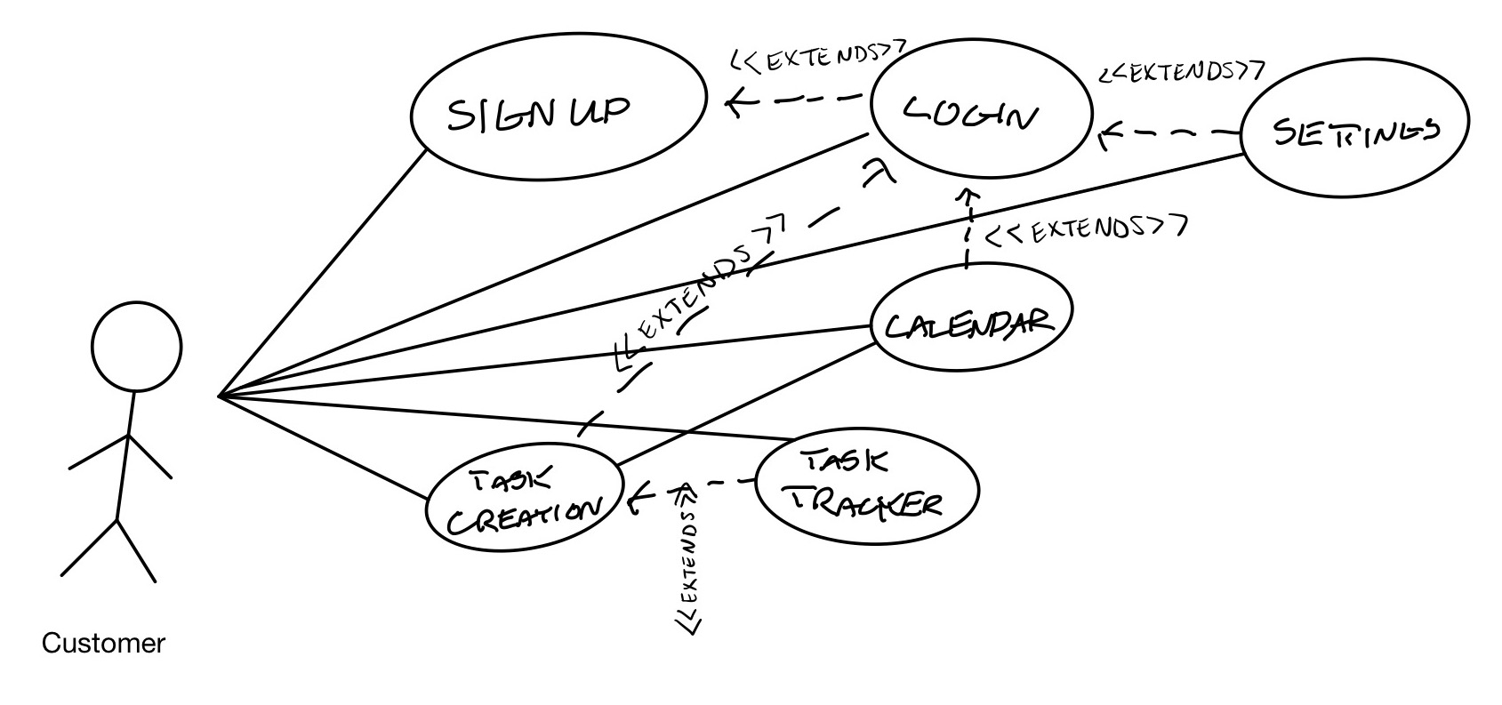

1. 4. Evolutionary Requirements

4.1. Functional Requirements

< List all functional requirements in the following example format >

4.1.1. Requirement Title

|  |  |
| --- | --- |
| Title | <Insert title> |
| Description | <A one or two sentence description> |
| Priority | <Priority from 0 (highest) – 5 (lowest)> |
| Precondition(s) | <What needs to happen before> |
| Postconditions(s) | <What happens as a result> |
| Use Case Diagram | <Link or number, if present> |

4.2. Non-Functional Requirements

< List all non-functional requirements in the following example format >

4.2.1. Requirement Title

|  |  |
| --- | --- |
| Title | <Insert title> |
| Description | <A one or two sentence description> |
| Priority | <Priority from 0 (highest) – 5 (lowest)> |
| Applicable FR(s) | <Which functional requirement(s) is this applicable to?> |