Codebook for df_tidy

Autogenerated data summary from dataMaid

2020-01-22 11:54:09

# Data report overview

The dataset examined has the following dimensions:

|  |  |
| --- | --- |
| Feature | Result |
| Number of observations | 126 |
| Number of variables | 88 |

# Codebook summary table

|  |  |  |  |  |  |
| --- | --- | --- | --- | --- | --- |
| Label | Variable | Class | # unique values | Missing | Description |
|  | **subject** | integer | 21 | 0.00 % |  |
|  | **activity** | factor | 6 | 0.00 % |  |
|  | **tbodyacc-mean()-x** | numeric | 126 | 0.00 % |  |
|  | **tbodyacc-mean()-y** | numeric | 126 | 0.00 % |  |
|  | **tbodyacc-mean()-z** | numeric | 126 | 0.00 % |  |
|  | **tbodyacc-std()-x** | numeric | 126 | 0.00 % |  |
|  | **tbodyacc-std()-y** | numeric | 126 | 0.00 % |  |
|  | **tbodyacc-std()-z** | numeric | 126 | 0.00 % |  |
|  | **tgravityacc-mean()-x** | numeric | 126 | 0.00 % |  |
|  | **tgravityacc-mean()-y** | numeric | 126 | 0.00 % |  |
|  | **tgravityacc-mean()-z** | numeric | 126 | 0.00 % |  |
|  | **tgravityacc-std()-x** | numeric | 126 | 0.00 % |  |
|  | **tgravityacc-std()-y** | numeric | 126 | 0.00 % |  |
|  | **tgravityacc-std()-z** | numeric | 126 | 0.00 % |  |
|  | **tbodyaccjerk-mean()-x** | numeric | 126 | 0.00 % |  |
|  | **tbodyaccjerk-mean()-y** | numeric | 126 | 0.00 % |  |
|  | **tbodyaccjerk-mean()-z** | numeric | 126 | 0.00 % |  |
|  | **tbodyaccjerk-std()-x** | numeric | 126 | 0.00 % |  |
|  | **tbodyaccjerk-std()-y** | numeric | 126 | 0.00 % |  |
|  | **tbodyaccjerk-std()-z** | numeric | 126 | 0.00 % |  |
|  | **tbodygyro-mean()-x** | numeric | 126 | 0.00 % |  |
|  | **tbodygyro-mean()-y** | numeric | 126 | 0.00 % |  |
|  | **tbodygyro-mean()-z** | numeric | 126 | 0.00 % |  |
|  | **tbodygyro-std()-x** | numeric | 126 | 0.00 % |  |
|  | **tbodygyro-std()-y** | numeric | 126 | 0.00 % |  |
|  | **tbodygyro-std()-z** | numeric | 126 | 0.00 % |  |
|  | **tbodygyrojerk-mean()-x** | numeric | 126 | 0.00 % |  |
|  | **tbodygyrojerk-mean()-y** | numeric | 126 | 0.00 % |  |
|  | **tbodygyrojerk-mean()-z** | numeric | 126 | 0.00 % |  |
|  | **tbodygyrojerk-std()-x** | numeric | 126 | 0.00 % |  |
|  | **tbodygyrojerk-std()-y** | numeric | 126 | 0.00 % |  |
|  | **tbodygyrojerk-std()-z** | numeric | 126 | 0.00 % |  |
|  | **tbodyaccmag-mean()** | numeric | 126 | 0.00 % |  |
|  | **tbodyaccmag-std()** | numeric | 126 | 0.00 % |  |
|  | **tgravityaccmag-mean()** | numeric | 126 | 0.00 % |  |
|  | **tgravityaccmag-std()** | numeric | 126 | 0.00 % |  |
|  | **tbodyaccjerkmag-mean()** | numeric | 126 | 0.00 % |  |
|  | **tbodyaccjerkmag-std()** | numeric | 126 | 0.00 % |  |
|  | **tbodygyromag-mean()** | numeric | 126 | 0.00 % |  |
|  | **tbodygyromag-std()** | numeric | 126 | 0.00 % |  |
|  | **tbodygyrojerkmag-mean()** | numeric | 126 | 0.00 % |  |
|  | **tbodygyrojerkmag-std()** | numeric | 126 | 0.00 % |  |
|  | **fbodyacc-mean()-x** | numeric | 126 | 0.00 % |  |
|  | **fbodyacc-mean()-y** | numeric | 126 | 0.00 % |  |
|  | **fbodyacc-mean()-z** | numeric | 126 | 0.00 % |  |
|  | **fbodyacc-std()-x** | numeric | 126 | 0.00 % |  |
|  | **fbodyacc-std()-y** | numeric | 126 | 0.00 % |  |
|  | **fbodyacc-std()-z** | numeric | 126 | 0.00 % |  |
|  | **fbodyacc-meanfreq()-x** | numeric | 126 | 0.00 % |  |
|  | **fbodyacc-meanfreq()-y** | numeric | 126 | 0.00 % |  |
|  | **fbodyacc-meanfreq()-z** | numeric | 126 | 0.00 % |  |
|  | **fbodyaccjerk-mean()-x** | numeric | 126 | 0.00 % |  |
|  | **fbodyaccjerk-mean()-y** | numeric | 126 | 0.00 % |  |
|  | **fbodyaccjerk-mean()-z** | numeric | 126 | 0.00 % |  |
|  | **fbodyaccjerk-std()-x** | numeric | 126 | 0.00 % |  |
|  | **fbodyaccjerk-std()-y** | numeric | 126 | 0.00 % |  |
|  | **fbodyaccjerk-std()-z** | numeric | 126 | 0.00 % |  |
|  | **fbodyaccjerk-meanfreq()-x** | numeric | 126 | 0.00 % |  |
|  | **fbodyaccjerk-meanfreq()-y** | numeric | 126 | 0.00 % |  |
|  | **fbodyaccjerk-meanfreq()-z** | numeric | 126 | 0.00 % |  |
|  | **fbodygyro-mean()-x** | numeric | 126 | 0.00 % |  |
|  | **fbodygyro-mean()-y** | numeric | 126 | 0.00 % |  |
|  | **fbodygyro-mean()-z** | numeric | 126 | 0.00 % |  |
|  | **fbodygyro-std()-x** | numeric | 126 | 0.00 % |  |
|  | **fbodygyro-std()-y** | numeric | 126 | 0.00 % |  |
|  | **fbodygyro-std()-z** | numeric | 126 | 0.00 % |  |
|  | **fbodygyro-meanfreq()-x** | numeric | 126 | 0.00 % |  |
|  | **fbodygyro-meanfreq()-y** | numeric | 126 | 0.00 % |  |
|  | **fbodygyro-meanfreq()-z** | numeric | 126 | 0.00 % |  |
|  | **fbodyaccmag-mean()** | numeric | 126 | 0.00 % |  |
|  | **fbodyaccmag-std()** | numeric | 126 | 0.00 % |  |
|  | **fbodyaccmag-meanfreq()** | numeric | 126 | 0.00 % |  |
|  | **fbodybodyaccjerkmag-mean()** | numeric | 126 | 0.00 % |  |
|  | **fbodybodyaccjerkmag-std()** | numeric | 126 | 0.00 % |  |
|  | **fbodybodyaccjerkmag-meanfreq()** | numeric | 126 | 0.00 % |  |
|  | **fbodybodygyromag-mean()** | numeric | 126 | 0.00 % |  |
|  | **fbodybodygyromag-std()** | numeric | 126 | 0.00 % |  |
|  | **fbodybodygyromag-meanfreq()** | numeric | 126 | 0.00 % |  |
|  | **fbodybodygyrojerkmag-mean()** | numeric | 126 | 0.00 % |  |
|  | **fbodybodygyrojerkmag-std()** | numeric | 126 | 0.00 % |  |
|  | **fbodybodygyrojerkmag-meanfreq()** | numeric | 126 | 0.00 % |  |
|  | **angle(tbodyaccmean,gravity)** | numeric | 126 | 0.00 % |  |
|  | **angle(tbodyaccjerkmean),gravitymean)** | numeric | 126 | 0.00 % |  |
|  | **angle(tbodygyromean,gravitymean)** | numeric | 126 | 0.00 % |  |
|  | **angle(tbodygyrojerkmean,gravitymean)** | numeric | 126 | 0.00 % |  |
|  | **angle(x,gravitymean)** | numeric | 126 | 0.00 % |  |
|  | **angle(y,gravitymean)** | numeric | 126 | 0.00 % |  |
|  | **angle(z,gravitymean)** | numeric | 126 | 0.00 % |  |

# Variable list

## subject

|  |  |
| --- | --- |
| Feature | Result |
| Variable type | integer |
| Number of missing obs. | 0 (0 %) |
| Number of unique values | 21 |
| Median | 17 |
| 1st and 3rd quartiles | 8; 25 |
| Min. and max. | 1; 30 |

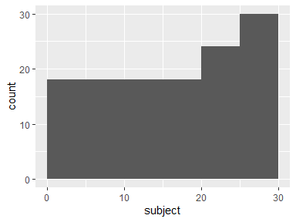

## activity

|  |  |
| --- | --- |
| Feature | Result |
| Variable type | factor |
| Number of missing obs. | 0 (0 %) |
| Number of unique values | 6 |
| Mode | “LAYING” |
| Reference category | LAYING |

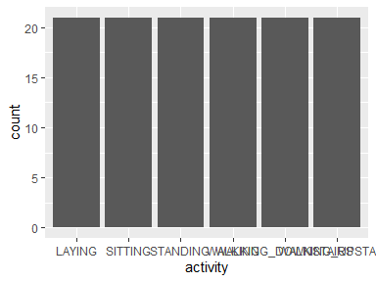

* Observed factor levels: "LAYING", "SITTING", "STANDING", "WALKING", "WALKING_DOWNSTAIRS", "WALKING_UPSTAIRS".

## tbodyacc-mean()-x

|  |  |
| --- | --- |
| Feature | Result |
| Variable type | numeric |
| Number of missing obs. | 0 (0 %) |
| Number of unique values | 126 |
| Median | 0.28 |
| 1st and 3rd quartiles | 0.27; 0.28 |
| Min. and max. | 0.22; 0.3 |

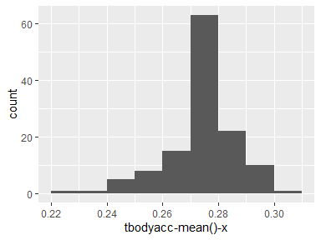

## tbodyacc-mean()-y

|  |  |
| --- | --- |
| Feature | Result |
| Variable type | numeric |
| Number of missing obs. | 0 (0 %) |
| Number of unique values | 126 |
| Median | -0.02 |
| 1st and 3rd quartiles | -0.02; -0.02 |
| Min. and max. | -0.04; 0 |

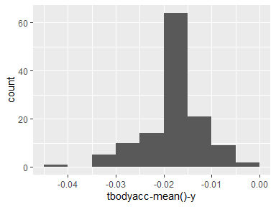

## tbodyacc-mean()-z

|  |  |
| --- | --- |
| Feature | Result |
| Variable type | numeric |
| Number of missing obs. | 0 (0 %) |
| Number of unique values | 126 |
| Median | -0.11 |
| 1st and 3rd quartiles | -0.11; -0.1 |
| Min. and max. | -0.15; -0.09 |

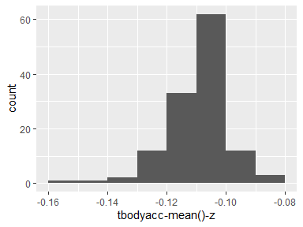

## tbodyacc-std()-x

|  |  |
| --- | --- |
| Feature | Result |
| Variable type | numeric |
| Number of missing obs. | 0 (0 %) |
| Number of unique values | 126 |
| Median | -0.75 |
| 1st and 3rd quartiles | -0.98; -0.17 |
| Min. and max. | -1; 0.63 |

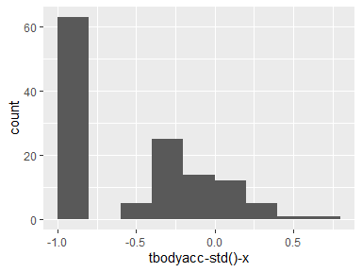

## tbodyacc-std()-y

|  |  |
| --- | --- |
| Feature | Result |
| Variable type | numeric |
| Number of missing obs. | 0 (0 %) |
| Number of unique values | 126 |
| Median | -0.51 |
| 1st and 3rd quartiles | -0.94; -0.01 |
| Min. and max. | -0.99; 0.51 |

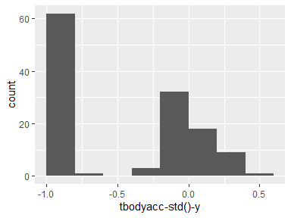

## tbodyacc-std()-z

|  |  |
| --- | --- |
| Feature | Result |
| Variable type | numeric |
| Number of missing obs. | 0 (0 %) |
| Number of unique values | 126 |
| Median | -0.62 |
| 1st and 3rd quartiles | -0.95; -0.23 |
| Min. and max. | -0.99; 0.61 |

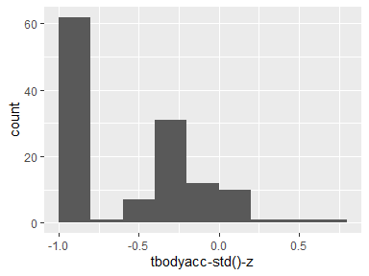

## tgravityacc-mean()-x

|  |  |
| --- | --- |
| Feature | Result |
| Variable type | numeric |
| Number of missing obs. | 0 (0 %) |
| Number of unique values | 126 |
| Median | 0.92 |
| 1st and 3rd quartiles | 0.83; 0.94 |
| Min. and max. | -0.68; 0.97 |

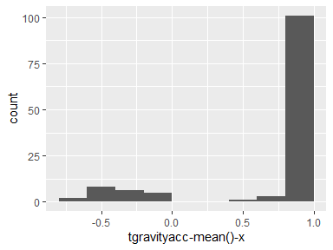

## tgravityacc-mean()-y

|  |  |
| --- | --- |
| Feature | Result |
| Variable type | numeric |
| Number of missing obs. | 0 (0 %) |
| Number of unique values | 126 |
| Median | -0.14 |
| 1st and 3rd quartiles | -0.23; 0.13 |
| Min. and max. | -0.43; 0.96 |

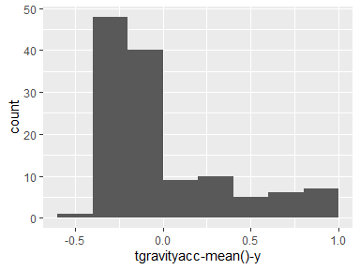

## tgravityacc-mean()-z

|  |  |
| --- | --- |
| Feature | Result |
| Variable type | numeric |
| Number of missing obs. | 0 (0 %) |
| Number of unique values | 126 |
| Median | 0.02 |
| 1st and 3rd quartiles | -0.14; 0.15 |
| Min. and max. | -0.5; 0.92 |

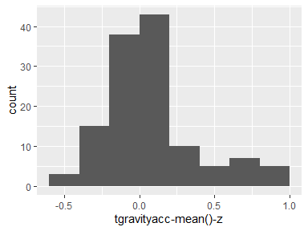

## tgravityacc-std()-x

|  |  |
| --- | --- |
| Feature | Result |
| Variable type | numeric |
| Number of missing obs. | 0 (0 %) |
| Number of unique values | 126 |
| Median | -0.97 |
| 1st and 3rd quartiles | -0.98; -0.95 |
| Min. and max. | -1; -0.83 |

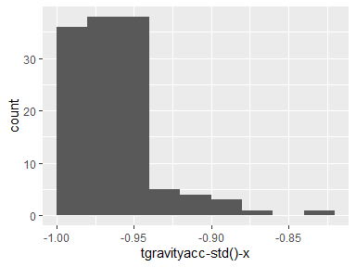

## tgravityacc-std()-y

|  |  |
| --- | --- |
| Feature | Result |
| Variable type | numeric |
| Number of missing obs. | 0 (0 %) |
| Number of unique values | 126 |
| Median | -0.96 |
| 1st and 3rd quartiles | -0.97; -0.94 |
| Min. and max. | -0.99; -0.64 |

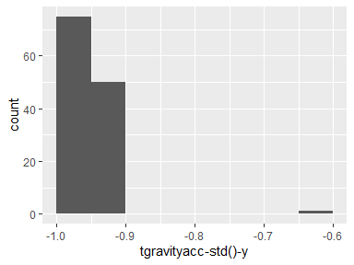

## tgravityacc-std()-z

|  |  |
| --- | --- |
| Feature | Result |
| Variable type | numeric |
| Number of missing obs. | 0 (0 %) |
| Number of unique values | 126 |
| Median | -0.94 |
| 1st and 3rd quartiles | -0.96; -0.92 |
| Min. and max. | -0.99; -0.61 |

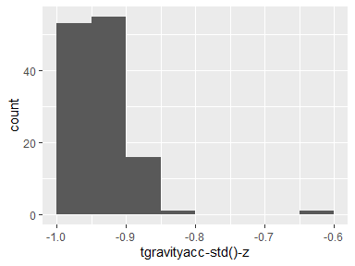

## tbodyaccjerk-mean()-x

|  |  |
| --- | --- |
| Feature | Result |
| Variable type | numeric |
| Number of missing obs. | 0 (0 %) |
| Number of unique values | 126 |
| Median | 0.08 |
| 1st and 3rd quartiles | 0.07; 0.08 |
| Min. and max. | 0.04; 0.12 |

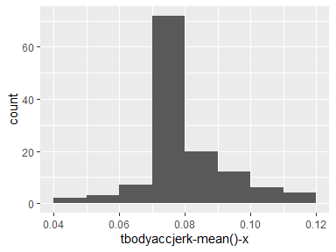

## tbodyaccjerk-mean()-y

|  |  |
| --- | --- |
| Feature | Result |
| Variable type | numeric |
| Number of missing obs. | 0 (0 %) |
| Number of unique values | 126 |
| Median | 0.01 |
| 1st and 3rd quartiles | 0; 0.01 |
| Min. and max. | -0.04; 0.06 |

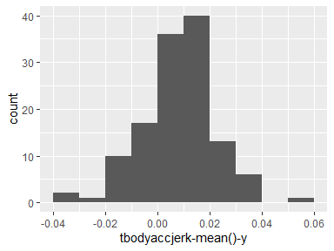

## tbodyaccjerk-mean()-z

|  |  |
| --- | --- |
| Feature | Result |
| Variable type | numeric |
| Number of missing obs. | 0 (0 %) |
| Number of unique values | 126 |
| Median | 0 |
| 1st and 3rd quartiles | -0.01; 0 |
| Min. and max. | -0.07; 0.04 |

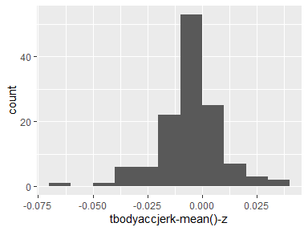

## tbodyaccjerk-std()-x

|  |  |
| --- | --- |
| Feature | Result |
| Variable type | numeric |
| Number of missing obs. | 0 (0 %) |
| Number of unique values | 126 |
| Median | -0.81 |
| 1st and 3rd quartiles | -0.98; -0.22 |
| Min. and max. | -0.99; 0.54 |

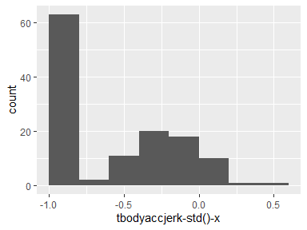

## tbodyaccjerk-std()-y

|  |  |
| --- | --- |
| Feature | Result |
| Variable type | numeric |
| Number of missing obs. | 0 (0 %) |
| Number of unique values | 126 |
| Median | -0.78 |
| 1st and 3rd quartiles | -0.97; -0.11 |
| Min. and max. | -0.99; 0.36 |

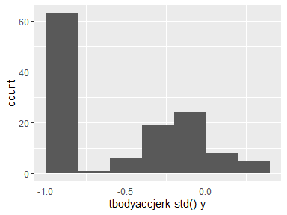

## tbodyaccjerk-std()-z

|  |  |
| --- | --- |
| Feature | Result |
| Variable type | numeric |
| Number of missing obs. | 0 (0 %) |
| Number of unique values | 126 |
| Median | -0.88 |
| 1st and 3rd quartiles | -0.98; -0.48 |
| Min. and max. | -0.99; 0.03 |

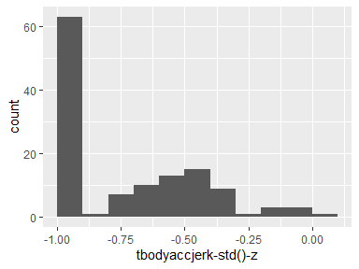

## tbodygyro-mean()-x

|  |  |
| --- | --- |
| Feature | Result |
| Variable type | numeric |
| Number of missing obs. | 0 (0 %) |
| Number of unique values | 126 |
| Median | -0.03 |
| 1st and 3rd quartiles | -0.04; -0.02 |
| Min. and max. | -0.21; 0.19 |

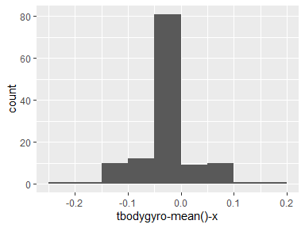

## tbodygyro-mean()-y

|  |  |
| --- | --- |
| Feature | Result |
| Variable type | numeric |
| Number of missing obs. | 0 (0 %) |
| Number of unique values | 126 |
| Median | -0.07 |
| 1st and 3rd quartiles | -0.09; -0.06 |
| Min. and max. | -0.2; 0.03 |

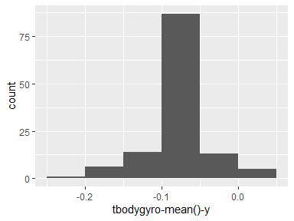

## tbodygyro-mean()-z

|  |  |
| --- | --- |
| Feature | Result |
| Variable type | numeric |
| Number of missing obs. | 0 (0 %) |
| Number of unique values | 126 |
| Median | 0.08 |
| 1st and 3rd quartiles | 0.07; 0.1 |
| Min. and max. | -0.07; 0.18 |

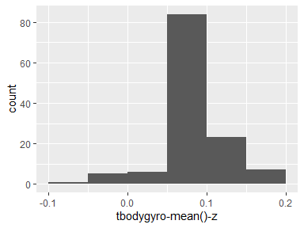

## tbodygyro-std()-x

|  |  |
| --- | --- |
| Feature | Result |
| Variable type | numeric |
| Number of missing obs. | 0 (0 %) |
| Number of unique values | 126 |
| Median | -0.76 |
| 1st and 3rd quartiles | -0.97; -0.44 |
| Min. and max. | -0.99; 0.27 |

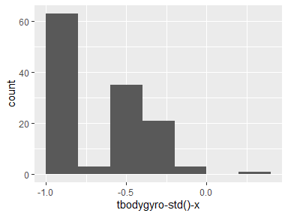

## tbodygyro-std()-y

|  |  |
| --- | --- |
| Feature | Result |
| Variable type | numeric |
| Number of missing obs. | 0 (0 %) |
| Number of unique values | 126 |
| Median | -0.77 |
| 1st and 3rd quartiles | -0.96; -0.4 |
| Min. and max. | -0.99; 0.48 |

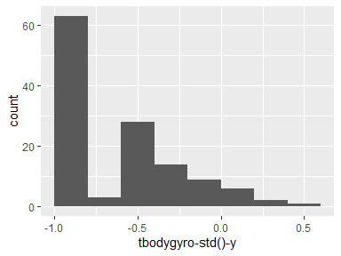

## tbodygyro-std()-z

|  |  |
| --- | --- |
| Feature | Result |
| Variable type | numeric |
| Number of missing obs. | 0 (0 %) |
| Number of unique values | 126 |
| Median | -0.8 |
| 1st and 3rd quartiles | -0.96; -0.31 |
| Min. and max. | -0.99; 0.56 |

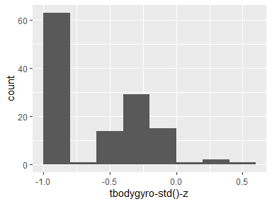

## tbodygyrojerk-mean()-x

|  |  |
| --- | --- |
| Feature | Result |
| Variable type | numeric |
| Number of missing obs. | 0 (0 %) |
| Number of unique values | 126 |
| Median | -0.1 |
| 1st and 3rd quartiles | -0.1; -0.09 |
| Min. and max. | -0.16; -0.02 |

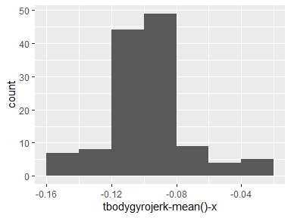

## tbodygyrojerk-mean()-y

|  |  |
| --- | --- |
| Feature | Result |
| Variable type | numeric |
| Number of missing obs. | 0 (0 %) |
| Number of unique values | 126 |
| Median | -0.04 |
| 1st and 3rd quartiles | -0.05; -0.04 |
| Min. and max. | -0.08; -0.01 |

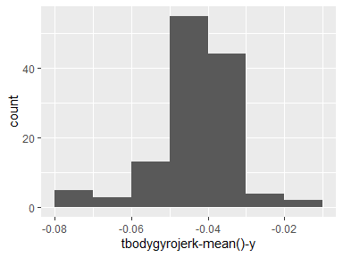

## tbodygyrojerk-mean()-z

|  |  |
| --- | --- |
| Feature | Result |
| Variable type | numeric |
| Number of missing obs. | 0 (0 %) |
| Number of unique values | 126 |
| Median | -0.05 |
| 1st and 3rd quartiles | -0.06; -0.05 |
| Min. and max. | -0.09; -0.01 |

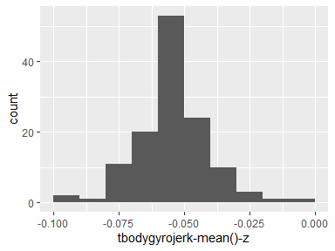

## tbodygyrojerk-std()-x

|  |  |
| --- | --- |
| Feature | Result |
| Variable type | numeric |
| Number of missing obs. | 0 (0 %) |
| Number of unique values | 126 |
| Median | -0.83 |
| 1st and 3rd quartiles | -0.98; -0.46 |
| Min. and max. | -1; 0.18 |

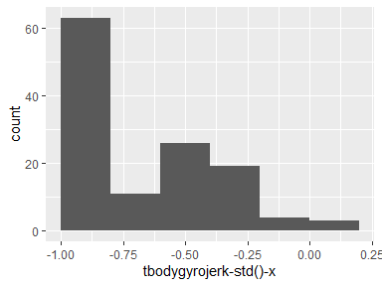

## tbodygyrojerk-std()-y

|  |  |
| --- | --- |
| Feature | Result |
| Variable type | numeric |
| Number of missing obs. | 0 (0 %) |
| Number of unique values | 126 |
| Median | -0.9 |
| 1st and 3rd quartiles | -0.98; -0.59 |
| Min. and max. | -1; 0.3 |

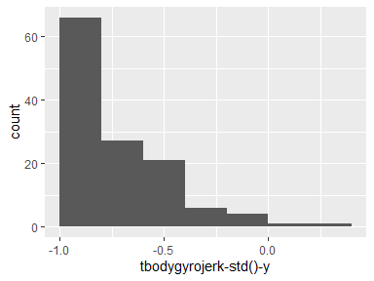

## tbodygyrojerk-std()-z

|  |  |
| --- | --- |
| Feature | Result |
| Variable type | numeric |
| Number of missing obs. | 0 (0 %) |
| Number of unique values | 126 |
| Median | -0.86 |
| 1st and 3rd quartiles | -0.99; -0.48 |
| Min. and max. | -1; 0.19 |

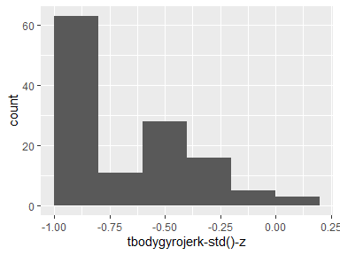

## tbodyaccmag-mean()

|  |  |
| --- | --- |
| Feature | Result |
| Variable type | numeric |
| Number of missing obs. | 0 (0 %) |
| Number of unique values | 126 |
| Median | -0.48 |
| 1st and 3rd quartiles | -0.96; -0.04 |
| Min. and max. | -0.99; 0.64 |

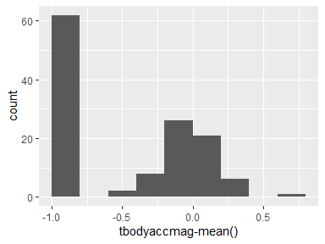

## tbodyaccmag-std()

|  |  |
| --- | --- |
| Feature | Result |
| Variable type | numeric |
| Number of missing obs. | 0 (0 %) |
| Number of unique values | 126 |
| Median | -0.61 |
| 1st and 3rd quartiles | -0.94; -0.18 |
| Min. and max. | -0.98; 0.43 |

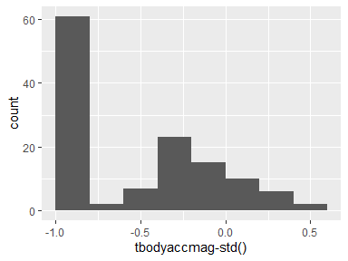

## tgravityaccmag-mean()

|  |  |
| --- | --- |
| Feature | Result |
| Variable type | numeric |
| Number of missing obs. | 0 (0 %) |
| Number of unique values | 126 |
| Median | -0.48 |
| 1st and 3rd quartiles | -0.96; -0.04 |
| Min. and max. | -0.99; 0.64 |

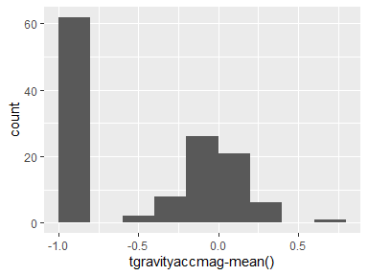

## tgravityaccmag-std()

|  |  |
| --- | --- |
| Feature | Result |
| Variable type | numeric |
| Number of missing obs. | 0 (0 %) |
| Number of unique values | 126 |
| Median | -0.61 |
| 1st and 3rd quartiles | -0.94; -0.18 |
| Min. and max. | -0.98; 0.43 |

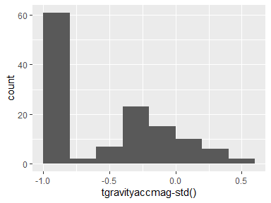

## tbodyaccjerkmag-mean()

|  |  |
| --- | --- |
| Feature | Result |
| Variable type | numeric |
| Number of missing obs. | 0 (0 %) |
| Number of unique values | 126 |
| Median | -0.82 |
| 1st and 3rd quartiles | -0.98; -0.23 |
| Min. and max. | -0.99; 0.43 |

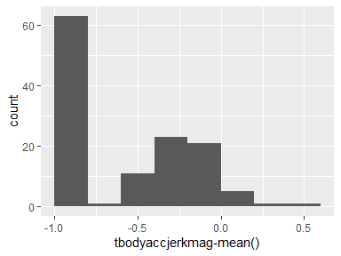

## tbodyaccjerkmag-std()

|  |  |
| --- | --- |
| Feature | Result |
| Variable type | numeric |
| Number of missing obs. | 0 (0 %) |
| Number of unique values | 126 |
| Median | -0.8 |
| 1st and 3rd quartiles | -0.98; -0.21 |
| Min. and max. | -0.99; 0.45 |

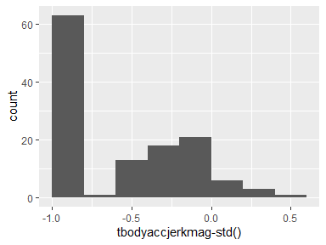

## tbodygyromag-mean()

|  |  |
| --- | --- |
| Feature | Result |
| Variable type | numeric |
| Number of missing obs. | 0 (0 %) |
| Number of unique values | 126 |
| Median | -0.65 |
| 1st and 3rd quartiles | -0.95; -0.2 |
| Min. and max. | -0.98; 0.42 |

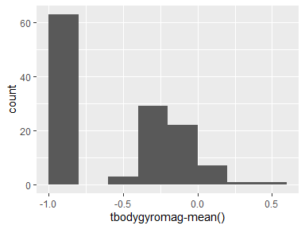

## tbodygyromag-std()

|  |  |
| --- | --- |
| Feature | Result |
| Variable type | numeric |
| Number of missing obs. | 0 (0 %) |
| Number of unique values | 126 |
| Median | -0.74 |
| 1st and 3rd quartiles | -0.95; -0.34 |
| Min. and max. | -0.98; 0.3 |

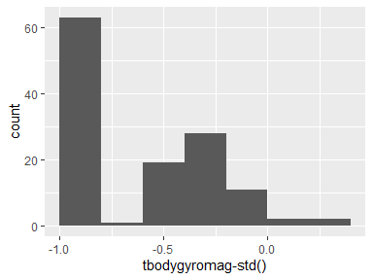

## tbodygyrojerkmag-mean()

|  |  |
| --- | --- |
| Feature | Result |
| Variable type | numeric |
| Number of missing obs. | 0 (0 %) |
| Number of unique values | 126 |
| Median | -0.87 |
| 1st and 3rd quartiles | -0.99; -0.51 |
| Min. and max. | -1; 0.09 |

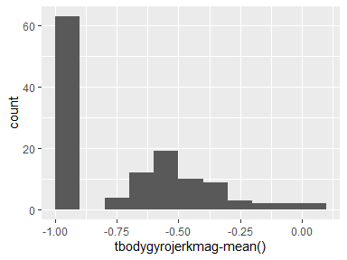

## tbodygyrojerkmag-std()

|  |  |
| --- | --- |
| Feature | Result |
| Variable type | numeric |
| Number of missing obs. | 0 (0 %) |
| Number of unique values | 126 |
| Median | -0.88 |
| 1st and 3rd quartiles | -0.98; -0.58 |
| Min. and max. | -1; 0.25 |

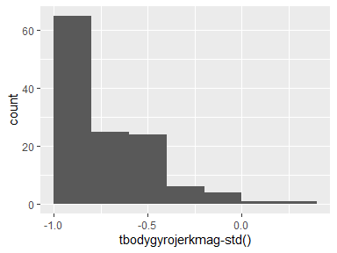

## fbodyacc-mean()-x

|  |  |
| --- | --- |
| Feature | Result |
| Variable type | numeric |
| Number of missing obs. | 0 (0 %) |
| Number of unique values | 126 |
| Median | -0.77 |
| 1st and 3rd quartiles | -0.98; -0.19 |
| Min. and max. | -1; 0.54 |

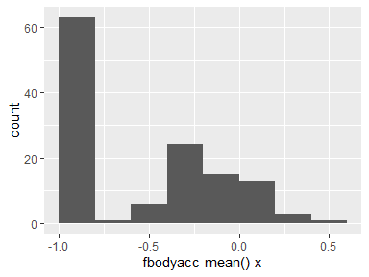

## fbodyacc-mean()-y

|  |  |
| --- | --- |
| Feature | Result |
| Variable type | numeric |
| Number of missing obs. | 0 (0 %) |
| Number of unique values | 126 |
| Median | -0.58 |
| 1st and 3rd quartiles | -0.95; -0.04 |
| Min. and max. | -0.99; 0.49 |

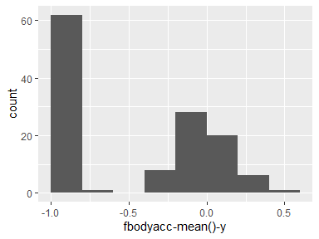

## fbodyacc-mean()-z

|  |  |
| --- | --- |
| Feature | Result |
| Variable type | numeric |
| Number of missing obs. | 0 (0 %) |
| Number of unique values | 126 |
| Median | -0.72 |
| 1st and 3rd quartiles | -0.96; -0.32 |
| Min. and max. | -0.99; 0.28 |

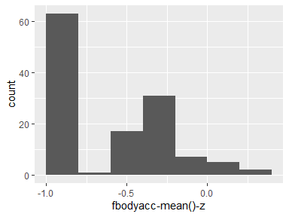

## fbodyacc-std()-x

|  |  |
| --- | --- |
| Feature | Result |
| Variable type | numeric |
| Number of missing obs. | 0 (0 %) |
| Number of unique values | 126 |
| Median | -0.75 |
| 1st and 3rd quartiles | -0.98; -0.18 |
| Min. and max. | -1; 0.66 |

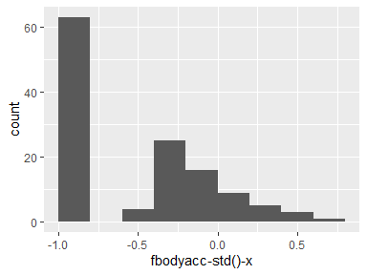

## fbodyacc-std()-y

|  |  |
| --- | --- |
| Feature | Result |
| Variable type | numeric |
| Number of missing obs. | 0 (0 %) |
| Number of unique values | 126 |
| Median | -0.51 |
| 1st and 3rd quartiles | -0.94; -0.05 |
| Min. and max. | -0.99; 0.43 |

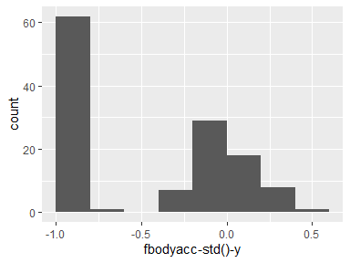

## fbodyacc-std()-z

|  |  |
| --- | --- |
| Feature | Result |
| Variable type | numeric |
| Number of missing obs. | 0 (0 %) |
| Number of unique values | 126 |
| Median | -0.62 |
| 1st and 3rd quartiles | -0.95; -0.25 |
| Min. and max. | -0.99; 0.69 |

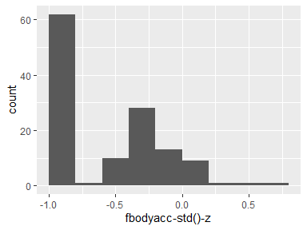

## fbodyacc-meanfreq()-x

|  |  |
| --- | --- |
| Feature | Result |
| Variable type | numeric |
| Number of missing obs. | 0 (0 %) |
| Number of unique values | 126 |
| Median | -0.26 |
| 1st and 3rd quartiles | -0.4; -0.06 |
| Min. and max. | -0.64; 0.14 |

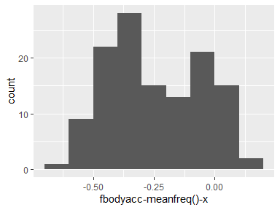

## fbodyacc-meanfreq()-y

|  |  |
| --- | --- |
| Feature | Result |
| Variable type | numeric |
| Number of missing obs. | 0 (0 %) |
| Number of unique values | 126 |
| Median | 0.01 |
| 1st and 3rd quartiles | -0.09; 0.09 |
| Min. and max. | -0.38; 0.47 |

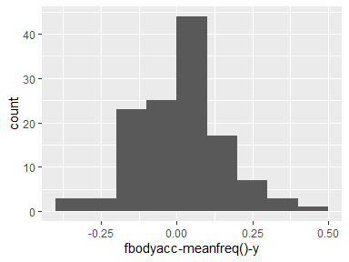

## fbodyacc-meanfreq()-z

|  |  |
| --- | --- |
| Feature | Result |
| Variable type | numeric |
| Number of missing obs. | 0 (0 %) |
| Number of unique values | 126 |
| Median | 0.06 |
| 1st and 3rd quartiles | -0.04; 0.18 |
| Min. and max. | -0.52; 0.37 |

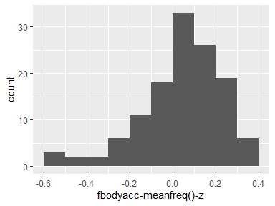

## fbodyaccjerk-mean()-x

|  |  |
| --- | --- |
| Feature | Result |
| Variable type | numeric |
| Number of missing obs. | 0 (0 %) |
| Number of unique values | 126 |
| Median | -0.81 |
| 1st and 3rd quartiles | -0.98; -0.26 |
| Min. and max. | -0.99; 0.47 |

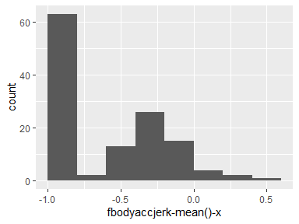

## fbodyaccjerk-mean()-y

|  |  |
| --- | --- |
| Feature | Result |
| Variable type | numeric |
| Number of missing obs. | 0 (0 %) |
| Number of unique values | 126 |
| Median | -0.78 |
| 1st and 3rd quartiles | -0.97; -0.18 |
| Min. and max. | -0.99; 0.28 |

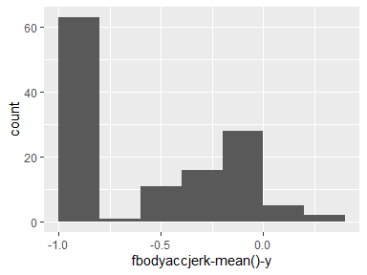

## fbodyaccjerk-mean()-z

|  |  |
| --- | --- |
| Feature | Result |
| Variable type | numeric |
| Number of missing obs. | 0 (0 %) |
| Number of unique values | 126 |
| Median | -0.87 |
| 1st and 3rd quartiles | -0.98; -0.43 |
| Min. and max. | -0.99; 0.16 |

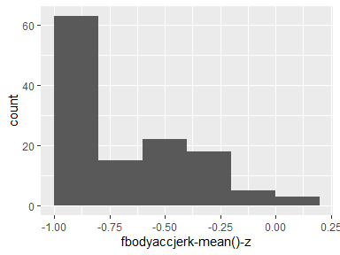

## fbodyaccjerk-std()-x

|  |  |
| --- | --- |
| Feature | Result |
| Variable type | numeric |
| Number of missing obs. | 0 (0 %) |
| Number of unique values | 126 |
| Median | -0.83 |
| 1st and 3rd quartiles | -0.99; -0.25 |
| Min. and max. | -1; 0.48 |

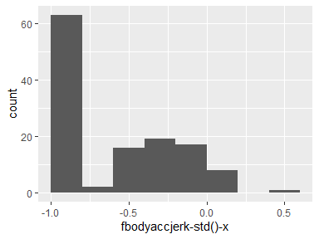

## fbodyaccjerk-std()-y

|  |  |
| --- | --- |
| Feature | Result |
| Variable type | numeric |
| Number of missing obs. | 0 (0 %) |
| Number of unique values | 126 |
| Median | -0.79 |
| 1st and 3rd quartiles | -0.98; -0.15 |
| Min. and max. | -0.99; 0.35 |

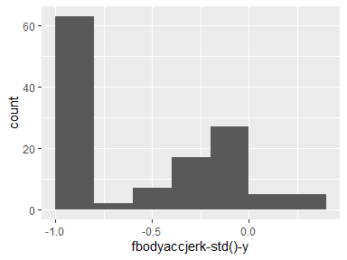

## fbodyaccjerk-std()-z

|  |  |
| --- | --- |
| Feature | Result |
| Variable type | numeric |
| Number of missing obs. | 0 (0 %) |
| Number of unique values | 126 |
| Median | -0.9 |
| 1st and 3rd quartiles | -0.98; -0.54 |
| Min. and max. | -0.99; -0.01 |

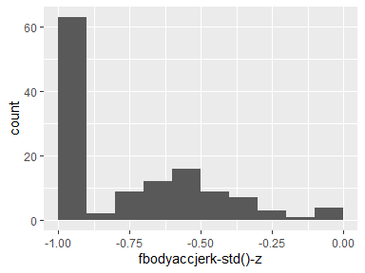

## fbodyaccjerk-meanfreq()-x

|  |  |
| --- | --- |
| Feature | Result |
| Variable type | numeric |
| Number of missing obs. | 0 (0 %) |
| Number of unique values | 126 |
| Median | -0.07 |
| 1st and 3rd quartiles | -0.29; 0.18 |
| Min. and max. | -0.58; 0.31 |

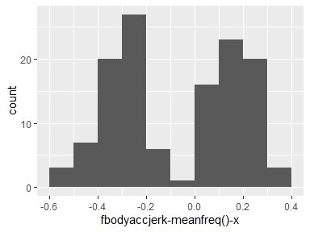

## fbodyaccjerk-meanfreq()-y

|  |  |
| --- | --- |
| Feature | Result |
| Variable type | numeric |
| Number of missing obs. | 0 (0 %) |
| Number of unique values | 126 |
| Median | -0.25 |
| 1st and 3rd quartiles | -0.4; -0.04 |
| Min. and max. | -0.6; 0.2 |

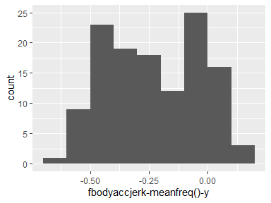

## fbodyaccjerk-meanfreq()-z

|  |  |
| --- | --- |
| Feature | Result |
| Variable type | numeric |
| Number of missing obs. | 0 (0 %) |
| Number of unique values | 126 |
| Median | -0.09 |
| 1st and 3rd quartiles | -0.3; 0.03 |
| Min. and max. | -0.63; 0.23 |

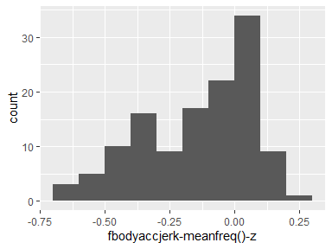

## fbodygyro-mean()-x

|  |  |
| --- | --- |
| Feature | Result |
| Variable type | numeric |
| Number of missing obs. | 0 (0 %) |
| Number of unique values | 126 |
| Median | -0.72 |
| 1st and 3rd quartiles | -0.97; -0.34 |
| Min. and max. | -0.99; 0.47 |

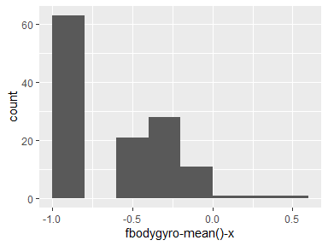

## fbodygyro-mean()-y

|  |  |
| --- | --- |
| Feature | Result |
| Variable type | numeric |
| Number of missing obs. | 0 (0 %) |
| Number of unique values | 126 |
| Median | -0.81 |
| 1st and 3rd quartiles | -0.97; -0.44 |
| Min. and max. | -0.99; 0.33 |

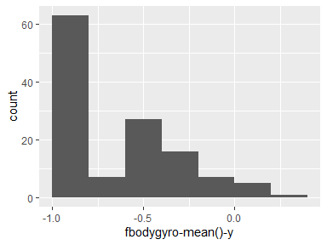

## fbodygyro-mean()-z

|  |  |
| --- | --- |
| Feature | Result |
| Variable type | numeric |
| Number of missing obs. | 0 (0 %) |
| Number of unique values | 126 |
| Median | -0.79 |
| 1st and 3rd quartiles | -0.96; -0.26 |
| Min. and max. | -0.99; 0.49 |

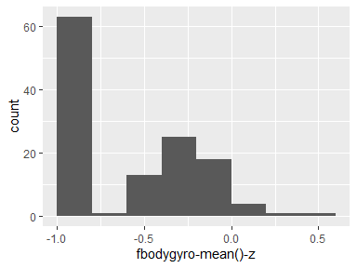

## fbodygyro-std()-x

|  |  |
| --- | --- |
| Feature | Result |
| Variable type | numeric |
| Number of missing obs. | 0 (0 %) |
| Number of unique values | 126 |
| Median | -0.78 |
| 1st and 3rd quartiles | -0.98; -0.48 |
| Min. and max. | -0.99; 0.2 |

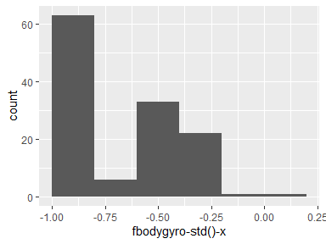

## fbodygyro-std()-y

|  |  |
| --- | --- |
| Feature | Result |
| Variable type | numeric |
| Number of missing obs. | 0 (0 %) |
| Number of unique values | 126 |
| Median | -0.77 |
| 1st and 3rd quartiles | -0.96; -0.37 |
| Min. and max. | -0.99; 0.65 |

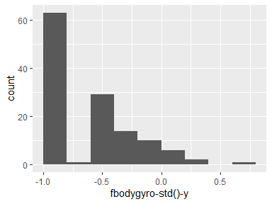

## fbodygyro-std()-z

|  |  |
| --- | --- |
| Feature | Result |
| Variable type | numeric |
| Number of missing obs. | 0 (0 %) |
| Number of unique values | 126 |
| Median | -0.82 |
| 1st and 3rd quartiles | -0.96; -0.38 |
| Min. and max. | -0.99; 0.52 |

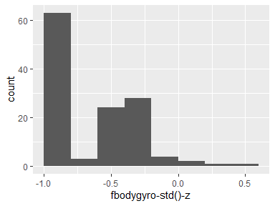

## fbodygyro-meanfreq()-x

|  |  |
| --- | --- |
| Feature | Result |
| Variable type | numeric |
| Number of missing obs. | 0 (0 %) |
| Number of unique values | 126 |
| Median | -0.12 |
| 1st and 3rd quartiles | -0.21; 0 |
| Min. and max. | -0.4; 0.25 |

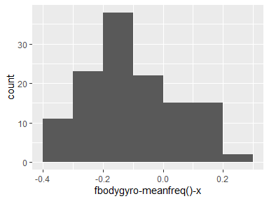

## fbodygyro-meanfreq()-y

|  |  |
| --- | --- |
| Feature | Result |
| Variable type | numeric |
| Number of missing obs. | 0 (0 %) |
| Number of unique values | 126 |
| Median | -0.16 |
| 1st and 3rd quartiles | -0.3; -0.06 |
| Min. and max. | -0.67; 0.27 |

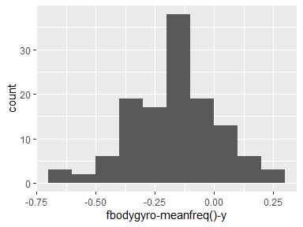

## fbodygyro-meanfreq()-z

|  |  |
| --- | --- |
| Feature | Result |
| Variable type | numeric |
| Number of missing obs. | 0 (0 %) |
| Number of unique values | 126 |
| Median | -0.04 |
| 1st and 3rd quartiles | -0.15; 0.04 |
| Min. and max. | -0.5; 0.3 |

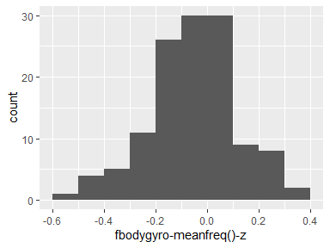

## fbodyaccmag-mean()

|  |  |
| --- | --- |
| Feature | Result |
| Variable type | numeric |
| Number of missing obs. | 0 (0 %) |
| Number of unique values | 126 |
| Median | -0.67 |
| 1st and 3rd quartiles | -0.96; -0.15 |
| Min. and max. | -0.99; 0.59 |

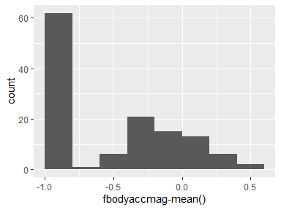

## fbodyaccmag-std()

|  |  |
| --- | --- |
| Feature | Result |
| Variable type | numeric |
| Number of missing obs. | 0 (0 %) |
| Number of unique values | 126 |
| Median | -0.64 |
| 1st and 3rd quartiles | -0.95; -0.36 |
| Min. and max. | -0.98; 0.18 |

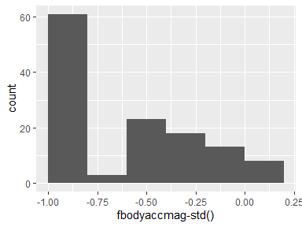

## fbodyaccmag-meanfreq()

|  |  |
| --- | --- |
| Feature | Result |
| Variable type | numeric |
| Number of missing obs. | 0 (0 %) |
| Number of unique values | 126 |
| Median | 0.07 |
| 1st and 3rd quartiles | -0.02; 0.17 |
| Min. and max. | -0.31; 0.44 |

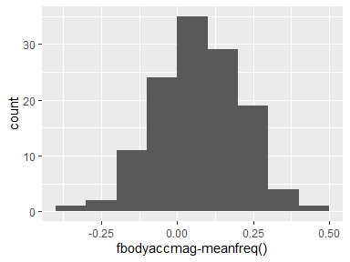

## fbodybodyaccjerkmag-mean()

|  |  |
| --- | --- |
| Feature | Result |
| Variable type | numeric |
| Number of missing obs. | 0 (0 %) |
| Number of unique values | 126 |
| Median | -0.79 |
| 1st and 3rd quartiles | -0.98; -0.19 |
| Min. and max. | -0.99; 0.54 |

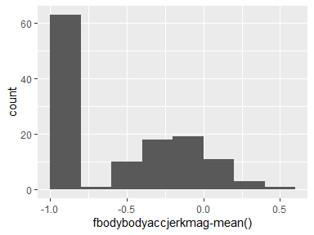

## fbodybodyaccjerkmag-std()

|  |  |
| --- | --- |
| Feature | Result |
| Variable type | numeric |
| Number of missing obs. | 0 (0 %) |
| Number of unique values | 126 |
| Median | -0.81 |
| 1st and 3rd quartiles | -0.98; -0.24 |
| Min. and max. | -0.99; 0.32 |

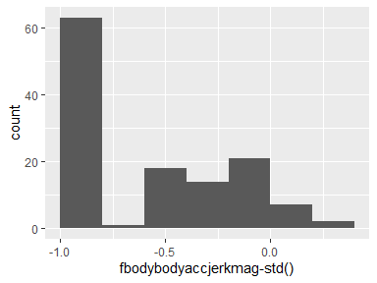

## fbodybodyaccjerkmag-meanfreq()

|  |  |
| --- | --- |
| Feature | Result |
| Variable type | numeric |
| Number of missing obs. | 0 (0 %) |
| Number of unique values | 126 |
| Median | 0.17 |
| 1st and 3rd quartiles | 0.06; 0.28 |
| Min. and max. | -0.13; 0.49 |

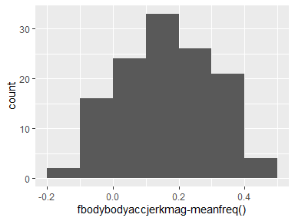

## fbodybodygyromag-mean()

|  |  |
| --- | --- |
| Feature | Result |
| Variable type | numeric |
| Number of missing obs. | 0 (0 %) |
| Number of unique values | 126 |
| Median | -0.77 |
| 1st and 3rd quartiles | -0.96; -0.38 |
| Min. and max. | -0.98; 0.2 |

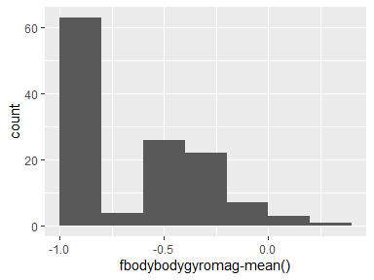

## fbodybodygyromag-std()

|  |  |
| --- | --- |
| Feature | Result |
| Variable type | numeric |
| Number of missing obs. | 0 (0 %) |
| Number of unique values | 126 |
| Median | -0.77 |
| 1st and 3rd quartiles | -0.95; -0.4 |
| Min. and max. | -0.98; 0.24 |

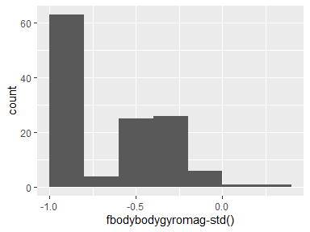

## fbodybodygyromag-meanfreq()

|  |  |
| --- | --- |
| Feature | Result |
| Variable type | numeric |
| Number of missing obs. | 0 (0 %) |
| Number of unique values | 126 |
| Median | -0.06 |
| 1st and 3rd quartiles | -0.17; 0.08 |
| Min. and max. | -0.46; 0.41 |

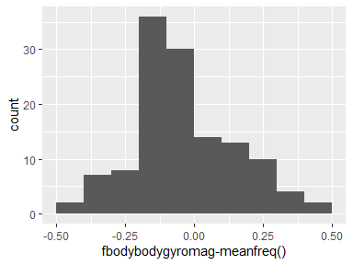

## fbodybodygyrojerkmag-mean()

|  |  |
| --- | --- |
| Feature | Result |
| Variable type | numeric |
| Number of missing obs. | 0 (0 %) |
| Number of unique values | 126 |
| Median | -0.88 |
| 1st and 3rd quartiles | -0.98; -0.58 |
| Min. and max. | -1; 0.15 |

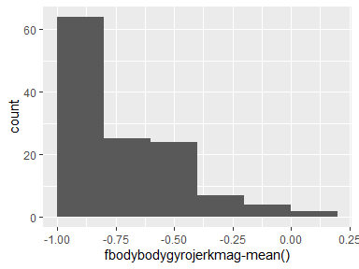

## fbodybodygyrojerkmag-std()

|  |  |
| --- | --- |
| Feature | Result |
| Variable type | numeric |
| Number of missing obs. | 0 (0 %) |
| Number of unique values | 126 |
| Median | -0.89 |
| 1st and 3rd quartiles | -0.98; -0.61 |
| Min. and max. | -1; 0.29 |

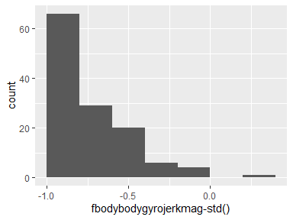

## fbodybodygyrojerkmag-meanfreq()

|  |  |
| --- | --- |
| Feature | Result |
| Variable type | numeric |
| Number of missing obs. | 0 (0 %) |
| Number of unique values | 126 |
| Median | 0.11 |
| 1st and 3rd quartiles | 0.05; 0.21 |
| Min. and max. | -0.18; 0.43 |

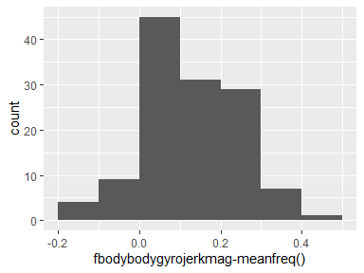

## angle(tbodyaccmean,gravity)

|  |  |
| --- | --- |
| Feature | Result |
| Variable type | numeric |
| Number of missing obs. | 0 (0 %) |
| Number of unique values | 126 |
| Median | 0.01 |
| 1st and 3rd quartiles | -0.01; 0.03 |
| Min. and max. | -0.16; 0.1 |

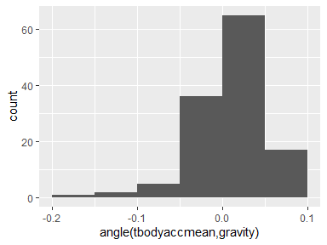

## angle(tbodyaccjerkmean),gravitymean)

|  |  |
| --- | --- |
| Feature | Result |
| Variable type | numeric |
| Number of missing obs. | 0 (0 %) |
| Number of unique values | 126 |
| Median | 0 |
| 1st and 3rd quartiles | -0.02; 0.02 |
| Min. and max. | -0.12; 0.2 |

-1.png)

## angle(tbodygyromean,gravitymean)

|  |  |
| --- | --- |
| Feature | Result |
| Variable type | numeric |
| Number of missing obs. | 0 (0 %) |
| Number of unique values | 126 |
| Median | 0.02 |
| 1st and 3rd quartiles | -0.03; 0.06 |
| Min. and max. | -0.39; 0.44 |

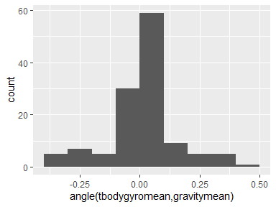

## angle(tbodygyrojerkmean,gravitymean)

|  |  |
| --- | --- |
| Feature | Result |
| Variable type | numeric |
| Number of missing obs. | 0 (0 %) |
| Number of unique values | 126 |
| Median | -0.01 |
| 1st and 3rd quartiles | -0.05; 0.04 |
| Min. and max. | -0.22; 0.18 |

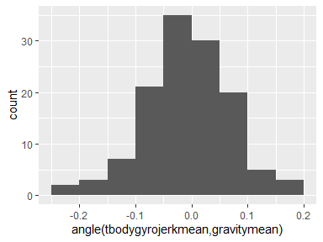

## angle(x,gravitymean)

|  |  |
| --- | --- |
| Feature | Result |
| Variable type | numeric |
| Number of missing obs. | 0 (0 %) |
| Number of unique values | 126 |
| Median | -0.73 |
| 1st and 3rd quartiles | -0.78; -0.58 |
| Min. and max. | -0.95; 0.74 |

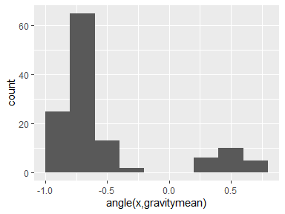

## angle(y,gravitymean)

|  |  |
| --- | --- |
| Feature | Result |
| Variable type | numeric |
| Number of missing obs. | 0 (0 %) |
| Number of unique values | 126 |
| Median | 0.18 |
| 1st and 3rd quartiles | 0; 0.24 |
| Min. and max. | -0.87; 0.39 |

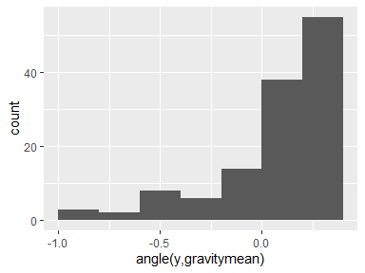

## angle(z,gravitymean)

|  |  |
| --- | --- |
| Feature | Result |
| Variable type | numeric |
| Number of missing obs. | 0 (0 %) |
| Number of unique values | 126 |
| Median | 0.01 |
| 1st and 3rd quartiles | -0.09; 0.12 |
| Min. and max. | -0.81; 0.39 |

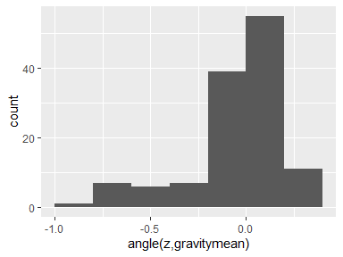

Report generation information:

* Created by: isadoraellis (username: iellis).
* Report creation time: wo jan 22 2020 11:54:11
* Report was run from directory: C:/Users/iellis/OneDrive - Deloitte (O365D)/Documents/Algemeen/Personal Development/Dat science certification
* dataMaid v1.4.0 [Pkg: 2019-12-10 from CRAN (R 3.6.2)]
* R version 3.6.2 (2019-12-12).
* Platform: x86_64-w64-mingw32/x64 (64-bit)(Windows 10 x64 (build 17763)).
* Function call: dataMaid::makeDataReport(data = df_tidy, mode = c("summarize", "visualize", "check"), smartNum = FALSE, file = "codebook_df_tidy.Rmd", checks = list(character = "showAllFactorLevels", factor = "showAllFactorLevels", labelled = "showAllFactorLevels", haven_labelled = "showAllFactorLevels", numeric = NULL, integer = NULL, logical = NULL, Date = NULL), listChecks = FALSE, maxProbVals = Inf, codebook = TRUE, reportTitle = "Codebook for df_tidy")