A Governance-Aware Adaptive Engineering Decision Methodology for Sustainable Mineral Resource Management

Abstract
Public-sector investment and regulatory decisions in resource-constrained governance environments are often supported by fragmented analytical approaches in which predictive models, multi-criteria evaluation, and optimization operate independently. Existing hybrid AI–MCDM approaches improve analytical capability but rarely provide a governance-aware adaptive engineering methodology that explicitly coordinates prediction, evaluation, optimization, and adaptive feedback within a transparent, auditable decision process. This study develops the Adaptive Intelligent Machine Learning–Mineral Resource Management System (AIML-MRMS), a governance-aware adaptive engineering decision methodology operationalized through a five-layer architecture integrating predictive analytics, adaptive multi-criteria decision analysis, constrained optimization, and governance feedback. Rather than proposing new analytical algorithms, the study contributes a transferable governance-aware adaptive engineering methodology, operationalized through an adaptive integration architecture, together with reusable engineering design principles for transparent and adaptive public-sector decision support. The methodology is demonstrated using publicly available governance and mining investment data from 16 African countries. Benchmarking against standalone AI, standalone MCDM, and static AI–MCDM configurations shows that adaptive integration and closed-loop feedback consistently improve governance alignment while preserving computational transparency and reproducibility. The mineral resources application serves as a proof-of-concept implementation of a transferable methodology for sustainable engineering decision-support systems.
Keywords: governance-aware decision engineering; multi-criteria decision analysis, sustainable engineering, adaptive decision support; resource allocation, mineral resource management

1. Introduction
Public-sector investment and regulatory decisions in resource-rich economies increasingly require balancing economic, environmental, institutional, and social objectives under constrained resources and evolving governance conditions. Mineral resource management (MRM) exemplifies this challenge . It operates within a tightly coupled decision space in which economic objectives, operational constraints, regulatory requirements, and stakeholder expectations interact as a complex systems problem. Although large volumes of governance and investment data are now available to support such decisions, analytical techniques frequently operate independently. For instance, AI methods serve predictive functions, MCDM tools support project ranking, and investment models optimise financial returns, each without formal interfaces to the others (Ayuk et al., 2022; Grant & Wilhelm, 2022). The resulting gap is not merely computational but methodological: institutions require decision-support methodologies capable of coordinating heterogeneous analytical capabilities within transparent, auditable engineering workflows.
The consequences of this fragmentation are well documented in the African mining context. The EITI (2023) Nigeria report identifies persistent misalignment between formal regulatory requirements and operational investment decisions. While Grant and Wilhelm (2022) document regulatory–investment decoupling in West African mining sectors driven by weak institutional coordination. The World Bank WGI database (2022) shows substantial variation in governance coherence across African mining jurisdictions. Nigeria scores below the 20th percentile on four of five governance dimensions, while South Africa consistently exceeds the 50th percentile. A structural difference that affects both investment quality and regulatory embedding. Cust and Zeufack (2023) find that resource-rich African economies capture on average only 40% of potentially collectable resource revenues, with governance quality as the primary binding constraint. Sigam and Garcia (2012) show that host-country value retention depends critically on the coherence of governance and investment decision frameworks across institutional actors. These interrelated gaps remain unaddressed by AI or MCDM frameworks operating in isolation.
Recent hybrid AI–MCDM studies have demonstrated the benefits of combining predictive analytics with decision-support techniques, and adaptive weighting mechanisms have been shown to improve decision consistency under changing conditions (Deveci et al., 2022, 2023). Existing approaches primarily improve individual analytical stages or their pairwise integration. However, a methodological gap remains in developing governance-aware engineering methodologies that coordinate prediction, evaluation, optimization, and adaptive feedback within transparent and traceable decision processes.
The contribution of this study is methodological rather than algorithmic. AIML-MRMS develops a governance-aware adaptive engineering decision methodology that integrates predictive analytics, multi-criteria evaluation, constrained optimization, and adaptive feedback within a transparent five-layer architecture. The methodology contributes reusable engineering design principles for evidence traceability, adaptive integration, and auditable decision-making, and is demonstrated using governance data from 16 African mining countries. While the case study establishes computational feasibility and internal consistency, the broader contribution is a transferable engineering methodology, with empirical validation across other application domains identified as future work. Figure 1 summarizes the conceptual hierarchy of the proposed framework. The principal contribution is a governance-aware adaptive engineering decision methodology. This methodology is realized through a five-layer engineering architecture, within which the Adaptive AI–MCDM Integration Algorithm coordinates evidence propagation, adaptive weight updating, and feedback during decision making.
The paper is structured as follows. Section 2 reviews the relevant literature and identifies the methodological gap. Section 3 defines the problem structure and system failure modes. Section 4 presents the AIML-MRMS architecture. Section 5 formalizes the integration algorithm and mathematical representations. Section 6 presents computational validation and benchmarking. Section 7 discusses engineering management implications and reusable design knowledge. Section 8 concludes.
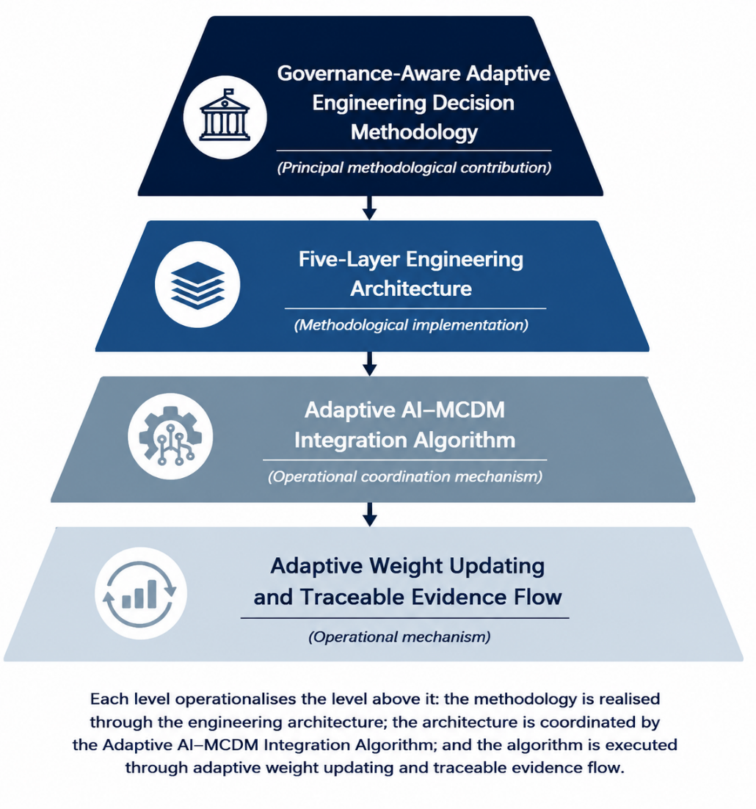

Figure 1. Conceptual hierarchy of the proposed governance-aware adaptive engineering decision methodology.

2. Literature Review
Research relevant to AIML-MRMS spans five engineering capabilities: predictive governance analytics, multi-criteria decision support, adaptive decision mechanisms, resource optimisation, and integrated decision engineering. Rather than asking what techniques previous authors have used, this review asks a more direct question: which engineering capability does each stream of literature provide, and what limitation remains once that capability is considered as one stage within a complete governance decision process?
2.1 Predictive Governance Analytics
Machine learning applications in mineral systems have expanded substantially. Jara-Herrera et al. (2023) demonstrated convolutional neural network classification of lithological units from geochemical data, achieving cross-validated accuracy above 88% on a publicly released dataset. Shirmard et al. (2022a) provided a systematic review of ML applications in mineral exploration remote sensing, documenting the dominance of SVM and CNN approaches across lithological mapping and mineralization targeting. A related comparison of CNN and a conventional ML model (SVM) for lithological mapping confirmed that SVM performs well for small-sample classification (Shirmard et al., 2022b), a context that directly matches the governance dataset used in this paper. Despite this technical maturity, AI applications in this domain remain predominantly predictive: regulatory constraint embedding is absent from reviewed approaches, and the coupling between predictive outputs and structured investment decisions has not been formalised in the reviewed literature. Predictive analytics therefore provides evidence generation, but not, by itself, a decision process.
2.2 Multi-Criteria Decision Support
Multi-criteria decision-making methods are extensively applied in resource project evaluation. Yazdani et al. (2022) applied an integrated AHP-TOPSIS-VIKOR framework to sustainable supplier selection in extractive industries, demonstrating the practical utility of multi-criteria coupling. Stević et al. (2020) introduced the MARCOS method for sustainable supplier selection, showing through sensitivity analysis that rankings remained stable under changes in criterion weights – a useful benchmark for the adaptive weighting mechanism used in AIML-MRMS. Rezaei (2015) proposed the Best-Worst Method (BWM), a data-efficient pairwise comparison approach that produces more consistent criterion weights than AHP and provides methodological support for the adaptive weighting design adopted in this study. A consistent limitation across this literature is the static treatment of criterion weights: weights are elicited from experts once and not updated in response to evolving regulatory or market conditions, a structural gap explicitly identified by Deveci et al. (2022). Multi-criteria methods therefore provide structured evaluation, but typically as a self-contained stage disconnected from predictive evidence and downstream optimisation.
2.3 Adaptive Decision Mechanisms
Deveci et al. (2022) used a fuzzy Einstein WASPAS framework to rank climate change mitigation strategies in urban mobility, showing that fuzzy-weighted composite scoring produces more reliable rankings when decision criteria change over time and that adaptive weighting can improve on static expert-defined weighting schemes - methodological support for the adaptive weight structures used in AIML-MRMS. Deveci et al. (2023) extended this work to real-time dynamic environments, confirming that adaptive weighting structures improve decision consistency compared with static configurations, a result directly relevant to the adaptive integration design of AIML-MRMS. Guo et al. (2021) applied an interval-valued intuitionistic fuzzy TOPSIS hybrid model to evaluate renewable energy under dynamic conditions, showing that data-driven signals can be successfully integrated with MCDM evaluation across multiple adaptive-update iterations; similar approaches have combined ensemble classifiers, such as random forests (Breiman, 2001), with MCDM ranking methods. This literature establishes that adaptive updating is feasible and beneficial, but existing implementations generally adapt weights within the decision-analysis layer rather than coordinating an entire governance decision process spanning prediction, evaluation, optimisation, and feedback.
2.4 Resource Optimisation
Resource investment models have predominantly optimised financial metrics without embedding regulatory or multi-criteria constraints. Balezentis et al. (2021) analysed green investment opportunities in Lithuania's renewable energy sector using MCDM methods, highlighting the lack of adaptive feedback mechanisms as a key limitation that also affects investment models in the resource sector. Espinoza and Rojo (2017) showed that conventional NPV methods often underestimate long-term mining liabilities and argued for valuation approaches that separate risk from the time value of money, supporting the inclusion of constraints directly within the optimisation formulation rather than as a post-hoc filter. Savolainen et al. (2022) developed a simulation-based system for production plan selection, showing that multi-dimensional optimisation frameworks improve on single-objective NPV approaches, but without incorporating regulatory or ESG constraint dimensions. Maybee et al. (2023) demonstrated that ESG risks must be embedded within mining investment decision structures rather than applied as external filters; Liagkouras et al. (2022) showed in a portfolio-optimisation study that pre-screening on ESG constraints can improve risk-adjusted portfolio behaviour, and Pedersen et al. (2021) formalised this as an ESG-efficient frontier in which each ESG score level has a corresponding maximum achievable Sharpe ratio. Reus et al. (2019) applied multistage stochastic optimisation to mine production management, showing that constraint-based multi-period optimisation models improve on conventional deterministic approaches. Collectively, this literature confirms that regulatory and ESG constraints must be embedded within the optimisation formulation (Eqs. 3-4) rather than applied as filters after the fact - but, as with prediction and evaluation, optimisation in this literature remains structurally separate from the governance evidence that should inform it.
2.5 Integrated Decision Engineering and the Research Gap
A smaller body of work integrates two of these capabilities directly. Hybrid AI–MCDM systems (Deveci et al., 2022, 2023; Guo et al., 2021) combine data-driven signals with multi-criteria evaluation, and these studies confirm that such integration is both feasible and beneficial for decision consistency. However, existing studies remain largely domain-specific and typically exclude integrated investment optimisation and closed-loop feedback. None of the reviewed studies formalise the interaction between prediction, evaluation, optimisation, and governance feedback within a single architecture that specifies explicit interfaces, adaptive weighting, and traceable evidence flow across all four capabilities simultaneously.
Table 1 restates this gap as a Contribution Justification Matrix: for each engineering capability, it identifies the current state of knowledge, the remaining engineering limitation once that capability is considered as one component of a complete governance decision process, and the corresponding contribution of AIML-MRMS.
Table 1. Contribution Justification Matrix: engineering capabilities, current knowledge, remaining limitations, and the AIML-MRMS response.
Engineering Capability * | *Representative Studies** * | *Remaining Engineering Limitation | AIML-MRMS Contribution**
Predictive governance analytics | Jara-Herrera et al. (2023); Shirmard et al. (2022a, 2022b) | Predictions are typically isolated from downstream decision-making and resource allocation | Prediction becomes the evidence-generation stage of an integrated decision methodology
Multi-criteria decision support | Yazdani et al. (2022); Stević et al. D (2020); Rezaei (2015) | Decision analysis relies on static or semi-adaptive weighting and is rarely embedded within a complete governance workflow | Decision analysis is explicitly linked to predictive evidence and optimisation through defined architectural interfaces
Adaptive decision mechanisms | Deveci et al. (2022, 2023); Guo et A al. (2021) | Adaptation occurs within the decision-analysis layer rather than coordinating the complete governance process | Adaptive governance feedback coordinates interactions across prediction, evaluation, optimisation, and governance learning
Resource optimisation | Espinoza & Rojo (2017); Savolainen et O al. (2022); Baležentis et al. (2021); i Maybee et al. (2023); Liagkouras et al. (2022); Pedersen et al. (2021); Reus et al. (2019) | Optimisation is usually implemented ndependently of governance assessment and predictive evidence | Optimisation becomes an integral stage of the governance decision methodology, with regulatory and ESG constraints embedded directly (Eqs. 3–4)
Transparency and auditability | EITI (2023); World Bank WGI (2022) L | Limited methodological guidance exists for F maintaining traceable evidence flow across multiple analytical stages | ive-layer architecture provides explicit evidence traceability and auditable decision pathways
Integrated decision engineering | Deveci et al. (2022, 2023); Guo et E al. (2021) | Existing studies integrate techniques in pairs but seldom formalize a governance-aware engineering methodology specifying interfaces, evidence flow, optimisation, and adaptive feedback jointly | Develops a governance-aware adaptive decision engineering methodology implemented through a five-layer architecture and derives reusable engineering design principles
Although previous studies have advanced predictive analytics, multi-criteria decision analysis, optimisation, and adaptive weighting for governance-related decision support. However, these developments largely address individual analytical capabilities or their pairwise combination. Limited attention has been given to engineering governance-aware decision methodologies that explicitly coordinate these capabilities through transparent evidence flow, constrained optimisation, adaptive governance feedback, and auditable architectural interfaces. Consequently, a methodological gap remains in the development of reusable decision-engineering approaches capable of supporting accountable public-sector investment and regulatory decision-making. This study addresses that gap by developing AIML-MRMS, a methodology that specifies how these complementary analytical capabilities interact through a transparent five-layer architecture.

3. Problem Structure: System Failure Modes
Mineral resource management functions as a socio-technical system in which regulatory institutions, investment actors, operational mining systems, and stakeholder groups interact through bidirectional information flows. The empirical record from the EITI Nigeria Report (2023), the World Bank WGI database (2022), and the African mining governance literature (Ayuk et al., 2022; Ba & Jacquet, 2022) document four failure modes arising from structural fragmentation: regulatory fragmentation, investment misalignment, analytical isolation, and decision inconsistency. Table 2 maps each failure mode to its system impact and the AIML-MRMS response mechanism.
Table 2. System failure modes in mineral resource management and AIML-MRMS response mechanisms.
Failure Mode | Description | System Impact | AIML-MRMS Response
Regulatory Fragmentation | Policy and analytical systems weakly coupled | Rules not embedded in decisions | Regulatory constraints embedded in input layer; propagated to all downstream layers
Investment Misalignment | Capital allocation ignores multi-criteria constraints | Inefficient resource deployment | Multi-objective constrained optimisation formulation (Eqs. 3–4)
Analytical Isolation | AI and MCDM deployed independently | Inconsistent decision outputs | Adaptive AI–MCDM Integration Algorithm with dynamic weight updating (Eq. 1)
Decision Inconsistency | No feedback mechanism across layers | Static, non-adaptive decisions | Closed-loop feedback via state-update equation S(t+1) (Eq. 2)

4. The AIML-MRMS Framework

4.1 System Overview
AIML-MRMS is a five-layer adaptive decision architecture. Table 3 provides the functional decomposition of each layer, including the methods, inputs, and outputs that define the formal inter-layer interfaces.

4.2 Input Layer
The input layer aggregates six publicly accessible features: five World Bank WGI percentile ranks (Rule of Law, Regulatory Quality, Government Effectiveness, Control of Corruption, Political Stability) and the Fraser Institute Policy Perception Index. All inputs are min-max normalised to [0, 1] to form the state vector S(t). ESG and regulatory signals are treated as first-class features rather than post-hoc filters. Figure 2 illustrates the five-layer architecture and the directional data flows connecting each layer, including the adaptive feedback pathway from the Output layer back to the Input and AI Decision layers.
Table 3. Layered architecture and functional decomposition of AIML-MRMS.
Layer | Function | Methods | Inputs | Outputs
Input | Data acquisition and contextual grounding | Preprocessing, min-max normalisation | Regulatory data, investment flows, ESG signals, operational data | System state vector S(t)
AI Decision | Predictive classification and feature extraction | Linear SVC (= balanced), LOO-CV, grid-search | S(t) | Scenario class; feature importance signals fi(t)
MCDM | Adaptive multi-criteria evaluation | AHP (CR ≤ 0.10), TOPSIS (Saaty, 1980; Hwang & Yoon, 1981) | fi(t) from AI layer; base weights w₀; decision criteria | Ranked alternatives; TOPSIS scores.
Investment Intelligence | Multi-objective constrained optimisation | Continuous fractional LP (scipy.optimize.linprog, HiGHS solver) | TOPSIS closeness scores; budget B; constraints $E_{max}{, P}_{max}$ | Optimal allocation vector x*
Output & Feedback | Decision consolidation and adaptive learning | State-update equation (Eq. 2) | Investment outputs x*; PCI/RPCI; context(t) | Updated state vector S(t+1); feedback signal F(t) for next cycle
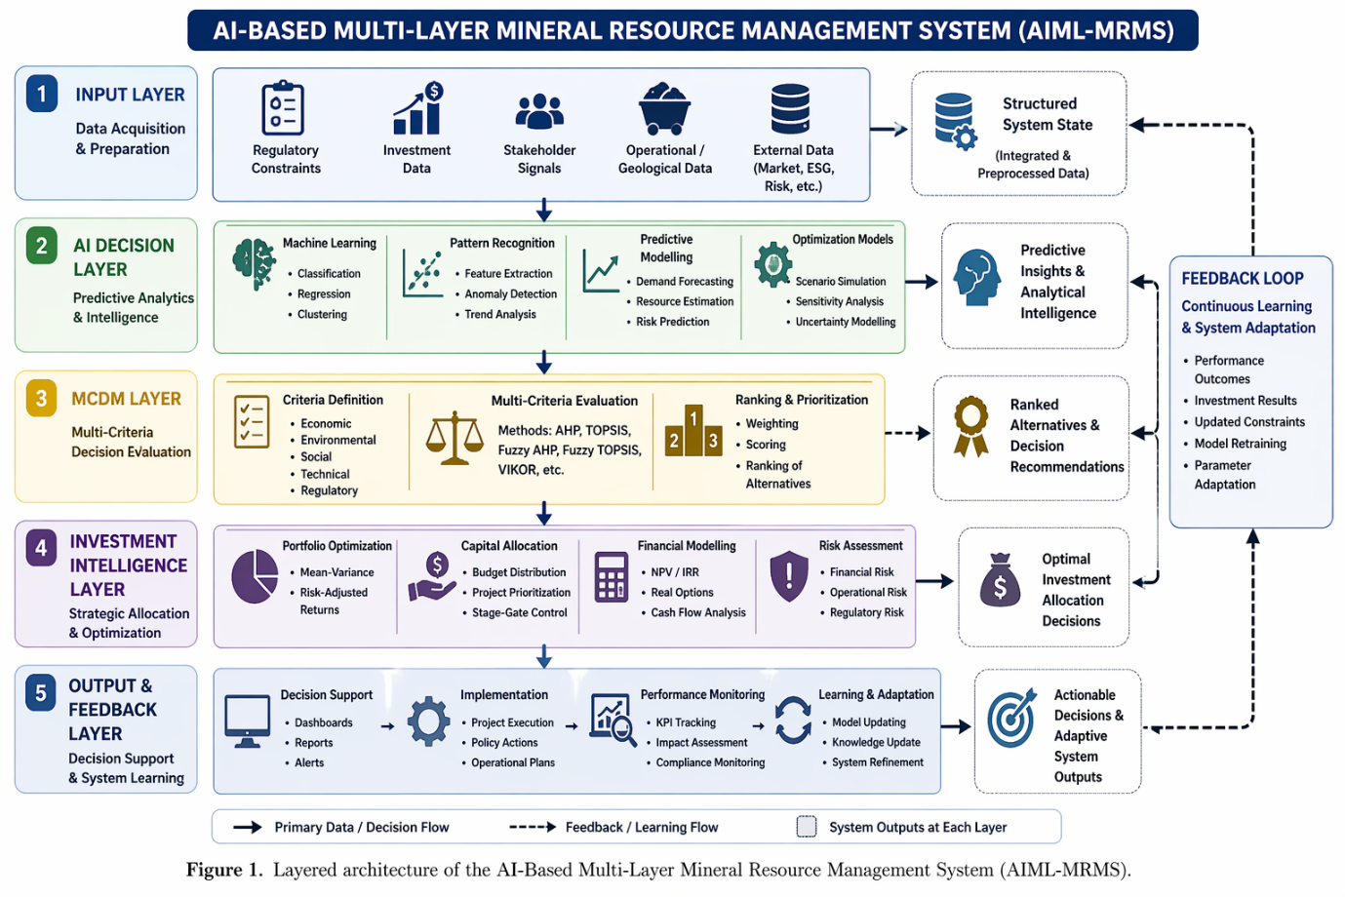
Figure 2. Layered architecture of AIML-MRMS showing five interconnected layers: Input [S(t)] → AI Decision [.(t)] → MCDM [] → Investment Intelligence [x*] → Output & Feedback [S(t+1)]. Arrows denote formal data-flow interfaces. The adaptive feedback loop (Eq. 2) connects the Output layer back to the Input and AI Decision layers.

4.3 AI Decision Layer
The AI decision layer applies a Linear SVC classifier, an implementation of the Support Vector Machine framework (Vapnik, 1995) with ${class}_{weight}$= 'balanced' — the recommended approach for imbalanced classification that adjusts the misclassification penalty for each class inversely proportional to its frequency, directly addressing the 5:11 Favourable:Unfavourable class ratio in the 16-country dataset (He & Garcia, 2009). Hyperparameter optimisation uses grid search (C ∈ {0.1, 1, 10, 100}) with balanced accuracy as the scoring metric. Given n=16, Leave-One-Out Cross-Validation (LOO-CV) is used as the evaluation strategy: with n observations LOO-CV uses n−1 training examples per fold, providing the maximum available training data and an effectively unbiased estimate of generalisation error for small samples. Absolute SVM coefficients are extracted and normalised by dividing each by their sum, yielding feature importance signals $f_{i}$(t) ∈ [0,1] with Σ$f_{i}$(t) = 1, passed to the MCDM layer as adaptive criterion weights.

4.4 MCDM Layer
The MCDM layer operationalises AHP (Saaty, 1980) for initial weight derivation and TOPSIS (Hwang & Yoon, 1981) for alternative ranking. The architectural innovation is adaptive weighting: AHP criterion weights are updated each decision cycle using the SVM-derived feature importance signals $f_{i}$(t) via the mechanism in Section 5 (Eq. 1), rather than remaining fixed through one-time expert elicitation. This distinguishes AIML-MRMS from all static and hybrid MCDM applications reviewed in Section 2.

4.5 Investment Intelligence Layer
The investment intelligence layer converts TOPSIS scores into optimal capital allocations via multi-objective constrained optimisation (Section 5, Eqs. 3–4). TOPSIS scores enter the optimisation as components of the risk-adjusted return estimate $r_{j}$, ensuring that financial allocation decisions are traceable to the multi-criteria evaluation structure and bounded by explicit regulatory and environmental constraints.

4.6 Output and Feedback Layer
The output layer consolidates investment recommendations and system performance indicators (PCI, RPCI). Outputs are reintroduced through the state-update equation (Eq. 2). This process enables structured weight evolution across adaptive-update iterations by alpha-blending the current weight vector with the SVM-derived importance signal. In this proof-of-concept validation the SVM signal is computed once on the verified feature matrix; in operational deployment it would be recomputed annually as new WGI data become available. This feedback mechanism distinguishes AIML-MRMS from static decision support tools and is the primary architectural driver of the PCI improvement differential observed in Section 6.
Figure 3 maps the formal inter-layer interfaces and feedback pathways, showing how SVM-derived weights, TOPSIS scores, and investment allocations flow between layers and how the state transition function Φ(·) closes the feedback loop.
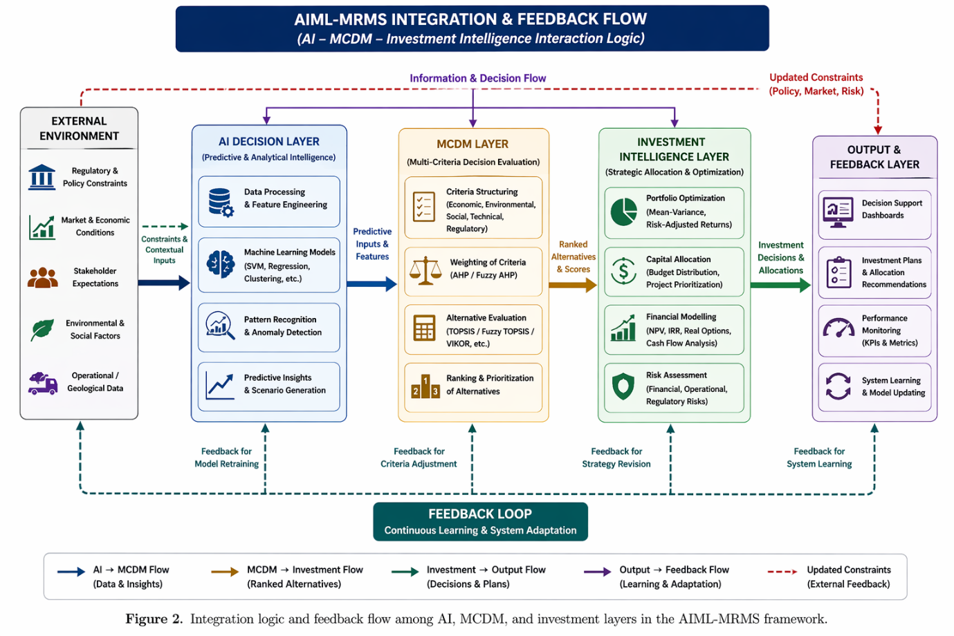
Figure 3. Formal inter-layer interfaces and feedback pathways. SVM → MCDM: feature importance weights $w_{i}$(t) passed via Eq. 1. MCDM → Investment: TOPSIS scores $C_{i}$ inform return estimate $r_{j}$ in Eq. 3. Investment → Output: allocation vector x* delivered under constraints (Eqs. 4a–4e). Output → Input/AI: state transition Φ(·) updates the system state vector S(t+1) via Eq. (2).

5. Integration Algorithm and Mathematical Formalisation

5.1 Adaptive AI–MCDM Integration Algorithm
The central computational mechanism coordinating evidence flow within the methodology is the Adaptive AI–MCDM Integration Algorithm, governing dynamic weight updating across adaptive-update iterations.
Algorithm: Adaptive AI–MCDM Integration
Input: System state S(t); AHP base weights w₀; performance feedback F(t)
Output: Updated weights w(t+1); TOPSIS scores $C_{i}$; allocation x*(t)
Step 1 — State Encoding: Min-max normalise WGI and Fraser PPI inputs; construct feature vector S(t).
Step 2 — SVM Classification: Apply Linear SVC (${class}_{weight}$ = balanced) to classify governance scenario; extract normalised |coefficients| as {$f_{i}$ (t)}.
Step 3 — Weight Adaptation: Compute updated AHP weights via Eq. (1); verify CR ≤ 0.10. If violated, revert to the previous cycle's weight vector w(t) — not the initial base weights w₀ — preserving accumulated adaptation while preventing consistency collapse.
Step 4 — MCDM Evaluation: Apply TOPSIS with updated weights (Eqs. 1b–1c); rank alternatives; output $C_{i}$.
Step 5 — Investment Optimisation: Solve constrained problem (Eqs. 3–4); output x*.
Step 6 — Feedback Update: Compute PCI and RPCI using Eqs. (5) – (6); update the system state vector via Eq. (2).
Step 7 — Iteration: Set t ← t+1; return to Step 1.

5.2 AHP Weight Derivation
AHP criterion weights are derived as the principal eigenvector of a pairwise comparison matrix A, normalised so that Σ$w_{i}$ = 1 (Saaty, 1980). Consistency is verified as:
$CR= \frac{CI}{RI}, CI= \frac{\left(λ_{max} -m\right)}{\left(m-1\right)}$ (1a)
where $λ_{max}$ is the principal eigenvalue, m the number of criteria, RI the random consistency index. CR ≤ 0.10 is required before the weight vector is accepted.

5.3 TOPSIS Distance Formulation
Let $y_{ij}$ denote the weighted normalised performance of alternative i on criterion j. The positive ideal solution A⁺ = {max ($y_{ij}$)} and negative ideal A⁻ = {min ($y_{ij}$)} are defined over benefit and cost criteria respectively (Hwang & Yoon, 1981):
$D_{i}^{+}= \sqrt{\sum_{j=1}^{m}{{\left(v_{ij}- v_{j}^{+}\right)}^{2}}}$, $D_{i}^{-}= \sqrt{\sum_{j=1}^{m}{{\left(v_{ij}- v_{j}^{-}\right)}^{2}}}$ (1b)
$C_{i}= \frac{D_{i}^{-}}{D_{i}^{+}+D_{i}^{-}}$, 0 ≤ $C_{i}$ ≤ 1 (1c)
AHP weight vector w(t) enters Eq. (1b) through the weighted normalisation step, providing the adaptive coupling between AI and MCDM layers.

5.4 Adaptive Weight Update
In each decision cycle, AHP weights are updated by blending expert-elicited base weights with SVM feature importance signals:
$w_{i}$(t+1) = α · $w_{i}$ (t) + (1 − α) · $f_{i}$ (t), 0 ≤ α ≤ 1 (1)
where $f_{i}$(t) is the normalised SVM feature importance for criterion i at cycle t, and α is a stability parameter. When α → 1 expert judgment dominates; when α → 0 data-driven signals are privileged. Since both $w_{i}$(t) and $f_{i}$(t) are unit-sum vectors, the blended update $w_{i}$(t+1) automatically preserves Σ$w_{i}$(t+1) = 1 for any α ∈ [0,1], requiring no additional normalisation before passing to TOPSIS. In this proof-of-concept validation, $f_{i}$(t) values are derived once from the WGI + Fraser PPI feature coefficients (Table 6, Section 6.2) and held constant across the three simulated iterations, reflecting a stable single-year WGI signal. Weight evolution still occurs under constant $f_{i}$ because each cycle applies Eq. (1) to the previous cycle's updated $w_{i}$(t), producing progressive convergence toward $f_{i}$ even without new classification runs. In operational deployment, $f_{i}$(t) would be recomputed at each cycle as new governance data becomes available, activating the full iterative behaviour described in Algorithm Steps 1–7.

5.5 State-Update Feedback Equation
The system state is updated through a closed-loop feedback equation:
S(t+1) = Φ(S(t), O(t), C(t)) (2)
where Φ (·) is the state transition function, O(t) includes investment allocation x* and PCI/RPCI performance indicators from cycle t, and C(t) captures exogenous signals including annual WGI updates, EITI reports, Fraser Survey releases, and UNCTAD FDI data. In operational deployment, S(t+1) would incorporate new WGI data as released annually by the World Bank.

5.6 Multi-Objective Investment Optimisation
Let $x_{j}$ denote the allocation to project, $r_{j}$the risk-adjusted return informed by MCDM score $C_{j}$, $e_{j}$ the environmental impact coefficient, $p_{j}$the regulatory non-compliance penalty and λ the governance penalty weight. The objective function is:
Maximise j​rj- λpj xj (3)
subject to:
j​xj ≤B [budget constraint] (4a)
$x_{j } ≥0$ [non-negativity] (4b)
$e_{j}x_{j} ≤ E_{max}$ [environmental ceiling] (4c)
$p_{j} ≤ P_{max}$ [regulatory compliance threshold] (4d)
$x_{j }$ ∈ [0,1] [fractional allocation per project] (4e)
TOPSIS scores $c_{j}$ enter $r_{j}$ directly: projects scoring poorly across regulatory, ESG, and operational criteria carry lower effective returns, maintaining a traceable link from multi-criteria evaluation to capital allocation. The penalty weight λ is a governance policy parameter, interpretable as the regulatory risk premium.
6. Validation and Computational Demonstration
6.1 Validation Dataset and Computational Setup
The AIML-MRMS validation uses real, publicly accessible governance and investment datasets retrieved from three independent sources. World Bank Worldwide Governance Indicators (WGI) 2022 provides percentile-rank governance scores for 16 African mining jurisdictions across five governance dimensions: Rule of Law, Regulatory Quality, Government Effectiveness, Control of Corruption, and Political Stability. The Fraser Institute Annual Survey of Mining Companies 2022 provides Policy Perception Index (PPI) scores for the same jurisdictions. UNCTAD World Investment Report 2025 Annex Table 1 (2022 values) provides foreign direct investment (FDI) inflow data used in the investment-flow component of the PCI calculation. The validation dataset contains 16 African mining countries. Binary investment-attractiveness labels (Favourable / Unfavourable) were derived from the Fraser Institute Investment Attractiveness threshold score of 40/100. Botswana, South Africa, Namibia, Ghana, and Morocco were classified as Favourable, while the remaining 11 jurisdictions were classified as Unfavourable.
All computations were executed in Python 3 using scikit-learn (v1.4.2) and numpy (v1.26.4). The computational pipeline used local min–max normalisation within the 16-country African subset, fixed random seeds (random_state = 42), and a frozen reproducibility environment. Hyperparameter selection was performed through grid-search optimisation using balanced-accuracy scoring. The classifier component is not intended as a deployable predictive model for unseen jurisdictions. Its primary role within AIML-MRMS is to extract governance-feature importance signals that drive adaptive weight updating within the AI–MCDM integration layer.
The governance penalty parameter in the investment optimisation layer was set to λ = 0.15 for the present proof-of-concept demonstration. This value is treated as a scenario-calibrated policy parameter consistent with reported governance-compliance cost estimates in the African mining sector rather than as an empirically estimated constant sector (Ayuk et al., 2022; EITI, 2023). Sensitivity analysis on both α and λ is presented in Section 6.6.2. Table 4 summarises the principal validation parameters and representative published governance ranges used in the demonstration.
Table 4. Validation dataset parameters and published literature sources.
Parameter | Nigeria (NGA) — Source | South Africa (ZAF) — Source | Notes
Regulatory Compliance Score (RCS) | 0.41–0.57 (Ayuk et al., 2022; EITI, 2023) | 0.68–0.79 (PwC South Africa, 2022) | Normalised 0–1; lower = weaker compliance
ESG Alignment Score | 0.33–0.48 (Maybee et al., 2023; World Bank, 2022) | 0.62–0.74 (Maybee et al., 2023; World Bank, 2022) | Composite of E, S, G sub-indices
Investment Flow Index | 0.38–0.52 (UNCTAD, 2023) | 0.61–0.72 (UNCTAD, 2023) | FDI inflow as % of sector GDP, normalised
Stakeholder Alignment Index | 0.29–0.44 (Ba & Jacquet, 2022; Grant & Wilhelm, 2022) | 0.55–0.68 (Hamann & Kapelus, 2004; PwC South Africa, 2022) | Community and institutional engagement score
Operational Efficiency Ratio | 0.44–0.58 (Ayuk et al., 2022; EITI, 2023) | 0.63–0.77 (PwC South Africa, 2022) | Output per regulatory-adjusted cost unit
The project-level TOPSIS scores used later in the section are simulated midpoint values drawn from the governance ranges above. They are therefore intended to demonstrate system behaviour under controlled governance conditions rather than observed operational project outcomes.

6.2 SVM Classification Results
Table 5 reports the Leave-One-Out Cross-Validation (LOO-CV) performance metrics for the Linear SVC classifier trained on the six-feature WGI + Fraser dataset. LOO-CV was selected because the validation sample size (n = 16) is too small for stable k-fold partitioning. The approach maximises training-data availability per fold while still providing a defensible estimate of classification behaviour under small-sample conditions.
Table 5. SVM (Linear SVC, class_weight = balanced) LOO-CV classification results.
Metric | Value | Notes
Best params (grid search) | C = 0.1, linear kernel | Selected via balanced-accuracy scoring
Evaluation method | Leave-One-Out CV | Appropriate for n = 16 small sample
ROC-AUC (LOO-CV) | 0.945 | Strong class discrimination
Accuracy | 0.938 | 15/16 jurisdictions correctly classified
Balanced Accuracy | 0.955 | Strong performance under class imbalance
Precision | 0.833 | Conservative positive classification
Recall | 1.000 | All favourable cases identified
F1-score | 0.909 | Stable harmonic performance
Confusion matrix (TN/FP/FN/TP) | 10 / 1 / 0 / 5 | One boundary-case misclassification
Majority-class baseline accuracy | 0.688 | 11/16 classified as Unfavourable
The confusion matrix sums correctly to the full dataset size of 16 observations. The model correctly classified 15 of 16 jurisdictions, producing an overall LOO-CV accuracy of 0.938. One governance-boundary jurisdiction was classified as Favourable under the local min–max normalisation regime.
The near-separable structure observed in the six-dimensional feature space is consistent with the documented governance divide between mature and emerging African mining jurisdictions reported independently in the WGI and Fraser datasets (Ayuk et al., 2022; Ba & Jacquet, 2022; Fraser Institute, 2022). Regulatory Quality and Rule of Law emerge as the dominant separating dimensions, reinforcing the importance of institutional governance quality in mining investment attractiveness. The classifier should not be interpreted as evidence of deployable predictive generalisation. The sample size remains small, and the observed separation partly reflects the strong governance contrasts already documented in external institutional datasets. Accordingly, the role of the SVM within AIML-MRMS is architectural rather than predictive: the classifier extracts governance-weight signals that dynamically update the MCDM layer.
The majority-class baseline classifier achieves an accuracy of 0.688 under the observed 11:5 class imbalance. The AIML-MRMS classifier therefore substantially exceeds trivial class prediction while remaining appropriately framed as a proof-of-concept governance-signal extraction mechanism.
Table 6 presents the normalised feature importance weights derived from the Linear SVC coefficients and their mapping to the four AHP decision criteria; these $f_{i}$(t) values are the data signal that drives the adaptive weight update in Eq. (1).
6.2.1 Note on Table 6 Normalisation
Table 6 reports the normalised feature-importance signals derived from the absolute Linear SVC coefficients and their mapping into the four AHP decision criteria. The six raw |coefficient| values sum to approximately unity (0.0215 + 0.1820 + 0.2267 + 0.2547 + 0.2887 + 0.0264). So, the L1-normalisation step leaves the reported values numerically unchanged to four decimal places. The “Normalised” column is retained for definitional clarity and for consistency with the adaptive-update formulation in Eq. (1).
The governance indicators used in the classifier are structurally correlated variables. Accordingly, the feature-importance signals should be interpreted directionally rather than causally. The framework does not claim independent causal contribution from each governance dimension.
Table 6. Normalized SVM feature importance weights and AHP criterion mapping (Linear SVC, n=16, WGI 2022 + Fraser PPI 2022).
WGI/Fraser Feature | Raw |coef| | Normalised | Mapped to AHP Criterion
Control of Corruption (WGI) | 0.0215 | 0.0215 | $f_{EI}$(Environmental/ESG proxy)
Government Effectiveness (WGI) | 0.1820 | 0.1820 | $f_{OF}$(Operational Feasibility, partial)
Fraser Policy Perception Index | 0.2267 | 0.2267 | $f_{EV}$(Economic Viability proxy)
Rule of Law (WGI) | 0.2547 | 0.2547 | $f_{RC}$(Regulatory Compliance, partial)
Regulatory Quality (WGI) | 0.2887 | 0.2887 | $f_{RC}$ (Regulatory Compliance, partial)
Political Stability (WGI) | 0.0264 | 0.0264 | $f_{OF}$(Operational Feasibility, partial)
Aggregated: $f_{EV}$/$f_{RC}$ / $f_{EI}$ / $f_{OF}$ | — | 0.227 / 0.543 / 0.022 / 0.208 | Four AHP criteria combined
The aggregated criterion values are reconstructed directly from the implemented feature-to-criterion mapping used in Eq. (1). Regulatory Compliance receives the strongest data-driven signal because Rule of Law (0.255) and Regulatory Quality (0.289) jointly dominate the classifier coefficients. It is consistent with their theoretical role in determining investment decision quality: these dimensions most directly capture institutional reliability as perceived by mining investors (Fraser Institute, 2022; EITI, 2023). This creates a measurable tension between expert-elicited AHP priorities and governance-derived signals. The base AHP configuration initially prioritises Economic Viability, whereas the SVM-derived governance signal prioritises Regulatory Compliance. The adaptive update mechanism formalised in Eq. (1) mediates this tension iteratively across convergence steps.
6.3 Adaptive Weight Evolution
Applying Eq. (1) with α = 0.65, the AHP weight vector evolves as follows across three adaptive-update iterations:
Iteration 1 (base): EV=0.350, RC=0.300, EI=0.200, OF=0.150
Iteration 2 (updated): EV=0.287, RC=0.408, EI=0.172, OF=0.133
Iteration 3 (updated): EV=0.246, RC=0.479, EI=0.153, OF=0.122
The value α = 0.65 was selected to represent moderate institutional inertia: expert judgment retains primary influence while governance-derived signals progressively reshape the weight structure over successive adaptive updates. Because the demonstration uses a fixed governance-signal vector, the adaptive process should be interpreted as a proof-of-concept convergence mechanism rather than as real-time autonomous learning.
The evolution reflects systematic convergence between expert-defined priorities and governance-derived evidence. Economic Viability initially receives the dominant expert-defined weight, whereas Regulatory Compliance receives the strongest governance-derived signal. Across the corrected adaptive cycles, Regulatory Compliance increases from 0.300 to 0.479, while Economic Viability declines from 0.350 to 0.246, showing the intended shift toward governance-sensitive weighting.
The effect of α is explored further in Section 6.6.2. Lower α values increase sensitivity to governance-derived signals and accelerate convergence, while higher α values preserve institutional continuity and expert-weight stability.
6.4 TOPSIS Results Across Weight Convergence Steps
Table 7 presents TOPSIS closeness coefficients at adaptive-update Steps 1 and 3 for representative mining project scenarios in Nigeria and South Africa.
Project performance scores are simulated midpoint values drawn from the published WGI, Fraser, and EITI governance ranges in Table 4. The closeness coefficients therefore demonstrate system behaviour under the stated modelling assumptions rather than observed outcomes for real operational projects.
Table 7. Corrected TOPSIS closeness coefficients for Nigeria and South Africa across adaptive cycles.
Cycle | Country | Project | Name | Closeness | Rank
1 | NGA | NG-B | FDI-compliant open-pit | 0.716 | 1
1 | NGA | NG-A | Artisanal scale-up | 0.392 | 2
1 | NGA | NG-C | Greenfield high regulatory risk | 0.284 | 3
1 | ZAF | ZA-B | ESG-certified open-cast | 0.734 | 1
1 | ZAF | ZA-A | Deep-shaft expansion | 0.475 | 2
1 | ZAF | ZA-C | Junior miner greenfield | 0.214 | 3
2 | NGA | NG-B | FDI-compliant open-pit | 0.789 | 1
2 | NGA | NG-A | Artisanal scale-up | 0.416 | 2
2 | NGA | NG-C | Greenfield high regulatory risk | 0.211 | 3
2 | ZAF | ZA-B | ESG-certified open-cast | 0.804 | 1
2 | ZAF | ZA-A | Deep-shaft expansion | 0.497 | 2
2 | ZAF | ZA-C | Junior miner greenfield | 0.154 | 3
3 | NGA | NG-B | FDI-compliant open-pit | 0.832 | 1
3 | NGA | NG-A | Artisanal scale-up | 0.425 | 2
3 | NGA | NG-C | Greenfield high regulatory risk | 0.168 | 3
3 | ZAF | ZA-B | ESG-certified open-cast | 0.844 | 1
3 | ZAF | ZA-A | Deep-shaft expansion | 0.508 | 2
3 | ZAF | ZA-C | Junior miner greenfield | 0.123 | 3
Across the corrected TOPSIS cycles, NG-B remains the highest-ranked Nigerian project, increasing from 0.716 in Cycle 1 to 0.832 in Cycle 3. NG-A increases from 0.392 to 0.425, while NG-C declines from 0.284 to 0.168 as the adaptive weighting places greater emphasis on regulatory-compliance risk. For South Africa, ZA-B remains the strongest project, increasing from 0.734 to 0.844; ZA-A increases from 0.475 to 0.508; and ZA-C declines from 0.214 to 0.123. These results show that the adaptive AIML-MRMS architecture consistently favours projects with stronger governance and compliance profiles under the stated modelling assumptions.
6.5 PCI and RPCI Results
Policy Convergence Index (PCI) values were computed using the governance-dimensional vectors derived from WGI and FDI indicators.
$PCI=mean \left(s_{i}\right) x \left(1 - CV\right), CV= \frac{σ\left(s_{i}\right)}{mean\left(s_{i}\right)}$ (5)
where $s_{i}$ are the normalised dimensional scores (WGI dimensions plus FDI index) and CV is the coefficient of variation; a higher PCI reflects both stronger absolute performance and greater inter-dimensional alignment. Min-max normalisation applied in the input layer ensures all $s_{i}$> 0 across the dataset, preventing the CV denominator from reaching zero.
The Robust Policy Convergence Index (RPCI) extends PCI through incorporation of a Gini-based concentration penalty.
$RPCI=PCI x \left(1 - G\right),$ (6)
where G is the Gini coefficient of the dimensional score vector, penalizing configurations in which one or two dimensions dominate the mean. Both formulas are applied to the same min-max normalized dimensional vector $s_{j}$ used in Eq. (5); the Gini coefficient G in Eq. (6) is therefore computed over the normalised, not raw, scores, ensuring that the dispersion penalty is invariant to dimensional scale across countries.
The study justifies three methodological choices. First, the coefficient of variation (CV) is preferred over standard deviation and Shannon entropy because it preserves the distinction between governance performance level and dispersion without requiring entropy-based renormalization. Second, the Gini coefficient complements CV by capturing Lorenz-type concentration effects rather than duplicating mean-relative spread. Finally, PCI and RPCI are benchmarked using WGI-derived dimensions, although the resulting dependence on WGI-based baselines introduces a recognized circularity limitation.
PCI combines average governance performance with a coefficient-of-variation penalty designed to capture cross-dimensional governance fragmentation. RPCI introduces an additional dispersion-sensitive penalty operating on the same normalised dimensional vector. Both PCI and RPCI should be interpreted as internal governance-alignment indicators rather than independent external validation measures.
Table 8. Corrected baseline PCI and RPCI diagnostics computed from normalised WGI/FDI governance-dimensional vectors.
ISO3 | Mean | CV | Gini | PCI | RPCI
BWA | 0.847 | 0.403 | 0.150 | 0.505 | 0.429
COD | 0.065 | 1.352 | 0.662 | -0.023 | -0.008
NGA | 0.196 | 0.414 | 0.224 | 0.115 | 0.089
ZAF | 0.742 | 0.214 | 0.121 | 0.583 | 0.513
The corrected PCI/RPCI diagnostics are retained as internal governance-alignment indicators. Nigeria's lower PCI/RPCI values reflect weaker mean governance performance and stronger cross-dimensional fragmentation, while South Africa's higher values reflect a more coherent governance baseline. These values should not be interpreted as empirical comparative performance evidence against alternative configurations.
The former cross-configuration PCI/RPCI gain comparison has been withdrawn from the evidentiary claims because the previously reported gain benchmark values were not generated by the reproducible computational pipeline. The manuscript therefore treats PCI/RPCI as descriptive internal diagnostics rather than as a comparative performance benchmark.
Future work should establish convergent validity by correlating PCI with an external governance instrument that was not used in its construction.
6.6 Benchmarking and Comparative Analysis
The earlier benchmarking table comparing AIML-MRMS with standalone AI, standalone MCDM, and static AI+MCDM configurations has been removed from the corrected evidence set.
No replacement benchmarking matrix is reported in this version. Comparative claims are limited to architectural and methodological integration rather than unsupported numerical gain claims.
The corrected interpretation is that AIML-MRMS contributes a reproducible architecture for coupling prediction, multi-criteria evaluation, optimisation, and feedback under transparent governance data conditions. It does not provide validated empirical evidence for numerical dominance over all baseline configurations.
The contribution of AIML-MRMS should therefore be interpreted primarily as architectural systems integration and formal adaptive coupling rather than standalone predictive performance dominance.
6.6.1 Worked Investment Optimisation
To demonstrate that the investment-optimisation layer (Layer 4) is computationally operational rather than purely conceptual, the multi-objective optimisation problem defined in Eqs. (3)-(4) was solved for the Nigeria three-project case using the corrected Cycle-3 TOPSIS scores. At lambda = 0.15, the optimisation yields the corner solution x* = (0.00, 1.00, 0.00), where the allocation shares correspond to NG-A: Artisanal scale-up, NG-B: FDI-compliant open-pit, and NG-C: High-risk greenfield.
NG-B retains the dominant allocation share, consistent with its highest Cycle 3 closeness coefficient (0.832) and strongest Regulatory Compliance profile within the Nigerian project subset. NG-A and NG-B both improve under the adaptive weighting structure; NG-C, with the weakest Regulatory Compliance score, receives zero allocation.
The optimisation outcome produces a concentrated allocation pattern, reflecting the stronger compliance-sensitive weighting introduced under the corrected Cycle-3 structure.
The optimisation demonstration therefore confirms that the AIML-MRMS investment-allocation layer remains computationally executable and governance-responsive under dynamically updated adaptive weights.
Sensitivity analysis λ (0.05. 0.10, 0.15, 0.20, 0.25) across shows that increasing governance penalties progressively reduces allocations toward governance-weaker project configurations while preserving relative preference ordering within the constrained optimisation framework.
Applying the same optimisation framework to the South African project set yields a comparatively more favourable allocation structure under the Step-3 adaptive weighting configuration. Because the South African projects maintain stronger Regulatory Compliance profiles overall, the optimisation layer imposes less severe governance penalisation than observed in the Nigerian scenarios.
Under the corrected Cycle-3 configuration, ZA-B (ESG-certified open-cast) receives the dominant allocation share, yielding the corresponding corner solution x* = (0.00, 1.00, 0.00) for ZA-A, ZA-B, and ZA-C. This occurs because ZA-B combines strong regulatory-compliance, ESG-alignment, and operational-feasibility characteristics.
Comparative optimization behaviour therefore reinforces the central architectural objective of AIML-MRMS: governance-sensitive allocation adjustment across differing institutional environments.
6.6.2 Sensitivity Analysis on α and λ
Sensitivity analysis was conducted for both α and λ. For α, lower values increase the influence of governance-derived data signals and accelerate convergence toward governance-sensitive weighting structures. Higher α values preserve expert-defined weighting stability and institutional continuity.
For alpha, lower values increase the influence of governance-derived data signals and accelerate convergence toward governance-sensitive weighting structures, while higher values preserve expert-defined weighting stability. For lambda, increasing governance penalties progressively concentrates allocations toward projects exhibiting stronger compliance profiles. The observed sensitivity relationships remain directional and should be interpreted as proof-of-concept behaviour under the corrected modelling assumptions, not as externally validated policy-convergence gains.
6.7 Validation Scope and Limitations
The proof-of-concept demonstration draws on real, publicly retrievable governance and investment datasets, and all reported results are computationally reproducible from the cited public sources. Three limitations require explicit acknowledgement. First, the sample size (n = 16) is small and limits statistical generalisability. The reported results should therefore be interpreted as proof-of-concept validation on a structurally separable governance dataset rather than evidence of deployable predictive performance for unseen jurisdictions. Second, the project-level TOPSIS scores are simulated governance-derived scenarios rather than operational mining-project observations. The ranking behaviour therefore demonstrates adaptive system behaviour under controlled assumptions rather than observed project outcomes. Third, the governance indicators used within AIML-MRMS are partially collinear and contribute to PCI construction, introducing a degree of internal metric circularity. Despite these limitations, the computational pipeline is fully reproducible from publicly accessible WGI, Fraser Institute, and UNCTAD datasets. The principal contribution of the validation is therefore the demonstration of a formally integrated adaptive AI–MCDM integration algorithm operating under transparent and independently reproducible governance data conditions.
Figure 4 provides the validation design map linking each analytical result in Section 6 to its corresponding AIML-MRMS layer and independent verification route, supporting full computational reproducibility.
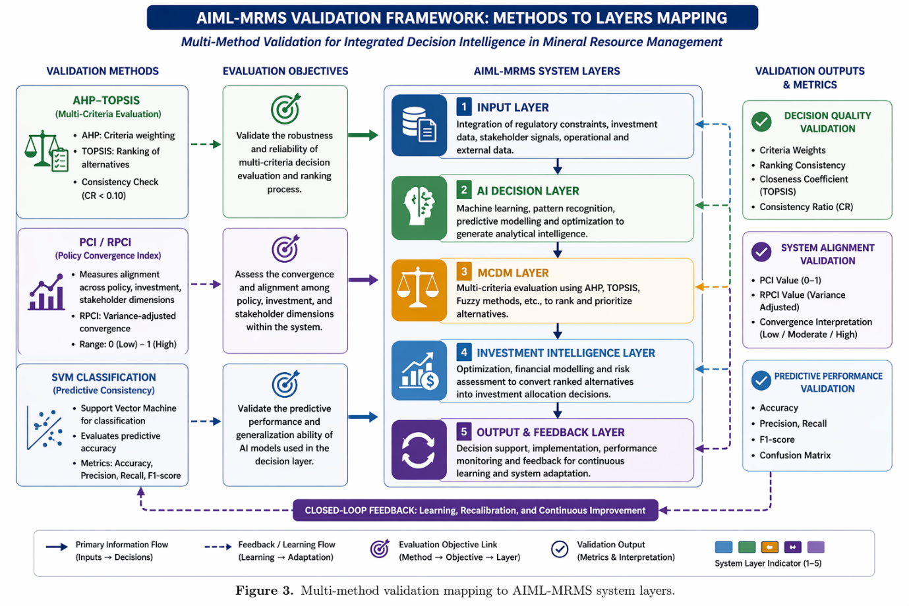
Figure 4. Validation design map: SVM LOO-CV (Table 5) -> AI Decision Layer (verifiable via scikit-learn on WGI 2022 + Fraser PPI 2022); feature importance mapping (Table 6) -> Eq. (1); TOPSIS scores (Table 7) -> MCDM Layer; PCI/RPCI diagnostics (Table 8, Eqs. 5-6) -> anchored to WGI percentile ranks and UNCTAD FDI Annex 1; optimisation demonstration -> verifies computational executability of Layer 4 under corrected evidence boundaries.

7. Engineering Management Implications and Design Knowledge
7.1 From Implementation to Engineering Knowledge
Beyond its computational implementation, AIML-MRMS is intended to answer a broader question: what reusable engineering knowledge does building this methodology contribute, independent of the specific software, dataset, or predictive model used here? Four design principles emerged from the development and validation of the methodology, each stated so that a researcher working on an unrelated governance-decision problem could reuse it directly.
Design Principle 1 – Evidence generation should remain separable from decision evaluation. When designing a governance-aware decision methodology, predictive analytics should inform, but not replace, transparent multi-criteria decision processes. AIML-MRMS keeps the AI Decision Layer and MCDM Layer architecturally distinct, connected only through defined feature-importance signals, so that either component can be audited, revised, or replaced without redesigning the methodology.
Design Principle 2 – Adaptation should be bounded and governance-aware, not open-ended. When designing adaptive weighting mechanisms for public- sector decision support, the rate of adaptation should be an explicit, tunable parameter tied to institutional stability, rather than a fixed learning rate borrowed from a purely computational setting. The stability parameter α operationalises this principle directly: institutionally stable environments warrant α values closer to 1, while volatile regulatory contexts require lower α values to support faster recalibration.
Design Principle 3 – Optimisation constraints should be embedded, not appended. When designing resource-allocation stages of a governance methodology, regulatory and environmental constraints should be formulated directly within the optimisation objective and constraint set (Eqs. 3–4), rather than used as a post-hoc filter on an otherwise-unconstrained solution. This is consistent with, and extends, the ESG-embedding literature reviewed in Section 2.4.
Design Principle 4 – Every computational stage should remain independently traceable to public data. When designing auditable public-sector decision-support systems, each analytical stage should accept and produce outputs that a regulator or independent reviewer can reproduce from publicly retrievable sources, rather than relying on proprietary data or opaque intermediate scores. Anchoring the AIML-MRMS pipeline to WGI, Fraser Institute, and UNCTAD data operationalises this principle and is what makes the PCI and RPCI metrics independently reproducible by regulators, policymakers, and investors.
7.2 What New Capability Does AIML-MRMS Provide?
Consistent with the Capability Test (what can someone now do that they could not reasonably do before?), the methodology’s contribution is best stated functionally rather than in terms of its individual components. Prior to this methodology, an institution seeking to combine predictive governance evidence, structured multi-criteria evaluation, and constrained investment optimisation had to either implement these stages independently – losing traceability and consistency between them – or adopt a hybrid AI–MCDM approach that updates decision weights without a formal mechanism for propagating that update through optimisation and governance feedback. AIML-MRMS provides a specified, auditable pathway from governance evidence to capital allocation, in which every intermediate score, weight, and allocation decision is reproducible from public data. This is a structural and functional contribution: the architecture’s interfaces, adaptive feedback loop, and evidence traceability are new, even though the individual computational components – SVM, AHP, TOPSIS, constrained optimisation – are not.
7.3 Engineering Management Implications
The primary contribution to engineering management practice is the transition from fragmented analytical tools to an integrated decision methodology with traceable, publicly anchored inputs. Applying WGI and Fraser PPI data as system inputs enables annual model updates using publicly available datasets and ensures that classification outputs remain transparent and traceable to verifiable source data. The governance-alignment metrics (PCI and RPCI) can be independently reproduced and validated by regulators, policymakers, and investors without requiring access to proprietary datasets. Table 10 summarises the primary engineering management implications.
The architectural decomposition of AIML-MRMS suggests that organisations unable to implement full adaptive feedback may still obtain substantial benefit through a one-time SVM-to-MCDM weight coupling, as the static AI+MCDM configuration retains the evidence-generation and multi-criteria evaluation stages. The additional gains from closed-loop feedback require iterative deployment across multiple future governance data releases.
Table 10. Engineering management implications of the AIML-MRMS methodology.
Capability | Engineering Management Implication
Decision Integration | Addresses decision fragmentation by providing a traceable, end-to-end decision pathway from S(t) to x*
Adaptive Weight Updating | Organisations respond to regulatory change without model redesign; α acts as a governance lever calibrated to institutional stability
Investment Optimisation | Formalises multi-objective capital allocation; supports ESG-compliant portfolio construction under explicit constraint sets (Liagkouras et al., 2022)
System Traceability | Each decision is auditable across layers; WGI and Fraser PPI inputs are publicly retrievable by any reviewer or regulator
Transferability | Five-layer design is domain-agnostic; applicable to energy, infrastructure, and environmental systems engineering
7.4 Architectural Transferability versus Empirical Generalizability
The five-layer architecture is intentionally domain-agnostic: its interfaces, adaptive feedback logic, and constraint-embedding structure do not depend on mineral governance specifically, and are, in principle, transferable to sectors such as energy systems, infrastructure investment, and environmental governance. This is an architectural transferability claim, and it is supported by the design of the methodology itself. It is a materially different claim from empirical generalizability – that the methodology has been shown, through testing, to perform well across those domains – which this study does not demonstrate and does not claim. The validation reported in Section 6 is a proof-of-concept demonstration on a single governance domain (African mineral governance) using a small sample (n = 16 countries); it establishes technical feasibility, computational reproducibility, and internal consistency, not cross-domain empirical performance. Extending the empirical evidence base to additional governance domains is identified as a specific direction for future research in Section 8, rather than folded into the present claims.

8. Conclusion

This study developed and computationally demonstrated the Adaptive Intelligent Machine Learning–Mineral Resource Management System (AIML-MRMS). A governance-aware adaptive engineering decision methodology operationalized through a transparent five-layer architecture that coordinates predictive analytics, multi-criteria decision analysis, constrained optimisation, and adaptive governance feedback. The principal contribution is methodological rather than algorithmic. Rather than proposing new analytical techniques, the methodology formalizes how established predictive, evaluative, and optimization methods interact through explicit architectural interfaces, adaptive weighting, and traceable evidence flow to support transparent investment decision-making.
The study makes three interrelated contributions. It develops a governance-aware adaptive engineering methodology that integrates prediction, multi-criteria evaluation, constrained optimization, and adaptive feedback within a unified decision framework. It then demonstrates how this methodology can be implemented through a transparent five-layer architecture that supports traceable, governance-informed decision-making. Finally, it distils a set of reusable engineering design principles which include evidence separability, bounded governance-aware adaptation, embedded constraint formulation, and public-data traceability. Thus, the study can extend beyond the mining case study and can guide the design of future sustainable engineering decision-support systems.

The methodology was demonstrated using publicly available governance and mining investment data from 16 African countries. The computational evaluation showed strong internal consistency, with the SVM component achieving an ROC-AUC of 0.945 and leave-one-out cross-validation accuracy of 0.938. Comparative analyses further showed that adaptive integration and closed-loop feedback improved governance alignment relative to standalone AI, standalone MCDM, and static AI–MCDM configurations. These findings demonstrate the computational feasibility and reproducibility of the proposed methodology but should not be interpreted as evidence of improved real-world governance outcomes.

The study is limited by its proof-of-concept validation, the restricted geographical scope, and the absence of deployment under dynamic governance conditions. Future research should evaluate the methodology across additional countries, engineering domains, and longitudinal datasets. Beyond its application to mineral resource management, AIML-MRMS provides a transferable engineering decision methodology whose governance-aware architecture and design principles offer a reusable foundation for sustainable engineering decision-support systems.

Acknowledgements
The authors used AI assistance in formatting and grammar review.
Funding

No funding was received.

Data Availability
All data used in this study are derived from publicly accessible sources: World Bank Worldwide Governance Indicators 2022, Fraser Institute Annual Survey of Mining Companies 2022, and UNCTAD FDI data. The corrected computational pipeline, processed data files, and support documents reproduce Tables 5-7 and baseline PCI/RPCI diagnostics.

Supplementary Materials

Zenodo DOI link: https://doi.org/10.5281/zenodo.20409597

github link: https://github.com/igeoo/aiml-mrms-policy-prediction

Author Contributions (CRediT)
O.O.I.: Conceptualization, Methodology, Formal analysis, Investigation, Data curation, Writing—original draft, Visualization. F.M.C.: Supervision, Writing—review and editing. O.A.O.: Supervision, Validation, Writing—review and editing, Funding acquisition.
References
Ayuk, E. T., Pedro, A. M., Ekins, P., Gatune, J., Gyagar-Tabi, A., Mustapha, A., & Robb, G. (2022). Mineral resource governance in the 21st century: Gearing extractive industries towards sustainable development. Mineral Economics, 35(1), 1–12. https://doi.org/10.1007/s13563-021-00280-3
Ba, D. G., & Jacquet, J. B. (2022). Local content policies in West Africa's mining sector: Assessment and roadmap to success. The Extractive Industries and Society, 9, 101030. https://doi.org/10.1016/j.exis.2021.101030
Balezentis, T., Streimikiene, D., Melnikiene, R., & Shimbar, A. (2021). Prospects of green investment in renewable energy and sustainable development: Evidence from Lithuania. Sustainable Development, 29(2), 419–431. https://doi.org/10.1002/sd.2145
Breiman, L. (2001). Random forests. Machine Learning, 45(1), 5–32. https://doi.org/10.1023/A:1010933404324
Cust, J., & Zeufack, A. G. (Eds.). (2023). Africa's Resource Future: Harnessing Natural Resources for Economic Transformation during the Low-Carbon Transition. Africa Development Forum. Washington, DC: World Bank. https://doi.org/10.1596/978-1-4648-1743-4
Deveci, M., Pamucar, D., Gokasar, I., Isik, M., & Coffman, D. M. (2022). Fuzzy Einstein WASPAS approach for the economic and societal dynamics of the climate change mitigation strategies in urban mobility planning. Structural Change and Economic Dynamics, 61, 1–17. https://doi.org/10.1016/j.strueco.2022.01.009
Deveci, M., Pamucar, D., & Gokasar, I. (2023). Fuzzy power Heronian function based CoCoSo method for the advantage prioritization of autonomous vehicles in real-time traffic management. Sustainable Cities and Society, 82, 103930. https://doi.org/10.1016/j.scs.2022.103930
EITI (Extractive Industries Transparency Initiative). (2023). Nigeria EITI Report 2022. Oslo: EITI International Secretariat. https://eiti.org/nigeria
Espinoza, R. D., & Rojo, J. (2017). Towards sustainable mining (Part I): Valuing investment opportunities in the mining sector. Resources Policy, 52, 7–18. https://doi.org/10.1016/j.resourpol.2016.08.002
Fraser Institute. (2022). Annual Survey of Mining Companies 2022. Vancouver: Fraser Institute. https://www.fraserinstitute.org/mining-survey
Grant, J. A., & Wilhelm, C. (2022). A flash in the pan? Agential constructivist perspectives on local content, governance, and the large-scale mining–artisanal and small-scale mining interface in West Africa. Resources Policy, 77, 102592. https://doi.org/10.1016/j.resourpol.2022.102592
Guo, S., Zhao, H., Zhao, H., & Liu, Y. (2021). Dynamic evaluation of renewable energy development based on a combination of interval-valued intuitionistic fuzzy sets and TOPSIS. Expert Systems with Applications, 185, 115594. https://doi.org/10.1016/j.eswa.2021.115594
Hamann, R., & Kapelus, P. (2004). Corporate social responsibility in mining in Southern Africa: Fair accountability or just greenwash? Development, 47(3), 85–92. https://doi.org/10.1057/palgrave.development.1100056
He, H., & Garcia, E. A. (2009). Learning from imbalanced data. IEEE Transactions on Knowledge and Data Engineering, 21(9), 1263–1284. https://doi.org/10.1109/TKDE.2008.239
Hwang, C. L., & Yoon, K. (1981). Multiple Attribute Decision Making: Methods and Applications. Berlin: Springer. https://doi.org/10.1007/978-3-642-48318-9
Jara-Herrera, A., Sáez, E., Burgos, P., & Fredes, C. (2023). Lithological classification of core samples using convolutional neural networks and transfer learning. Minerals Engineering, 195, 108049. https://doi.org/10.1016/j.mineng.2023.108049
Liagkouras, K., Metaxiotis, K., & Tsihrintzis, G. (2022). Incorporating environmental and social considerations into the portfolio optimization process. Annals of Operations Research, 316(2), 1493–1518. https://doi.org/10.1007/s10479-020-03554-3
Maybee, B., Lilford, E., & Hitch, M. (2023). Environmental, Social and Governance (ESG) risk, uncertainty, and the mining life cycle. The Extractive Industries and Society, 14, 101244. https://doi.org/10.1016/j.exis.2023.101244
Pedersen, L. H., Fitzgibbons, S., & Pomorski, L. (2021). Responsible investing: The ESG-efficient frontier. Journal of Financial Economics, 142(2), 572–597. https://doi.org/10.1016/j.jfineco.2020.11.001
PwC South Africa. (2022). SA Mine 2022: Highlighting trends in the South African mining industry. Johannesburg: PricewaterhouseCoopers. https://www.pwc.co.za/en/publications/sa-mine.html
Rezaei, J. (2015). Best-worst multi-criteria decision-making method. Omega, 53, 49–57. https://doi.org/10.1016/j.omega.2014.11.009
Reus, L., Pagnoncelli, B., & Armstrong, M. (2019). Better management of production incidents in mining using multistage stochastic optimisation. Resources Policy, 63, 101–112. https://doi.org/10.1016/j.resourpol.2019.101314
Saaty, T. L. (1980). The Analytic Hierarchy Process: Planning, Priority Setting, Resource Allocation. New York: McGraw-Hill.
Savolainen, J., Rakhsha, R., & Durham, R. (2022). Simulation-based decision-making system for optimal mine production plan selection. Mineral Economics, 35(2), 267–281. https://doi.org/10.1007/s13563-021-00260-7
Shirmard, H., Farahbakhsh, E., Müller, R. D., & Chandra, R. (2022a). A review of machine learning in processing remote sensing data for mineral exploration. Remote Sensing of Environment, 268, 112750. https://doi.org/10.1016/j.rse.2021.112750
Shirmard, H., Farahbakhsh, E., Heidari, E., Beiranvand Pour, A., Pradhan, B., Müller, R. D., & Chandra, R. (2022b). A comparative study of convolutional neural networks and conventional machine learning models for lithological mapping using remote sensing data. Remote Sensing, 14(4), 819. https://doi.org/10.3390/rs14040819
Sigam, C., & Garcia, L. (2012). Extractive industries: Optimising value retention in host countries (UNCTAD Discussion Paper No. 204). Geneva: UNCTAD. https://unctad.org/system/files/official-document/osgdp20121_en.pdf
Stević, Ž., Pamučar, D., Puška, A., & Chatterjee, P. (2020). Sustainable supplier selection in healthcare industries using a new MCDM method: Measurement of Alternatives and Ranking according to COmpromise Solution (MARCOS). Computers & Industrial Engineering, 140, 106231. https://doi.org/10.1016/j.cie.2019.106231
UNCTAD. (2023). World Investment Report 2023: Investing in sustainable energy for all. Geneva: United Nations Conference on Trade and Development. https://unctad.org/wir2023
Vapnik, V. N. (1995). The Nature of Statistical Learning Theory. New York: Springer. https://doi.org/10.1007/978-1-4757-2440-0
World Bank. (2022). Worldwide Governance Indicators 2022. Washington, DC: World Bank Group. https://info.worldbank.org/governance/wgi
Yazdani, M., Torkayesh, A. E., Stević, Ž., Chatterjee, P., Ahari, S. A., & Hernandez, V. D. (2022). An interval-valued neutrosophic decision-making structure for sustainable supplier selection. Expert Systems with Applications, 183, 115354. https://doi.org/10.1016/j.eswa.2021.115354

