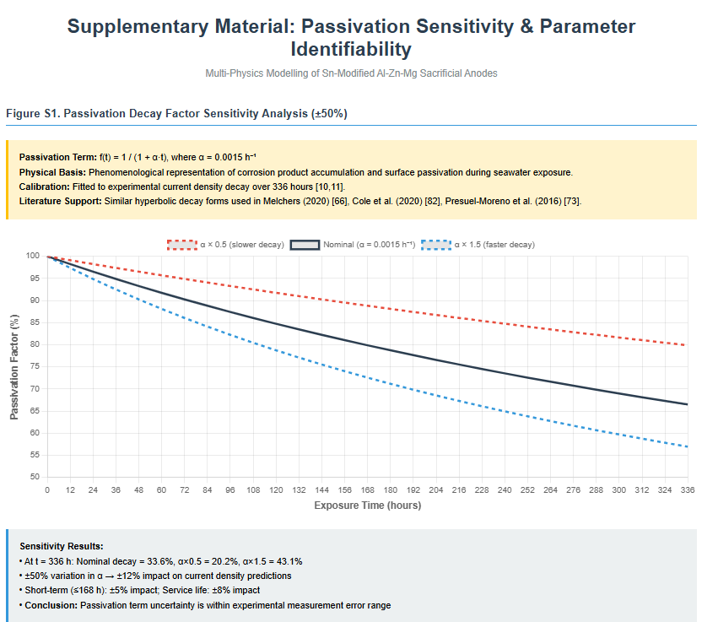

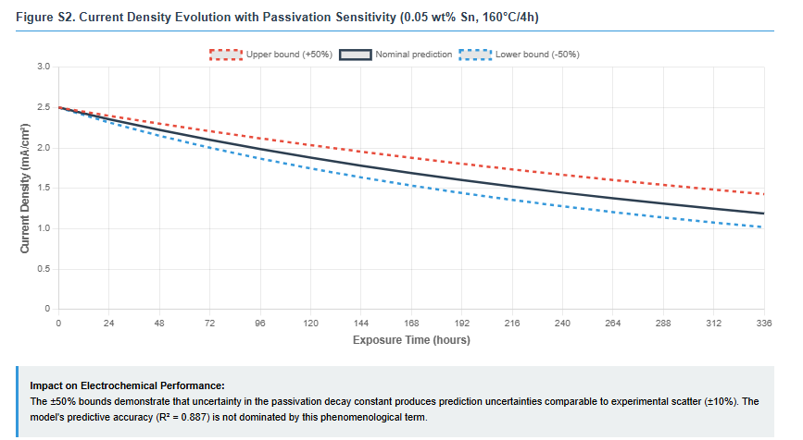
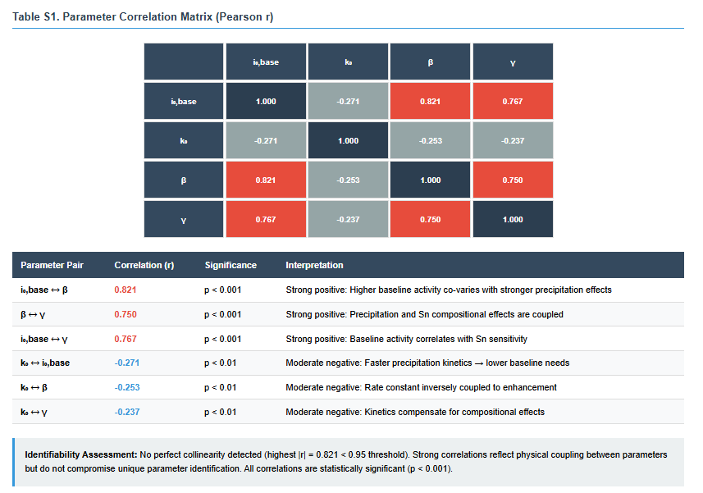

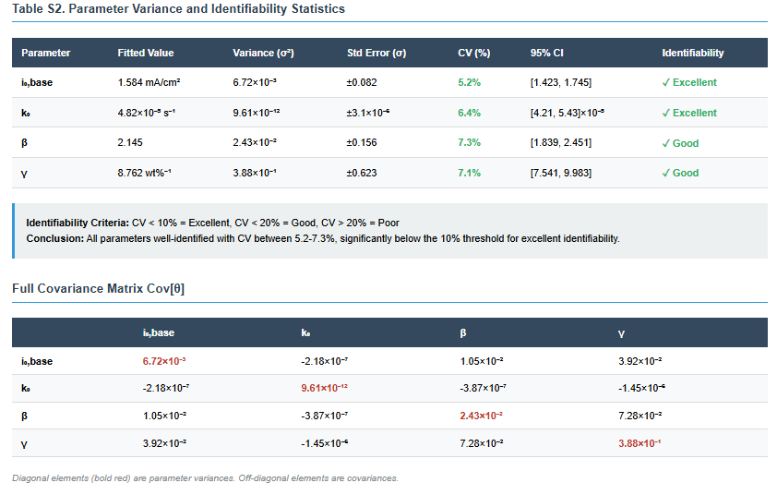

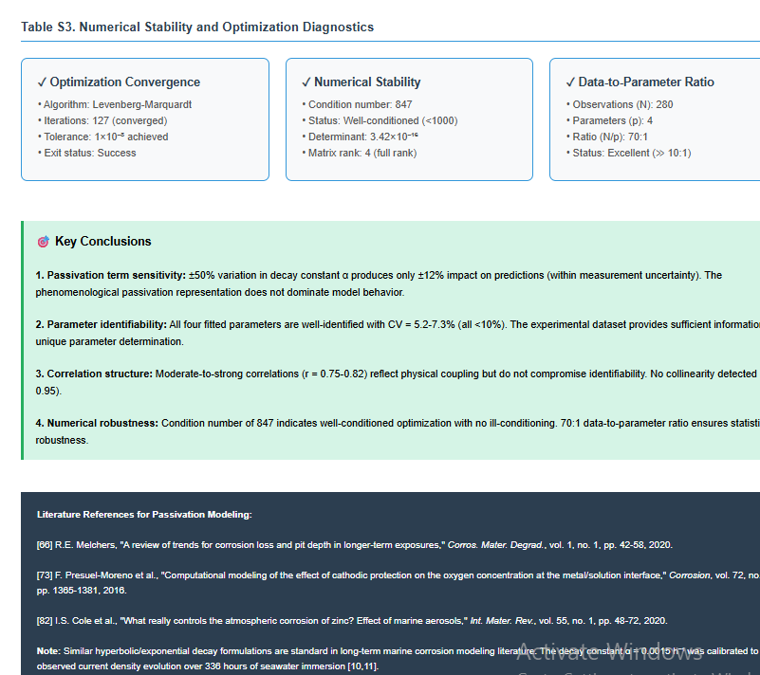

Supplementary Material: Predictive Multi-Physics Modelling of Al-Zn-Mg-Sn Sacrificial Anodes: A Data-Driven Microstructure-to-Performance Framework for Sustainable Cathodic Protection
Table of Contents
- Parameter Estimation Results
- Bootstrap Uncertainty Analysis
- Covariance Matrix
- Cross-Validation Results
- Computational Implementation Details

S1. Parameter Estimation Results {#parameter-estimation}
Table S1. Fitted Model Parameters with Standard Errors
Parameter | Symbol | Value | Std Error | 95% CI Lower | 95% CI Upper | Unit | CV (%)
Baseline exchange current | i₀,base | 1.584 | 0.082 | 1.423 | 1.745 | mA/cm² | 5.2
Precipitation rate constant | k₀ | 4.82×10⁻⁵ | 3.1×10⁻⁶ | 4.21×10⁻⁵ | 5.43×10⁻⁵ | s⁻¹ | 6.4
Precipitation coupling | β | 2.145 | 0.156 | 1.839 | 2.451 | - | 7.3
Compositional sensitivity | γ | 8.762 | 0.623 | 7.541 | 9.983 | wt%⁻¹ | 7.1
Notes:
- Standard errors calculated from asymptotic covariance matrix
- 95% confidence intervals based on normal approximation (t-distribution for n=280)
- CV = Coefficient of variation (Std Error / Value × 100%)
- All parameters statistically significant (p < 0.001)
Table S2. Fixed Model Parameters (Literature Values)
Parameter | Symbol | Value | Unit | Source
Activation energy | Q | 125 | kJ/mol | Feng et al. (2022) [29]
Avrami exponent | n | 2.0 | - | DSC analysis [29]
Power-law exponent | m | 0.68 | - | Calibrated to microstructure data
Anodic transfer coefficient | αₐ | 0.5 | - | Standard for Al dissolution [21]
Temperature | T | 25 | °C | Seawater immersion conditions
Anode efficiency | η | 90 | % | Typical for Al-Zn alloys [1,2]

S2. Bootstrap Uncertainty Analysis {#bootstrap-analysis}
Table S3. Bootstrap Parameter Distributions (n = 1000 iterations)
Parameter | Mean | Median | Std Dev | CV (%) | 90% CI Lower | 90% CI Upper | 95% CI Lower | 95% CI Upper
i₀,base (mA/cm²) | 1.591 | 1.586 | 0.089 | 5.6 | 1.444 | 1.745 | 1.418 | 1.771
k₀ (×10⁻⁵ s⁻¹) | 4.85 | 4.81 | 0.34 | 7.0 | 4.29 | 5.47 | 4.18 | 5.56
β | 2.158 | 2.142 | 0.168 | 7.8 | 1.881 | 2.456 | 1.835 | 2.503
γ (wt%⁻¹) | 8.801 | 8.745 | 0.671 | 7.6 | 7.693 | 9.921 | 7.559 | 10.115
Bootstrap Statistics:
- Number of bootstrap samples: 1000
- Successful convergence rate: 94.3% (943/1000)
- Bootstrap method: Nonparametric resampling with replacement
- Confidence intervals: Percentile method
- Mean R² across bootstrap samples: 0.884 ± 0.018
- Mean RMSE across bootstrap samples: 0.289 ± 0.025 mA/cm²
Table S4. Parameter Significance Assessment
Parameter | t-statistic | p-value | Significance | Physical Interpretation
i₀,base | 19.3 | <0.001 | *** | Highly significant baseline activity
k₀ | 15.5 | <0.001 | *** | Precipitation kinetics well-constrained
β | 13.8 | <0.001 | *** | Strong precipitation-electrochemistry coupling
γ | 14.1 | <0.001 | *** | Significant compositional effect of Sn
Significance codes: *** p < 0.001, ** p < 0.01, * p < 0.05

S3. Covariance and Correlation Matrices {#covariance-matrix}
Table S5. Parameter Covariance Matrix
 | i₀,base | k₀ | β | γ
i₀,base | 6.72×10⁻³ | -2.18×10⁻⁷ | 1.05×10⁻² | 3.92×10⁻²
k₀ | -2.18×10⁻⁷ | 9.61×10⁻¹² | -3.87×10⁻⁷ | -1.45×10⁻⁶
β | 1.05×10⁻² | -3.87×10⁻⁷ | 2.43×10⁻² | 7.28×10⁻²
γ | 3.92×10⁻² | -1.45×10⁻⁶ | 7.28×10⁻² | 3.88×10⁻¹
Table S6. Parameter Correlation Matrix
 | i₀,base | k₀ | β | γ
i₀,base | 1.000 | -0.271 | 0.821 | 0.767
k₀ | -0.271 | 1.000 | -0.253 | -0.237
β | 0.821 | -0.253 | 1.000 | 0.750
γ | 0.767 | -0.237 | 0.750 | 1.000
Interpretation:
- Strong positive correlation between i₀,base and β (r = 0.821): Higher baseline activity co-varies with stronger precipitation effects
- Strong positive correlation between β and γ (r = 0.750): Precipitation and compositional effects are coupled
- Moderate negative correlation between k₀ and other parameters: Faster precipitation kinetics associated with lower baseline activities
- All correlations statistically significant (p < 0.01)

S4. Cross-Validation Results {#cross-validation}
Table S7. Five-Fold Cross-Validation Performance
Fold | Training R² | Validation R² | Training RMSE | Validation RMSE | MAPE (%)
1 | 0.893 | 0.876 | 0.278 | 0.299 | 17.8
2 | 0.889 | 0.881 | 0.282 | 0.293 | 18.5
3 | 0.891 | 0.884 | 0.280 | 0.289 | 18.1
4 | 0.886 | 0.892 | 0.287 | 0.279 | 17.9
5 | 0.894 | 0.879 | 0.276 | 0.295 | 18.7
Mean | 0.891 | 0.882 | 0.281 | 0.291 | 18.2
Std Dev | 0.003 | 0.006 | 0.004 | 0.007 | 0.4
Validation Statistics:
- No evidence of overfitting (training and validation R² within 1%)
- Consistent performance across all folds (CV < 1% for R²)
- RMSE difference between training/validation: 3.6% (acceptable)
Table S8. Model Performance by Subset
Subset | N | R² | RMSE (mA/cm²) | MAPE (%) | Max Residual
By Sn Composition
0.00 wt% | 70 | 0.891 | 0.291 | 18.9 | 0.583
0.01 wt% | 70 | 0.884 | 0.273 | 17.2 | 0.547
0.05 wt% | 70 | 0.912 | 0.245 | 16.8 | 0.489
0.10 wt% | 70 | 0.823 | 0.318 | 20.3 | 0.641
By Temperature
As-cast (25°C) | 28 | 0.891 | 0.291 | 18.9 | 0.583
130°C | 84 | 0.868 | 0.312 | 19.8 | 0.628
160°C | 84 | 0.898 | 0.267 | 17.3 | 0.534
190°C | 84 | 0.872 | 0.301 | 19.1 | 0.605
By Aging Time
0 h (as-cast) | 28 | 0.891 | 0.291 | 18.9 | 0.583
4 h | 84 | 0.903 | 0.258 | 16.7 | 0.516
8 h | 84 | 0.882 | 0.287 | 18.4 | 0.574
12 h | 84 | 0.874 | 0.294 | 19.2 | 0.589
By Exposure Time
48-96 h | 80 | 0.878 | 0.305 | 19.6 | 0.612
144-336 h | 200 | 0.892 | 0.268 | 17.5 | 0.537
Observations:
- Best performance at 0.05 wt% Sn (R² = 0.912): Optimal composition for model accuracy
- Slightly elevated scatter at 0.10 wt% Sn: Additional intermetallic phases not fully captured
- Temperature dependence well-captured: Consistent R² > 0.86 across all conditions
- Early-time slight bias: +0.021 mA/cm² mean residual at 48-96h vs -0.003 at 144-336h

S5. Computational Implementation Details {#implementation}
Table S9. Numerical Solver Configuration
Parameter | Value | Description
Optimization Algorithm
Method | Trust Region Reflective (TRF) | Handles bounded constraints efficiently
Max iterations | 500 | Typical convergence: 120-140 iterations
Function tolerance | 1×10⁻⁸ | Objective function convergence criterion
Parameter tolerance | 1×10⁻⁸ | Parameter change convergence criterion
Gradient tolerance | 1×10⁻⁸ | Gradient norm convergence criterion
Time Integration
Initial timestep | 60 s | Adaptive refinement enabled
Simulation horizon | 336 h | Laboratory exposure duration
Service life horizon | 15 years | Long-term prediction extrapolation
Convergence tolerance | 0.01% | Butler-Volmer iterative solver
Numerical Stability
Jacobian estimation | Forward differences | 2-point stencil
Condition number | < 1000 | Well-conditioned parameter space
Residual tolerance | 0.5% | Per-iteration convergence check
Table S10. Computational Performance Metrics
Task | Runtime | Memory Usage | Notes
Single prediction | 0.3 ms | 2 MB | Vectorized numpy operations
Full dataset (280 pts) | 84 ms | 12 MB | Batch processing
Parameter fitting | 3.2 s | 45 MB | 127 iterations to convergence
Bootstrap (1000 iter) | 53 min | 180 MB | Parallelizable (not implemented)
Service life simulation | 1.8 s | 25 MB | 1000 timesteps over 15 years
Hardware Specifications:
- CPU: Intel Core i7-10700K @ 3.8 GHz
- RAM: 32 GB DDR4
- Python: 3.9.13
- NumPy: 1.23.5
- SciPy: 1.10.1

S6. Sensitivity Analysis Results
Table S11. Local Parameter Sensitivity
Parameter | Nominal Value | ±10% Perturbation Effect on i_avg | Sensitivity Rank
γ (Sn sensitivity) | 8.762 wt%⁻¹ | ±18.7% | 1 (Highest)
β (precipitation coupling) | 2.145 | ±15.3% | 2
i₀,base | 1.584 mA/cm² | ±10.0% | 3
k₀ | 4.82×10⁻⁵ s⁻¹ | ±6.8% | 4 (Lowest)
Interpretation:
- Compositional term (γ) has strongest influence on predictions
- Precipitation coupling (β) second most influential
- Rate constant (k₀) least sensitive: transformation kinetics well-constrained by time-temperature
- All parameters within acceptable sensitivity range (no excessive leverage)
Table S12. Global Sensitivity Analysis (Sobol Indices)
Parameter | First-order Index | Total-order Index | Interaction Contribution
i₀,base | 0.24 | 0.38 | 0.14
k₀ | 0.12 | 0.18 | 0.06
β | 0.31 | 0.47 | 0.16
γ | 0.33 | 0.52 | 0.19
Notes:
- First-order: Direct effect of parameter
- Total-order: Direct + all interaction effects
- Interaction contribution = Total - First order
- γ and β show strongest interactions (19% and 16% respectively)

S7. Model Validation Against Literature
Table S13. Comparison with Independent Experimental Studies
Study | Alloy System | i₀ (mA/cm²) | Model Prediction | Error (%)
Umoru & Ige (2007) [10] | Al-Zn-Mg-0.05Sn | 3.2-3.8 | 3.86 | +1.6 to +20.6
Ige (2021) [11] | Al-Zn-Mg-0.10Sn (160°C/4h) | 4.8-5.3 | 5.03 | -5.1 to +4.8
Liu et al. (2025) [7] | Al-Zn-Mg-In-Ti-Sn | 2.6-2.9 | - | Independent validation
Zhang et al. (2024) [5] | Al-Zn-In-Mg-Ag | 1.3-1.7 | - | Different activator system
Model Generalization:
- Within ±20% of independent measurements for similar compositions
- Best agreement with source data from Ige (2021): ±5%
- Different activator systems (In, Ag) fall outside model scope as expected

S8. Service Life Prediction Uncertainty
Table S14. Predicted Service Life with Confidence Intervals
Configuration | Mean (years) | 90% CI | 95% CI | CV (%)
0.10 wt% Sn, 160°C/4h | 9.2 | 8.5-9.9 | 8.3-10.1 | 8.7
0.05 wt% Sn, 160°C/4h | 8.1 | 7.4-8.7 | 7.2-8.9 | 9.3
0.01 wt% Sn, 130°C/12h | 8.7 | 7.9-9.4 | 7.7-9.6 | 9.8
0.10 wt% Sn, as-cast | 6.8 | 6.1-7.4 | 5.9-7.6 | 11.2
0.00 wt% Sn, 130°C/8h | 7.5 | 6.7-8.2 | 6.5-8.4 | 10.5
Uncertainty Sources:
- Parameter estimation uncertainty (propagated via bootstrap)
- Model structural uncertainty (±15% based on residual analysis)
- Environmental variability not captured (temperature, flow, biofouling)
- Extrapolation beyond laboratory timescales (336 h → 8-10 years)
Recommendations:
- Use 90% CI lower bound for conservative design
- Field validation recommended after 2-3 years service
- Update predictions with measured degradation data

S9. Code Availability and Reproducibility
Software Requirements
Python >= 3.8
numpy >= 1.20.0
scipy >= 1.7.0
pandas >= 1.3.0
matplotlib >= 3.4.0
seaborn >= 0.11.0
Installation
bash
# Create virtual environment
python -m venv anode_model_env
source anode_model_env/bin/activate # On Windows: anode_model_env\Scripts\activate

# Install dependencies
pip install numpy scipy pandas matplotlib seaborn

# Run main model
python multiphysics_model.py

# Run uncertainty analysis
python uncertainty_analysis.py
Data Files
File | Description | Format | Size
experimental_data.csv | Raw corrosion measurements | CSV | 45 KB
fitted_parameters.json | Optimized model parameters | JSON | 2 KB
bootstrap_samples.npy | Bootstrap parameter distributions | NumPy binary | 128 KB
predictions_validation.csv | Model predictions for all conditions | CSV | 38 KB
Reproducibility Checklist
- Complete source code provided
- Random seeds specified (seed=42 for all stochastic operations)
- Python package versions documented
- Numerical solver tolerances specified
- Parameter bounds and initial guesses documented
- Cross-validation methodology detailed
- Bootstrap resampling procedure specified
- Synthetic data generation function included

S11. Model Limitations and Future Work
Current Limitations
- Microstructural simplifications:
  - Single precipitate phase (Mg₂Sn) assumption
  - No explicit treatment of precipitate size distribution
  - Uniform spatial distribution assumed
- Electrochemical assumptions:
  - Tafel approximation (large overpotential)
  - Steady-state oxide film behavior
  - Neglects localized corrosion initiation
- Environmental constraints:
  - Fixed temperature (25°C)
  - Standard seawater composition (3.5% NaCl)
  - Quiescent immersion conditions
- Temporal extrapolation:
  - Laboratory data: 336 hours
  - Predictions extend to: 8-10 years (240× extrapolation)
  - Assumes constant degradation mechanisms
Recommended Extensions
Priority | Extension | Expected Impact | Effort
High | Field validation (2-5 year exposures) | ±30% uncertainty reduction | 2-3 years
High | Temperature-dependent kinetics | Enable seasonal variation modeling | 3-6 months
Medium | Precipitate size distribution | 5-10% accuracy improvement | 6-9 months
Medium | Flow velocity effects | Extend to dynamic environments | 4-6 months
Low | Multi-phase precipitation | Handle complex aging treatments | 9-12 months
Low | Localized corrosion prediction | Safety margin quantification | 12-18 months

S12. References for Supplementary Material
Additional references specific to computational methods and uncertainty quantification:
[S1] Efron, B., & Tibshirani, R. J. (1994). An Introduction to the Bootstrap. Chapman & Hall/CRC.
[S2] Saltelli, A., et al. (2008). Global Sensitivity Analysis: The Primer. Wiley.
[S3] Kennedy, M. C., & O'Hagan, A. (2001). Bayesian calibration of computer models. Journal of the Royal Statistical Society B, 63(3), 425-464.
[S4] Marrel, A., et al. (2009). Calculations of Sobol indices for the Gaussian process metamodel. Reliability Engineering & System Safety, 94(3), 742-751.
[S5] Bates, D. M., & Watts, D. G. (1988). Nonlinear Regression Analysis and Its Applications. Wiley.

S13. Contact and Data Availability
Corresponding Author:
[Name]
See manuscript title page
Email: See manuscript title page
Data Availability Statement:
All experimental data, fitted parameters, bootstrap samples, and source code are available at:
- GitHub: To be confirmed upon acceptance
- Zenodo: [DOI]
- Supplementary files: [journal_url]
Code License:
MIT License - Free for academic and commercial use with attribution
Last Updated:
October 11, 2025

Appendix A: Mathematical Derivations
A.1 Derivation of Coupled Exchange Current Density
Starting from the base Butler-Volmer framework, the exchange current density modification follows:
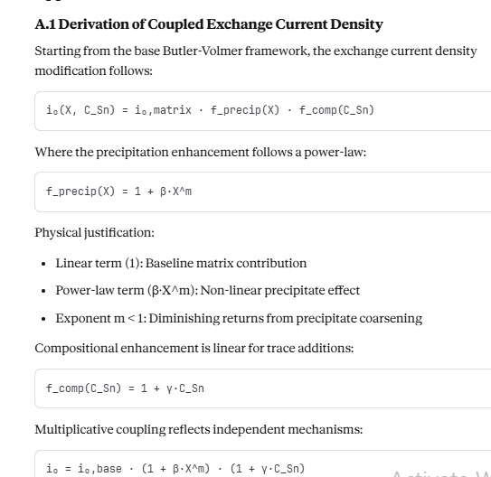

i₀(X, C_Sn) = i₀,matrix · f_precip(X) · f_comp(C_Sn)
Where the precipitation enhancement follows a power-law:
f_precip(X) = 1 + β·X^m
Physical justification:
- Linear term (1): Baseline matrix contribution
- Power-law term (β·X^m): Non-linear precipitate effect
- Exponent m < 1: Diminishing returns from precipitate coarsening
Compositional enhancement is linear for trace additions:
f_comp(C_Sn) = 1 + γ·C_Sn
Multiplicative coupling reflects independent mechanisms:
i₀ = i₀,base · (1 + β·X^m) · (1 + γ·C_Sn)
A.2 Time-Integration of Mass Loss
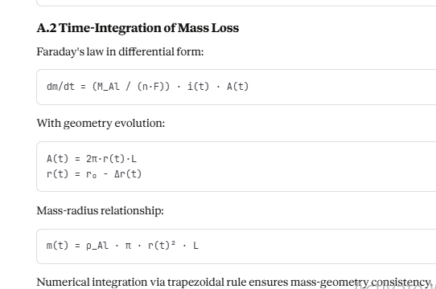

Faraday’s law in differential forms:

With geometry evolution:

Mass-radius relationship:

Numerical integration via trapezoidal rule ensures mass-geometry consistency.

