**Jim Allen**

**CS376 – Small Computer Programming**

**Project #1**

**Ascii Art Image Converter v1.0**

**July 6, 2018**

**ASCII ART IMAGE CONVERTER v1.0**

**DOCUMENTATION**

**Overview**

The Ascii Art Image Converter v1.0 was developed in June 2018 using a MacBook Pro running Mac OS Sierra. Source code was developed and tested using C# in Visual Studio 2017 on a virtual Windows 10 installation under Parallels v13.0.

The purpose of this project was to develop a PC based application that can read a photo image in BMP format, calculating the density ratio of the grayscale image, and then converting it to a mono-scale font-based ascii art image. Two separate projects have been created during the development process.

**ASCII Art** -- the main program executable (Figure 1). See the *Features* section for more information about this application.

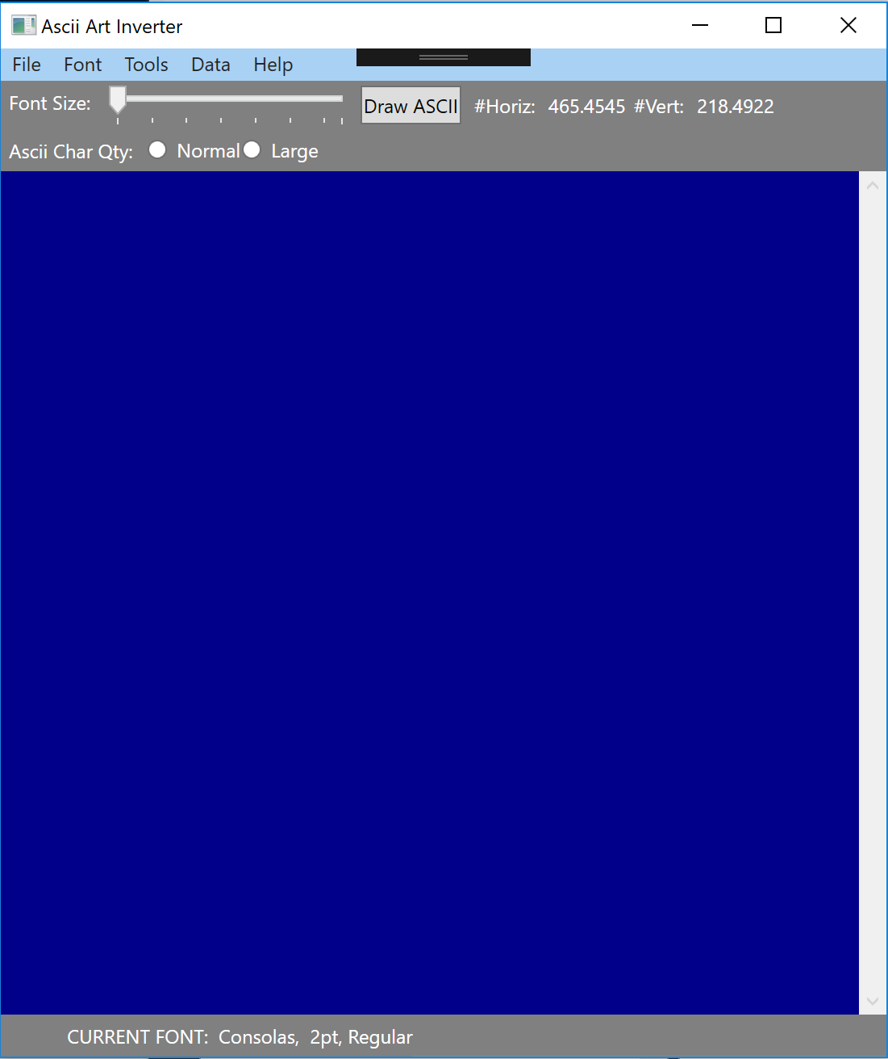

**Figure 1 -- *Ascii Art Convert Screenshot***

**Pixel Converter** – a simple stand-alone tool that determines the pixel density ratios for a given font style and font size. The user may select any of the currently loaded mono-scale fonts, and the ratios for each of the selected characters can then be computed. At this time, the two programs are not linked. The data generated from this application is hard coded into the source code of the *AsciiArt* application.

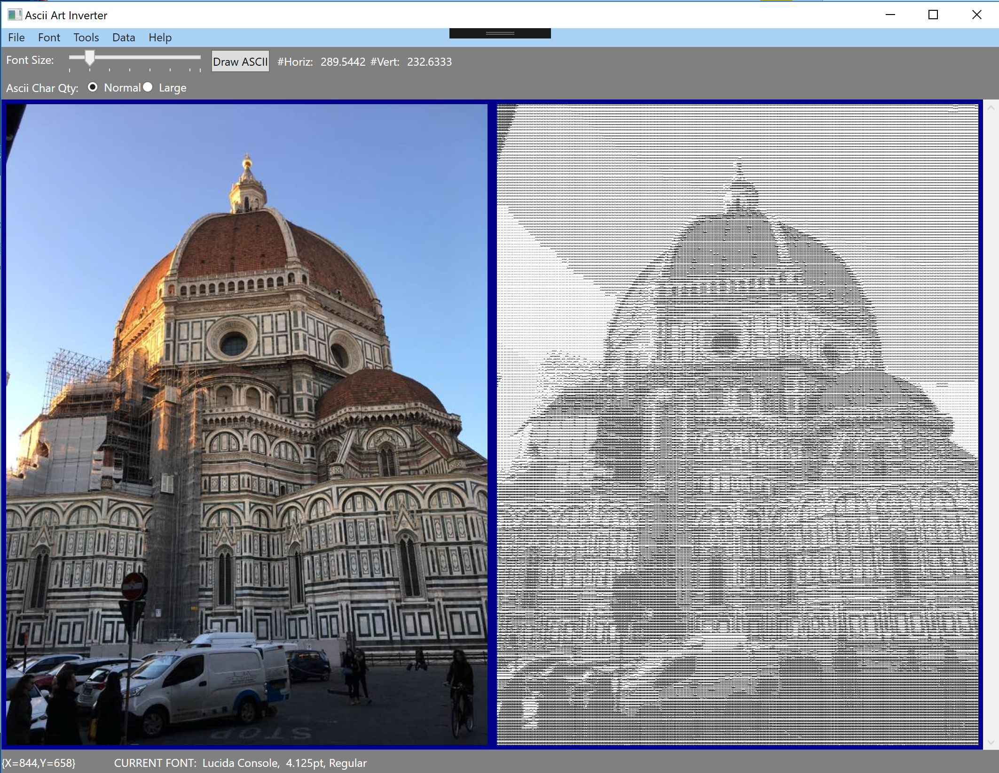**Figure 2 – Ascii Art Conversion of Il Duomo in Florence, Italy**

**Features**

The application allows for the convenient conversion of photo images (color or B/W) to ascii format. A complete menu system is implemented, as well as several shortcut features.

**Shortcuts**

* Right Clicking the mouse will draw the ASCII image without navigating to the Tools Menu
* Slider bar allows for quick change of font sizes from 2pt up to 15pt fonts. Larger font sizes may be selected from the Font menu (see below) Right-clicking the mouse after changing the slider position is required to render the image.
* Ascii Character Qty radio buttons allow for a normal and large data set to be used
  + Normal quantity – loads 10 unique characters and ratios for Ascii rendering
  + Large quantity – loads 70 unique characters and ratios for Ascii rendering.

*Note: It is my opinion that the normal set with a 4pt font produces the most realistic conversion in many cases.*

**Additional Features**

* Left-clicking the mouse will display the pixel coordinates of the current cursor location within the application window.
* File selector dialog boxes for loading and saving images (accessed via the File Menu).
* Font selector dialog boxes for loading fonts (accessed via the Font Menu).
* Dynamic display of the Current font type, size, and style are visible at the bottom of the window.
* Dynamic display of the number of font characters in both the horizontal (horiz#) and vertical (vert#) directions based on the currently loaded font dimensions. This data updates whenever the font size is changed an is visible at the top of the window.
* A shortcut “Draw Ascii” button is also available next to the slider – although right-clicking the mouse is probably more convenient.

**File Menu**

* Load Image -- file formats of any size may be loaded. Accepted formats for image files are BMP, JPG, GIF, and TIFF using a file selector dialog box.
* Save Converted Image – allows the modified image to be saved to file using a file selector dialog box.

**Font Menu**

At the top of the application windows, several shortcut features are visible for quick and convenient Ascii art manipulation.

* Dialog box to load mono-scale fonts up to font size 72pt.

**Tools Menu**

* NEGATIVE IMAGE – creates a negative inversion of the loaded image
* GRAYSCALE – computes the grayscale image of the loaded image (color or B/W are converted).
* COLOR PIXELATED – computes a pixelated conversion of the image by calculating the average RGB value for a region of the source image. The size of this region is controlled by the currently selected font size.
* GRAYSCALE PIXELATED – computes a pixelated conversion of the image by computing the average grayscale value for a region of the source image. The size of this region is controlled by the currently selected font size.
* ASCII ART – converts the loaded source image to an Ascii Art conversion using the currently loaded font parameters (font type, size, and style).
* CLEAR IMAGE – clears the current modified image from the screen

**Help Menu**

* HELP – displays a brief help for the application. Much of the information in this document is contained here.
* ABOUT – the author, date, and version number.