**Jim Allen**

**CS376 – Small Computer Programming**

**Project #3**

**Hourglass Simulator Project v1.0**

**August 30, 2018**

**Hourglass Simulator v1.0**

**DOCUMENTATION**

**Overview**

The Hourglass Simulator v1.0 was developed in August 2018 using a MacBook Pro running Mac OS Sierra. Source code was developed and tested using C# in Visual Studio 2017 on a virtual Windows 10 installation under Parallels v13.0.

The purpose of this project was to develop a PC based application that simulates the flow of sand through an hourglass. The sand movement calculations are handled by a BackgroundWorker thread.

**Hourglass Simulator** -- the main program executable (Figure 1). See the *Features* section for more information about this application. The program starts by prompting the user to select input parameters for the dimensions of the hourglass and the size of the particle to be drawn. Selection is made utilizing combo box selection for a variety of integer values. In addition, there are two modes available for selection in the Shapes Menu: Hourglass mode and Sieve mode (Figure 2). Figure three shows both modes in action. Once the “Submit” button is clicked, the input data vanishes and the hourglass / sieve is drawn according to the selected data. The user is presented with a “Start” button that upon being clicked creates a background worker thread which animates the rotation of the hourglass and begins the flow of sand.

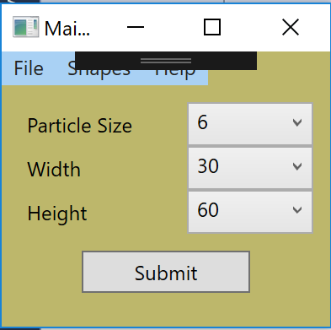

**Figure 1 – *Hourglass Simulator Input Screen***

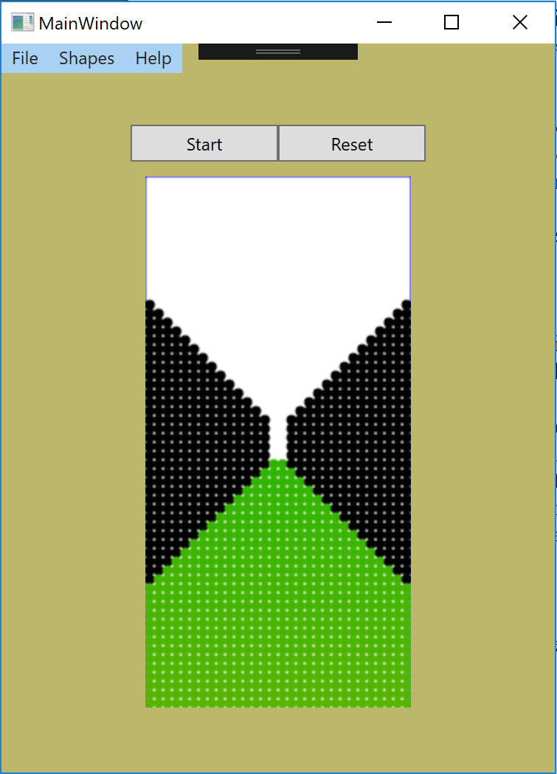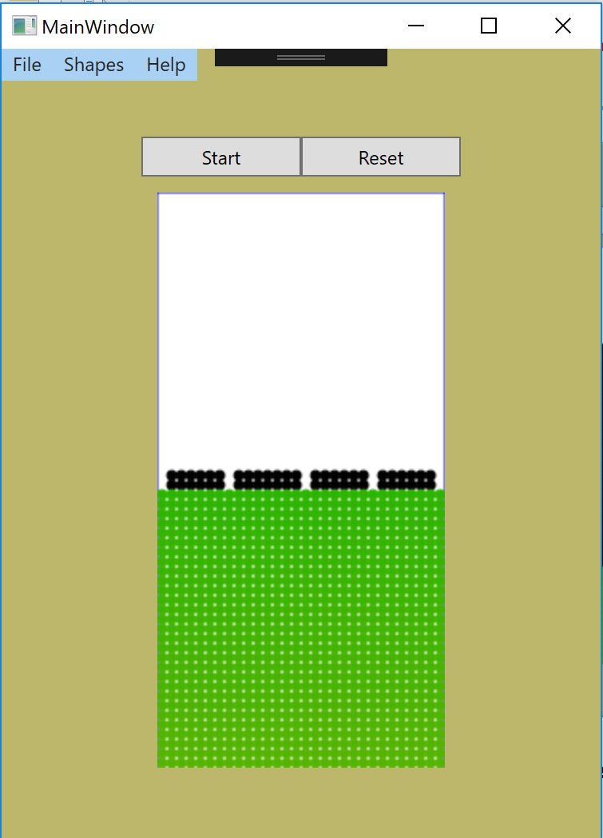

**Figure 2 – Hourglass mode (left) and Sieve mode (right) prior to starting with sand still in the bottom (green).**

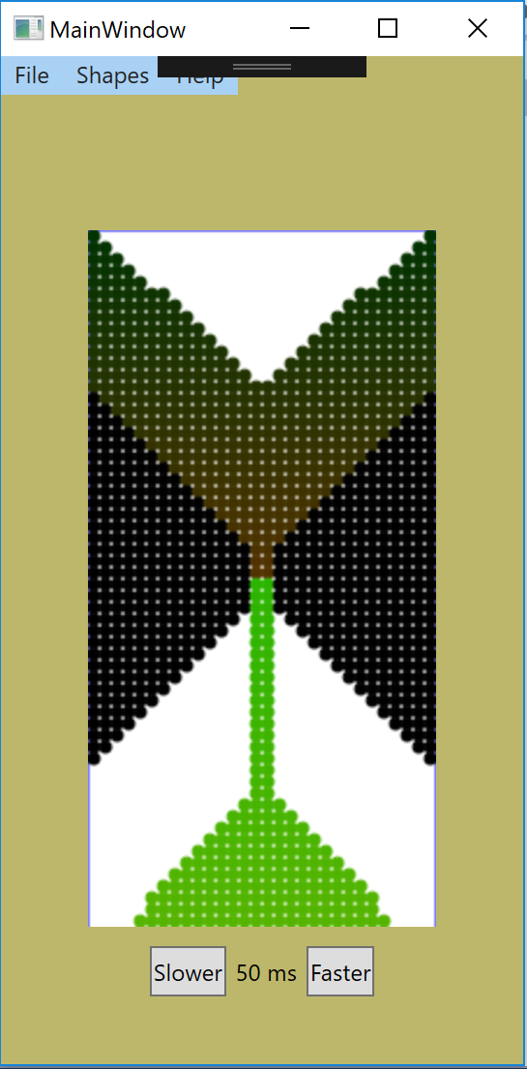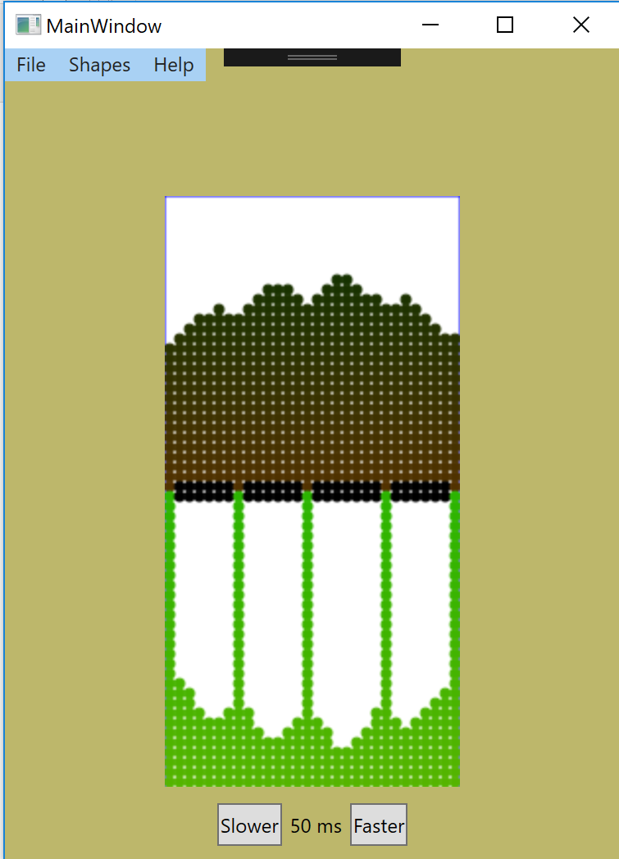

**Figure 3 – Hourglass mode (left) and Sieve mode (right) in action with sand (brown) pouring down (green).**

**Features**

The application allows for the convenient simulation of an hourglass of variable height and width. A complete menu system is implemented, as well as several shortcut features.

**Shortcuts**

* Hitting the space-bar at any time will close the application.
* Combo boxes allow the user to select preset values for particle size, number of particles in horizontal and vertical directions.
* Submit button finalizes user selection and draws the hourglass / sieve to the user designated dimensions.

**Additional Features**

* Hourglass and Sieve Mode -- In addition to the hourglass mode required in the project specs, a “sieve mode” has also been implement which simulates the flow of sand through a boundary with multiple openings / orifices.
* Run Forever Mode -- After all sand has been moved, the hourglass / sieve automatically inverts and restarts the the simulation without requiring any keystrokes by the user.
* Animations -- Used to invert the hourglass / sieve at the start of each simulation run.
* Pause Button – pause button that pauses the simulator
* Pause and Reset Button can be hidden -- Pause and Restart buttons hide and appear whenever the mouse enters or leaves the window region.
* Falling Speed adjustments -- Speed of falling sand may be increased or decreased by the “Faster” and “Slower” buttons.

**File Menu**

* Exit the Application

**Help Menu**

* HELP – displays a brief help for the application. Much of the information in this document is contained here.
* ABOUT – the author, date, and version number.