**PREMIUM September 10, 11, and 12, 2021**

**All-Breed OBEDIENCE**

**(Rally Event** 2021081522 and 2021081521)

(**Obedience Events** 2021081519 and 2021081520)

 **EVANSVILLE**

**OBEDIENCE CLUB, INC.**

**Evansville, Indiana**

**September 2021**

At Evansville **Obedience Club Training Center**

**1400A North Cullen Avenue, Evansville, IN 47715**

Trial hours: September 10, 2021 10:30 am to 5:30 pm CDT.

September 11 and 12 2021 7:30 am to 5:30 pm

**Trials will be held indoors on cushioned flooring, unbenched­.**

**\*\*EOC will follow current Indiana State Guidelines, the advice of our Trial Advisory Committee, and EOC Board. Please consult our website/facebook for updated information regarding restrictions \*\***

**Entries will be accepted until a full eight hours of judging has been reached for each obedience trial.**

***Entries are open to All-American dogs listed in the AKC Canine Partners program.***

**Entries close Wednesday August 18 2021 @ 6 PM CDT** at the trial secretary's office for all trials, after which time entries cannot be accepted, cancelled, or altered except as may be specifically provided for in Chapter 11, Section 6 of the AKC Dog Show Rules.

|  |  |
| --- | --- |
| Description: AKC logo-Horizontal-black.jpg | **CERTIFICATION**  Permission has been granted by the AKC for holding these events under AKC rules and regulations.  **James P. Crowley, Secretary** |

**OFFICERS OF THE**

**EVANSVILLE OBEDIENCE CLUB, INC.**

President Debbie Purdy

Vice President Jim Walker

Treasurer Danetta Ohning

Secretary Ray Reising

**OBEDIENCE TRIAL COMMITTEE:**

Obedience Chair Deborah Yoder   
1111 S Harlan Ave  
EVANSVILLE, IN 47714  
[dzyoder54@gmail.com](mailto:dzyoder54@gmail.com)

812-550-0246

Secretary, Deborah Yoder

1111 S Harlan Ave., Evansville, Indiana 47714

[dzyoder54@gmail.com](mailto:dzyoder54@gmail.com)

812-550-0246

Committee members: Debbie Purdy, Aaron Terwiske, Danetta Ohning, Tricia Wallerstedt, Debbie Yoder

**JUDGE:**

|  |
| --- |
|  |
| **James Comunale #27181** |

741 JARES CT, BALLWIN, MO 63011-2830

**Email: jimcomunale@gmail.com**

|  |
| --- |
| Phone: (630) 460-2292 |

|  |  |
| --- | --- |
| **September 10 2021 Rally Obedience Trial 1 and Trial 2** | |
| **Rally Novice A and B** |  |
| **Rally Advanced A and B** | **Rally Intermediate** |
| **Rally Excellent A and B** | **Rally Master** |
|  |  |  |

|  |  |
| --- | --- |
| **September 11 and 12 2020 OBEDIENCE** | |
| **Beginner Novice A and B** | **Novice A and B** |
| **Open A and B** | **Utility A and B** |
| **Preferred Novice** | **Preferred Open** |
| **Preferred Utility** |  |
| **Graduate Novice** | **Graduate Open** |

**CLASSES with jumps will in tall to short for all obedience. Rally trials will run tall to short for both Trials**

**Ribbon Prizes for Rally**

**Regular Classes:**

First prize…...Blue

Second prize…Red

Third prize…..Yellow

Fourth prize….White

**Qualifying score**…..A dark green qualifying ribbon

will be given to each dog attaining a qualifying score.

**Highest Triple Q in Rally Advanced B, Excellent B and Master**: Rosette

**Rally Cone for New First Time RAE’S**

**PRIZES for THE trials**

**RIBBON PRIZES for obedience**

**Regular Classes:**

First prize…...Blue

Second prize…Red

Third prize…..Yellow

Fourth prize….White

**Qualifying score**…..A dark green qualifying ribbon

will be given to each dog attaining a qualifying score.

**HIGHEST SCORING DOG IN REGULAR OBEDIENCE CLASSES:**

Blue and Gold Rosette

**HIGHEST COMBINED SCORE IN OBEDIENCE OPEN B AND UTILITY:**

Blue and Green Rosette

**OTCH:** Red, White, and Blue rosette

.

**Move-ups** between trials will be allowed. The request to move up must be made to the Trial Secretary **no later than** one-half hour after the conclusion of classes.

MARK YOUR CALENDARS NOW!

Description: j0281224 For the Evansville Obedience Club’s trials:

*November Obedience and Rally

Check EOC or AKC websites for opening dates.

**ENTRY FEES**

Weekend Special:

Any 4 entries same dog for obedience and/or rally.................$90.00

Single/Additional entry ……………………..............................$28.00

**CATALOG**

Catalog, pre-ordered...........................................................................$4.00

(A limited supply of catalogs will be available at the trial)

**Mail entries with fees payable to “Evansville Obedience Club” to:**

|  |
| --- |
| Deborah Yoder  1111 S. Harlan Ave  Evansville, IN 47714 |

**IMPORTANT NOTES:**

**Entries that are illegible or do not contain complete information, with the AGREEMENT form attached and including the jump height when applicable, will not be accepted. The exhibitor may not be notified of the entry’s status before closing.**

VETERINARIANS ON CALL

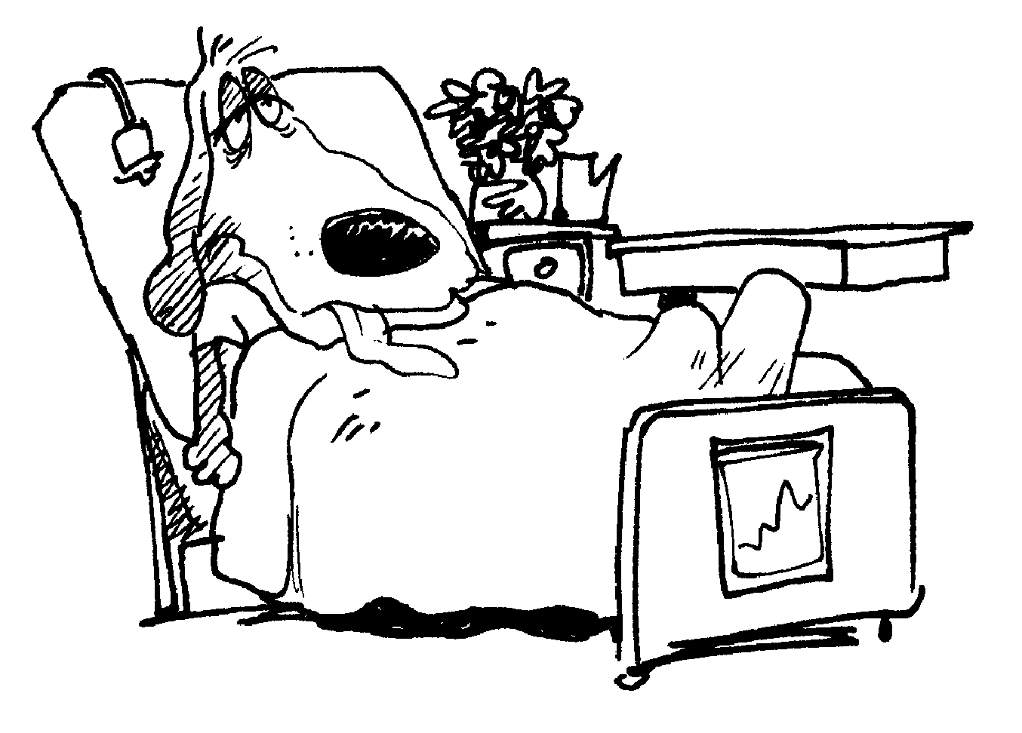All Pet Emergency Clinic, 812/422-3300

104 S. Heidelbach Ave, Evansville

Friday-Saturday, 6 PM-8 AM

Saturday, 12 N through Monday, 8 AM

NOTICE TO EXHIBITORS

The following pertains to all obedience events:

**OBEDIENCE FEES include a 50-cent AKC Recording Fee and $3.00 Event**

**Service Fee...** The fees are INCLUDED in the entry fee; DO **NOT ADD FEES TO YOUR ENTRY.** (American Kennel Club rule, Chapter 11, Section 2).

**ENTRY FEES** shall not be refunded in the event that a dog is absent, disqualified, excused by veterinarian or judge, or barred from competition by action of the show committee. If because of riots, civil disturbances, extreme and/or dangerous weather conditions, emergency, or other acts beyond the control of the management, it is impossible to open or complete the show, no refund of entry fees will be made.

**PLEASE NOTE: Refund of entry fees, less AKC processing fees (see above) and a $5 administration fee, for bitches that come in season after the closing date of these trials, may be obtained by sending a veterinarian's certificate to the trial secretary. This certificate must be postmarked before the opening day of the trials or given to the trial secretary before the start of the trials.**

**RETURNED CHECKS** do not constitute a valid entry fee. The trial secretary will collect a $25 administrative fee from the exhibitor for each returned check. Subsequent returned checks from the same exhibitor may result in cash only transactions.

**ENTRIES** will not be accepted if received without fees, signature, or AKC agreement on back of the official form. **No fax, phone, or credit card entries accepted.**

**ENTRIES WILL NOT BE ACCEPTED** if illegible or without complete information, including jump height. **NO ENTRY** that specifies any condition will be accepted. **OWNERS** without an e-mail address may not be notified of entry errors or other issues in time for corrections.

**ALL RIBBONS/TROPHIES must** be claimed at the trial. None will be mailed.

**DOGS NEED** be present only at scheduled time of judging and may leave immediately thereafter, unless required for further judging. **THE HANDLER** of each dog is solely responsible for having it ready at ringside when its class is to be judged. Judges are not required to wait for any dog.

**ALL DOGS** must be on leash and under control at all times. **'DOG'** means either sex.

*Please note: At this time, due to the Covid 19 Pandemic, we will continue to follow the guideline set forth by the State of Indiana, our local government, the EOC Board and The Trail Advisory Committee *

**CRATING SPACE IS VERY LIMITED. NO EX-PENS or UNENTERED DOGS** inside the building. EOC members’ crates may be available for use.

**No crating before the assigned times for your classes. CRATE IN VEHICLE IF POSSIBLE.**

NO RV or OVERNIGHT PARKING.

EOC will provide seating.

THE EVANSVILLE OBEDIENCE CLUB, INC**.** assumes no responsibility for any loss, damage, or injury sustained by the exhibitors, handlers, or any of their dogs or property, and further assumes no responsibility for injury to children not under the control of their parents or guardians. Please see the back of the entry form for details. EOC participates in the AKC Arbitration option. Hotels and motels are considered part of the trial site.

**\*\*\*\*\*\*\*\*\*This is a NON-SMOKING property\*\*\*\*\*\*\*\*\*\***

**DO NOT SUBMIT THIS PAGE WITH YOUR ENTRY FOR**

**.**AKC Rules, Regulations, Policies and Guidelines are available on the American Kennel Club Web site, www.akc.org

**AGREEMENT**I (we) agree that the club holding this event has the right to refuse this entry for cause which

the club shall deem sufficient. In consideration of the acceptance of this entry and of the holding of this event and of the opportunity to have the dog judged and to win prizes, ribbons or trophies, I (we) agree to hold the AKC, the event-giving club, their members, directors, governors, officers, agents, superintendents or event secretary and the owner and/or lessor of the premises and any provider of services that are necessary to hold this event and any employees or volunteers of the afore-mentioned parties, and any AKC approved judge judging at this event, harmless from any claim or loss or injury which may be alleged to have been caused directly or indirectly to any person or thing by the act of this dog while in or about the event premises or grounds or near any entrance thereto, and I (we) personally assume all responsibility and liability for any such claim; and I (we) further agree to hold the aforementioned parties harmless from any claim for loss, injury or damage to this dog.

Additionally, I (we) hereby assume the sole responsibility for and agree to indemnify, defend and save the aforementioned parties harmless from any and all lose and expenses (including legal fees) by reason of the liability imposed by law upon any of the aforementioned parties for damage because of bodily injuries, including death at any time resulting therefrom, sustained by any person or persons, including myself (ourselves), or on account of damage to property, arising out of or in consequence of my (our) participation in this event, however such, injuries, death or property damage may be caused, and whether or not the same may have been caused or may be alleged to have been caused by the negligence of the aforementioned parties or any of their employees, agents, or any other persons. I (we) agree that any cause of action, controversy or claim arising out of or related to the entry, exhibition or attendance at the event between the AKC and the event-giving club (unless otherwise stated in its premium list) and myself (ourselves) or as to the construction, interpretation and effect of this agreement shall be settled by arbitration pursuant to the applicable rules of the American Arbitration Association. However, prior to arbitration all applicable AKC bylaws, rules, regulations and procedures must first be followed as set forth in the AKC charter and bylaws, rules, regulations, published policies and guidelines.

**INSTRUCTIONS**

1. (Variety) if you are entering a dog of a breed in which there are varieties for show purposes, please designate the particular variety you are entering i.e., Cocker Spaniel (solid color black, ASCOB, parti-color). Beagles (not exceeding 13 inches over 13 inches but not exceeding 15 inches). Dachshunds (longhaired, smooth, wirehaired), Bull Terriers (colored, white), Manchester Terriers (standard, toy), Chihuahuas (smooth coat, long coat), English Toy Spaniels (King Charles and Ruby, Blenheim and Prince Charles), Poodles (toy, miniature, standard), Collies (rough, smooth).
2. The following categories of dogs may be entered and shown in Best of Breed competition: Dogs that are Champions of Record and dogs which according to their owner’s records, have completed the requirements for a championship, but whose championships are unconfirmed. The showing of unconfirmed Champions in Best of Breed competition is limited to a period of 90 days from the date of the show where the dog completed the requirements for a championship.
3. (Dog Show Class) Consult the classification in this premium list. If the dog show class in which you are entering your dog is divided, then, in addition to designating the class, specify the particular division of the class in which you are entering your dog, i.e., age division, color division, weight division.
4. A dog must be entered in the name of the person who actually owned it at the time entries for a show closed. If a registered dog has been acquired by a new owner, it must be entered in the name of its new owner in any show for which entries closed after the date of acquirement, regardless of whether the new owner has received the registration certificate indicating that the dog is recorded in his name. State on entry form whether transfer application has been mailed to A.K.C. (for complete rule refer to Chapter 11, Section 3)

**JUNIOR SHOWMANSHIP**. If this entry is for Jr. Showmanship, please give the following information:

AKC Jr. Handler # Jr.’s date of birth

__ __ __ __ __ __ __ __ __ __ __ - __ __ - __ __

By signing I certify that the junior does not now and will not act as an agent/handler for pay while competing in Junior Showmanship

NAME OF JUNIOR HANDLER:

ADDRESS:

CITY: STATE: ZIP

If Jr. Handler is not the owner of the dog identified on the face of this form, what is the relationship of the Jr. Handler to the owner?: **OFFICIAL AMERICAN KENNEL CLUB ENTRY FORM for all Events EVANSVILLE OBEDIENCE CLUB, INC.**

**Entry fees**: Weekend Special: Any 4 entries same dog $90 (Multiple Specials may be purchased). Single/Additional entries $28 **Fees payable to EOC. Mail entries to:** **EOC Trial Secretary: Deborah Yoder 1111 S Harlan Ave, Evansville, IN 47714.**

**Enclosed is $__­_____ for entry fees. Add $4.00 per catalog. TOTAL $_____**

**IMPORTANT: Please read the instructions on the reverse side carefully before filling out.**

**Rally Trial #1 September 10, 2021 Trial #2021081521**

|  |  |  |
| --- | --- | --- |
|  |  |  |

**Rally Trial #2 September 4, 2020 Trial** #**2021081522**

|  |  |  |  |
| --- | --- | --- | --- |
|  |  |  |  |

**Saturday September 5, 2020 Trial #2021081519**

|  |  |
| --- | --- |
| **Obedience Class** | **Additional Class(es)** |

Sunday September 6,2020 **Trial #2021081520**

|  |  |
| --- | --- |
| **Obedience Class** | **Additional Class(es)** |

|  |  |  |  |  |
| --- | --- | --- | --- | --- |
| BREED  OF DOG | | VARIETY (1) | | SEX |
| FULL NAME  OF DOG | | | | |
| **Enter number here**  AKC REG. NO.  AKC LITTER NO.  ILP NO.  FOREIGN REG. NO. AND COUNTRY | BIRTH DATE  BIRTH PLACE (CIRCLE)  USA Canada Foreign  Do not print in catalog | | **0BED JUMP**  **HGT**  **RALLY JUMP**  **HGT** | |
| BREEDER | | | | |
| SIRE | | | | |
| DAM | | | | |

**ACTUAL OWNER(S) [4]**

(PLEASE PRINT)

**OWNER’S ADDRESS**

**CITY**  **STATE**  **ZIP +4**

**NAME OF OWNER’S AGENT CODE #**

**(IF ANY) AT SHOW**

**Junior Handlers: complete and sign back of form.**

**I CERTIFY** that I am the actual owner of the dog, or that I am the duly authorized agent of the actual owner whose name I have entered above. In consideration of the acceptance of this entry, I (we) agree to abide by the rules and regulations of the American Kennel Club in effect at the time of this show or obedience trial, and by any additional rules and regulations appearing in the premium list for this show or obedience trial or both, and further agree to be bound by the “Agreement” printed on the reverse side of this entry form. I (we) certify and represent that the dog entered is not a hazard to persons or other dogs. This entry is submitted for acceptance on the foregoing representation and agreement.

**SIGNATURE** of owner or agent duly authorized to make this entry:

**Telephone: E-Mail:_________________________________**

This Waiver MUST be returned with your entry for it to be valid.

Waiver of Liability and Informed Consent Covid-19 Waiver September 10, 11, and 12, 2021 Hereafter, American Kennel Club will be referred to as AKC. Hereafter, Evansville Obedience Club building and grounds will be referred to as Site. Hereafter, Evansville Obedience Club will be referred to as Club

⃝ I attest that to the best of my knowledge, I do not have COVID-19 at the time of attending this event, and understand the risks of unknowing exposure to this and other illnesses by or to myself, my family, other participants and third parties. I have not been tested and found positive; am not waiting for test results; and do not have symptoms. I agree that I will not knowingly expose others to any illness I may have or be at risk to have. I will follow all AKC and Club rules and requirements to reduce any exposure and possibility of contracting or spreading the virus. I will also fully cooperate with and follow any City, County or State/Province guidelines that have jurisdiction in the area in which the event is taking place. If any of the above should change prior to my arrival at the trial site or during the completion of the event that is the subject of this consent, I will inform AKC and Club and proceed accordingly in light of the new information.

⃝ I agree that I am attending this AKC and Club event entirely at my own risk and assume all risk and full responsibility for my own health, wellbeing, and safety during this class or event. I fully agree that AKC and Club, the owners/board members, employees, assistants and volunteers are in no way liable for any present or future COVID-19 exposure incurred at any time by any person, in attendance or not in attendance, during or after this event I herby waive and release AKC and Site and Club, the owners/board members, employees, assistants and volunteers from any and all liability for damages or personal injury to me, my dogs or my property

⃝ Further, I hereby indemnify and hold harmless AKC, the Site and Club, the owners/board members, employees, assistants and volunteers from any and all claims by or liability to any third party arising out of my participation in the Site and Club event. Any liability to anyone for any incident involving myself, the location, or those pets or actions of other participants and spectators will by my sole responsibility and I assume all financial liability and will also assume all and any financial costs associated with my actions.

PRINT NAME_______________________________________________________ Signature __________________________________________________________________ Phone __________________________________________________________________

This number will be used to call you when it is time for you to be on “deck”.