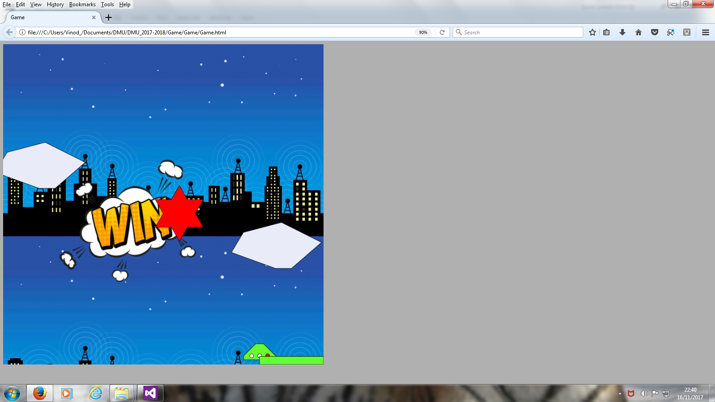

[1] Changed some parameters for collisions, i.e. made the speed highre before collision registers

Ship.prototype.crash = function () {
//temp variable to store the vy/vx values
var temp = vy,
temp2 = vx;
//kill all velocity
vx = 0;
vy = 0;

////////////NEW BELOW
// if ((temp > 0.001)|(temp2 > 0.001)) {
if ((temp > 0.5) | (temp2 > 0.5)) {
Boom = true;
}
////////////////////

}

[2] Added a new Boolean, Gameover, which allows Win or Boom once only

function Ship() {

//variables of ship start positions
var x = Math.floor((Math.random() * 400 + 70) + 50),
y = 0,
vx = 0,
vy = 0;
RedWindow = 1;
var Boom,
Win;
var Gameover = false;//NEW

[3] see [2] above...Also made collision speed a bit more user friendly

Ship.prototype.moor = function () {
////////////NEW/////////

if (Gameover==false)//only if first time
{
Gameover = true;
//temp variable to store the vy value
var tem = vy;

//kill all velocity

vy = 0;
vx = 0;

//if (tem < .01) {
if (tem < .6) {
Win = true;
Boom = false;

//console.log('win', tem);
// tem = 0;
alert(tem);

}

else {
Boom = true;
alert(tem);
}

}//END if (Gameover==false)

}

