# ELISA Report Generation

Python project for automatic report generation from Hamilton measurements.

## Prerequisities

To install python libraries use

pip install -r requirements.txt

Install pandoc frpm [pandoc](https://pandoc.org/installing.html) website.

Install latex from any of the [distributions](https://www.latex-project.org/get/#tex-distributions).

## Buld distribution of elisarep

For experts only.  
To build a hemrep library execute following command:

python -m build --sdist --wheel

## Running the script

python .\report_gen.py --help  
  
usage: report_gen.py [-h] [--analysis ANALYSIS] [--cfg CFG]  
 [--ifld IFLD]  
  
options:  
 -h, --help show this help message and exit  
 --analysis ANALYSIS analysis directory  
 --cfg CFG config and params directory  
 --ifld IFLD initial analysis folder

--cgf is path to the configuration directory.  
--ifld set an initial folder where GUI analysis folder shall open at start.

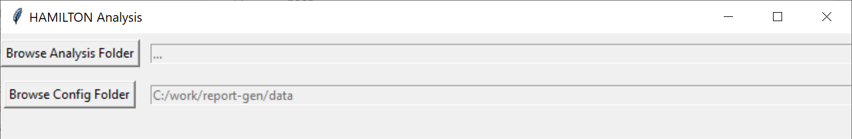

gui

--analysis is path to a folder with finished Hamilton analysis, e.g. C:/work/hamilton/230801_AAV9-ELISA_sey_GN004240-053  
If analysis directory is not given, GUI window opens to select the diectory.  
**Analysis folder name is parsed to retrieve certain analysis information!**  
The structume shall be [DATE]_[METHOD]_[USER]_[GN], where the fields are separated by underscore character _  
where  
[DATE] is a date in format %y%m%d (*230801*)  
[GN] is analysis identifier (*GN004240-033*)  
[PROTOCOL] is a protocol name (*AAV9-ELISA*)  
[USER] is user name/code (*sey*)

The working directory **must** contain following files in given format:

* [DATE]_[GN]_-_worklist-ELISA.xls
* [DATE]_[GN]_-_[PROTOCOL]_Parameters.csv

Examples:  
230426_GN004240-033_-_worklist-ELISA.xls  
230426_GN004240-033_-_AAV9-ELISA_Parameters.csv

### Config file config.json

Command line argument is used to define a folder containing configuration file, and other files necessary to execute report_gen.py programm.

python report_gen.py --cfg ./data

**Important: if relative path is used for --cfg argument, the path is relative to the current execution/working directory!**  
To make sure intended folder path is used, provide absolute path.

python report_gen.py --cfg C:/work/elisa-report/data

Configuration file config.json is a json format file containing configurable parameters. It could be located in either default folder ./data or in local analysis folder. If the file is located in the **analysis** folder it has precedence (is meant to be modified by a user). Though, if the config file is not found in analysis folder it is read from the default location in the ./data folder.  
referenceValue is identified automatically from the analysis folder name (see above). If the analysis folder name contains a string AAV8 or AAV9 reference value for given AAV* is used, otherwise an exception is thrown.

Validity limits are defined for AAV9 or AAV8. Test validity is checked according to 3σ limits. Control result shall lie within interval <limits[0], limits[1]>. Default limits should not be used, and are defined so that the report_gen doesn’t thow exception (fail).

The file shall contain entries listed below.

{  
 "pandoc_bin": "c:/work/pandoc/pandoc",  
 "pdflatex_bin": "c:/Users/hwn6193/AppData/Local/Programs/MiKTeX/miktex/bin/x64/pdflatex",  
 "reference_docx": "custom-reference.docx",  
 "plate_layout_id": "plate_layout_ident.csv",  
 "plate_layout_num": "plate_layout_num.csv",  
 "plate_layout_dil_id": "plate_layout_dil_id.csv",  
 "numeric_warning_disable": true,  
 "AAV9": {  
 "SOP": "SOP-234702",  
 "MHF": "DMD-211328",  
 "referenceValue": 1.7954e+10,  
 "limits": [  
 1.888E+12,  
 2.703E+12  
 ]  
 },  
 "AAV8": {  
 "SOP": "SOP-236462",  
 "MHF": "DMD-211877",  
 "referenceValue": 2.1167E+10,  
 "limits": [  
 1.119E+11,  
 1.648E+11  
 ]  
 },  
 "default": {  
 "referenceValue": 1.0E+10,  
 "limits": [  
 1.0E+10,  
 1.0E+12  
 ]  
 },  
 "dilutions": [  
 1.0,  
 2.0,  
 4.0,  
 8.0,  
 16.0,  
 32.0,  
 64.0  
 ]  
}

### Running with exported photometer txt data

This is a prefered way to run the preocessing of the results and following report generation.  
--cfg argument is a path of config directory, containing params.json, layout *.csv files, custom-reference.docx and params.json

python report_gen.py DIR_NAME --cfg ./data

## HAMILTON

To export data in **TXT** format run the *SoftMax Pro* softare, and open given analysis. From the main menu choose ‘Export’ and select the Export to XML XLS TXT option.

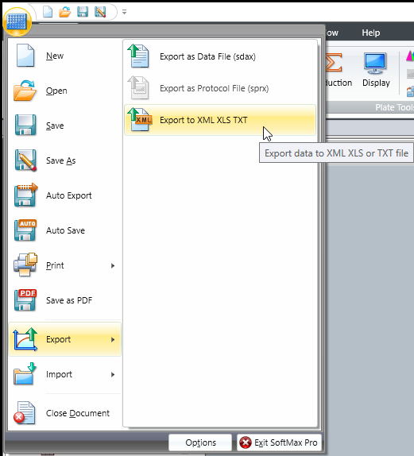

softmax_export

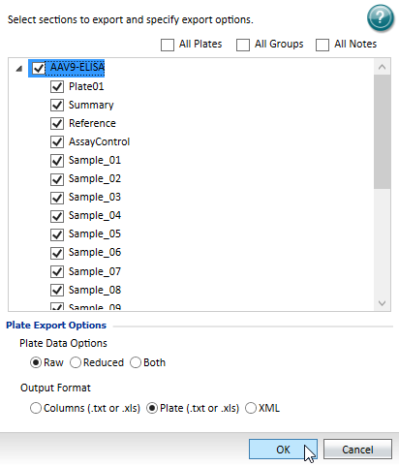

softmax_export_opt

**Export measurements for all plates.**

**Make sure the exported file name matches the folder name structure!**  
folder name example 230922_AAV9-ELISA_fff_GN004360-086  
corresponding file name example 230922_AAV9-ELISA_1_20230922_103137.txt

Folder with Hamilton related stuff.

[Hamilton](C:\Users\hwn6193\OneDrive%20-%20Takeda\2%20Geräte\Hamilton_System)

## Profiling

Define profiling in launch.json in VS Code:

{  
 "name": "profiler",  
 "type": "python",  
 "request": "launch",  
 "module": "cProfile",  
 "args": [  
 "-o",  
 "./.tmp/tmp.prof",  
 "report_gen.py",  
 "--analysis",  
 "c:/work/hamilton/analysis/231213_AAV9-ELISA_sey_GN004240-068",  
 "--cfg",  
 "C:/work/elisa-report/data"  
 ]  
}

Run the profing server… (make su snakeviz is installed pip install snakeviz)

python -m snakeviz .tmp/tmp.prof --server