Employee Attrition — What the Data Tells Us
Prepared by Shaik Atif Furkan | Internship Project, Week 2 | Based on 1,470 employee records
The Headline
Analysis of 1,470 employee records shows that 237 people — roughly 1 in 6 — left the company, a 16% attrition rate. The important finding is not the overall number, but who is leaving and why. Certain roles and working conditions drive exits at two to three times the company average, and these are patterns the company can act on today.
Who Is Leaving — and Why
Five warning signs strongly predict whether an employee will leave. When multiple apply to the same person, risk compounds:
Warning Sign | Employees | Exit Rate | vs Company Average (16%)
Working overtime regularly | 417 | 30.5% | Nearly 3× higher
Sales Representative role | 83 | 39.8% | 2.5× higher
Frequent business travel | 277 | ~24% | 1.5× higher
Poor work-life balance (self-rated) | 80 | 31.3% | Twice the average
Tenure under 3 years | ~390 | ~25% | High-risk window

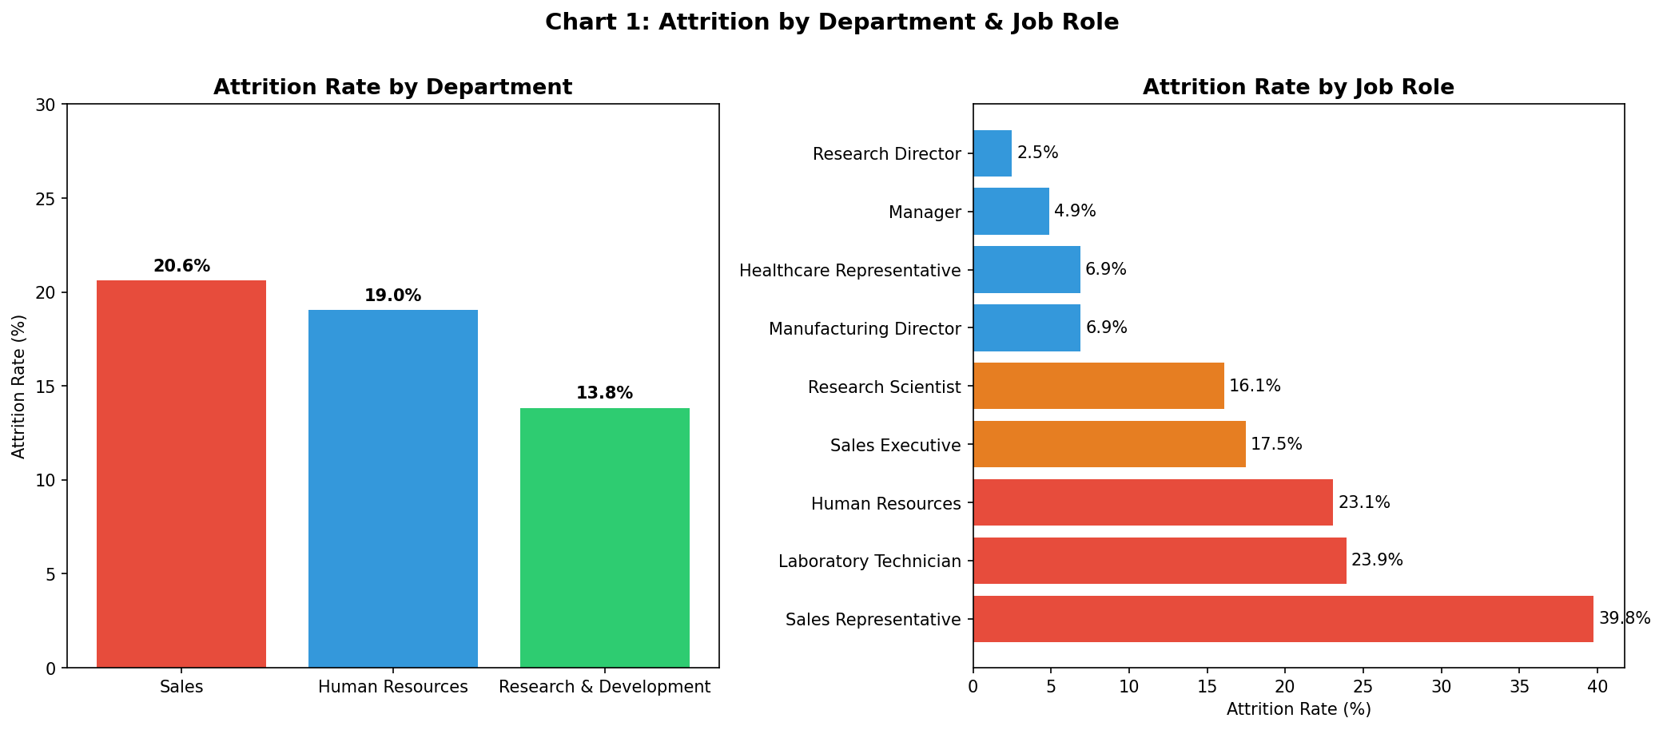
Sales and HR departments have the highest exit rates. Sales Representatives leave at nearly 40% — roughly 1 in every 2.5 hires.
It Is Not Just Salary
- Overtime is the strongest warning sign. Employees working overtime leave at three times the rate of those who do not (30.5% vs 10.4%). This is the clearest lever HR can pull immediately.
- Career growth matters more than pay alone. Managers and Research Directors leave at only 2.5–5%, while Technicians and Sales Reps exit at 24–40%. Employees with a visible career path stay. Employees who feel stuck leave.
- Salary contributes but is not decisive. Leavers earned 30% less on average — but overtime, role type, and travel frequency all predict exits more strongly than income alone.
Two Actions HR Should Take Now
- Introduce an Overtime Review. Flag any employee working overtime for three or more consecutive months for a manager conversation about workload or team resourcing. If overtime is unavoidable, ensure it is compensated. Target: cut overtime-driven exits from 30.5% to below 15%.
- Prioritise Sales Representative Retention. With 40% of Sales Reps leaving, this role needs immediate attention: structured check-ins at 90 and 180 days, and a clear career path to Senior Sales Executive. The data shows that roles with visible progression (Research Directors: 2.5% exit rate) retain people far more effectively.
A Note Before Acting on This
This analysis spots patterns — it is not a crystal ball. It will miss some people who are about to leave and may flag some who are perfectly happy. Factors the data cannot see — a difficult manager, a personal life event, a better job offer — will always play a role. Use this as an early-warning tool and a conversation-starter, not as the final word on any individual.

