OBJECT-ORIENTED PROGRAMMING
Jobsheet 02
4.2 Assignments
Class and Object - Code Screenshots and Program Results
Nama : Gesangrah Swandaru Pratama
NIM : 254107020178
Kelas : TI-2I

Assignment 1 Video Game Rental Class Diagram
Class diagram for one video-game rental transaction. The total payment equals the daily price multiplied by the rental duration.
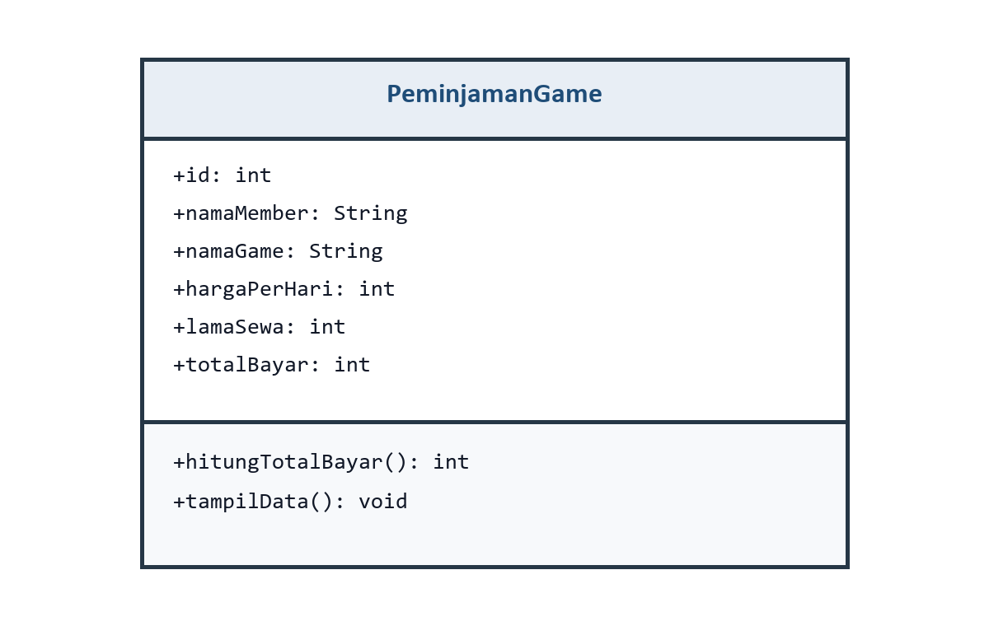
Figure 1. PeminjamanGame class diagram

Assignment 2 Video Game Rental Program

PeminjamanGame.java
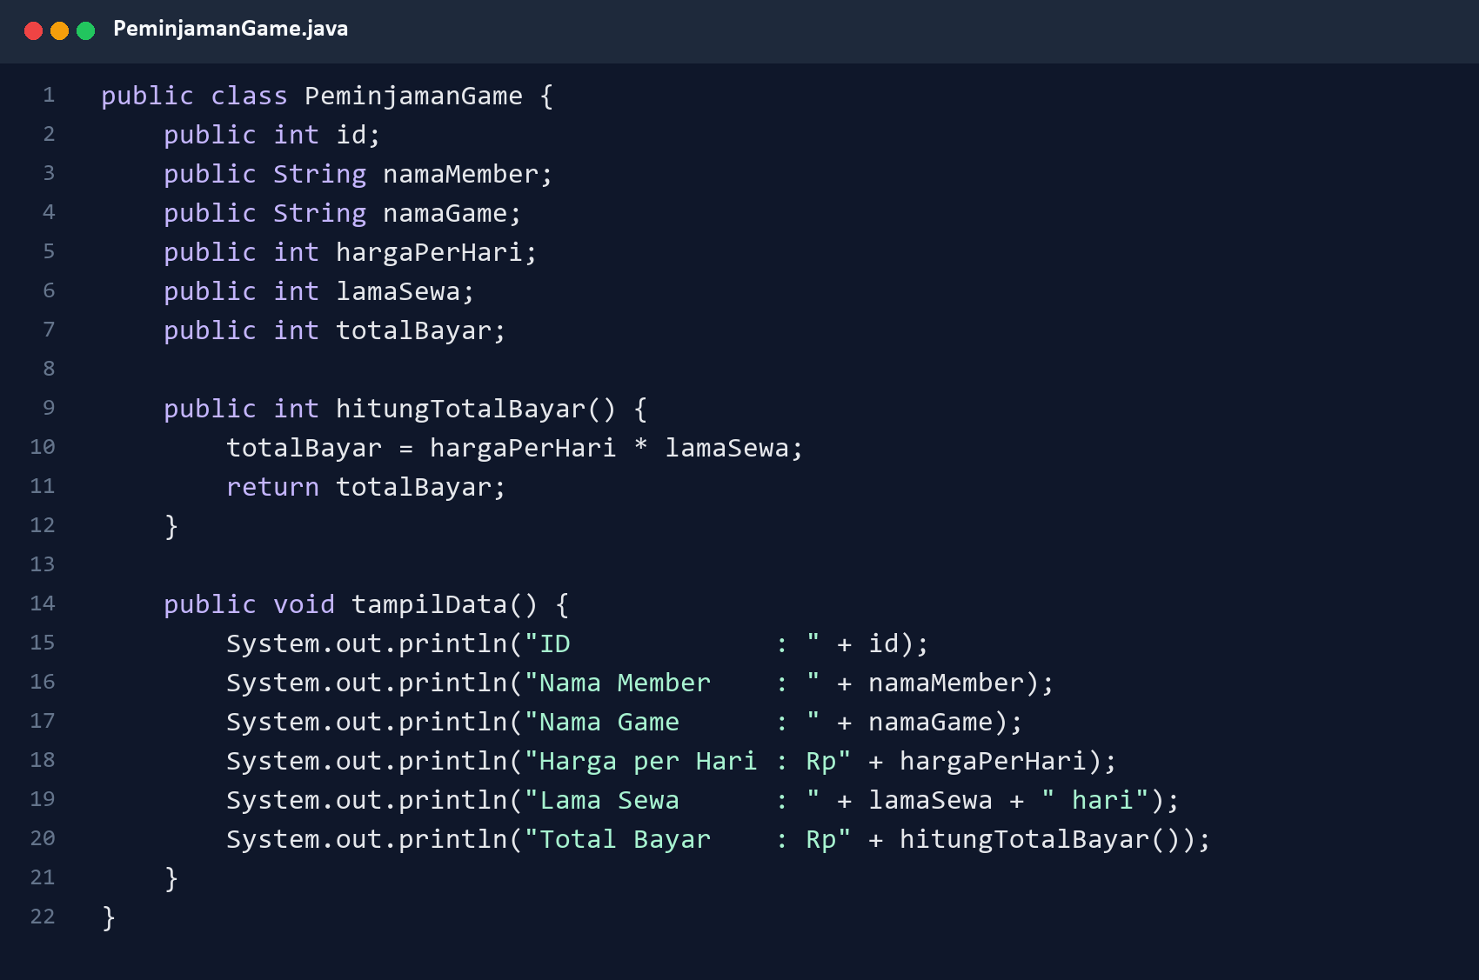
Figure 2. Rental transaction class implementation

TestPeminjamanGame.java
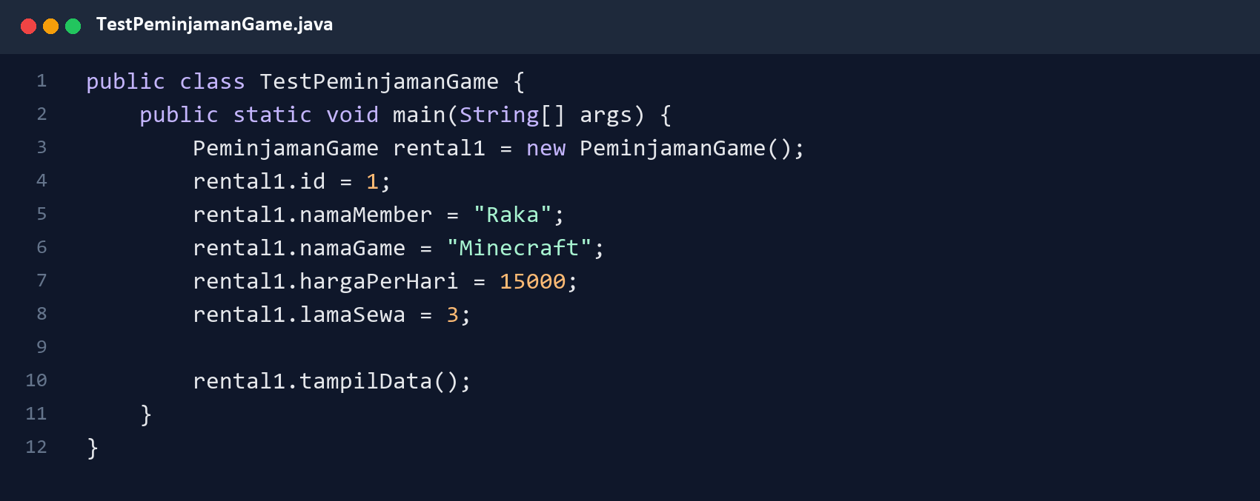
Figure 3. Rental transaction test program

Program Output
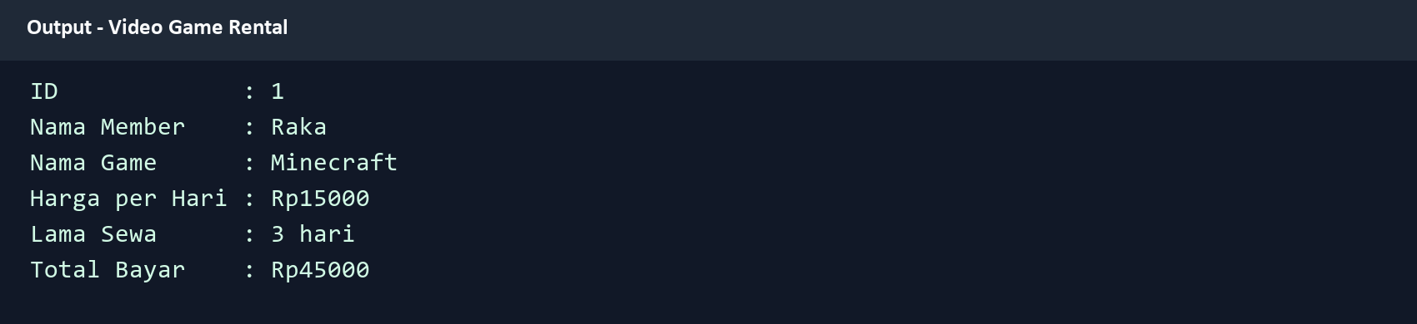
Figure 4. Verified rental total: Rp45000

Assignment 3 Circle Program

Lingkaran.java
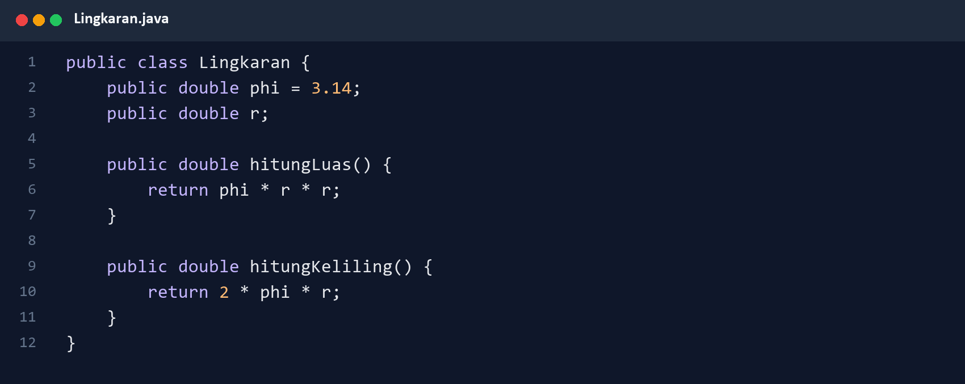
Figure 5. Circle area and circumference methods

TestLingkaran.java
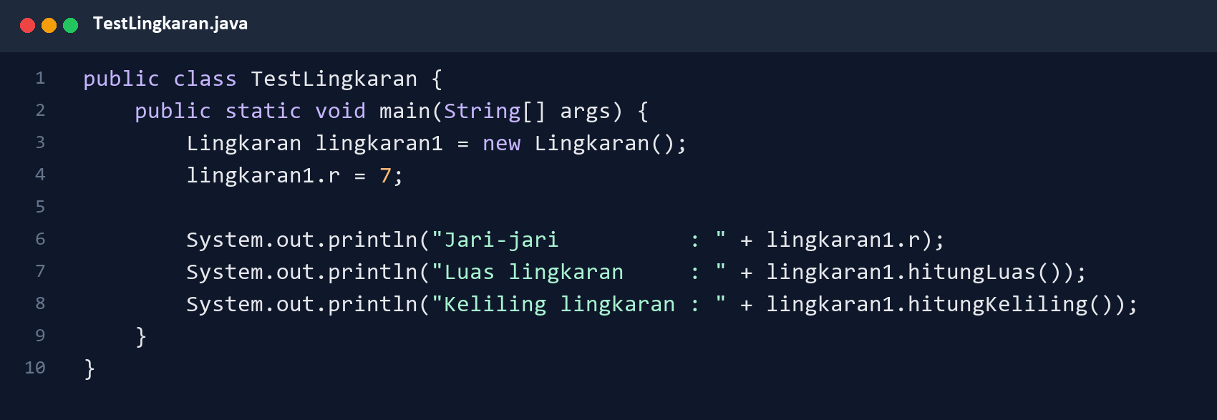
Figure 6. Circle test program

Assignment 3 Program Output
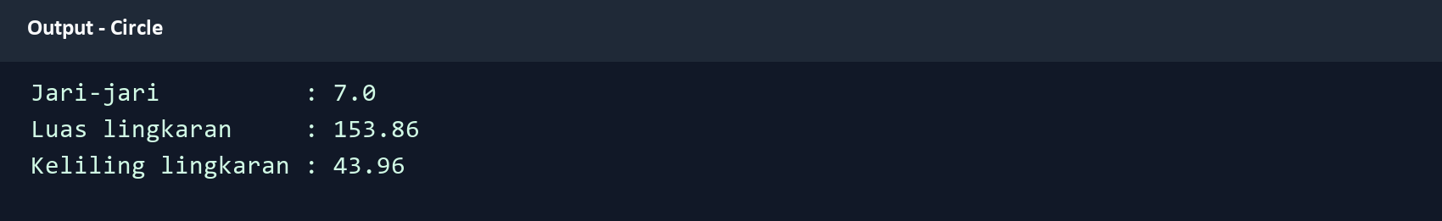
Figure 7. Verified area and circumference for radius 7

Assignment 4 Discounted Product Program

Barang.java
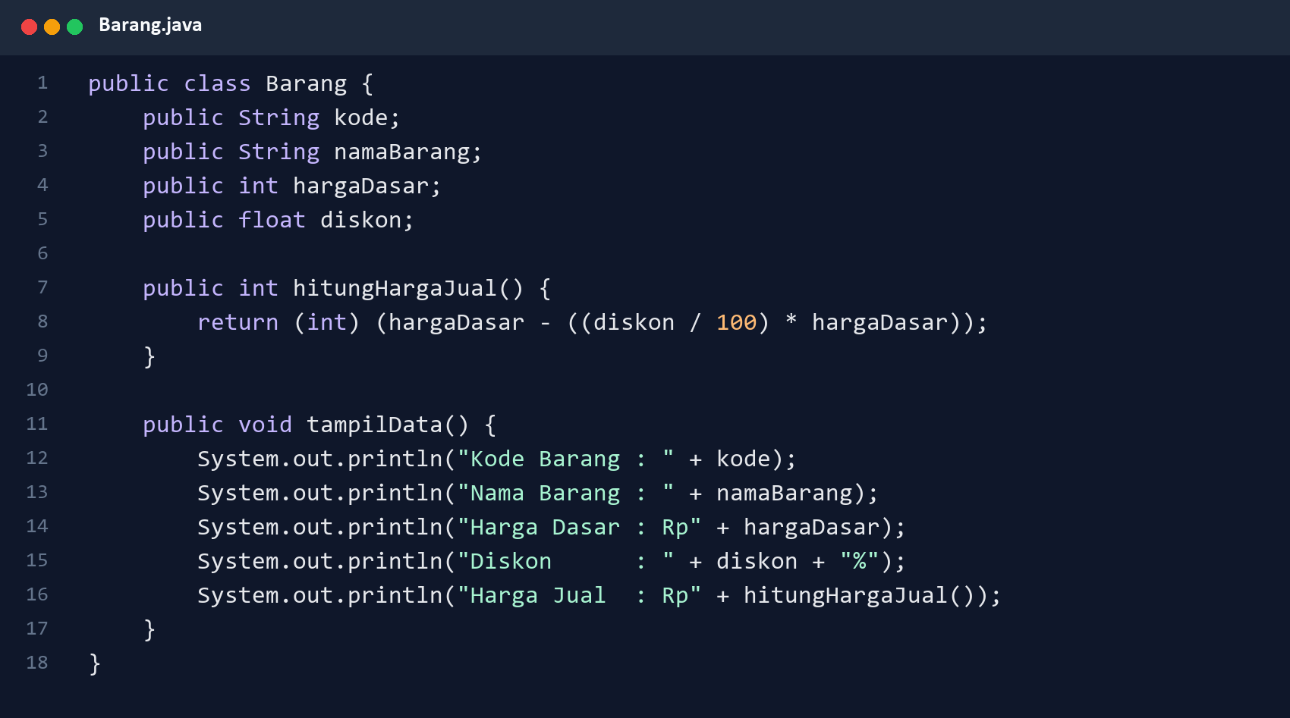
Figure 8. Product selling-price calculation and display method

TestBarang.java
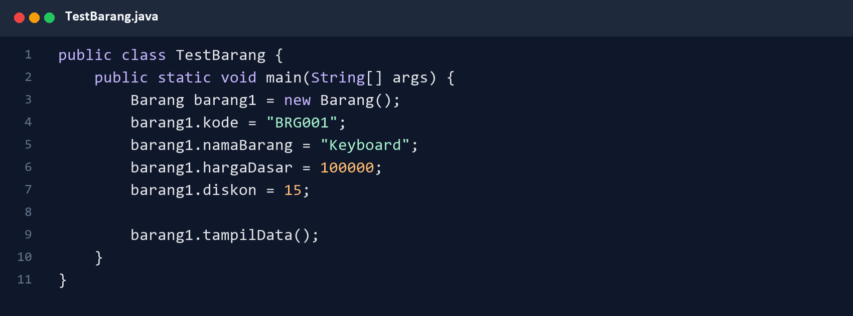
Figure 9. Discounted product test program

Program Output
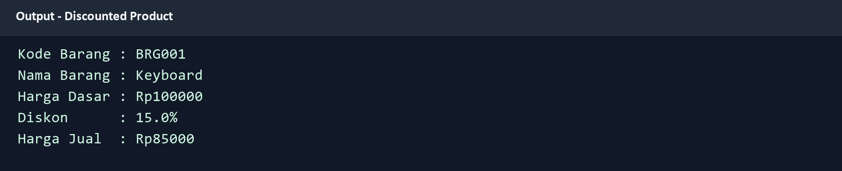
Figure 10. Verified selling price after a 15 percent discount

