PRAKTIKUM OBJECT ORIENTED PROGRAMMING
Jobsheet 02
Class and Object
Complete Experimental and Assignment Submission
Nama : Gesangrah Swandaru Pratama
NIM : 254107020178
Kelas : TI-2I
Semester 3 | Jobsheet 02

4.1 Experiment 1: Creating a Class Diagram
Figure 1. Karyawan class diagram
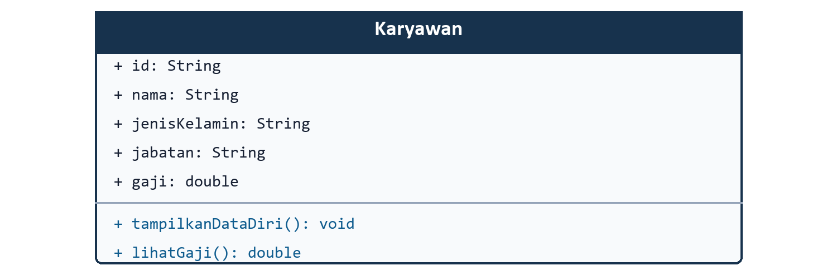
Code 1. Karyawan.java
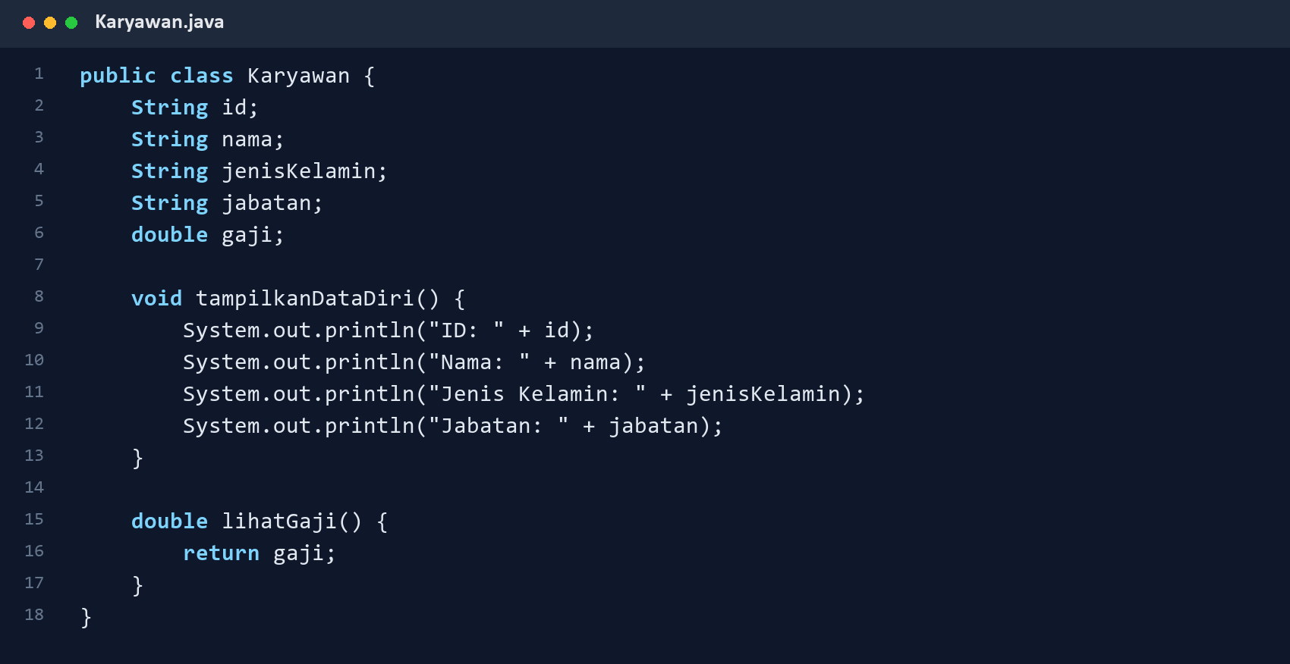

4.2 Experiment 2: Writing Class Members
Code 2. Mahasiswa.java
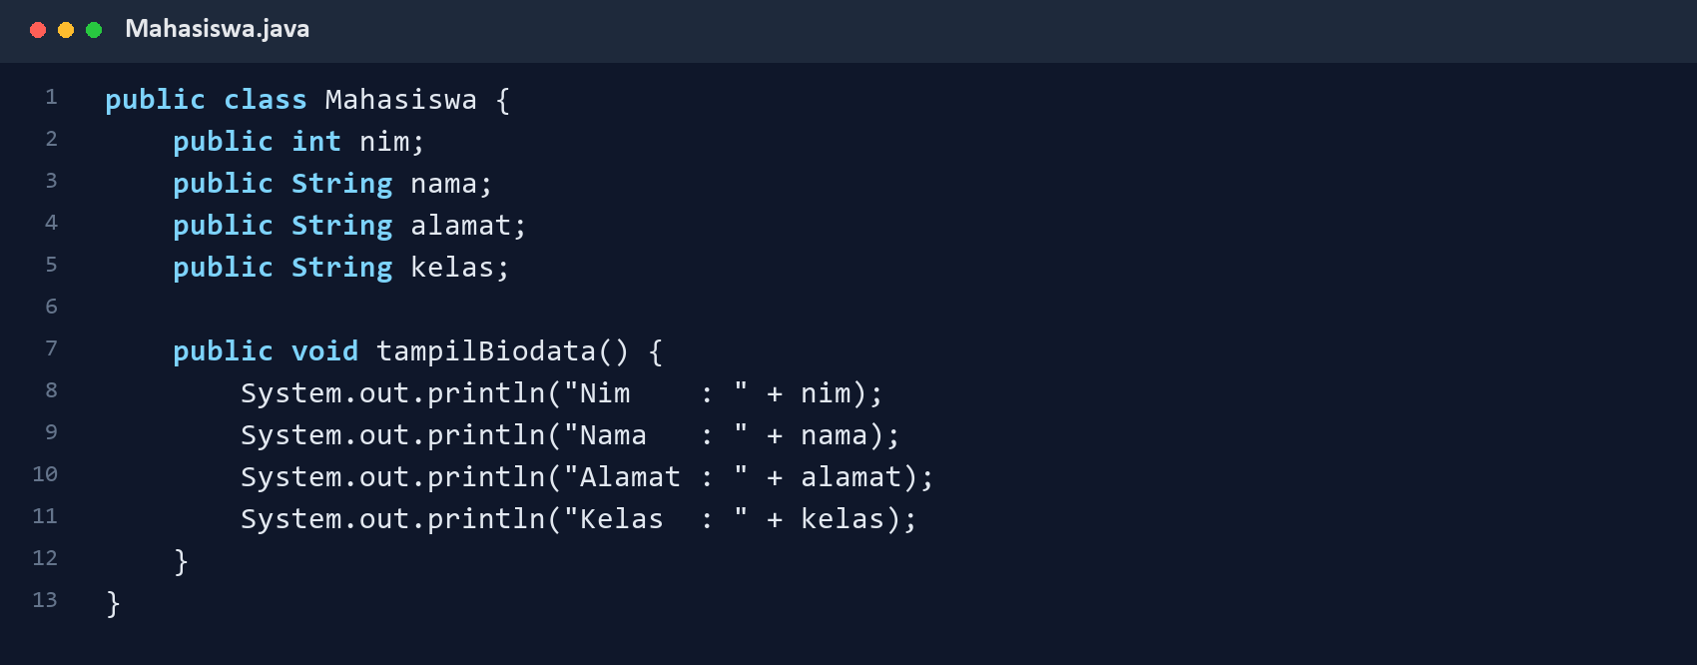

4.2 Experiment 2: Object Test and Output
Code 3. TestMahasiswa.java
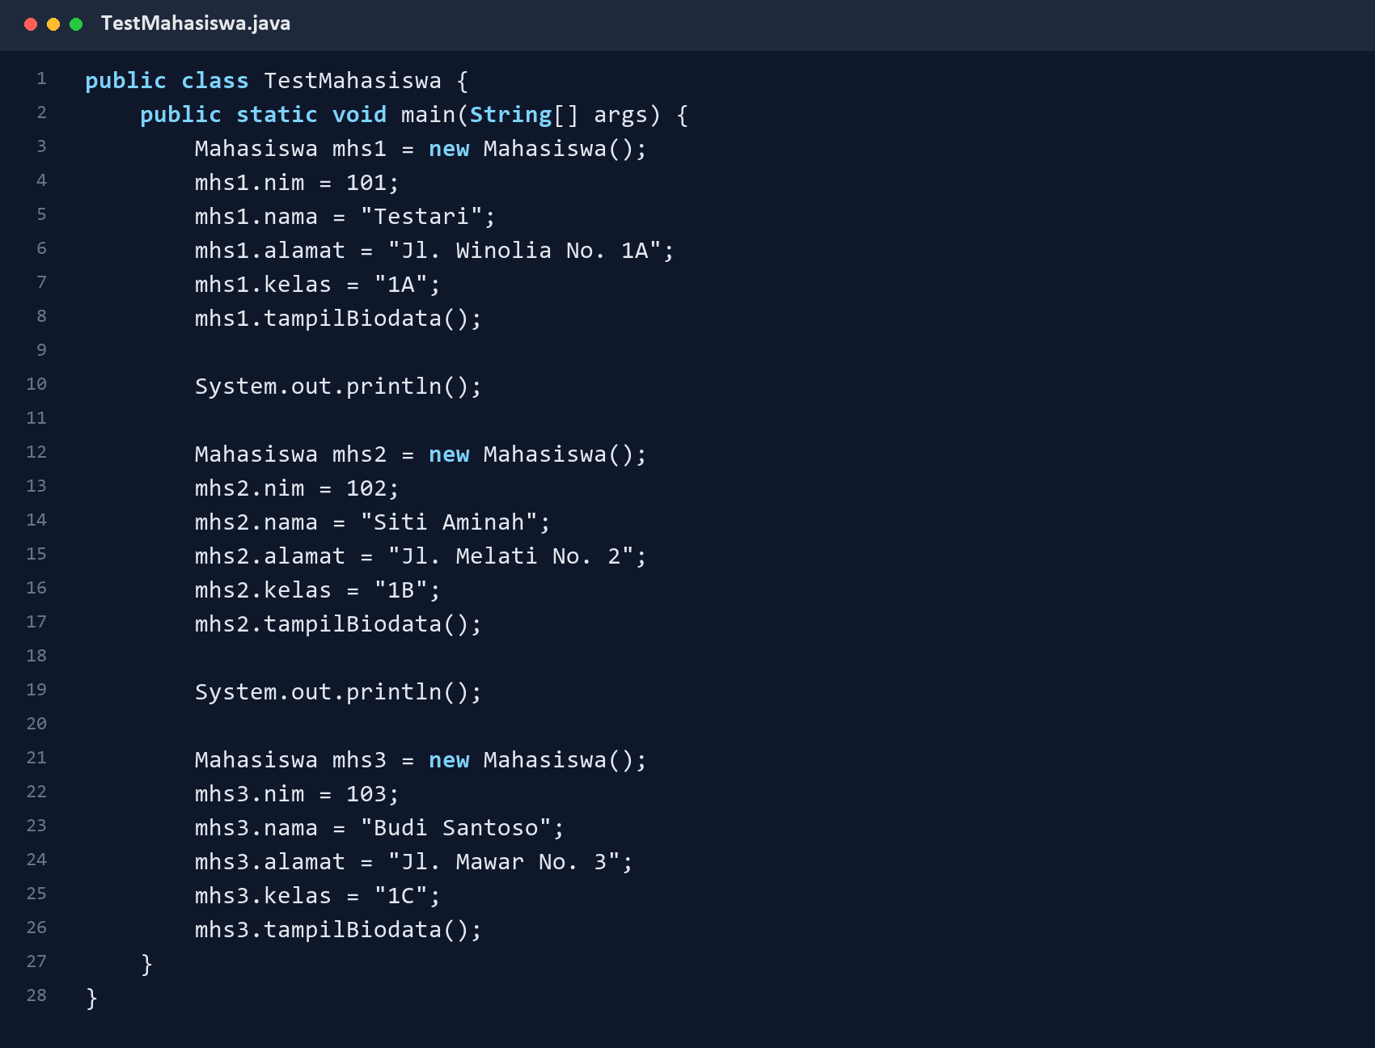
Result 1. TestMahasiswa program output
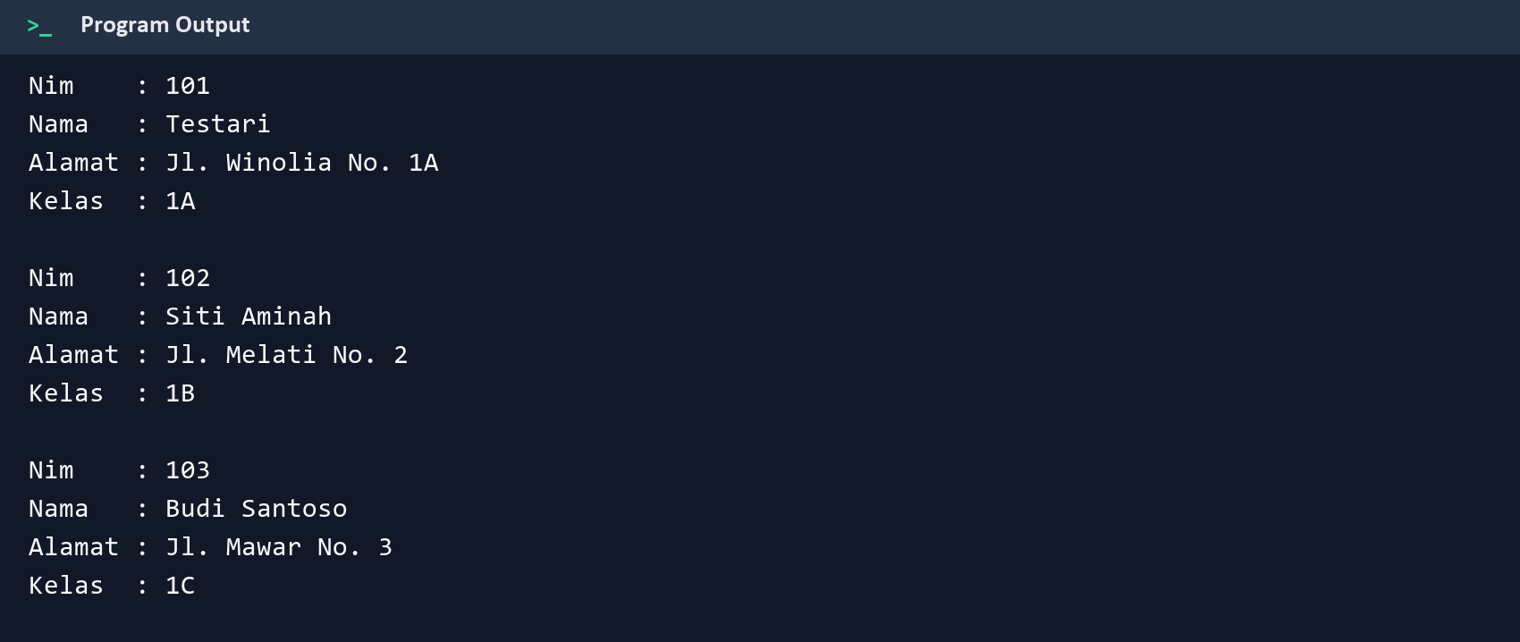

4.3 Experiment 3: Method with a Return Value
The tambahStok(int brgMasuk) method accepts an argument, adds it to the current stock, and returns the new stock value as an integer.
Code 4. Barang.java
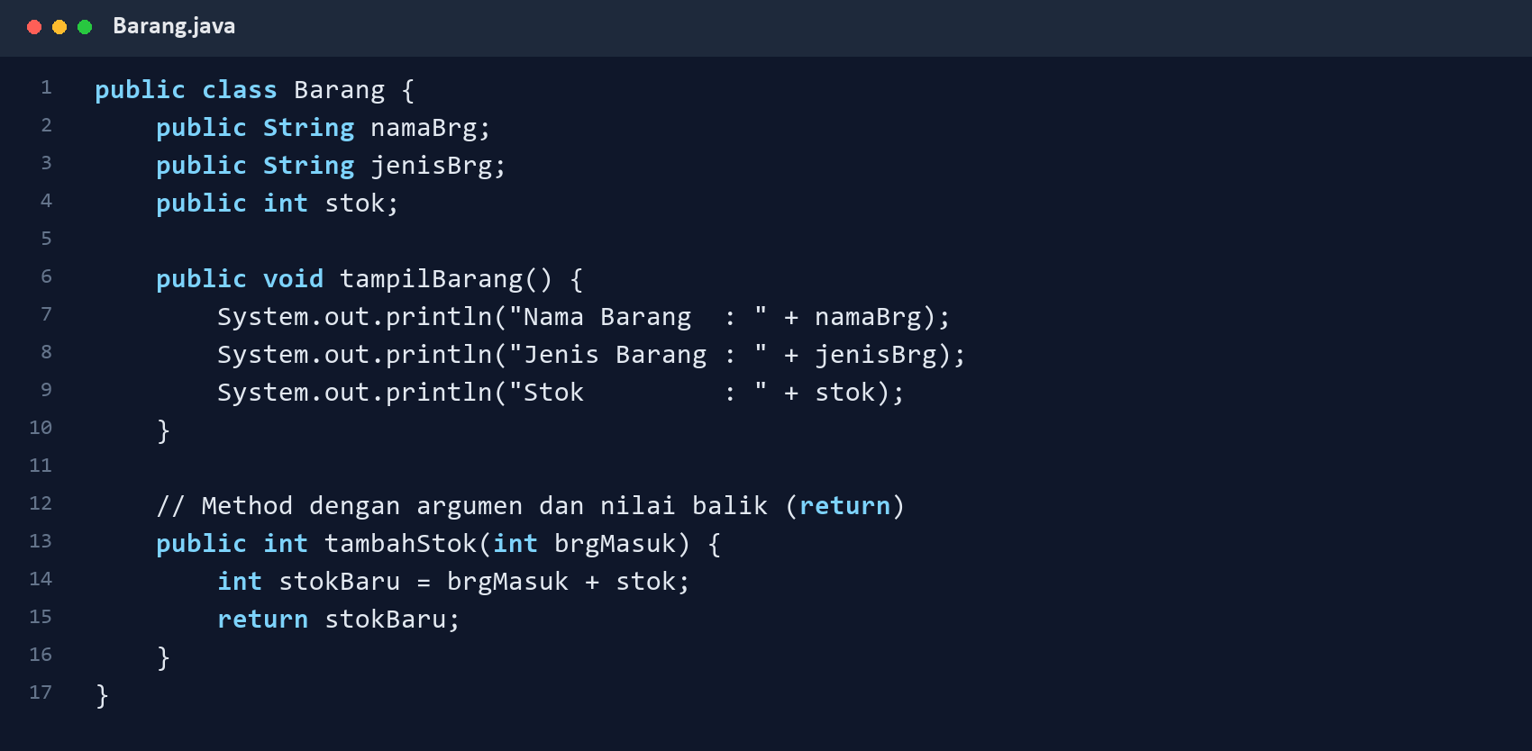

4.3 Experiment 3: Test and Output
Code 5. TestBarang.java
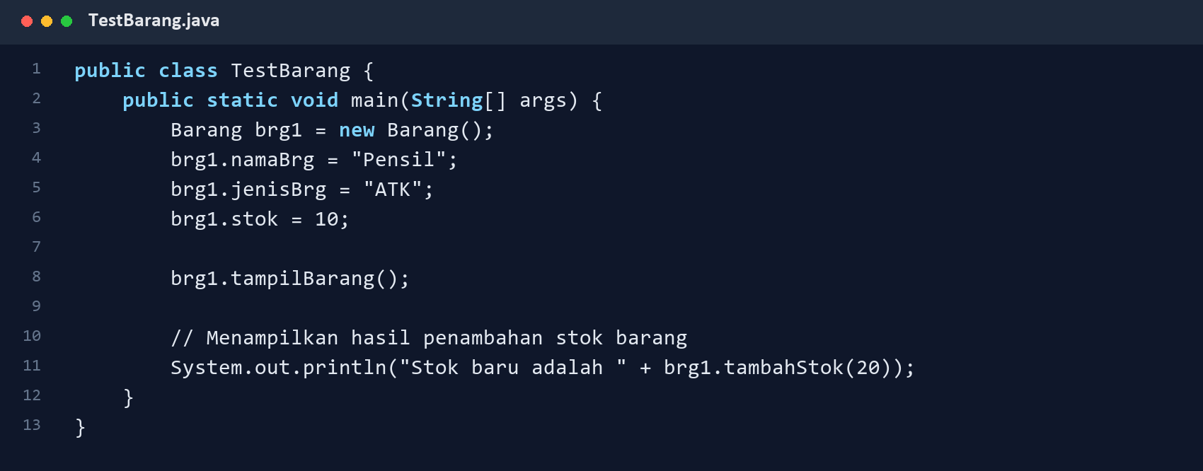
Result 2. Return-value method output
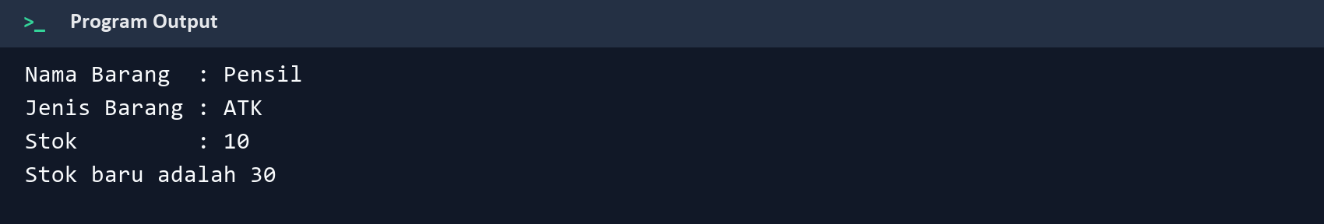

Assignment 1: PeminjamanGame Class Diagram
The rental model stores member, game, price, duration, and payment information. Its methods calculate the total and display a complete transaction summary.
Figure 2. PeminjamanGame class diagram
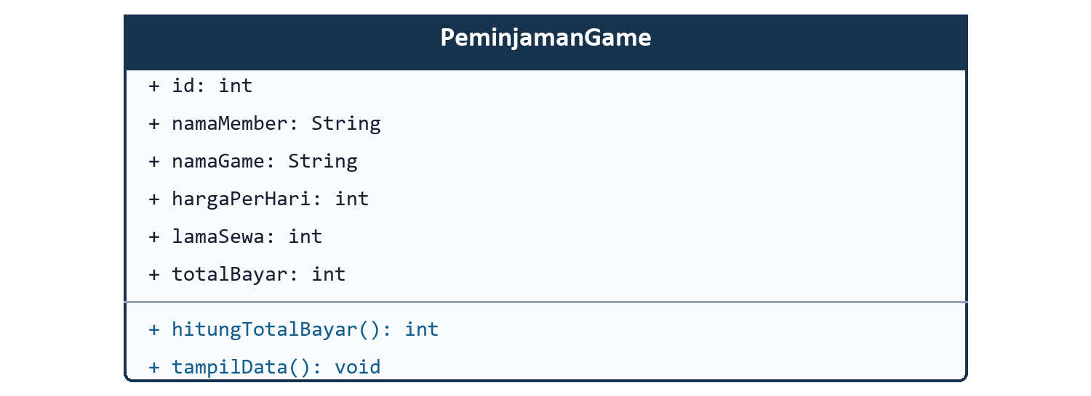

Attribute-to-Method Relationship
hitungTotalBayar() multiplies hargaPerHari by lamaSewa and stores the result in totalBayar. tampilData() prints the rental details and the calculated payment.

Assignment 2: Game Rental Implementation
Code 6. PeminjamanGame.java
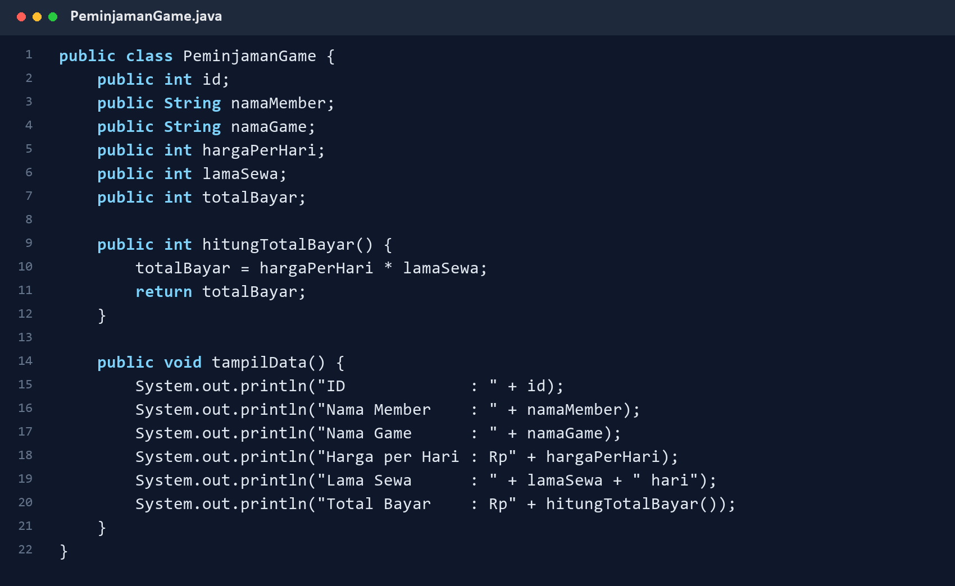

Assignment 2: Test and Output
Code 7. TestPeminjamanGame.java
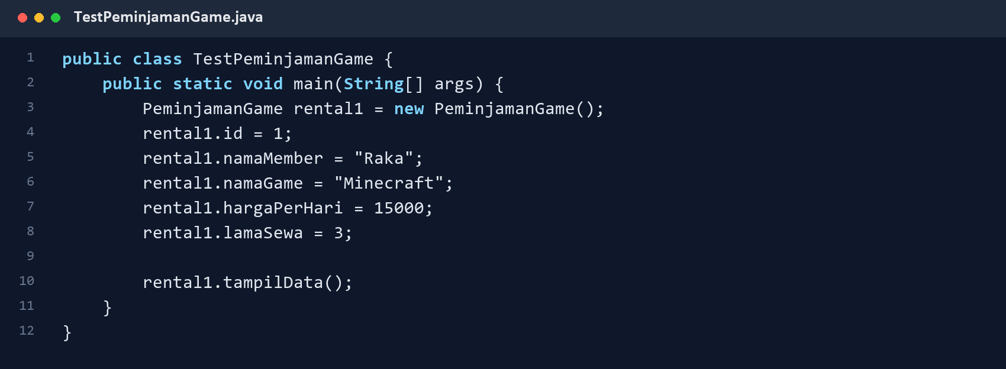
Result 3. Rental program output
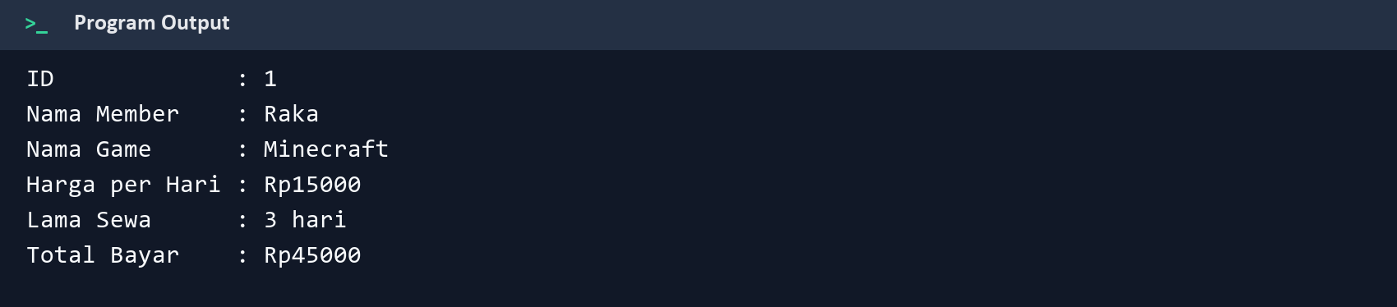

Assignment 3: Circle
The Lingkaran class provides methods for calculating area and circumference using phi = 3.14.
Code 8. Lingkaran.java
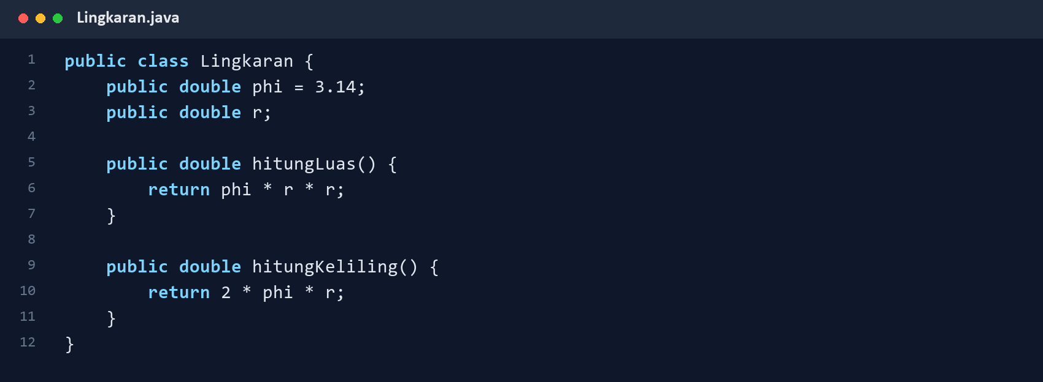
Code 9. TestLingkaran.java
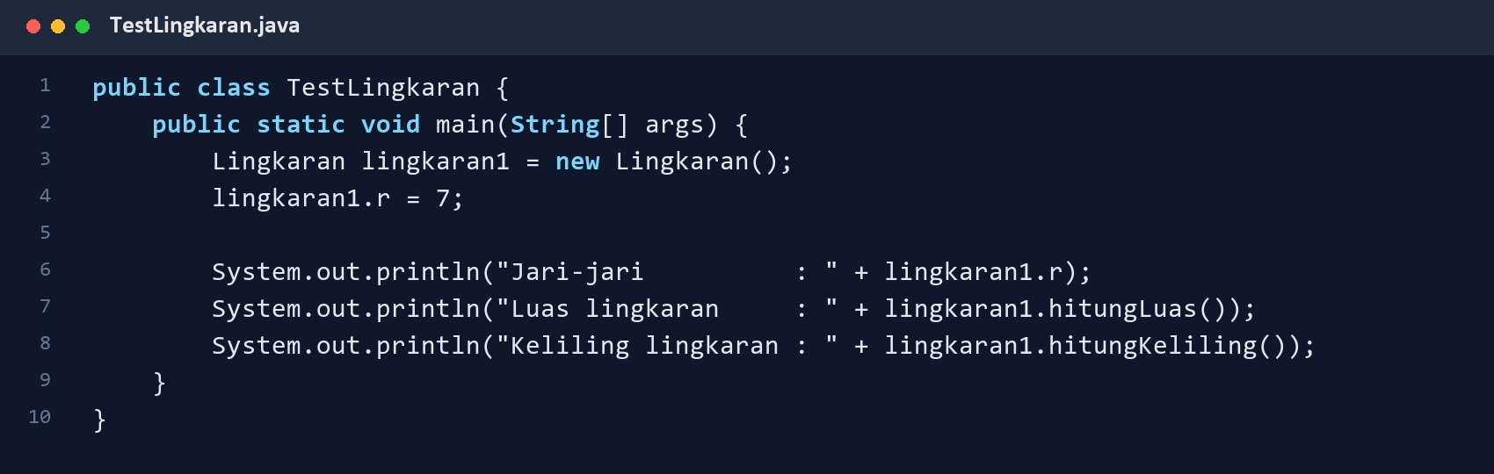
Result 4. Circle calculation output
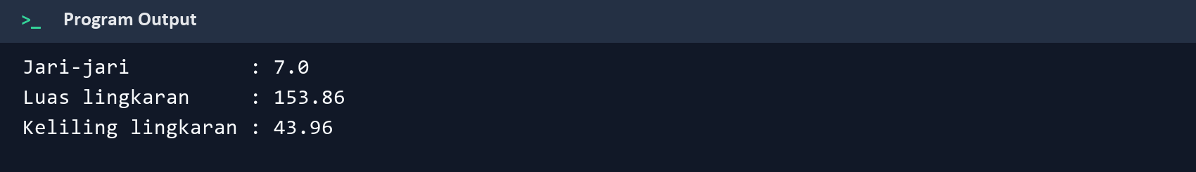

Assignment 4: Discounted Product
Barang calculates the selling price by subtracting the percentage discount from the base price.
Code 10. Barang.java
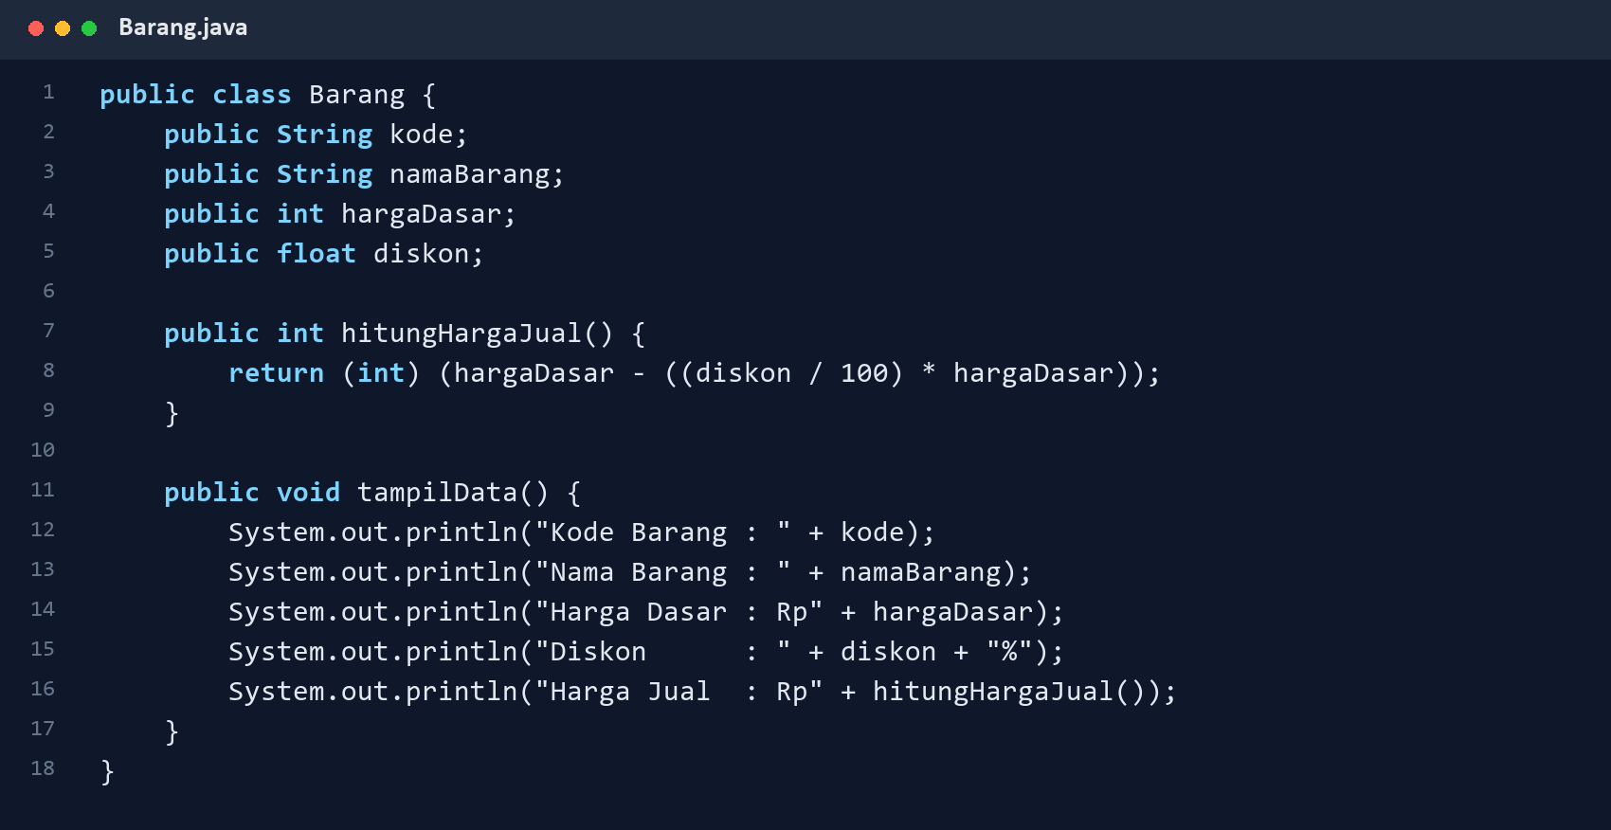

Assignment 4: Test and Output
Code 11. TestBarang.java
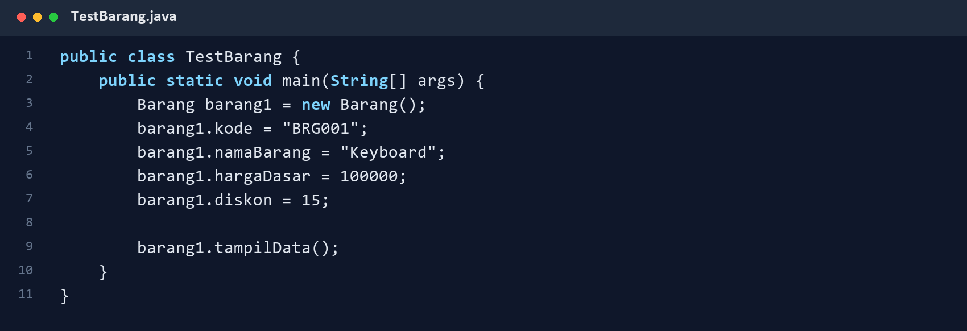
Result 5. Discount calculation output
