No event needed for floor.
Set both sprites -Player/Char + Floor tile collision masks
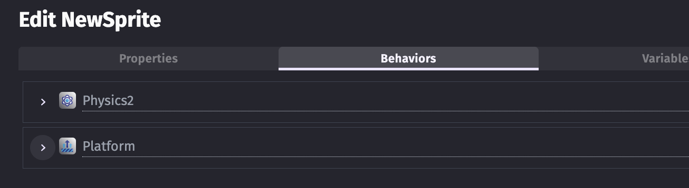

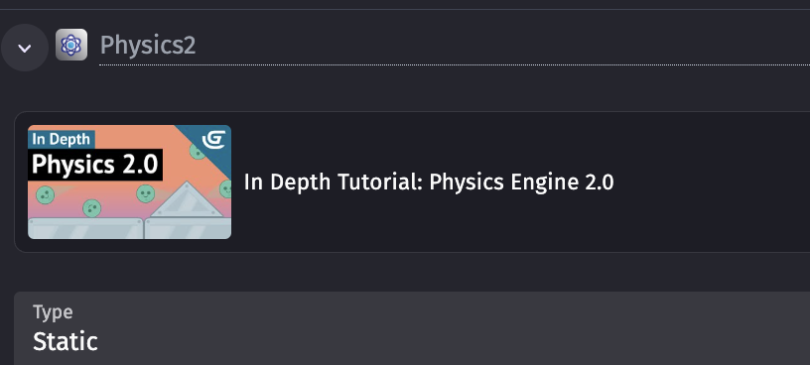

Set Opacity – Edit Effects opt on Sprite
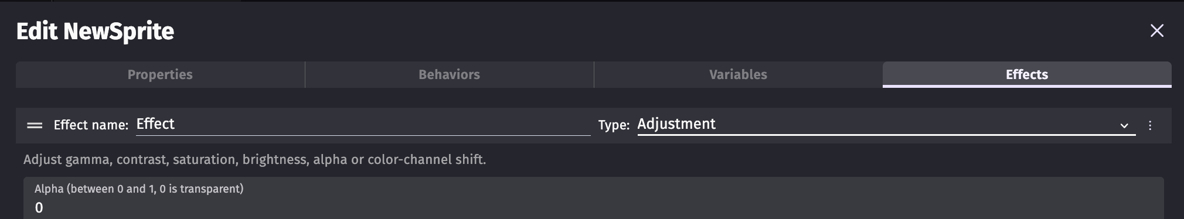

Set wall – Copy sprite and in Properties
