Coin

Add event
Condition set Collision
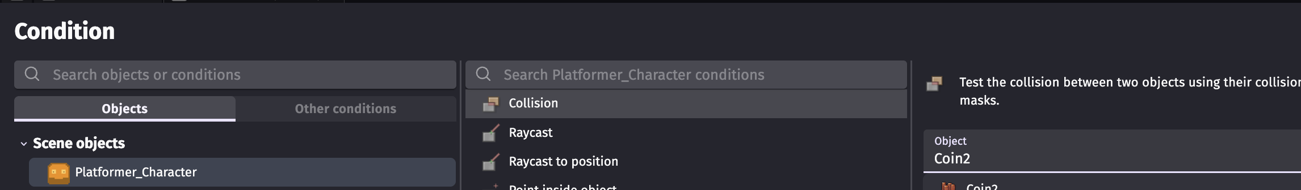
Action
1. For Coin - deletion
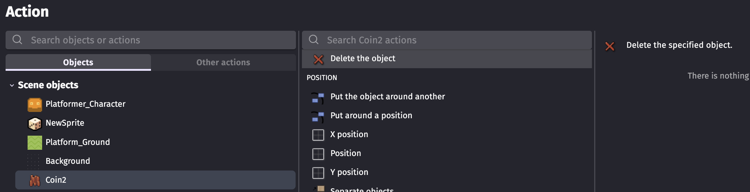
2. For Coin – audio
