Documentación
AldComputerService

# Copyright

# Prólogo

# Índice
Sumario
1. Main page 5
1.1 Content 5
1.2 Menus 5
1.2.1 File 5
1.2.2 Reports 6
1.2.3 Notifications 6
2. Manage data 6
2.1 Content 6
3. Manage computers 7
3.1 Content 7
3.1.1 Delete computer 7
3.1.2 Edit computer 8
3.1.3 Add computer 9
3.1.4 Possible errors 9
4. Generate report 10
4.1 Content 10
4.1.1 Possible errors 12
5. Notifications 12
5.1 Content 12

1. Main page

1.1 Content
In the main tab of the application we can find a window with menus at the top and a clock at the bottom right.
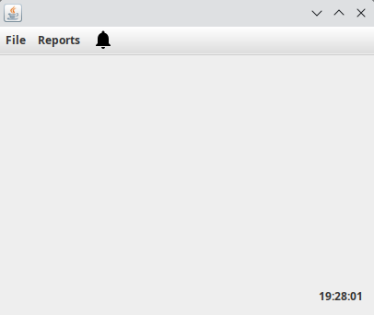

1.2 Menus

1.2.1 File
In the File menu you will find different submenus:
- Manage data (Ctrl-D)
- Manage computers (Ctrl-C)
- Quit (Ctrl-Q)
The Manage data submenu will open a view that will allow us to insert our company data. Manage computers allows us to access the computers in the shop and view the data. And finally, Quit, will allow us to close the application. For these different submenus we can use keyboard shortcuts.
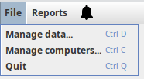

1.2.2 Reports
This menu allows us to go to the report creation view with customer data.
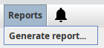

1.2.3 Notifications
This menu will open a customisation tab for the clock we have in the main tab of the application. You can open the tab directly with the keyboard shortcut Ctrl-N.
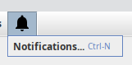

2. Manage data

2.1 Content
The Manage data window in the application allows you to set up your company data. The data it stores are as follows:
- Name
- Address
- Phone number
- Number of employees
This window has 3 buttons: Cancel, Edit and Save. With the Cancel button we close the window, with Edit we can edit the data entered about our company and with Save we can save and set the data of our company in the application.
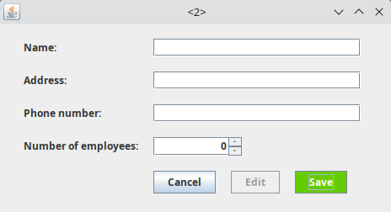

To be able to use the edit button we must first enter some data and save them. When the data is saved, the text fields are disabled and cannot be edited until the Edit button is pressed, to be able to save the edited data we must press save again and we will see how the fields are disabled with the new data entered.

3. Manage computers

3.1 Content
Esta ventana permite manegar los ordenadores de la empresa. En el centro de la ventana vemos una tabla que muestra la siguiente información sobre los ordenadores:
- Serial number
- Brand
- Model
También encontramos 3 botones en la parte inferior derecha de la tabla:
- Delete: allows you to delete a computer from the table.
- Edit: allows you to modify the data of a computer.
- Add: allows you to add a new computer to the program.

3.1.1 Delete computer
To delete a computer we must select it in the list with a click and press the red Delete button. When you do so, you will see a dialog box to confirm the removal of the computer.
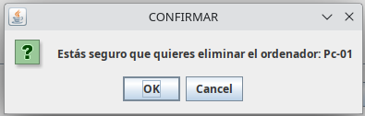

Pressing OK will delete the computer and pressing Cancel will close the confirmation window and will not delete the computer.

3.1.2 Edit computer
To edit a computer we must select it with a click on the list and press the Edit button. When we press the edit button we will see a panel below the list of computers that will show us the data of the computer, which are:
- Computer Type: type of the computer. Values of computer type may be: PERSONAL_COMPUTER, LAPTOP or SERVER.
- Serial number: identificator of the computer, it must be unique.
- Brand
- Model
In the panel we will see the data of the selected computer and we will be able to edit them except the identifier. To save the edited data we can press the green Save button.
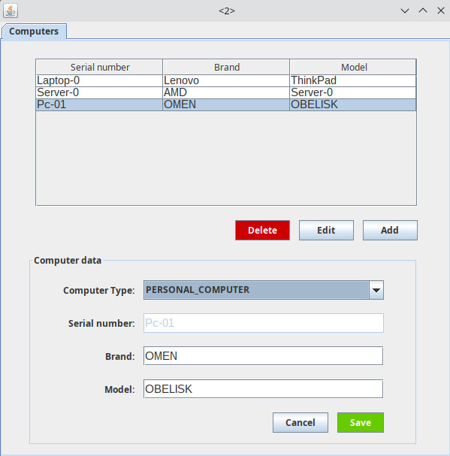

If we press the Cancel button, the changes we have made will not be saved. And the lower panel will close.

3.1.3 Add computer
If we press the Add button we will see the same panel as above but this time empty to fill with new data.
We must enter the data and press the Save button to save the newly entered computer or Cancel to cancel the action and not add a new one.
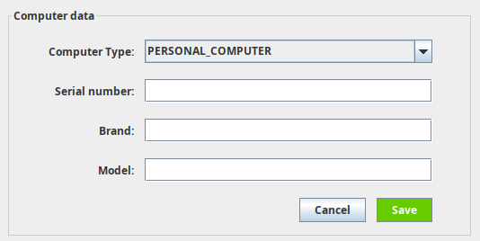

3.1.4 Possible errors
The errors that can be found in this window are the following:
- Incomplete data entry when adding or editing a computer. If do not fill an information field, the following error will be displayed:
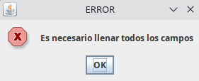Texto 1: Error message: All fields must be filled in.

4. Generate report

4.1 Content
This window allows the creation of a report with data from a MariaDB database.
We can see text fields that ask for information about the connection to the database. The data to be filled in are:
- Server Host
- Port
- Database
- Username
- Password
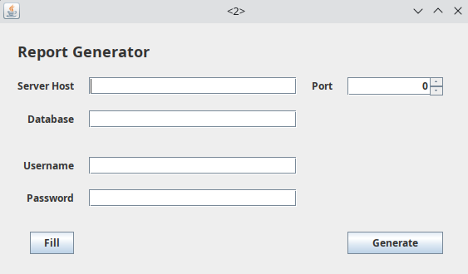

We can fill in the data manually or we can use the Fill button which will set the default settings to make the connection to the database. By pressing the Fill button:
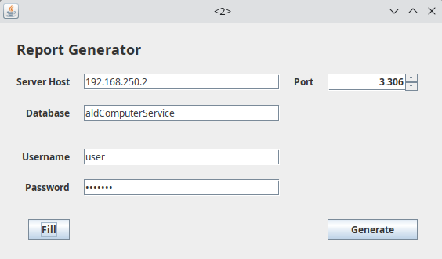

Once we have the data entered, we can click on the Generate button, which will show us a window in which we must select the path where the report will be saved in PDF format. By default, this window will open a Reports folder in the base folder of the application.
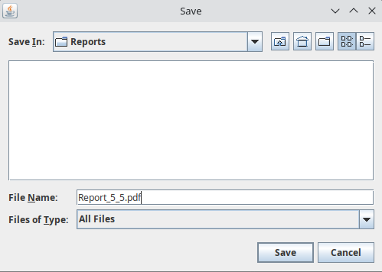
The default file name will be Report_5₅.pdf. We can change it to our liking but we must add the extension .pdf to the name.
Once we have selected the path and name of the file we want, we can click Save. When we press Save we must wait because if everything is correct the report is being generated. If everything goes well, after a few seconds a window will open in which we can see the newly generated report.
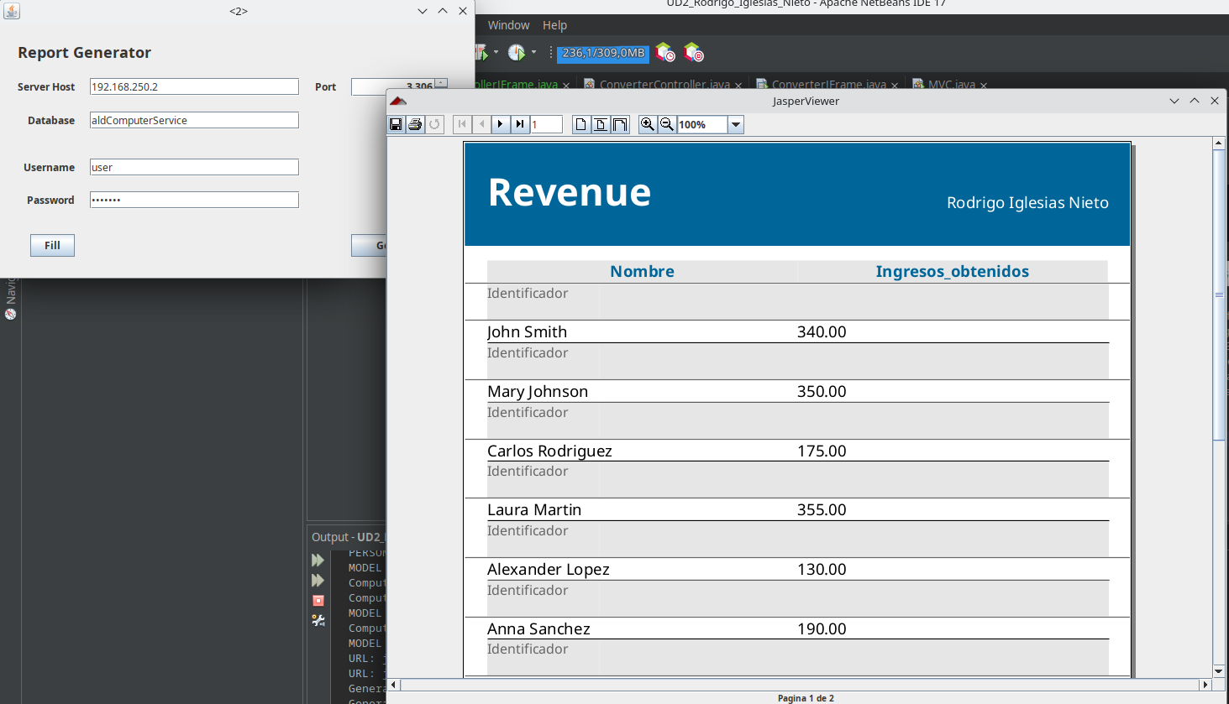

The report generated by this window is the money paid by each customer in the company.

4.1.1 Possible errors
The errors that can be found in this window are the following:
- Error connecting to the database. This error displays a message and the URL to which the connection was attempted to make to make it easier to see the error.
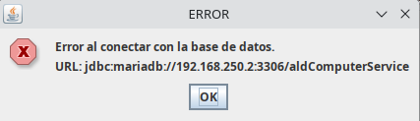

- Error creating the report:
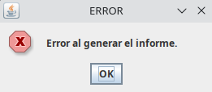

5. Notifications

5.1 Content
In this window we find the menu of the notifications or alerts of the application. We can also configure the clock from 12-hour to 24-hour format. In addition, it allows us to set alerts that will appear in the application.
We can find:
- Clock mode: select the mode that the main application window clock will work with.
- Alert time: choose the time of the alert, select an hour and minute.
- Message: the text that will display the notification.
- Set clock: save the selected mode for the clock and enable the alert time if the message text field is not empty.
- Disable alarm: will disable the alarm if there is one notification running in the background.
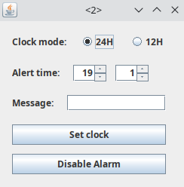

An example of a notification:
This is how we would set up a notification and how the message will be shown:
