Experience with access regime policies influences compliance and enforcement behaviors of common-pool resource users

Ignacia Rivera

# Data analysis and figures

## **1. Data description**

1. **union:** unique id for each union (not disclosed to ensure anonymity)
2. **performance:** type of association

* High performance = 1
* Low performance = 2

1. **framing:** framing under which the game was played

* Loco = 1
* Hake = 2

1. **id:** unique number for subject identification built combining codes for id, union and frame
2. **group_id:** unique number for group identification built combining codes for union, session and frame (note that groups were reassembled in each round for union 3 due to an implementation error)
3. **round:** round of the game

* From 1 to 20

1. **overextraction:** number of units overharvested by a subject in a given round

* From 0 to 50

1. **observer:** the role assigned to that subject in that round

* Observer = 1
* Inactive = -1
* Inspected = 0
* Round with no observation = NA

1. **overext_observed:** overextraction performed by the subject being inspected by the subject

* From 0 to 50
* Round with no observation = NA

1. **report:** whether the subject reported a parnter’s violation when having the chance

* Yes = 1
* No = 0
* Round with no obsrevation = NA

1. **punished:** whether the subject got punished after being observed violating the quota

* Yes = 1
* No = 0
* Round with no obsrevation = NA

1. **round_profit:** profit made by the subject in a given round

* From 0 to 1,500

|  |  |  |  |  |  |  |  |  |  |  |  |  |  |  |  |  |  |
| --- | --- | --- | --- | --- | --- | --- | --- | --- | --- | --- | --- | --- | --- | --- | --- | --- | --- |
| union | performance | framing | id | group_id | round | overextraction | observer | overext_observed | report | punished | round_profit | group id fixed | compliance | stage | stage nm | frame nm | performance nm |
| 1 | 1 | 1 | 32111 | 121 | 1 | 25 | NA | NA | NA | NA | 930 | 121 | 50 | 1 | Nonenforced | Loco | High performance |
| 1 | 1 | 1 | 64211 | 111 | 1 | 15 | NA | NA | NA | NA | 1050 | 111 | 70 | 1 | Nonenforced | Loco | High performance |
| 1 | 1 | 1 | 96311 | 121 | 1 | 50 | NA | NA | NA | NA | 1300 | 121 | 0 | 1 | Nonenforced | Loco | High performance |
| 1 | 1 | 1 | 128411 | 111 | 1 | 0 | NA | NA | NA | NA | 820 | 111 | 100 | 1 | Nonenforced | Loco | High performance |
| 1 | 1 | 1 | 160511 | 111 | 1 | 0 | NA | NA | NA | NA | 820 | 111 | 100 | 1 | Nonenforced | Loco | High performance |
| 1 | 1 | 1 | 192611 | 121 | 1 | 0 | NA | NA | NA | NA | 550 | 121 | 100 | 1 | Nonenforced | Loco | High performance |

## **2. Differences in compliance**

### 2.a. Non-parametric tests for differences in individual mean compliance

Wilcoxon rank-sum: differences in compliance levels

performance

frame

stage

p.value

stat

corrected.p.value

sign.corrected

High performance

vs

All

0.000

965.0

0.000

*

Low performance

vs

All

0.204

1557.5

1.628

vs

Hake

All

0.638

1710.0

5.105

vs

Loco

All

0.003

2362.5

0.024

*

High performance

Hake

vs

0.020

92.0

0.163

Low performance

Hake

vs

0.577

130.0

4.616

High performance

Loco

vs

0.056

47.0

0.447

Low performance

Loco

vs

0.019

91.0

0.153

Significance level is ajusted using a Bonferroni correction for 8 hypotheses

Tests comparing differences between stages are paired

### 2.b. Plot of mean individual compliance per treatment and association type

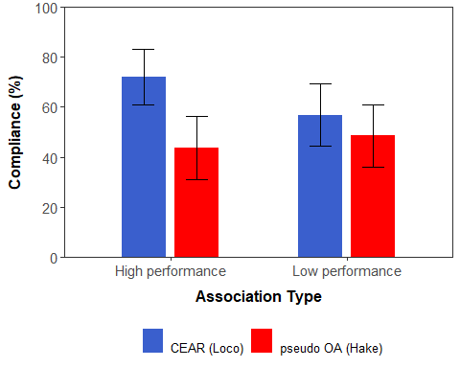

### 2.c. Comparing number of subjects that choose to comply in every round between treatments within association types

Fisher’s exact test for count data: differences in number of compliers between frames

Performance

odds ratio

p.value

corrected.p.value

High performance

6.786

0.021

0.042

Low performance

2.047

1

2

Significance level is ajusted using a Bonferroni correction for 2 hypotheses

### 2.d. Regressing group compliance over treatment, association type and stage

Dependent variable:

Group percent of compliance

(1)

(2)

(3)

(4)

(5)

(6)

CEAR

18.28***

18.28***

18.28***

6.73

6.73

11.34

(2.62)

(2.56)

(2.55)

(4.86)

(4.84)

(8.82)

Peer-enforced stage

6.77***

3.67

4.37

1.27

7.62

(2.56)

(4.52)

(4.46)

(5.86)

(8.21)

HP

5.17**

5.17**

-5.50

-5.50

-7.94

(2.56)

(2.55)

(4.24)

(4.25)

(7.51)

Non-enforced rounds

-1.10*

-1.10*

(0.65)

(0.64)

Peer-enforced rounds

-0.41

-0.41

(0.60)

(0.59)

CEAR x Peer-enf. stage

3.27

3.27

-8.04

(5.00)

(4.99)

(8.92)

CEAR x HP

19.81***

19.81***

23.60***

(5.00)

(4.99)

(8.92)

Peer-enf. stage x HP

1.53

1.53

0.14

(5.00)

(4.99)

(8.92)

CEAR × HP × Non-enf. rounds

-2.02*

(1.13)

CEAR × HP × Peer-enf. rounds

0.18

(0.76)

Pseudo-OA × HP × Non-enf. rounds

-0.06

(1.07)

Pseudo-OA × HP × Peer-enf. rounds

-0.57

(1.34)

CEAR × LP × Non-enf. rounds

-1.62

(1.45)

CEAR × LP × Peer-enf. rounds

0.07

(1.17)

Pseudo-OA × LP × Non-enf. rounds

-0.70

(1.20)

Pseudo-OA × LP × Peer-enf. rounds

-1.32

(1.24)

Constant

46.18***

40.21***

45.16***

46.36***

51.31***

49.28***

(1.79)

(2.56)

(3.84)

(3.51)

(4.54)

(6.29)

AIC

4125.53

4117.35

4117.47

4105.78

4105.74

4114.9

Observations

440

440

440

440

440

440

R2

0.11

0.14

0.14

0.17

0.18

0.18

Adjusted R2

0.11

0.13

0.13

0.16

0.16

0.16

Residual Std. Error

19.10 (df = 438)

18.88 (df = 436)

18.84 (df = 434)

18.57 (df = 433)

18.53 (df = 431)

18.60 (df = 425)

Note:

*p<0.1;* ***p<0.05;*** p<0.01

Weights are assigned based on the number of individuals in each group

Robust standard errors

## **3. Differences in peer-enforcement**

### 3.a. Nonparametric test for differences in individual report probability

Wilcoxon rank-sum test: differences in individual probability of reporting

performance.nm

frame.nm

statistic

p.value

corrected.p.value

High performance

vs

215.5

0.027

0.106

Low performance

vs

353.5

0.217

0.868

vs

Hake

560.5

0.015

0.062

vs

Loco

476.0

0.004

0.016

Significance level is ajusted using a Bonferroni correction for 4 hypotheses

### 3.b. Plot of mean individual probability of reporting per treatment and association type

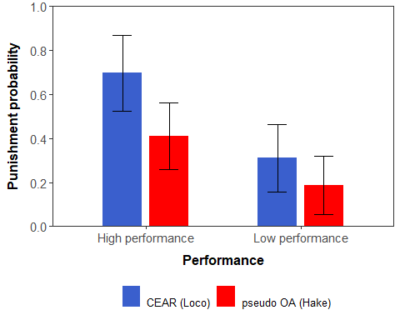

### 3.d. Regressing group probability of reporting over treatment, association type and stage

Dependent variable:

group.prob.report

(1)

(2)

(3)

(4)

(5)

(6)

(7)

(8)

cear

0.21***

0.21***

0.22***

0.24***

0.10

0.12*

(0.06)

(0.06)

(0.06)

(0.06)

(0.07)

(0.07)

round

-0.01

-0.01

-0.01

-0.01

(0.01)

(0.01)

(0.01)

(0.01)

mean.obs.overharvest

0.001

0.002

0.002

0.002

(0.002)

(0.002)

(0.002)

(0.002)

hp

0.24***

0.24***

0.13*

0.13*

(0.06)

(0.05)

(0.07)

(0.07)

cear.hp

0.24**

0.26**

(0.11)

(0.11)

oa.hp

-0.35***

-0.37***

(0.08)

(0.09)

cear.lp

-0.37***

-0.38***

(0.08)

(0.08)

oa.lp

-0.48***

-0.50***

(0.08)

(0.08)

Constant

0.28***

0.43**

0.16***

0.27

0.22***

0.32*

0.69***

0.82***

(0.04)

(0.17)

(0.05)

(0.17)

(0.05)

(0.17)

(0.07)

(0.16)

Observations

187

187

187

187

187

187

187

187

R2

0.07

0.07

0.15

0.16

0.18

0.19

0.18

0.19

Adjusted R2

0.06

0.06

0.15

0.14

0.16

0.16

0.16

0.16

Residual Std. Error

0.29 (df = 185)

0.29 (df = 183)

0.28 (df = 184)

0.28 (df = 182)

0.28 (df = 183)

0.28 (df = 181)

0.28 (df = 183)

0.28 (df = 181)

F Statistic

13.03*** (df = 1; 185)

4.74*** (df = 3; 183)

16.83*** (df = 2; 184)

8.82*** (df = 4; 182)

13.16*** (df = 3; 183)

8.34*** (df = 5; 181)

13.16*** (df = 3; 183)

8.34*** (df = 5; 181)

Note:

*p<0.1;* ***p<0.05;*** p<0.01

Weights are assigned based on the number of individuals in each group

Robust standard errors

## **4. The effect of peer-enforcement on compliance**

### 4.a. Nonparametric tests for evolution of compliance

Wilcoxon rank-sum paired test: differences in compliance between the first and last round in each stage

frame

stage

statistic

p.value

corrected.p.value

sign.corrected

High performance

Hake

nonenforced

78.5

0.519

4.149

Loco

nonenforced

147.0

0.001

0.007

**

Hake

peer-enforced

80.5

0.254

2.036

Loco

peer-enforced

7.0

0.272

2.175

Low performance

Hake

nonenforced

122.5

0.111

0.890

Loco

nonenforced

142.0

0.061

0.488

Hake

peer-enforced

42.5

0.421

3.368

Loco

peer-enforced

44.5

0.695

5.556

Significance level is ajusted using a Bonferroni correction for 8 hypotheses

### 4.b. Plot of evolution of individual compliance

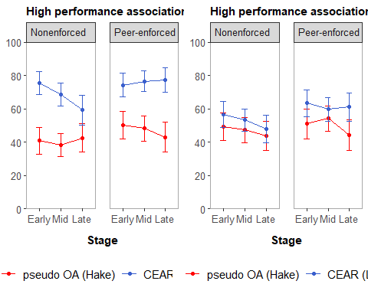 ### 4.c. Plot of evolution of probability of reporting in each round 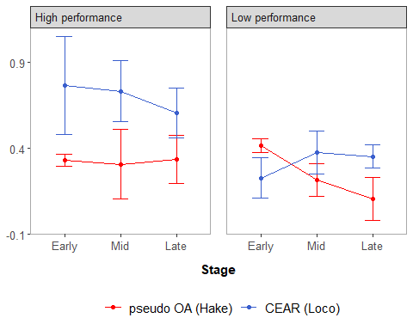

## **5. Individual determinants of compliance and peer-neforcement**

### 5.a. Regressing individual compliance in peer-enforced stage on game variables (OLS)

Dependent variable:

compliance

(1)

(2)

(3)

(4)

avg.comp.non.enf

0.83***

0.96***

0.94***

0.92***

(0.04)

(0.04)

(0.04)

(0.04)

avg.oth.comp.prev

-0.32***

0.29***

-0.16***

0.07

(0.06)

(0.05)

(0.06)

(0.07)

punished.prev.round

-9.11

-4.59

5.93

17.49*

(5.88)

(4.61)

(6.96)

(9.53)

punished.prev.prev.round

4.59

3.91

-2.87

7.92

(4.46)

(5.07)

(7.16)

(9.13)

report.prev.round

4.04

1.07

13.32***

2.90

(4.63)

(3.85)

(5.12)

(6.29)

peer.enf.rounds

0.92*

-0.82**

-0.40

-0.88

(0.48)

(0.40)

(0.50)

(0.62)

Constant

39.36***

-1.51

21.71***

5.82

(5.58)

(3.23)

(5.17)

(4.11)

Observations

300

300

300

300

R2

0.58

0.75

0.63

0.52

Adjusted R2

0.57

0.75

0.62

0.51

Residual Std. Error (df = 293)

22.88

21.06

24.37

30.07

F Statistic (df = 6; 293)

66.89***

148.81***

83.01***

53.44***

Note:

*p<0.1;* ***p<0.05;*** p<0.01

Robust standard errors

### 5.b. Regressing individual compliance in peer-enforced stage on game variables (OLS with individual random effects)

Dependent variable:

compliance

(1)

(2)

(3)

(4)

avg.comp.non.enf

0.79***

1.00***

0.88***

0.86***

(0.11)

(0.07)

(0.09)

(0.14)

avg.oth.comp.prev

0.01

0.20***

0.02

0.13

(0.09)

(0.07)

(0.09)

(0.09)

punished.prev.round

-2.22

-1.29

11.53**

7.83

(3.26)

(3.84)

(4.70)

(5.17)

punished.prev.prev.round

11.93***

7.71*

3.03

-0.17

(3.43)

(4.08)

(5.15)

(4.95)

report.prev.round

-0.12

1.07

6.61

-2.76

(3.22)

(3.90)

(4.78)

(5.37)

peer.enf.rounds

0.41

-0.90**

-0.58

-0.94**

(0.35)

(0.37)

(0.43)

(0.39)

Constant

18.89**

0.99

14.50**

7.55

(9.50)

(4.64)

(6.45)

(8.45)

Observations

300

300

300

300

Log Likelihood

-1,293.26

-1,313.78

-1,347.29

-1,343.79

Akaike Inf. Crit.

2,604.51

2,645.56

2,712.58

2,705.59

Bayesian Inf. Crit.

2,637.63

2,678.68

2,745.70

2,738.71

Note:

*p<0.1;* ***p<0.05;*** p<0.01

### 5.c. Regressing individual reports on game variables (Probit)

## Warning: glm.fit: fitted probabilities numerically 0 or 1 occurred

Dependent variable:

report

(1)

(2)

(3)

(4)

avg.comp.non.enf

-0.01

-0.01

-0.01

-0.04***

(0.01)

(0.01)

(0.01)

(0.01)

neg.comp.inspected.deviation

0.001

0.01

-0.02

0.02

(0.01)

(0.01)

(0.01)

(0.01)

pos.comp.inspected.deviation

-0.03

-0.02

-0.04**

0.01

(0.02)

(0.02)

(0.02)

(0.01)

diff.comp.group.comp.prev

0.01

-0.002

0.02**

0.01

(0.01)

(0.01)

(0.01)

(0.01)

avg.oth.comp.prev

0.02

0.01*

0.003

0.01

(0.02)

(0.01)

(0.01)

(0.01)

punished.prev.round

0.48

-0.07

-1.29*

-0.49

(0.57)

(0.62)

(0.76)

(0.58)

punished.prev.prev.round

-0.64

0.19

-6.36

0.29

(0.82)

(0.47)

(395.61)

(0.53)

peer.enf.rounds

-0.09

0.002

0.14**

-0.13*

(0.07)

(0.05)

(0.06)

(0.07)

Constant

0.34

-0.70**

-0.36

0.39

(0.97)

(0.35)

(0.57)

(0.59)

Observations

57

99

82

90

Log Likelihood

-30.86

-56.91

-38.57

-34.67

Akaike Inf. Crit.

79.71

131.81

95.14

87.34

Note:

*p<0.1;* ***p<0.05;*** p<0.01

### 5.d. Regressing individual reports on game variables (Probit with individual random effects)

## Warning in checkConv(attr(opt, "derivs"), opt$par, ctrl = control$checkConv, :  
## Model failed to converge with max|grad| = 0.0450486 (tol = 0.002, component 1)

Dependent variable:

report

(1)

(2)

(3)

(4)

avg.comp.non.enf

0.01

0.002

0.01

-0.10***

(0.02)

(0.01)

(0.02)

(0.002)

neg.comp.inspected.deviation

-0.004

0.02

-0.004

0.05***

(0.01)

(0.01)

(0.02)

(0.002)

pos.comp.inspected.deviation

-0.03

-0.03

-0.03

-0.01***

(0.03)

(0.02)

(0.02)

(0.002)

diff.comp.group.comp.prev

-0.004

-0.01

0.01

0.04***

(0.01)

(0.01)

(0.01)

(0.002)

punished.prev.round

0.09

0.39

-0.62

-1.15***

(0.82)

(1.11)

(1.16)

(0.002)

Constant

0.88

-0.86

-1.43

-0.07***

(1.04)

(0.63)

(1.46)

(0.002)

Observations

57

99

82

90

Log Likelihood

-29.09

-50.31

-38.21

-24.31

Akaike Inf. Crit.

72.18

114.61

90.42

62.62

Bayesian Inf. Crit.

86.48

132.78

107.27

80.12

Note:

*p<0.1;* ***p<0.05;*** p<0.01