**No association between cooperative strategies elicited in a public good game and *MAOA-*uVNTR*, OXTR* rs53576, and *AVPR1* RS3 genetic polymorphisms.**

María Ignacia Rivera-Hechem1, Carlos Rodríguez-Sickert1, Ricardo Andrés Guzmán1, Tadeo Ramírez1, Felipe Benavides2, Víctor Landaeta1, Mauricio Aspé-Sánchez1, and Gabriela Repetto2.

1 Centro de Investigación en Complejidad Social (CICS), Facultad de Gobierno, Universidad del Desarrollo, Santiago, Chile.

2 Centro de Genética y Genómica, Facultad de Medicina, Universidad del Desarrollo, Santiago, Chile.

3 Facultad de Medicina, Universidad del Desarrollo, Santiago, Chile.

**Abstract:**

The understanding of the genetics underlying human sociality has been encouraged by the diversity and heritability of social traits like cooperation. Most studies researching genes associated with cooperative behavior use actions to characterize cooperative phenotypes. Yet, actions result from multiple cognitive processes that are not always under the experimenter's control and which can involve multiple biological pathways. In this study, we characterize cooperative phenotypes as the strategies that subjects display in a public good game. Measuring strategies rather than actions allows to collect data over the entire decision space, control for subjects’ expectations, and to differentiate between different cooperative preferences. We tested whether cooperative strategies are associated with three candidate genetic polymorphisms — MAOA-uVNTR, OXTR rs53576, and AVPR1 RS3 in a Latino-admix sample (n= 188). We found no association among the displayed cooperative strategies and genetic variability for any of the studied polymorphisms. Our results suggest that refining measurements of cooperative phenotypes is not enough to overcome the inherent statistical power problem of candidate gene studies.

1. **Introduction**

The puzzle of why and when people are willing to cooperate, bearing individual costs in the pursuit of collective benefit, has been a major focus in the social and natural sciences (Cosmides and Tooby, 1992; Fehr and Schurtenberger, 2018; Kasper et al., 2017; Rand and Nowak, 2013). Although cooperation is widespread among humans, there exists considerable diversity in cooperative behaviors (Fischbacher et al., 2001; Kurzban and Houser, 2001; Sutter and Untertrifaller, 2020). Evidence supporting the heritability of social behaviors has encouraged the understanding of the genetics underlying this diversity (Cesarini et al., 2008; 2009; Hiraishi et al., 2015). Despite the efforts spent in finding genes associated with cooperation and related behaviors such as trust, reciprocity, and altruism, this task has remained elusive (Kasper et al., 2017).

Existing literature heavily relies on studies testing the association between prosocial phenotypes and a handful of candidate polymorphisms (i.e. candidate genes studies) (Aspé-Sánchez et al., 2016; Ebstein et al., 2010). Results from these studies are inconsistent and usually fail in replicability (Benjamin et al., 2012a; Chabris et al., 2012; Duncan and Keller, 2011; Hewitt et al., 2012). The most accepted explanation for the lack of robust findings is that most candidate gene studies lack statistical power given the small effects that single polymorphisms have on complex social traits (Benjamin et al., 2012b; Chabris et al, 2013, 2015; Visscher et al., 2017). Nonetheless, the lack of robust associations could also be a consequence of confounded measurements of cooperative phenotypes. This possibility has been mostly overlooked in the literature.

A common approach to characterize social phenotypes is to measure actions displayed in incentivized tasks designed based on game theory (see **Table 1** for a summary of this literature). Yet, actions displayed in these tasks result from the interaction of multiple cognitive processes. For example, in tasks for which the outcome is given by the simultaneous decisions of multiple players, actions will be influenced by the expectations that subjects hold about others' behaviors (Andreozzi et al., 2020). Additionally, in tasks involving repeated decisions, actions will be influenced by learning (Gächter and Thöni, 2005). Expectations and learning are likely to involve different neural networks and structures (Declerck and Boone, 2018). Therefore, unpacking cooperative traits into more elementary constructs could help elucidate associations with particular polymorphisms (Gottesman and Gould, 2003).

Strategies, for instance, are game-theoretic constructs that are independent of learning and expectations. A strategy is a player’s contingent plan specifying her actions in response to every possible action of the other players. Heterogeneity in cooperative strategies among humans has been widely documented (Fischbacher et la., 2001; Thöni and Volk, 2018). Most people show a preference for conditional cooperation (i.e. they cooperate if others do so), while others tend to free-ride no matter what others do. In situations where others’ actions are unknown, conditional cooperators choose their actions based on their expectations about others’ decisions (Fehr and Schurtenberger et al., 2018). Therefore, if only actions are observed, as has been done in most candidate gene studies, it is not possible to discriminate between conditional cooperators and free riders. This differentiation is possible, however, if incentivized tasks are designed to elicit strategies rather than actions (Fischbacher et al., 2001).

Recent evidence supports the heritability of cooperative strategies (Hiraishi et al., 2015) and sheds light on its neurological basis (Baumgartner et al., 2019). To our knowledge, only Mertins et al., (2013) have reported a polymorphism associated with cooperative strategies; *MAOA*-uVNTR, located in the gene coding for monoamine oxidase A which metabolizes monoamine neurotransmitters. This polymorphism presents variants that lead to a lower expression (MAOA-L) or higher expression (MAOA-H) of monoamine oxidase A (Sabol et al., 1998). Mertins et al. (2013) found that women with MAOA-L variants are less likely to behave like free-riders than MAOA-H carriers. Similarly, it has been observed that women carrying MAOA-L variants cooperate more in repeated interactions (Mertins et al., 2011) and that MAOA-L genotypes correlate with social sensitivity (Way & Lieberman., 2010).

Other polymorphisms that are commonly associated with social behaviors are in genes encoding receptors for oxytocin and vasopressin, which are two neurotransmitters highly linked to sociality (Bachner-Melman & Ebstein, 2014). The single nucleotide polymorphism rs53576in *OXTR* and the microsatellite RS3 in *AVPR1a* have emerged as promising candidates for social behavior. Individuals homozygous for the G allele (GG) of *OXTR* rs53576 show higher levels of empathy (Gong et al., 2017), sociality (Tost et al., 2010; Li et al., 2015), and higher levels of trust (Niahina et al., 2015) compared to individuals with one or two copies of the A allele (AA/AG). The G allele has also been suggested to modulate the effect of oxytocin in cooperative interactions (Feng et al., 2015). Length polymorphisms of *AVPR1a* RS3 also correlate with social traits related to cooperation. For instance, individuals with relatively long repeats in *AVPR1a* RS3 show increased altruism (Knafao et al., 2008; Wang et al., 2016), but less trust and reciprocity (Nishina et al., 2019).

We aim to explore whether more precise measures of cooperative phenotypes — strategies rather than actions — support the replicability and robustness of previous observations. We replicate Mertins et al., (2013) analysis by testing the association between cooperative strategies and *MAOA-*uVNTR polymorphism in a Latino-admixed population and extend it by including *OXTR* rs53576, and *AVPR1a* RS3as candidate polymorphisms (n=188). Based on previous observations, we expected free-riding strategies to be less frequent for MAOA-L women and GG genotypes. We also expected an association between cooperative strategies and *AVPR1a* RS3 variants. Our results did not replicate results by Mertins et al. (2013) and show no association between cooperative strategies and any of the studied polymorphisms.

1. **Methods**

**II.a. Subjects and recruitment**

Our sample consisted of 200 Chilean undergraduate students (18 to 25 years old, women = 109) from Universidad del Desarrollo (UDD), in Santiago, Chile. The sample is representative of a Latino-admixed population (Eyheramendy et al., 2015). Recruitment was performed by emailing all students an invitation to participate in a study about genetics and decision-making, as well as via posters posted on campus. Volunteers filled out an online form with their contact information and time availability. The only inclusion criterion was to be an undergrad student at UDD.

**II.b. Experimental procedures**

We conducted 10 sessions in a computer laboratory at UDD, between June and September 2013. Subjects were cited to an experimental session via email and were offered a show-up fee of $2.500 CLP plus additional earnings from the decision task. In each session, 20 students entered the room and seated in front of an individual computer. The facilitator informed the subjects that their participation would consist of playing a four-person public good game (PGG) and providing a saliva sample after. Subjects were also informed that decisions would be recorded anonymously and that they could leave the experiment at any moment. The game was programmed in z-Tree (Fischbacher, 2007) and communication during the game was not allowed. A printed copy of the instructions of the game was handed to each participant and the facilitator read them aloud at the beginning of the session (**S1 Text**). Examples of outcomes were shown, and questions were answered aloud before the game started. Our protocol was approved by the ethics committee of research at UDD.

In the game, subjects were individually endowed with 20 tokens (valued $250 CLP) and had to privately decide how many tokens to contribute to the public good and how many to keep for themselves. Contributions to the public good were duplicated and divided into equal parts among the four members in the group, regardless of how many each member contributed. The game’s payoff function was:

Where is the final payoff of subject *I,* ∈ {0,1, ..., 20} is the contribution of individual *i* to the public good, and ∈ {0,1, ..., 20} is the contribution of each member of the group. As the marginal gain of contributing one token to the public good is 0.5 while the marginal gain of keeping it is one, we expected no contributions to the public good under the assumption of self-interested, profit-maximizing individuals.

We used the PGG game protocol developed by Fischbacher et al., (2001) in which subjects are asked to make two types of decisions: an “uninformed contribution” and a “contingent contribution”. The “uninformed contribution” was the answer to the question: You have 20 tokens; how many tokens will you contribute to the public good? (**S2 Figure**). This question did not provide subjects with information about what other members of the group were contributing. Consequently, this decision involved individual expectations about others’ contributions. Instead, the “contingent contribution” required the subject to fill out a table in which she or he answered how many, from her or his 20 tokens, would contribute to the public good given the scenario in which the other members of the group would contribute an average of tokens (rounded to the integer), with ∈ {0,1, 2...20} (**S3 Figure**). The answer to this question elicited subjects’ cooperative strategies avoiding the confounding effects of intertemporal strategies, learning or expectations about others' cooperative behavior.

After subjects completed their contribution decisions, they were randomly and anonymously matched in groups of four by the software. The uninformed contributions of three random players in the group were averaged and rounded to the integer to obtain which was then employed to find the contribution of the fourth player based on her or his contingent contribution. This provided the total contribution to the public good and individual payoffs were calculated. This procedure ensured that both answers were incentive compatible as both could be considered to calculate individual payoffs.

Saliva samples were collected at the end of the session using the commercial kit of 23andMe ®. Each subject provided a sample in a tube labeled with the same identification code under which her or his answers in the game were recorded. Subjects collected their profits privately in a separate room.

**II.c. Genotyping**

DNA could only be extracted from 188 samples (women = 107). The three polymorphisms of interest were amplified by polymerase chain reaction using the primers and reaction conditions, as described in these protocols. Sequencing revealed four alleles for *MAOA*-uVNTR in our sample presenting 3.5, 4.5, 5.5, and 6.5 repeats (**S4 Table**). These alleles correspond respectively to the 3, 4, 5, and 6 repeats alleles observed in previous studies (Das et al., 2006). Given the low frequencies of the 5.5 and 6.5 repeats alleles in our sample, we excluded their carriers from the analysis of this polymorphism. Since the *MAOA* gene is in the X chromosome, men only present one allele for *MAOA*-uVNTR, therefore genotypes for men are 4.5 and 3.5 repeats equivalent to the MAOA-H and MAOA-L, respectively (Sabol et al., 1998). In the case of women, one of the two X chromosomes in somatic cells becomes transcriptionally inactive early in development (Lyon, 1994). We cannot determine which of the alleles is being expressed in women that are heterozygous for *MAOA*-uVNTR, therefore we excluded them from the analysis. This left us with two analyzable genotypes of *MAOA-*uVNTR in women — 4.5/4.5 and 3.5/3.5 repeats — equivalent to the MAOA-H and MAOA-L variants, respectively (Sabol et al., 1998). Consequently, genotypes for u-VNTR MAOA were coded under “MAOA-H” or “MAOA-L” in both women and men.

Genotypes for *OXTR* rs53576 were coded as “GG”, “GA”, and “AA”. Alleles for *AVPR1a* RS3 were classified as “Short” if they were between 324 bp to 341 bp long and as “Long” if they were between 342 bp to 356 bp long (**S5 Table**). This cutoff was established to ensure that both groups were balanced in the number of observations. This classification method is often used for microsatellite repeats due to a usually high number of low‐frequency alleles (Knafao et al., 2008). Genotypes for the RS3 *AVPR1a* were coded as “Short/Short”, “Short/Long” and “Long/Long”.

The resulting genotype distribution is not at Hardy-Weinberg equilibrium for rs53576 OXTR (X2 = 5.29, p = 0.02), but it does satisfy Hardy-Weinberg equilibrium for RS3 AVPR1a (X2 = 2.84, p = 0.09) (**S6 and S7 Table** show genotype distributions for women and men) .

**II.d. Cooperative strategies**

We classified each subject’s cooperative strategy into four types using the following classification algorithm. First, subjects whose maximum contribution in the contingent contribution table was below or equal to 20% of the endowment (4 tokens) were considered as free riders (FR). For strategies that did not enter the FR category, we ran Spearman rank correlations between the subject’s contingent contribution and the others’ hypothetical average contribution including each entry in the contingent contribution table sequentially. These strategies were classified as hump-shaped (HS) if they showed at least one positive-to-negative change in the sign of their Spearman correlation coefficient at a 1% significance level. The remaining strategies were classified as conditional cooperators (CC) if they displayed a significant positive Spearman coefficient (at a 1% significance level). Following Fischbacher et al., (2001), we classified all the strategies that did not fall into FR, HS, or CC as others (OT). The OT category consists of strategies that presented miscellaneous patterns of contributions, including unconditional cooperation (three players) (see **S7 Figure** for individual OT strategies). We ran robustness checks with different FR classification criteria which considered subjects whose maximum contribution in the contingent contribution table was below or equal to 10% and 30% of the endowment.

**II.d. Statistical analysis**

We ran all our analysis separately for each sex since previous studies suggest sex-specific associations (Mertin et al., 2013; Nishina et al., 2019). We applied a Bonferroni correction to correct for multiple hypotheses testing in each set of analyses. Associations between polymorphisms and cooperative strategies were tested using a Fisher exact test (α = 0.008 given six hypotheses). Additionally, to test the relationship between specific genotypes and cooperative strategies we ran a multinomial logistic regression model with bootstrapped standard errors for each polymorphism. Then, we calculated the marginal effects of each genotype on the probability of a subject displaying a given cooperative preference (α = 0.00125 given 40 hypotheses).

Following Mertins et al., (2013) we also tested whether mean conditional contribution differed between genotypes under three cooperative scenarios. The “low contributions scenario” corresponds to the first seven entries in the contingent contribution table (i.e. when the mean hypothetical others’ contribution goes from 0 to 6 tokens), the “mid contributions scenario” corresponds to the next seven entries in the table (i.e. when the mean hypothetical others’ contribution goes from 7 to 13 tokens), and the “high contributions scenario” corresponds to the last seven entries in the table (i.e. when the mean hypothetical others’ contribution goes from 14 to 20 tokens). We ran Kruskal-Wallis rank tests to test significant differences in mean contribution between genotypes for each polymorphism under the three scenarios (α = 0.003 given 18 hypotheses).

Finally, we tested whether uninformed contributions significantly differed between genotypes for each polymorphism using a Kruskal-Wallis rank test (α = 0.008 given six hypotheses). All analyses were run in R Studio v1.1.456 (R Development Core Team, 2020) except multinomial logistic regressions which were run in Stata v.12.0. Data and code are available at <https://github.com/ignacia-rivera/genetics_coop>.

**Results**

The distribution of cooperative strategies is presented in **Table 2**. No significant difference was observed in the distribution of cooperative strategies between women and men (p = 0.545, two-sided Fisher test). The average profile for each type of strategy is shown in **Figure 1**. On average, the strategy of CCs deviates from the diagonal (perfect conditional cooperation) downwards displaying a self-serving bias.

The distribution of cooperative strategies for each genotype is shown in **Figure 2.** No association between cooperative strategies and any of the polymorphisms was found, neither for women nor men (p ≥ 0.145, two-sided Fisher exact test). This result holds for classification criteria that use a cutoff of 10 and 30% of the endowment to characterize the FR strategy. Our regression analysis confirmed this result since no genotype was found to have a significant effect on the probability of a subject displaying a particular type of strategy after correcting for multiple hypotheses testing (p ≥ 0.01 with α = 0.00125, dy/dx from multinomial logistic regression, **S4 and S5 Tables**).

Some differences between genotypes were observed in their average strategy (**Figure 3**). For *OXTR* rs53756, AA women contributed more, on average, in mid contribution scenarios relative to other genotypes, while men carriers of the G allele were more cooperative in low contribution scenarios compared to AA men. Females carrying Long and Short copies for *AVPR1a* RS3 reduced their levels of contribution once others’ average contribution reached approximately 9 tokens relative to the homozygous types. Among men, Long/Long genotypes of *AVPR1a* RS3 presented strategies that were more self-serving compared to strategies of Short alleles carriers. MAOA-L women displayed strategies with higher contributions in low cooperation scenarios relative to MAOA-H women. In the case of men, MAOA-L showed higher contribution levels than MAOA-H in scenarios of high contribution. Despite these observed patterns, we found no statistically significant differences between genotypes regarding their mean contingent contribution under different cooperative scenarios (p ≥ 0.025 with α = 0.003, Kruskal-Wallis rank test). No significant differences in uninformed contributions were found between genotypes for any of the polymorphisms neither for women nor men (p ≥ 0.18, Kruskal-Wallis).

**Discussion**

Unlike most candidate gene studies investigating associations with actions, we tested whether candidate polymorphisms are associated with strategies. Our results showed no association between cooperative strategies and the three studied polymorphisms: *MAOA-*uVNTR, and *OXTR* rs53576, *AVPR1 RS3*. Therefore, our findings did not replicate previous results by Mertins et al. (2013) for MAOA-uVNTR and did not match expected associations based on previous results linking *OXTR* rs53576, and *AVPR1* RS3with sociality. This suggests that when cooperative phenotypes are measured more precisely as strategies —which provide a less confounded measurement of cooperative preferences than actions— associations with candidate polymorphisms cannot be consistently replicated in small samples (n <= 188). This goes in line with the consensus amongst geneticists that no single polymorphism can explain a meaningful part of the variance observed in humans social traits (Benjanim et al., 2012a; 2012b; Hewitt et al., 2012; Visscher et al., 2017; Chabris et al., 2012; 2013; 2015; Okbay and Rietveld , 2015).

We characterize cooperative phenotype as subjects’ strategies in a PGG using the protocol by Fischbacher et al. (2001). Results for this method have been replicated in samples across the world, showing that the most prevalent strategy is CC (Thöni & Volk, 2018). To our knowledge, we report the first application of this protocol to elicit cooperative strategies in a Latino-admixed sample. We replicated the main finding that the most frequent strategy is CC in both women and men, with frequencies that fall within the range of previous studies (from around 40% to 70% of trials; Thöni & Volk, 2018). Typically, studies find that the second most frequent strategy is FR; in our sample, however, the second most frequent strategy was HS. Nonetheless, the frequencies we found for both HS and FR fall within the ranges observed in previous studies (Thöni & Volk, 2018). We found a high number of strategies that could not be categorized within the CC, FR, or HS categories (i.e. around 34% for women and 24% for men), which we classified as OT. The share of OT observed in our sample is high compared to most previous studies, but still within the ranges reported by other researchers (e.g. Gächter et al., 2017). The high number of OT in our sample relative to other studies can be due to differences in classification criteria as well as in populations. Overall, our behavioral results replicate broader strategies’ patterns found in previous studies and therefore, provide a robust characterization of cooperative preferences.

The strategy method purposely minimizes the effect that others have on individual decisions to elicit a controlled measure of cooperative preferences. Yet, cooperative interactions also involves social cognitive processes such as emotion recognition (Elfenbein et al., 2007; Krumhuber et al., 2007), empathy and theory of mind (Sally and Hill, 2006; Paal and Bereczkei, 2007), social communication (Miller et al., 2002), and social reward seeking (Haas et al., 2013). All of those are excluded from our measurement of cooperation and could be influenced by the polymorphisms studied here. Indeed, a study by Mertins et al. (2011) suggests that variation in MAOA correlates with differences in expectations about others’ behaviors, and variations in *OXTR* polymorphism have been associated with empathy (Luo et al., 2015) and social reward (Baumgartner et al. 2008; see Aspé-Sánchez et al., 2016). Furthermore, observations suggest that empathy and perspective taking mediate the effects of *OXTR* polymorphisms on prosocial behavior (Christ et al., 2016). This highlights the importance of disentangling the multiple cognitive phenomena involved in complex behaviors such as cooperation when aiming to link them to distant genotype.

At least, three reasons can explain the lack of replicability and mismatch with previous related observations. First, our Latino-admixed population differs, both genetically and environmentally, from the Caucasian and Asian populations commonly studied in similar candidate gene studies (see **Table 1**). Variability in associations between populations can arise due to differences in gene-environment interactions (Plomin et al., 2008). Indeed, social behaviors are largely influenced by culture and group behavior which can mask genetic influences differentially across populations (Henrich, 2015). Different patterns of linkage disequilibrium can also explain differences in gene-trait associations across populations (Ioannidis et al., 2007).

A second possible explanation for our null results is a real disconnection between the three studied polymorphisms and cooperative traits. Despite having selected our candidate polymorphisms based on an exhaustive literature review on the neurogenetics of sociality, new evidence has come to question common findings in this body of research. In particular, serious methodological concerns question the validity of several observations linking oxytocin with trust, which is one of the most studied associations in social neuroscience (McCullough et al., 2013; Nave tal., 2015; Leng et al., 2016; Walum et al., 2016). For instance, the association between exogenous intranasal oxytocin and higher levels of trust (Kosfeld et al., 2005; Baumgartner et al., 2008) and the correlation between trust and oxytocin plasma levels (Zak et al., 2005) has been poorly replicated (Nave et al., 2015; Mierop et al., 2020). Lack of robust results linking trust with *OXTR* has also been evidenced in candidate gene studies. While Kruger et al., (2012) reported a significant association between *OXTR* rs53576 and investments in a trust game, Apicella et al., (2010) reported no association in a larger sample (N = 684). Moreover, many results of candidate gene studies including those looking at social traits, are thought to be false positives since most of them do not account for family-wise error (see **Table 1;** Okbay and Rietveld, 2015). Indeed, if we had not corrected for multiple hypotheses testing, we would have observed misleading significant associations. All this demonstrates the susceptibility of candidate gene studies to fall into biases by following genes and polymorphisms overrepresented in the literature and underscores the value of publishing null results.

The third and most likely explanation for the lack of associations observed in our study is insufficient statistical power. In theory, more precise measurements of social phenotypes should increase a study’s capacity to detect associations between genes and social traits. Nonetheless, our results suggest that increasing precision in the characterization of cooperative phenotypes is not enough to overcome the inherent statistical power problem of candidate gene studies. This detection problem is fundamentally due to the small effects that single genes have on social complex behaviors which would require massive sample sizes to be detected. For this reason, geneticists have seriously come to question the value of candidate gene studies in understanding the underlying genetics of complex social behaviors (Hewitt et al., 2012; Chabris et al., 2015; Benjamin et al., 2012; Chabris et al., 2013). Successful candidate gene studies require large enough sample sizes and candidate polymorphisms that have a credible high prior probability of being associated with the trait of interest (Okbay and Rietveld, 2015; Chabris et al., 2015).

Therefore, there is still a need to better understand the links between genotype and cooperation using approaches with higher statistical power before implementing promising candidate genes studies. Genome-wide association studies (GWAS) ―which simultaneously explore thousands of polymorphisms while accounting for family-wise error― have a lot to offer in terms of pointing to potentially relevant genetic variants (Duncan et al., 2019; Linnér et al., 2019; Okbay et al., 2016; Rietveld et al., 2013; Sniekers et al., 2017). Nonetheless, GWAS directly exploring cooperation are still lacking and those looking into similar prosocial constructs have not found promising associations (Benjamin et al., 2012b; de Moor et al., 2012). Studies involving neuroimaging and neurotransmitter measurements are also promising to identify neurobiological pathways involved in cooperative decision making (Brunnlieb et al., 2016; Wang et al., 2016). These studies can further point to promising candidate genes by narrowing down the neural structures, molecules, and networks involved in cooperative decisions.

We explored whether refining the measurement of cooperative phenotypes could increase a study’s capacity to detect associations between candidate polymorphisms and cooperation. Our results suggest that this approach alone cannot solve the inherent statistical power problem of candidate gene studies. Nonetheless, in GWAS, the refinement of the cognitive constructs and their proper measurement is still a promising approach to improve our ability to detect genes associated with complex behaviors. Better measurements can be informed by novel designs in experimental economics and psychology that allow unpacking decisions involving multiple cognitive phenomena like the strategy method implemented in our study.

**References**

1. Andreozzi, L., Ploner, M., & Saral, A. S. (2020). The stability of conditional cooperation: beliefs alone cannot explain the decline of cooperation in social dilemmas. Scientific reports, 10(1), 1-10.
2. Apicella, C. L., Cesarini, D., Johannesson, M., Dawes, C. T., Lichtenstein, P., Wallace, B., ... & Westberg, L. (2010). No association between oxytocin receptor (OXTR) gene polymorphisms and experimentally elicited social preferences. PloS one, 5(6), e11153.
3. Aspé-Sánchez, M., Moreno, M., Rivera, M. I., Rossi, A., & Ewer, J. (2016). Oxytocin and vasopressin receptor gene polymorphisms: role in social and psychiatric traits. Frontiers in neuroscience, 9, 510.
4. Bachner-Melman, R., & Ebstein, R. P. (2014). The role of oxytocin and vasopressin in emotional and social behaviors. In Handbook of clinical neurology (Vol. 124, pp. 53-68). Elsevier.
5. Baumgartner, T., Heinrichs, M., Vonlanthen, A., Fischbacher, U., and Fehr, E. (2008). Oxytocin shapes the neural circuitry of trust and trust adaptation in humans. Neuron 58, 639–650. doi: 10.1016/j.neuron.2008.04.009
6. Baumgartner, T., Dahinden, F. M., Gianotti, L. R., & Knoch, D. (2019). Neural traits characterize unconditional cooperators, conditional cooperators, and noncooperators in group‐based cooperation. Human brain mapping, 40(15), 4508-4517.
7. Benjamin, D. J., Cesarini, D., Chabris, C. F., Glaeser, E. L., Laibson, D. I., Age, G., ... & Smith, A. V. (2012a). The promises and pitfalls of genoeconomics. Annual Review of Economics, 4, 627- 662.
8. Benjamin, Daniel J., et al. The genetic architecture of economic and political preferences. Proceedings of the National Academy of Sciences 109.21 (2012b): 8026-8031.
9. Brunnlieb, C., Nave, G., Camerer, C. F., Schosser, S., Vogt, B., Münte, T. F., & Heldmann, M. (2016). Vasopressin increases human risky cooperative behavior. Proceedings of the National Academy of Sciences, 113(8), 2051-2056.
10. Cesarini, D., Dawes, C. T., Fowler, J. H., Johannesson, M., Lichtenstein, P., & Wallace, B. (2008). Heritability of cooperative behavior in the trust game. Proceedings of the National Academy of sciences, 105(10), 3721-3726.
11. Cesarini, D., Dawes, C. T., Johannesson, M., Lichtenstein, P., & Wallace, B. (2009). Genetic variation in preferences for giving and risk taking. The Quarterly Journal of Economics, 12
12. Chabris, Christopher F., et al. "Most reported genetic associations with general intelligence are probably false positives." Psychological science 23.11 (2012): 1314-1323.4(2), 809-842.
13. Chabris, C. F., Lee, J. J., Benjamin, D. J., Beauchamp, J. P., Glaeser, E. L., Borst, G., ... & Laibson, D. I. (2013). Why it is hard to find genes associated with social science traits: Theoretical and empirical considerations. American journal of public health, 103(S1), S152-S166.
14. Chabris, Christopher F., et al. "The fourth law of behavior genetics." Current Directions in Psychological Science 24.4 (2015): 304-312.
15. Christ, C. C., Carlo, G., & Stoltenberg, S. F. (2016). Oxytocin receptor (OXTR) single nucleotide polymorphisms indirectly predict prosocial behavior through perspective taking and empathic concern. Journal of personality, 84(2), 204-213.
16. Cosmides, L., & Tooby, J. (1992). Cognitive adaptations for social exchange. The adapted mind: Evolutionary psychology and the generation of culture, 163, 163-228.
17. Das, M., Das Bhowmik, A., Sinha, S., Chattopadhyay, A., Chaudhuri, K., Singh, M., & Mukhopadhyay, K. (2006). MAOA promoter polymorphism and attention deficit hyperactivity disorder (ADHD) in Indian children. American Journal of Medical Genetics Part B: Neuropsychiatric Genetics, 141(6), 637-642.
18. Declerck, C. H., & Boone, C. (2018). The neuroeconomics of cooperation. Nature human behaviour, 2(7), 438-440.
19. De Moor, M. H., Costa, P. T., Terracciano, A., Krueger, R. F., De Geus, E. J., Toshiko, T., ... & Amin, N. (2012). Meta-analysis of genome-wide association studies for personality. Molecular psychiatry, 17(3), 337-349.
20. Duncan, L. E., & Keller, M. C. (2011). A critical review of the first 10 years of candidate gene-by-environment interaction research in psychiatry. American Journal of Psychiatry, 168(10), 1041-1049.
21. Duncan, L. E., Ostacher, M., & Ballon, J. (2019). How genome-wide association studies (GWAS) made traditional candidate gene studies obsolete. Neuropsychopharmacology, 44(9), 1518-1523.
22. Ebstein, R. P., Israel, S., Chew, S. H., Zhong, S., & Knafo, A. (2010). Genetics of human social behavior. Neuron, 65(6), 831-844.
23. Elfenbein H. A., Foo M. D., White J., Tan H. H., Aik V. C. (2007). Reading your counterpart: the benefit of emotion recognition accuracy for effectiveness in negotiation. J. Nonverbal. Behav. 31, 205–223 10.1007/s10919-007-0033-7
24. Eyheramendy, S., Martinez, F. I., Manevy, F., Vial, C., & Repetto, G. M. (2015). Genetic structure characterization of Chileans reflects historical immigration patterns. Nature communications, 6(1), 1-10.
25. Fehr, E., & Schurtenberger, I. (2018). Normative foundations of human cooperation. Nature Human Behaviour, 2(7), 458-468.
26. Feng, C., Lori, A., Waldman, I. D., Binder, E. B., Haroon, E., & Rilling, J. K. (2015). A common oxytocin receptor gene (OXTR) polymorphism modulates intranasal oxytocin effects on the neural response to social cooperation in humans. Genes, Brain and Behavior, 14(7), 516-525.
27. Fischbacher, U. (2007). z-Tree: Zurich toolbox for ready-made economic experiments. Experimental economics, 10(2), 171-178.
28. Fischbacher, U., Gächter, S., & Fehr, E. (2001). Are people conditionally cooperative? Evidence from a public goods experiment. Economics letters, 71(3), 397-404.
29. Gächter, S & Thöni, C. (2005). Social learning and voluntary cooperation among like-minded people. Journal of the European Economic Association, 3(2-3), 303-314.
30. Gächter, S., Kölle, F., & Quercia, S. (2017). Reciprocity and the tragedies of maintaining and providing the commons. Nature human behaviour, 1(9), 650-656.
31. Gong, P., Fan, H., Liu, J., Yang, X., Zhang, K., & Zhou, X. (2017). Revisiting the impact of OXTR rs53576 on empathy: A population-based study and a meta-analysis. Psychoneuroendocrinology, 80, 131-136.
32. Gottesman, I. I., & Gould, T. D. (2003). The endophenotype concept in psychiatry: etymology and strategic intentions. American journal of psychiatry, 160(4), 636-645.
33. Haas, B. W., Anderson, I. W., & Smith, J. M. (2013). Navigating the complex path between the oxytocin receptor gene (OXTR) and cooperation: an endophenotype approach. Frontiers in human neuroscience, 7, 801.
34. Henrich, J. (2015). Culture and social behavior. Current Opinion in Behavioral Sciences, 3, 84-89.
35. Hewitt, John K. "Editorial policy on candidate gene association and candidate gene-by-environment interaction studies of complex traits." Behavior genetics 42.1 (2012): 1-2.
36. Hiraishi, K., Shikishima, C., Yamagata, S., & Ando, J. (2015). Heritability of decisions and outcomes of public goods games. Frontiers in psychology, 6, 373.
37. Ioannidis, J. P., Patsopoulos, N. A., & Evangelou, E. (2007). Heterogeneity in meta-analyses of genome-wide association investigations. PloS one, 2(9), e841.
38. Kasper, C., Vierbuchen, M., Ernst, U., Fischer, S., Radersma, R., Raulo, A., ... & Taborsky, B. (2017). Genetics and developmental biology of cooperation. Molecular ecology, 26(17), 4364-4377.
39. Knafo, A., Israel, S., Darvasi, A., Bachner‐Melman, R., Uzefovsky, F., Cohen, L., ... & Nemanov, L. (2008). Individual differences in allocation of funds in the dictator game associated with length of the arginine vasopressin 1a receptor RS3 promoter region and correlation between RS3 length and hippocampal mRNA. Genes, brain and behavior, 7(3), 266-275.
40. Krumhuber E., Manstead A. S., Cosker D., Marshall D., Rosin P. L., Kappas A. (2007). Facial dynamics as indicators of trustworthiness and cooperative behavior. Emotion 7, 730–735 10.1037/1528-3542.7.4.730
41. Kosfeld, M., Heinrichs, M., Zak, P. J., Fischbacher, U., & Fehr, E. (2005). Oxytocin increases trust in humans. Nature, 435(7042), 673-676.
42. Krueger, F., Parasuraman, R., Iyengar, V., Thornburg, M., Weel, J., Lin, M., ... & Lipsky, R. (2012). Oxytocin receptor genetic variation promotes human trust behavior. Frontiers in human neuroscience, 6, 4.
43. Kurzban, R., & Houser, D. (2001). Individual differences in cooperation in a circular public goods game. European Journal of Personality, 15(S1), S37-S52.
44. Leng, G., & Ludwig, M. (2016). Intranasal oxytocin: myths and delusions. Biological psychiatry, 79(3), 243-250.
45. Li, J., Zhao, Y., Li, R., Broster, L. S., Zhou, C., & Yang, S. (2015). Association of oxytocin receptor gene (OXTR) rs53576 polymorphism with sociality: a meta-analysis. PloS one, 10(6), e0131820.
46. Linnér, R. K., Biroli, P., Kong, E., Meddens, S. F. W., Wedow, R., Fontana, M. A., ... & Nivard, M. G. (2019). Genome-wide association analyses of risk tolerance and risky behaviors in over 1 million individuals identify hundreds of loci and shared genetic influences. Nature genetics, 51(2), 245-257.
47. Luo, S., Li, B., Ma, Y., Zhang, W., Rao, Y., and Han, S. (2015). Oxytocin receptor gene and racial ingroup bias in empathy-related brain activity. Neuroimage 110, 22–31. doi: 10.1016/j.neuroimage.2015.01.042
48. Lyon, M. F. (1994). X-chromosome inactivation. In Molecular Genetics of Sex Determination (pp. 123-142). Academic Press.
49. McCullough, M. E., Churchland, P. S., & Mendez, A. J. (2013). Problems with measuring peripheral oxytocin: can the data on oxytocin and human behavior be trusted?. Neuroscience & Biobehavioral Reviews, 37(8), 1485-1492.
50. Mertins, V., Schote, A. B., Hoffeld, W., Griessmair, M., & Meyer, J. (2011). Genetic susceptibility for individual cooperation preferences: the role of monoamine oxidase A gene (MAOA) in the voluntary provision of public goods. PLoS One, 6(6), e20959.
51. Mertins, V., Schote, A. B., & Meyer, J. (2013). Variants of the Monoamine Oxidase A gene (MAOA) predict free-riding behavior in women in a strategic public goods experiment. Journal of neuroscience, psychology, and economics, 6(2), 97.
52. Meyer-Lindenberg, A., Kolachana, B., Gold, B., Olsh, A., Nicodemus, K. K., Mattay, V., ... & Weinberger, D. R. (2009). Genetic variants in AVPR1A linked to autism predict amygdala activation and personality traits in healthy humans. Molecular psychiatry, 14(10), 968-975.
53. Mierop, A., Mikolajczak, M., Stahl, C., Béna, J., Luminet, O., Lane, A., & Corneille, O. (2020). How can intranasal oxytocin research be trusted? A systematic review of the interactive effects of intranasal oxytocin on psychosocial outcomes. Perspectives on Psychological Science, 1745691620921525.
54. Miller J. H., Butts C. T., Rode D. (2002). Communication and cooperation. J. Econ. Behav. Organ. 47, 179–195 10.1016/S0167-2681(01)00159-7
55. Nave, G., Camerer, C., & McCullough, M. (2015). Does oxytocin increase trust in humans? A critical review of research. Perspectives on Psychological Science, 10(6), 772-789.
56. Nishina, K., Takagishi, H., Inoue-Murayama, M., Takahashi, H., & Yamagishi, T. (2015). Polymorphism of the oxytocin receptor gene modulates behavioral and attitudinal trust among men but not women. PloS one, 10(10), e0137089.
57. Nishina, K., Takagishi, H., Takahashi, H., Sakagami, M., & Inoue-Murayama, M. (2019). Association of polymorphism of arginine-vasopressin receptor 1A (AVPR1a) gene with trust and reciprocity. Frontiers in human neuroscience, 13, 230.
58. Okbay, A., & Rietveld, C. A. (2015). On improving the credibility of candidate gene studies: A review of candidate gene studies published in Emotion. Emotion, 15(4), 531.
59. Okbay, A., Baselmans, B. M., De Neve, J. E., Turley, P., Nivard, M. G., Fontana, M. A., ... & Gratten, J. (2016). Genetic variants associated with subjective well-being, depressive symptoms, and neuroticism identified through genome-wide analyses. Nature genetics, 48(6), 624-633.
60. Plomin, R., DeFries, J. C., Knopik, V. S., and Neiderhiser, J. M. (2008). Behavioral Genetics, 5th Edn. New York, NY: Worth Publishers.
61. R Core Team (2020). R: A language and environment for statistical computing. R Foundation for Statistical Computing, Vienna, Austria. URL: https://www.R-project.org/.
62. Rand, D. G., & Nowak, M. A. (2013). Human cooperation. Trends in cognitive sciences, 17(8), 413-425.
63. Rietveld, C. A., Medland, S. E., Derringer, J., Yang, J., Esko, T., Martin, N. W., ... & Albrecht, E. (2013). GWAS of 126,559 individuals identifies genetic variants associated with educational attainment. science, 340(6139), 1467-1471.
64. Sabol SZ, Hu S, Hamer D. A functional polymorphism in the monoamine oxidase A gene promoter. Hum Genet. 1998 Sep 1;103(3):273–9.
65. Sally D., Hill E. (2006). The development of interpersonal strategy: autism, theory-of-mind, cooperation and fairness. J. Econ. Psychol. 27, 73–97 10.1016/j.joep.2005.06.015
66. Sniekers, S., Stringer, S., Watanabe, K., Jansen, P. R., Coleman, J. R., Krapohl, E., ... & Amin, N. (2017). Genome-wide association meta-analysis of 78,308 individuals identifies new loci and genes influencing human intelligence. Nature genetics, 49(7), 1107-1112.
67. Sutter, M., & Untertrifaller, A. (2020). Children's heterogeneity in cooperation and parental background: An experimental study. Journal of Economic Behavior & Organization, 171, 286-296.
68. Tansey, K. E., Hill, M. J., Cochrane, L. E., Gill, M., Anney, R. J., & Gallagher, L. (2011). Functionality of promoter microsatellites of arginine vasopressin receptor 1A (AVPR1A): implications for autism. Molecular autism, 2(1), 3.
69. Thöni, C., & Volk, S. (2018). Conditional cooperation: Review and refinement. Economics Letters, 171, 37-40.
70. Tost, H., Kolachana, B., Hakimi, S., Lemaitre, H., Verchinski, B. A., Mattay, V. S., ... & Meyer–Lindenberg, A. (2010). A common allele in the oxytocin receptor gene (OXTR) impacts prosocial temperament and human hypothalamic-limbic structure and function. Proceedings of the National Academy of Sciences, 107(31), 13936-13941.
71. Visscher, Peter M., et al. "10 years of GWAS discovery: biology, function, and translation." The American Journal of Human Genetics 101.1 (2017): 5-22.
72. Walum, H., Waldman, I. D., & Young, L. J. (2016). Statistical and methodological considerations for Wang, J., Qin, W., Liu, F., Liu, B., Zhou, Y., Jiang, T., & Yu, C. (2016). Sex‐specific mediation effect of the right fusiform face area volume on the association between variants in repeat length of AVPR 1 A RS 3 and altruistic behavior in healthy adults. Human brain mapping, 37(7), 2700-2709. the interpretation of intranasal oxytocin studies. Biological psychiatry, 79(3), 251-257.
73. Wang, J., Qin, W., Liu, F., Liu, B., Zhou, Y., Jiang, T., & Yu, C. (2016). Sex‐specific mediation effect of the right fusiform face area volume on the association between variants in repeat length of AVPR 1 A RS 3 and altruistic behavior in healthy adults. Human brain mapping, 37(7), 2700-2709.
74. Way, B. M., & Lieberman, M. D. (2010). Is there a genetic contribution to cultural differences? Collectivism, individualism and genetic markers of social sensitivity. Social cognitive and affective neuroscience, 5(2-3), 203-211.
75. Zak, P. J., Kurzban, R., & Matzner, W. T. (2005). Oxytocin is associated with human trustworthiness. Hormones and Behavior, 48, 522–527.

**Tables**

**Table 1.** Summary of candidate gene association studies using incentivized tasks to characterize social trait.

|  |  |  |  |  |  |  |  |  |  |
| --- | --- | --- | --- | --- | --- | --- | --- | --- | --- |
| **Reference** | **Sample size** | **Population** | **Incentivized task** | **Strategic interaction?** | **Repeated?** | **Social trait** | **Candidate polymorphism** | **Result** | **Report correction family-wise error** |
| Apicella et al., 2010 | 684 | Swedish twins | Dictator game | No | No | Altruism | *OXTR* rs75775, rs53576, rs237887, rs4686302, rs237897,  rs2254298, rs2268493, rs1042778 | No association | Yes |
| Trust game | Yes | No | Trust and trustworthiness |
| Avinun et al., 2011 | 158 | Israeli preschooler twins | Dictator game | No | No | Altruism | *AVPR1A* RS3 | Associations between low altruism and target allele (327 bp) | No |
| Nishina et al., 2019 | 434 | Tokyo non-student residents | Trust game | Yes | No | Trust and reciprocity | Microsatellite in the intron of the *AVPR1a* gene | Association between trust in men as well as reciprocity, and a short form of AVPR1a polymorphism | No |
| Nishina et al., 2015 |  |  |  |  |  |  |  |  |  |
| Chen et al., 2019 |  |  |  |  |  |  |  |  |  |
| Feng et al., 2015 |  |  |  |  |  |  |  |  |  |
| Israel et al., 2009 |  |  |  |  |  |  |  |  |  |
| Knafao et al., 2008 |  |  |  |  |  |  |  |  |  |
| Krueger et al., 2012 |  |  |  |  |  |  |  |  |  |
| Mertins et al., 2011 |  |  |  |  |  |  |  |  |  |
| Mertins et al., 2013 |  |  |  |  |  |  |  |  |  |
| Reuter et al., 2013 |  |  |  |  |  |  |  |  |  |
| Schroeder et al., 2013 |  |  |  |  |  |  |  |  |  |
| Zhong et al., 2010 |  |  |  |  |  |  |  |  |  |
| Wang et al., 2016 |  |  |  |  |  |  |  |  |  |

**Table 2**. Percent distribution of cooperative strategies for women (n = 107) and men (n = 81). Considering as a FR any strategy in which the maximum contingent contribution was equal or below 20% of the endowment.

|  |  |  |
| --- | --- | --- |
| **Cooperative strategy** | **Percent of women (%)** | **Percent of men (%)** |
| CC | 44.86 | 54.32 |
| HS | 12.15 | 11.11 |
| FR | 9.35 | 9.88 |
| OT | 33.64 | 24.69 |

**Figures**

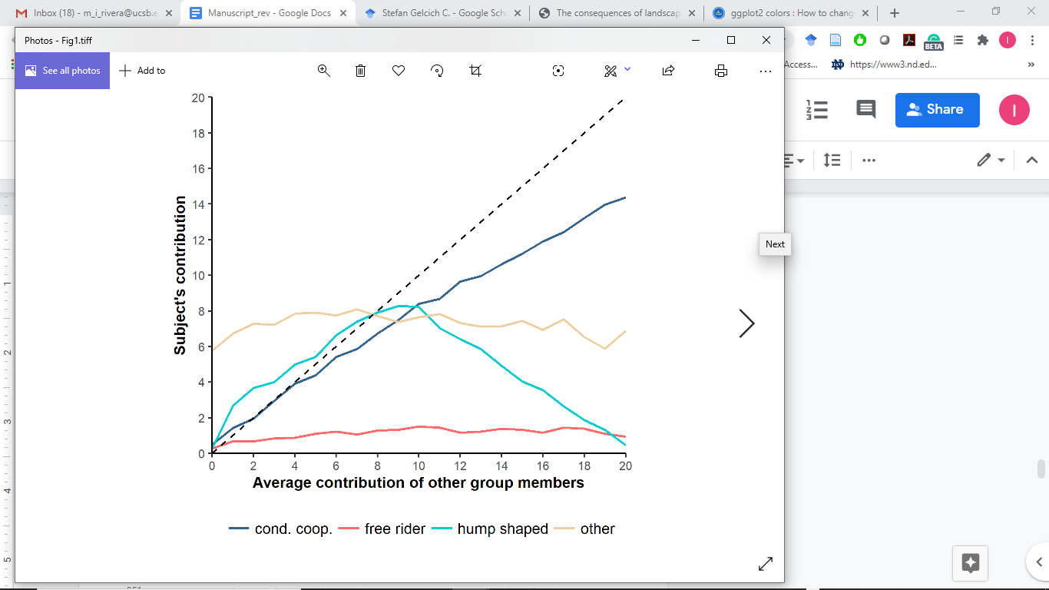**Figure 1**. Average cooperative strategy for each strategy type (n= 188); free riders (red), conditional cooperators (blue), hump shaped (cyan) and others (light brown). Dashed line represents the contribution profile of a perfect conditional cooperator.

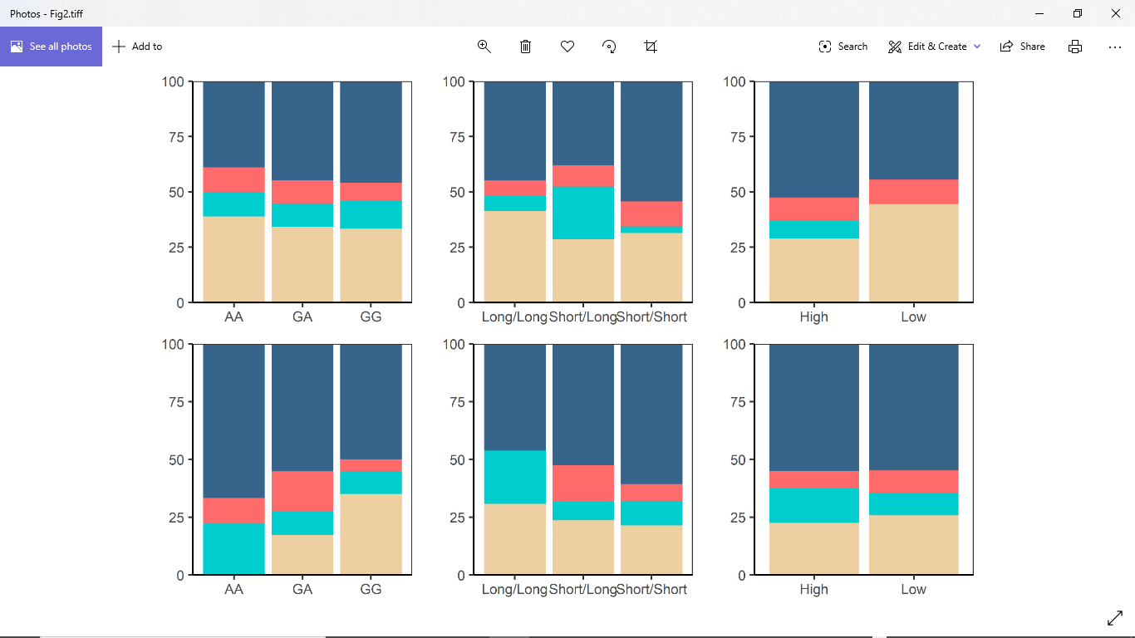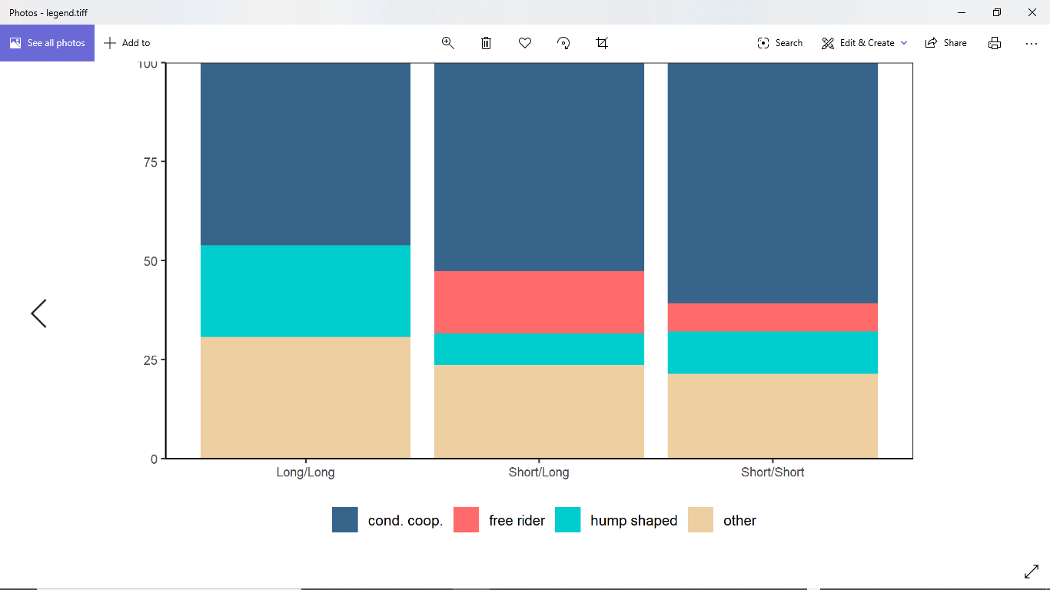

d)

e)

a)

f)

b)

c)

**Figure 2.** Percent distribution of cooperative strategies, conditional cooperators (blue), hump shaped (cyan), free riders (red) and others (light brown) in women for AA (n=18), GA (n=38), and GG (n=48) rs53576 *OXTR* genotypes (a); for Long/Long (n=29), Short/Long (n=42), and Short/Short (n=35) RS3 *AVPR1a* genotypes (b); High (n=9) and Low (n=38) *MAOA* u-VNTR genotypes in women (c). Percent distribution of cooperative strategies in men for AA (n=9), GA (n=29), and GG (n=40) rs53576 *OXTR* genotypes (d); for Long/Long (n=13), Short/Long (n=38), and Short/Short (n=28) RS3 *AVPR1a* genotypes (e); High (n=31) and Low (n=40) *MAOA* u-VNTR genotypes in women (f).

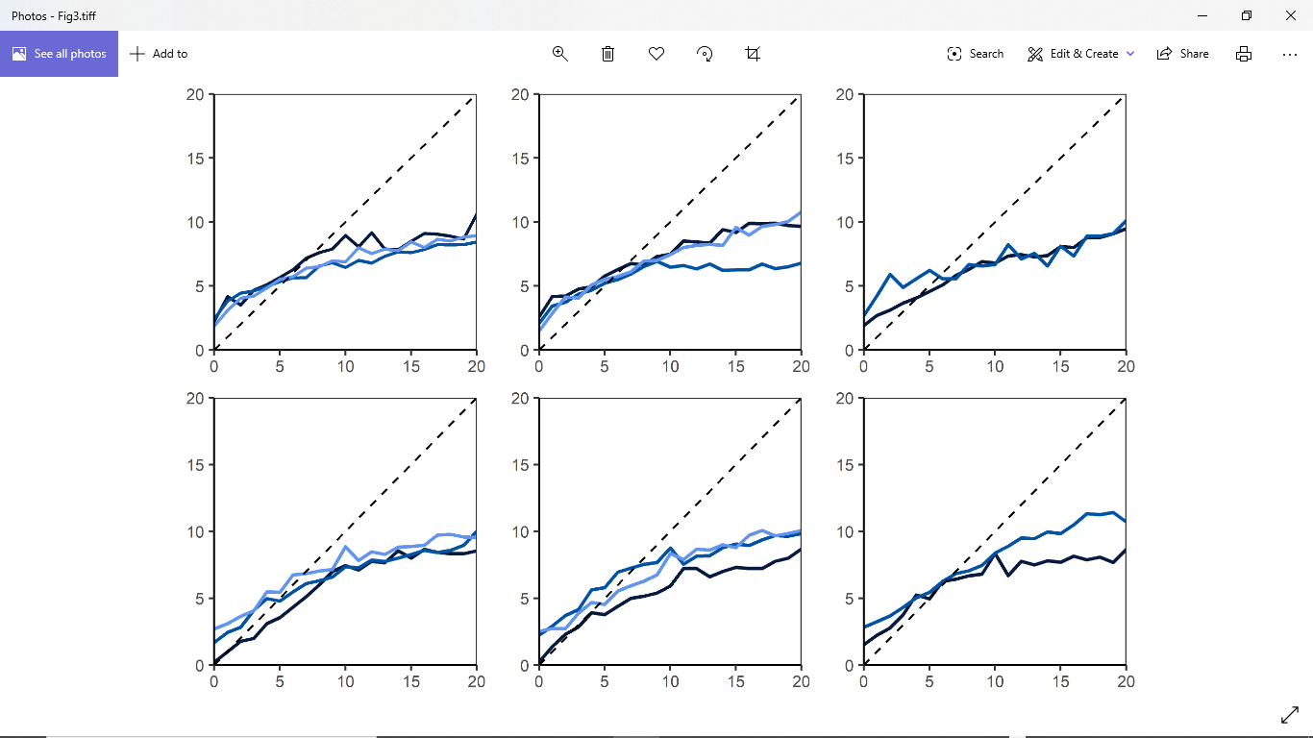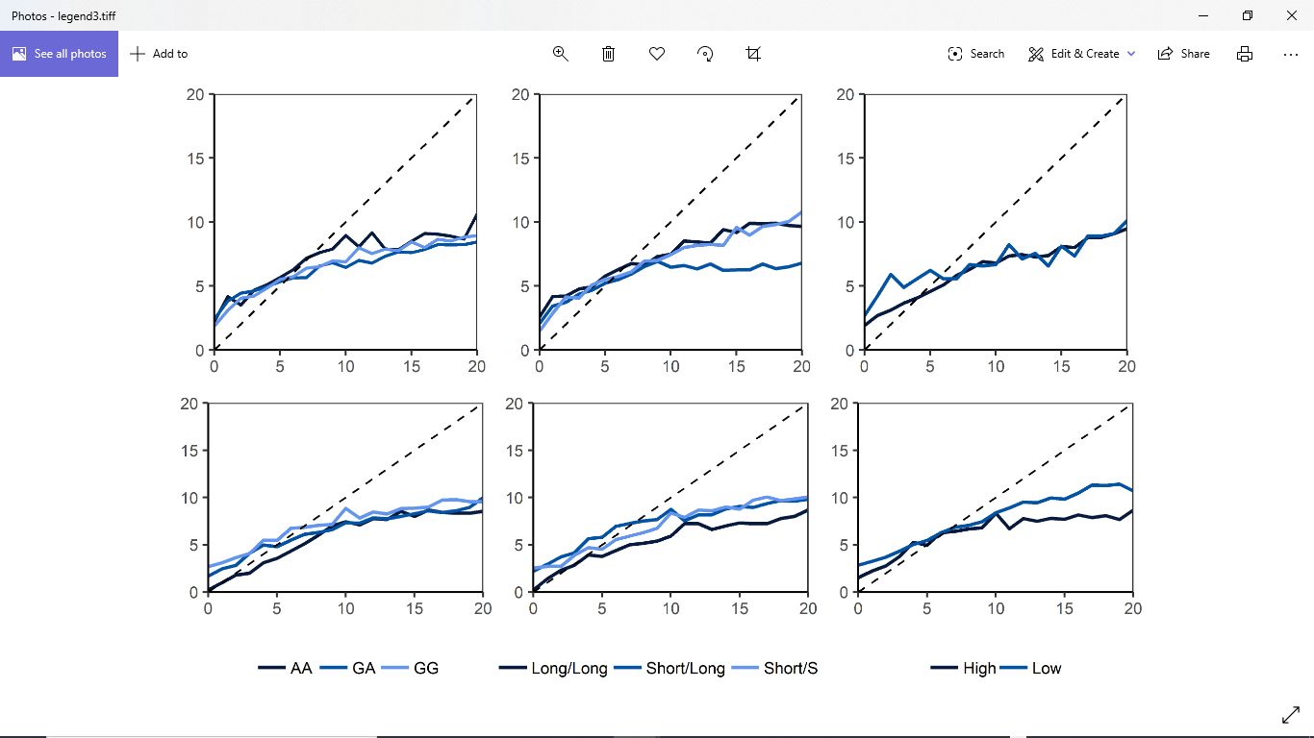

f)

e)

d)

c)

b)

a)

**Figure 3.** Average cooperative strategies per genotype for *OXTR* rs53576 (a), *AVPR1a* RS3 (b), and *MAOA* u-VNTR (c) in women, and for *OXTR* rs53576 (d), *AVPR1a* RS3 (e), and *MAOA* u-VNTR (f) in men.

**Supporting Information**

**S1 Text. Game instructions**

**S2 Figure.** Screen to ask the subjects for their uninformed contribution**.**



**S3 Figure.** Screen to ask the subjects for their contingent contribution**.**



**S4 Table**. u-VNTR MAOA allele’s frequencies.

|  |  |
| --- | --- |
| **Allele (number of repeats)** | **Frequency** |
| **3.5** | 92 |
| **4.5** | 158 |
| **5.5** | 3 |
| **6.5** | 1 |

**S5 Table.** AVPR1a RS3 allele’s frequencies and classification depending on length (number of bp).

|  |  |  |
| --- | --- | --- |
| **Allele (bp)** | **Frequency** | **Length classification** |
| **324** | 5 | Short |
| **325** | 2 |
| **326** | 1 |
| **331** | 1 |
| **333** | 1 |
| **334** | 1 |
| **335** | 18 |
| **337** | 23 |
| **338** | 2 |
| **339** | 80 |
| **341** | 72 |
| **342** | 1 | Long |
| **343** | 38 |
| **344** | 1 |
| **345** | 58 |
| **346** | 1 |
| **347** | 21 |
| **348** | 5 |
| **349** | 2 |
| **351** | 18 |
| **352** | 3 |
| **353** | 10 |
| **354** | 5 |
| **356** | 1 |

**S6 Table.** Genotypes’ relative frequencies for each polymorphism in women.

|  |  |  |  |  |  |
| --- | --- | --- | --- | --- | --- |
| ***OXTR* rs53576** | **n** | ***AVPR1* RS3** | **n** | ***MAOA* u-VNTR** | **n** |
| GG | 48 | Long/Long | 29 | 3.5/3.5 or Low | 9 |
| GA | 38 | Long/Short | 42 | 3.5/4.5 * | 41 |
| AA | 18 | Short/Short | 35 | 4.5/4.5 or High | 38 |
| Not amplified | 3 | Not amplified | 1 | Not amplified or excluded** | 19 |

* The genotype 3.5/4.5 repeats were excluded from the association analysis for *MAOA* u-VNTR polymorphisms since it is not possible to know which one is being expressed in women.

** Given the low frequencies of the 5.5 and 6.5 repeats alleles in our sample, we excluded their carriers from the association analysis for this polymorphism.

**S7 Table.** Genotypes’ relative frequencies for each polymorphism in men.

|  |  |  |  |  |  |
| --- | --- | --- | --- | --- | --- |
| ***OXTR* rs53756** | **n** | ***AVPR1* RS3** | **n** | ***MAOA* u-VNTR** | **n** |
| GG | 40 | Long/Long | 13 | 3.5 or Low | 31 |
| GA | 29 | Long/Short | 38 | 4.5 or High | 40 |
| AA | 9 | Short/Short | 28 | - | - |
| Not amplified | 3 | Not amplified | 2 | Not amplified or excluded * | 10 |

* Given the low frequencies of the 5.5 and 6.5 repeats alleles in our sample, we excluded their carriers from the association analysis for this polymorphism.

**S6 Figure.** Individual schedules for strategies categorized as others. Each plot shows the strategies of five individuals except the last one that shows six.

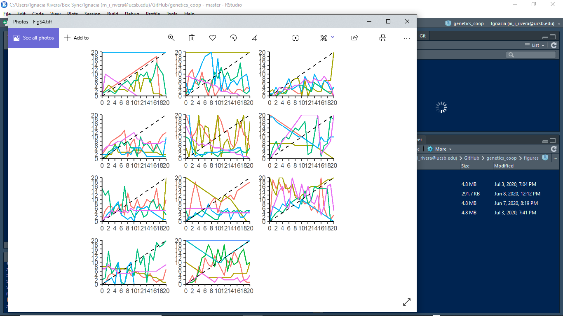

**S7 Table. Marginal effects of each genotype on each cooperative strategy in women.** Obtained from a multinomial logistic regression model for each polymorphism using cooperative strategy as dependent variable and genotypes as independent variables. For *OXTR* rs53567 AA is the baseline genotype (n=104), for *AVPR1* RS3 Long/Long is the baseline genotype (n=106), and for *MAOA* u-VNTR the Low expression is the baseline genotype (n=47).

|  |  |  |  |  |
| --- | --- | --- | --- | --- |
| **Polymorphism** | **Cooperative strategy** | **Genotype** | **Marginal effect** | **p-value** |
| *OXTR* rs53576 | CC | AG | 0.06 (*0.42* ) | 0.89 |
| GG | 0.07 (*0.38*) | 0.85 |
| HS | AG | -0.01 (*0.49*) | 0.99 |
| GG | 0.01 (*0.44*) | 0.98 |
| FR | AG | -0.01 (*0.55*) | 0.99 |
| GG | -0.03 (*0.52*) | 0.96 |
| OT | AG | -0.05 (0*.39*) | 0.91 |
| GG | -0.06 (0*.39*) | 0.87 |
| *AVPR1 RS3* | CC | Short/Long | -0.07 (*0.24*) | 0.78 |
| Short/Short | 0.09 (*0.30*) | 0.75 |
| HS | Short/Long | 0.17 (*0.32*) | 0.60 |
| Short/Short | -0.04 (*0.39*) | 0.92 |
| FR | Short/Long | 0.03 (*0.31*) | 0.93 |
| Short/Short | 0.05 (*0.41*) | 0.91 |
| OT | Short/Long | -0.13 (*0.23*) | 0.58 |
| Short/Short | -0.10 (*0.24*) | 0.679 |
| *MAOA u-VNTR* | CC | High | 0.08 (*0.99*) | 0.94 |
|
| HS | High | 0.08 (*0.04*) | 0.07 |
|
| FR | High | -0.01 (*0.85*) | 0.99 |
|
| OT | High | -0.16 (*0.77*) | 0.84 |
|

**S8 Table. Marginal effects of each genotype on each cooperative strategy in men.** Obtained from a multinomial logistic regression model for each polymorphism using cooperative strategy as dependent variable and genotypes as independent variables. For *OXTR* rs53567 AA is the baseline genotype (n=78), for *AVPR1* RS3 Long/Long is the baseline genotype (n=79), and for *MAOA* u-VNTR the Low expression is the baseline genotype (n=71).

|  |  |  |  |  |
| --- | --- | --- | --- | --- |
| **Polymorphism** | **Cooperative strategy** | **Genotype** | **Marginal effect** | **p-value** |
| *OXTR* rs53576 | CC | AG | -0.12 (*1.15*) | 0.92 |
| GG | -0.17 (*1.11*) | 0.88 |
| HS | AG | -0.12 (*1.15*) | 0.92 |
| GG | -0.12 (*1.13*) | 0.91 |
| FR | AG | 0.06 (*0.79*) | 0.94 |
| GG | -0.06 (*0.85*) | 0.94 |
| OT | AG | 0.17 (*0.09*) | 0.05 |
| GG | 0.35 (*0.14*) | 0.01 |
| *AVPR1 RS3* | CC | Short/Long | 0.07 (*0.39*) | 0.87 |
| Short/Short | 0.15 (*0.55*) | 0.79 |
| HS | Short/Long | -0.15 (*0.59*) | 0.80 |
| Short/Short | -0.12 (*0.68*) | 0.86 |
| FR | Short/Long | 0.16 (*0.08*) | 0.04 |
| Short/Short | 0.07 (*0.36*) | 0.84 |
| OT | Short/Long | -0.07 (*0.27*) | 0.79 |
| Short/Short | -0.09 (*0.34*) | 0.78 |
| *MAOA u-VNTR* | CC | High | 0.00 (0.28) | 0.99 |
|
| HS | High | 0.05 (0.21) | 0.80 |
|
| FR | High | -0.02 (0.37) | 0.95 |
|
| OT | High | -0.03 (0.16) | 0.83 |
|