The using file is “eigt_wide_viz” (in gcwealth/output/databases/website), where all variables are numeric but: GEO, applies_to, tax, currency and sources that are strings. It is a long-format on type of tax and applies to, while the plotting variables are in columns.
Important: the underlying principle is that the filtering process select ONE row per each country-year (in the case of multiple rows due to different brackets, the required values are repeated equally for each bracket). Furthermore, in the case of “estate or inheritance” filter, if a given country-year has both estate and inheritance taxes, we give priority to inheritance. In other words, the category “EI Tax” refers to a situation where both estate and inheritance tax are existing, but we consider (and plot) the information associated with inheritance tax.

Case 1. Top marginal-rates
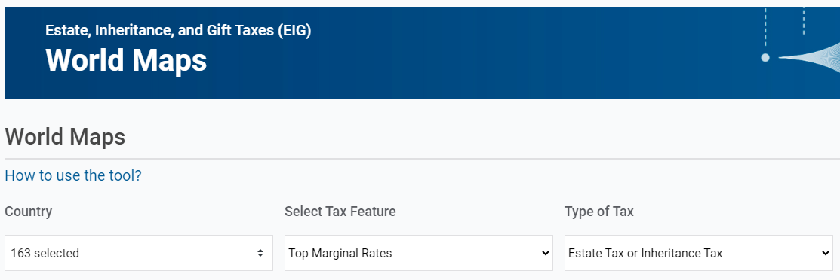
Command: (value of toprat) if tax == “ EI Tax” & status==1 & (applies_to == “children” | applies_to == “everybody”)
(In the old setting this corresponds to: Value of x_hs_rat_toprat if x_hs_cat_eigsta == “Y“)

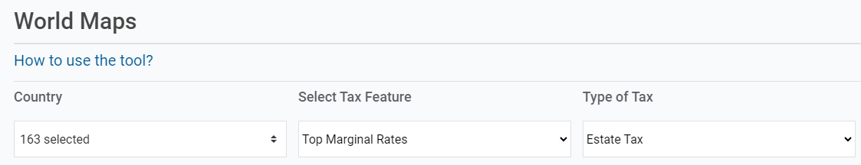
Command: (value of toprat) if tax == “Estate Tax” & status == 1 & (applies_to == “children” | applies_to == “everybody” )
(In the old setting this corresponds to: Value of x_hs_rat_etopra if x_hs_cat_eigsta == “Y“)

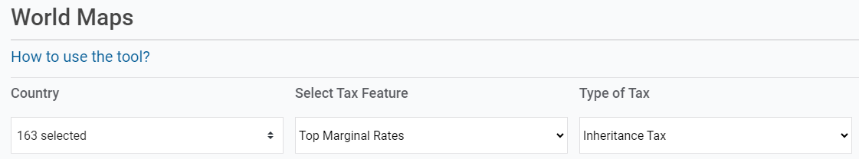
Command: (value of toprat) if tax == “Inheritance Tax” & status == 1 & (applies_to == “children” | applies_to == “everybody” )

(In the old setting this corresponds to: Value of x_hs_rat_itopra if x_hs_cat_eigsta == “Y“)
+ ADD A NEW TYPE OF TAX FILTER CALLED “Gift Tax”
Command: (value of toprat) if tax == “Gift Tax” & status == 1 & (applies_to == “children” | applies_to == “everybody” )

Case 2. Exemption Thresholds
Command: (value of exempt) if tax == “EI Tax” & status == 1 & (applies_to == “children” | applies_to == “everybody” )
(In the old setting this corresponds to: value of x_hs_thr_chiexe if x_hs_cat_eigsta == “Y“)

Command: (value of exempt) if tax == “Estate Tax” & status == 1 & (applies_to == “children” | applies_to == “everybody” )

(In the old setting this corresponds to: x_hs_thr_chiexe IF x_hs_cat_esttax == “Y“)

Command: (value of exempt) if tax == “Inheritance Tax” & status == 1 & (applies_to == “children” | applies_to == “everybody” )

(In the old setting this corresponds to: x_hs_thr_chiexe IF x_hs_cat_inhtax == “Y“)

+ ADD A NEW TYPE OF TAX FILTER CALLED “Gift Tax”
Command: (value of exempt) if tax == “Gift Tax” & status == 1 & (applies_to == “children” | applies_to == “everybody” )

Case 3 – Tax Revenues
Tax Revenues do not vary by the type of tax: they are the total EIG revenues collected.

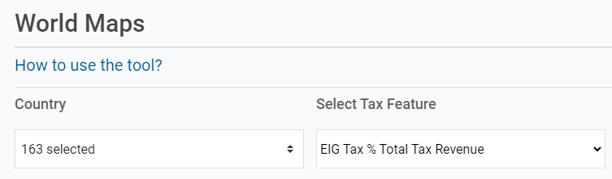
(REVENUE INFORMATION DOES NOT DEPEND ON THE TYPE OF TAX)
Command: (value of prorev) if prorev != . (i.e., we plot all non-missing values of prorev)
(In the old setting this corresponds to: value of x_hs_rto_tprrev if x_hs_cat_eigsta=="Y")

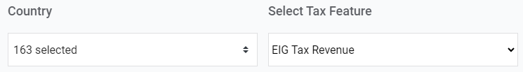
(REVENUE INFORMATION DOES NOT DEPEND ON THE TYPE OF TAX)
Command: (value of revenu) if revenu != . (i.e., we plot all non-missing values of revenu)
(In the old setting this corresponds to: value of x_hs_agg_totrev if x_hs_cat_eigsta=="Y")

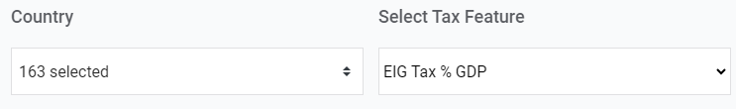
(REVENUE INFORMATION DOES NOT DEPEND ON THE TYPE OF TAX)
Command: (value of revgdp) if revgdp != . (i.e., we plot all non-missing values of revgdp)
(In the old setting this corresponds to: value of x_hs_rto_trvgdp if x_hs_cat_eigsta=="Y")

