Critical Thinking Week 6:
#1 Basic Implementation of
A
Custom LinkedList ADT

Ignacio Cerda Avalos
Colorado State University Global
CSC400: DATA STRUCTURE
AND
ALGORITHMS
Dr. Vanessa Cooper
January 20, 2026

Critical Thinking Week 6:
#1 Basic Implementation of
A
Custom LinkedList ADT
Java:
// CustomLinkedList.java
public class CustomLinkedList {

// ---------- Node class ----------
private static class Node {
int data;
Node next;

Node(int data) {
this.data = data;
}
}

private Node head; // start of the list

// ---------- Insert ----------
public void insert(int data) {
Node newNode = new Node(data);

if (head == null) {
head = newNode;
return;
}

Node current = head;
while (current.next != null) {
current = current.next;
}

current.next = newNode;
}

// ---------- Delete first occurrence ----------
public void delete(int data) {
if (head == null) return;

// If the head is the node to delete
if (head.data == data) {
head = head.next;
return;
}

Node current = head;
while (current.next != null && current.next.data != data) {
current = current.next;
}

// Found the node
if (current.next != null) {
current.next = current.next.next;
}
}

// ---------- Iterator ----------
public LinkedListIterator iterator() {
return new LinkedListIterator();
}

// ---------- Inner Iterator Class ----------
public class LinkedListIterator {
private Node current = head;

public boolean hasNext() {
return current != null;
}

public int next() {
int value = current.data;
current = current.next;
return value;
}
}

// ---------- Demo ----------
public static void main(String[] args) {
CustomLinkedList list = new CustomLinkedList();

list.insert(10);
list.insert(20);
list.insert(30);
list.insert(40);

System.out.println("List contents:");
CustomLinkedList.LinkedListIterator it = list.iterator();
while (it.hasNext()) {
System.out.print(it.next() + " ");
}

System.out.println("\n\nDeleting 20...");
list.delete(20);

System.out.println("List contents after deletion:");
it = list.iterator();
while (it.hasNext()) {
System.out.print(it.next() + " ");
}
}
}
OUTPUT:
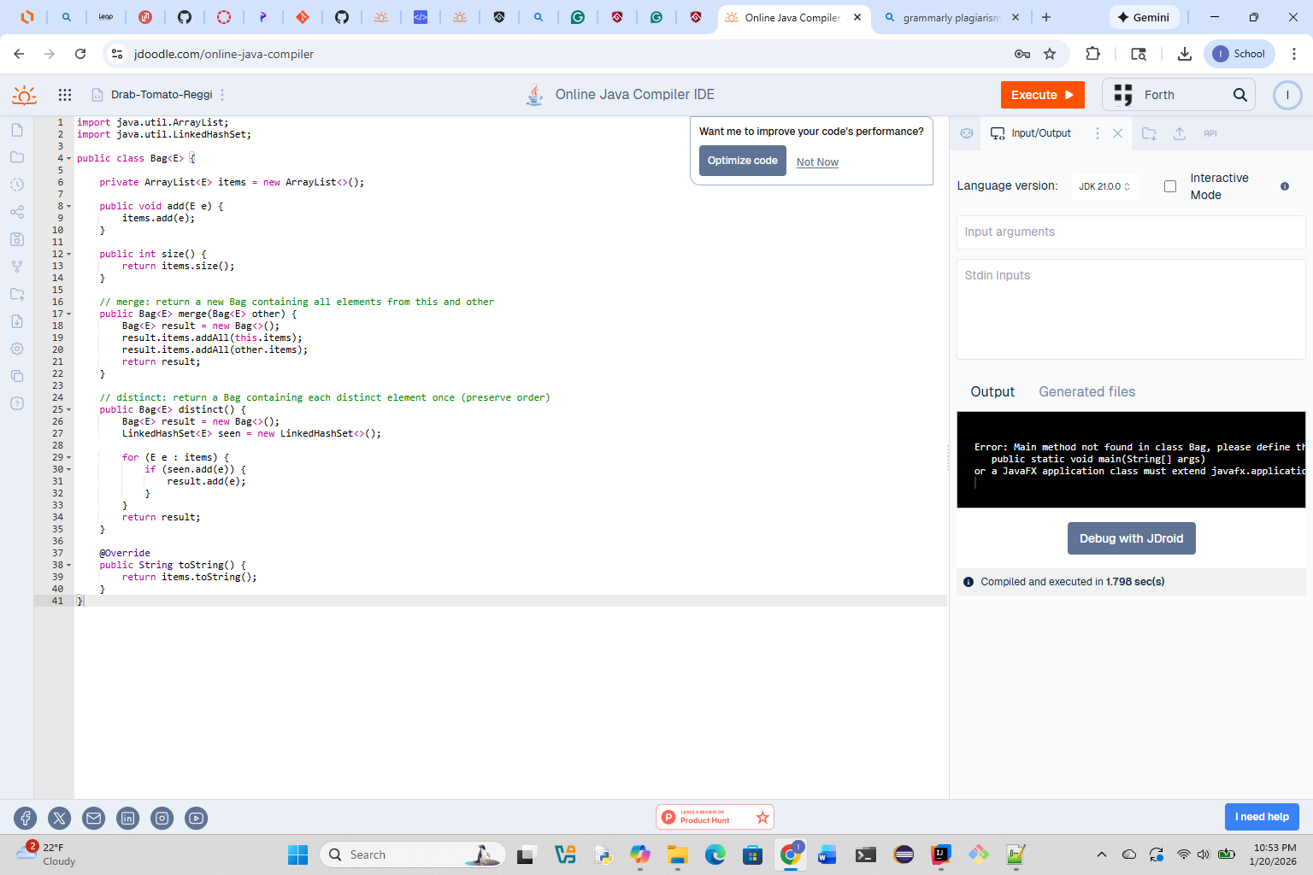
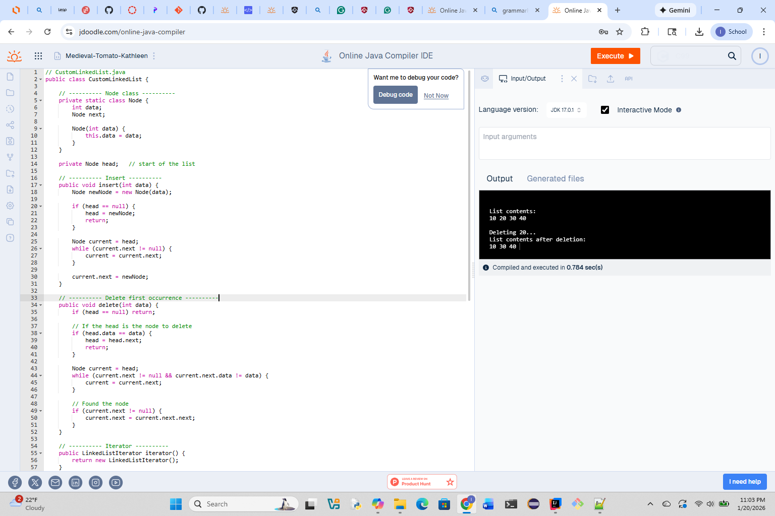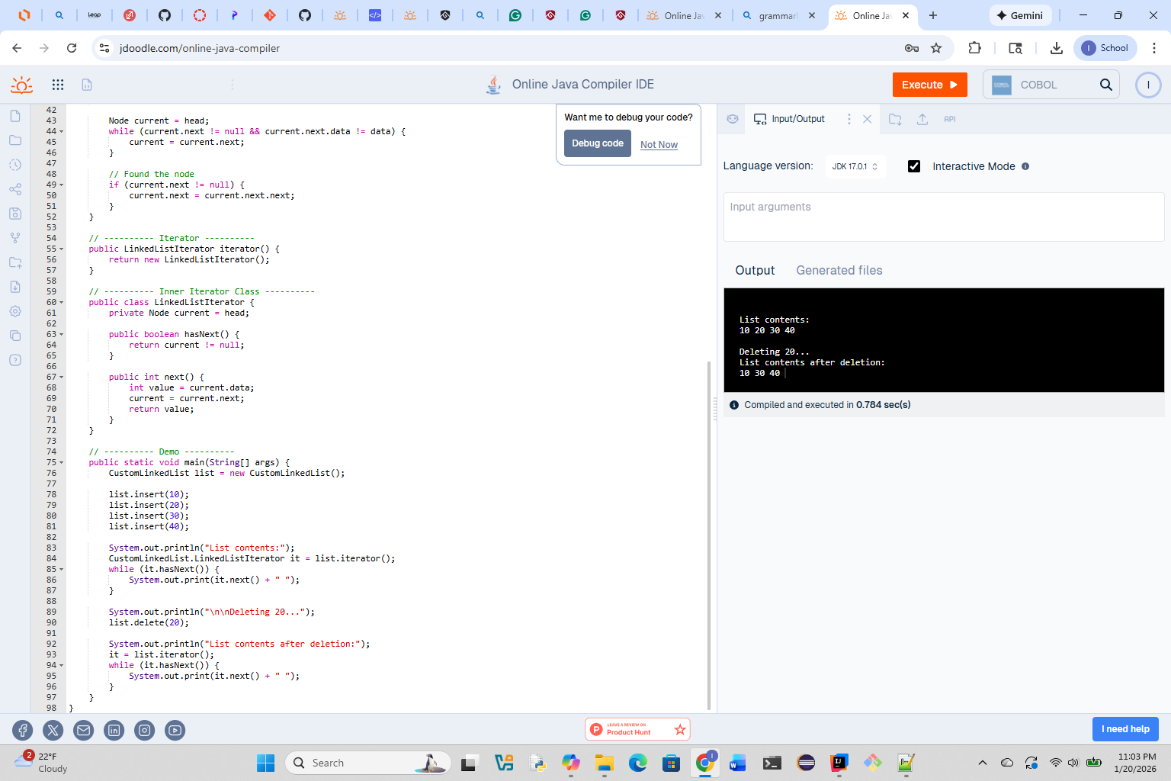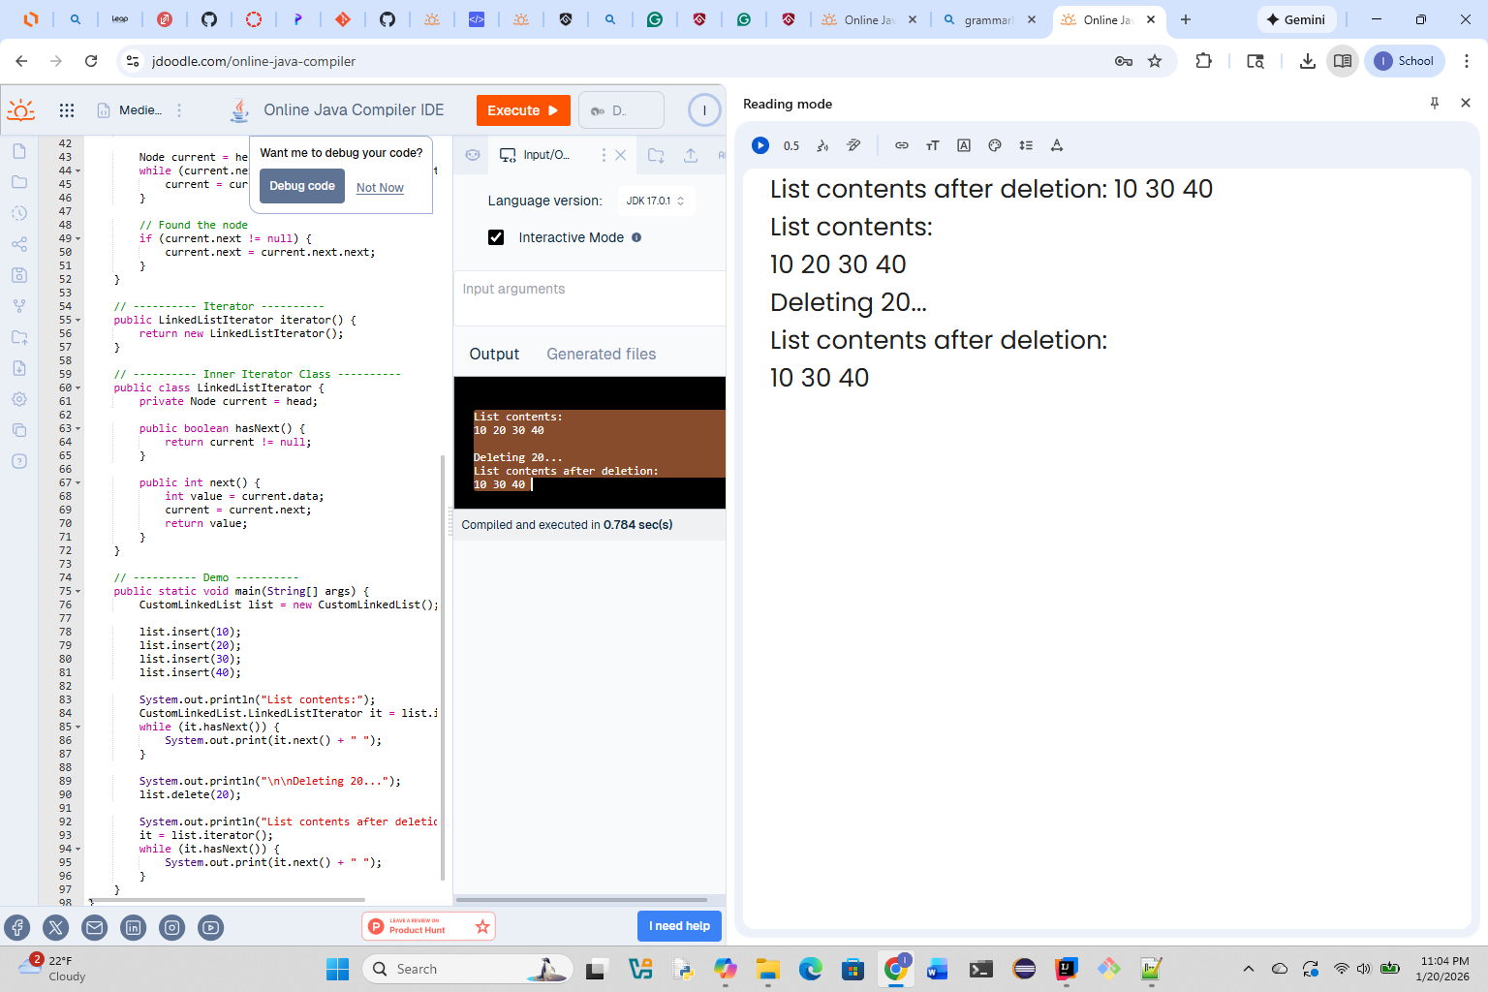
Repository:
https://github.com/ignaciocerdaavalos-create/CSC400.git
gh repo clone ignaciocerdaavalos-create/CSC400

