MODULE: 8
PORTFOLIO PROJECT

Ignacio Cerda Avalos
Colorado State University Global
CSC400: DATA STRUCTURE
AND ALGORITHMS
DR. Vanessa Cooper
February 8, 2026
MODULE 8:
PORTFOLIO PROJECT:
Option #1 Person Class

FINAL PROGRAM:
import java.util.Scanner;

class Person {
private String firstName;
private String lastName;
private int age;

public Person(String firstName, String lastName, int age) {
this.firstName = firstName;
this.lastName = lastName;
this.age = age;
}

public String getFirstName() { return firstName; }
public String getLastName() { return lastName; }
public int getAge() { return age; }

@Override
public String toString() {
return firstName + " " + lastName + " (Age: " + age + ")";
}
}

class PersonQueue {
private Person[] queue;
private int size;

public PersonQueue(int capacity) {
queue = new Person[capacity];
size = 0;
}

public void enqueue(Person p) {
if (size < queue.length) {
queue[size++] = p;
}
}

public Person[] getArray() {
return queue;
}

public void displayQueue() {
for (int i = 0; i < size; i++) {
System.out.println(queue[i]);
}
}

// QuickSort by last name (descending)
public void sortByLastName() {
quickSortLastName(queue, 0, size - 1);
}

private void quickSortLastName(Person[] arr, int low, int high) {
if (low < high) {
int pi = partitionLastName(arr, low, high);
quickSortLastName(arr, low, pi - 1);
quickSortLastName(arr, pi + 1, high);
}
}

private int partitionLastName(Person[] arr, int low, int high) {
String pivot = arr[high].getLastName();
int i = low - 1;

for (int j = low; j < high; j++) {
if (arr[j].getLastName().compareToIgnoreCase(pivot) > 0) { // descending
i++;
Person temp = arr[i];
arr[i] = arr[j];
arr[j] = temp;
}
}

Person temp = arr[i + 1];
arr[i + 1] = arr[high];
arr[high] = temp;

return i + 1;
}

// QuickSort by age (descending)
public void sortByAge() {
quickSortAge(queue, 0, size - 1);
}

private void quickSortAge(Person[] arr, int low, int high) {
if (low < high) {
int pi = partitionAge(arr, low, high);
quickSortAge(arr, low, pi - 1);
quickSortAge(arr, pi + 1, high);
}
}

private int partitionAge(Person[] arr, int low, int high) {
int pivot = arr[high].getAge();
int i = low - 1;

for (int j = low; j < high; j++) {
if (arr[j].getAge() > pivot) { // descending
i++;
Person temp = arr[i];
arr[i] = arr[j];
arr[j] = temp;
}
}

Person temp = arr[i + 1];
arr[i + 1] = arr[high];
arr[high] = temp;

return i + 1;
}
}

public class FinalProgram {
public static void main(String[] args) {
Scanner input = new Scanner(System.in);
PersonQueue queue = new PersonQueue(5);

System.out.println("Enter 5 people:");

for (int i = 0; i < 5; i++) {
System.out.print("First name: ");
String first = input.nextLine();

System.out.print("Last name: ");
String last = input.nextLine();

System.out.print("Age: ");
int age = Integer.parseInt(input.nextLine());

queue.enqueue(new Person(first, last, age));
System.out.println();
}

System.out.println("\nOriginal Queue:");
queue.displayQueue();

System.out.println("\nSorted by Last Name (Descending):");
queue.sortByLastName();
queue.displayQueue();

System.out.println("\nSorted by Age (Descending):");
queue.sortByAge();
queue.displayQueue();
}
}

OUTCOME: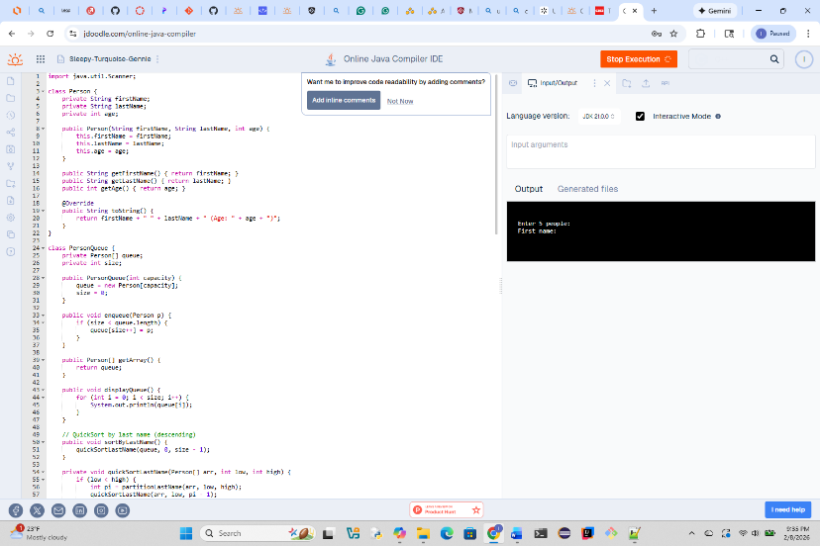
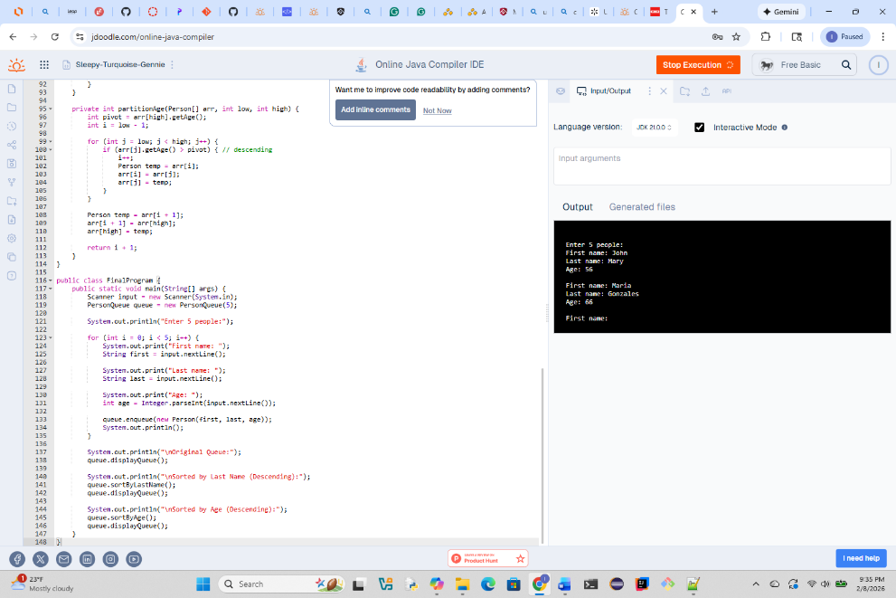

MILESTONE_1-5
JAVA:
Portfolio Milestone Module 5:
Corrections to Program 1 – Module 2
Corrections to Program 2- Module 4
Program 1/MODULE2:
BEGIN MAIN

----------------------------------------------------
// Create first bag and add elements
CREATE bag1 AS NEW Bag<String>

CALL bag1.add("apple")
CALL bag1.add("banana")
CALL bag1.add("apple")
CALL bag1.add("cherry")
CALL bag1.add("banana")

PRINT "Original bag: " + bag1
PRINT "Size: " + bag1.size()
----------------------------------------------------

// Create a distinct version of bag1
SET distinctBag = bag1.distinct()
PRINT "Distinct bag: " + distinctBag
----------------------------------------------------

// Create second bag and add elements
CREATE bag2 AS NEW Bag<String>
CALL bag2.add("date")
CALL bag2.add("apple")
----------------------------------------------------

// Merge bag2 into bag1
CALL bag1.merge(bag2)
PRINT "After merge: " + bag1
----------------------------------------------------

// Display distinct elements after merge
SET distinctAfterMerge = bag1.distinct()
PRINT "Distinct after merge: " + distinctAfterMerge
----------------------------------------------------

END MAIN
PSEUDO CODE:
CLASS Bag<T>

// Internal storage for all elements (duplicates allowed)
DECLARE items AS LIST OF T

----------------------------------------------------
METHOD add(element)
// Add a single element to the bag
ADD element TO items
END METHOD
----------------------------------------------------

METHOD size()
// Return total number of elements (including duplicates)
RETURN LENGTH OF items
END METHOD
----------------------------------------------------

METHOD merge(otherBag)
// Add all elements from another bag into this one
FOR EACH element IN otherBag.items
ADD element TO items
END FOR
END METHOD
----------------------------------------------------

METHOD distinct()
// Create a new bag containing only the first occurrence
// of each element, preserving original order

CREATE result AS NEW Bag<T>
CREATE seen AS EMPTY SET

FOR EACH element IN items
IF element NOT IN seen
ADD element TO seen
CALL result.add(element)
END IF
END FOR

RETURN result
END METHOD
----------------------------------------------------

METHOD toString()
// Return a string representation of the bag contents
RETURN STRING VERSION OF items
END METHOD

END CLASS
MILESTONE_2-4
JAVA:
Module 4:
Java:
IF expression is null OR empty AFTER trimming
THROW error "Empty expression"

CREATE an empty stack

SPLIT expression into tokens separated by whitespace

FOR each token in tokens DO

IF token represents a valid number (integer or decimal, optional +/-)
PUSH numeric value of token onto stack
CONTINUE to next token
ENDIF

IF token length is NOT 1
THROW error "Invalid token"
ENDIF

IF stack has fewer than 2 values
THROW error "Insufficient operands"
ENDIF

POP b from stack
POP a from stack

SWITCH on token character
CASE '+':
result = a + b
CASE '-':
result = a - b
CASE '*':
result = a * b
CASE '/':
IF b == 0
THROW error "Division by zero"
ENDIF
result = a / b
CASE '%':
IF b == 0
THROW error "Modulo by zero"
ENDIF
result = a % b
DEFAULT:
THROW error "Unsupported operator"
END SWITCH

PUSH result onto stack

END FOR

IF stack size is NOT exactly 1
THROW error "Invalid postfix expression"
ENDIF

RETURN the single value popped from stack

MISSING PSEUDO CODE:
IF expression is null OR empty AFTER trimming
THROW error "Empty expression"

CREATE an empty stack

SPLIT expression into tokens separated by whitespace

FOR each token in tokens DO

IF token represents a valid number (integer or decimal, optional +/-)
PUSH numeric value of token onto stack
CONTINUE to next token
ENDIF

IF token length is NOT 1
THROW error "Invalid token"
ENDIF

IF stack has fewer than 2 values
THROW error "Insufficient operands"
ENDIF

POP b from stack
POP a from stack

SWITCH on token character
CASE '+':
result = a + b
CASE '-':
result = a - b
CASE '*':
result = a * b
CASE '/':
IF b == 0
THROW error "Division by zero"
ENDIF
result = a / b
CASE '%':
IF b == 0
THROW error "Modulo by zero"
ENDIF
result = a % b
DEFAULT:
THROW error "Unsupported operator"
END SWITCH

PUSH result onto stack

END FOR

IF stack size is NOT exactly 1
THROW error "Invalid postfix expression"
ENDIF

RETURN the single value popped from stack

MAIN PROGRAM:
CREATE list of test expressions:
"3 4 +"
"12 3 /"
"5 1 2 + 4 * + 3 -"
"2 3 * 5 +"
"10 3 %"
"2 3 ^"
"1 +"
""
"5 0 /"

FOR each expression in the list DO
TRY
result = evaluatePostfix(expression)
PRINT "Expression: <expression> => Result: <result>"
CATCH any error
PRINT "Expression: <expression> => Error: <error message>"
END TRY
END FOR
Module 7:
Program 3: Module 5:
public class RadixSort {

// Returns the maximum value in the array
private static int getMax(Integer[] arr) {
int max = arr[0];
for (int num : arr) {
if (num > max) {
max = num;
}
}
return max;
}

// Counting sort used by radix sort for each digit place
private static void countingSort(Integer[] arr, int place) {
int n = arr.length;
Integer[] output = new Integer[n];
int[] count = new int[10];

// Count occurrences of each digit
for (int num : arr) {
int digit = (num / place) % 10;
count[digit]++;
}

// Convert count[] to prefix sum array
for (int i = 1; i < 10; i++) {
count[i] += count[i - 1];
}

// Build output array (stable)
for (int i = n - 1; i >= 0; i--) {
int digit = (arr[i] / place) % 10;
output[count[digit] - 1] = arr[i];
count[digit]--;
}

// Copy back to original array
System.arraycopy(output, 0, arr, 0, n);
}

// Main radix sort method
public static void radixSort(Integer[] arr) {
if (arr == null || arr.length == 0) {
return;
}

int max = getMax(arr);

// Apply counting sort for each digit place
for (int place = 1; max / place > 0; place *= 10) {
countingSort(arr, place);
}
}

// Test harness for JDoodle
public static void main(String[] args) {
Integer[] arr = {170, 45, 75, 90, 802, 24, 2, 66};

radixSort(arr);

for (int num : arr) {
System.out.print(num + " ");
}
}
Module 5:
Program 3: Module 5:
public class RadixSort {

// Returns the maximum value in the array
private static int getMax(Integer[] arr) {
int max = arr[0];
for (int num : arr) {
if (num > max) {
max = num;
}
}
return max;
}

// Counting sort used by radix sort for each digit place
private static void countingSort(Integer[] arr, int place) {
int n = arr.length;
Integer[] output = new Integer[n];
int[] count = new int[10];

// Count occurrences of each digit
for (int num : arr) {
int digit = (num / place) % 10;
count[digit]++;
}

// Convert count[] to prefix sum array
for (int i = 1; i < 10; i++) {
count[i] += count[i - 1];
}

// Build output array (stable)
for (int i = n - 1; i >= 0; i--) {
int digit = (arr[i] / place) % 10;
output[count[digit] - 1] = arr[i];
count[digit]--;
}

// Copy back to original array
System.arraycopy(output, 0, arr, 0, n);
}

// Main radix sort method
public static void radixSort(Integer[] arr) {
if (arr == null || arr.length == 0) {
return;
}

int max = getMax(arr);

// Apply counting sort for each digit place
for (int place = 1; max / place > 0; place *= 10) {
countingSort(arr, place);
}
}

// Test harness for JDoodle
public static void main(String[] args) {
Integer[] arr = {170, 45, 75, 90, 802, 24, 2, 66};

radixSort(arr);

for (int num : arr) {
System.out.print(num + " ");
}
}
Module 6:
import java.util.Scanner;

public class CustomLinkedList {

// ---------- Node class ----------
private static class Node {
int data;
Node next;

Node(int data) {
this.data = data;
}
}

private Node head; // start of the list

// ---------- Insert ----------
public void insert(int data) {
Node newNode = new Node(data);

if (head == null) {
head = newNode;
return;
}

Node current = head;
while (current.next != null) {
current = current.next;
}

current.next = newNode;
}

// ---------- Delete first occurrence ----------
public void delete(int data) {
if (head == null) return;

if (head.data == data) {
head = head.next;
return;
}

Node current = head;
while (current.next != null && current.next.data != data) {
current = current.next;
}

if (current.next != null) {
current.next = current.next.next;
}
}

// ---------- Simulated file reading (JDoodle-safe) ----------
public void loadFromString(String fileData) {
Scanner scanner = new Scanner(fileData);
while (scanner.hasNextInt()) {
insert(scanner.nextInt());
}
}

// ---------- Iterator ----------
public LinkedListIterator iterator() {
return new LinkedListIterator();
}

// ---------- Inner Iterator Class ----------
public class LinkedListIterator {
private Node current = head;

public boolean hasNext() {
return current != null;
}

public int next() {
int value = current.data;
current = current.next;
return value;
}
}

// ---------- Demo ----------
public static void main(String[] args) {
CustomLinkedList list = new CustomLinkedList();

// Simulated file contents (JDoodle cannot load external files)
String fakeFile = "10 20 30 40 50";

// Load integers as if reading from a file
list.loadFromString(fakeFile);

System.out.println("List contents:");
CustomLinkedList.LinkedListIterator it = list.iterator();
while (it.hasNext()) {
System.out.print(it.next() + " ");
}

System.out.println("\n\nDeleting 20...");
list.delete(20);

System.out.println("List contents after deletion:");
it = list.iterator();
while (it.hasNext()) {
System.out.print(it.next() + " ");
}
}
}

