Module 2: Critical Thinking:
String Input Console Application

Ignacio Cerda Avalos
Colorado State University Global
CSC450: PROGRAMMING III
Professor Jack Li
May 3, 2026

Module 2: Critical Thinking:
Integer Pointers Program

Pseudo Code:
START
Declare three integer variables: a, b, c
Ask the user to enter three integers
Store the inputs into a, b, c

Create three integer pointers using dynamic memory:
p1 = new int
p2 = new int
p3 = new int
Store the values of a, b, c into the memory pointed to by p1, p2, p3
Display:
The values of a, b, c
The values stored in *p1, *p2, *p3
The memory addresses stored in p1, p2, p3
Use delete to free the dynamic memory:
delete p1
delete p2
delete p3
Set pointers to nullptr
END

Source Code:
#include <iostream>
using namespace std;

int main() {
// Step 1: Variables
int a, b, c;

cout << "Enter three integer values: ";
cin >> a >> b >> c;

// Step 2: Dynamic memory allocation
int* p1 = new int;
int* p2 = new int;
int* p3 = new int;

// Step 3: Store values in dynamic memory
*p1 = a;
*p2 = b;
*p3 = c;

// Step 4: Display results
cout << "\n--- Variable Values ---\n";
cout << "a = " << a << endl;
cout << "b = " << b << endl;
cout << "c = " << c << endl;

cout << "\n--- Pointer Values (Dereferenced) ---\n";
cout << "*p1 = " << *p1 << endl;
cout << "*p2 = " << *p2 << endl;
cout << "*p3 = " << *p3 << endl;

cout << "\n--- Pointer Memory Addresses ---\n";
cout << "p1 = " << p1 << endl;
cout << "p2 = " << p2 << endl;
cout << "p3 = " << p3 << endl;

// Step 5: Free memory
delete p1;
delete p2;
delete p3;

// Step 6: Avoid dangling pointers
p1 = nullptr;
p2 = nullptr;
p3 = nullptr;

return 0;
}

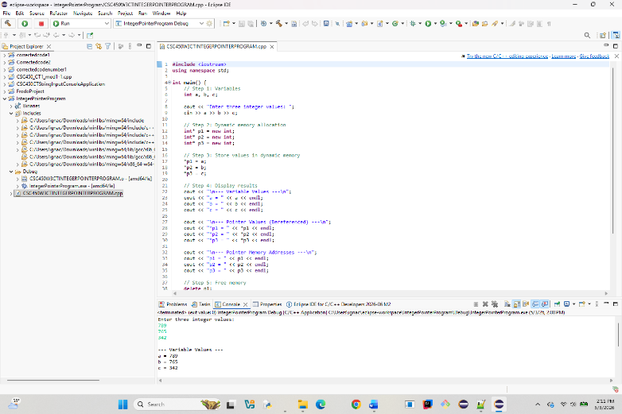
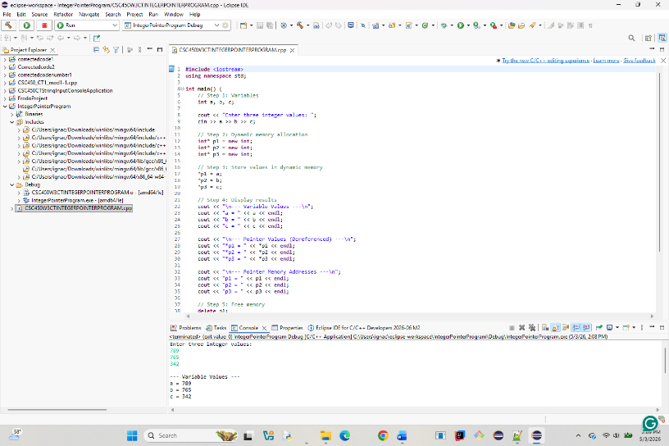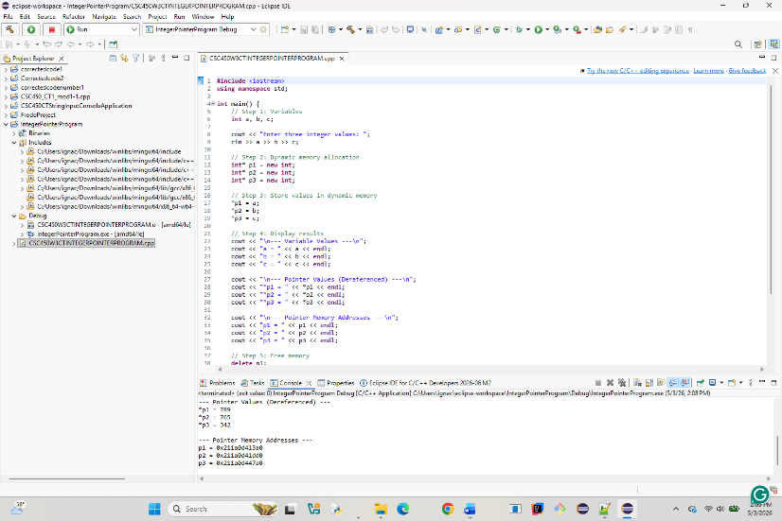

REPOSITORY:
https://github.com/ignaciocerdaavalos-create/CSC450.git

