Module 2: Critical Thinking:
String Input Console Application

Ignacio Cerda Avalos
Colorado State University Global
CSC450: PROGRAMMING III
Professor Jack Li
April 26, 2026

Module 2: Critical Thinking:
String Input Console

Pseudo Code:
BEGIN PROGRAM

FOR counter FROM 1 TO 3 DO
DISPLAY "Enter first string: "
READ string1

DISPLAY "Enter second string: "
READ string2

concatenatedString ← string1 + string2

DISPLAY "Concatenated result: " + concatenatedString
END FOR

END PROGRAM

Source Code:
#include <iostream>
#include <string>
using namespace std;

int main() {
string str1, str2, result;

cout << "This program will take two strings from the user 3 times,\n";
cout << "concatenate them, and display the result.\n\n";

for (int i = 1; i <= 3; i++) {
cout << "---- Input Set " << i << " ----\n";

cout << "Enter first string: ";
getline(cin, str1);

cout << "Enter second string: ";
getline(cin, str2);

// Concatenate strings
result = str1 + str2;

cout << "Concatenated result: " << result << "\n\n";
}

return 0;
}

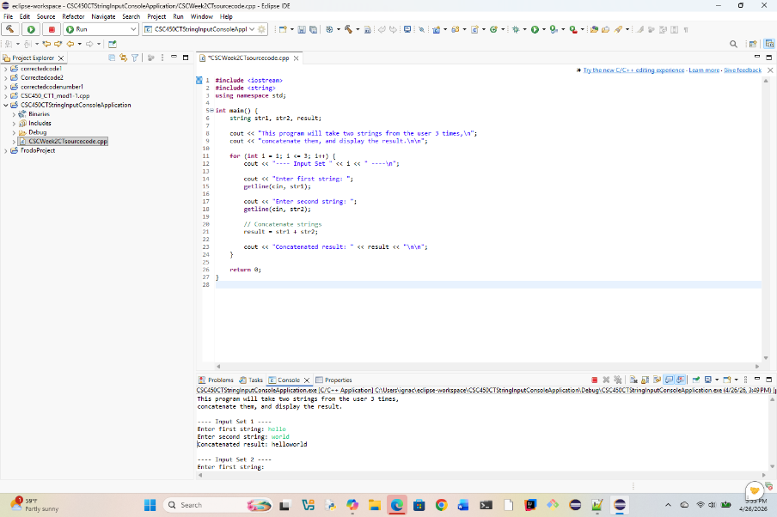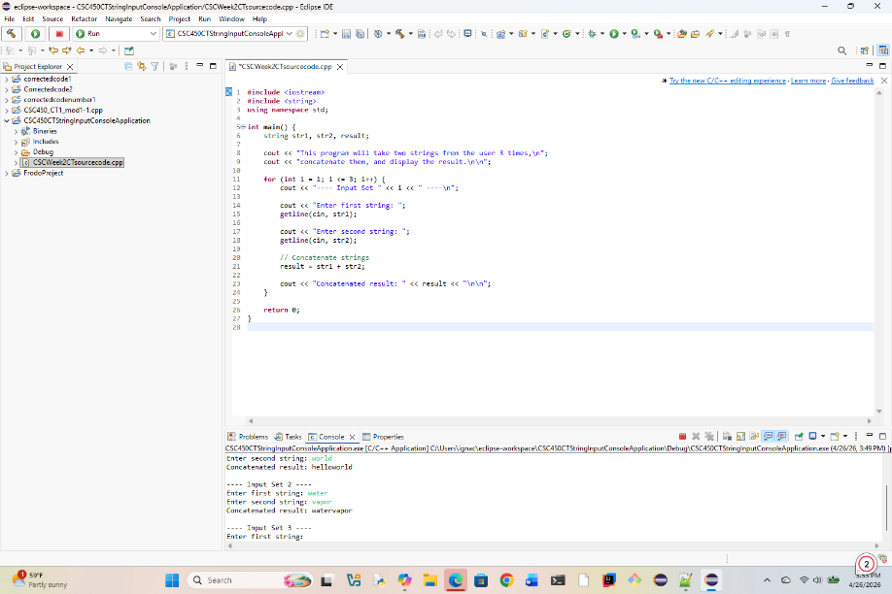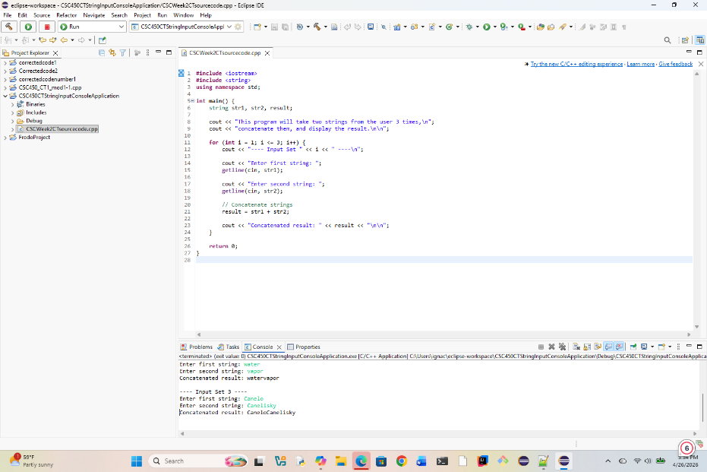
REPOSITORY:
https://github.com/ignaciocerdaavalos-create/CSC450.git

