Module 5: Critical Thinking:
User Input Program

Ignacio Cerda Avalos
Colorado State University Global
CSC450: PROGRAMMING III
Professor Jack Li
May 17, 2026

Module 5: Critical Thinking:
User Input Program

Pseudo Code:
BEGIN PROGRAM

DISPLAY "Enter text to append to the file:"
GET userInput

OPEN "CSC450_CT5_mod5.txt" in APPEND mode
WRITE userInput to the file
CLOSE the file

OPEN "CSC450_CT5_mod5.txt" in READ mode
READ entire file contents into a string variable called fileData
CLOSE the file

CALL reverseString(fileData) and store result in reversedData

OPEN "CSC450-mod5-reverse.txt" in WRITE mode
WRITE reversedData to the file
CLOSE the file

END PROGRAM

FUNCTION reverseString(inputString):
SET left = 0
SET right = length(inputString) - 1

WHILE left < right:
SWAP characters at positions left and right
INCREMENT left
DECREMENT right

RETURN inputString
END FUNCTION

Source Code:
#include <iostream>
#include <fstream>
#include <string>
using namespace std;

// Function to reverse a string
string reverseString(const string& input) {
string reversed = input;
int left = 0;
int right = reversed.length() - 1;

while (left < right) {
swap(reversed[left], reversed[right]);
left++;
right--;
}

return reversed;
}

int main() {
string userInput;

// Get user input
cout << "Enter text to append to the file: ";
getline(cin, userInput); // Correct: getline allows spaces

// Append user input to the file
ofstream outFile("CSC450_CT5_mod5.txt", ios::app);
if (!outFile) {
cout << "Error opening CSC450_CT5_mod5.txt for appending." << endl;
return 1;
}
outFile << userInput << endl;
outFile.close();

// Read entire file into a string
ifstream inFile("CSC450_CT5_mod5.txt");
if (!inFile) {
cout << "Error opening CSC450_CT5_mod5.txt for reading." << endl;
return 1;
}

string fileData((istreambuf_iterator<char>(inFile)),
istreambuf_iterator<char>());
inFile.close();

// Reverse the file contents
string reversedData = reverseString(fileData);

// Write reversed contents to new file
ofstream reverseFile("CSC450-mod5-reverse.txt"); // Correct filename
if (!reverseFile) {
cout << "Error creating CSC450-mod5-reverse.txt." << endl;
return 1;
}
reverseFile << reversedData;
reverseFile.close();

cout << "Data appended and reversed file created successfully." << endl;

return 0;
}

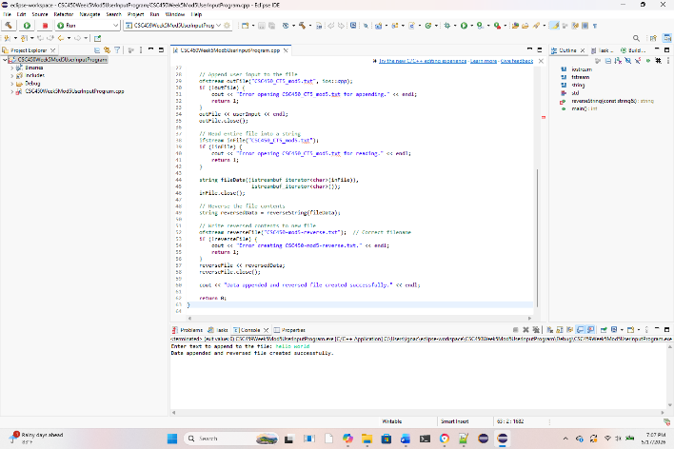

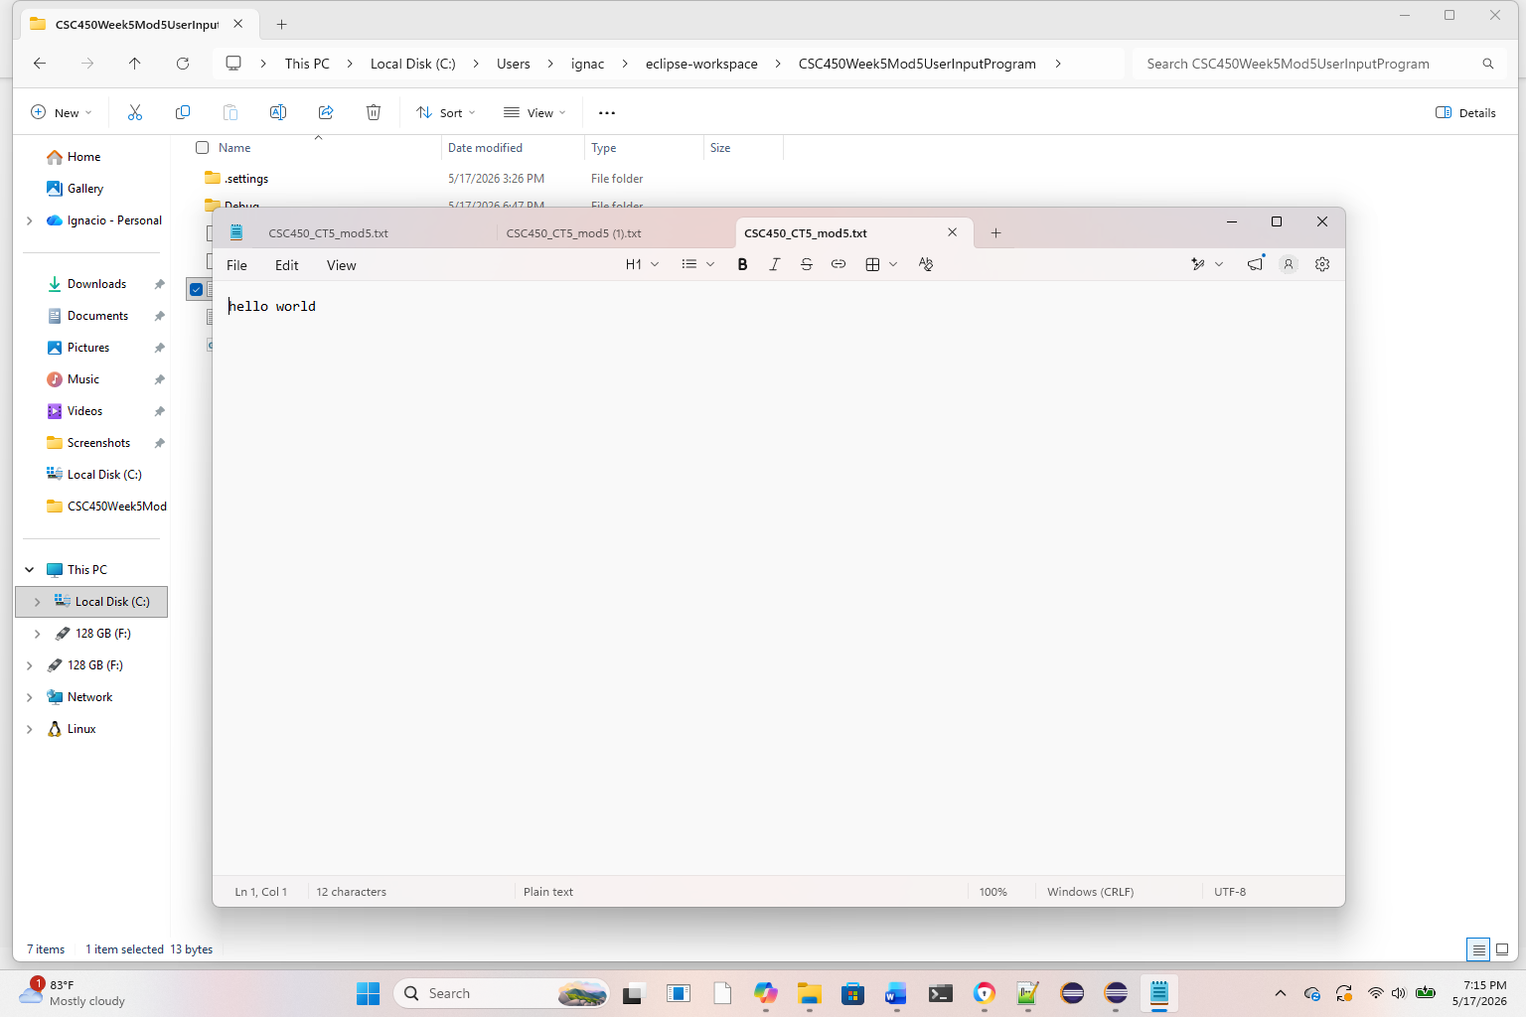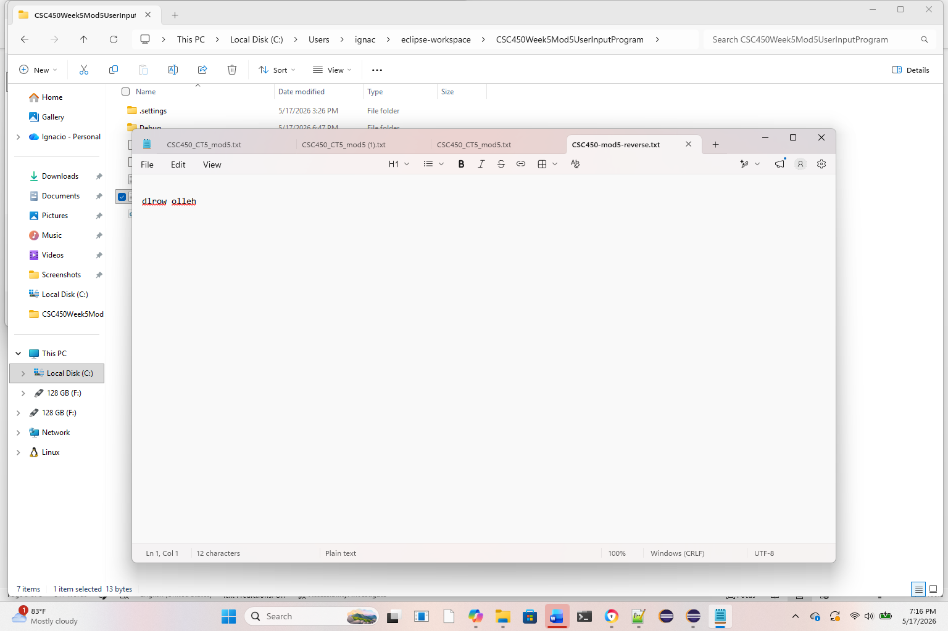

REPOSITORY:
https://github.com/ignaciocerdaavalos-create/CSC450.git

