Module 1: Critical Thinking:
Console Application and Syntax Corrections

Ignacio Cerda Avalos
Colorado State University Global
CSC450: PROGRAMMING III
Professor Jack Li
April 19, 2026

Module 1: Critical Thinking:
Console Application and Syntax Corrections

C++ Console Application:
#include <iostream>
using namespace std;

int main() {
// Variables for fictional person
string firstName = "Frodo";
string lastName = "Baggins";
string streetAddress = "1 Bagshot Row";
string city = "Hobbiton";
string zipCode = "00001";

// Display the information
cout << "First Name: " << firstName << endl;
cout << "Last Name: " << lastName << endl;
cout << "Street Address: " << streetAddress << endl;
cout << "City: " << city << endl;
cout << "Zip Code: " << zipCode << endl;

return 0;
}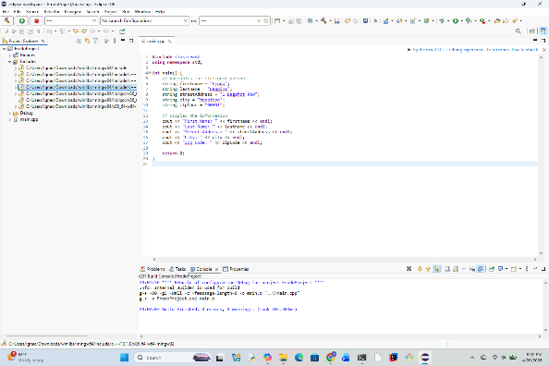

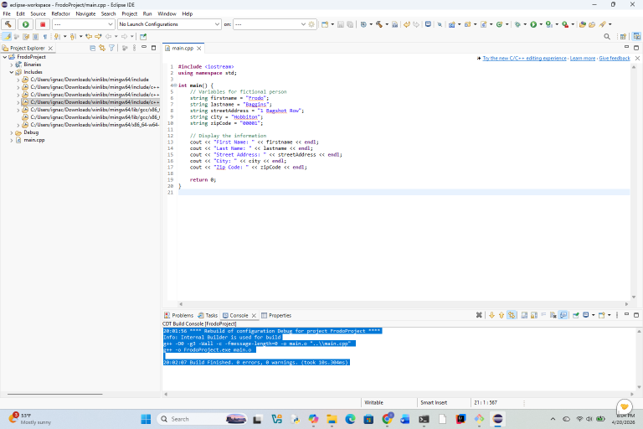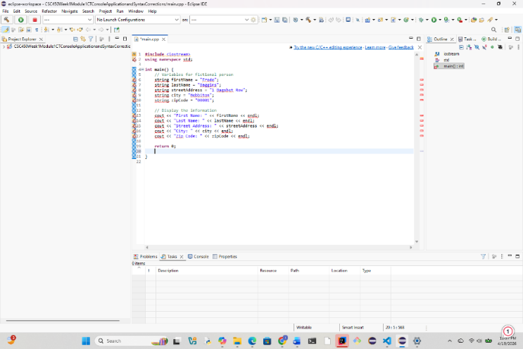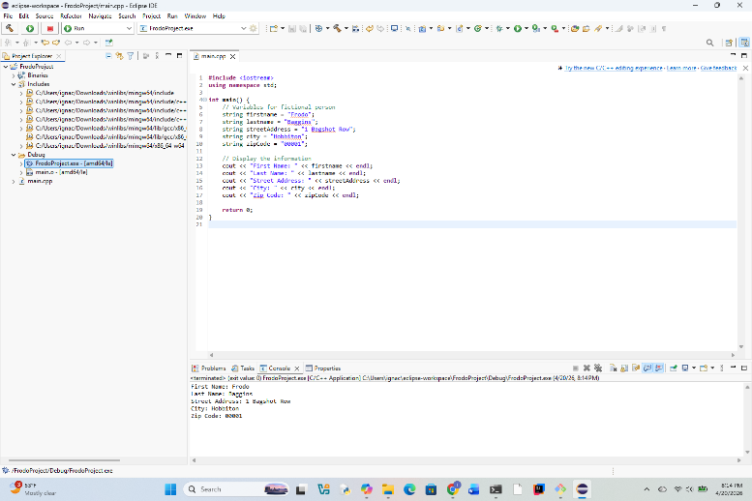

Source Code:
#include <iostream>
using namespace std;

int main() {
string firstName = "Frodo";
string lastName = "Baggins";
string street = "1 Bagshot Row";
string city = "Hobbiton";
string zip = "00001";

cout << "First Name: " << firstName << endl;
cout << "Last Name: " << lastName << endl;
cout << "Street Address: " << street << endl;
cout << "City: " << city << endl;
cout << "Zip Code: " << zip << endl;

return 0;
}

Pseudo Code:
BEGIN

// Create variables to store personal information
SET firstName TO "Frodo"
SET lastName TO "Baggins"
SET street TO "1 Bagshot Row"
SET city TO "Hobbiton"
SET zip TO "00001"

// Display the stored information
OUTPUT "First Name: " + firstName
OUTPUT "Last Name: " + lastName
OUTPUT "Street Address: " + street
OUTPUT "City: " + city
OUTPUT "Zip Code: " + zip

END

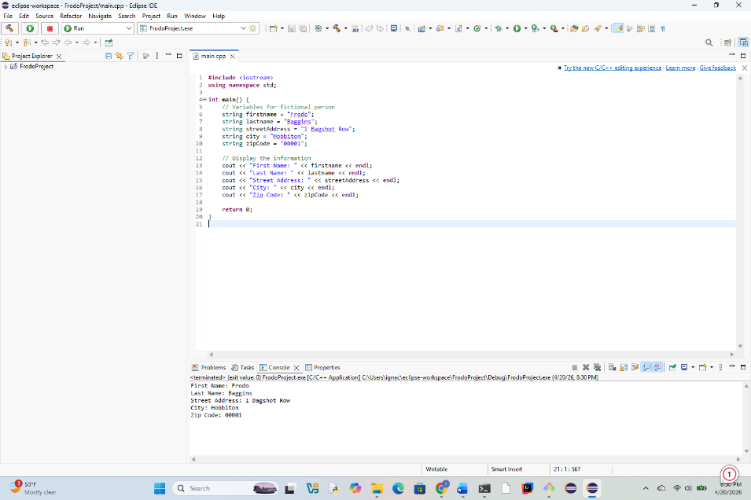

Code # 1:
/* Simple Program with a few Errors for Correction
Please be sure to correct all outlined errors.
#include<iostream>
#include<conio.h>
Standard namespace declaration
using namespace std;
Main Function
int main()
{
//Standard Ouput Statement
cout<<"Welcome to this C++ Program"<<endl;
cout<<I have corrected all errors for this program. <<endl;
// Wait For Output Screen
//Main Function return Statement
}
Corrected code:
/* Simple Program with a few Errors for Correction
Please be sure to correct all outlined errors.
*/

#include <iostream>
#include <conio.h> // optional, only works on Windows

// Standard namespace declaration
using namespace std;

// Main Function
int main()
{
// Standard Output Statement
cout << "Welcome to this C++ Program" << endl;
cout << "I have corrected all errors for this program." << endl;

// Wait For Output Screen (optional)
getch(); // only works if <conio.h> is available

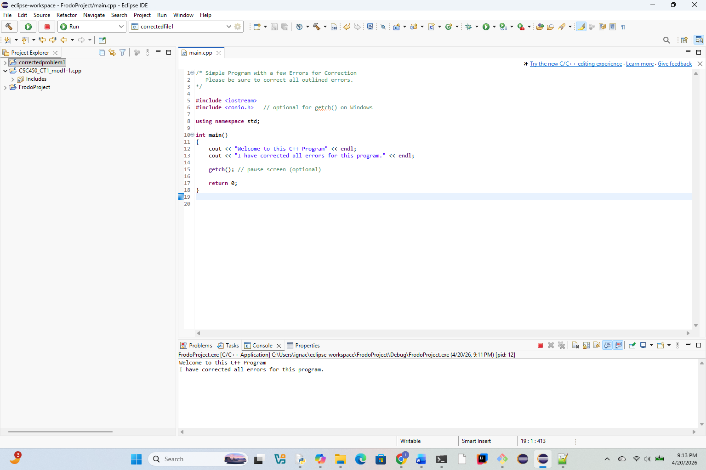

// Main Function return Statement
return 0;
}

CODE 2:

#include<iostream>
#include<conio.h>
Standard namespace declaration
using namespace std;
Main Function
int main()
{
double myMoney = 1000.50; //this should be printed out
Standard Ouput Statement
cout"Please be sure to correct all syntax errors in this program"<<endl;
cout<<"I have corrected all errors for this program. <<endl;
cout<<" The total amount of money available is = "<< <<endl;
// Wait For Output Screen
Main Function return Statement
return 0;
}
Corrected code:
/* Simple Program with a few Errors for Correction
Please be sure to correct all outlined errors.
*/

#include <iostream>
#include <conio.h> // optional, only works on Windows

// Standard namespace declaration
using namespace std;

// Main Function
int main()
{
// Standard Output Statement
cout << "Welcome to this C++ Program" << endl;
cout << "I have corrected all errors for this program." << endl;

// Wait For Output Screen (optional)
getch(); // only works if <conio.h> is available

// Main Function return Statement
return 0;
}