Module 8: Portfolio Project
Part 2: Concurrency Concepts

Ignacio Cerda Avalos
Colorado State University Global
CSC450: PROGRAMMING III
Professor Jack Li
June7, 2026

Module 8: Portfolio Project
Part 2: Concurrency Concepts
JAVA:
public class CounterDemo {

private static final Object lock = new Object();
private static boolean firstDone = false;

public static void main(String[] args) {
Thread countUpThread = new Thread(new CountUpTask(), "CountUpThread");
Thread countDownThread = new Thread(new CountDownTask(), "CountDownThread");

countUpThread.start();
countDownThread.start();

try {
countUpThread.join();
countDownThread.join();
} catch (InterruptedException e) {
Thread.currentThread().interrupt();
System.err.println("Main thread interrupted: " + e.getMessage());
}

System.out.println("Both threads have finished.");
}

// Thread 1: counts from 0 to 20
private static class CountUpTask implements Runnable {
@Override
public void run() {
for (int i = 0; i <= 20; i++) {
synchronized (lock) {
System.out.println(Thread.currentThread().getName() + " -> " + i);
}
try {
Thread.sleep(100);
} catch (InterruptedException e) {
Thread.currentThread().interrupt();
return;
}
}

synchronized (lock) {
firstDone = true;
lock.notifyAll();
}
}
}

// Thread 2: waits until firstDone == true, then counts from 20 down to 0
private static class CountDownTask implements Runnable {
@Override
public void run() {
synchronized (lock) {
while (!firstDone) {
try {
lock.wait();
} catch (InterruptedException e) {
Thread.currentThread().interrupt();
return;
}
}
}

for (int i = 20; i >= 0; i--) {
synchronized (lock) {
System.out.println(Thread.currentThread().getName() + " -> " + i);
}
try {
Thread.sleep(100);
} catch (InterruptedException e) {
Thread.currentThread().interrupt();
return;
}
}
}
}
}

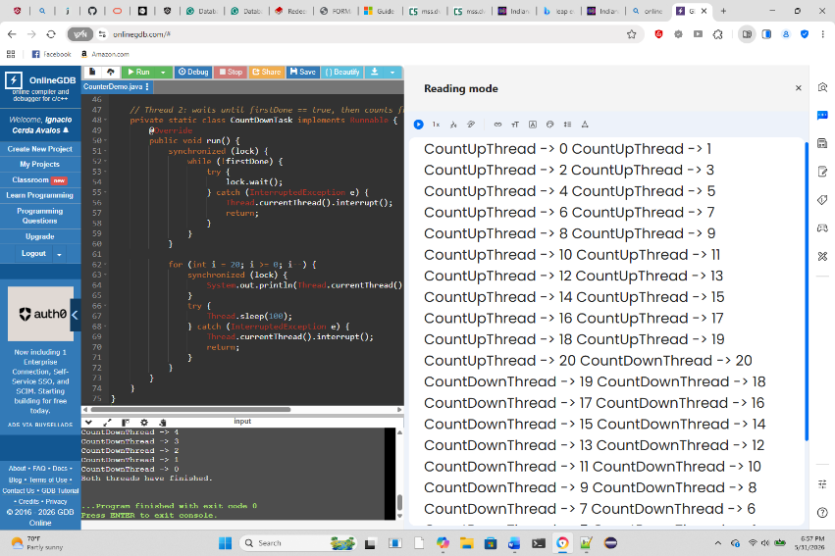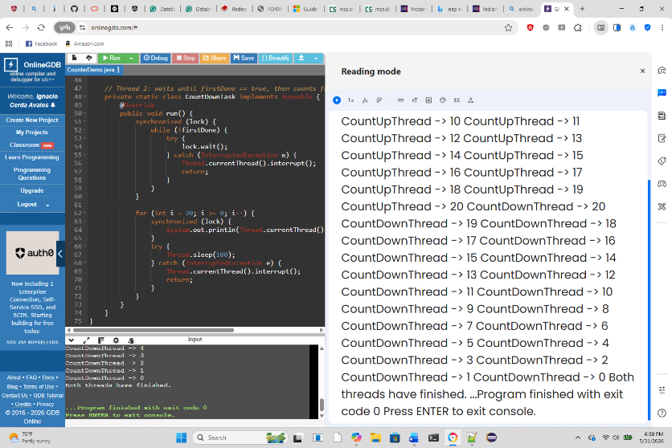

REPOSITORY:
https://github.com/ignaciocerdaavalos-create/CSC450.git

Introduction:
Concurrency enables programs to accomplish more than one job, making them more responsive and efficient in many real‑world applications. In this work, we created a Java program that uses two threads: one that counts upward from 0 to 20, and one that counts downward from 20 to 0 after the first thread finishes. This paper does a better characterization of how concurrency works in different programming languages by comparing a Java implementation with an equivalent in C++. We compare performance, security, memory behavior and general safety of each language’s concurrency model. Both languages can do the same thing, but they do it in completely different ways, and such differences have significant implications for processing and safety of the program. Differences in performance between Java and C++
JAVA Performance
Java is hosted in the Java Virtual Machine (JVM), a software program runtime, where the hardware interacts with both the software programs. Such design makes Java more convenient to control and more portable for the system. It, however, creates extra work. The JVM needs to load, verify, and interpret the program before it runs. It also employs a garbage collector to automatically clean up memory. However, these features also serve a double-edged purpose, enhancing safety and reducing programmer errors, but slowing down execution, especially for small programs (Oracle, 2023). As Java threads work correctly under concurrency, the JVM introduces an overhead that causes the program to function slower than the single‑threaded Java version. Additional processes must be handled inside the JVM including thread creation, context switching, and synchronization.
C++ Performance
C++ compiles directly into machine code, meaning that the program runs straight on the hardware without a virtual machine. This gives C++ an edge in performance, particularly for programs that begin and end fast. Threading in C++ is also closer to the operating system, which lowers overhead and makes threading a tad more efficient (Stroustrup, 2022). For the project, the C++ system would probably have a faster start time and it would consume fewer resources. But even if some of that difference is small, of course the program itself is simple. On the larger scale, C++ typically yields better results than Java because of its low‑level control and lack of garbage‑collection pauses.
Security Differences Between Java and C++
Java Security
Java was built to be safe. These strict rules of memory prevent much of the common programming error. For example: Arrays and strings are automatically bounds‑checked. Memory cannot be accessed directly with pointers. The garbage collector prevents use‑after‑free errors. These defenses make Java programs less susceptible to memory‑based attacks such as buffer overflows, which are typically found in lower‑level languages (Oracle, 2023). Java’s concurrency tools, such as synchronized, are also built with a carefully defined memory model that helps prevent unpredictable behavior.
C++ Security
The programmer has full access to the memory in C++. This is powerful but risky. Mistakes such as writing outside of an array, freeing memory incorrectly, or using dangling pointers may cause crashes or lead to security vulnerabilities. Memory-related issues in C or C++ are also a common reason for well-known security failures of software (MITRE, 2024). C++ concurrency is also more dangerous because data races lead to undefined behavior; therefore, the program may behave unpredictably or expose memory in unsafe ways. Java, on the other hand, avoids many of these problems using its managed runtime.
Which Language Is Safer?
On the whole, Java is a bit safer for all intents and purposes, because it gets rid of whole categories of memory‑related bugs. C++ can be safe, but that can only be guaranteed if the programmer is extremely careful and practices current best practice. For newcomers and for most apps, Java has stronger built‑in protection. Java’s Concurrency model is more comprehensible, for it has high‑level tools for doing that sort of thing, such as Thread, synchronized, wait(), notifyAll(). These tools follow stringent rules that provide predictability about thread behavior. Also, thanks to the JVM, memory is shared safely between threads, i.e., there is a decreased risk of race conditions. C++ Concurrency Model. C++ uses std::thread, std::mutex, and std::condition variable. These tools are helpful, but they are time-consuming. All these tools are good, but manual tasks are an added burden. However, if a programmer fails to lock a mutex or unlocks it incorrectly the program can also deadlock or otherwise function in a way that is unpredictable. C++ permits greater control too but carries greater responsibility with that control.
Conclusion:
Java and C++ concurrency can also be handled but in distinct ways impacting performance and safety. C++ frequently speeds up due to writing code directly into machine code and does not depend on the use of a VM. Java, on the other hand, gives better security, has more automatically controlled memory management, and uses a more predictable concurrency model. The Java implementation for this project is safer and easier to maintain (even if the C++ version is slightly better). For the vast majority of applications, the decision between Java and C++ is often a matter of speed or safety.

REFERENCES:
1. MITRE. (2024). Common Weakness Enumeration (CWE) Top 25 Most Dangerous Software Weaknesses. https://cwe.mitre.org
2. Oracle. (2023). Java Platform, Standard Edition Documentation. https://docs.oracle.com
3. Stroustrup, B. (2022). A Tour of C++ (3rd ed.). Addison‑Wesley.

