Module 7: Portfolio Milestone
Portfolio Project Part 1

Ignacio Cerda Avalos
Colorado State University Global
CSC450: PROGRAMMING III
Professor Jack Li
May 31, 2026

Module 7: Portfolio Milestone
Portfolio Project Part 1

Pseudo Code:
START

FUNCTION countUp():
FOR i FROM 1 TO 20:
PRINT "Counting up: " + i
SLEEP for a short time

FUNCTION countDown():
FOR i FROM 20 DOWN TO 0:
PRINT "Counting down: " + i
SLEEP for a short time

MAIN:
CREATE thread t1 to run countUp
WAIT for t1 to finish

CREATE thread t2 to run countDown
WAIT for t2 to finish

END

Source Code:
#include <iostream>
#include <thread>
#include <chrono>
#include <string>
using namespace std;

void countUp() {
for (int i = 1; i <= 20; i++) {
cout << "Counting up: " << i << endl;
this_thread::sleep_for(chrono::milliseconds(150));
}
}

void countDown() {
for (int i = 20; i >= 0; i--) {
cout << "Counting down: " << i << endl;
this_thread::sleep_for(chrono::milliseconds(150));
}
}

int main() {
cout << "Starting Thread 1 (Count Up)" << endl;

thread t1(countUp);
t1.join(); // Wait for thread 1 to finish

cout << "\nThread 1 finished. Starting Thread 2 (Count Down)" << endl;

thread t2(countDown);
t2.join(); // Wait for thread 2 to finish

cout << "\nBoth threads completed successfully." << endl;

return 0;
}

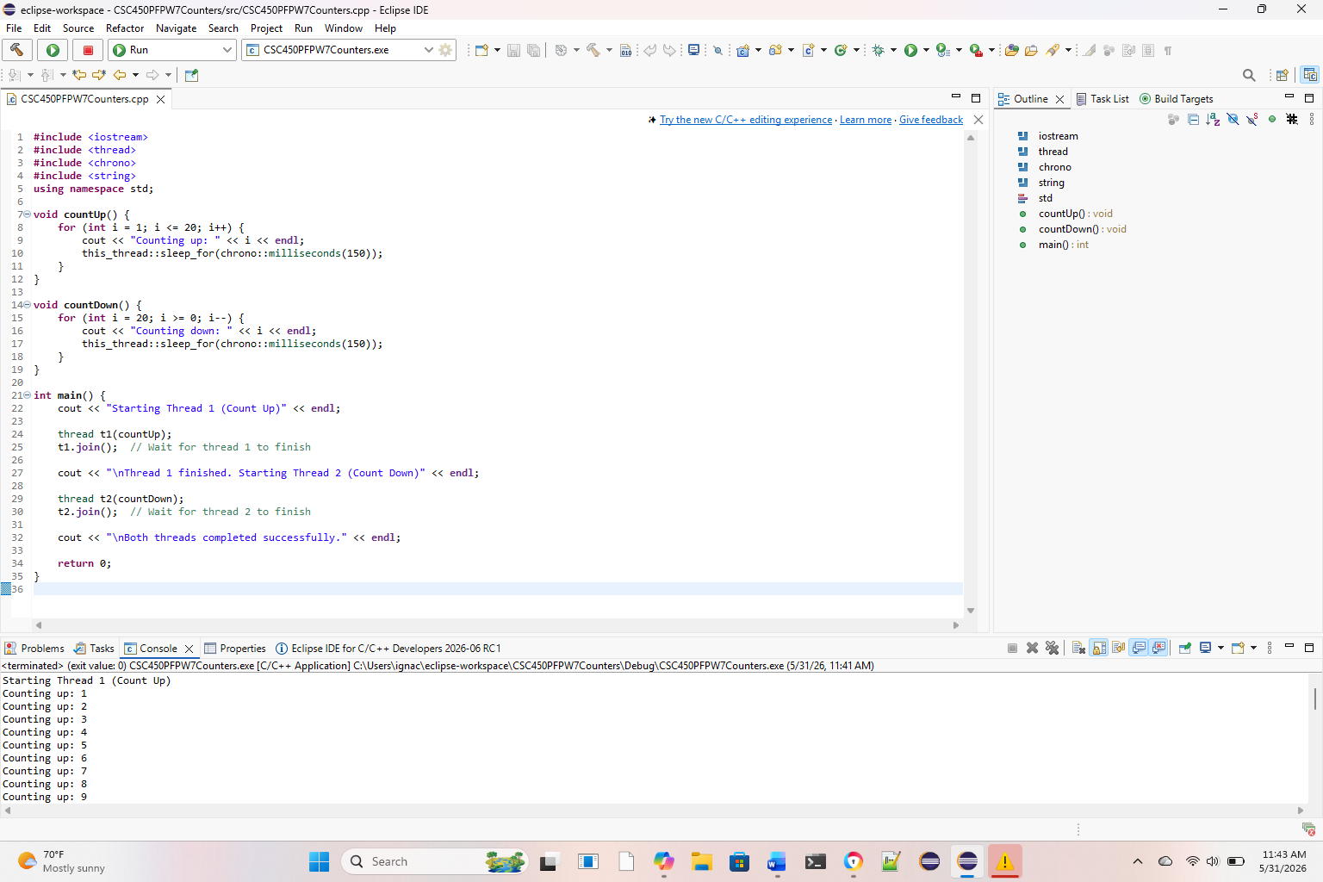
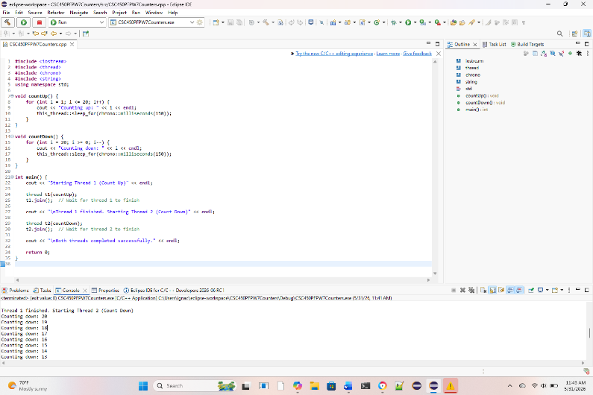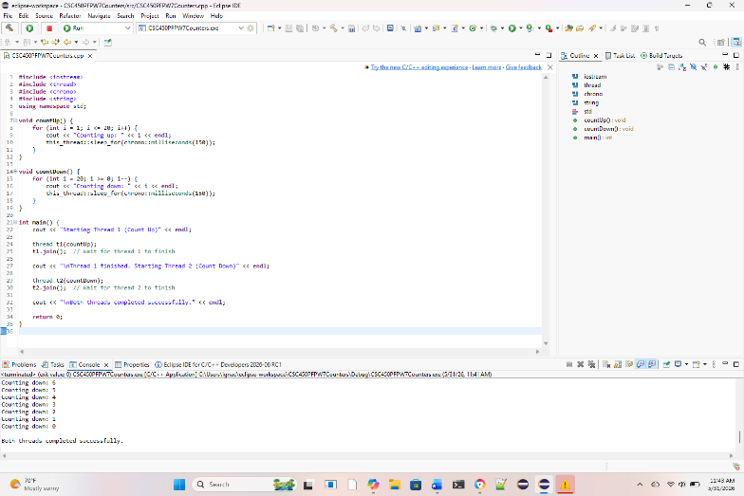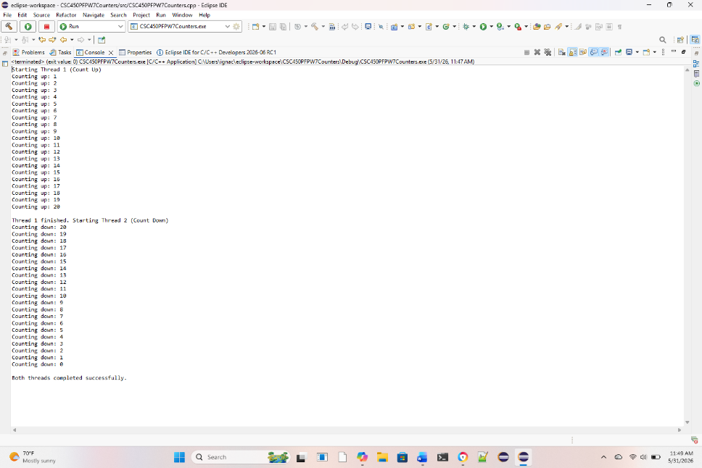

REPOSITORY:
https://github.com/ignaciocerdaavalos-create/CSC450.git

