[1]

Optimizing Pipeline Costs: Evaluating Corrosion Allowance and Inner Epoxy Coating for Water Transport Systems

I. Mella[2]

*Abstract*— This paper presents a quantitative comparison of two corrosion mitigation strategies for water pipelines: increasing wall thickness through a corrosion allowance versus applying an interior Fusion Bonded Epoxy (FBE) coating. The analysis evaluates the cost-effectiveness of each approach by examining both capital expenditures (CAPEX) and operational expenditures (OPEX) over the lifecycle of the pipeline infrastructure.

# Introduction

The selection of an appropriate corrosion mitigation strategy is critical for ensuring the long-term performance and economic viability of water pipelines. This study compares two commonly used approaches: constructing pipelines with a corrosion allowance (increased wall thickness) versus protecting pipelines with an interior epoxy coating.

Pipelines designed with a corrosion allowance typically require significantly thicker walls to compensate for material loss over time. In contrast, inner epoxy coatings act as highly effective barriers against corrosion, potentially eliminating the need for additional wall thickness. However, the implications of these strategies extend beyond initial material design and installation.

Pipelines relying on a corrosion allowance often feature smaller internal diameters due to the increased wall thickness, which can result in higher energy demands for pumping operations. Additionally, the bare steel surface exhibits greater roughness compared to FBE-coated surfaces, further contributing to increased pump power consumption. To mitigate ongoing corrosion in bare steel pipelines, operators must also inject corrosion inhibitors and other chemicals into the transported fluid—adding to operational complexity and costs.

Given these factors, comparing the cost-effectiveness of these two strategies requires a holistic analysis that accounts for both CAPEX and OPEX throughout the pipeline's service life. This paper aims to provide such an evaluation, offering insights into the economic trade-offs between FBE-coated pipelines and those designed with a corrosion allowance.

# Case Study Parameters

To support peer review and enable further analysis, this section details the parameters utilized in our quantitative comparison for an arbitrary industrial water transport case. These parameters form the foundation of our economic and operational analysis, allowing for a comprehensive evaluation of the two corrosion mitigation strategies.

Table 1. Arbitrary Project Parameters

|  |  |  |
| --- | --- | --- |
| Parameter | Value | Unit |
| Pipeline length | 70 | km |
| Static Head (elevation change) | 1000 | m |
| Pipeline Outside diameter | 28 | inches |
| Corrosion rate per year | 0.15 | mm/yr |
| Density of water | 1030 | kg/m³ |
| Dynamic Viscosity of water | 0.0013 | Pa·s |
| Design flow rate | 700 | L/s |
| Service life | 25 | years |
| Annual hours of pump operation | 8400 | h/yr |
| Pump efficiency | 82 | % |
| Annual discount Rate | 10 | % |

To ensure transparency and reproducibility, we have made our calculations accessible via a [public GitHub repository “Bare-vs-Coated-Water-Pipelines”](https://github.com/ignaciomella/Bare-vs-Coated-Water-Pipelines) where there is a spreadsheet file that incorporates the parameters listed in Table 1 and utilizes Microsoft Excel's "iterative calculation" feature to determine the Darcy-Weisbach friction factor (f) using the Newton-Raphson numerical technique.

By providing this detailed set of parameters and our calculation methodology, we aim to facilitate peer review and encourage further exploration of corrosion mitigation strategies in water transport systems.

# Capital Expenditures

## Cost of steel pipes

This analysis integrates current steel market indices (primarily hot-rolled coil, HRC), manufacturing costs, and inspection fees to provide a robust pricing model for steel pipes [1].

Chart 1. Historical Price of China Hot-Rolled Steel Coils ($/t)

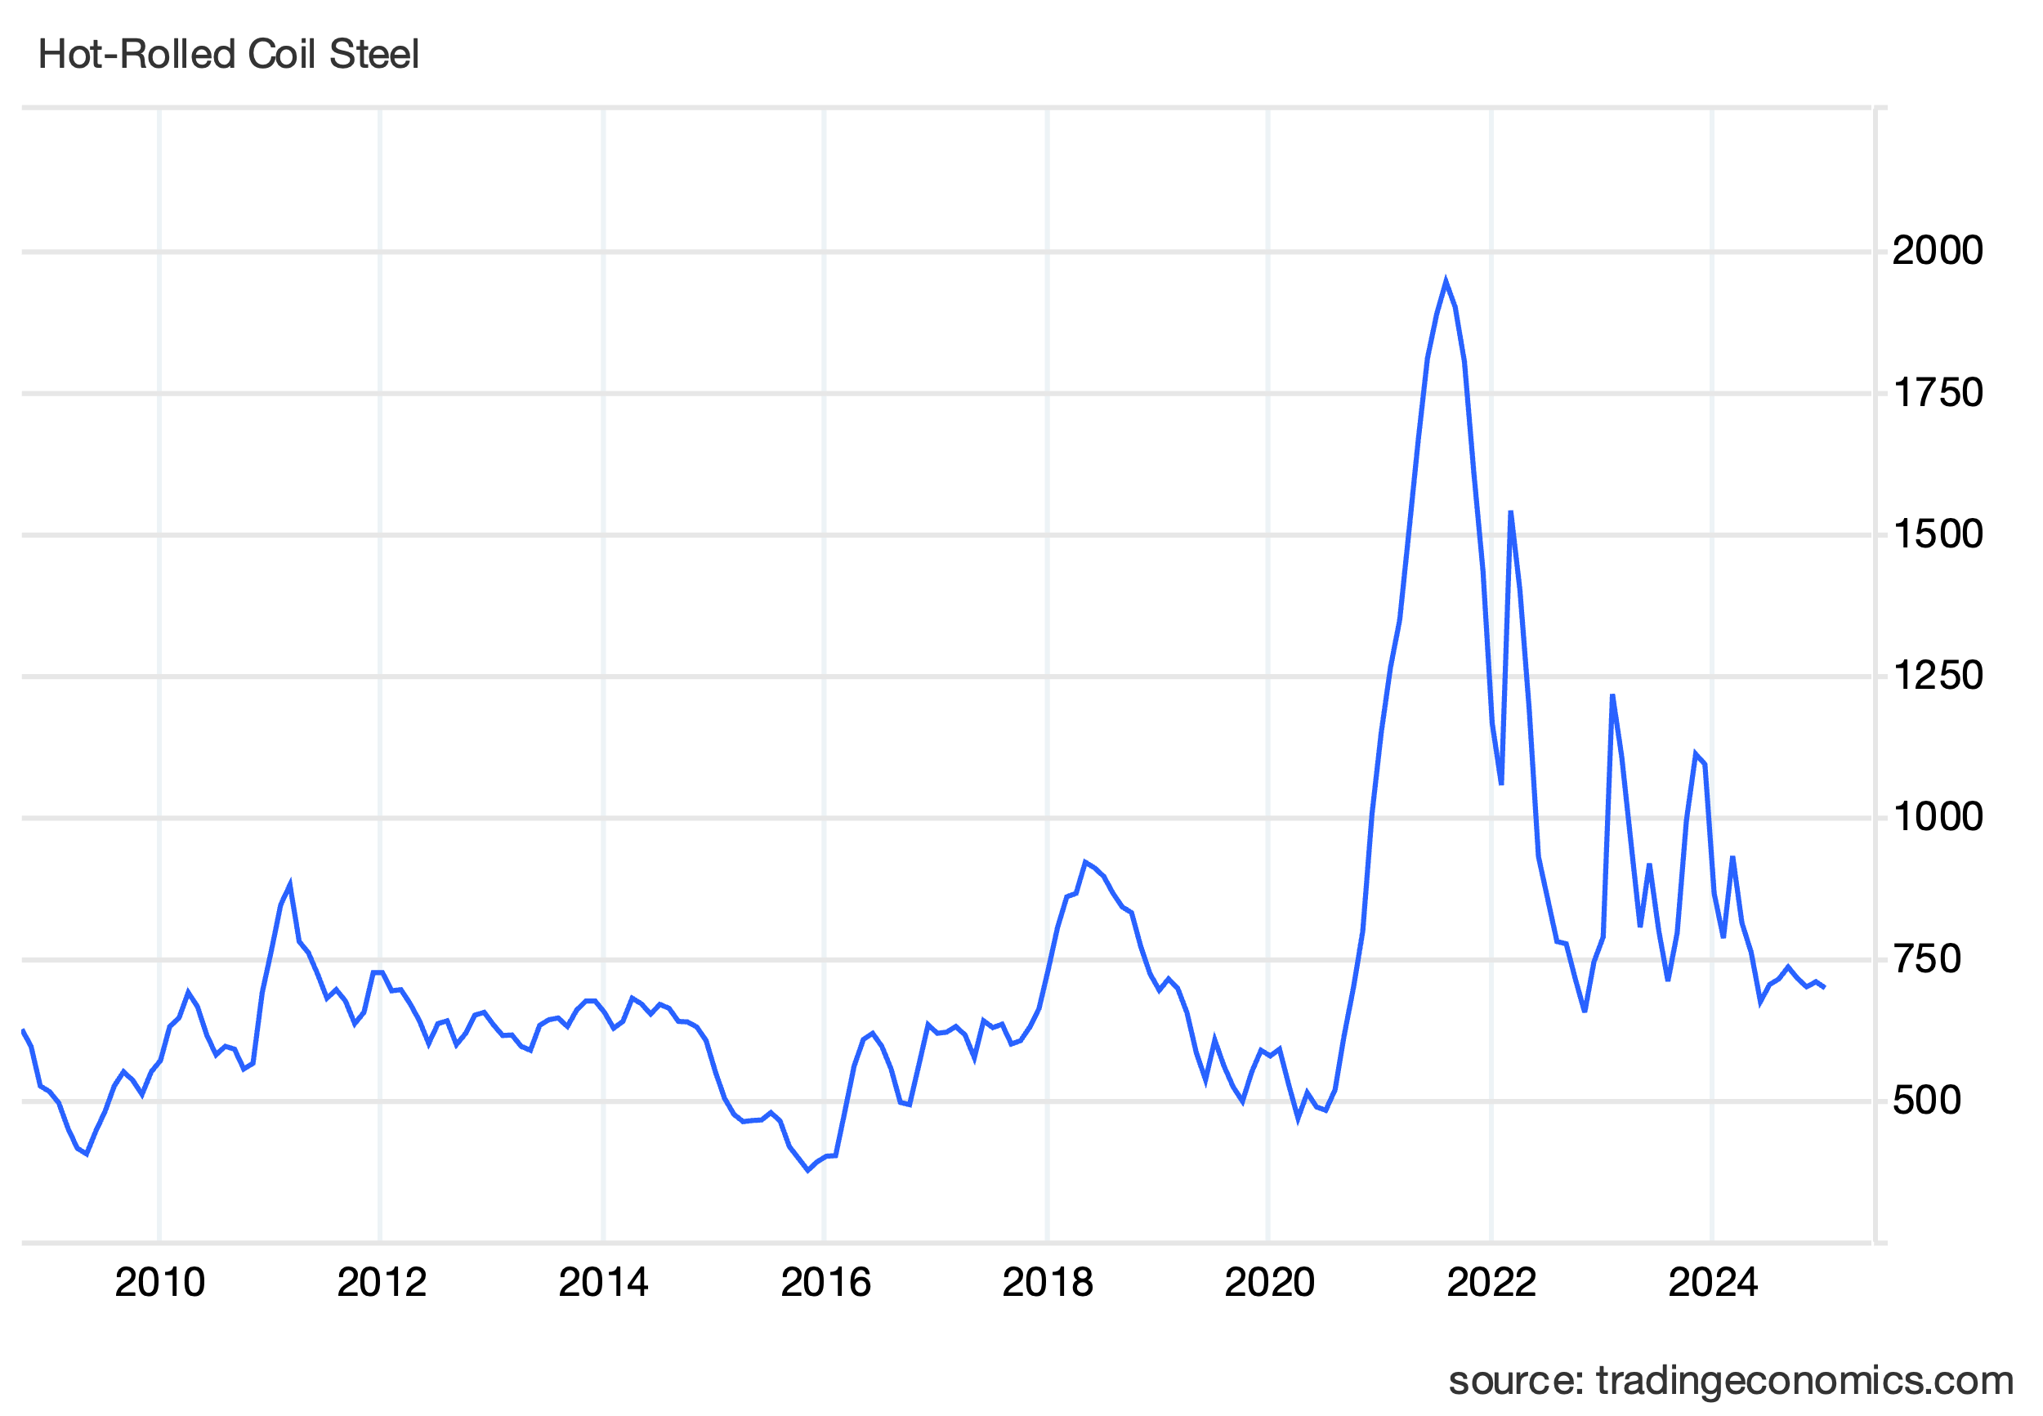

Historical data reveals a 1.8–2.2x multiplier for finished pipe versus Hot-Rolled Coils (HRC), reflecting the value-added during pipe manufacturing. This analysis uses the HRC spot price as a reference point for estimating API 5L X70 pipe costs. [2] [3].

Key assumptions:

* Average HRC spot price: 625 $/t (based on recent Chinese market trends) [4].
* Manufacturing multiplier: 2x
* Transportation cost: $170/t (factory to job site in Chile)

Estimated delivered pipe cost per weight (CPW):

(625 $/t · 2) + 170 $/t = 1,420 $/t

This approach provides a estimate of pipe material costs, considering both manufacturing processes and logistics, while grounding our economic analysis in current market conditions. Having estimated CPW, we can calculate the total cost of the pipeline using the formula for the volume of a hollow cylinder and the initial wall thickness for each case.

(1)

where *D* is the outside pipe diameter, 0.7112 m; *t* is the wall thickness, which for year 1 is 13.28 mm for the bare pipe case, and 9.53 mm for the coated pipe case; *L* is the length of the pipeline, 70 km; and is the API 5L X70 steel density, 7850 kg/m³. Replacing these values in eq (1):

Table 2. Steel cost for each corrosion strategy.

| Item | Bare Pipe | Coated Pipe |
| --- | --- | --- |
| Wall thickness | 13.28 mm | 9.53 mm |
| Steel weight | 16,000 t | 11,544 t |
| Cost of steel | $22,720,068 | $16,391,992 |

## Dosing Plant

For the bare pipe case, a Dosing Plant is needed to store, handle, and dose chemicals into the water. This plant includes tanks, pumps, valves, metering equipment, and control systems for precise chemical injection proportionally to the flow rate. It operates continuously to ensure the correct chemical concentrations are maintained in the pipeline.

The upfront investment for a corrosion inhibitor and biocide dosing plant for a 0.7 m³/s pipeline and an expected corrosion rate of 0.15 mm/yr s estimated at $208,000–$370,000. This range accounts for industrial-grade equipment, regional logistics, and automation [5]. We will assume that the upfront investment required to construct and commission the dosing plant is mid-range: $272,160.

Take note that the main problem with average corrosion allowances is that they assume a uniform corrosion rate along the entire pipeline, which is seldom if ever the case. Localized pitting corrosion is often the primary cause of pipeline failure, rather than uniform general corrosion. Pitting can create deep, localized areas of material loss that may penetrate the pipe wall before the average corrosion allowance is depleted.

## Shop-applied inner coating

The estimated cost for shop-applied 0.3 mm (300 μm) FBE interior coating on a steel pipeline ranges between $3.50 to $5.00 per square meter. This calculation accounts for material expenses, energy consumption, labor, and equipment costs associated with industrial-scale shop FBE application processes [6] [7] [8]. This analysis considers a Cost per interior Surface Area (*CPS*) of $5.00 per m² which is used in equation (2)

(2)

Where *D* is the interior diameter of the pipe to be FBE coated, 0.69214 mm and *L* is the length of the pipeline.

The total cost for applying an interior FBE coating to the whole pipeline is $761,048, or 4.6% of the steel cost of the pipeline. According to the R&D Center for the Saline Water Conversion Corporation, pipeline fabshop coating only represents approximately 5% of the total pipeline cost [5].

Chart 2. Shop FBE coating compared to steel cost.

## Internal Robotic Field Joint Coating

On-site, the steel pipes are welded together sequentially, but the heat generated during welding will burn and destroy the manufacturer's inner FBE coating. To address this, a field joint coating uses a self-contained robot crawler that travels inside the pipe. However, field coating the interior pipe surface after welding is challenging and rarely achieves the same quality as the original factory-applied coating.

Field joint coating is done using either FBE powder or liquid epoxy via rotating nozzles after a robotic cleaner uses abrasive blasting and vacuuming to achieve ISO 8501-1 Sa 2.5 surface cleanliness, critical for adhesion, on the interior of welded joints [9] [10].

However, field coating the interior pipe surface after welding is challenging and rarely achieves the same quality as the original factory-applied coating [11, 12]. Unlike factory-applied coatings performed in controlled environments, field applications are subject to variable ambient conditions such as temperature, humidity, and wind. These factors affect coating viscosity, cure rates, and overall performance [13] [14].

The risks associated with improper grinding or surface preparation leading to poor adhesion are well-documented [15] [16]. These areas are considered weak points in the pipeline, as they are more prone to premature corrosion.

|  |  |
| --- | --- |
|  |  |
| *Photo 1. Factory-applied Fusion Bonded Epoxy* | *Photo 2. Field-applied Liquid Epoxy next to weld inner seam* |

Studies on losses due to pipeline damage indicate that of all the factors or causes underlying failures, approximately 60% are due to internal corrosion [17] [18] [19].

Currently there are only two providers for the internal field joint coating robot service:

* **Aegion/CRTS**. Higher upfront costs (+20–30%) but lower rework expenses. Requires frequent maintenance in dusty environment. [20]
* **TYHOO Group**: Targets cost-sensitive markets with modular, reusable robots. Limited to smaller diameters (<28") and lower production rates [21].

Although both direct and indirect costs associated with the Robotic Internal Field Joint Coating Service must be accounted for, this study will only quantify direct costs associated to expenses related to coating the inner welds. Indirect costs, on the other hand, arise from production losses or downtime during repairs, and other factors, such as environmental damages will not be quantified.

Table 3. Cost components for robotic field coating. [22]

|  |  |
| --- | --- |
| ***Cost Component*** | ***Cost per Joint*** |
| Mobilization of Crew & Equipment | $22.08 |
| Demobilization of Crew & Equipment | $13.80 |
| Personnel & Robotic Equipment | $505.08 |
| Pre-blasting Personnel & Equipment | $149.04 |
| Internal Coating Application | $181.24 |
| Pipe-End Pre-blasting | $48.76 |
| Total Cost per Joint | $920.00 |

Since there are 5834 joints, the total cost for field coating the welded joints is 5834 · $920.00 = $5,367,280.

Table 4. CAPEX composition

|  |  |  |
| --- | --- | --- |
| CAPEX Item | Cost | % |
| Total steel cost | $16,391,992 | 69% |
| Field joint coating | $5,367,280 | 28% |
| Shop FBE coating | $761,048 | 3% |
| Dosing Plant | $272,160 | 1% |
| Total CAPEX | $22,520,319 | 100% |

Chart 3. Proportion of CAPEX items

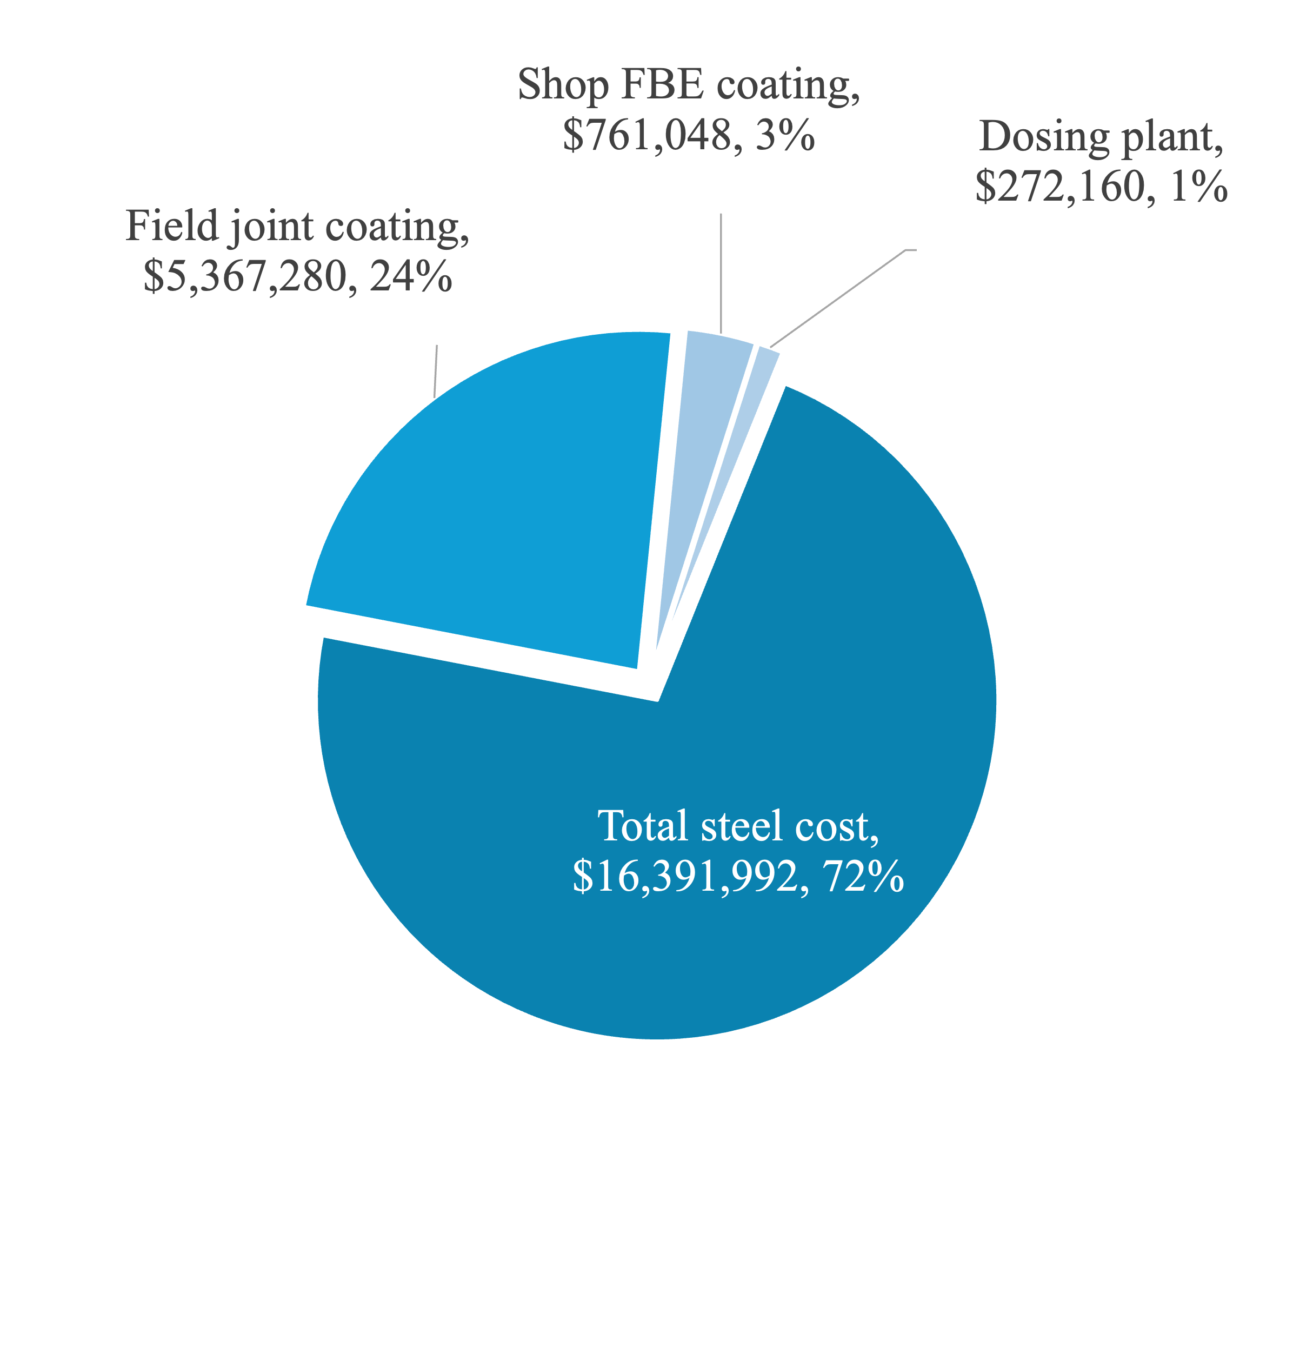

The current landscape of post-weld field interior coating methods presents significant challenges, with costs eight times that of factory-applied pipeline coatings and demonstrating a concerning 45–60% higher failure rate in corrosion protection compared to shop-applied alternatives. [23] [24] [25].

These stark disparities in cost-effectiveness and performance reliability underscore the pressing need for innovation in the industry, serving as key market drivers for companies to develop more efficient and dependable alternatives to robotic interior field coatings on welded joints. Below some recent alternatives to avoid the use of the internal robot crawler field joint coating:

* **FlexSleeve**®. A stiff polymer sleeve with bore seals that is inserted into pipe ends before welding. [26].
* **SIDGMAN**®. A two-piece system—one male and one female—welded in the shop to the ends of each pipe, so that they end up as field welded pipe flanges [27].

|  |
| --- |
| **[A long pipe on a road  AI-generated content may be incorrect.](https://youtu.be/e14DHsekBIg?si=nDQ1uiHFtaoSzMGE)**  Photo 1. [SQM’s TEA project, a 32" seawater interior FBE coated pipeline](https://youtu.be/e14DHsekBIg?si=nDQ1uiHFtaoSzMGE) was joined by Victaulic’s X07 couplings. The need for robot field coating was eliminated. Project achieved a rate of 30 joints per day per crew using a single excavator and a Deckhand accessory [31] [58]. |
|  |

* **Style X07**. A very high-pressure Victaulic coupling listed under ASME B31.4. It has been installed in two projects in Chile: 24" MLP INCO and 32" SQM TEA [28]. This alternative eliminate welds, takes 5 minutes per joint, and does not require skilled labor.

# Operational Expenditures

## Corrosion inhibitors injection

While corrosion allowance provides extra thickness to accommodate material loss, corrosion inhibitors actively slow down the corrosion process [29]. For long-distance pipelines, relying solely on corrosion allowance can be extremely expensive [30]. The use of corrosion inhibitors usually offers a more economical solution to manage corrosion over time [31] [32].

Based on experimental data from studies, a 26 ppm dosage of a sodium polyphosphate inhibitor is recommended to maintain a corrosion rate at or below 0.2 mm/year [33] [34]. Sodium polyphosphate works as a passivant forming a thin, protective film on the metal surface, which acts as a barrier against corrosive [35] [36].

Also, it is assumed that a biocide is applied during a 4-hour shock of 20 ppm once a week (equal to continuous 0.46 ppm) to prevent bacteria, fungi, and algae growth [37].

Now, given that the flow rate is 0.7 m³/s, and the annual operating hours is 8400, the annual volume is 21,168,000 m³. Multiplying this volume by the dosage described in the paragraph above, we get the corrosion and biocide inhibitors OPEX per year shown in table 5.

Table 5. Dosage to meet at least 0.2 mm/yr corrosion rate.

|  |  |  |  |  |
| --- | --- | --- | --- | --- |
| ***Chemical item*** | ***Dosage*** *ppm* | ***Price*** *per  kg [38]* | ***Mass*** *kg per year* | ***Cost*** *per Year* |
| Inhibitor | 26.00 | $1.7 | 550,368 | $920,215 |
| Biocide | 0.46 | $12.8 | 9,660 | $123,648 |
|  |  |  | OPEX | $1,043,863 |

To compare future OPEX cash flows directly on an equal footing with CAPEX, we need to discount future cash flows to their current worth using equation (1):

(1)

Where *PV* is the Present value, *FV* is the future value (annual OPEX of $1,043,863); *r* is the discount rate, 10%; *n* is the number of years into the future. This PV function assumes the cash flows occur at the end of each period. Thus, the inhibitors OPEX present value is $9,475,189.

## Inspections

Bare uncoated steel pipes with corrosion allowance and internally FBE-coated pipes require fundamentally different inspection approaches due to their corrosion management strategies.

For bare uncoated steel pipes with corrosion allowance, the inspection approach focuses on monitoring the gradual loss of wall thickness over time.

On the other hand, internally FBE-coated pipes, the inspection strategy for these pipes centers on evaluating the integrity and effectiveness of the coating itself.

Table 6 shows a comparison of inspection methodologies, frequencies, and associated costs:

Table 6. Inspections feature comparison.

|  |  |  |
| --- | --- | --- |
| ***Concept*** | ***Bare Pipe*** | ***Coated pipe*** |
| Main Inspection Methodology | Magnetic flux leakage (MFL) and/or ultrasonic testing (UT). | Electrochemical impedance spectroscopy and/or linear polarization resistance. |
| Repair | Weld patches or sleeves or replace entire section. | Apply liquid epoxy to the interior surface. |
| Periodicity | 3–5 years. | 5–10 years. |
| Cost/Year | $8,000–$15,000/km | $4,000–$8,000/km |

For analytical purposes, this study adopts 8000 $/km, and 4000/km as the annual cost for the internally FBE coated pipe and the bare pipe respectively. Since the length of the pipe is 70 km, the annual OPEX is $560,000, and $280,000. Using a discount rate of 10%, present value results in $5,083,142 for bare pipe, and $2,541,571 for coated pipe.

## Energy consumption

Chile's electricity pricing for industrial users combines generation costs, transmission fees, and distribution charges. The generation component reflects marginal system costs influenced by fossil fuel prices and renewable penetration [39] [40]. Transmission and distribution costs remain regulated, with recent adjustments adding complexity to tariff calculations [41].

For large industrial consumers, July 2024 data showed an average rate of $128/MWh [42]. This baseline industrial rate of $128/MWh requires adjustment through three critical factors: fuel price volatility (45.77% fossil dependency amid declining coal production) [43], renewable integration costs ($5-8/MWh for grid stability with 27% solar/wind penetration) [40], and transmission constraints ($3-12/MWh regional differentials) [40]. Chile's 2024 Tariff Stabilization Law further modifies pricing via:

* Generation component adjustments. (+15% from 2022 baseline, CPI-indexed) [44].
* Debt servicing surcharge ($0.02/kWh until 2035) [45] [46].
* Transmission upgrades. ($1.2/MWh fee) [47].

This comprehensive adjustment framework elevates the 2024 effective rate to:

It is important to note that the energy costs for the Chilean mining sector costs rose from $85/MWh (2015) to $112/MWh (2024), 40% above Peruvian competitors [48]. The successful execution of coal phase-outs and renewable integration will determine whether the next decade sustains the deflationary trends of 2015-2020 or reverts to the volatility of earlier periods.

As shown in Table 7, historical context, this analysis adopts a projected rate of *P* = $175/MWh for years 2025 onwards. This rate *P* is used in equation (2) which calculates de cost of energy consumed by the pipeline project pump(s).

Table 7.Historical Price Context

|  |  |  |
| --- | --- | --- |
| **Year** | **Avg. Industrial Rate** | **Key Influencers** |
| 2022 | $145/MWh | Coal phase-out begins |
| 2023 | $158/MWh | Gas price spike |
| 2024 | $168/MWh (adjusted) | Debt repayment initiated |
| 2025 | $175/MWh (projected) | Full tariff normalization |

(2)

Where is fluid density; *g* is the gravitational acceleration; *Q* is the volumetric flow rate; is the total head loss due to friction losses () plus elevation head ( = 1000 m); is the pump efficiency (82%) and *t* is the annual operating time (8400 hours).

To estimate energy required to overcome friction losses in the pipeline we will use the Darcy-Weisbach equation (3). For this analysis.

(3)

Where is the head loss due to friction losses in the pipeline; *f* is the Darcy-Weisbach friction factor, a dimensionless parameter representing energy loss due to friction in a pipe; *L* is the length of the pipeline; is the velocity of the fluid; *g* is the acceleration due to gravity, which normalizes the equation for gravitational effects; and *D* is the inside diameter of the pipeline, where larger diameters reduce friction losses by lowering fluid velocity for a given flow rate.

To calculate the Darcy-Weisbach friction factor *f*, the Colebrook-White equation is utilized.

(4)

Where *f* is the Darcy-Weisbach friction factor; *k* is the pipe’s roughness height and *D* is the pipe inside diameter; *Re* is the Reynolds number; and the logarithmic term accounts for both surface roughness and viscous effects in turbulent flow. The equation is implicit in *f* and requires iterative or numerical methods to solve.

**Bare Pipe Case Calculations**

For the bare pipe case, on year 1, the Reynolds number is calculated as using equation:

(5)

Where is the fluid density (1030), is the fluid velocity on year 1 (1.915 m/s) derived from the flow ratio of 0.7 m³/s, is the pipe inside diameter (0.68464m) for wall thickness of 13.28 mm on year 1, is the dynamic viscosity (0.0013 Pa·s). Substituting values, . Again, we substitute values on eq (4):

(6)

And we solve for *f* using the Newton-Raphson iterative numerical technique which converges to *f* = 0.014030.

We substitute values on eq (3):

(7)

Again, we substitute values on eq (2):

(8)

For the **bare pipe case**, we repeat this calculation procedure for the next 25 years, decreasing the wall thickness by the design corrosion rate of 0.15 mm/yr; from 13.28 mm on year 1 to 9.53 mm on year 25; and increasing the pipe roughness from 0.1 mm on first year to 0.3 mm by the end of year 25.

Same procedure is done for the **coated pipe case**, only this time, wall thickness is maintained at 9.53 mm, and pipe roughness increases from 0.01 mm on first year to 0.05 mm by year 25 end. The results for both the bare and coated pipe are listed on Annex A – Energy Consumption Calculations.

The consequent Present Value for the cost of electricity during these 25 years at a discount rate of 10% presented for both cases in the next table.

Table 8. Electricity Consumption Present Value Comparison

|  |  |  |  |
| --- | --- | --- | --- |
| Energy Cost | Bare Pipe | Coated Pipe | Difference |
| Friction | $32,323,586 | $25,223,188 | $7,100,398 |
| Elevation | $115,054,517 | $115,054,517 | $0 |

As it can be seen from Table 8, energy consumption cost due to elevation (static head) is equal for both cases. This cost is unavoidable and thus shouldn’t be accounted for when comparing both strategies. It is, for this analysis, irrelevant, and will be excluded in the Analysis of Results chapter.

# Analysis of Results

As can be seen from Table 9, CAPEX vs Present Value of OPEX comparison, the lifecycle cost analysis over the 25-year service period reveals a 10.6%% ($19,589,067 over $184,928,662) total cost advantage for the coated pipeline strategy compared to the corrosion allowance approach.

Table 9. CAPEX and Present Value of OPEX   
for each corrosion mitigation strategy.

|  |  |  |  |
| --- | --- | --- | --- |
| Item | Bare Pipe | Coated Pipe | Difference |
| Inhibitors | $9,475,189 |  | $11,843,98 |
| Steel | $22,720,068 | $16,391,992 |  |
| Field Joint Coating |  | $5,367,280 | $5,367,280 |
| Friction Energy | $32,323,586 | $25,223,188 |  |
| Elevation Energy | $115,054,517 | $115,054,517 |  |
| Inspections | $5,083,142 | $2,541,571 | $2,541,571 |
| Shop FBE |  | $761,048 | $761,048 |
| Dosing Plant | $272,160 |  | $272,160 |
| Total | $184,928,662 | $165,339,595 | $19,589,067 |
|  |  |  | (10.6%) |

However, this 10.6% advantage is not a fair comparison since it includes the elevation cost ($115,054,517) which is unavoidable, unrelated to this analysis and equal for both approaches. Instead, consider Table 10, differences between each approach.

Table 10. Differential comparison excluding Elevation Costs.

|  |  |  |  |
| --- | --- | --- | --- |
| Item | Bare Pipe | Coated Pipe | Difference |
| Extra Inhibitors | $9,475,189 |  |  |
| Extra Friction Energy | $7,100,398 |  |  |
| Extra Steel | $6,328,077 |  |  |
| Joint Field Coating |  | $5,367,280 |  |
| Extra Inspections | $2,541,571 |  |  |
| Shop Coating |  | $761,048 |  |
| Dosing Plant | $272,160 |  |  |
| Total | $25,717,395 | $6,128,328 | $19,589,067 |

As shown in Table 10, the primary cost drivers of the corrosion allowance strategy are the additional expenses associated with corrosion inhibitors, increased electricity consumption due to higher friction losses, and the extra steel required to compensate for material loss over time. Remarkably, each of these cost components individually exceeds the combined cost of shop and field coatings for an internally coated pipeline.

This stark contrast underscores the inherent cost inefficiency of the bare pipe strategy. It raises an intriguing question: under what specific circumstances might the bare pipe approach justify its significantly higher overhead? Further exploration into niche applications or unique project constraints could provide valuable insights into this question.

• **Material Savings**: The bare pipe requires 29.6% more steel by mass (13.28 mm vs 9.53mm wall thickness), accounting for $6,328,077 in additional capital expenditure.

• **Operational Efficiencies**: The coated system demonstrates $7,100,398 savins in net present value energy savings from reduced pipe roughness (0.01-0.05mm vs 0.1-0.3mm) and increased pipe inside diameter, and does not require inhibitors, saving $9,475,189 in present value from the OPEX of inhibitors injection.

• **Maintenance Optimization**: Combined inspection and chemical treatment costs for the bare pipe total $2,541,571 higher than the coated pipe strategy.

Chart 4. Differential comparison between corrosion mitigation strategies. Elevation energy OPEX are excluded.

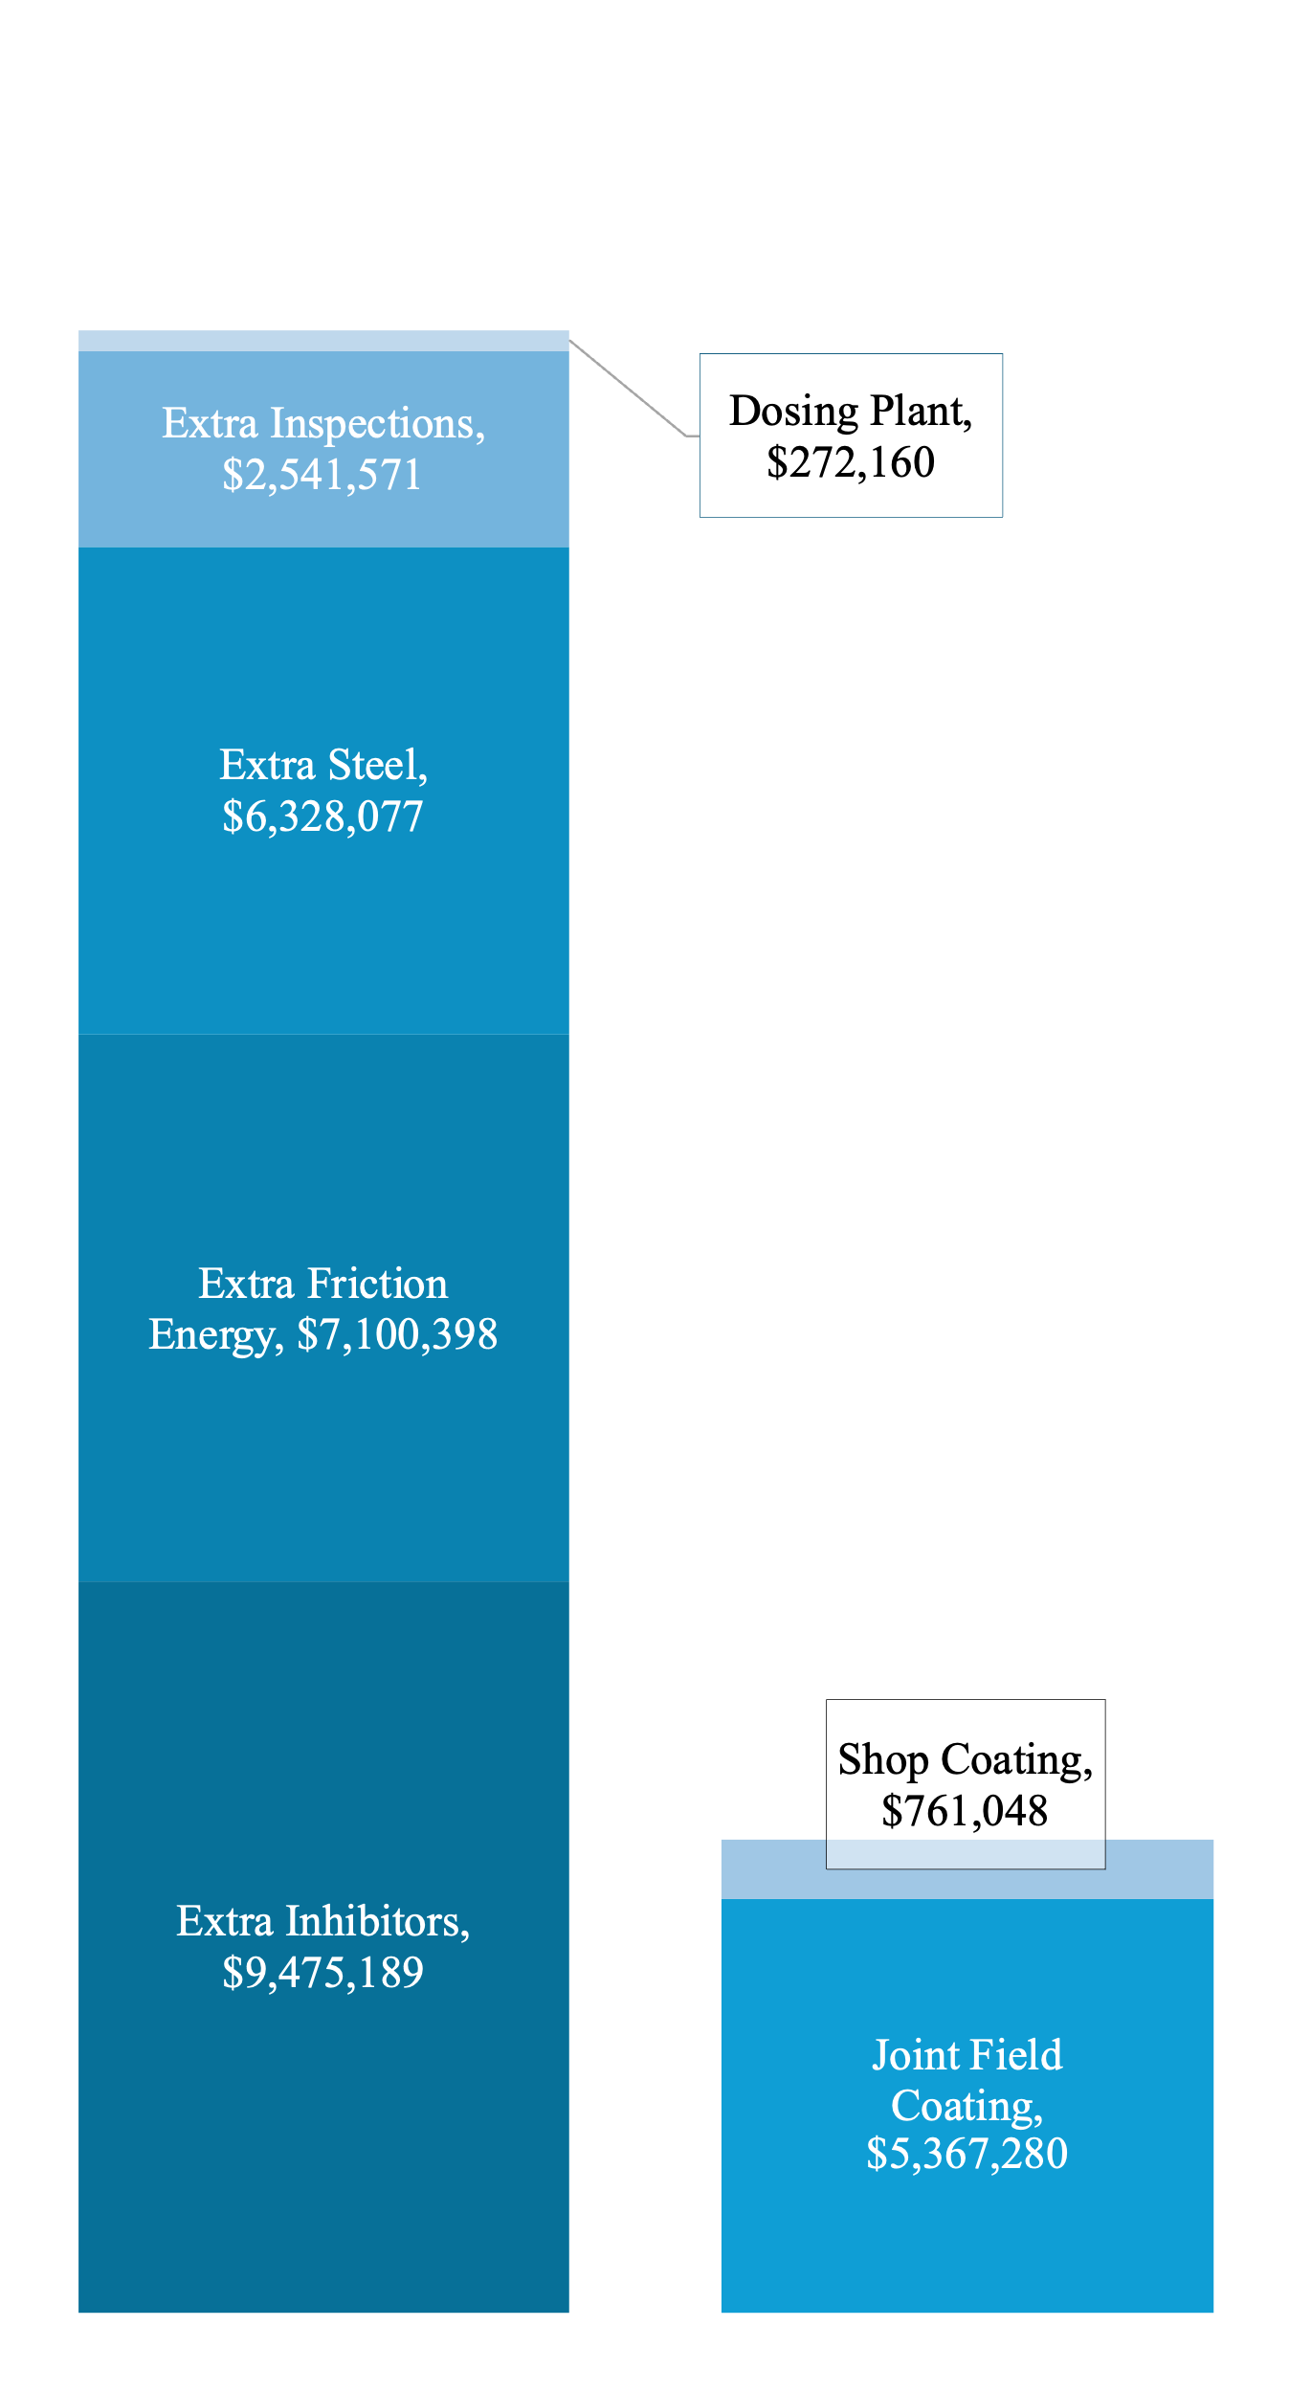

# Conclusion

This study provides a comprehensive evaluation of two corrosion mitigation strategies—corrosion allowance via increased wall thickness and interior Fusion Bonded Epoxy (FBE) coating—for water transport pipelines. The analysis, grounded in a 25-year lifecycle cost assessment, highlights **significant economic and operational advantages** of the FBE-coated pipeline approach over the corrosion allowance strategy. Key findings include:

1. **Cost-Effectiveness**: The FBE-coated pipeline demonstrates a 10.6% total lifecycle cost advantage when elevation energy costs are included. When excluding these unavoidable costs, the coated pipeline's differential advantage becomes even more pronounced, driven by reduced material requirements, lower energy consumption, and minimized maintenance costs.
2. **Material Efficiency**: The corrosion allowance strategy requires 29.6% more steel due to increased wall thickness (13.28 mm vs. 9.53 mm), resulting in an additional capital expenditure of $6.33 million. This highlights the inefficiency of using thicker walls to account for long-term corrosion.
3. **Operational Savings**: The FBE-coated pipeline achieves $7.1 million in energy savings due to its smoother internal surface and larger effective diameter, which reduce friction losses during pumping operations. Additionally, it eliminates the need for costly corrosion inhibitors, saving $9.48 million in present value over the service life.
4. **Maintenance Optimization**: Inspection and repair costs for the FBE-coated pipeline are substantially lower than those for the bare pipe with corrosion allowance, yielding $2.54 million in savings over 25 years due to less frequent and less invasive maintenance requirements.
5. **Technical Viability**: While robotic field joint coating for FBE pipelines incurs higher costs and unreliability risks compared to factory-applied coatings, alternative solutions such as Victaulic’s X07 couplings and other innovative technologies can eliminate this expense altogether, further enhancing the feasibility of FBE-coated pipelines.

|  |  |  |
| --- | --- | --- |
| ****Aspect**** | ****Corrosion Allowance**** | ****Internally Coated Pipe (FBE)**** |
| **Capital Expenditure (CAPEX)** | Requires 29.6% more steel due to increased wall thickness, adding $6.33 million to initial costs | Lower initial steel cost; additional $761,048 for shop coating and $5.37 million for field joint coating1. |
| **Operational Costs  (OPEX)** | - High energy costs due to increased friction from rougher pipe surface and smaller internal diameter. - Requires corrosion inhibitors, adding $11.84 million in present value over 25 years. | - Smoother surface reduces friction, saving $7.1 million in energy costs. - No need for inhibitors, reducing complexity and cost. |
| **Maintenance** | - Frequent inspections and repairs due to progressive wall thinning. - Higher inspection costs ($5.08 million over 25 years). | - Less frequent inspections (every 5-10 years) and lower costs ($2.54 million over 25 years). |
| **Durability** | Relies on material thickness; prone to localized pitting corrosion that may lead to failures. | Effective barrier against corrosion; weak points at field joints if improperly coated. |
| **Technical Challenges** | Simple design but less adaptable to varying corrosion rates or localized damage. | Requires specialized application techniques; challenges with field joint coating quality. |
| **Energy Efficiency** | Higher friction losses increase pumping energy consumption by $7.1 million in present value. | Improved hydraulic efficiency reduces energy consumption. |

# Summary

**Corrosion Allowance**: While simpler to implement, this strategy incurs higher material, energy, and maintenance costs over the pipeline's lifecycle. It is less adaptable to localized corrosion risks and relies heavily on chemical inhibitors, which pose environmental concerns.

**Internally Coated Pipe (FBE):** Offers better long-term cost savings due to reduced energy consumption and maintenance needs. However, it requires careful application and quality control during installation, particularly at field joints.

Overall, the internally coated pipe strategy demonstrates superior lifecycle performance but involves higher initial technical complexity.

Appendix A

Table 11. Bare pipe Electricity cost calculations.

|  |  |  |  |  |  |  |  |  |  |  |
| --- | --- | --- | --- | --- | --- | --- | --- | --- | --- | --- |
| Analyzed case: Bare pipe. Initial wall thickness = 13.28 mm; year 25 wall thickness = 9.53 mm. Initial pipe roughness = 0.1 mm; year 25 pipe roughness = 0.3 mm. Fixed parameters: Elevation head = 1000 m; pump efficiency = 0.82%; energy cost = 175 $/MWh; outside diameter = 28''; flow rate = 700 L/s; density of water = 1030 kg/m3; viscosity of water = 0.0013 Pa·s | | | | | | | | | | |
| Yr | Pipe  roughness  [ mm ] | Interior  Diameter  [ mm ] | Wall  thickness  [ mm ] | Fluid  Velocity  [m/s] | Friction  factor f  [ ] | Head  Loss  [ m ] | Pump  Friction  [ kW ] | Pump  Elevation  [ kW ] | Electricity  Friction  [ M$ ] | Electricity  Elevation  [ M$ ] | |
| 1 | 0.100 | 682.140 | 14.53000 | 1.915 | 0.014030 | 269.32 | 2322 | 8623 | $3,413,697 | $12,675,334 | |
| 2 | 0.108 | 682.557 | 14.32167 | 1.913 | 0.014180 | 271.37 | 2340 | 8623 | $3,439,685 | $12,675,334 | |
| 3 | 0.117 | 682.973 | 14.11333 | 1.911 | 0.014325 | 273.31 | 2357 | 8623 | $3,464,266 | $12,675,334 | |
| 4 | 0.125 | 683.390 | 13.90500 | 1.908 | 0.014466 | 275.14 | 2372 | 8623 | $3,487,545 | $12,675,334 | |
| 5 | 0.133 | 683.807 | 13.69667 | 1.906 | 0.014602 | 276.89 | 2387 | 8623 | $3,509,618 | $12,675,334 | |
| 6 | 0.142 | 684.223 | 13.48833 | 1.904 | 0.014734 | 278.54 | 2402 | 8623 | $3,530,569 | $12,675,334 | |
| 7 | 0.150 | 684.640 | 13.28000 | 1.901 | 0.014862 | 280.11 | 2415 | 8623 | $3,550,473 | $12,675,334 | |
| 8 | 0.158 | 685.057 | 13.07167 | 1.899 | 0.014987 | 281.60 | 2428 | 8623 | $3,569,398 | $12,675,334 | |
| 9 | 0.167 | 685.473 | 12.86333 | 1.897 | 0.015108 | 283.02 | 2440 | 8623 | $3,587,405 | $12,675,334 | |
| 10 | 0.175 | 685.890 | 12.65500 | 1.895 | 0.015227 | 284.38 | 2452 | 8623 | $3,604,550 | $12,675,334 | |
| 11 | 0.183 | 686.307 | 12.44667 | 1.892 | 0.015342 | 285.66 | 2463 | 8623 | $3,620,882 | $12,675,334 | |
| 12 | 0.192 | 686.723 | 12.23833 | 1.890 | 0.015455 | 286.89 | 2474 | 8623 | $3,636,447 | $12,675,334 | |
| 13 | 0.200 | 687.140 | 12.03000 | 1.888 | 0.015565 | 288.06 | 2484 | 8623 | $3,651,288 | $12,675,334 | |
| 14 | 0.208 | 687.557 | 11.82167 | 1.885 | 0.015673 | 289.18 | 2493 | 8623 | $3,665,442 | $12,675,334 | |
| 15 | 0.217 | 687.973 | 11.61333 | 1.883 | 0.015778 | 290.24 | 2503 | 8623 | $3,678,945 | $12,675,334 | |
| 16 | 0.225 | 688.390 | 11.40500 | 1.881 | 0.015881 | 291.26 | 2511 | 8623 | $3,691,830 | $12,675,334 | |
| 17 | 0.233 | 688.807 | 11.19667 | 1.879 | 0.015983 | 292.23 | 2520 | 8623 | $3,704,127 | $12,675,334 | |
| 18 | 0.242 | 689.223 | 10.98833 | 1.876 | 0.016082 | 293.16 | 2528 | 8623 | $3,715,863 | $12,675,334 | |
| 19 | 0.250 | 689.640 | 10.78000 | 1.874 | 0.016179 | 294.04 | 2535 | 8623 | $3,727,065 | $12,675,334 | |
| 20 | 0.258 | 690.057 | 10.57167 | 1.872 | 0.016275 | 294.88 | 2543 | 8623 | $3,737,757 | $12,675,334 | |
| 21 | 0.267 | 690.473 | 10.36333 | 1.869 | 0.016368 | 295.69 | 2550 | 8623 | $3,747,962 | $12,675,334 | |
| 22 | 0.275 | 690.890 | 10.15500 | 1.867 | 0.016461 | 296.46 | 2556 | 8623 | $3,757,699 | $12,675,334 | |
| 23 | 0.283 | 691.307 | 9.94667 | 1.865 | 0.016551 | 297.19 | 2563 | 8623 | $3,766,990 | $12,675,334 | |
| 24 | 0.292 | 691.723 | 9.73833 | 1.863 | 0.016640 | 297.89 | 2569 | 8623 | $3,775,852 | $12,675,334 | |
| 25 | 0.300 | 692.140 | 9.53000 | 1.860 | 0.016728 | 298.56 | 2574 | 8623 | $3,784,304 | $12,675,334 | |
|  | Bare Pipe Case. Present Value (annual OPEX discounted at 10% rate) | | | | | | | | $32,323,586 | $115,054,517 | |

Table 12. Coated pipe Electricity cost calculations

|  |  |  |  |  |  |  |  |  |  |  |
| --- | --- | --- | --- | --- | --- | --- | --- | --- | --- | --- |
| Analyzed case: FBE coated. Initial wall thickness = 9.53 mm; year 25 wall thickness = 9.53 mm. Initial pipe roughness = 0.01 mm; year 25 pipe roughness = 0.05 mm. Fixed parameters: Elevation head = 1000 m; pump efficiency = 82%; energy cost = 0.174 $/kWh; outside diameter = 28''; flow rate = 700 L/s; density of water = 1030 kg/m3; viscosity of water = 0.0013 Pa·s | | | | | | | | | | |
| Yr | **Pipe**  **roughness**  **[ mm ]** | **Interior**  **Diameter**  **[ mm ]** | **Wall**  **thickness**  **[ mm ]** | **Fluid**  **Velocity**  **[m/s]** | **Friction**  **factor**  **f** | **Head**  **Loss**  **[ m ]** | **Pump**  **Friction**  **[ kW ]** | **Pump**  **Elevation**  **[ kW ]** | **Electricity**  **Friction**  **[ M$ ]** | **Electricity**  **Elevation**  **[ M$ ]** |
| 1 | 0.0100 | 692.140 | 9.53000 | 1.860 | 0.011929 | 212.91 | 1836 | 8623 | $2,698,730 | $12,675,334 |
| 2 | 0.0117 | 692.140 | 9.53000 | 1.860 | 0.011980 | 213.83 | 1844 | 8623 | $2,710,311 | $12,675,334 |
| 3 | 0.0133 | 692.140 | 9.53000 | 1.860 | 0.012031 | 214.73 | 1852 | 8623 | $2,721,728 | $12,675,334 |
| 4 | 0.0150 | 692.140 | 9.53000 | 1.860 | 0.012080 | 215.61 | 1859 | 8623 | $2,732,985 | $12,675,334 |
| 5 | 0.0167 | 692.140 | 9.53000 | 1.860 | 0.012130 | 216.49 | 1867 | 8623 | $2,744,089 | $12,675,334 |
| 6 | 0.0183 | 692.140 | 9.53000 | 1.860 | 0.012178 | 217.35 | 1874 | 8623 | $2,755,043 | $12,675,334 |
| 7 | 0.0200 | 692.140 | 9.53000 | 1.860 | 0.012226 | 218.21 | 1882 | 8623 | $2,765,852 | $12,675,334 |
| 8 | 0.0217 | 692.140 | 9.53000 | 1.860 | 0.012273 | 219.05 | 1889 | 8623 | $2,776,522 | $12,675,334 |
| 9 | 0.0233 | 692.140 | 9.53000 | 1.860 | 0.012319 | 219.88 | 1896 | 8623 | $2,787,055 | $12,675,334 |
| 10 | 0.0250 | 692.140 | 9.53000 | 1.860 | 0.012365 | 220.70 | 1903 | 8623 | $2,797,457 | $12,675,334 |
| 11 | 0.0267 | 692.140 | 9.53000 | 1.860 | 0.012411 | 221.51 | 1910 | 8623 | $2,807,731 | $12,675,334 |
| 12 | 0.0283 | 692.140 | 9.53000 | 1.860 | 0.012456 | 222.31 | 1917 | 8623 | $2,817,880 | $12,675,334 |
| 13 | 0.0300 | 692.140 | 9.53000 | 1.860 | 0.012500 | 223.10 | 1924 | 8623 | $2,827,908 | $12,675,334 |
| 14 | 0.0317 | 692.140 | 9.53000 | 1.860 | 0.012544 | 223.89 | 1930 | 8623 | $2,837,819 | $12,675,334 |
| 15 | 0.0333 | 692.140 | 9.53000 | 1.860 | 0.012587 | 224.66 | 1937 | 8623 | $2,847,616 | $12,675,334 |
| 16 | 0.0350 | 692.140 | 9.53000 | 1.860 | 0.012630 | 225.42 | 1944 | 8623 | $2,857,302 | $12,675,334 |
| 17 | 0.0367 | 692.140 | 9.53000 | 1.860 | 0.012672 | 226.18 | 1950 | 8623 | $2,866,879 | $12,675,334 |
| 18 | 0.0383 | 692.140 | 9.53000 | 1.860 | 0.012714 | 226.93 | 1957 | 8623 | $2,876,351 | $12,675,334 |
| 19 | 0.0400 | 692.140 | 9.53000 | 1.860 | 0.012756 | 227.66 | 1963 | 8623 | $2,885,721 | $12,675,334 |
| 20 | 0.0417 | 692.140 | 9.53000 | 1.860 | 0.012797 | 228.40 | 1969 | 8623 | $2,894,990 | $12,675,334 |
| 21 | 0.0433 | 692.140 | 9.53000 | 1.860 | 0.012837 | 229.12 | 1976 | 8623 | $2,904,163 | $12,675,334 |
| 22 | 0.0450 | 692.140 | 9.53000 | 1.860 | 0.012877 | 229.84 | 1982 | 8623 | $2,913,240 | $12,675,334 |
| 23 | 0.0467 | 692.140 | 9.53000 | 1.860 | 0.012917 | 230.54 | 1988 | 8623 | $2,922,224 | $12,675,334 |
| 24 | 0.0483 | 692.140 | 9.53000 | 1.860 | 0.012956 | 231.25 | 1994 | 8623 | $2,931,118 | $12,675,334 |
| 25 | 0.0500 | 692.140 | 9.53000 | 1.860 | 0.012995 | 231.94 | 2000 | 8623 | $2,939,924 | $12,675,334 |
| Bare Pipe Case. Present Value (annual OPEX discounted at 10% rate) | | | | | | | | | **$25,223,188** | **$115,054,517** |

References

|  |  |
| --- | --- |
| [1] | "Important factors influencing on steel pipe price," 2018. [Online]. Available: https://www.mrpipeoffer.com/post/what-is-the-main-factors-influencing-pipe-price. |
| [2] | Union Victory, "How are API 5L PSL1 Pipes Manufactured?," 30 Apr 2024. [Online]. Available: https://www.vicsteelpipe.com/info/how-are-api-5l-psl1-pipes-manufactured-95245361.html. |
| [3] | "Tubos India," [Online]. Available: https://www.tubos.in/iso-3183-l450-api5l-x65-psl1-psl2-pipe-manufacturer.html. |
| [4] | FastMarkets, "Steel forecasts," September 2024. [Online]. Available: https://www.fastmarkets.com/uploads/2024/09/fm-mb-steel-forecast.pdf. |
| [5] | Confidential, Interviewee, *Tratamiento Aguas Acueducto · OFERTA TECNICO ECONOMICA.* [Interview]. May 2022. |
| [6] | "Fbe Coating Price," [Online]. Available: https://www.made-in-china.com/products-search/hot-china-products/Fbe_Coating_Price.html. |
| [7] | "INTERNAL PIPELINE COATING," [Online]. Available: https://relisleeve.com/products/internal-pipe-line-coating/. |
| [8] | J.Cox. DuPont Canada Inc., "DEVELOPMENT OF A COST EFFECTIVE POWDER COATED MULTI-COMPONENT COATING FOR UNDERGROUND PIPELINES," [Online]. Available: https://docs2.cer-rec.gc.ca/ll-eng/llisapi.dll/fetch/2000/90464/90552/384192/620327/624798/861762/B109-25_-_Northern_Gateway_Pipelines_Limited_Partnership_-_Attachment_1_JRP_IR_12.3_-_A3A0W2.pdf?nodeid=862007&vernum=-2. |
| [9] | CRTS Inc, "INTERNAL FIELD JOINT COATING," [Online]. Available: https://www.iecengenharia.com.br/wp-content/uploads/2017/11/bt_img/crts---completo.pdf. |
| [10] | AEGION Coating Services, "ROBOTIC CORROSION PREVENTION," 2016. [Online]. Available: https://www.iecengenharia.com.br/wp-content/uploads/2018/01/Data-Sheet_RoboticCorrosionPrevention.pdf. |
| [11] | Lined Pipe Systems, "What are field joint coating considerations?," Nov 2022. [Online]. Available: https://www.linedpipesystems.com/what-are-field-joint-coating-considerations/. |
| [12] | Coatings & Linings, " Field Joint Coatings," Apr 2020. [Online]. Available: https://www.materialsperformance.com/articles/coating-linings/2018/08/field-joint-coatings. |
| [13] | "Common Challenges with Field-Applied Liquid Epoxy Pipeline Coatings," 2024. [Online]. Available: https://pgjonline.com/magazine/2024/march-2024-vol-251-no-3/features/common-challenges-with-field-applied-liquid-epoxy-pipeline-coatings. |
| [14] | E. S. L. a. K.-J. Harris, "Challenges of Installing a New Pipeline," April 2020. [Online]. Available: https://www.materialsperformance.com/articles/cathodic-protection/2018/04/challenges-of-installing-a-new-pipeline. |
| [15] | LPS, "What’s Your Solution to Internal Corrosion?," 2021. [Online]. Available: https://www.linedpipesystems.com/lps-vs-robot/. |
| [16] | Gas Technology Institute , "In-field Welding and Coating Protocols," May 2009. [Online]. Available: https://www.linedpipesystems.com/what-are-field-joint-coating-considerations/. |
| [17] | U.S. Department of Transportation, "Fact Sheet: Internal Corrosion," 2018. [Online]. Available: https://primis.phmsa.dot.gov/comm/FactSheets/FSInternalCorrosion.htm. |
| [18] | Advanced FRP Systems, "Internal Pipe Corrosion: What to Look For and How to Repair It," 28 Apr 2022. [Online]. Available: advancedfrpsystems.com/internal-pipe-corrosion/. |
| [19] | "National Association of Corrosion Engineers Report," *NACE,* 2012. |
| [20] | CRTS, Inc, "INTERNALLY COATED FIELD JOINTS ON WELDED STEEL PIPELINES.," [Online]. Available: https://www.iecengenharia.com.br/wp-content/uploads/2017/11/bt_img/crts---completo.pdf. |
| [21] | TYHOO Group, "Internal Field Joint Coating Robot," 2023. [Online]. Available: https://www.tyhoogroup.com/index.php/default/category/25.html. |
| [22] | Confidential, Interviewee, *Internal Girth Weld Coating · Firm Proposal.* [Interview]. Sept 2024. |
| [23] | G. Pettitt, "KEY FACTORS FOR THE ESTIMATION OF CROSS-COUNTRY PIPELINES FAILURE RATES," 2012. [Online]. Available: https://www.icheme.org/media/9042/xxiii-paper-40.pdf. |
| [24] | †. ,. K.-Y. W. 2. ,. E. L. D. 3. a. A. M. 1. Zahra Mahmoodzadeh 1, "Condition-Based Maintenance with Reinforcement Learning for Dry Gas Pipeline Subject to Internal Corrosion," August 2020. [Online]. Available: https://repositorio.uchile.cl/bitstream/handle/2250/178842/Condition-Based-Maintenance.pdf?sequence=1. |
| [25] | R. Zamorano, "Internal coating total gas transport cost reduction study," October 2002. [Online]. Available: https://www.researchgate.net/publication/279709947_Internal_coating_total_gas_transport_cost_reduction_study. |
| [26] | Lined Pipe Systems, "Flexsleeve," 2023. [Online]. Available: https://www.linedpipesystems.com/lps-vs-robot/. |
| [27] | ASICORP S.A., "Sidgman Welded Flange," 2023. [Online]. Available: https://www.asicorp.cl/en/sidgman-welded-flange/#diseno. |
| [28] | I. Mella, "Victaulic X07 installed with LaValley's Deckhand on a 32" pipeline in Chile," 9 10 2024. [Online]. Available: https://youtu.be/e14DHsekBIg?si=N89lD3ft4ZJaisFm. |
| [29] | J. Eyo, "HOW DOES CORROSION INHIBITOR WORK," Aug 2024. [Online]. Available: https://www.gz-supplies.com/news/how-does-corrosion-inhibitor-work/. |
| [30] | LittleInch, "Is use of a corrosion allowance on long distance pipelines still valid?," 1 Nov 2013. [Online]. Available: https://www.eng-tips.com/threads/is-use-of-a-corrosion-allowance-on-long-distance-pipelines-still-valid.354438/. |
| [31] | T. M. P. R. J. S. C. H. N. S. W. M. M. H. E. D. Smith, "Development of the Pipe Loop System for F etermining Effectiveness of Corrosion *Control Chemicals in Potable Water Systems," 1988. [Online]. Available: https://www.govinfo.gov/content/pkg/GOVPUB-D103-PURL-gpo50403/pdf/GOVPUB-D103-PURL-gpo50403.pdf. |
| [32] | 2. M. H. 3. S. 2. E. S. 5. a. A. F. A. M. Eldesoky 1, "Water Pipes Corrosion Inhibitors for Q235 Steel in Hydrochloric Acid Medium Using Spiropyrazoles Derivatives," 2020. [Online]. Available: https://www.mdpi.com/2079-6412/10/2/167. |
| [33] | A. I. I. U. L. S. Fachrul Nurcholis*, "Corrosion Control of Metal Alloy Using Inhibitor Synergy: Phospate – Carbohydrazide," 2022. [Online]. Available: https://nstproceeding.com/index.php/nuscientech/article/download/808/767. |
| [34] | E. L. L. 2. S. K. 1. Y. W. 3. R. J. N. 2. P. J. M. 1. Lee K Kimbell 1, "Impact of corrosion inhibitors on antibiotic resistance, metal resistance, and microbial communities in drinking water," 8 Sep 2023. [Online]. Available: https://pmc.ncbi.nlm.nih.gov/articles/PMC10597465/. |
| [35] | H. Lee, 2011. [Online]. Available: https://utpedia.utp.edu.my/id/eprint/333/1/Sir_Ho_Wee_Lee.pdf. |
| [36] | Water Research Foundation , "Optimization of Phosphorus-Based Corrosion Control Chemicals Using a Comprehensive Perspective of Water Quality," 2018. [Online]. Available: https://www.bu.edu/rccp/files/2018/12/Supplement_4_Corrosion_Study.pdf. |
| [37] | T. M. Williams, "Isothiazolone Biocides In Water Treatment Applications," March 2004. [Online]. Available: https://onepetro.org/NACECORR/proceedings-abstract/CORR04/All-CORR04/NACE-04083/115442. |
| [38] | C. Supplier, Interviewee, *Tratamiento Aguas Acueducto.* [Interview]. May 2022. |
| [39] | "Wholesale Electricity Price Projections for Chile," [Online]. Available: https://aim.afry.com/download/18.4fa6f584172a25f5dcf63897/1594029136600/AIMRFlyer_Chile20_v100.pdf. |
| [40] | Eduardo Milligan, ENGIE, "Press Release Engie," January 2025. [Online]. Available: https://www.engie.cl/wp-content/uploads/2024/10/Press-Release-EECL-4Q24-English-vf.pdf. |
| [41] | Megan Hylton, Global Legal Group, "Energy Laws and Regulations 2025 – Chile," 2024. [Online]. Available: https://www.globallegalinsights.com/practice-areas/energy-laws-and-regulations/chile/. |
| [42] | Statista, "Price of electricity for industries in Chile from February 2022 to July 2024," [Online]. Available: https://www.statista.com/statistics/1373368/monthly-industrial-electricity-price-chile/. |
| [43] | Global Petrol Prices, "Chile electricity prices," December 2024. [Online]. Available: https://www.globalpetrolprices.com/Chile/electricity_prices/. |
| [44] | V. P. &. I. M. L. Andrés Pérez M., "CHILE – Electricity price readjustments: A potential game changer on inflation, less so on rates," 15 Jun 2024. [Online]. Available: https://www.itau.com.br/itaubba-pt/analises-economicas/latam/chile-electricity-price-readjustments. |
| [45] | G. Ledger, "Bad news for Chileans: electricity bills would not go down until 2035," 6 11 2024. [Online]. Available: https://www.americaeconomia.com/en/node/287725. |
| [46] | R. Raineri, "Chile’s Electricity Rate Debacle Has Lessons for Latin America," 11 November 2024. [Online]. Available: https://www.americasquarterly.org/article/chiles-electricity-rate-debacle-has-lessons-for-latin-america/. |
| [47] | Systep, "Chilean Electricity Market," 28 Sept 2022. [Online]. Available: https://systep.cl/wp-content/uploads/Uchile-Chilean_electricity_market.pdf. |
| [48] | InvestChile Insights, "Energy Projection & Opportunities," April 2021. [Online]. Available: https://investchile.gob.cl/wp-content/uploads/2021/04/03ebook-energia-eng-.pdf. |
| [49] | M. G. H. &. M. A. Mohitpour, Pipeline Design & Construction: A Practical Approach (3rd ed.), New York: ASME Press, 2007. |
| [50] | D. B. J. E. &. M. R. Stalmasek, Pipe Steel Manufacturing and Pipe Manufacturing Practices, Houston, TX: Gulf Professional Publishing, 2005. |
| [51] | T. M. M. Kenneth P. Goodboy, "Evaluation of desalinated seawater vs. filtered raw seawater for heap leach copper extraction on mountaintop mines in arid regions," April 2020. [Online]. Available: https://www.sciencedirect.com/science/article/pii/S1944398624102810. |
| [52] | S. A. I. A. F. A.-M. T. P. J. O. A.U. Malik, "Corrosion Protection Evaluation of Some Organic Coatings in Water Transmission Lines," Al-Jubail, Kingdom of Saudi Arabia, 1999. |
| [53] | M. E. S. D. T. V. S. González, "Water in Mining," 9 June 2010. [Online]. Available: https://wisa.org.za/wp-content/uploads/2018/12/WISA2010-P049.pdf. |
| [54] | Y. I. J. Hair, "The Sherwin-Williams Company," 2010. [Online]. Available: https://www.hartenergy.com/news/sherwin-williams-liquid-epoxy-coatings-offer-cost-effective-alternative-52270. |
| [55] | J. C. A.-H. A.-M. Al-Anzi, "Intelligent Pigging of a Seawater Injection Pipeline in Kuwait," 2009. [Online]. Available: https://www.researchgate.net/publication/293204753_Intelligent_Pigging_of_a_Seawater_Injection_Pipeline_in_Kuwait. |
| [56] | S. Shipping, "Freight Shipping from China to Chile," 2022. [Online]. Available: https://es.sino-shipping.com/freight-china-chile/. |
| [57] | "Shipping to Valparaiso," [Online]. Available: https://www.icontainers.com/ship-container/valparaiso/. |
| [58] | LaValley, "DECKHAND® Pipe Handler," [Online]. Available: https://lavalleyindustries.com/products/deckhand-for-pipe-handling/. |
| [59] | Ignacio Mella, Victaulic, 1 March 2025. [Online]. Available: https://www.dropbox.com/t/6yZZum3GziOA6o0q. |
| [60] | D.-j. Peng, I. Annan, A. Salami, T. Wood, A. Taylor, H. Ndione and S. Jones, "Inhibitor Dosage Rates and Corrosion - A CFD Model Investigating Inhibitor Over-Dosing and Increased Corrosion Rates in Subsea Pipelines," 2013. [Online]. Available: https://onepetro.org/OTCBRASIL/proceedings-abstract/13OTCB/All-13OTCB/OTC-24438-MS/41031. |
| [61] | A. I. I. U. L. S. Fachrul Nurcholis, "Corrosion Control of Metal Alloy Using Inhibitor Synergy: Phospate – Carbohydrazide," 2022. [Online]. Available: file:///Users/igna/Downloads/808-Article%20Text-2487-1-10-20221124.pdf. |

1. © 2025 I. Mella. This is an Open Access article distributed under the terms of the Creative Commons Attribution License (CC-BY 4.0), which permits the user to copy, distribute, and transmit the work provided that the original author(s) and source are credited.
2. I. Mella works for Victaulic as an Engineering Specialist based in Chile, (phone: +5699240028; e-mail: imella@victaulic.com, ignacio.mella@gmail.com).