HUMBOLDT SQUID POPULATION SIMULATOR, Beta Version 0.0
Ignacio Payá C., IFOP, Chile
julio 12, 2018

Requires “HSquid_Par.csv”
Assume Beverton and Holt stock-recruitment relationship

Table of Contents
INDIVIDUAL FUNCTIONS 2
Figure 1. Growth at size and age. 2
Figure 2. Maturity at size and age. 3
Table 1. Individual Parameters 3
POPULATION FUNCTIONS 4
Figure 3. M by age and YEAR.MONTH. 4
Figure 4. Recruitment before the starting time. 5
Figure 5. N at the first year. 6
Figure 6. Seasonal recruitment patterns. 7
Figure 7. Spawning Biomass and Recruitment. 8
Figure 8. Seasonal Pattern of recruitment and Number at the begginning. 9
Figure 8. Number at age by YEAR.MONTH. 10
Figure 9. Number at age in the first Year and Recruitment by YEAR.MONTH. 18
Figure 10. Whole number by YEAR.MONTH. 19
Figure 11. Whole number by YEAR.MONTH. 20
Figure 12. Number by age and YEAR.MONTH. 21
Figure 13. Biomass by YEAR.MONTH. 22
Figure 14. Spawning Biomass by YEAR.MONTH. 23
Table 2. Population Parameters. 23

- INDIVIDUAL FUNCTIONS

Figure 1. Growth at size and age.
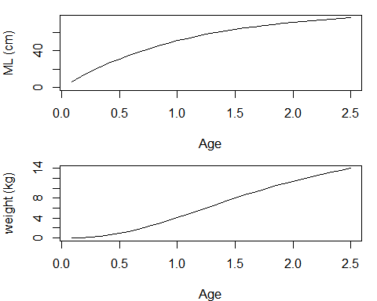

Figure 2. Maturity at size and age.
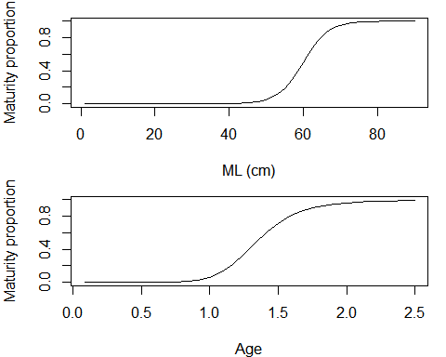

Table 1. Individual Parameters

Growth Parameters
loo | r | t0 | a | b
83.94 | 0.93 | 0 | 2.31e-05 | 3.077
Maturity Parameters
lm50 | lmrange
60 | 10

POPULATION FUNCTIONS

Figure 3. M by age and YEAR.MONTH.
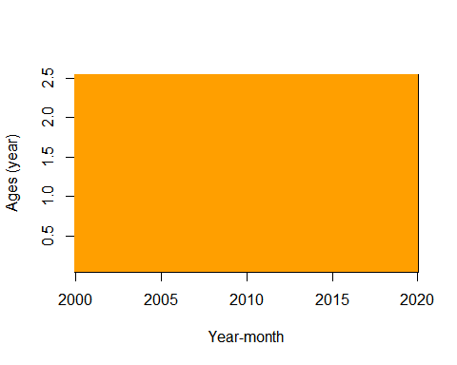

Figure 4. Recruitment before the starting time.
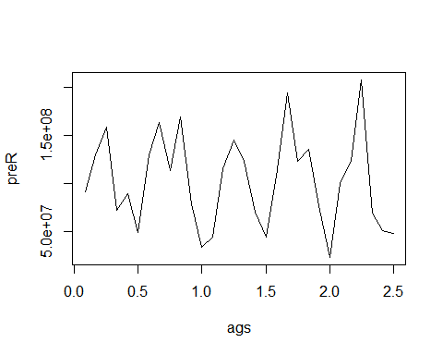

Figure 5. N at the first year.
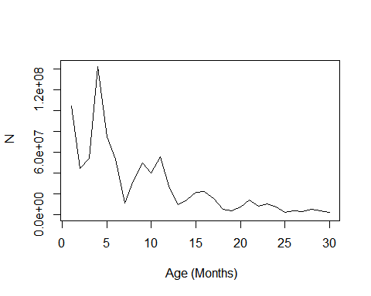

Figure 6. Seasonal recruitment patterns.
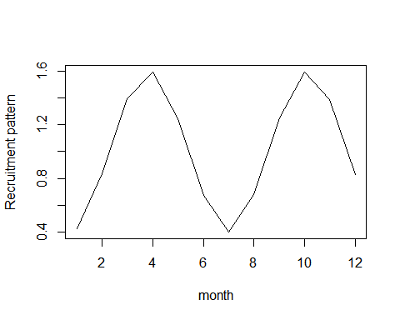

Figure 7. Spawning Biomass and Recruitment.
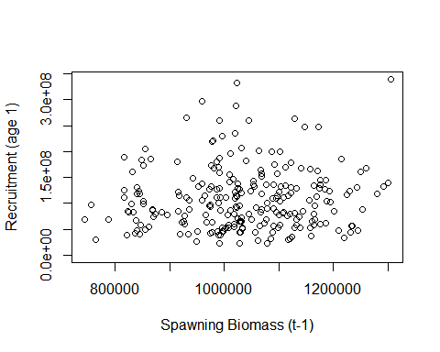

Figure 8. Seasonal Pattern of recruitment and Number at the begginning.
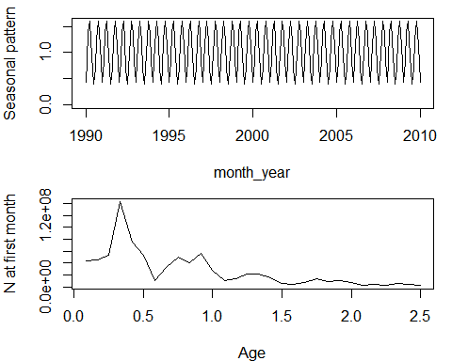

Figure 8. Number at age by YEAR.MONTH.
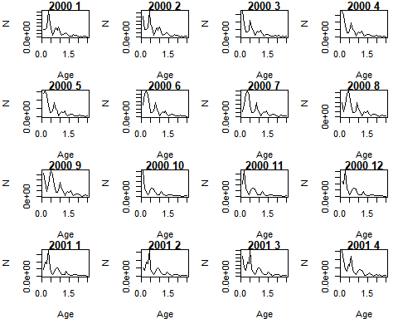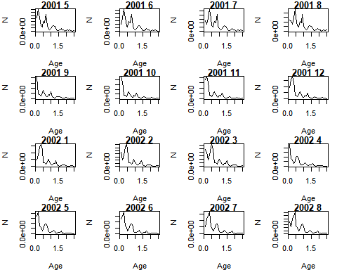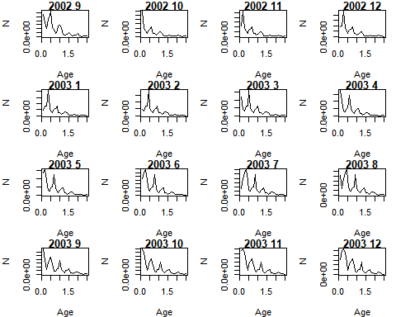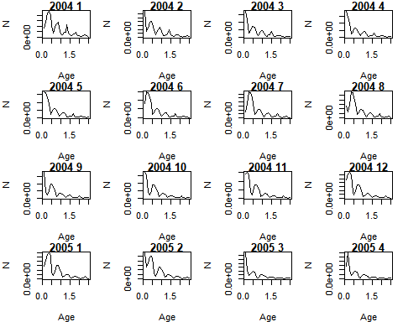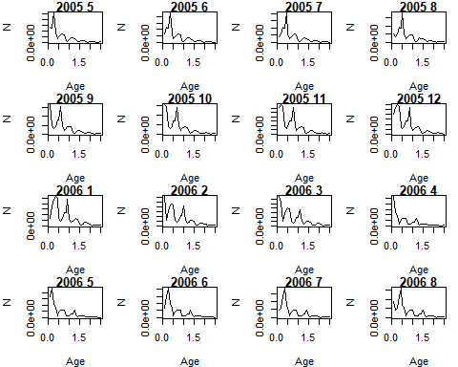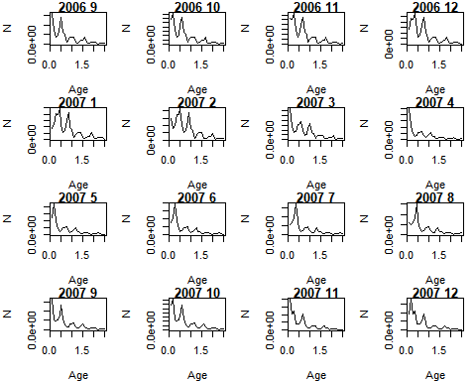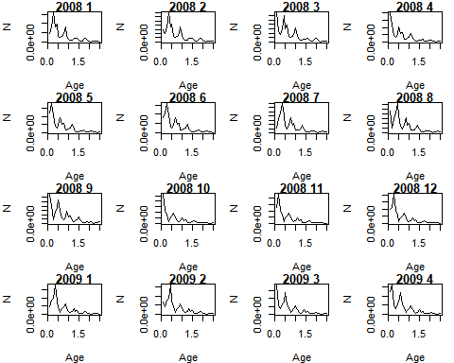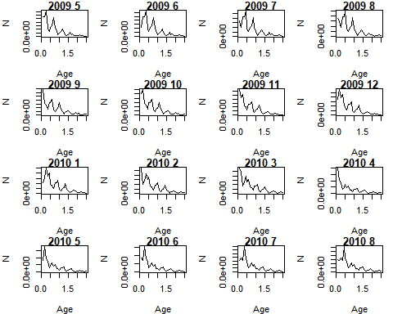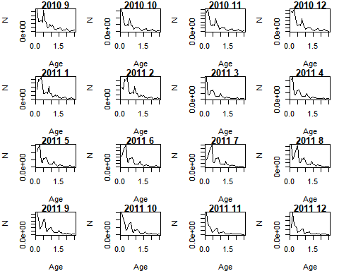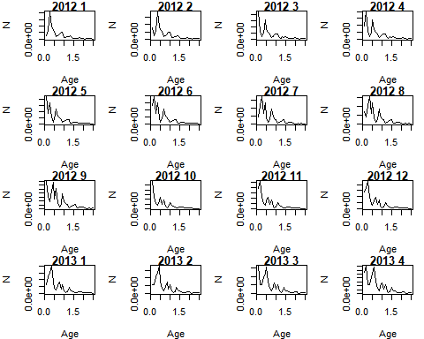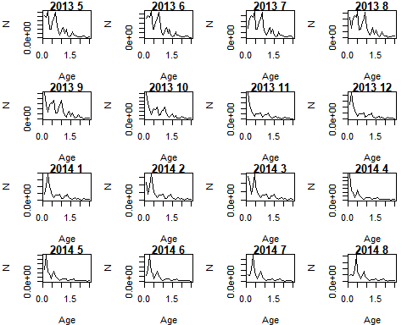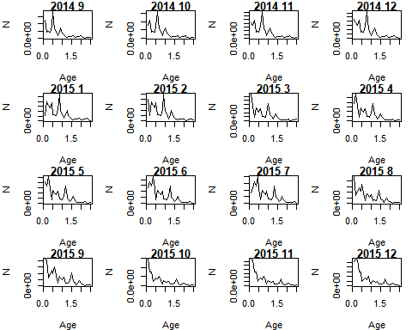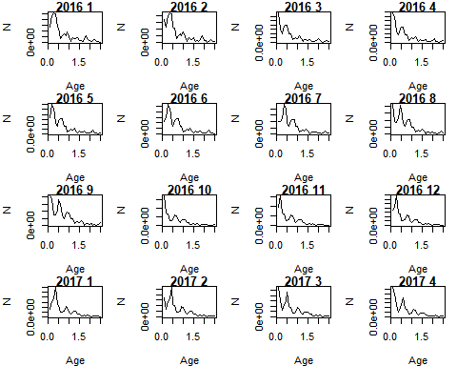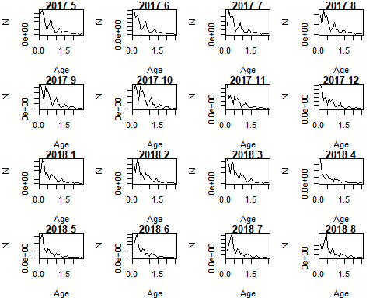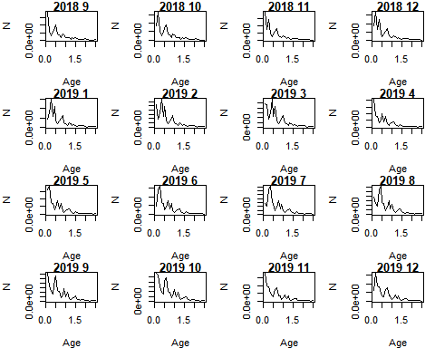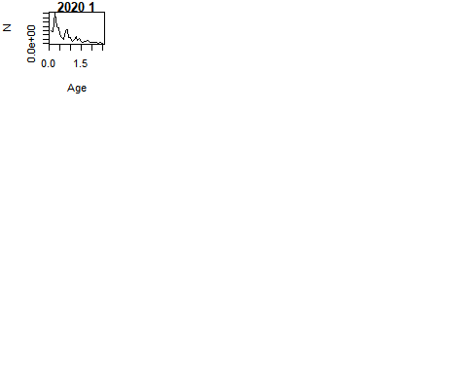

Figure 9. Number at age in the first Year and Recruitment by YEAR.MONTH.
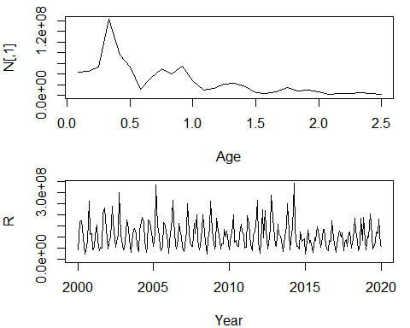

Figure 10. Whole number by YEAR.MONTH.
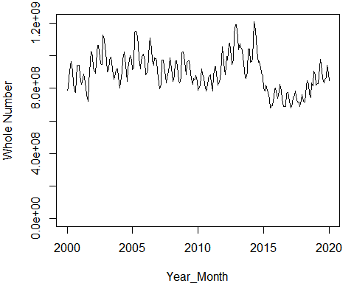

Figure 11. Whole number by YEAR.MONTH.
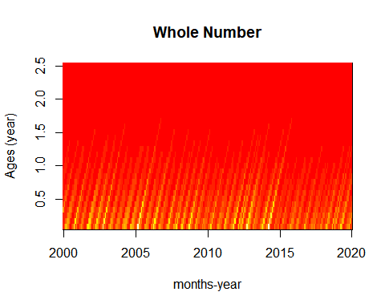

Figure 12. Number by age and YEAR.MONTH.
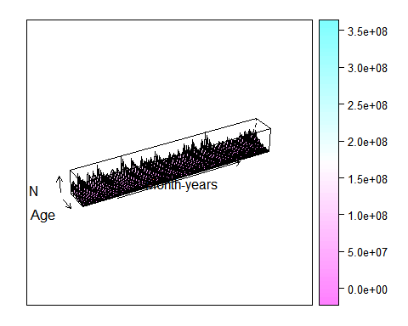

Figure 13. Biomass by YEAR.MONTH.
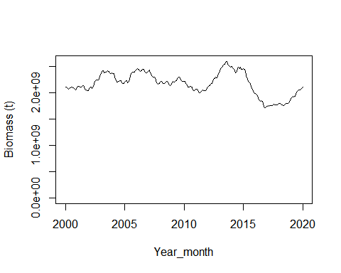

Figure 14. Spawning Biomass by YEAR.MONTH.
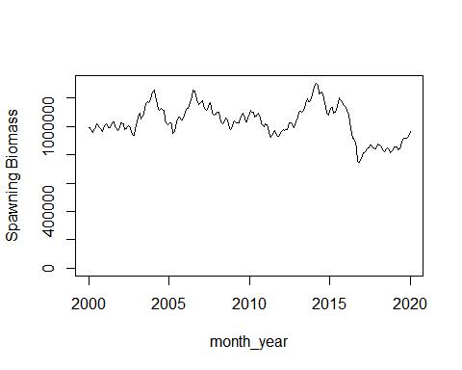

Table 2. Population Parameters.

Recruitment Seasonal Parameters
tr | R_sd | corre | cv
3 | 0 | 0 | 0
M and Stock Recruitment Parameters
M_Annual | M_bin | M_cv | h | prev.rsigma | rsigma
1.5 | 0.125 | 0 | 0.7 | 0.3 | 0.3

