SQUIDSIM, SQUID SIMULATOR, Version 1.1
Ignacio Payá C., IFOP, Chile
marzo 23, 2021
Table of Contents
SUMMARY 3
INTRODUCCTION 3
METHODS 5
INDIVIDUAL FUNCTIONS 5
Growth models 5
Allometric growth 5
Maturity 5
POPULATION FUNCTIONS 5
Natural Mortality (M) 5
N at the first month 6
Seasonal Recruitment Patterns 6
Equilibrium functions 6
Population after the first month (j>1) 7
FISHERY FUNCTIONS 8
Selectivity and Fishing mortality. 8
Catch 9
CPUE 9
Acoustic Selectivities. 9
Acoustic Biomass 10
RESULTS 11
INDIVIDUAL FUNCTIONS 11
Figure 1. Growth at size and age. 11
Figure 2. Maturity at size and age. 12
Table 1. Individual Parameters 12
POPULATION FUNCTIONS 13
Figure 3. M by age and YEAR.MONTH (if M is constant then one color). 13
Figure 4. Recruitment before the starting time. 14
Figure 5. N at the first year. 15
Figure 6. Seasonal recruitment patterns. 16
Figure 7. Fishing Selectivity by fleet. 17
Figure 8. Spawning Biomass and Recruitment. 18
Figure 9. Seasonal Pattern of recruitment and Number at the begginning. 19
Figure 10. Number at age by YEAR.MONTH. 20
Figure 11. Whole Catch in number at age by YEAR.MONTH. 24
Figure 12. Fleet 1 Catch in number at age by YEAR.MONTH. 28
Figure 13. Fleet 2 Catch in number at age by YEAR.MONTH. 32
Figure 14. Length-age key. 36
Figure 15. Length frequency by Year.Month. 37
Figure 16. Whole Catch in number at length by Year.Month. 41
Figure 17. Fleet 1 Catch in number at length by Year.Month. 45
Figure 18. Fleet 2 Catch in number at length by Year.Month. 49
Figure 19. Number at age in the first Year and Recruitment by YEAR.MONTH. 53
Figure 20. Whole number by YEAR.MONTH. 54
Figure 21. Catch (tons) by YEAR.MONTH. 55
Figure 22. Whole number by YEAR.MONTH. 56
Figure 23. Number by age and YEAR.MONTH. 57
Figure 24. Biomass by YEAR.MONTH. 58
Figure 25. Spawning Biomass by YEAR.MONTH. 59
ABUNDANCE INDICES 60
Figure 26. Hyperstability. 60
Figure 27. CPUE by YEAR.MONTH. 61
Figure 28. Acoustic Biomass by YEAR.MONTH. 62
Figure 29. Acoustic Selectivities. 63
Figure 30. MPH Biomass by YEAR.MONTH. 64
Table 2. Population, Fishery and Indices Parameters. 64
REFERENCES 65

SUMMARY

A program to simulate individual, population and fishery components of Humboldt Squid stock in month scale was developed. Two growth functions (exponential or VonBertalanffy) were included. Maturity was modelled as a logistic function. Two options for modelling stock-recruitment relationship (Ricker or Beverton and Holt) with steepness parameters and process errors were included. Three options (constant, exponential and sinusoidal) for seasonal recruitment patterns were allowed. The fishing component includes two fleets with selectivity patterns modelled as double half-normal functions. A length-age key is calculated based on the growth model in order to estimate the mantle length frequency in the population and in the commercial catches. This simulator was coded in R Mardown in R Studio, which allows to automatically knit text, R codes, tables and figures to produce a report in html, word and pdf formats. In order to run the simulation with different cases, the parameters must be input in an csv format file.

INTRODUCCTION

The Scientific Committee seems to agree that because of the short lifetime (1 -1.5 year) of Humbodlt squid, the stock assessment and management should be done in-season scale. However, the impact of not doing so and try to apply models with year scale, as the global production models, has not been formally evaluated.
Management strategy evaluation requires to build an operational model to test different stock assessment models and harvesting rules. The simulation of the stock dynamics and the fisheries is the first step in development an operational model. Therefore, this contribution offers a simulator of the population dynamic and fishery of Humboldt squid stock.
From the point of view of the local squid stock assessment in the EEZ of Chile, the simulator should be able to reproduce the mantle length frequencies observed by month in artisanal catches in 2015 (broken line) and 2016 (solid line)(Payá 2015, 2016).
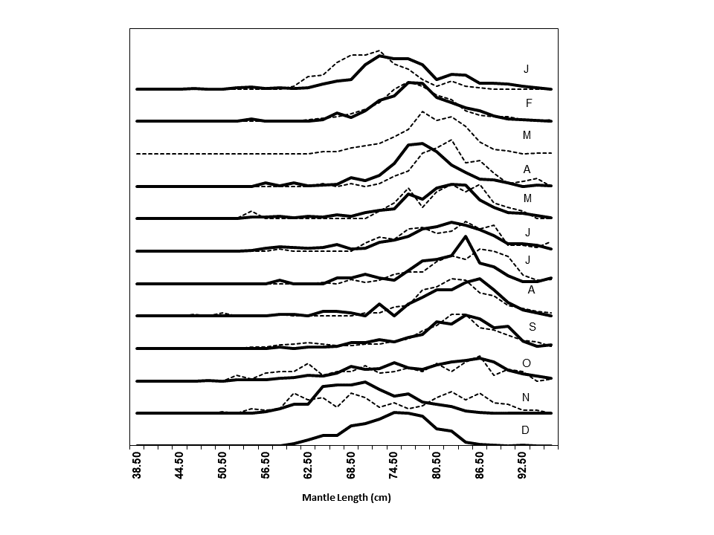
These frequencies had a clear modal progression that suggests the arrival of large squids in November and the departure in October of the next year (Payá 2016). This mantle length data combined with abundance indices have been used in fitting successfully local depletion models (Payá 2015, 2016, 2017).
Therefore, this is a program to simulate the dynamic of Humboldt Squid population off Chilean waters. The time scale is month. The recruitments are modelled using a Ricker (1954) or a Beverton and Holt (1957) stock-recruitment relationship, with a steepness parameter (h) (Mace and Doonan 1988) and process errors (rsigma). Recruitment can also be multiply by a seasonal factor to generate a seasonal pattern. Seasonal pattern can be constant (no effect), exponential decreasing or sinusoidal.
The fishing component includes two fleets. The fishing selectivities are modelled using double half-normal functions.
This simulator is coded in R Mardown in R Studio (Allaire et al. 2018). The individual, population and fishery parameters are setting in a file named “HSquid_Par.csv”. The use of external parameter file allows to run the simulation with different set of parameters.

METHODS

The age and time variables are in units of years and they are divided by month. The $bin$ is the fraction of the year for a month ($bin=1/12$). The age $i$, $i=1,...,nags$, where $nags$ is numbers of months in the lifetime. The time $j$, $j=1,.....nbtins$, where $nbtins$ is the whole numbers of months in the time series.

INDIVIDUAL FUNCTIONS

Growth models
There are two model options. If gm=1 the exponential model is used:
$$l_{i}=a_{expo}exp(b_{expo}t)$$
where $l$ is the Mantle length (cm) and $a_{expo}$ and $b_{expo}$ are the parameters, which were taken from Argüelles et al. (2001) for large squid with hatching in spring.
If gm>1 the vonBertalanffy model is used:
$$l_{i}=loo(1-exp(-r(t-t_{0}))$$
where $loo$: Infinite length (cm); $r$: growth rate; $t$: age in years; $t0$: age in years at length zero;

Allometric growth
$$w_{i}=al_{i}^{b}$$
where $a$ and $b$ are the allometric parameters and $w$ is the whole weight.
The vonBertalanffy parameters and the allometric parameters were taken from Payá et al. (2014).

Maturity
$$pm_{i}=1/(1+exp(-log(19)(l_{i}-lm50)/lmrange))$$
where $lm50$ is the length at 50% of maturity and $lmrange$ is the amplitude of the function.

POPULATION FUNCTIONS

Natural Mortality (M)
$$M_{i,j}=M_{bin}+e_{i,j}^{M}$$
where $e^{M}∼N(0,sd_{M})$ and $sd_{M}$ is the standard deviation of $Mbin$

N at the first month
The number at age 1 for the first month is R0, and for the older ages is the number of survivors of previous recruitments
The recruitment before the first year is vector of length equals to numbers of ages (nags)
$$predR_{i}=R0 exp(e_{i}^{0})$$
For i (age) = 1
$$N_{1,1}=B0+e_{i}=predR_{nags} exp(e_{i}^{0})$$
For i (age)>1
$$N_{i,1}=predR_{nags-1-i} exp(-M_{i-1,1}(i-1)) exp(e_{i}^{0})$$
$$e_{i}^{0}∼N(0,prevrsigma)$$
where $prevrsigma$ is the standard deviation of recruitments before the starting month.

Seasonal Recruitment Patterns
Constant pattern ($RSeason$=1):
$$inbinR=1 exp(e_{1}^{s})$$
Exponential pattern ($RSeason$=2), with $inbinR_{1}=1$:
$$inbinR_{i}=exp(-0.20(i-1)) exp(e_{i}^{s}) for i=2,...,12$$
Sinusoidal Pattern ($RSeason$=3):
$$inbinR_{i}=sin(3+i) exp(e_{i}^{s}) for i=1,...,12$$
$$e^{s}∼N(0,SdSeason)$$
Non negative $inbinR_{i}$ were allowed, so if $inbinR_{i}$<0 then $inbinR_{i}$=0.

Equilibrium functions
The numbers per recruit ($Neq_{1}=1$), are :
$$Neq_{i}=Neq_{i-1}exp(-M_{i-1,1}) for i=2,...,nags$$
The potential spawning biomass per recruit, $SPBR$, in tons:
$$SBPR=\sum_{i=1}^{nags}{w_{i}}pm_{i}Neq_{i}/1000$$
For $SB0$ (in tons) $R0$ is:
$$R0=SB0/SBPR$$
There are two options for the stock-recruitment model. If parameter SRModel= 1 then Ricker else Beverton-Holt.
The Ricker parameters are calculated based on the steepness parameter $h$ are:
$$alpha=1.25log(5*h)-log(SBPR)$$
$$beta=1.25log(5h)/SB0$$
The Beverton-Holt parameters based on steepness parameter $h$ are:
$$alpha=(1-h)/(4h) SBPR$$
$$beta=(5h-1)/(4h SB0) SBPR$$
The recruitment at the first month $j$=1, using Ricker model is calculated as:
$$R_{1}=N_{1,1}=SB0exp(alpha-beta*SB0) inbinR_{j} exp(e_{j}^{r}-rsigma^{2}/2)$$
while with Beverton-Holt model as:
$$R_{1}=N_{1,1}=SB0/(alpha+betaSB0) inbinR_{j} exp(e_{j}^{r}-rsigma^{2}/2)$$
where $e_{j}^{r}$ is:
$$e_{j}^{r}∼N(0,rsigma)$$

Population after the first month (j>1)
The number $N_{i,j}$ are:
$$N_{i,j}=N_{i-1,j-1}exp(-M_{i,j})$$
The whole number by mnonth, $NT$(tons), is:
$$NT_{j}=\sum_{i=1}^{nags}{N_{i,j}}$$
The whole biomass by mnonth, $BT$(tons), is:
$$BT_{j}=\sum_{i=1}^{nags}{N_{i,j}}w_{i}/1000$$
The whole spawning biomass, $SBT$(tons), is:
$$SBT_{j}=\sum_{i=1}^{nags}{N_{i,j}}pm_{?}w_{i}/1000$$
The recruitment, $R_{j}$, with Ricker model is:
$$R_{j}=N_{1,j}=SBT_{j-1}exp(alpha-betaSBT_{j-1}) inbinR_{j} exp(e_{j}^{r}-rsigma^{2}/2)$$
while with Beverton-Holt is:
$$R_{j}=N_{1,j}=SBT_{j-1}/(alpha+betaSBT_{j-1}) inbinR_{j} exp(e_{j}^{r}-rsigma^{2}/2)$$
To estimate the length frequency an age-length key,$alkey$ , is calculated assuming a normal distribution of length at age:
$$alkey_{i,j}=\frac{1}{σ_{i}\sqrt{2π}}e^{-(ls_{j}-l_{i})^{2}/2σ_{i}^{2}} for i=1,...,nags; j=1,...,nls$$
where $ls_{i}$ is the mean length at age and $σ_{i}$ is the standardt deviation at age. $σ_{i}$ = $ls_{i}$*$CVGrowth$
The number at length ($k$) and month ($j$), $N_{k,j}$, is calculated as:
$$N_{k,j}=\sum_{i=1}^{nags}{(}N_{i,j} * alkey_{k,i})$$

FISHERY FUNCTIONS

Selectivity and Fishing mortality.
Selectivty, $S$, are modelled by fleet ($f$) using double half-normal functions:
$$S_{i}^{f}=exp(-0.5(i-bs^{f})^{2})/{as^{f}}^{2}) for i<sb^{f}.$$
$$S_{i}^{f}=exp(-0.5(i-bs^{f})^{2})/{cs^{f}}^{2}) for i=>sb^{f}.$$
where $as,bs$ and $cs$ are parameters. $bs$ is the age of maximun selectivity ($S_{bs}^{f}=1$)
The fishing mortality,$F$, by fleet ($f$) at age and month is calculated as:
$$F_{i,j}^{f}=F_{ref}^{f}bin S_{i}^{f}$$
The whole fishing mortality is:
$$F_{i,j}=∑F_{i,j}^{f}$$

Catch
Catch, $C$, by fleet ($f$) in numbers at age ($i$) and month ($j$):
$$C_{i,j}^{f}=F_{i,j}^{f}/(F_{i,j}+M_{i,j})N_{i,j}(1-exp(-M_{i,j}-F_{i,j}))$$
Catch in number by fleet ($f$) at length ($k$) and month ($j$) is calculated as:
$$C_{k,j}^{f}=\sum_{i=1}^{nags}{(}C_{i,j}^{f} * alkey_{k,i})$$
The whole catches in numbers are:
$$C_{i,j}=∑C_{i,j}^{f} ; C_{k,j}=∑C_{k,j}^{f}$$
The catch (tons) by fleet, $YT^{f}$(tons), is:
$$YT_{j}^{f}=\sum_{i=1}^{nags}{C_{i,j}^{f}}w_{i}/1000$$
The whole catch (tons) is:
$$YT_{i,j}=∑YT_{i,j}^{f}$$
## INDICES FUNCTIONS

CPUE
$CPUE$ by fleet ($f$) and month ($j$) is:
$$CPUE_{j}^{f}=q^{f}(\sum_{i=1}^{nags}{(}C_{i,j}^{f}w_{i}/1000)/F_{i,j}^{f})^{hyp}$$

Acoustic Selectivities.
Acoustic selectivities ($S$) by length ($l$) are modelled by survey ($f$) using double half-normal functions:
$$S_{l}^{f}=exp(-0.5(l-bs^{f})^{2})/{as^{f}}^{2}) for l<sb^{f}.$$
$$S_{l}^{f}=exp(-0.5(l-bs^{f})^{2})/{cs^{f}}^{2}) for l=>sb^{f}.$$
where $as,bs$ and $cs$ are parameters. $bs$ is the length at the maximun selectivity ($S_{bs}^{f}=1$)

Acoustic Biomass
Acoustic Biomass ($Bacous$) by survey ($f$) and month ($j$) is:
$$Bacous_{j}^{f}=qacous_{j}^{f}\sum_{i=1}^{nls}{S_{l,j}^{f}}N_{l,j}w_{l}/1000$$

RESULTS

The results are presented in graphs and then the parameters in tables.

INDIVIDUAL FUNCTIONS

Figure 1. Growth at size and age.
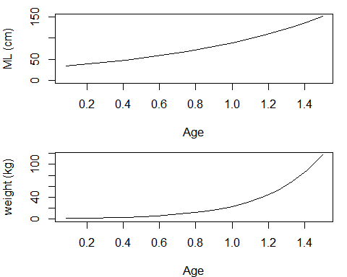

Figure 2. Maturity at size and age.
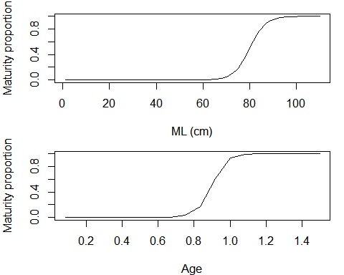

Table 1. Individual Parameters

## Warning: package 'knitr' was built under R version 3.6.3
Growth Parameters
a_expo | b_expo | a | b
309.11 | 0.0029 | 2.31e-05 | 3.077

Maturity Parameters
lm50 | lmrange
80 | 10

POPULATION FUNCTIONS

Figure 3. M by age and YEAR.MONTH (if M is constant then one color).
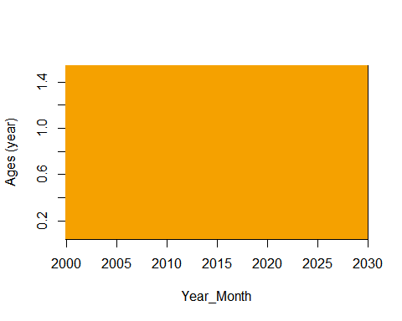

Figure 4. Recruitment before the starting time.
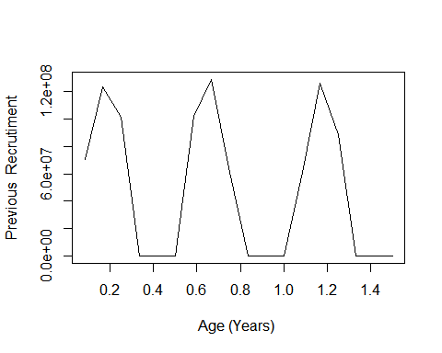

Figure 5. N at the first year.
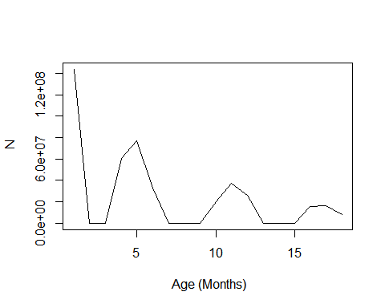

Figure 6. Seasonal recruitment patterns.
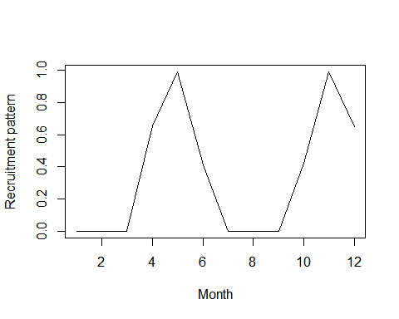

Figure 7. Fishing Selectivity by fleet.
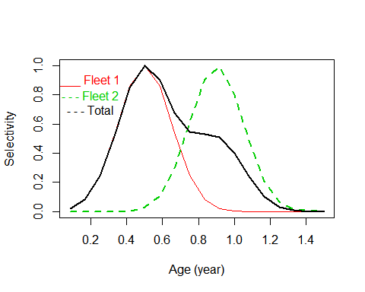

Figure 8. Spawning Biomass and Recruitment.
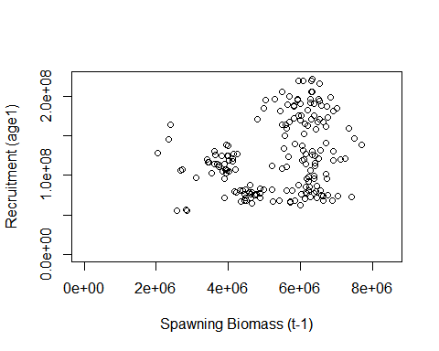

Figure 9. Seasonal Pattern of recruitment and Number at the begginning.
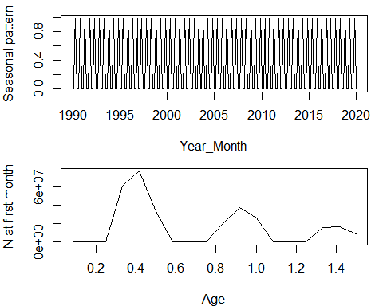

Figure 10. Number at age by YEAR.MONTH.
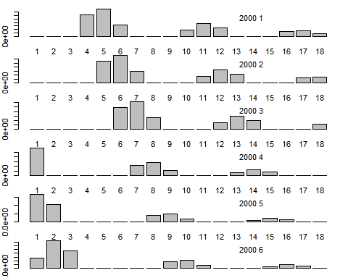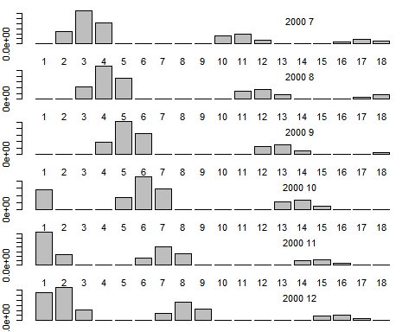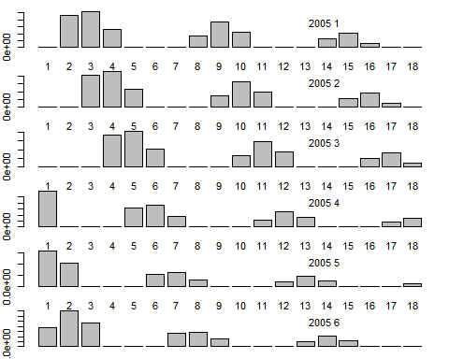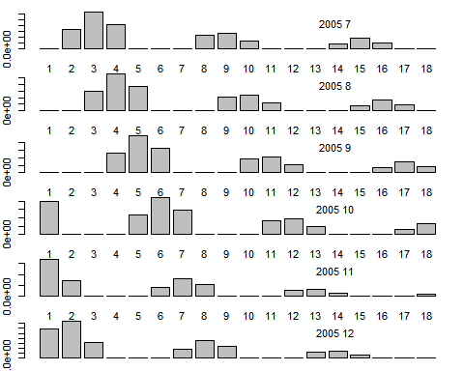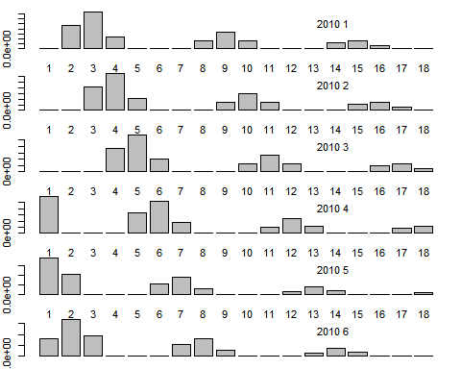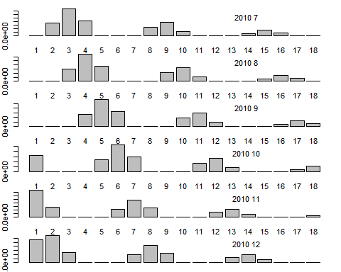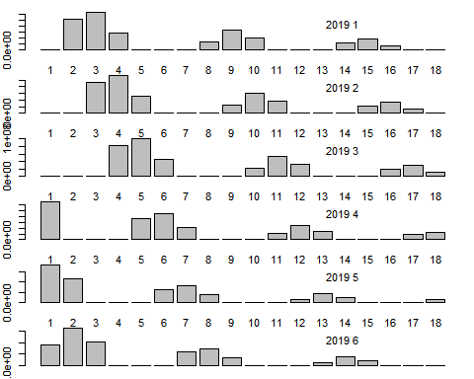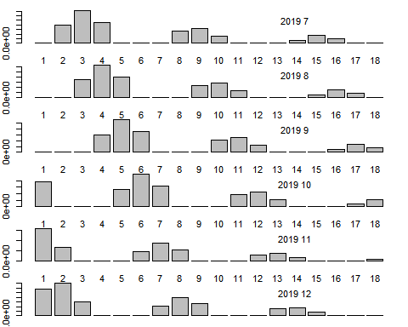

Figure 11. Whole Catch in number at age by YEAR.MONTH.
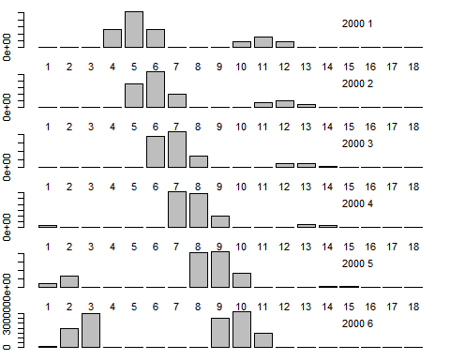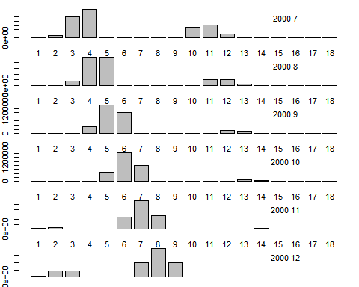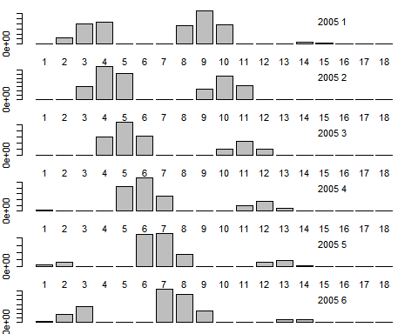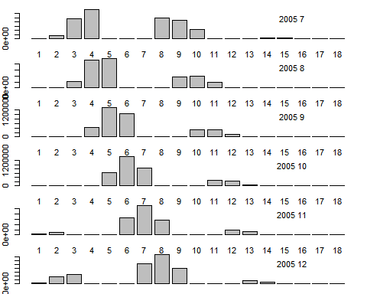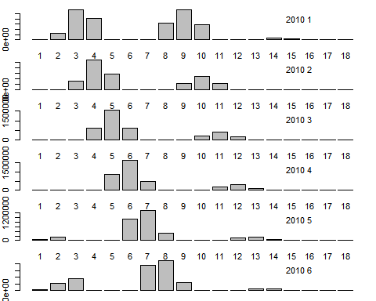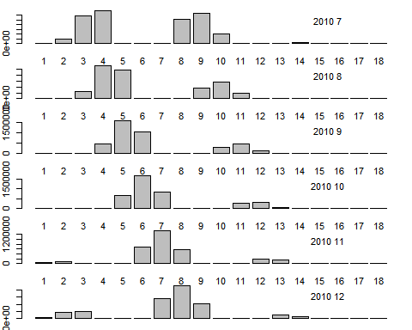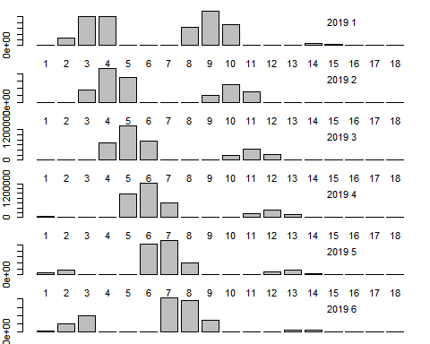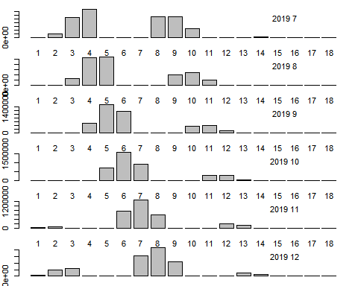

Figure 12. Fleet 1 Catch in number at age by YEAR.MONTH.
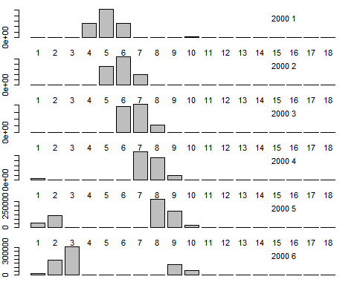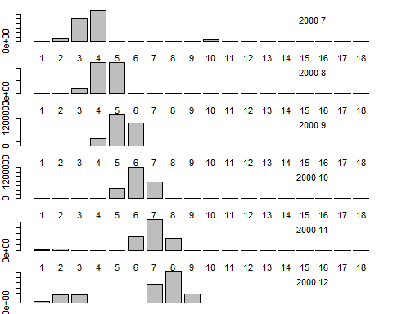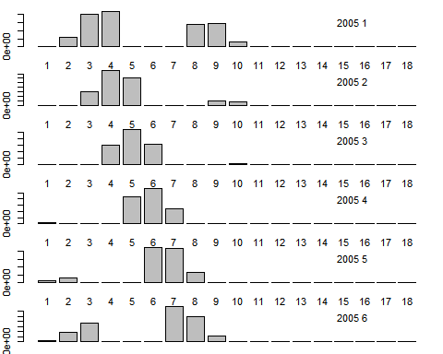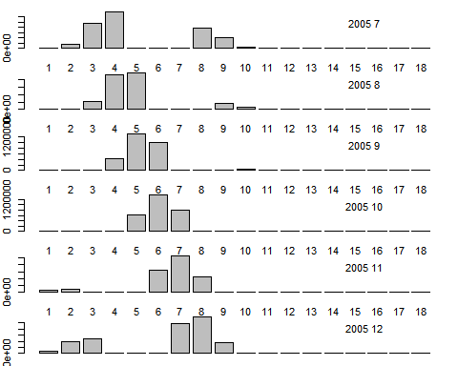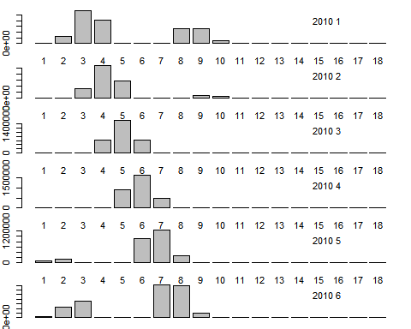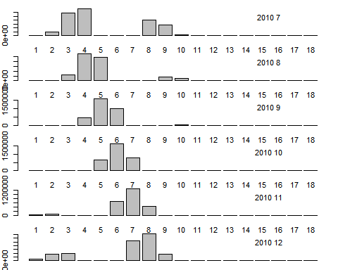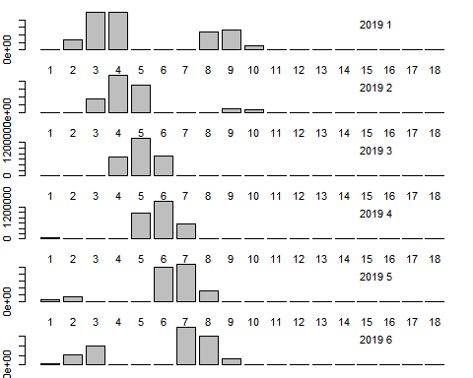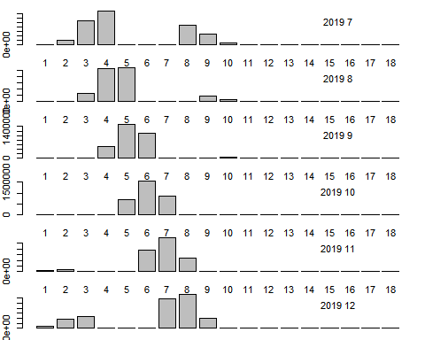

Figure 13. Fleet 2 Catch in number at age by YEAR.MONTH.
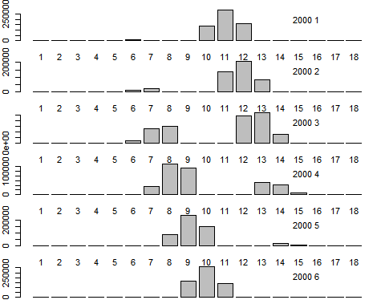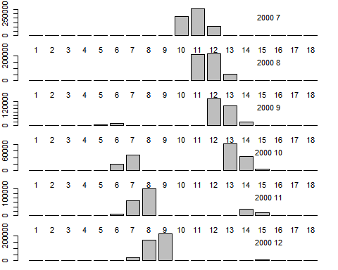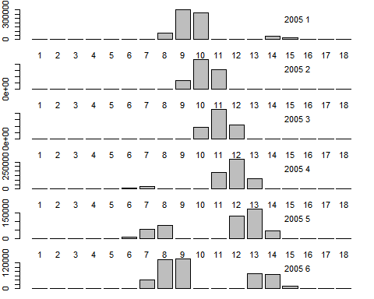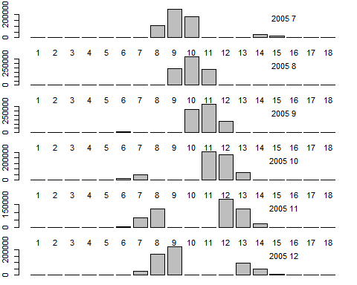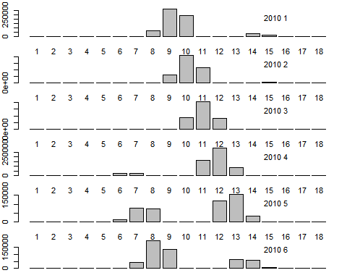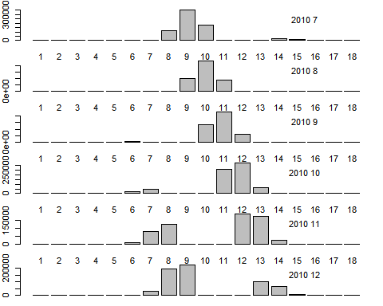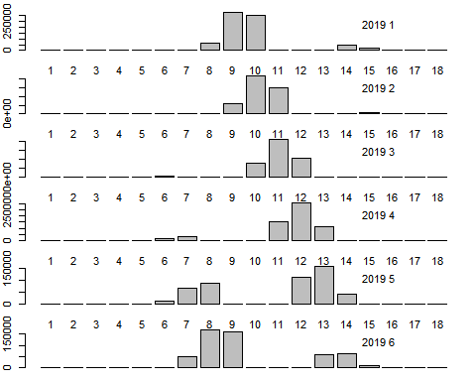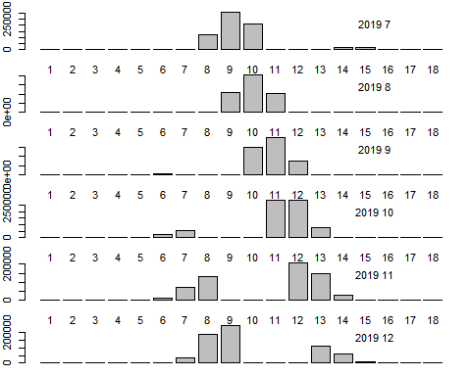

Figure 14. Length-age key.
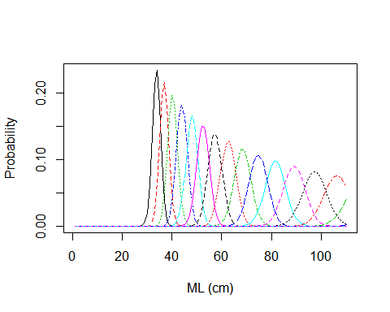

Figure 15. Length frequency by Year.Month.
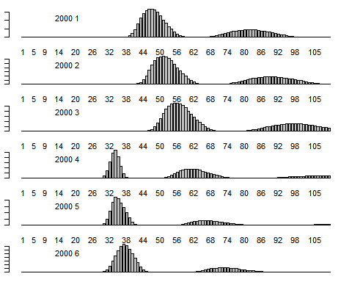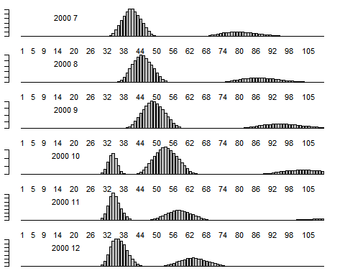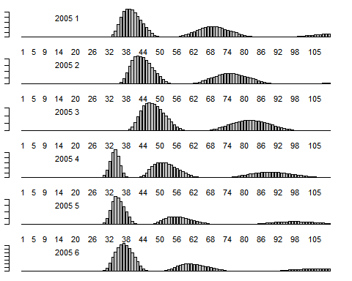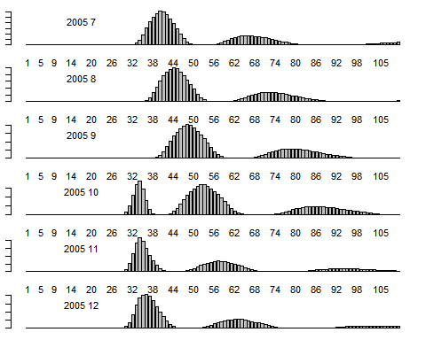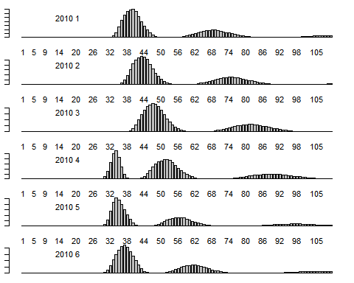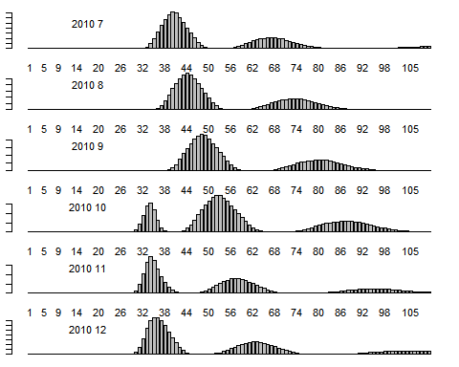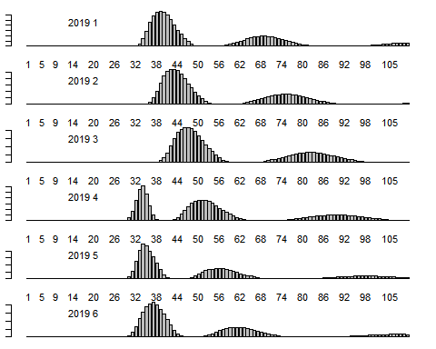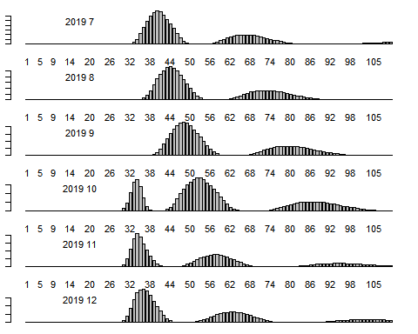

Figure 16. Whole Catch in number at length by Year.Month.
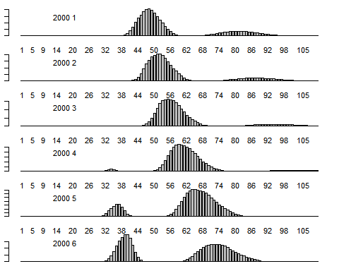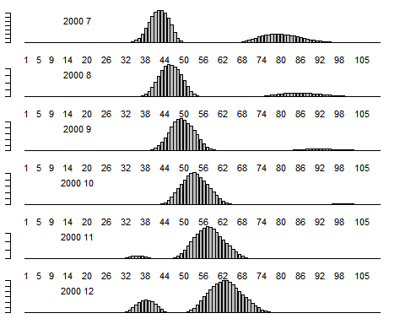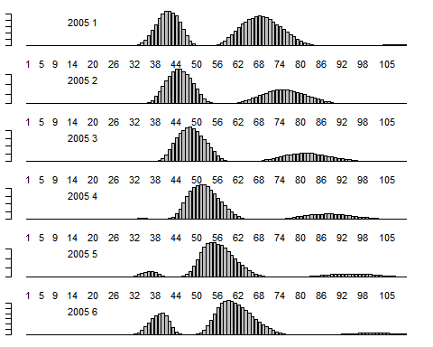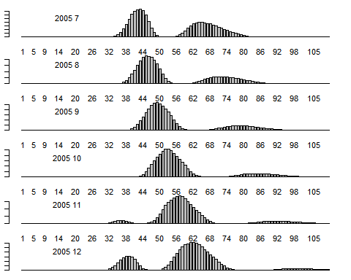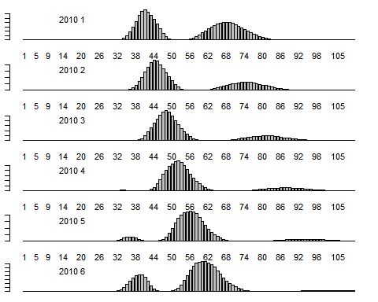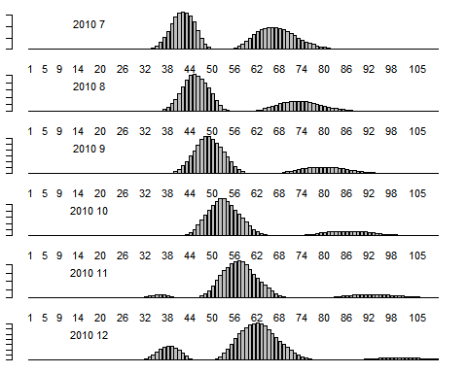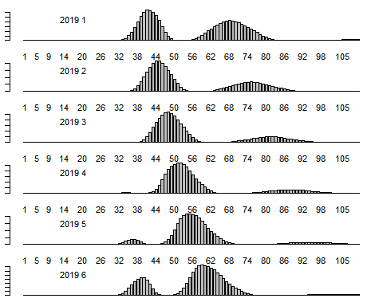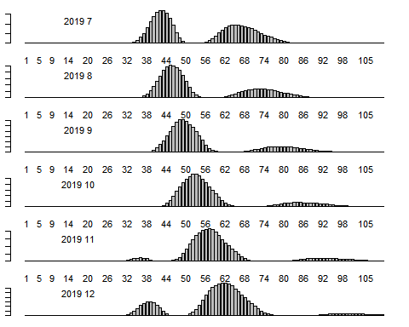

Figure 17. Fleet 1 Catch in number at length by Year.Month.
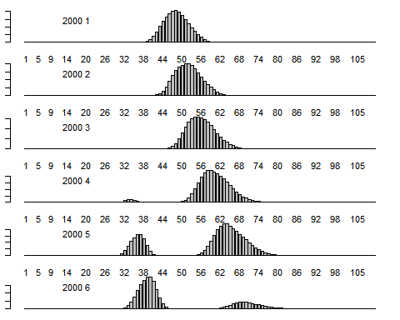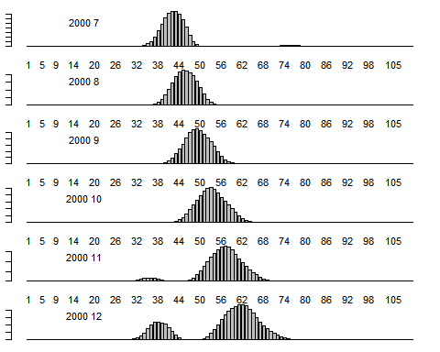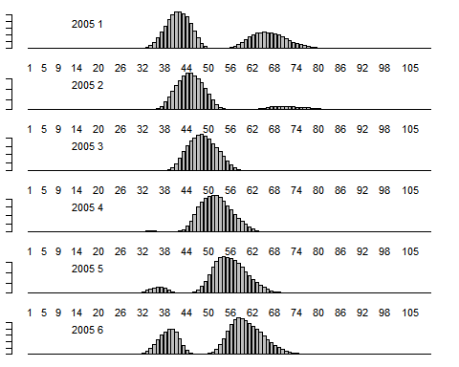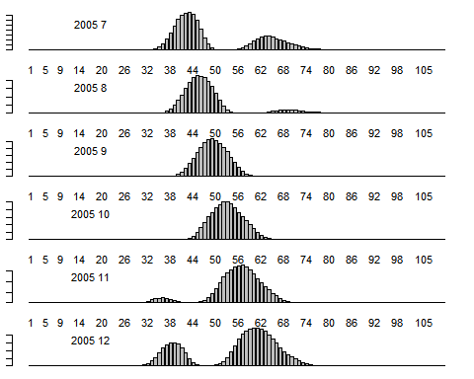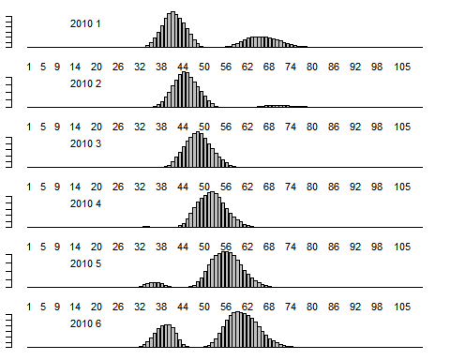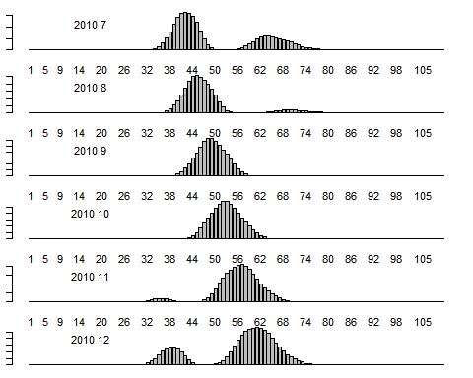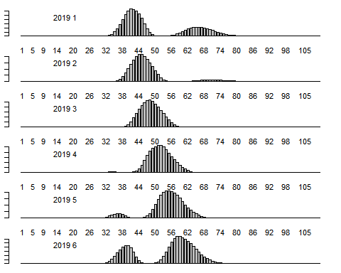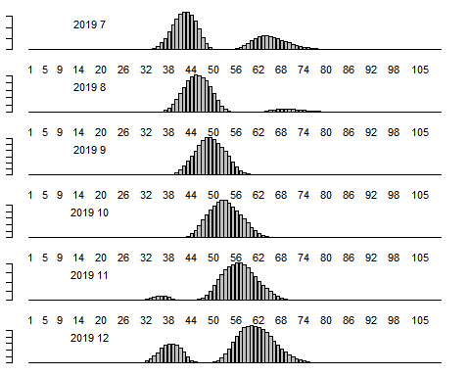

Figure 18. Fleet 2 Catch in number at length by Year.Month.
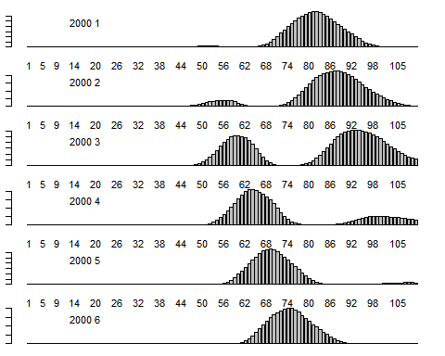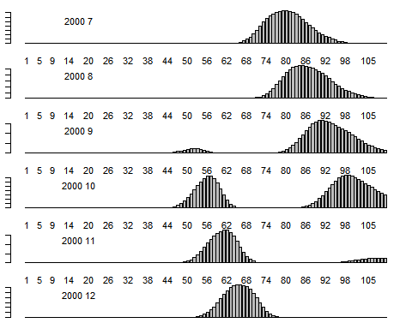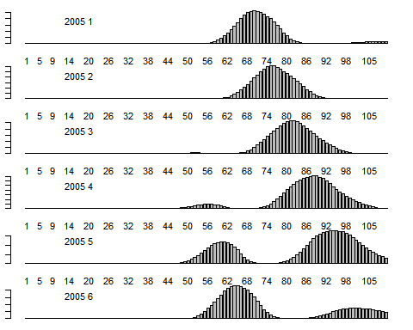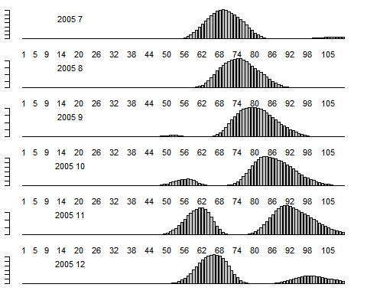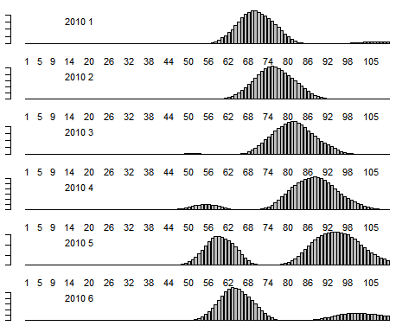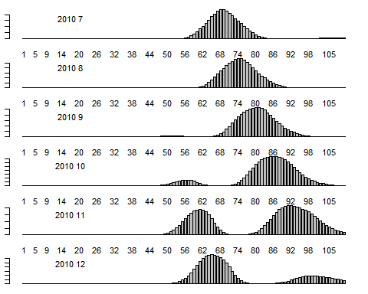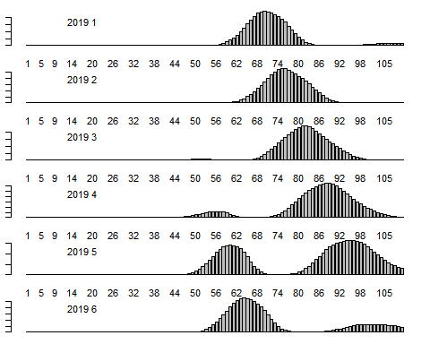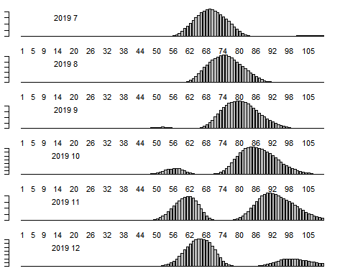

Figure 19. Number at age in the first Year and Recruitment by YEAR.MONTH.
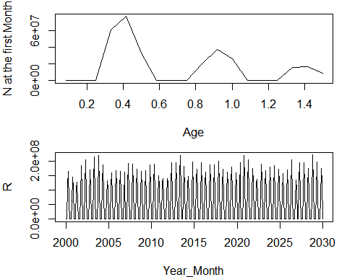

Figure 20. Whole number by YEAR.MONTH.
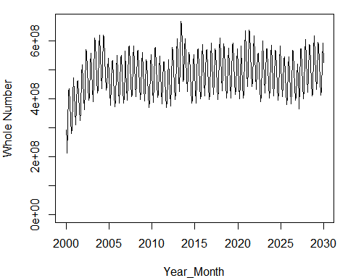

Figure 21. Catch (tons) by YEAR.MONTH.
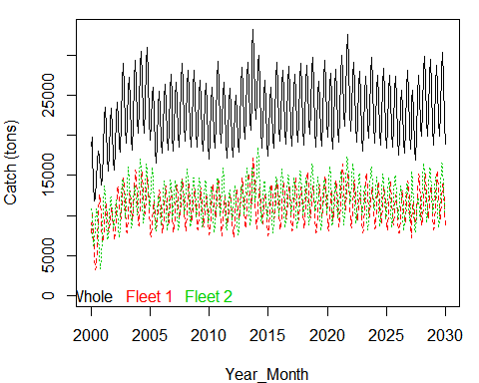

Figure 22. Whole number by YEAR.MONTH.
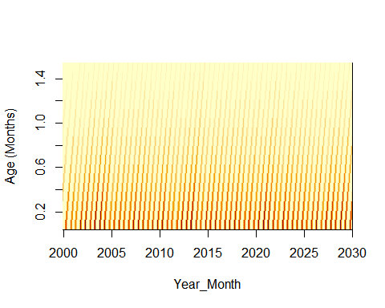

Figure 23. Number by age and YEAR.MONTH.
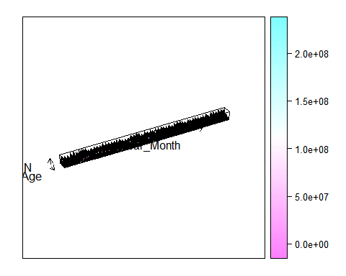

Figure 24. Biomass by YEAR.MONTH.
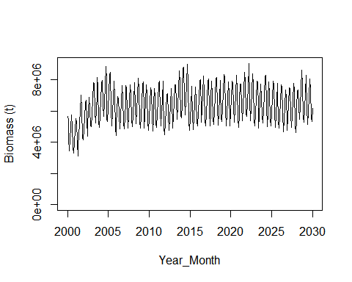

Figure 25. Spawning Biomass by YEAR.MONTH.
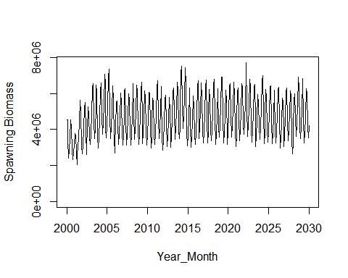

ABUNDANCE INDICES

Figure 26. Hyperstability.
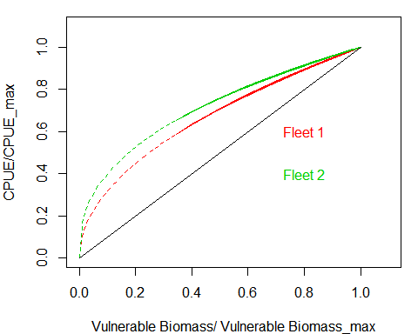

Figure 27. CPUE by YEAR.MONTH.
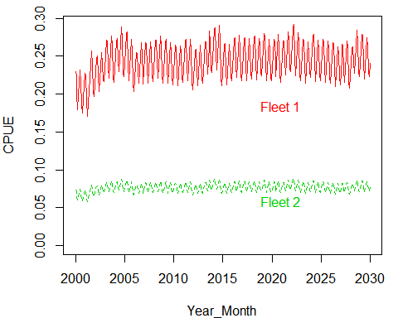

Figure 28. Acoustic Biomass by YEAR.MONTH.
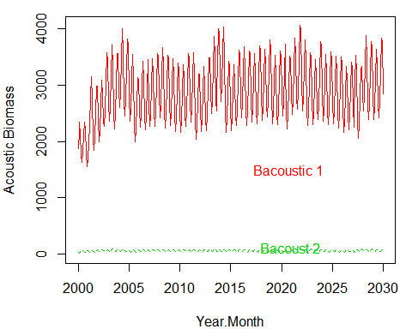

Figure 29. Acoustic Selectivities.
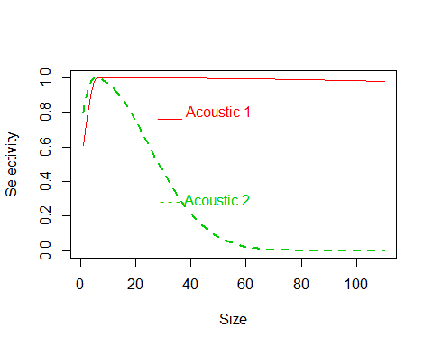

Figure 30. MPH Biomass by YEAR.MONTH.
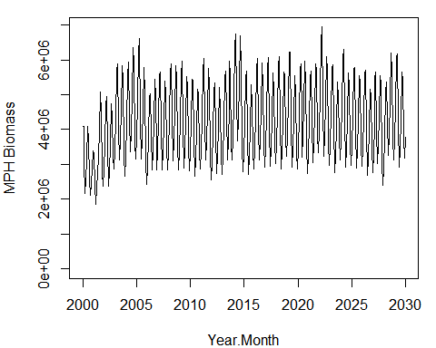

Table 2. Population, Fishery and Indices Parameters.

Recruitment Seasonal Parameters
RSeason | SdSeason
3 | 0

M and Stock Recruitment Parameters
M_Annual | M_bin | M_cv | SB0 | SRModel | h | prev.rsigma | rsigma
1.5 | 0.125 | 0 | 1e+07 | 1 | 0.9 | 0.1 | 0.1

Fishery Parameters
Fref1 | as1 | bs1 | cs1 | Fref2 | as2 | bs2 | cs2
0.2 | 0.15 | 0.5 | 0.15 | 0.1 | 0.15 | 0.9 | 0.15

Indices Parameters
q1 | hyp1 | q2 | hyp2 | as3 | bs3 | cs3 | as4 | bs4 | cs4 | qacous1 | qacous2 | qMPH
1e-04 | 0.5 | 0.00015 | 0.4 | 5 | 6 | 500 | 6 | 5 | 20 | 0.9 | 0.5 | 0.9

REFERENCES
Allaire, JJ., Y. Xie, J. McPherson, and et. al. 2018. “R Markdown.” Computer Program. https://rmarkdown.rstudio.com.
Argüelles, J., P.G. Rodhouse, P. Villegas, and G. Castillo. 2001. “Age, Growth and Population Structure of the Jumbo Flying Squid Dosidicus Gigas in Peruvian Waters.” Fisheries Research 54:51-61.
Beverton, R., and S.J. Holt. 1957. “On the Dynamics of Exploited Fish Populations.” FAO Fishery investigations serie II Volumen XIX 533 p.
Mace, P. M., and I. J. Doonan. 1988. “A Generalised Bioeconomic Simulation Model for Fish Population Dynamics.” New Zealand Fisheries Assessment Research Document 88/4.Fisheries Research Centre, MAFFish, POB 297, Wellington, NZ.
Payá, I. 2015. “Estatus Y Posibilidades de Explotación Biológicamente Sustentables de Los Principales Recursos Pesqueros Nacionales. Año 2016. Jibia.” Instituto de Fomento Pesquero. Informe de Estatus y Cuota. 85 p + 4 annexes.
———. 2016. “Estatus Y Posibilidades de Explotación Biológicamente Sustentables de Los Principales Recursos Pesqueros Nacionales. Año 2017. Jibia.” Instituto de Fomento Pesquero. Informe de Estatus y Cuota. 95 p + 4 annexes.
———. 2017. “Estatus Y Posibilidades de Explotación Biológicamente Sustentables de Los Principales Recursos Pesqueros Nacionales. Año 2018. Jibia.” Instituto de Fomento Pesquero. Informe de Estatus y Cuota. 94 p + 3 annexes.
Payá, I., L. Caballero, A. Barraza, J. Cavieres, A. Yañez, and R. Tascheri. 2014. “Estatus Y Posibilidades de Explotación Biológicamente Sustentables de Los Principales Recursos Pesqueros Nacionales. Año 2015. Jibia.” Instituto de Fomento Pesquero. Informe de Estatus y Cuota. 83 p + 4 annexes.
Ricker, W. E. 1954. “Stock and Recruitment.” Journal of the Fisheries Research Board of Canada, 11(5): 559–623.

