SQUIDSIM, SQUID SIMULATOR, Version 1.3, SPRFMO SC13
Ignacio Payá C., IFOP, Chile
febrero 04, 2025
Table of Contents

SUMMARY

SQUIDSIM is a program designed to simulate individual, population, and fishery components of Humboldt Squid stock over the years on a monthly scale. Natural mortality is estimated using the gnomonic method (Caddy, 1996), employing five gnomonic stages, longevity, and fecundity. Three growth functions (exponential, Gompertz, and Von Bertalanffy) are included. Maturity is modeled as a logistic function. Two options for modeling the stock-recruitment relationship (Ricker or Beverton and Holt) with steepness parameters and process errors are included. Three options (constant, exponential, and sinusoidal) for seasonal recruitment patterns are included. The fishing components include four fleets with selectivity patterns modeled as double half-normal functions. A length-age key is calculated based on the growth model to estimate the mantle length frequency in the population and in the commercial catches. Seven abundance indices are included: four commercial CPUE (with hyperstability), two acoustic biomass surveys, and an egg production survey. The selectivity curves of the acoustic surveys are modeled by length using double half-normal functions.
This simulator was coded in R Mardown in R Studio, which allows to automatically knit text, R codes, tables and figures to produce a report in html, word, and pdf formats. In order to run the simulation with different cases, the parameters must be input in a csv format file.

INTRODUCCTION

The Scientific Committee seems to agree that because of the short lifetime (1 -2 year) of Humboldt squid, the stock assessment and management should be done in-season scale. However, the impact of not doing so and try to apply models with year scale, as the global production models, has not been formally evaluated.
Management strategy evaluation requires to build an operational model to test different stock assessment models and harvesting rules. The simulation of the stock dynamics and the fisheries is the first step in development an operational model. Therefore, this contribution offers a simulator of the population dynamic and fishery of Humboldt squid stock.
From the point of view of the local squid stock assessment in the EEZ of Chile, the simulator should be able to reproduce the mantle length frequencies observed by month in artisanal catches in 2015 (broken line) and 2016 (solid line)(I. Payá 2015, 2016).
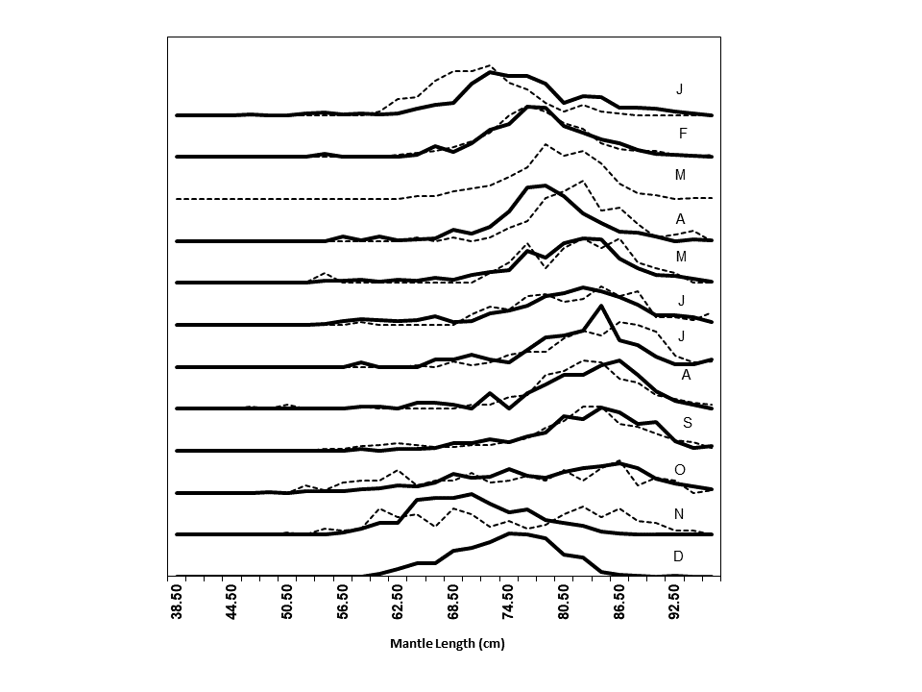
These frequencies had a clear modal progression that suggests the arrival of large squids in November and the departure in October of the next year (I. Payá 2016). This mantle length data combined with abundance indices have been used in fitting successfully local depletion models (I. Payá 2015, 2016, 2017, 2019).
The version 1.0 was design to simulate the dynamic of Humboldt Squid population in Chilean waters (I. Payá (2019)). The simultaions were done through years using a monthly steps. The recruitments were modelled using a Ricker (1954) or a Beverton and Holt (1957) stock-recruitment relationship, with a steepness parameter (h) (Mace and Doonan 1988) and process errors (rsigma). Recruitment could be multiply by a seasonal factor to generate a seasonal pattern. Seasonal pattern can be constant (no effect), exponential decreasing or sinusoidal. The fishing component includes two fleets. The fishing selectivity were modeled as double half-normal functions.
The version 1.1 extended the squid simulator to the FAO area 87. It added four abundance indices: two CPUE indices (with or without hyperstability) and two acoustic biomasses. Selectivity curves of the acoustic surveys were modelled by length using double half-normal functions. Also, adds a new option for seasonal recruitment pattern, new charts and improvements to some others charts.
The version 1.2 added 1) the longevity and the fecundity parameters to estimate the natural mortality using gnomonic method Caddy (1996), and 2) a third commercial fishery.
The current version 1.3 adds a fourth commercial fisheries and the Gompertz growth model as a third option for growth models.
This simulator is coded in R Mardown in R Studio (Allaire et al. 2018). The individual, population and fishery parameters are setting in a file named “HSquid_Par.csv”. The use of external parameter file allows to run the simulation with different set of parameters.

METHODS

The age and time variables are in units of years and they are divided by month. The $bin$ is the fraction of the year for a month ($bin=1/12$). The age $i$, $i=1,...,nags$, where $nags$ is numbers of months in the lifetime. The time $j$, $j=1,.....nbtins$, where $nbtins$ is the whole numbers of months in the time series.

INDIVIDUAL FUNCTIONS

Growth models
There are three model options. If gm=1 the exponential model is used:
$$l_{i}=a_{expo}exp\left(b_{expo}t\right)$$
where $l$ is the Mantle length (cm) and $a_{expo}$ and $b_{expo}$ are the parameters, which were taken from Argüelles et al. (2001) for large squid with hatching in spring.
If gm=2 the vonBertalanffy model is used:
$$l_{i}=loo(1−exp\left(−r\left(t−t_{0}\right)\right)$$
where $loo$: Infinite length (cm); $r$: growth rate; $t$: age in years; $t0$: age in years at length zero;
If gm=3 the Gompertz model is used: # l[i]=gm_a * exp(-gm_bm * exp(-gm_c * ags[i]))
$$l_{i}=A*exp\left(−B*exp\left(−C*t\right)\right)$$
## Allometric growth
$$w_{i}=al_{i}^{b}$$
where $a$ and $b$ are the allometric parameters and $w$ is the whole weight.
The vonBertalanffy parameters and the allometric parameters were taken from Payá I. et al. (2014).

Maturity
$$pm_{i}=1/(1+exp\left(−log\left(19\right)\left(l_{i}−lm50\right)/lmrange\right))$$
where $lm50$ is the length at 50% of maturity and $lmrange$ is the amplitude of the function.

POPULATION FUNCTIONS

Natural Mortality (M)
M is estimated using the gnomonic method Caddy (1996) and the R package gnomonicM of Torrejon-Magallanes (2021). Following to Martínez-Aguilar et al. (2010), the number of gnomonic intervals is fixed to 5 and the duration of the first interval (egg) is fixed to 6 days, while longevity and fecundity are input parameters. M is equal to adult mortality.
$$M_{i,j}=M_{bin}+e_{i,j}^{M}$$
where $e^{M}∼N\left(0,sd_{M}\right)$ and $sd_{M}$ is the standard deviation of $Mbin$

N at the first month
The recruitment before the first year is a vector of length equals to numbers of ages -1 (nags-1)
$$predR_{i}=R0 exp\left(e_{i}^{0}\right)$$
$$e_{i}^{0}∼N\left(0,prevrsigma\right)$$
where $prevrsigma$ is the standard deviation of recruitments before the starting month.
The number at age 1 at the first month is R1
$$N_{1,1}=R1$$
and for the older ages (i>2) is the number of survivors of previous recruitments
$$N_{i,1}=predR_{nags−1−i} exp\left(−M_{i−1,1}\left(i−1\right)\right) exp\left(e_{i}^{0}\right)$$

Seasonal Recruitment Patterns
Constant pattern ($RSeason$=1):
$$inbinR=1 exp\left(e_{1}^{s}\right)$$
Exponential pattern ($RSeason$=2), with $inbinR_{1}=1$:
$$inbinR_{i}=exp\left(−0.20\left(i−1\right)\right) exp\left(e_{i}^{s}\right) for i=2,...,12$$
Sinusoidal Pattern, two peaks in a year ($RSeason$=3):
$$inbinR_{i}=sin\left(3+i\right) exp\left(e_{i}^{s}\right) for i=1,...,12$$
Sinusoidal Pattern, one peak in a year ($RSeason$=4):
$$inbinR_{i}=sin\left(9+i/2\right) exp\left(e_{i}^{s}\right) for i=1,...,12$$
$$e^{s}∼N\left(0,SdSeason\right)$$
Non negative $inbinR_{i}$ were not allowed, so if $inbinR_{i}$<0 then $inbinR_{i}$=0.

Figure 1. Seasonal recruitment pattern options.
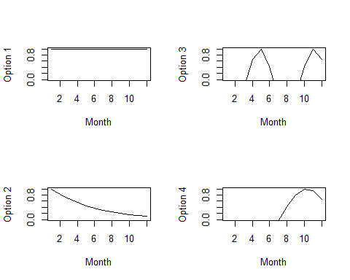

Equilibrium functions
The numbers per recruit ($Neq_{1}=1$), are :
$$Neq_{i}=Neq_{i−1}exp\left(−M_{i−1,1}\right) for i=2,...,nags$$
The potential spawning biomass per recruit, $SPBR$, in tons:
$$SBPR=\sum_{i=1}^{nags}{w_{i}}pm_{i}Neq_{i}/1000$$
For $SB0$ (in tons) $R0$ is:
$$R0=SB0/SBPR$$
There are two options for the stock-recruitment model. If parameter SRModel= 1 then Ricker else Beverton-Holt.
The Ricker parameters are calculated based on the steepness parameter $h$ are:
$$alpha=1.25log\left(5*h\right)−log\left(SBPR\right)$$
$$beta=1.25log\left(5h\right)/SB0$$
The Beverton-Holt parameters based on steepness parameter $h$ are:
$$alpha=\left(1−h\right)/\left(4h\right) SBPR$$
$$beta=\left(5h−1\right)/\left(4h SB0\right) SBPR$$
The recruitment at the first month $j$=1, using Ricker model is calculated as:
$$R_{1}=N_{1,1}=SB0exp\left(alpha−beta*SB0\right) inbinR_{j} exp\left(e_{j}^{r}−rsigma^{2}/2\right)$$
while with Beverton-Holt model as:
$$R_{1}=N_{1,1}=SB0/\left(alpha+betaSB0\right) inbinR_{j} exp\left(e_{j}^{r}−rsigma^{2}/2\right)$$
where $e_{j}^{r}$ is:
$$e_{j}^{r}∼N\left(0,rsigma\right)$$

Population after the first month (j>1)
The number $N_{i,j}$ are:
$$N_{i,j}=N_{i−1,j−1}exp\left(−M_{i,j}−F_{i,j}\right)$$
The whole number by month, $NT$(tons), is:
$$NT_{j}=\sum_{i=1}^{nags}{N_{i,j}}$$
The whole biomass by month, $BT$(tons), is:
$$BT_{j}=\sum_{i=1}^{nags}{N_{i,j}}w_{i}/1000$$
The whole spawning biomass, $SBT$(tons), is:
$$SBT_{j}=\sum_{i=1}^{nags}{N_{i,j}}mat_{i}w_{i}/1000$$
where, $mat_{i}$ is the maturity at age.
The recruitment, $R_{j}$, with Ricker model is:
$$R_{j}=N_{1,j}=SBT_{j−1}exp\left(alpha−betaSBT_{j−1}\right) inbinR_{j} exp\left(e_{j}^{r}−rsigma^{2}/2\right)$$
while with Beverton-Holt is:
$$R_{j}=N_{1,j}=SBT_{j−1}/\left(alpha+betaSBT_{j−1}\right) inbinR_{j} exp\left(e_{j}^{r}−rsigma^{2}/2\right)$$
To estimate the length frequency an age-length key,$alkey$ , is calculated assuming a normal distribution of length at age:
$$alkey_{i,j}=\frac{1}{σ_{i}\sqrt{2π}}e^{−{\left(ls_{j}−l_{i}\right)}^{2}/2σ_{i}^{2}} for i=1,...,nags; j=1,...,nls$$
where $ls_{i}$ is the mean length at age and $σ_{i}$ is the standardt deviation at age. $σ_{i}$ = $ls_{i}$*$CVGrowth$
The number at length ($k$) and month ($j$), $N_{k,j}$, is calculated as:
$$N_{k,j}=\sum_{i=1}^{nags}{\left(N_{i,j} * alkey_{k,i}\right)}$$

FISHERY FUNCTIONS

Selectivity and Fishing mortality.
Selectivity, $S$, are modelled by fleet ($f$) using double half-normal functions:
$$S_{i}^{f}=exp\left(−0.5{\left(i−bs^{f}\right)}^{2}\right)/{as^{f}}^{2}) for i<sb^{f}.$$
$$S_{i}^{f}=exp\left(−0.5{\left(i−bs^{f}\right)}^{2}\right)/{cs^{f}}^{2}) for i=>sb^{f}.$$
where $as,bs$ and $cs$ are parameters. $bs$ is the age of maximun selectivity ($S_{bs}^{f}=1$)
The fishing mortality,$F$, by fleet ($f$) at age and month is calculated as:
$$F_{i,j}^{f}=F_{ref}^{f}bin S_{i}^{f}$$
The whole fishing mortality is:
$$F_{i,j}=∑F_{i,j}^{f}$$

Catch
Catch, $C$, by fleet ($f$) in numbers at age ($i$) and month ($j$):
$$C_{i,j}^{f}=F_{i,j}^{f}/\left(F_{i,j}+M_{i,j}\right)N_{i,j}\left(1−exp\left(−M_{i,j}−F_{i,j}\right)\right)$$
Catch in number by fleet ($f$) at length ($k$) and month ($j$) is calculated as:
$$C_{k,j}^{f}=\sum_{i=1}^{nags}{\left(C_{i,j}^{f} * alkey_{k,i}\right)}$$
The whole catches in numbers are:
$$C_{i,j}=∑C_{i,j}^{f} ; C_{k,j}=∑C_{k,j}^{f}$$
The catch (tons) by fleet, $YT^{f}$(tons), is:
$$YT_{j}^{f}=\sum_{i=1}^{nags}{C_{i,j}^{f}}w_{i}/1000$$
The whole catch (tons) is:
$$YT_{i,j}=∑YT_{i,j}^{f}$$

ABUNDANCE INDICES

CPUE
$CPUE$ by fleet ($f$) and month ($j$) is:
$$CPUE_{j}^{f}=q^{f}{\left(\sum_{i=1}^{nags}{\left(C_{i,j}^{f}w_{i}/1000\right)}/F_{i,j}^{f}\right)}^{hyp}$$

Acoustic Selectivity.
Acoustic selectivity ($S$) by length ($l$) are modelled by survey ($f$) using double half-normal functions:
$$S_{l}^{f}=exp\left(−0.5{\left(l−bs^{f}\right)}^{2}\right)/{as^{f}}^{2}) for l<sb^{f}.$$
$$S_{l}^{f}=exp\left(−0.5{\left(l−bs^{f}\right)}^{2}\right)/{cs^{f}}^{2}) for l=>sb^{f}.$$
where $as,bs$ and $cs$ are parameters. $bs$ is the length at the maximun selectivity ($S_{bs}^{f}=1$)

Acoustic Biomass
Acoustic Biomass ($Bacous$) by survey ($f$) and month ($j$) is:
$$Bacous_{j}^{f}=qacous_{j}^{f}\sum_{i=1}^{nls}{S_{l,j}^{f}}N_{l,j}w_{l}/1000$$

RESULTS

The results are presented in graphs and then the parameters in tables.

INDIVIDUAL FUNCTIONS

Figure 2. Growth at size and age.
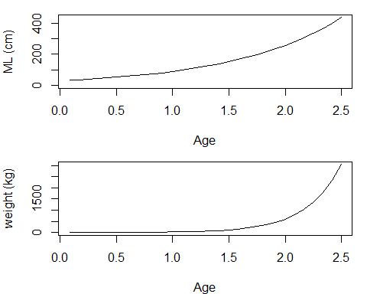

Figure 3. Maturity at size and age.
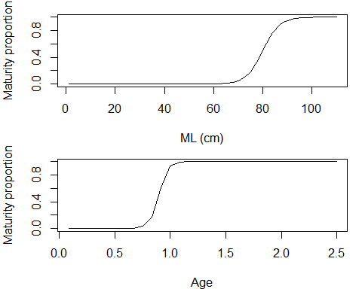

Table 1. Individual Parameters

Growth Parameters
gm_a | gm_b | a | b
309.11 | 0.0029 | 2.31e-05 | 3.077

Maturity Parameters
lm50 | lmrange
80 | 10

POPULATION FUNCTIONS
## --------------------------------------------------------
##
## No additional information. You are only considering the egg stage duration = 6
##
## --------------------------------------------------------

Figure 4. M by age and YEAR.MONTH (if M is constant then one color).
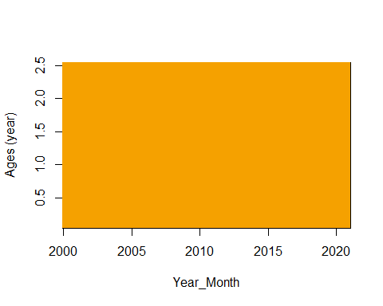

Figure 5. Recruitment before the starting time.
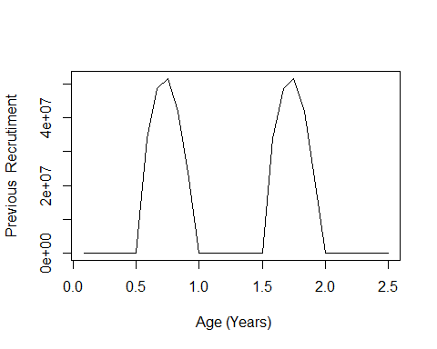

Figure 6. N at the first year.
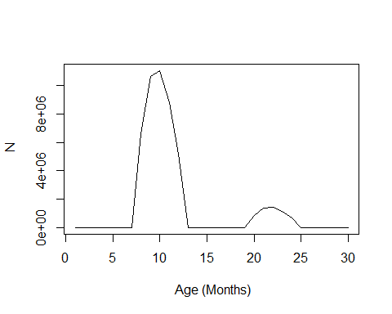

Figure 7. Seasonal recruitment patterns.
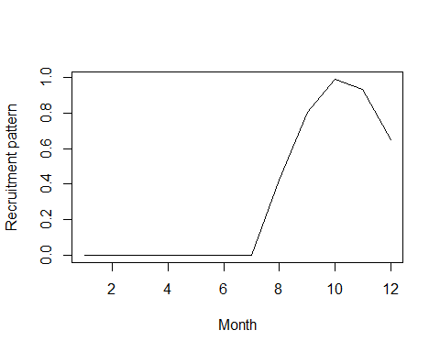

Figure 8. Fishing Selectivity by fleet.
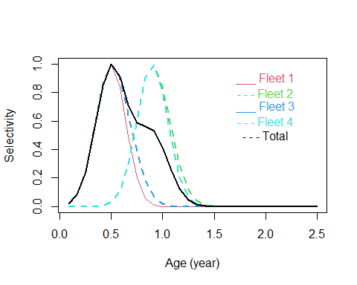

Figure 9. Spawning Biomass and Recruitment.
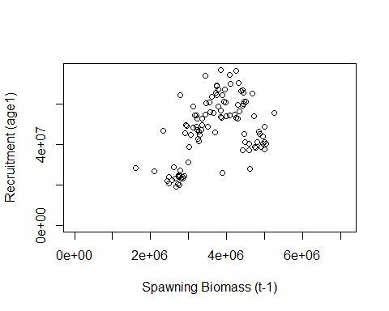

Figure 10. Seasonal Pattern of recruitment and Number at the begginning.
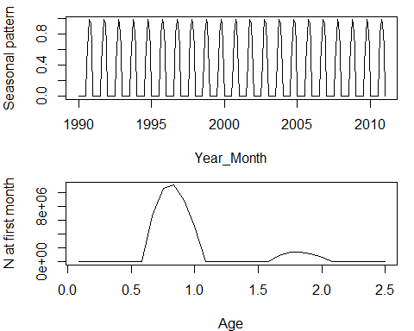

Figure 11. Number at age by YEAR.MONTH.
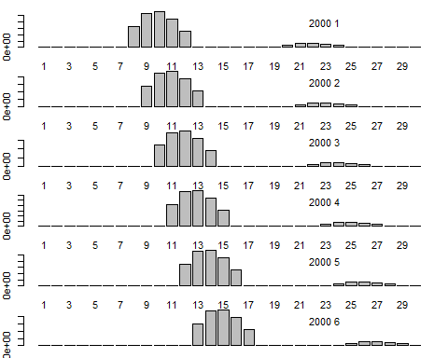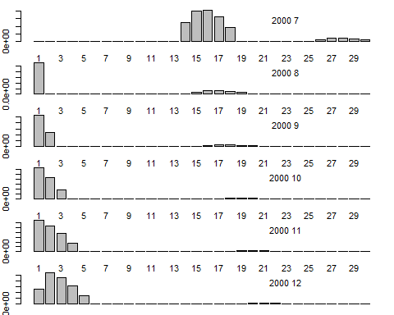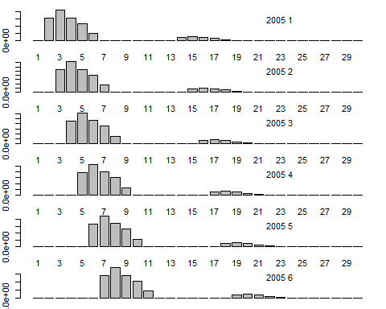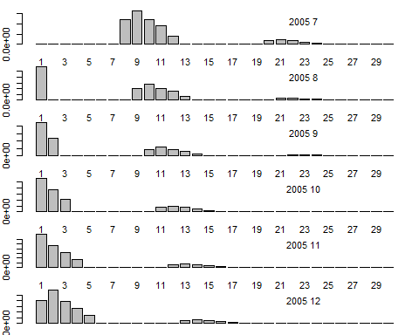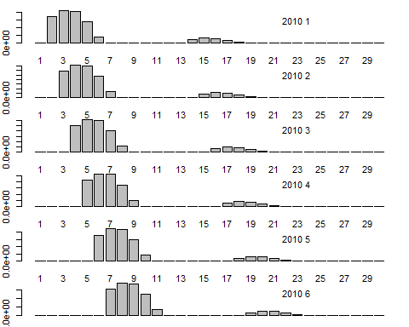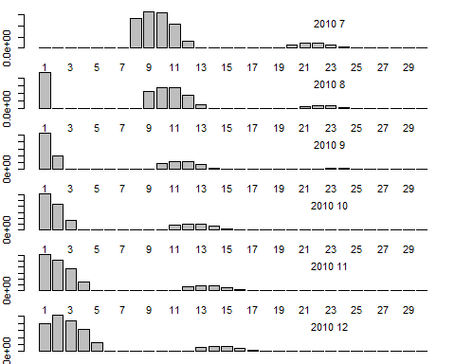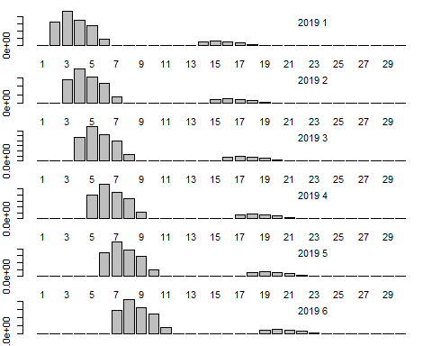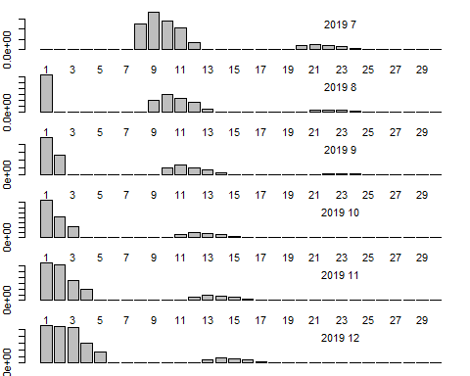

Figure 12. Whole Catch in number at age by YEAR.MONTH.
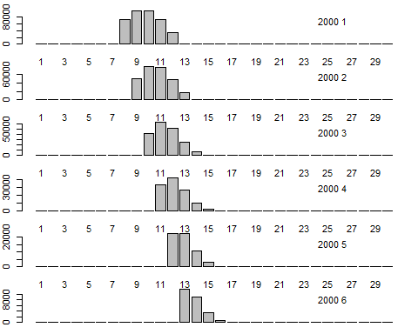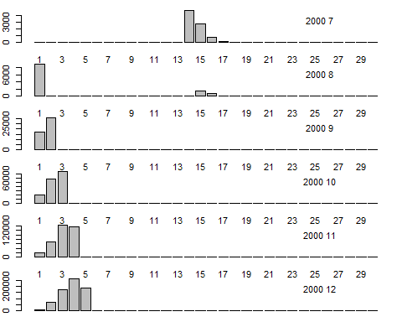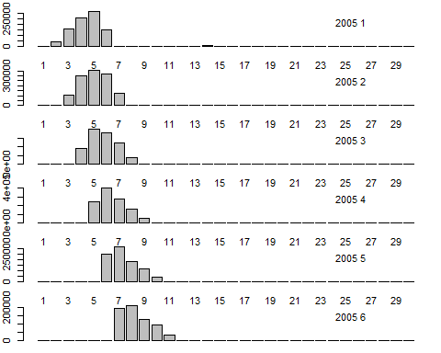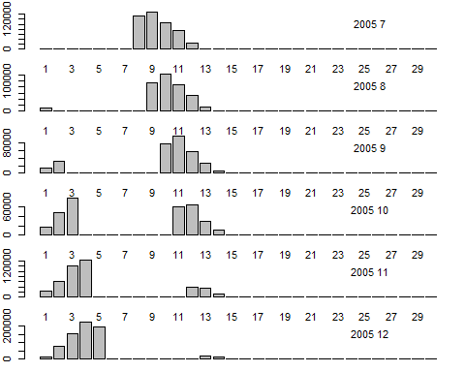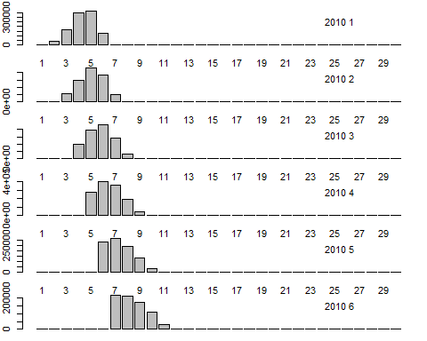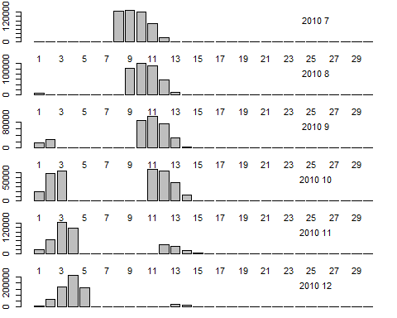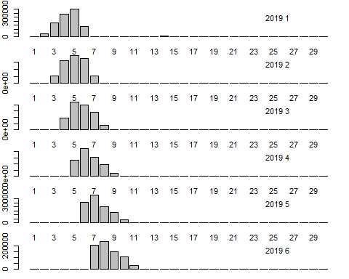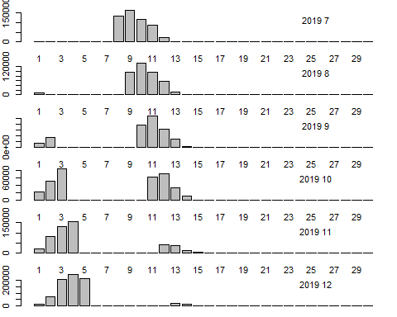

Figure 13. Fleet 1 Catch in number at age by YEAR.MONTH.
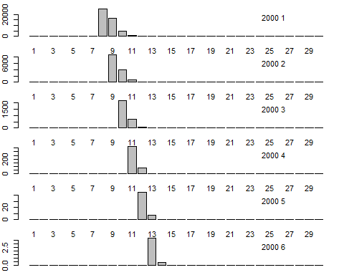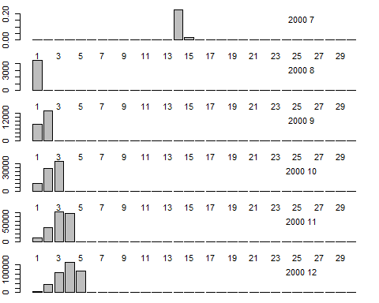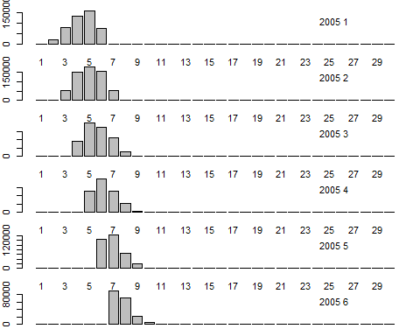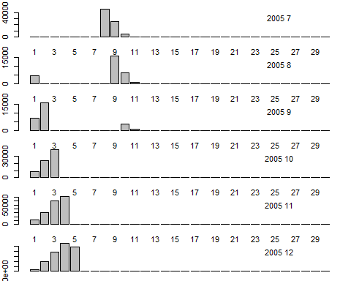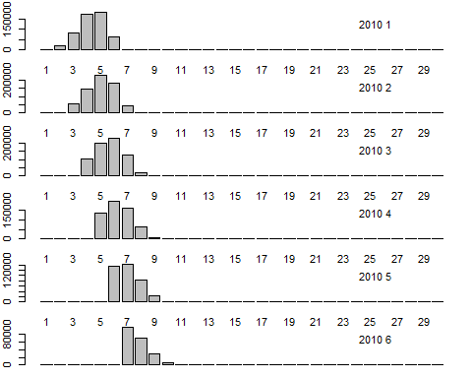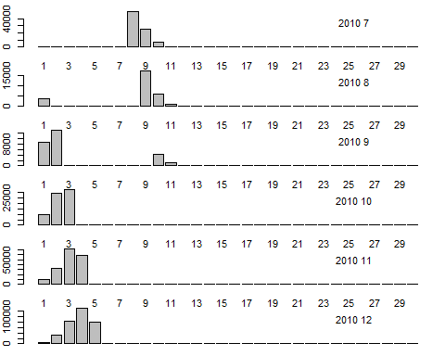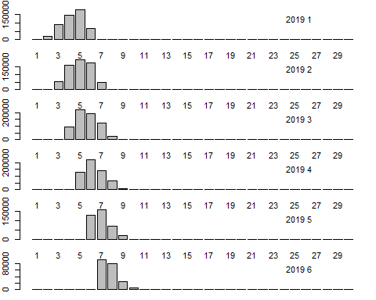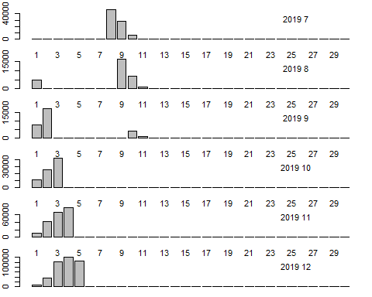

Figure 14. Fleet 2 Catch in number at age by YEAR.MONTH.
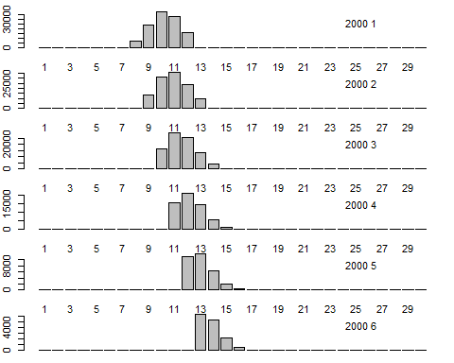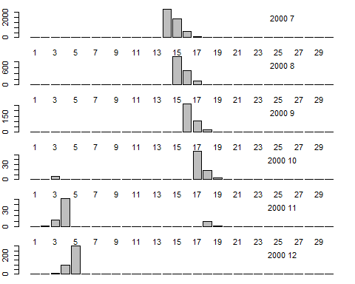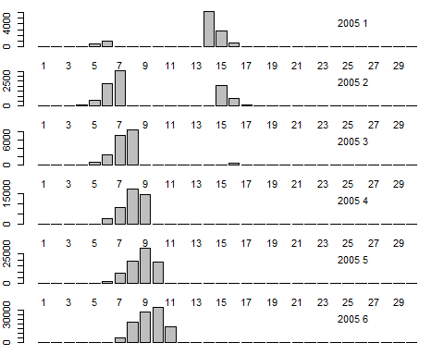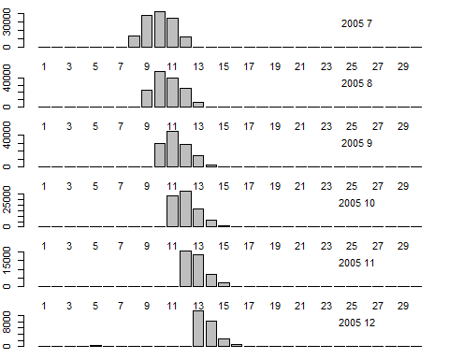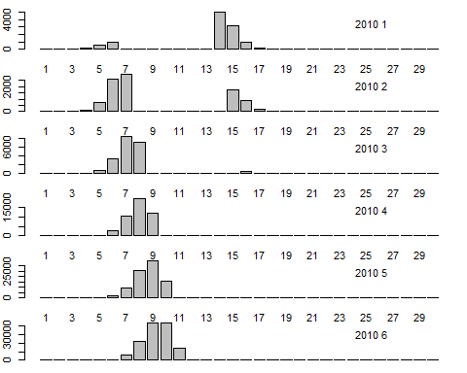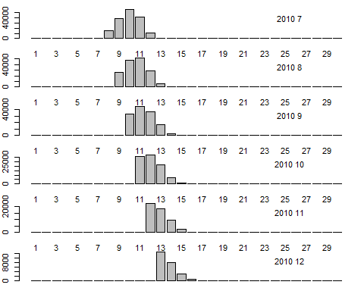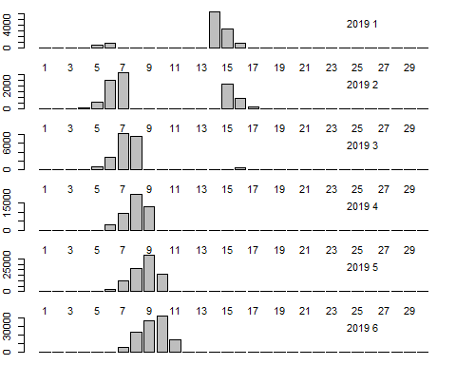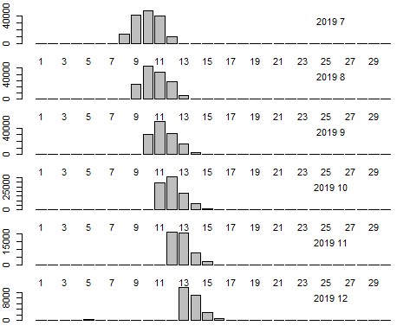

Figure 15. Fleet 3 Catch in number at age by YEAR.MONTH.
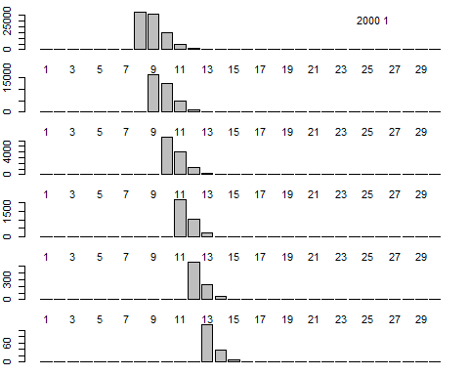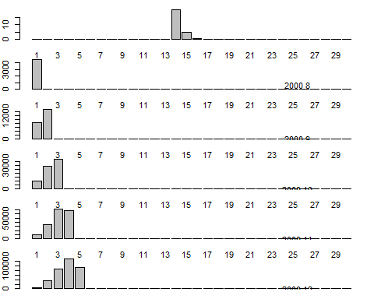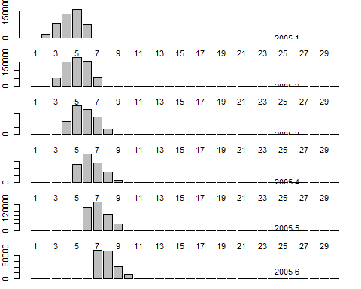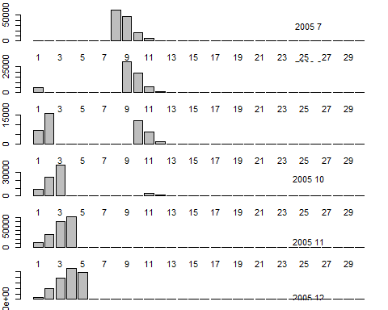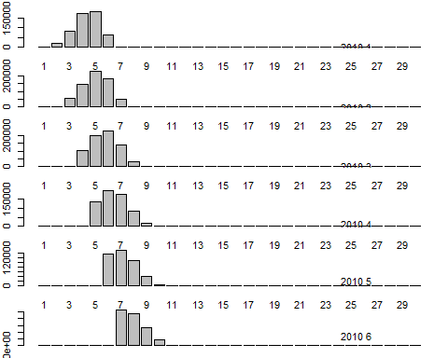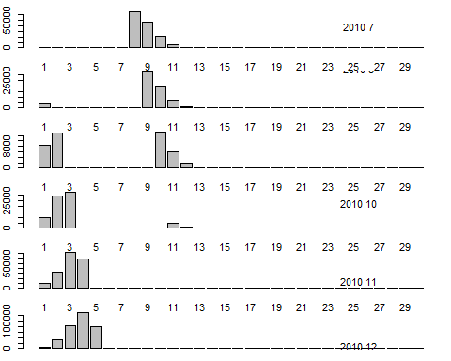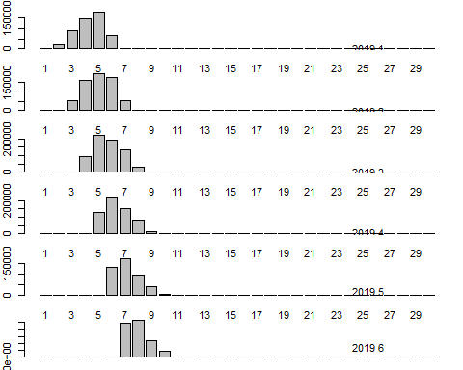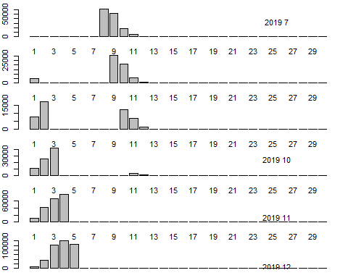

Figure 15b. Fleet 4 Catch in number at age by YEAR.MONTH.
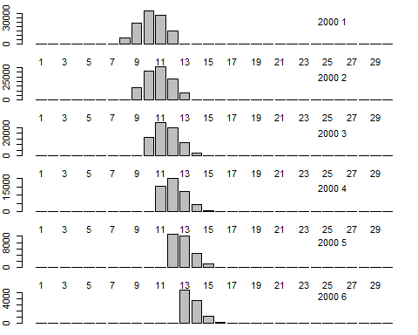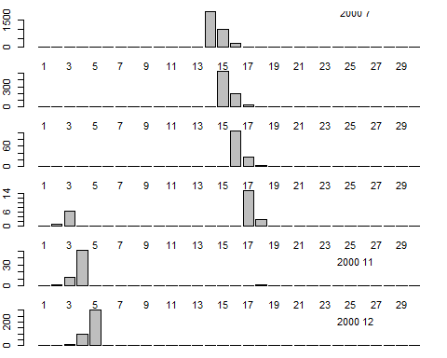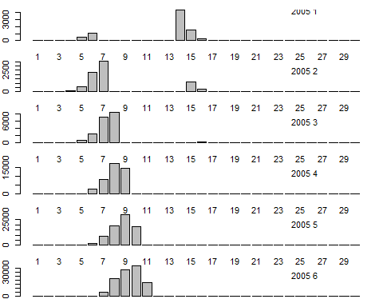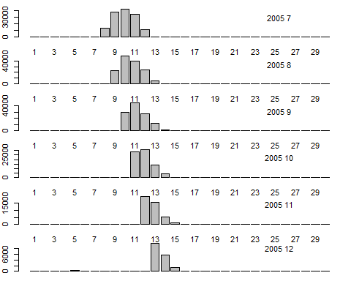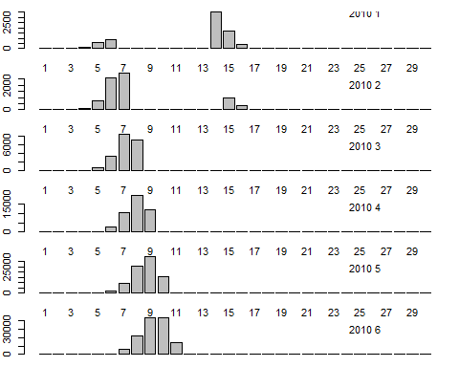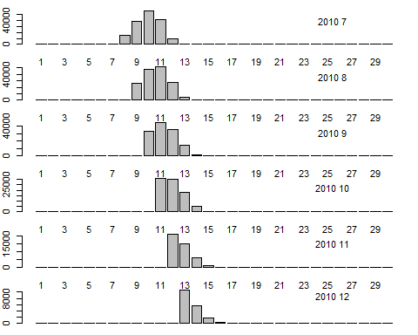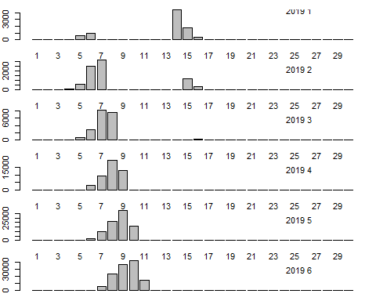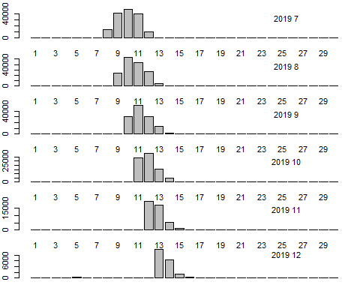

Figure 16. Length-age key.
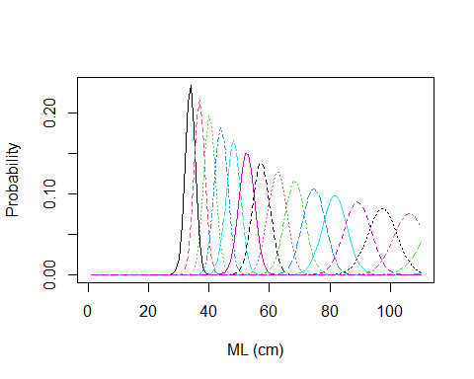

Figure 17. Length frequency by YEAR.MONTH.
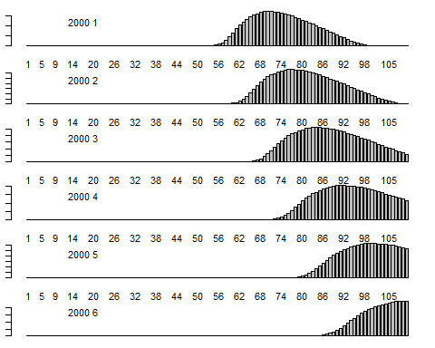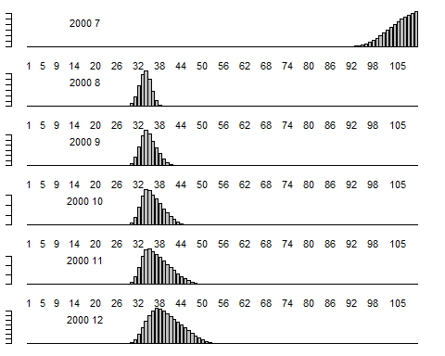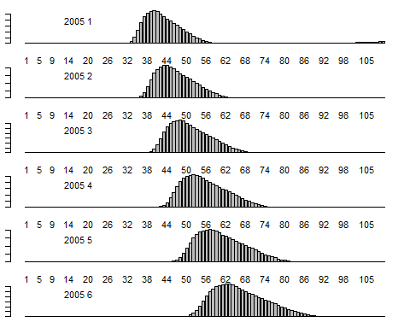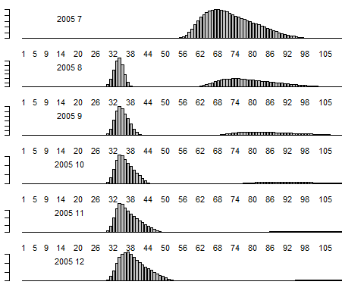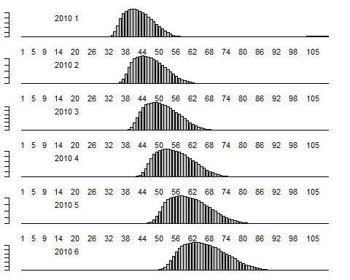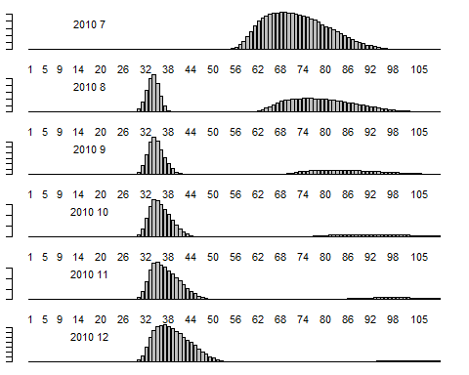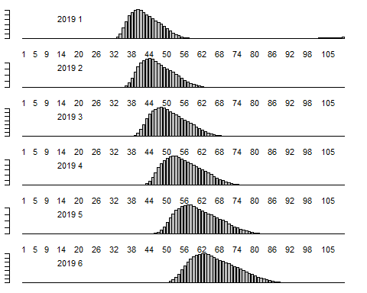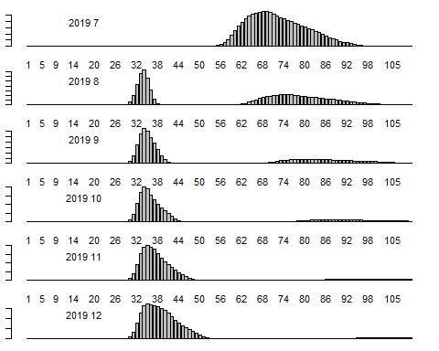

Figure 18. Whole Catch in number at length by YEAR.MONTH.
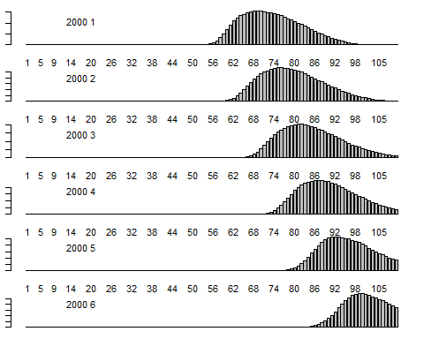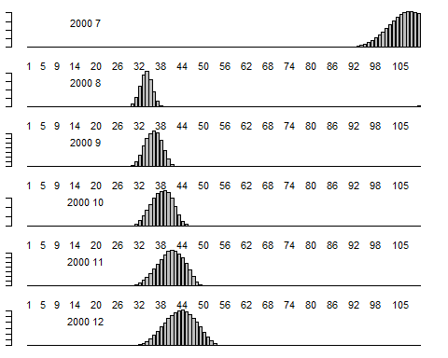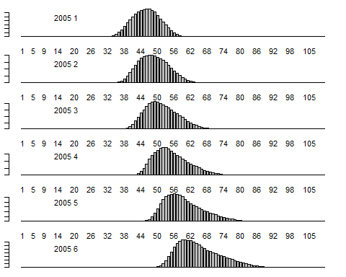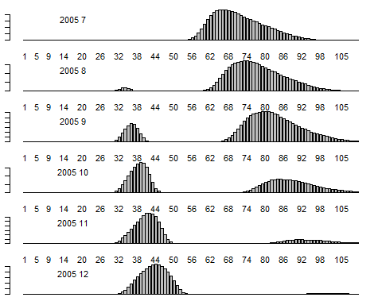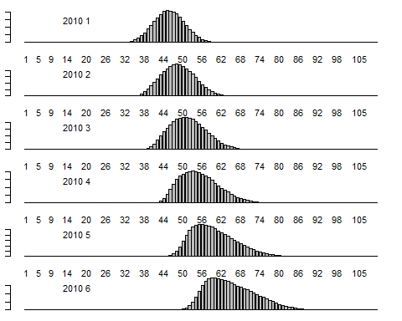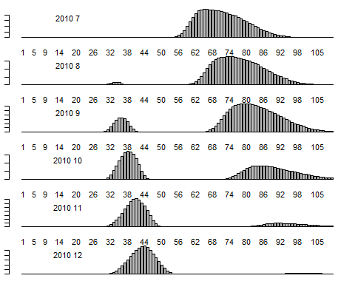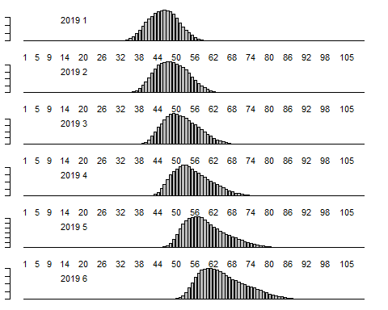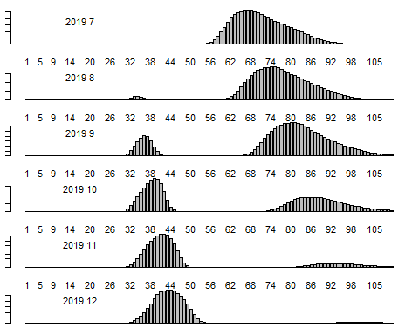

Figure 19. Fleet 1 Catch in number at length by YEAR.MONTH.
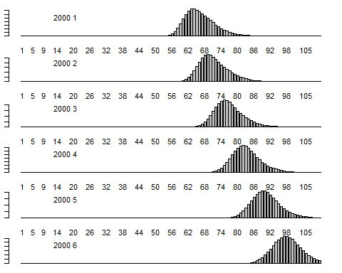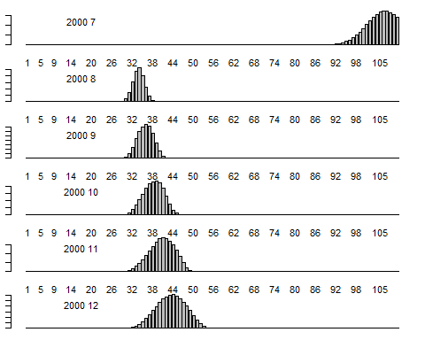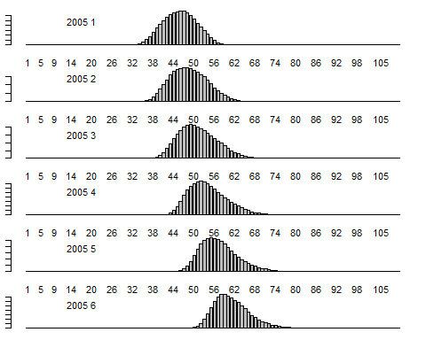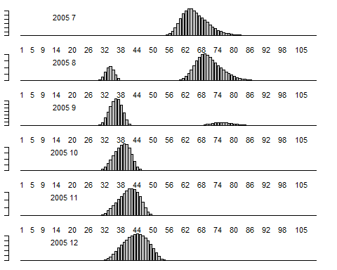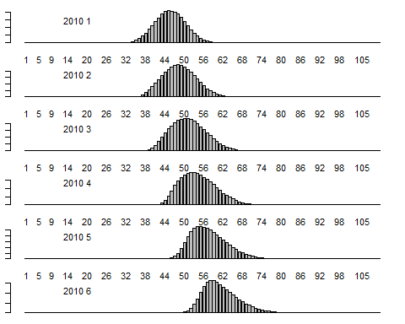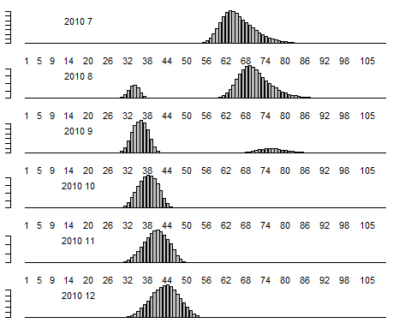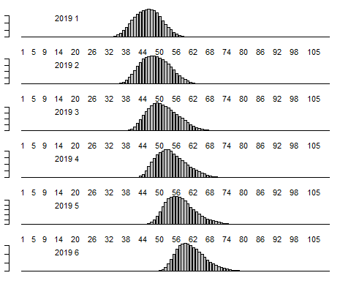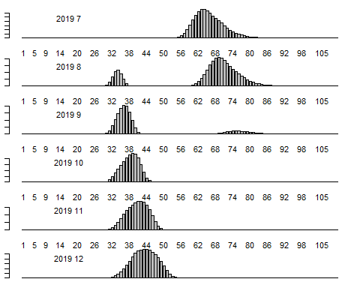

Figure 20. Fleet 2 Catch in number at length by YEAR.MONTH.
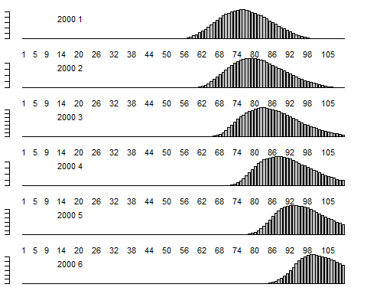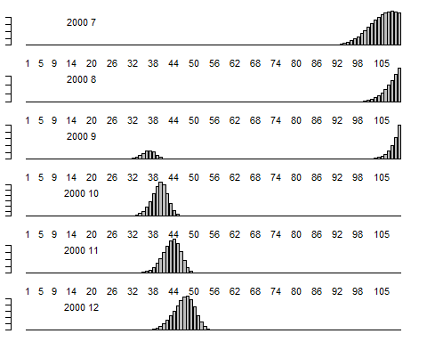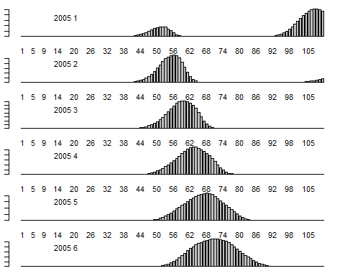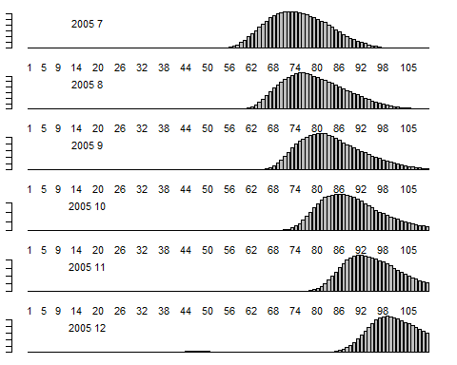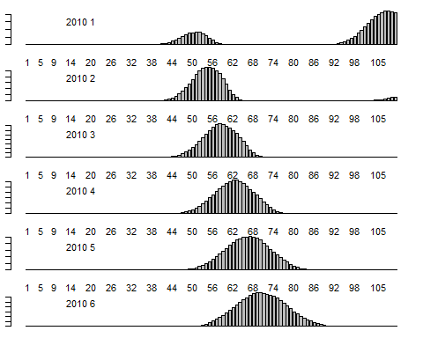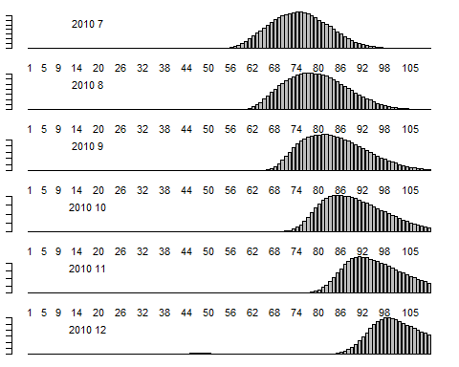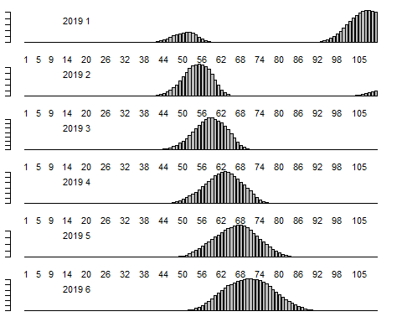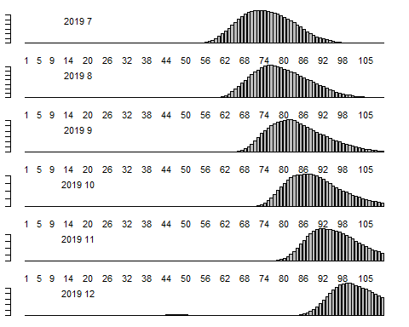

Figure 21. Fleet 3 Catch in number at length by YEAR.MONTH.
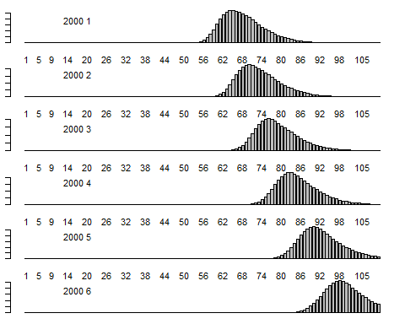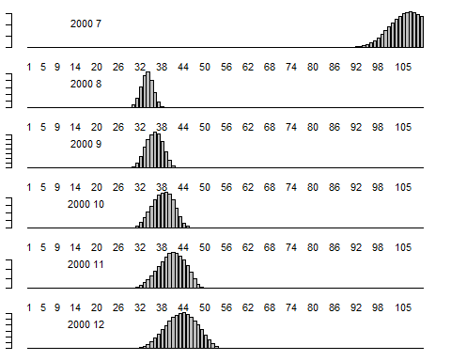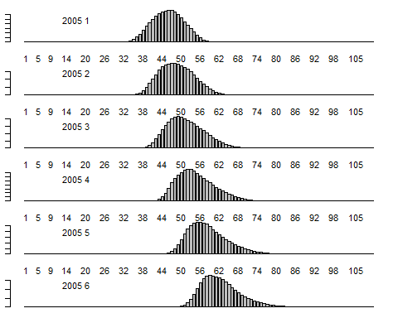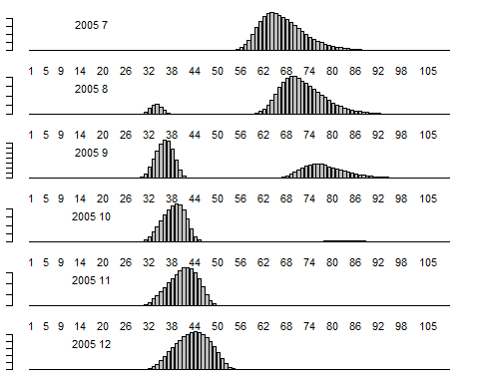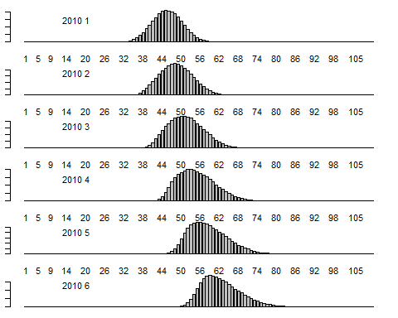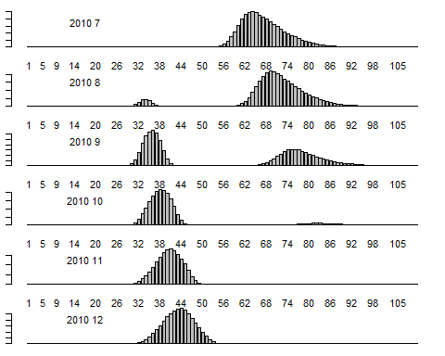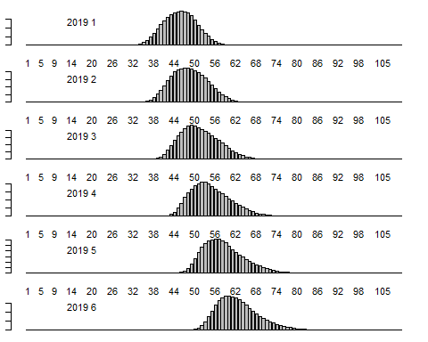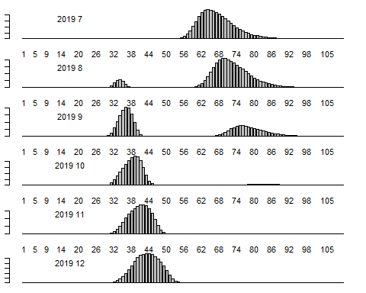

Figure 21b. Fleet 4 Catch in number at length by YEAR.MONTH.
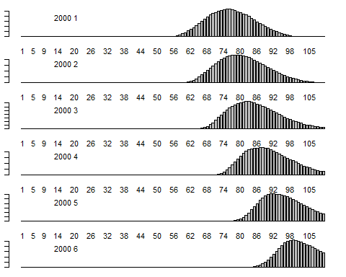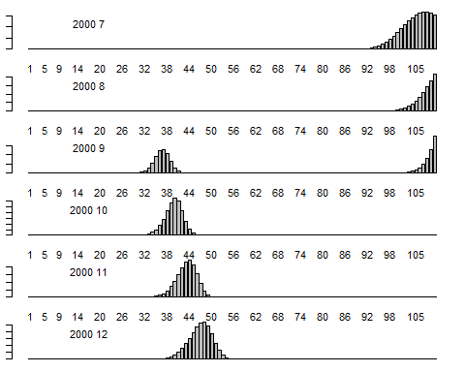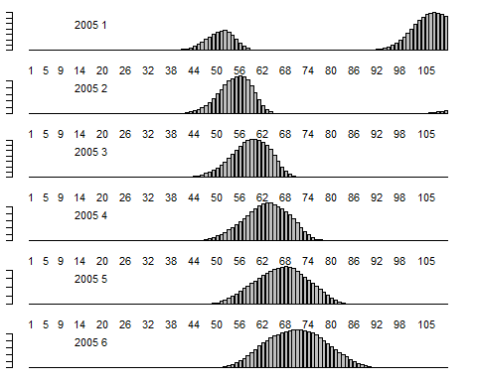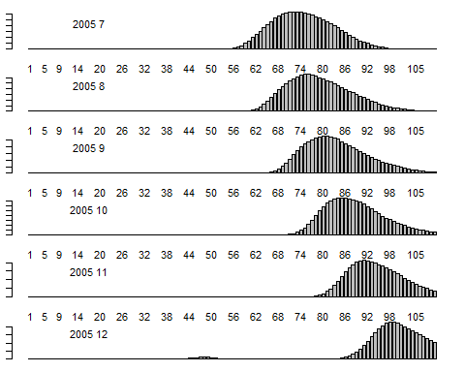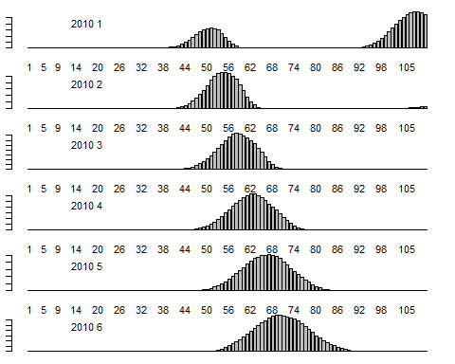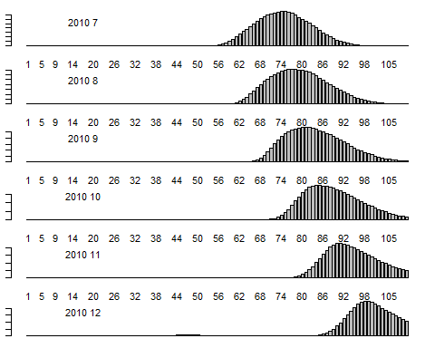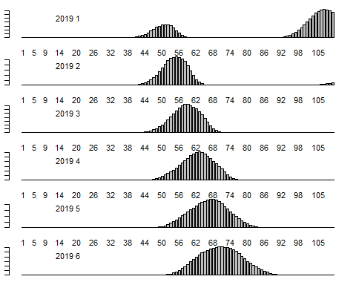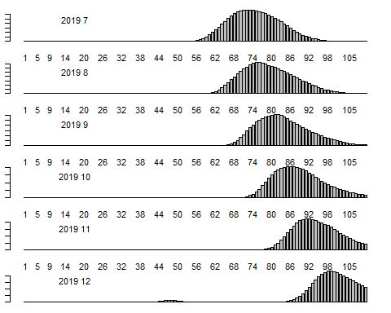

Figure 22. Number at age in the first Year and Recruitment by YEAR.MONTH.
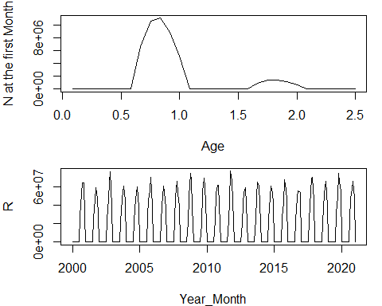

Figure 23. Whole number by YEAR.MONTH.
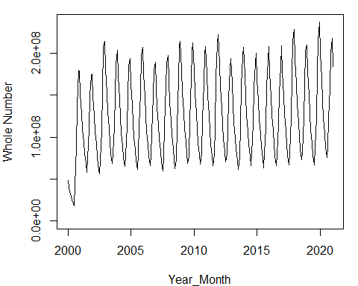

Figure 24. Catch (tons) by YEAR.MONTH.
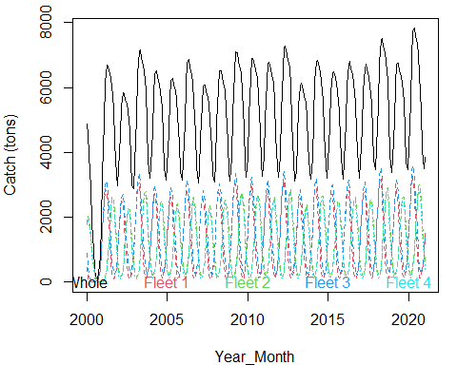

Figure 25. Whole number by YEAR.MONTH.
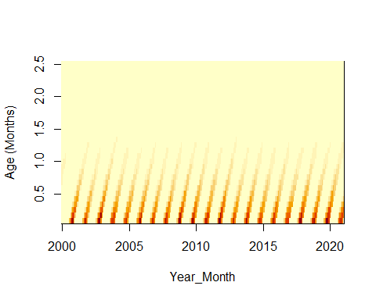

Figure 26. Biomass by YEAR.MONTH.
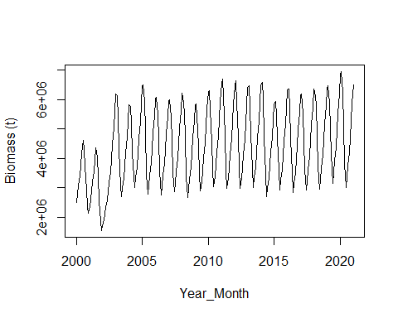

Figure 27. Spawning Biomass by YEAR.MONTH.
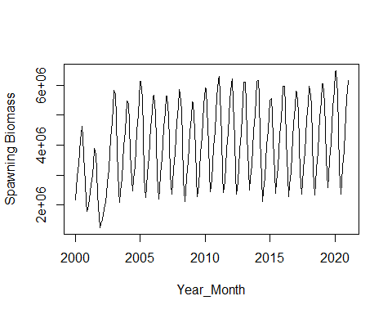

ABUNDANCE INDICES

Figure 28. Hyperstability.
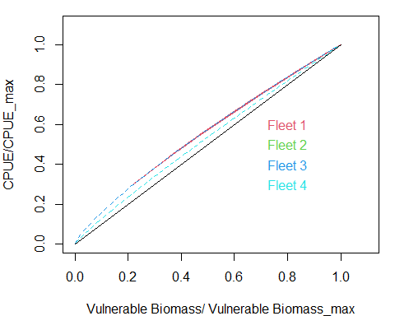

Figure 29. CPUE by YEAR.MONTH.
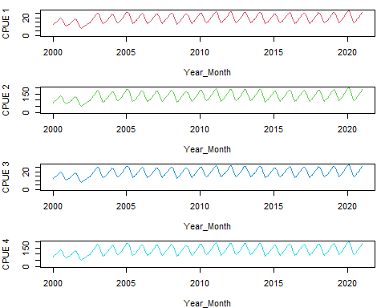

Figure 30. Examples of CPUE by month and fleet in two different years.
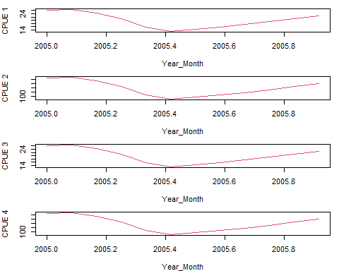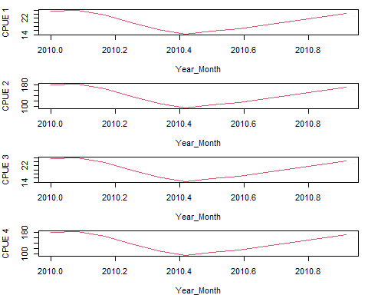

Figure 31. Acoustic Biomass by YEAR.MONTH.
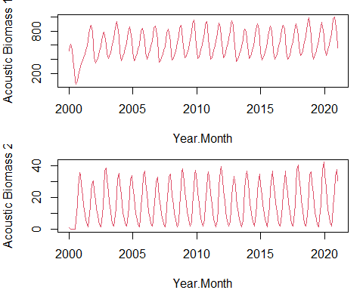

Figure 32. Acoustic Selectivity.
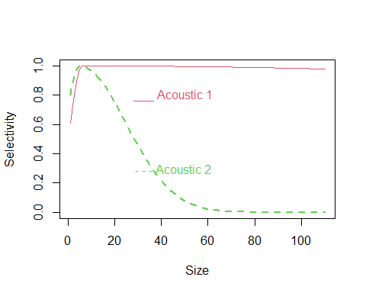

Figure 33. Mean weight by Fleet and YEAR.MONTH.
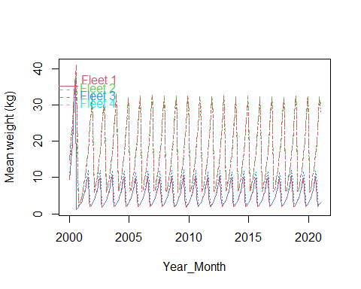

Figure 34. Mean weight by Acoustic Survey and YEAR.MONTH.
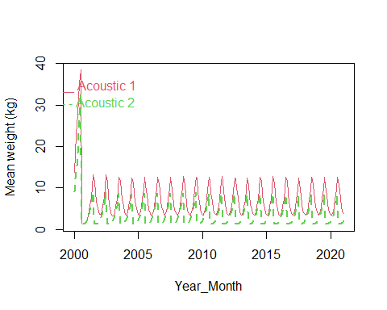

Table 2. Population, Fishery and Indices Parameters.

Recruitment Seasonal Parameters
RSeason | SdSeason
4 | 0

Gnomic M Parameters
 | Egg | Paralarvae | Juvenile | Subadult | Adult
Gnomonic_interval | 1.0 | 2.0 | 3.0 | 4.0 | 5.0
interval_duration_day | 6.0 | 15.1 | 52.9 | 185.9 | 652.7
total_duration | 6.0 | 21.0 | 74.0 | 260.0 | 912.0
M_day | 0.6 | 0.2 | 0.1 | 0.0 | 0.0
M_year | 223.6 | 89.0 | 25.4 | 7.2 | 2.1
No_Surv | 4870666.0 | 123296.0 | 3121.0 | 79.0 | 2.0

M and Stock Recruitment Parameters
M_Annual | 2.056
M_bin | 0.171
M_cv | 0.000
SB0 | 10000000.000
SRModel | 1.000
h | 0.900
prev.rsigma | 0.000
rsigma | 0.100

Fishery Parameters
Fref1 | 0.1000
as1 | 0.1500
bs1 | 0.5000
cs1 | 0.1400
Fref2 | 0.0500
as2 | 0.1500
bs2 | 0.9000
cs2 | 0.1700
Fref3 | 0.1000
as3 | 0.1500
bs3 | 0.5000
cs3 | 0.1800
Fref4 | 0.0500
as4 | 0.1500
bs4 | 0.9000
cs4 | 0.1500
q1 | 0.0001
hyp1 | 0.8000
q2 | 0.0001
hyp2 | 0.9000
q3 | 0.0001
hyp3 | 0.8000
q4 | 0.0001
hyp4 | 0.9000

Survey Parameters
as5 | 5.0
bs5 | 6.0
cs5 | 500.0
as6 | 6.0
bs6 | 5.0
cs6 | 20.0
qacous1 | 0.9
qacous2 | 0.5
qMPH | 0.9

REFERENCES
Allaire, JJ., Y. Xie, J. McPherson, and et. al. 2018. “R Markdown.” Computer Program. https://rmarkdown.rstudio.com.
Argüelles, J., P. G. Rodhouse, P. Villegas, and G. Castillo. 2001. “Age, Growth and Population Structure of the Jumbo Flying Squid Dosidicus Gigas in Peruvian Waters.” Fisheries Research 54:51-61.
Beverton, R., and S. J. Holt. 1957. “On the Dynamics of Exploited Fish Populations.” FAO Fishery investigations serie II Volumen XIX 533 p.
Caddy, I. 1996. “Modelling Natural Mortality with Age in Short-Lived Invertebrate Populations: Definition of a Strategy of Gnomonic Time Division.” Aquat Living Resour 9:197–207. doi:10.1051/alr:1996023.
Mace, P. M., and I. J. Doonan. 1988. “A Generalised Bioeconomic Simulation Model for Fish Population Dynamics.” New Zealand Fisheries Assessment Research Document 88/4.Fisheries Research Centre, MAFFish, POB 297, Wellington, NZ.
Martínez-Aguilar, S., J. G. Díaz-Uribe, J. A. Anda-Montañez, and M. A. Cisneros-Mata. 2010. “Natural Mortality and Life History Stage Duration for the Jumbo Squid (Dosidicus Gigas) in the Gulf of California, Mexico, Using the Gnomonic Time Division.” Ciencia Pesquera Vol 18. Núm 1: 31-42.
Payá, I. 2015. “Estatus y Posibilidades de Explotación Biológicamente Sustentables de Los Principales Recursos Pesqueros Nacionales. Año 2016. Jibia.” Instituto de Fomento Pesquero. Informe de Estatus y Cuota. 85 p + 4 annexes.
———. 2016. “Estatus y Posibilidades de Explotación Biológicamente Sustentables de Los Principales Recursos Pesqueros Nacionales. Año 2017. Jibia.” Instituto de Fomento Pesquero. Informe de Estatus y Cuota. 95 p + 4 annexes.
———. 2017. “Estatus y Posibilidades de Explotación Biológicamente Sustentables de Los Principales Recursos Pesqueros Nacionales. Año 2018. Jibia.” Instituto de Fomento Pesquero. Informe de Estatus y Cuota. 94 p + 3 annexes.
———. 2019. “SQUIDSIM, SQUID SIMULATOR, Version 1.0.” Instituto de Fomento Pesquero. Anexo III en Estatus y posibilidades de explotación biológicamente sustentables de los principales recursos pesqueros nacionales. Jibia. Año 2019. 34 pp.
Payá, I., L. Caballero, A. Barraza, J. Cavieres, A. Yañez, and R. Tascheri. 2014. “Estatus y Posibilidades de Explotación Biológicamente Sustentables de Los Principales Recursos Pesqueros Nacionales. Año 2015. Jibia.” Instituto de Fomento Pesquero. Informe de Estatus y Cuota. 83 p + 4 annexes.
Ricker, W. E. 1954. “Stock and Recruitment.” Journal of the Fisheries Research Board of Canada, 11(5): 559–623.
Torrejon-Magallanes, J. 2021. “gnomonicM: An r Package to Estimate Natural Mortality for Different Life Stages.” Computer Program.

