COMPARISON OF DIFFERENT SQUID SIMULATIONS
Ignacio Payá, IFOP.
septiembre 12, 2024
Table of Contents

SUMMARY

This report was developed in rmakdown to compare results of different cases of Humboldt Squid Stock simulations. It collects the output files of “Run HSquid_Rmd.R” script. The parameters by cases are shown in tables and the main variables (recruitments, biomass, fishing selectivity, catches, etc.) are shown in graphs.

INTRODUCTION

The ‘SQUIDSIM.rmd’ rmardwon script was developed to simulate Humboldt Squid Stock dynamics using an input parameter file named HSquid_Par.csv.
The ‘SQUIDSIM_RunCases_Purl.R’ R script was written to conduct different simulation by means of run ‘SQUIDSIM.rmd’ with different input parameters and to save parameters and main results in csv format file and graphs in png format files.
Therefore, it was neccesary to write a rmarkdown script to report on the different simulations outputs (‘SQUIDSIM_RunCases_Purl.R’).

METHODS

No calculations were done in this script. The figures and tables are read from the current folder.
The individual, population and fishery parameters are shown in tables 1 to 3.

RESULTS

Table 1. Individual Parameters by case.
Case | a_expo | b_expo | a | b | lm50 | lmrange
1 | 309.11 | 0.0029 | 2.31e-05 | 3.077 | 80 | 10
2 | 309.11 | 0.0029 | 2.31e-05 | 3.077 | 80 | 10
3 | 309.11 | 0.0029 | 2.31e-05 | 3.077 | 80 | 10

Table 2. Season Recruitment Parameters by case.
Case | RSeason | SdSeason
1 | 1 | 0
2 | 1 | 0
3 | 1 | 0

Table 3. Population Parameters by case.
Case | M_Annual | M_bin | M_cv | SB0 | SRModel | h | prev.rsigma | rsigma
1 | 2.056 | 0.1713333 | 0 | 1.0e+07 | 1 | 0.6 | 0 | 0.1
2 | 2.056 | 0.1713333 | 0 | 1.5e+07 | 1 | 0.7 | 0 | 0.1
3 | 2.056 | 0.1713333 | 0 | 1.5e+07 | 2 | 0.5 | 0 | 0.1

Table 4. Fishery Parameters by case.
Case | Fref1 | as1 | bs1 | cs1 | Fref2 | as2 | bs2 | cs2 | Fref3 | as3 | bs3 | cs3
1 | 0.1 | 0.15 | 0.5 | 0.15 | 0.05 | 0.15 | 0.9 | 0.15 | 0.05 | 0.2 | 0.7 | 0.15
2 | 0.1 | 0.15 | 0.4 | 0.15 | 0.05 | 0.15 | 1.0 | 0.15 | 0.05 | 0.5 | 0.7 | 0.15
3 | 0.1 | 0.15 | 0.7 | 0.15 | 0.05 | 0.15 | 0.9 | 0.10 | 0.05 | 0.2 | 0.7 | 0.15

Figure 1. N at first Month by case.
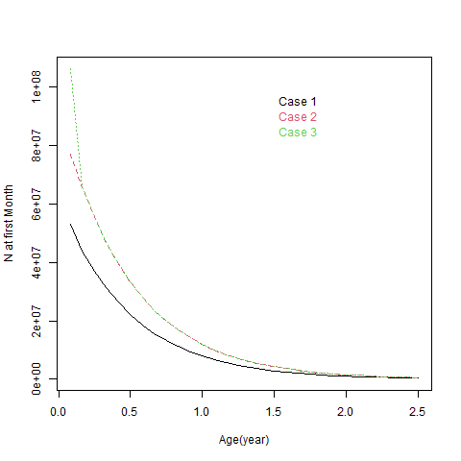

Figure 2. Recruitment by case.
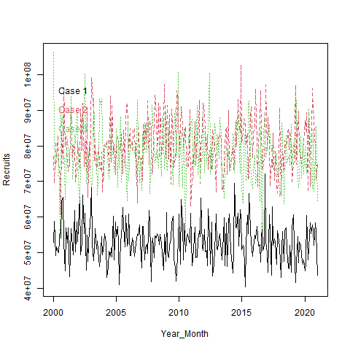

Figure 3. Stock versus Recruitment by case.
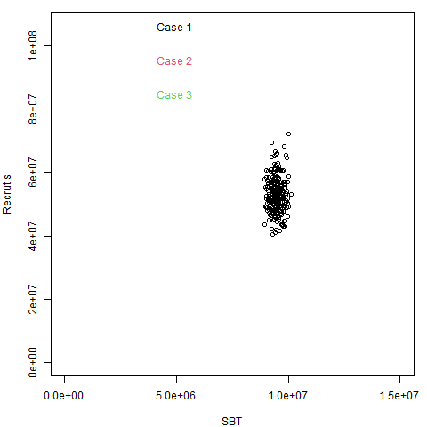

Figure 4. Whole Biomass by case.
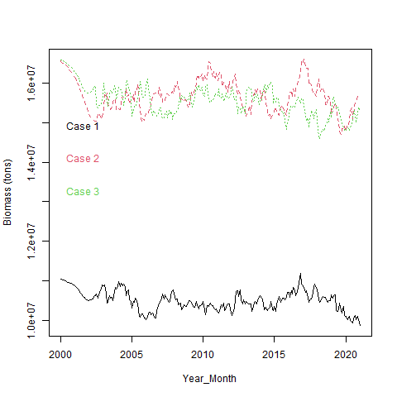

Figure 5. Spawning Biomass by case.
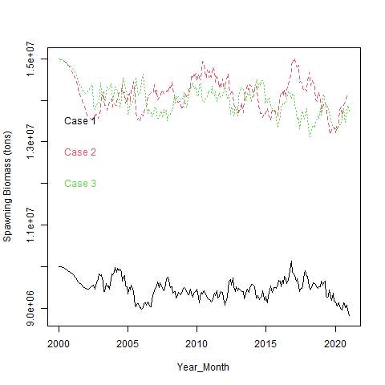

Figure 6. Fleet 1 Selectivity by case.
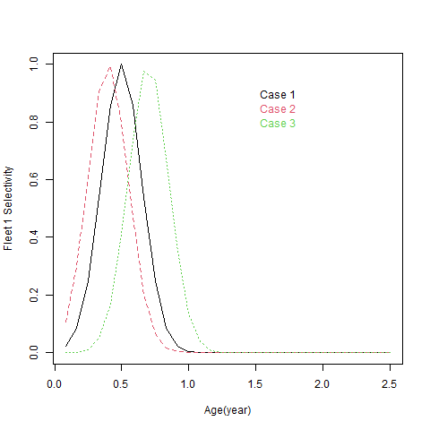

Figure 7. Fleet 2 Selectivity by case.
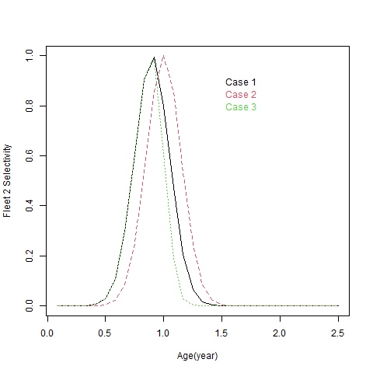

Figure 8. Fleet 3 Selectivity by case.
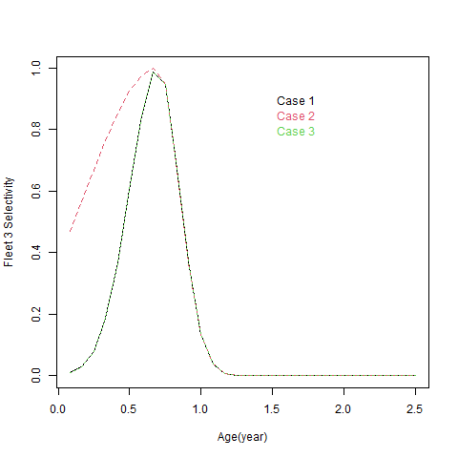

Figure 9. Fleet 1 Catch (tons) by case.
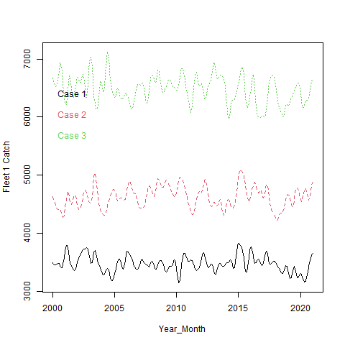

Figure 10. Fleet 2 Catch (tons) by case.


Figure 11. Fleet 3 Catch (tons) by case.


Figure 12. Whole Catch (tons) by case.
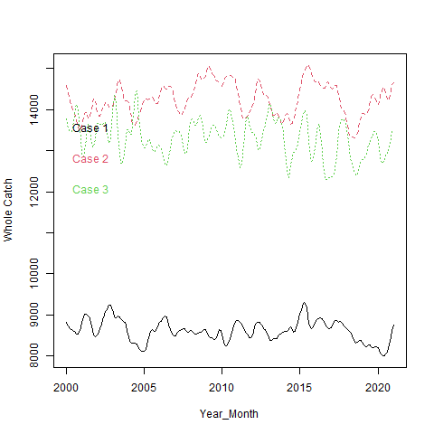

Figure 13. Fleet 1 CPUE by case.
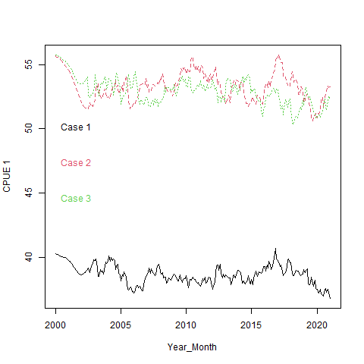

Figure 14. Fleet 2 CPUE by case.
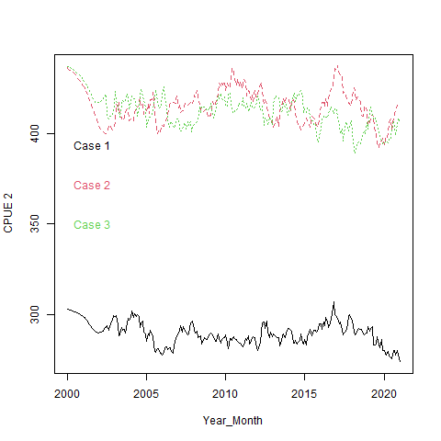

Figure 15. Fleet 3 CPUE by case.
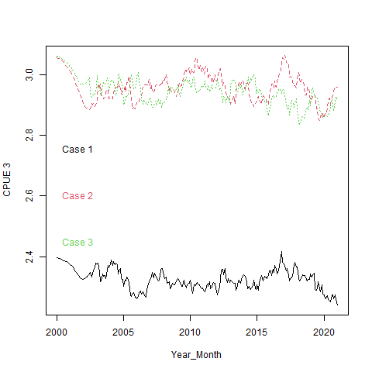

Figure 16. Acoustic 1 Selectivity by case.
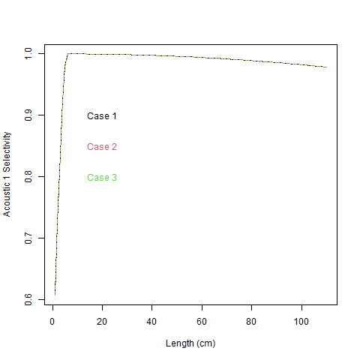

Figure 17. Acoustic 2 Selectivity by case.
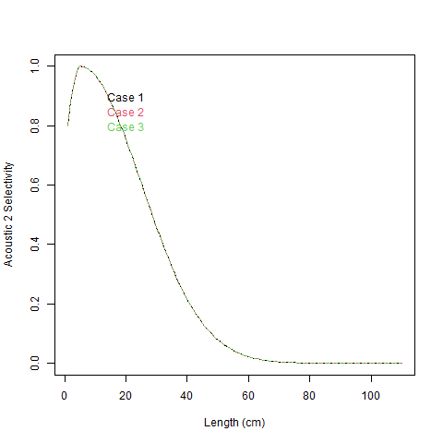

Figure 18. Acoustic Biomass 1 by case.
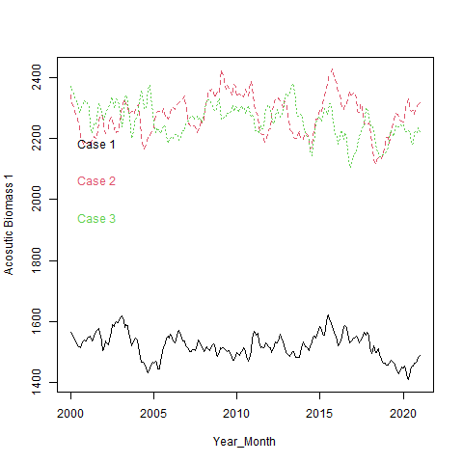

Figure 19. Acoustic Biomass 1 by case.
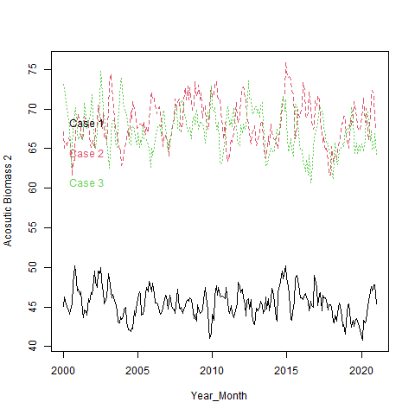

Figure 20. Fleet 1 Mean weight by case.
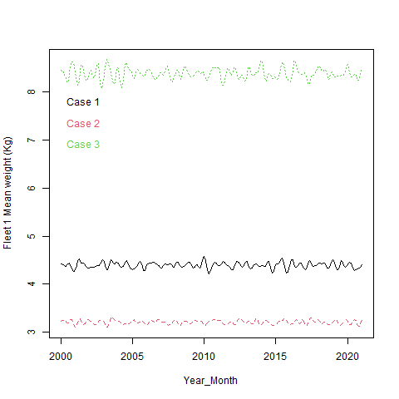

Figure 21. Fleet 2 Mean weight by case.
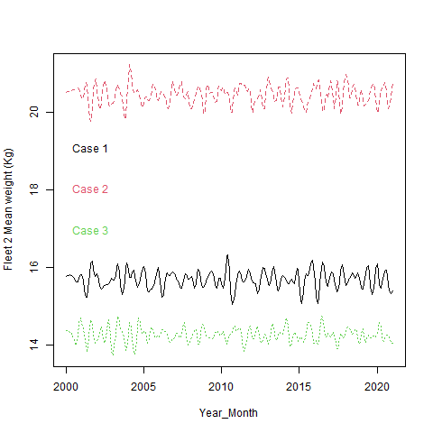

Figure 22. Fleet 3 Mean weight by case.
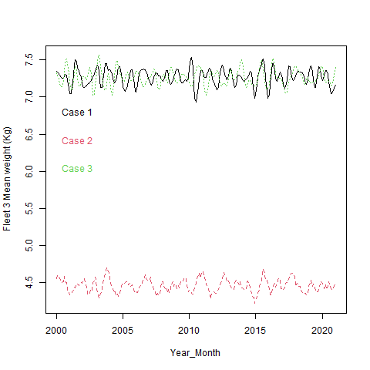

Figure 23. Acoustic 1 Mean weight by case.
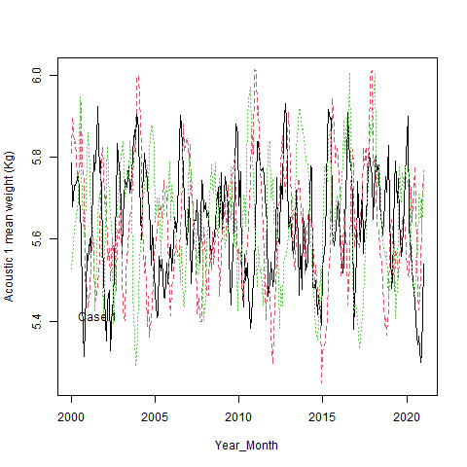

Figure 24. Acoustic 2 Mean weight by case.
