# Update a file through a Python algorithm

## Project description

At my organization, access to restricted content is controlled with an allow list of IP addresses. The “allow_list.txt” file identifies these IP addresses. A separate remove list identifies IP addresses that should no longer have access to this content. I created an algorithm to automate updating the “allow_list.txt” file and remove these IP addresses that should no longer have access.

## Open the file that contains the allow list

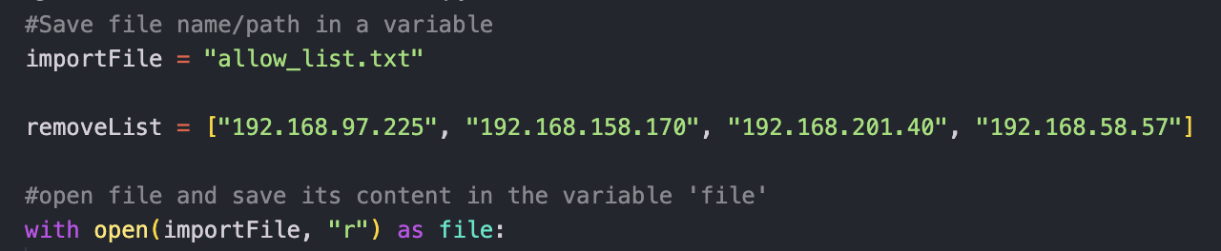

## Read the file contents

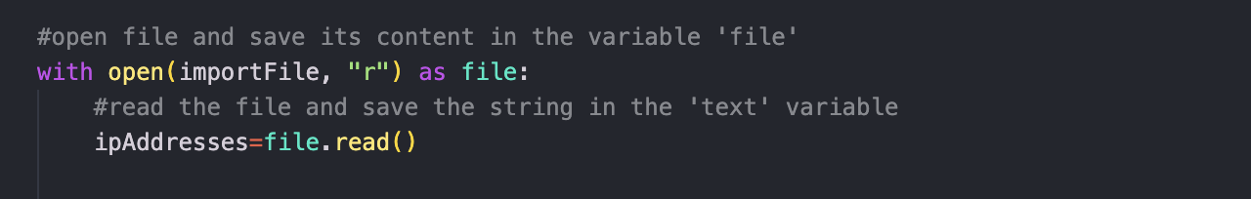

## Convert the string into a list

## 

## Iterate through the remove list

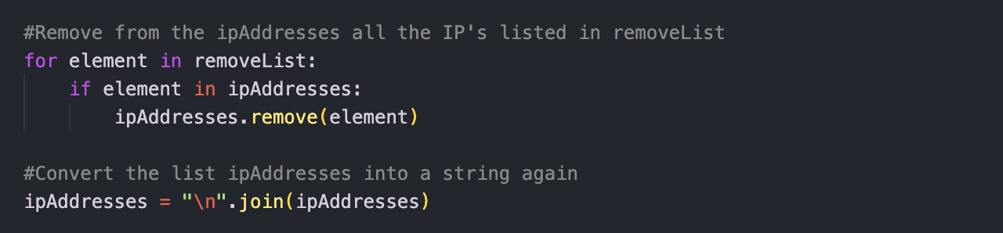

## Update the file with the revised list of IP addresses

## 

## Summary

I created an algorithm to remove IP addresses from the "allow_list.txt" file based on a list of addresses in the "removeList" variable. The algorithm reads the file, saves its content as a string, and converts it into a list for comparison with the "removeList". When matching IP addresses are found, they are removed from the list. Afterward, the modified list is converted back to a string, and the file is updated with the updated data, effectively removing the specified IP addresses from the "allow_list.txt" file.