# Apply filters to SQL queries

## Project description

My organization is working to make their system more secure. It is my job to ensure the system is safe, investigate all potential security issues, and update employee computers as needed. The following steps provide examples of how I used SQL with filters to perform security-related tasks.

## Retrieve after hours failed login attempts

There was a potential security incident that occurred after business hours (after 18:00). All after hours login attempts that failed need to be investigated.

This query filters for failed login attempts that occurred after 18:00.

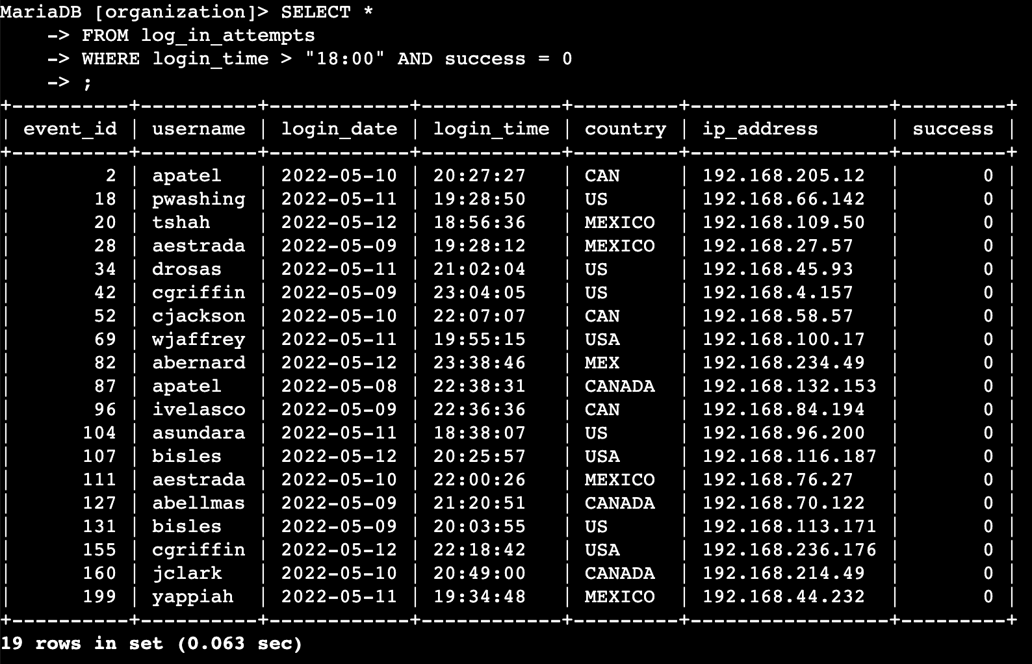

## Retrieve login attempts on specific dates

A suspicious event occurred on 2022-05-09. Any login activity that happened on 2022-05-09 or on the day before needs to be investigated.

This query returns all login attempts that occurred on 2022-05-09 or 2022-05-08.

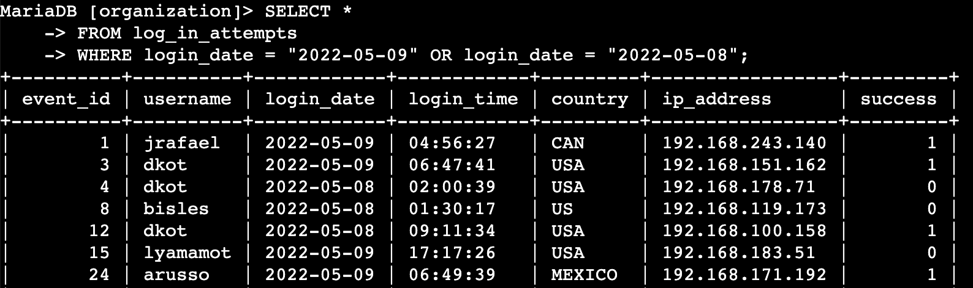

## Retrieve login attempts outside of Mexico

After investigating the organization’s data on login attempts, I believe there is an issue with the login attempts that occurred outside of Mexico. These login attempts should be investigated.

This query returns all login attempts that occurred in countries other than Mexico.

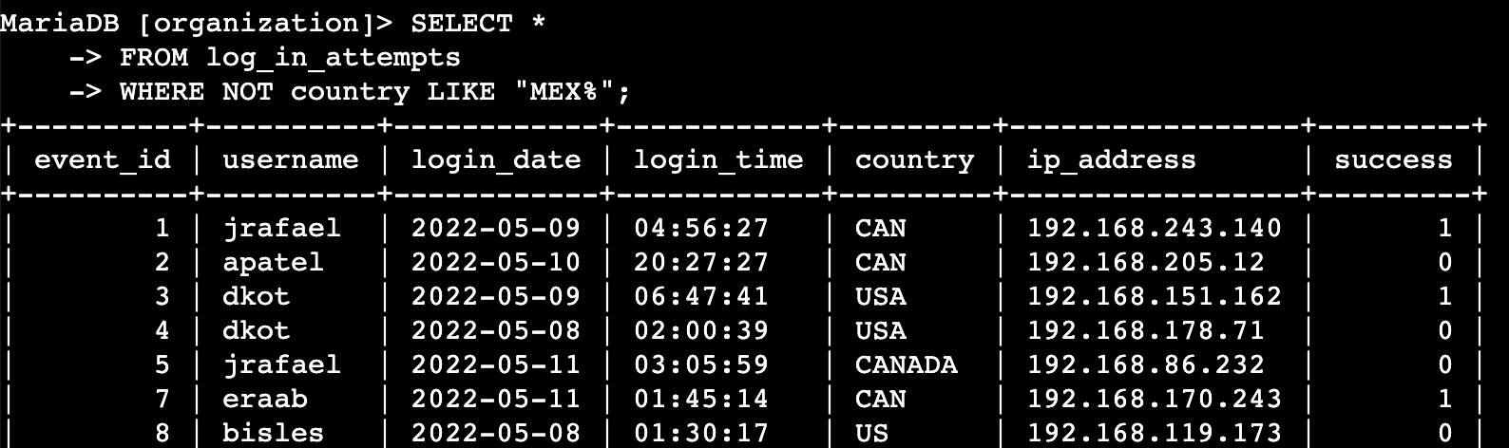

## Retrieve employees in Marketing

My team wants to update the computers for certain employees in the Marketing department. To do this, I must get information on which employee machines to update.

This query returns all employees in the Marketing department in the East building.

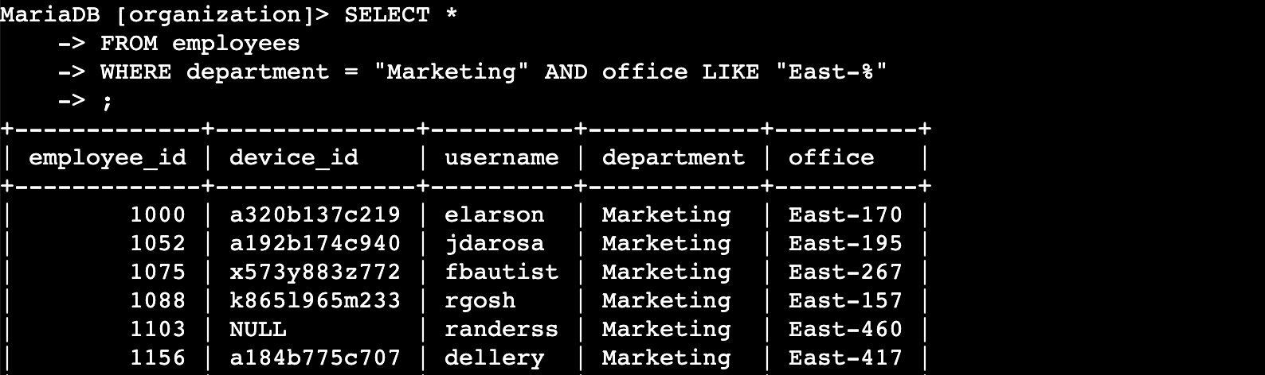

## Retrieve employees in Finance or Sales

The machines for employees in the Finance and Sales departments also need to be updated. Since a different security update is needed, I have to get information on employees only from these two departments.

This query returns all employees in the Finance and Sales departments.

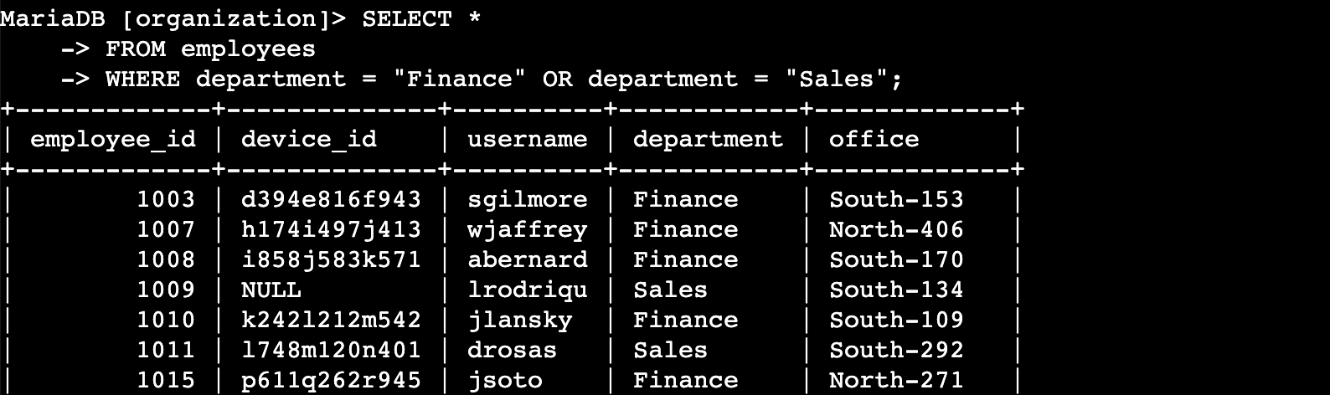

## Retrieve all employees not in IT

My team needs to make one more security update on employees who are not in the Information Technology department. To make the update, I first have to get information on these employees.

The query returns all employees not in the Information Technology department.

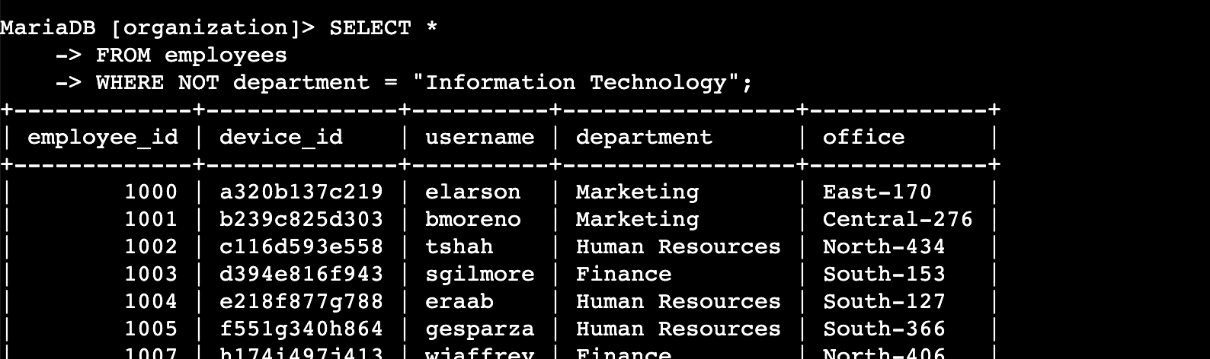

## Summary

I applied filters to SQL queries to get specific information on login attempts and employee machines. I used two different tables, log_in_attempts and employees. I used the AND, OR and NOT operators to filter for the specific information needed for each task. I also used LIKE and the percentage sign (%) wildcard to filter for patterns.