MGT 403 — Problem Set 4, Question 2: The Distribution of Childcare Prices
Team: Ignacio Sanchez Urdaneta · Beck Jamilov · Claudia Palacios Surco · Gary Chen
Data. DOL National Database of Childcare Prices (NDCP, 2024 release), variables MCINFANT, MCTODDLER, MCPRESCHOOL — the county median weekly full-time price of center-based care (infant 0–23 months, toddler 24–35 months, preschool 36–54 months), 2015–2022. These age groups are NDCP’s own standard definitions (Technical Report, Appendix C data dictionary): NDCP enters prices in 6-month age bands and combines them into the three groups; we did not redefine them. All code, data and the prompt history are in the project repository, https://github.com/ignaciosanur/mgt403-childcare-project-green-cohort-7b.
Methods. 95% confidence intervals use the large-sample (CLT) formula $\overset{‾}{x}±1.96 s/\sqrt{n}$. The voucher test in Q4 uses the one-sample t-statistic with $n−1$ degrees of freedom. With $n>1,000$ counties the t and normal distributions are practically identical ($t_{0.975, 1012}=1.962$ vs. $1.960$), so the choice does not affect any conclusion.
Sample or population? Our data cover every metro county with a reported price, not a random draw, so as a description of these counties they are close to a population. We still use sample tools (SD with divisor $n−1$, standard errors and CIs), as the assignment asks, for two reasons. (i) The question is about the underlying price level (e.g. what the “average metro area” pays), and each year’s county prices are one realization of it. (ii) Each county value is itself an estimate from a state market-rate survey of providers. In practice the choice barely matters: the population SD (divisor $n$) differs from the sample SD by 0.05% (preschool $59.95 vs $59.98). We do not apply a finite-population correction for the ~222 metro counties without prices, because they are missing by whole state (PA, IN, MO, NM, PR, AR), not at random.

1. Metro analysis sample
We merged NDCP to the course crosswalk county_oews_crosswalk.csv on county FIPS (5-character text) × year, using each year’s own crosswalk row, and kept counties whose oews_area begins with 00 (OEWS metropolitan areas). All 25,763 NDCP county-year rows matched the crosswalk.
Year | 2015 | 2016 | 2017 | 2018 | 2019 | 2020 | 2021 | 2022
NDCP counties | 3,220 | 3,220 | 3,220 | 3,220 | 3,220 | 3,221 | 3,221 | 3,221
Metro counties | 1,233 | 1,233 | 1,234 | 1,233 | 1,235 | 1,235 | 1,235 | 1,235
… with preschool price | 1,003 | 1,025 | 1,063 | 1,063 | 1,063 | 1,063 | 918 | 1,013
The crosswalk lists 1,237 metro counties in 2022; the two not in NDCP are legacy codes for counties that NDCP reports under their current code (12025 Dade → 12086 Miami-Dade; 51515 Bedford city → 51019 Bedford County), so no metro county is lost. In 2022, 222 metro counties have no center-based price (all of Puerto Rico, Indiana, Pennsylvania, Missouri and Arkansas, plus a few others): the state did not report usable data.

2. Distribution of 2022 prices by age group
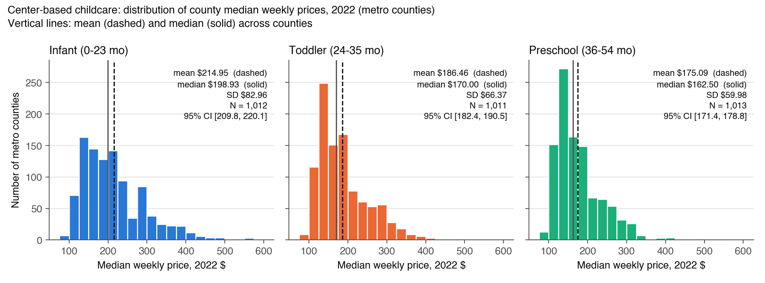
Center-based, 2022 (weekly $) | N | Mean | Median | SD | SE = s/√n | 95% CI for the mean
Infant (0–23 months) | 1,012 | 214.95 | 198.93 | 82.96 | 2.61 | [209.84, 220.07]
Toddler (24–35 months) | 1,011 | 186.46 | 170.00 | 66.37 | 2.09 | [182.36, 190.55]
Preschool (36–54 months) | 1,013 | 175.09 | 162.50 | 59.98 | 1.88 | [171.39, 178.78]
Discussion. Prices fall with the child’s age: the average metro county charges about $215/week for infant care, $186 for toddlers and $175 for preschoolers. The three 95% CIs do not overlap, so the differences are not sampling noise. Because the same counties report all three prices, a sharper comparison is the within-county difference: infant care is on average $28.5 more than toddler care (SE 0.97, z ≈ 29) and $39.8 more than preschool (SE 1.16, z ≈ 34); toddler exceeds preschool by $11.3 (SE 0.60, z ≈ 19). Infant care costs more than preschool in 96% of counties, and the median county’s infant price is 1.17× its preschool price. This matches the cost structure of centers: state staff-to-child ratio rules require far more teachers per infant (often 1:4) than per preschooler (often 1:10), and labor is the main cost.
All three distributions are right-skewed (skewness 1.3–1.4; mean above median). Most metro counties sit between $110 and $250 a week, with a long tail of expensive, high-income metros (e.g. preschool at Arlington VA $496, San Francisco $477, San Mateo $437, Marin $433). The spread is also larger for younger children (SD $83 vs $60), both in dollars and relative to the mean (coefficient of variation 0.39 vs 0.34).
Weighting. The statistics above treat every metro county equally, since each county is one candidate market. Weighting counties by their number of children under 6 (ACS 2022) raises the 2022 means to $269 (infant), $226 (toddler) and $211 (preschool). Large metro counties charge more, so the typical child faces higher prices than the typical county.

3. Trends in real prices, 2015–2022
Nominal prices were converted to constant 2022 dollars with the CPI-U (series CUUR0000SA0, annual average): ${\text{real}}_{t}={\text{nominal}}_{t}×{\text{CPI}}_{2022}/{\text{CPI}}_{t}$. CPI values (verified against the BLS Public Data API as the mean of the 12 monthly values): 2015 237.017 · 2016 240.007 · 2017 245.120 · 2018 251.107 · 2019 255.657 · 2020 258.811 · 2021 270.970 · 2022 292.655.
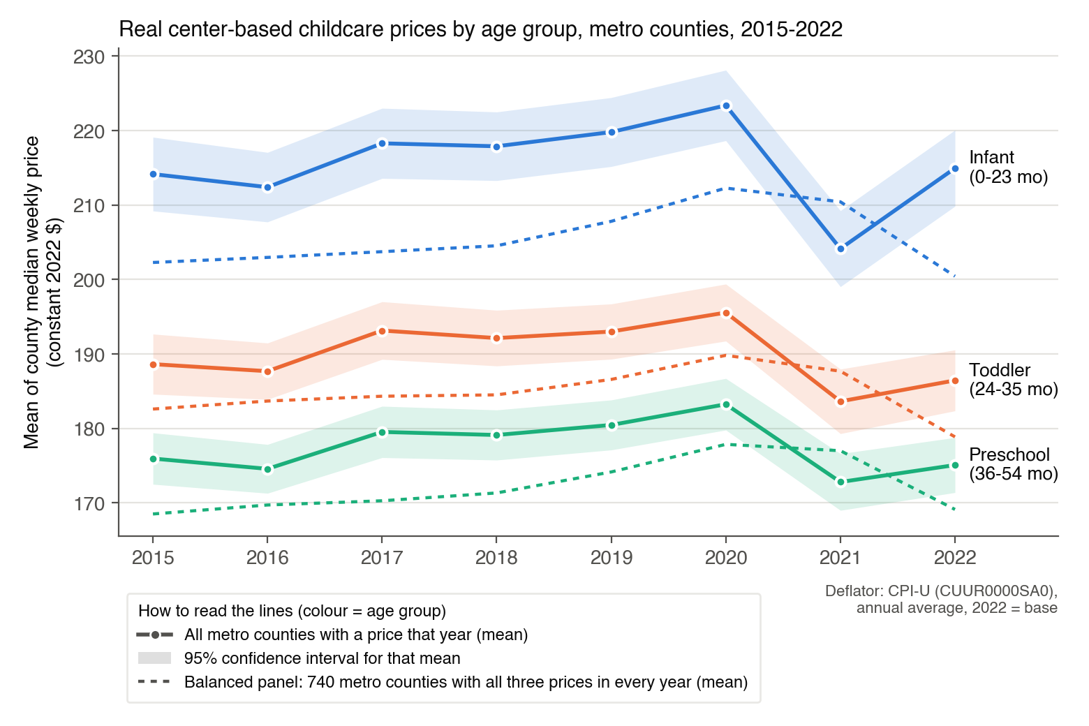
Note on Q2 in real terms: Q2’s 2022 results are unchanged by the CPI-U adjustment, because 2022 is the base year.
Mean real price, 2022 $/week | 2015 | 2016 | 2017 | 2018 | 2019 | 2020 | 2021 | 2022
Infant (0–23 mo), all counties | 214.2 | 212.4 | 218.3 | 217.9 | 219.8 | 223.4 | 204.1 | 215.0
Toddler (24–35 mo), all counties | 188.6 | 187.7 | 193.1 | 192.1 | 193.0 | 195.6 | 183.6 | 186.5
Preschool (36–54 mo), all counties | 176.0 | 174.6 | 179.5 | 179.1 | 180.5 | 183.3 | 172.8 | 175.1
Infant (0–23 mo), balanced panel | 202.3 | 203.0 | 203.7 | 204.5 | 207.8 | 212.3 | 210.4 | 200.4
Toddler (24–35 mo), balanced panel | 182.6 | 183.7 | 184.3 | 184.5 | 186.6 | 189.8 | 187.7 | 178.9
Preschool (36–54 mo), balanced panel | 168.5 | 169.7 | 170.3 | 171.3 | 174.2 | 177.9 | 177.0 | 169.1
A caution on composition. The set of reporting states changes from year to year. In 2021, California, North Carolina, Pennsylvania and Virginia (all relatively high-price) are missing while Puerto Rico (69 low-price counties) appears only in that year, so the drop in the all-county 2021 mean is mostly a change in which counties are measured. We therefore also track a balanced panel of 740 metro counties that report all three prices in every year (dashed lines), which isolates price changes within the same markets.
Change in real prices over each period (%). “All” = all metro counties (solid lines); “Bal.” = balanced panel of 740 counties (dashed lines).
Period | Infant (0–23 mo): All | Bal. | Toddler (24–35 mo): All | Bal. | Preschool (36–54 mo): All | Bal. | CPI-U
2015→2020 | +4.3 | +4.9 | +3.7 | +3.9 | +4.1 | +5.5 | +9.2
2020→2021 | −8.6 | −0.9 | −6.1 | −1.1 | −5.7 | −0.5 | +4.7
2021→2022 | +5.3 | −4.7 | +1.5 | −4.7 | +1.3 | −4.5 | +8.0
2015→2022 | +0.4 | −0.9 | −1.2 | −2.0 | −0.5 | +0.4 | +23.5
Discussion. Childcare prices went through three phases.
- 2015–2020: modest real growth. Real prices rose about 4–5% in total (balanced panel: infant +4.9%, toddler +3.9%, preschool +5.5%). In nominal terms, prices rose about 1.5–3.5% a year, slightly faster than inflation.
- 2021: the COVID-era dip in the solid lines is mostly a change in which states are measured. Across all counties, real prices fell 8.6% (infant), 6.1% (toddler) and 5.7% (preschool). But the 2021 sample lacks California, North Carolina, Pennsylvania and Virginia (high-price states) and adds 69 low-price Puerto Rico counties. Within the same 740 counties, real prices dipped only 0.9%, 1.1% and 0.5%, and nominal prices kept rising (+3.8%, +3.5%, +4.2%). The data show no COVID price cut. The small real dip is inflation (+4.7%) slightly outpacing price increases.
- 2022: the solid-line rebound is also composition; within the same counties real prices fell. The all-county means rebound (+5.3%, +1.5%, +1.3%) because CA, NC and VA return to the data. In the balanced panel, nominal prices rose about 3% again (+2.9%, +2.9%, +3.2%), but 8.0% inflation cut real prices by 4.7%, 4.7% and 4.5%, back to roughly their 2015 level.
Interpretation and outlook. Nominal childcare prices look remarkably steady, rising about 3–4% a year from 2019 through 2022, before, during and after COVID. That is consistent with our hypothesis that prices are stabilizing after the shock and will keep rising. Because providers did not raise prices as fast as the 2021–22 inflation surge, real prices should recover once inflation falls back below about 3%. This should be checked when post-2022 NDCP data are released. A caveat on timing: NDCP prices come from state market-rate surveys run only every 2–3 years, with NDCP interpolating the years in between, so the recorded series is smoother and later than actual price changes.
Infant premium. In the solid lines, the infant premium over preschool appears to widen in 2022 (infant/preschool ratio 1.18 in 2021 → 1.23 in 2022; gap $31 → $40). This is again the change in reporting states. Within the same counties the premium has been stable to slightly narrowing (ratio 1.200 in 2015, 1.193 in 2020, 1.185 in 2022; gap $33.8 → $31.3). It is based on one year of data, so it is a trend to monitor rather than a finding. The ordering infant > toddler > preschool holds in every year.

4. Is the CCDF voucher equal to the median preschool price in the average metro area?
The Administration for Children and Families (ACF) asserts that, in the average metro area, the CCDF voucher equals the price of care at the median-priced center-based preschool. The unit of observation is the metro county: $X_{i}$ is county $i$’s median weekly center-based preschool (36–54 months) price (MCPRESCHOOL), and $μ$ is the mean of $X_{i}$ across metro counties (the “average metro area”).
Putting the voucher in weekly terms. NDCP prices are weekly and the voucher is monthly, so we convert with 4.33 weeks per month:
$$μ_{0}^{2022}=\frac{\$706}{4.33}=\$163.05\text{ per week}, μ_{0}^{2015}=\frac{\$473}{4.33}=\$109.24\text{ per week}.$$
Equivalently, one can multiply every weekly price by 4.33 and test against $706 per month. Since this rescales $\overset{‾}{X}$, $s$ and $μ_{0}$ by the same factor, the test statistic is identical (shown below).

(a) Hypotheses
The ACF claim is about a specific difference: the gap between what the voucher pays and what care costs. Specifically, it is the difference between the 2022 CCDF monthly voucher for center-based preschool ($706, or $163.05 per week) and the price charged by the median-priced center-based preschool, averaged across metro areas. ACF asserts this difference is zero. In our data each county’s MCPRESCHOOL is already the median-priced center’s weekly price in that county, so the claim concerns $μ$, the mean of these county medians across metro counties:
$$H_{0}: μ=μ_{0}=\$163.05 \text{(the voucher exactly covers median-center preschool in the average metro area)}$$
$$H_{1}: μ≠\$163.05 \text{(the voucher and the median-center price differ in the average metro area)}$$
We test at significance level $α=0.05$. The alternative is two-sided because a difference in either direction contradicts the claim. If $μ>μ_{0}$, the voucher falls short and a family using it must pay the difference out of pocket at a median-priced center. If $μ<μ_{0}$, the voucher exceeds the typical market price. The same hypotheses apply to 2015, with $μ_{0}^{2015}=\$473/4.33=\$109.24$ per week.

(b) Test statistic: one-sample t
The one-sample t-statistic tests whether the underlying mean price $μ$ equals the hypothesized mean $μ_{0}$, using the sample average $\overset{‾}{X}$ across metro counties as evidence. We treat the counties as a sample, so $s$ uses the divisor $n−1$ (see Methods):
$$t=\frac{\overset{‾}{X}−μ_{0}}{SE(\overset{‾}{X})}=\frac{\overset{‾}{X}−μ_{0}}{s/\sqrt{n}}, t∼t_{ n−1}\text{ under }H_{0}.$$
Its elements, each computed separately from the 2022 metro sample:
- Sample size $n$: the number of metro counties with a non-missing 2022 center-based preschool price (as in Q2): $n=1,013$, so the degrees of freedom are $n−1=1,012$.
- Sample mean:
$$\overset{‾}{X}=\frac{1}{n}\sum_{i=1}^{n}{X_{i}}=\$175.0885\text{ per week}.$$
- Sample standard deviation:
$$s=\sqrt{\frac{1}{n−1}\sum_{i=1}^{n}{{\left(X_{i}−\overset{‾}{X}\right)}^{2}}}=\$59.9800\text{ per week}.$$
- Standard error of the mean:
$$SE(\overset{‾}{X})=\frac{s}{\sqrt{n}}=\frac{59.9800}{\sqrt{1013}}=\frac{59.9800}{31.8277}=1.8845.$$
- Hypothesized mean:
$$μ_{0}=\frac{706}{4.33}=\$163.0485\text{ per week}.$$
Manual calculation:
$$t=\frac{175.0885−163.0485}{1.8845}=\frac{12.0400}{1.8845}=6.389.$$
The same calculation in monthly terms (every element × 4.33) gives the identical statistic:
$$t=\frac{758.13−706}{259.71/\sqrt{1013}}=\frac{52.13}{8.160}=6.389.$$
Element | Weekly | Monthly (× 4.33)
$n$ | 1,013 | 1,013
$\overset{‾}{X}$ | $175.0885 | $758.13
$s$ | $59.9800 | $259.71
$SE(\overset{‾}{X})=s/\sqrt{n}$ | 1.8845 | 8.160
$μ_{0}$ | $163.0485 | $706.00
$\overset{‾}{X}−μ_{0}$ | $12.0400 | $52.13
$t$ | 6.389 | 6.389

(c) Software check and p-value
For a two-sided test, the p-value is the probability, under $H_{0}$, of a t-statistic at least as far from zero as the one observed:
$$p=P\left(|T_{n−1}|≥|t|\right)=2\left[1−F_{t, n−1}\left(|t|\right)\right],$$
where $F_{t, n−1}$ is the CDF of the t distribution with $n−1$ degrees of freedom. Python’s scipy.stats.ttest_1samp(x, 706/4.33) returns
$$t=6.3889, p=2\left[1−F_{t, 1012}(6.3889)\right]=2.5×{10}^{−10},$$
which matches the manual calculation. With $n$ this large the t and standard normal distributions are nearly identical: the critical value is $t_{0.975, 1012}=1.962$ (vs. $z_{0.975}=1.960$), and a large-sample z-test gives $p=2[1−Φ(6.389)]=1.7×{10}^{−10}$. The conclusion is the same.

(d) Interpretation
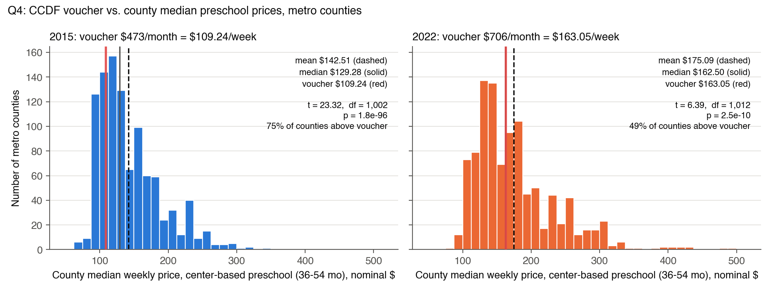
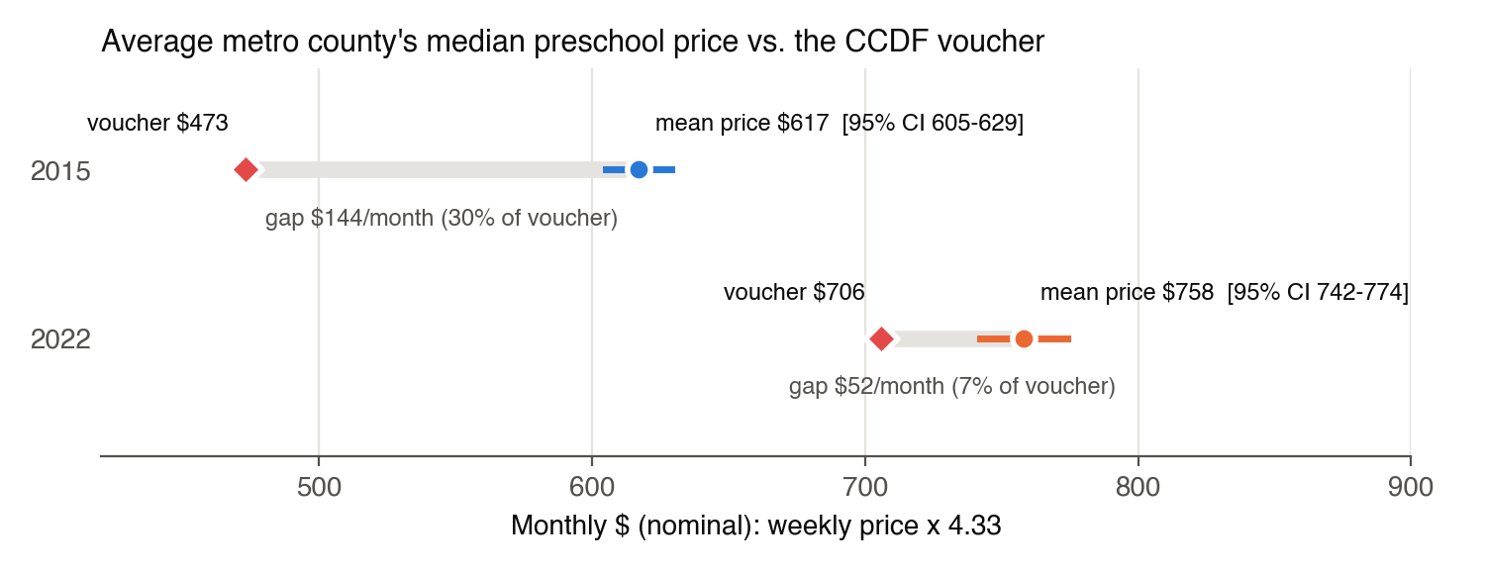
Since $|t|=6.39>t_{0.975, 1012}=1.962$ and $p≈2.5×{10}^{−10}<0.05$, we reject $H_{0}$. If the voucher really equalled the average metro median price, a sample mean $12 or more away from $163.05 would almost never occur by chance. In 2022 the average metro county’s median preschool price ($175.09/week, 95% CI [$171.39, $178.78], ≈ $758/month) is about $12/week (≈ $52/month, 7%) above the voucher, so a family relying only on the voucher would have to pay the difference at a median-priced center.
Nuance: “median” and “average” refer to different levels. The claim’s “median-priced center” is the median across centers within an area. That is already each data point: MCPRESCHOOL is a county’s median price across its providers. “In the average metro area” is the average across areas, which is what the t-test above tests. If “average metro area” is read instead as the typical (median) metro county, the right tool is a sign test: under $H_{0}$ each county is equally likely to be priced above or below the voucher, so the number above is $\text{Binomial}(n,0.5)$, and
$$z=\frac{\hat{p}−0.5}{\sqrt{0.5×0.5/n}}, \hat{p}=\frac{\#\{X_{i}>μ_{0}\}}{n}.$$
Sign test (median across counties = voucher) | 2022 | 2015
Median across counties vs. voucher (weekly) | $162.50 vs. $163.05 | $129.28 vs. $109.24
Counties above / below the voucher | 496 / 517 | 753 / 250
$\hat{p}$ (share above) | 0.490 | 0.751
$z$ | −0.66 | 15.88
p-value (exact binomial) | 0.53 | $4×{10}^{−59}$
Decision at 5% | fail to reject | reject
So in 2022 ACF is right about the typical metro county: the voucher sits almost exactly at the median county price. It is wrong about the average, because the price distribution is right-skewed and a tail of expensive counties pulls the mean about $52/month above the voucher. We keep the t-test on the mean as our main answer because it matches the wording (“average”) and parts (b)–(c).
Repeating with 2015 data and the 2015 voucher (nominal prices vs. the nominal voucher):
$$t=\frac{\overset{‾}{X}−μ_{0}}{s/\sqrt{n}}=\frac{142.5075−109.2379}{45.1741/\sqrt{1003}}=\frac{33.2696}{1.4264}=23.32, p=2\left[1−F_{t, 1002}(23.32)\right]≈1.8×{10}^{−96}.$$
Element | 2015 (weekly)
$n$ (df $=n−1$) | 1,003 (1,002)
$\overset{‾}{X}$ | $142.5075
$s$ | $45.1741
$SE(\overset{‾}{X})=45.1741/\sqrt{1003}=45.1741/31.6702$ | 1.4264
$μ_{0}=473/4.33$ | $109.2379
$t$ | 23.32
$p$ | $≈1.8×{10}^{−96}$ (effectively 0)
We reject $H_{0}$ in 2015 as well, and by a much larger margin. In 2015 the voucher covered only 77% of the average metro median preschool price (a $33/week gap, about $144/month), and 75% of metro counties had median prices above the voucher. Between 2015 and 2022 the nominal voucher rose 49% while metro preschool prices rose about 23–24%, so the gap shrank from about 30% of the voucher to 7%. The voucher is much closer to market prices in 2022, but it is still significantly below the average. (Converting both years to 2022 dollars multiplies $\overset{‾}{X}$, $s$ and $μ_{0}$ by the same CPI factor, so the t-statistics are unchanged.)
Robustness. The metro analysis sample is a hard rule throughout: only counties in an OEWS metropolitan area (oews_area beginning 00). Using exactly the same 1,013 metro counties (2022), averaged within each of the 341 OEWS metro areas so that each area counts once, we still reject: 2022 mean $175.33, $n=341$ areas, $t=4.33$, $p=2.0×{10}^{−5}$; 2015 mean $144.47, $t=15.6$, $p≈{10}^{−41}$.

Data-handling decisions
Code, run instructions and the full prompt history are in the project repository, https://github.com/ignaciosanur/mgt403-childcare-project-green-cohort-7b (see README.md there). The decisions below shaped the numbers in this write-up.
- Metro definition uses the year-specific crosswalk row (oews_area starts with 00); FIPS codes are kept as 5-character strings and OEWS areas as 7-character strings throughout.
- Missing prices are left out (not imputed); N is reported for every statistic.
- Legacy county codes: two crosswalk metro codes (12025 Dade, 51515 Bedford city) have no NDCP row. NDCP reports these counties under their current codes (12086, 51019), so no county is lost.
- Balanced panel for trends: the states that report prices change from year to year (e.g. 2021 lacks CA, NC, PA and VA and adds Puerto Rico), so Q3 also tracks the 740 metro counties with all three prices in every year.
- Sample vs. population: we treat the metro counties as a sample (SD with divisor $n−1$, standard errors and tests); see Methods.
- Weights: all statistics are unweighted county averages. The child-weighted means in Q2 use ACS 2022 5-year kids_under6 (B23008_002E, from pull_acs.py). Connecticut’s 7 metro counties drop out of that calculation because the 2022 ACS reports CT by planning region.
- NDCP _flag columns (values 1/2/3) do not mark imputations. They record how NDCP collapsed its detailed age bands into one age-group price (1 = all bands had the same price, 2 = the most common price, 3 = the highest of several modes; NDCP Technical Report, Appendix C county data dictionary, p. 66). All non-missing values are kept.
- CPI-U values were verified against the BLS API (series CUUR0000SA0, annual averages).

Within-county comparison, 2022 metro counties. The mean of the within-county differences equals the difference of the group means ($28.5, $11.3, $39.8, up to a few cents from the 1–2 counties missing one price); pairing only makes the comparison more precise. The county-by-county split shows how often each gap exists: County by county Higher Same price Lower Infant (0–23 mo) vs toddler (24–35 mo) 92.4% 4.9% 2.7% Toddler (24–35 mo) vs preschool (36–54 mo) 64.5% 28.6% 6.9% Infant (0–23 mo) vs preschool (36–54 mo) 96.4% 0.0% 3.6% The infant premium is nearly universal. Toddler and preschool care cost exactly the same in 29% of counties, likely because many state surveys do not separate these age bands. The $11 average toddler premium therefore comes from roughly two-thirds of counties.
How Q2 changes with CPI-U-adjusted prices. Real prices are nominal × CPI₂₀₂₂ / CPI_year. For 2022 the factor is 292.655 / 292.655 = 1, so every Q2 number (histograms, means, medians, SDs, CIs, within-county gaps) is identical in nominal and in real 2022 dollars. The adjustment only matters when comparing across years (Q3, and the 2015 part of Q4). More generally, deflating one year’s data multiplies every price by the same constant c, which rescales dollar-valued statistics but leaves the shape and all unit-free results unchanged: Statistic Effect of multiplying all prices by c Mean, median, SD, SE, CI endpoints, within-county gaps multiplied by c N, skewness, coefficient of variation, % of counties with a gap unchanged z-statistics and p-values (e.g. infant vs preschool) unchanged, since (c·x̄ − c·μ₀)/(c·s/√n) = (x̄ − μ₀)/(s/√n) Histogram shape, ranking of counties and of age groups unchanged (only the x-axis is rescaled) For example, expressed in 2015 dollars (c = 237.017 / 292.655 = 0.810) the 2022 preschool mean would be $141.80 (SD $48.58, 95% CI [$138.81, $144.79]), infant $174.08 and toddler $151.01, and every conclusion in Q2 stays the same.
COVID restrictions and childcare prices (exploratory check). We summarized state COVID restrictions, March 2020–December 2021, from the Oxford COVID-19 Government Response Tracker (OxCGRT, US state totals; covid_check.py, output covid_state_restrictions_oxcgrt.csv). States differed a lot: days under a required stay-at-home order ranged from 0 (e.g. ND, SD, IA, NM) to over 300 (HI), and the average 2020 stringency index ranged from 46 (ND) to 78 (NM). Among the 34 states with balanced-panel metro counties, restriction intensity is essentially unrelated to childcare price changes. Correlations between stringency, stay-at-home or school-closure days and the 2019→2022 or 2020→2021 real price change range from −0.18 to +0.28, which is weak and noisy with 34 states. The stricter half of states saw a 2019→2022 real preschool change of −2.3%, against −1.5% for the less strict half. This is consistent with prices measured in the NDCP being driven more by general inflation and the survey schedule than by local lockdowns. Open questions: effects on capacity (center closures, enrollment) and on costs are not visible in price data. The NDCP series may also lag too much to show a short 2020–21 shock.
Caveat: counties in the same state are not independent. Many states report prices by region or cluster rather than county by county, so about 60% of metro counties share an exact price with another county in their state. The textbook standard error $s/\sqrt{n}$ assumes 1,013 independent observations. The effective amount of information is closer to the 45 states. Allowing for correlation within states (state-clustered standard errors, $t$ with $G−1$ df) makes the standard error about 4.3 times larger: State-clustered test of the mean 2022 2015 States (clusters) $G$ 45 43 Clustered SE (vs. textbook SE) 8.16 (vs. 1.88) 6.10 (vs. 1.43) $t$ (df $=G−1$) 1.48 (44) 5.45 (42) p-value 0.15 $2.4×{10}^{−6}$ 95% CI for the mean (weekly) [$158.64, $191.54] [$130.20, $154.82] With clustered errors the 2022 interval contains the voucher ($163.05), so we would no longer reject in 2022. The 2015 rejection is robust. Our main answer uses the textbook test the assignment asks for; this caveat means the 2022 rejection is less certain than the textbook p-value suggests.

