**ACM, IRTF & ISOC Applied Networking Research Workshop**

Berlin, Germany

Saturday, July 16, 2016

https://irtf.org/anrw/2016/

# Call For Papers

The inaugural ACM, IRTF & ISOC Applied Networking Research Workshop 2016 (ANRW’16) is an academic workshop that provides a forum for researchers, vendors, network operators and the Internet standards community to present and discuss emerging results in applied networking research. It is sponsored by ACM SIGCOMM, the Internet Research Task Force (IRTF) and the Internet Society (ISOC).

Researchers should consider submitting early/emerging results that illustrate the scientific and engineering principles underlying the Internet architecture, protocols and applications; that demonstrate new capabilities, features, or extensions to the Internet protocol layers; that enhance our understanding of how Internet protocols work in real-world deployments or realistic test-beds; or that improve Internet security and privacy, scalability, performance, and robustness.

The ANRW’16 particularly encourages the submission of results that could form the basis for future engineering work in the IETF, that could change operational Internet practices, that can help better specify Internet protocols, or that could influence further research and experimentation in the IRTF.

# Topics Of Interest

Topics of interest include, but are not limited to, applied work in the following areas:

* Evolution of the Internet architecture and deployment of new Internetworking paradigms
* Naming, addressing, and routing for the future Internet
* Development and deployment of new and improved transport protocols
* Congestion control for heterogeneous networks and novel applications
* Improvements to the security and privacy of Internet protocols
* Studies that characterize Internet security, privacy or censorship
* Measuring and understanding the behaviour and transparency of the Internet
* Internetworking and semantic interoperability for resource-constrained devices
* New approaches to network management, operations, and control
* Better ways of specifying protocols, including usable techniques for protocol verification
* Enabling global access to the Internet
* Improving the energy efficiency of the Internet
* Protocols and APIs for new Internet applications
* New approaches to decentralized mobility management
* Application of network programmability to the Internet

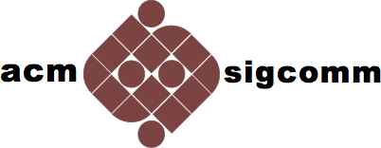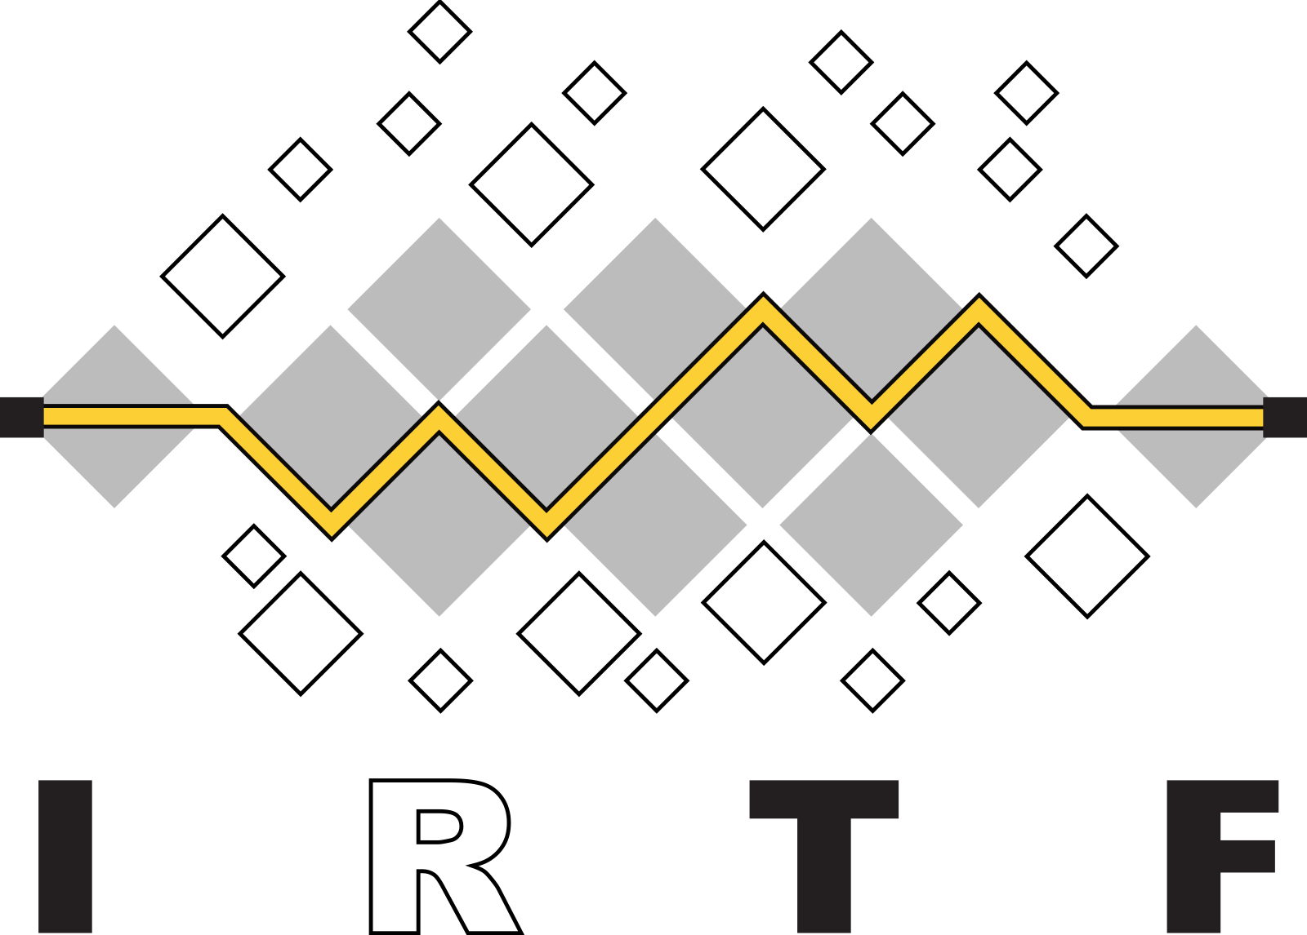

# Submission Types

The ANRW accepts two types of submissions: full papers and short papers.

* **Full paper** submissions should be complete academic papers on the topics above and may contain up to six pages of technical content, including figures, tables, any appendices, etc., optionally followed by a single additional page for references and acknowledgements only. Accepted full papers will be presented and discussed in depth at the workshop, and will be published in the ACM Digital Library.
* **Short paper** submissions are suitable for short position papers, for starting a discussion on new technical ideas, to present very early results, or to present other topics of interest to the community (software and tools, research initiatives or collaborative projects, major new funding vessels, etc.). They may contain up to two pages of content including figures, tables, any appendices, etc., optionally followed by a single additional page for references and acknowledgements only. Accepted short papers will be briefly presented during the workshop, and will be published in the ACM Digital Library.

Authors of accepted short papers may also bring a poster presenting their content to the workshop, for display and more in-depth discussion during the breaks.

# Important Dates

* Submission deadline: May 16, 2016
* Notification deadline: June 17, 2016
* Camera-ready deadline: June 24, 2016

# Organising Committee

Programme chairs:

* Lars Eggert (NetApp)
* Colin Perkins (University of Glasgow)

Technical Programme Committee:

* Aaron Falk (Akamai)
* Gorry Fairhurst (University of Aberdeen)
* Stephen Farrell (Trinity College Dublin)
* Jana Iyengar (Google)
* Dirk Kutscher (NEC Laboratories Europe)
* Mirja Kühlewind (ETH Zürich)
* Al Morton (AT&T)
* Jörg Ott (Technische Universität München)
* Arjuna Sathiaseelan (University of Cambridge)
* Brian Trammell (ETH Zürich)
* Lixia Zhang (UCLA)