Assignment:

Create an application with image processsing capabilities. Following please find some expected features in this application.

1. Allow to load image from image gallery. (Score: 10)

Refer to sample image.

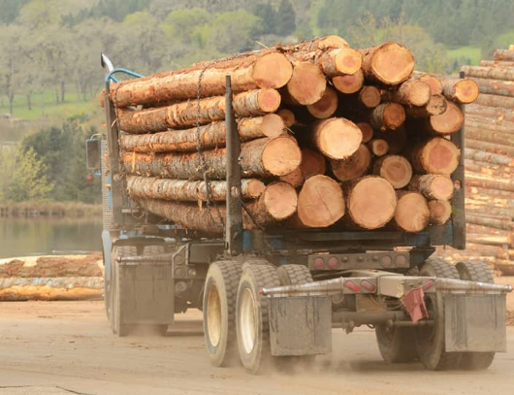

1. Able to identify circle objects (wood log) from the image. Highlight it by using green rectangle. (Score: 30)

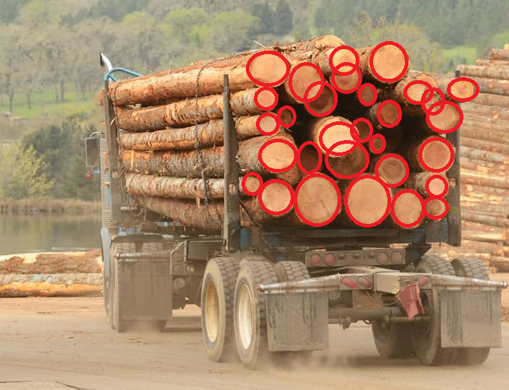

1. Able to identify rectangle object. Highlight it by using blue rectangle. (Score: 30)

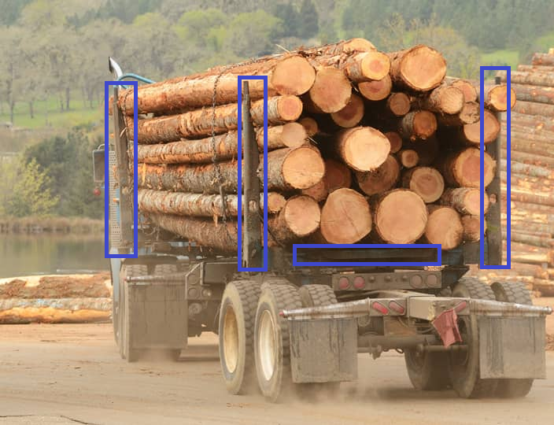

1. Able to identify the number of circle object. (Score: 30)

