Group 4

Statistics overview

Airport simulation

# Introduction

A big part of the simulation application that we designed is played by the statistics. The statistics part of the app is located on the right side of the main window and features icons for each stat that help the overall simplicity and looks of the application.

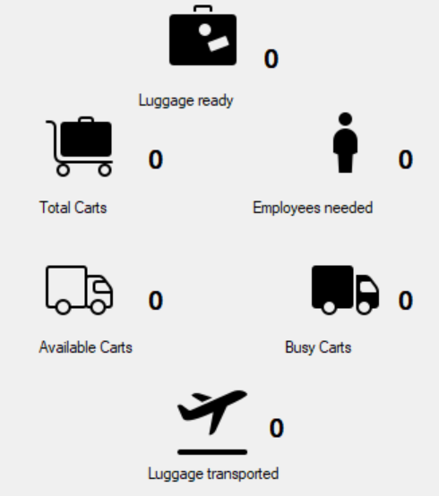 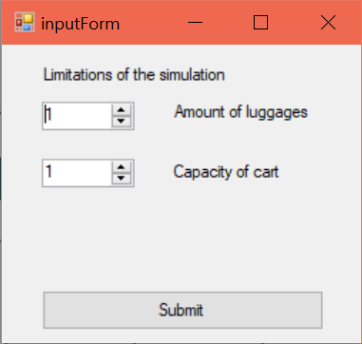

Statistics segment Simulation parameters form

# Rundown

* The **“luggage ready”** indicates the total number of luggage that made it past the belt portion of the airport and are either waiting to be transported, being transported or already in the plane.



* **“Total carts”** depicts the total amount of carts used for the entire process of transporting the luggage from the airport to the airplanes.



* **“Employees needed”** shows the total number of employees required for the whole process.



* The application takes into account the capacity of the carts specified in the input form above and the time it takes a cart to take the luggage to the plane and come back and knows when the cart has to wait for another batch of luggage – **“Available cart”** (to avoid using extra carts, and implicitly employees)



* **“Busy carts”** represents the number of carts that are currently on their way to/from the plane.



* **“Luggage transported”** provides the user with the amount of luggage that has already been transported to its corresponding airplane.