

Design document

Eshop store website

February 7, 2019

Ignas Ap - 3620557

LOKESH AGNIHOTRI - xxxxxxx

1.Introduction

We want to create simple electronic items store. The website is simple for any user to be able to purchase goods.

## Target audience

The appeal of our e-store website is that it sells new and discounted specific electronic items for small office’s. The site will have large images and will focus on providing an enjoyable and smooth user experience. The audience will already hold an interest specific office items and use the internet regularly, hence they will visit the site for purchase purpose or maybe just to check sales, where we have special offers.

### Website topic

Our main idea is to provide audience with new and cheap electronic items for a internet store in a simple and convenient manner. With the possibility to purchase electronics they want. User will be able to put his favourite items in a cart and checkout, in addition of being able to register and ask a question in a contact form.

# 2. Sitemap

## 2.1. Sign Up & Checkout as pop up forms.

# 3.Wireframes

## 3.1. Home

## 3.2. New

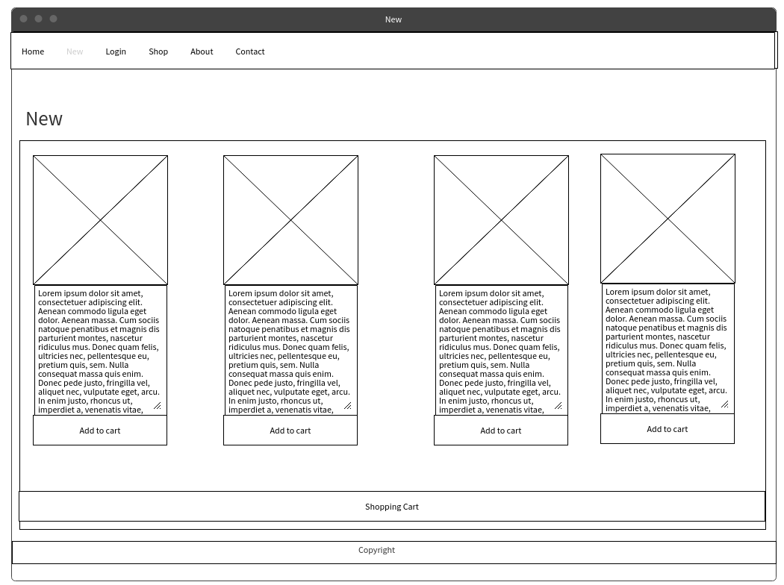

## 3.3. Login

## 3.4. Contact

## 3.5. Discount

## 3.6. About

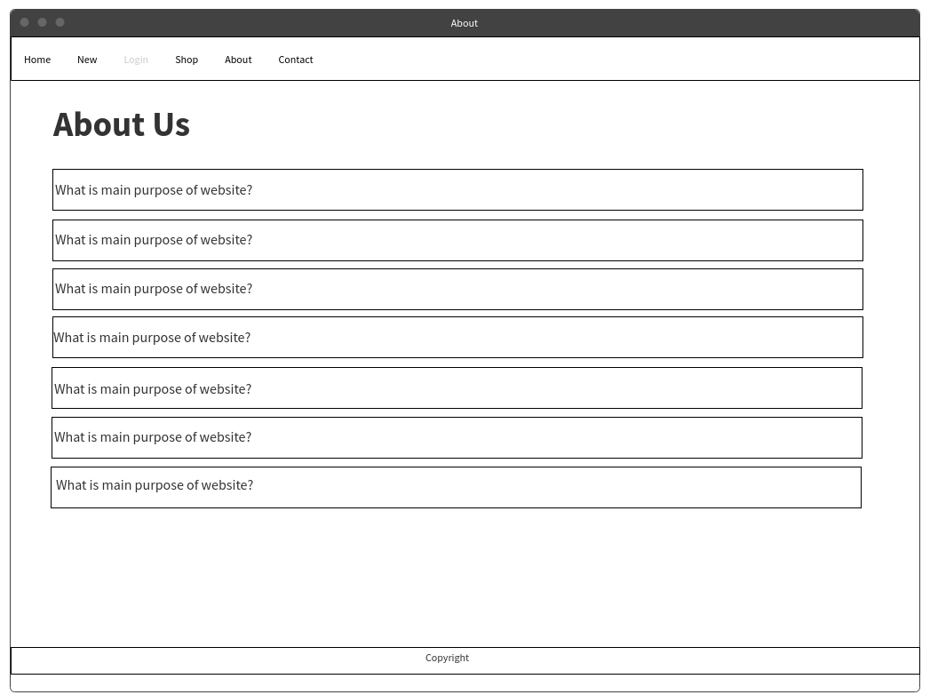

## 3.7. Shop

# 4. Visual Design

## 4.1 Home

## 4.2. Shop

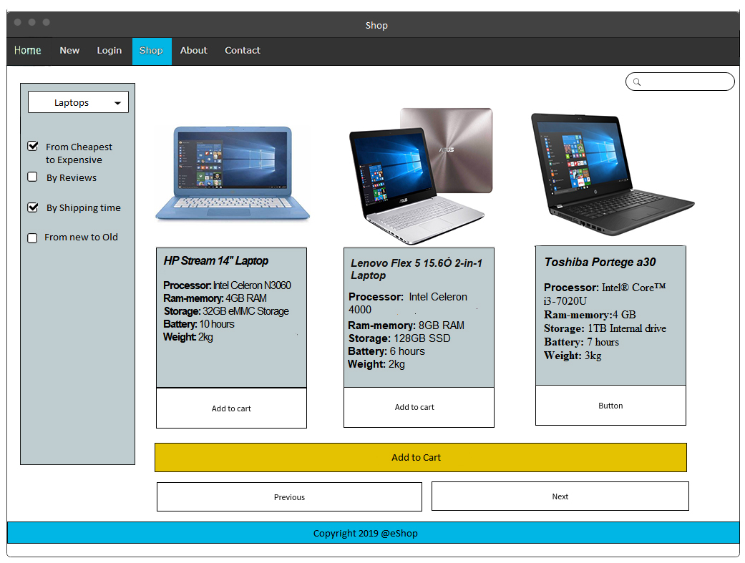

## 4.3. Login