Contents

Making IsThisTaxiLegal application 1

Making Proof of Concept with data 1

Step 1 : acquiring data from 2

***Step 2*** : cleaning data - read with Word and transform into CSV. 2

***Step 3*** : Making objects to support 2

***Step 4:***  Consolidating data from CSV to objects 2

***Step 5***: Application Web + WebAPI to display data 2

***Step 6***: Deploy sources to GitHub 2

***Step 7***: Create an application visible on internet 3

***Step 8***: Document the API 4

***Step 9*** : Remake the documentation 4

Thinking about application 4

1. What remains to be done / how can be improved 4

# Making a free application for fun and programming

The reasons to make an application could be more :

1. Make sure that you can do it
2. Add something valuable to your CV
3. Play with software without constraints of time or money
4. Show the best of yourself to you.
5. Play with different software concepts / languages
6. Understand the possibilities

# Idea to mockup

The idea can come from your daily work , form reading a newspaper , from a fried or even from internet (See <http://lmgtfy.com/?q=ideas+for+software+application> )

*For IsThisTaxiLegal I have had the idea from a friend that told me about a site wher can I find the taxi authorizations.*

The mockup is what you will do after the idea - making some sample pages about how the application will look . You can have in your head – or you can use a mockup tool, like <http://pencil.evolus.vn/Downloads.html> )

*For IsThisTaxiLegal I want a simple web page to look for the plate number - so no need for a*

Also you should note any ideas for later implementation

*For IsThisTaxiLegal the Proof of Concept: A WebAPI + WebSite( that can be accessed also by mobile) to enter a plate number and find if it is legal. Maybe later aphone application ( Android App + iOS). Also maybe add plate photo and make OCR to find the number/.*

# Making Proof of Concept with data

In this step you can make the application easy as you want. Do not bother about usability or about the data – you can do it manually and you will make automation later.

Step 1 : acquiring data

This is the step where you will have a precise idea where the data comes from . The data could be RSS, documents, a html page, a API…

*IsThisTaxiLegal I have download PDF about taxi licence for Bucuresti :* <http://www.pmb.ro/adrese_utile/transport_urban/autorizatii_taxi/autorizatii_TAXI.php>

*See link Download situatia_autorizatiilor_taxi_20171208.PDF*

## ***Step 2*** : cleaning data

The data will not come as you want - it implies some transformation. Be sure that you save anything that helped you transform the data - you can use later. This could imply some hack coding. Do not bother, it is not your primary application.

*For IsThisTaxiLegal it was a PDF with tables that I want as a table. The solution was to read with Word and transform into CSV.*

## ***Step 3*** : Starting application

Making objects to support

First creating objects to support this . Car, City, LicenseState, Licensee, TaxiAutorization.

Creating test - the City should be unique - even if Bucarest is multiple times, the City object should be the same.

## ***Step 4:*** Consolidating data from CSV to objects

Creating objects to mimic CSV data . Return to step 2 and put separator | instead of ,

Problem with parsing data

- a date could not exist, so it will be nullable

– could be either dd.mm.yyyy , either d.mm.yyyy either 27.02.202

Separate the lines with errors from the lines without errors . And return the result as a tuple

Making test in order to see the errors

## ***Step 5***: Application Web + WebAPI to display data

Making WEBAPI for seeing all and some taxis

See that valid taxis are not parsed correctly ( Validat vs Valid) . Modify test

Discover there are some licenses with state…

## ***Step 6***: Deploy sources to GitHub

Easy to do – create an application on GithUb, connecting with Visual Studio, submit and sync

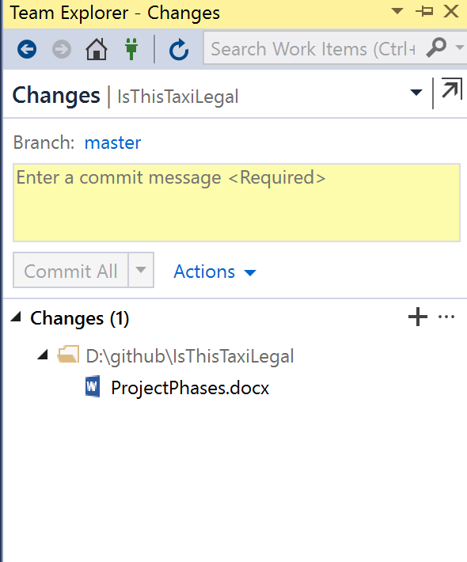

## ***Step 7***: Create an application visible on internet

You can create an account at appharbor.com , integrate with GitHub(follow the app harbor instructions) and deploy there : <http://isthistaxilegal.apphb.com/API/Home/Index>

## ***Step 8***: Document the API

Swagger / Swashbuckle is the easy way to do this.

For

Just reference Swashbuckle from NuGet.org and methods in Startup.ConfigureServices and in Startup.Configure

## ***Step 9*** : Remake the documentation

Mention all the documentation in all places ( API, GitHub, others)

Mention the contact name if something is wrong

Add API for enums

## ***Step 10*** : Deploying the application

It is very important that the people could see your application. You can find some free hosting providers.

*For IsThisTaxiLegal, I have choosed a free one ( AppHarbour,* [*http://isthistaxilegal.apphb.com*](http://isthistaxilegal.apphb.com) *). You can choose also some free Cloud provider.*

# Thinking about application - What remains to be done / how can be improved

It took more than was supposed to happen. And yet is not complete

Now it is time to think about application . You can brainstorm with a few friends or alone

*For IsThisTaxiLegal , It can be improved so many ways:*

* *Making OCR ( to recognize the plates number)*
* *Making application Android / iPhone*
* *Making Windows (Store ) application ( not really necessary, but anyway)*
* *Finding if another cities have taxi licenses available*
* *Publicity*
* *Improving with ratings for taxi drivers*
* *Find a lawyer that knows what to do next*
* *Improving the documentation*
* *Passing from csv to sql lite*
* *Downloading automatically the pdf with licences from* [*www.pmb.ro/adrese_utile/transport_urban/autorizatii_taxi/autorizatii_TAXI.php*](http://www.pmb.ro/adrese_utile/transport_urban/autorizatii_taxi/autorizatii_TAXI.php)
* *Making all this points on* [*https://github.com/ignatandrei/IsThisTaxiLegal*](https://github.com/ignatandrei/IsThisTaxiLegal) *as issues*
* *Running the test automatically*

All those should be added to a tracking system , in order to have it later.

*For IsTaxiLegal, I have used GitHub ,* [*https://github.com/ignatandrei/IsThisTaxiLegal/issues*](https://github.com/ignatandrei/IsThisTaxiLegal/issues) *.*

# Making programming fun again

This is the moment to recover from the long journey that you had.

## New Tasks

All new tasks , such as

* + previously manual - downloading data , parsing
  + modifying from a database to another ( csv to sqlite)

could be done in a new language. If you are OO, you can try functional.

*For IsThisTaxiLegal, being a C# programmer, I have had done the downloading and parsing in R. It was very good for me to force the mind over new concepts( and google was my friend)*

## Improving the application

Modifying parts of the application to improve speed or accuracy.

*For IsThisTaxiLegal, I have converted the database from CSV to Sqlite.*

## Tests

Do not forget adding tests for any new feature that you have. If not, this will backfire at you later

## Talking with friends / on internet

To gain new traction to the application, you could talk about this with your friends. Also , announce on social media / blogs. This could gain some traction for your application.

*For IsThisTaxiLegal, being a C# programmer, I have had done the downloading and parsing in R. It was very good for me to force the mind over new concepts( and google was my friend)*