AnthracoForm
User guide — AnthracoForm v1.3.1 (CSV schema v1.3)
Supplementary material S2. Software: https://doi.org/10.5281/zenodo.20487673 (MIT licence). Data dictionary: S1.
This guide explains how to record wood-charcoal fragments with AnthracoForm, step by step. The screenshots show the Saharo-Sindian (Sindh) module with a demonstration file (site code DEMO); the Eastern Mediterranean (Lebanon) module works in the same way and differs only in its reference data. AnthracoForm is an aid to identification, not a substitute for it: reference atlases, comparison collections and time at the microscope remain the basis of every determination.

1. What you need
- Any up-to-date web browser. Google Chrome or Microsoft Edge, version 86 or later, are recommended: they let AnthracoForm read and write the CSV file directly in a folder you choose (File System Access API). In other browsers you open the file with Open CSV and save it with Download CSV (section 3.3).
- The HTML file of a regional module: AnthracoForm_Saharo-Sindian.html or AnthracoForm_Eastern-Mediterranean.html. Nothing else: no installation, no server, no account and no internet connection.
- A folder for your data, ideally one that is backed up. AnthracoForm writes one CSV file per site in this folder.

1.1 Getting the application
- Download the latest release from Zenodo (https://doi.org/10.5281/zenodo.20487673) or from the Releases page of the GitHub repository (ignaziominervini-ctrl/AnthracoForm).
- Unzip the archive. Each module is in its own folder (Saharo-Sindian/, Eastern-Mediterranean/), with its README, CHANGELOG and LICENSE.
- Copy the HTML file of your module to your computer and open it in a web browser (double-click, or drag it onto a browser window). Do not open it from inside the zip archive.
The file works offline: it includes everything it needs, including the libraries that produce the PDF record sheet.

2. The screen at a glance
At start-up a welcome window reminds you what the tool is for (Figure 1). Tick don't show again on startup to skip it next time.
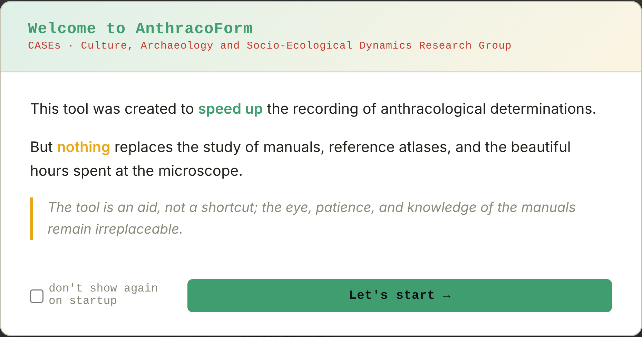
Figure 1. The welcome window.
The screen has three bands (Figure 2):
- Header: module name; record navigation (⇤ ← → ⇥); the position of the current record and the total number of records (Tot); ✓ Save (or ✓ Update when you are editing an existing record) and ✕ Delete. The badge on the left says whether you are writing a NEW RECORD or editing one (EDIT n/N).
- File bar: the folder and file in use, time of the last save and number of records; Select folder (then Change folder) and ⟳ Reload CSV; FIND, to jump to a record by SU or by id_det.
- Tabs: Form (recording), IAWA Reverse Lookup, Dichotomous Key and Compare Taxa (identification tools, section 6).
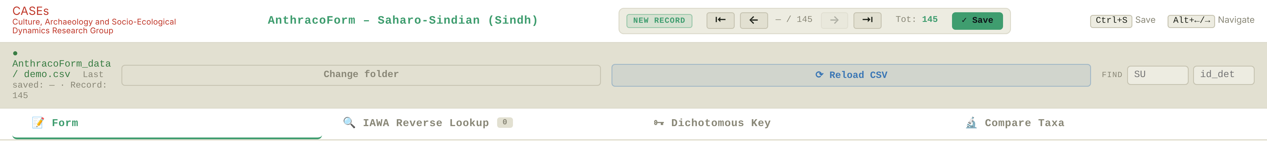
Figure 2. Header, file bar and tabs, with the demonstration file open.

3. Starting a session

3.1 Opening or creating the site file
- Click Select folder and choose the folder where your data are kept. The browser asks for permission to edit files in that folder: allow it.
- Type the name of the CSV file for this session, without .csv, and confirm. If a file with that name exists in the folder it is opened; otherwise a new, empty file is created. AnthracoForm proposes the name used last time.
- The file bar shows the folder and file name and the number of records loaded. The next free id_det is already filled in on the form.
From now on every save is written to the CSV file on disk immediately: there is no separate "save file" step, and the file on disk is always up to date. Use one file per site.

3.2 Reloading and changing file
- ⟳ Reload CSV reads the file again from disk (useful if you edited it elsewhere). Unsaved changes in the form are lost: AnthracoForm asks before reloading.
- Change folder opens another folder or file.

3.3 Browsers without folder access
In browsers without the File System Access API the file bar says No folder access in this browser and shows an Open CSV button. Click it to open an existing file, or start recording straight away for a new one. Records are kept in memory: save them with ↓ Download CSV (bottom right of the form), which downloads the file with the same name, and replace your copy with the downloaded one. Until you download, the file bar shows changes not yet downloaded, and the browser warns you if you try to close the page.

3.4 What the browser remembers
The data are only in the CSV file. The browser stores a few conveniences: the welcome-window setting, the fields locked with KEEP, the name of the last file, the list of taxa offered under the determination field, and the families and ecological groups you type for taxa that are not in the module's dictionary. These belong to the browser on that computer; clearing the browser data removes them, but never touches your CSV files.

4. Recording a fragment
The Form tab holds one fragment. Fill it in from top to bottom and save. Figure 3 shows the upper part of the form for a saved record.
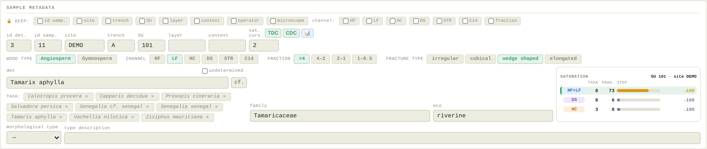
Figure 3. Sample metadata, wood type, channel, fraction, fracture type, determination and saturation panel.

4.1 Sample metadata
id det. is assigned automatically and gives the order of determination, which the curves follow. Fill in id samp. (sample or bag number), site, trench, SU, layer and context.
KEEP (padlock row): tick a field to keep its value for the next records. Typically you lock site, sample, SU, operator and microscope once per SU and then record only the fragment. The same row lets you keep the channel and the fraction. You can tick several channels: the channel of a record passes to the next one if it is ticked, so with HF, LF, DS and HC ticked it always carries over; with only one channel ticked, every new record starts with that channel.

4.2 Wood type, channel, fraction, fracture type
Click a button to select a value; click it again to clear it.
- Wood type: Angiosperm or Gymnosperm. It decides which IAWA list is shown below (hardwood or softwood features).
- Channel: where the fragment comes from. The channel decides what the fragment can contribute to (Table 1); if your assemblage lacks some channels, see section 7.4.
- Fraction: >4, 4–2, 2–1 or 1–0.5 mm (stored as gt4, 4to2, 2to1, 1to05).
- Fracture type: irregular, cubical, wedge shaped or elongated.

Channel | Meaning | Curves and counts
HF / LF | Heavy and light fraction from flotation of a sample of known volume (typically 20 or 40 L). | Abundances and saturation curve of the SU.
DS | Dry sieving in the field, fixed mesh, volume not recorded. | List of taxa; conditional discovery curve (CDC).
HC | Hand-collected during excavation, selected by eye. | List of taxa; site-level taxonomic discovery curve (TDC).
STR | Closed context: hearth, oven, dump area, or a charcoal concentration distinct from the surrounding matrix. | List of taxa; analysed by event, never summed with the SU.
C14 | Fragments selected for radiocarbon dating. | List of taxa only.
Table 1. Recovery channels. Every determined fragment enters the list of taxa of its SU; only HF and LF enter abundances and the saturation curve.

4.3 Determination
- Type the taxon in det. The TAXA buttons below list the taxa already recorded in the file: click one to insert it (the small ✕ removes it from the list, not from the data).
- cf. adds or removes "cf." in the determination. Fragments determined with cf., with a slash for several taxa (e.g. Senegalia/Prosopis type) or ticked as undetermined are recorded as usual but stay out of the curves: they count neither as fragments nor as taxa of a curve (Kabukcu and Chabal 2021).
- undetermined: tick it for fragments that cannot be identified.
- family and eco fill in automatically from the taxa dictionary of the module and can be edited. If you type family and eco for a taxon the dictionary does not know, AnthracoForm remembers them for that taxon in this browser.
- The saturation panel to the right of eco summarises the three curves for the SU and site of the current record (section 7.1). The fragments of an SU need not be recorded in a row: the curves follow the order of determination of all the records of the file.

4.4 Provisional morphological types
A fragment that you cannot identify yet can be assigned to a morphological type (tipo_1 to tipo_20 per file), with a short type description. When the type is identified, click Resolve →, enter det, family and eco and click ✓ Apply to all: the determination is written to every fragment of that type. The type field of those fragments is cleared, but the type is not lost: it is kept in the tipo_resolved column, together with its description, and the form shows resolved from tipo_n.

4.5 Taphonomy, morphology, observed sections and photo status
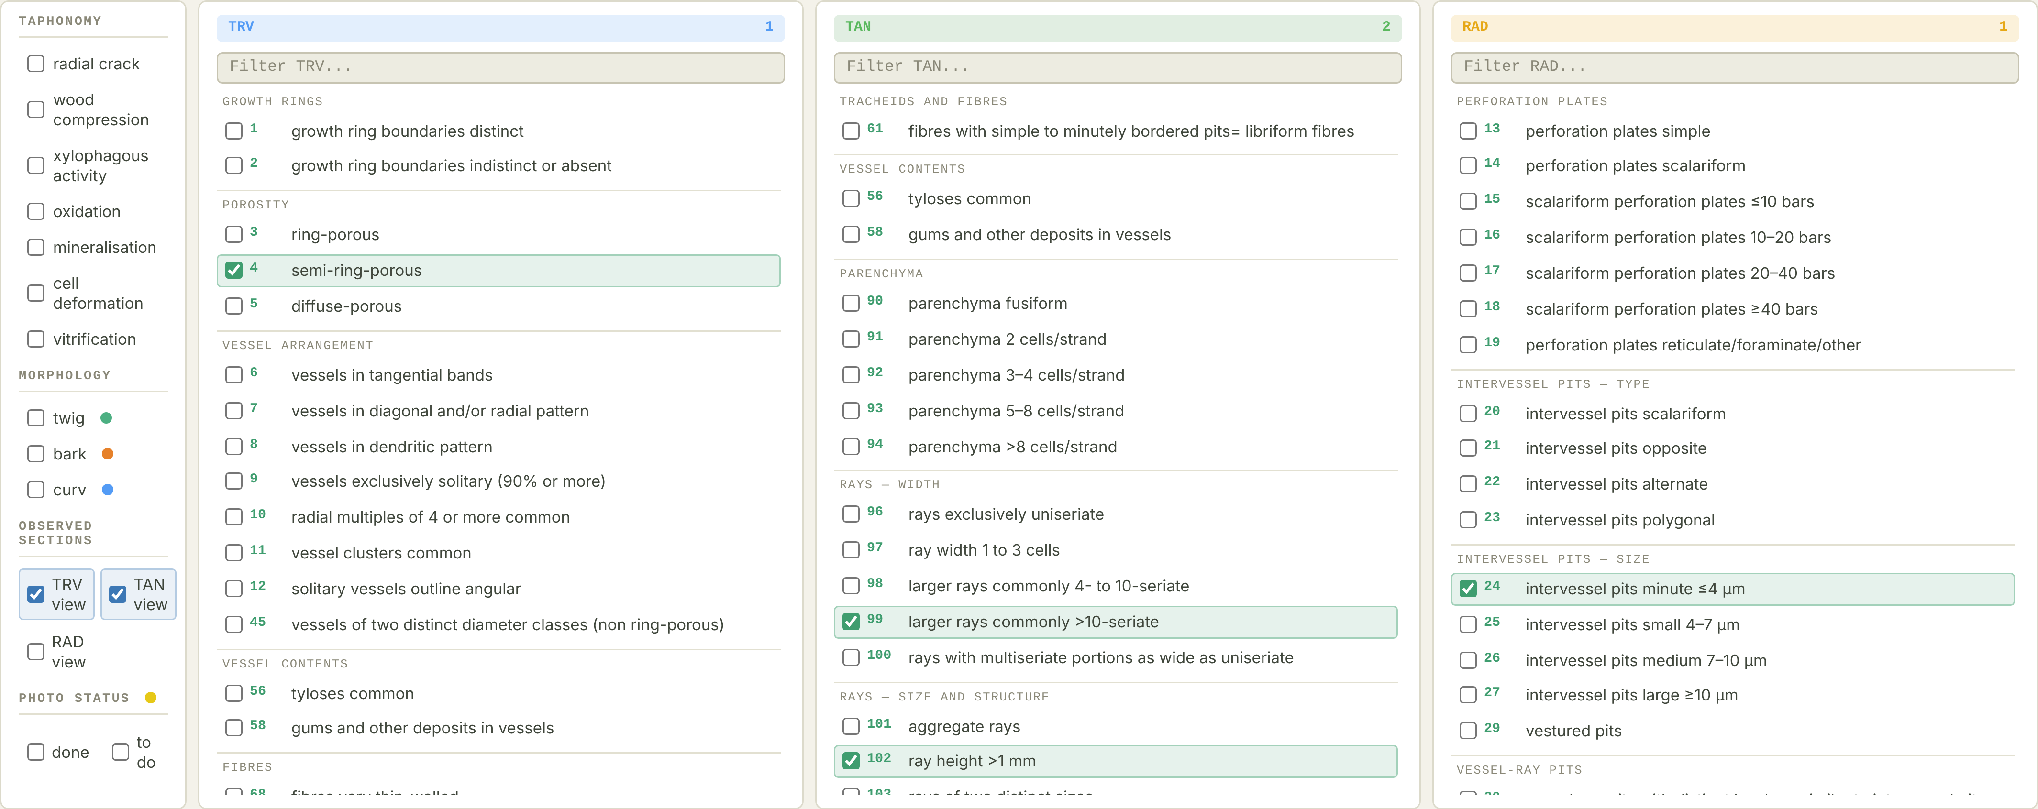
Figure 4. Left: taphonomy, morphology, observed sections and photo status. Right: the IAWA checklists for the transverse (TRV), tangential (TAN) and radial (RAD) sections, with the selected features highlighted.
- Taphonomy: tick the alterations present (radial cracks, wood compression, xylophagous activity, oxidation, mineralisation, cell deformation, vitrification). Each is recorded as 1 (present) or 0 (absent).
- Morphology: twig, bark, and curv when the ring curvature can be measured to estimate the original diameter.
- Observed sections: tick TRV, TAN and RAD for the sections you actually examined. This matters: a feature left unticked counts as absent only where its section was observed.
- Photo status: done or to do.

4.6 IAWA features
The three panels list the IAWA features observable on a charcoal fracture surface, grouped by anatomical category: 102 hardwood features (IAWA Committee 1989) or 77 softwood features (IAWA Committee 2004), depending on the wood type. Tick the features you see. The filter box above each panel searches by number or by text; the number at the top right of each panel counts the features ticked. Features visible in more than one section appear once. The numbers on screen are the IAWA feature numbers; in the CSV each feature is a column with the prefix of its list (e.g. iawa_A5, iawa_G40).

4.7 Selected codes, photographs, notes and saving
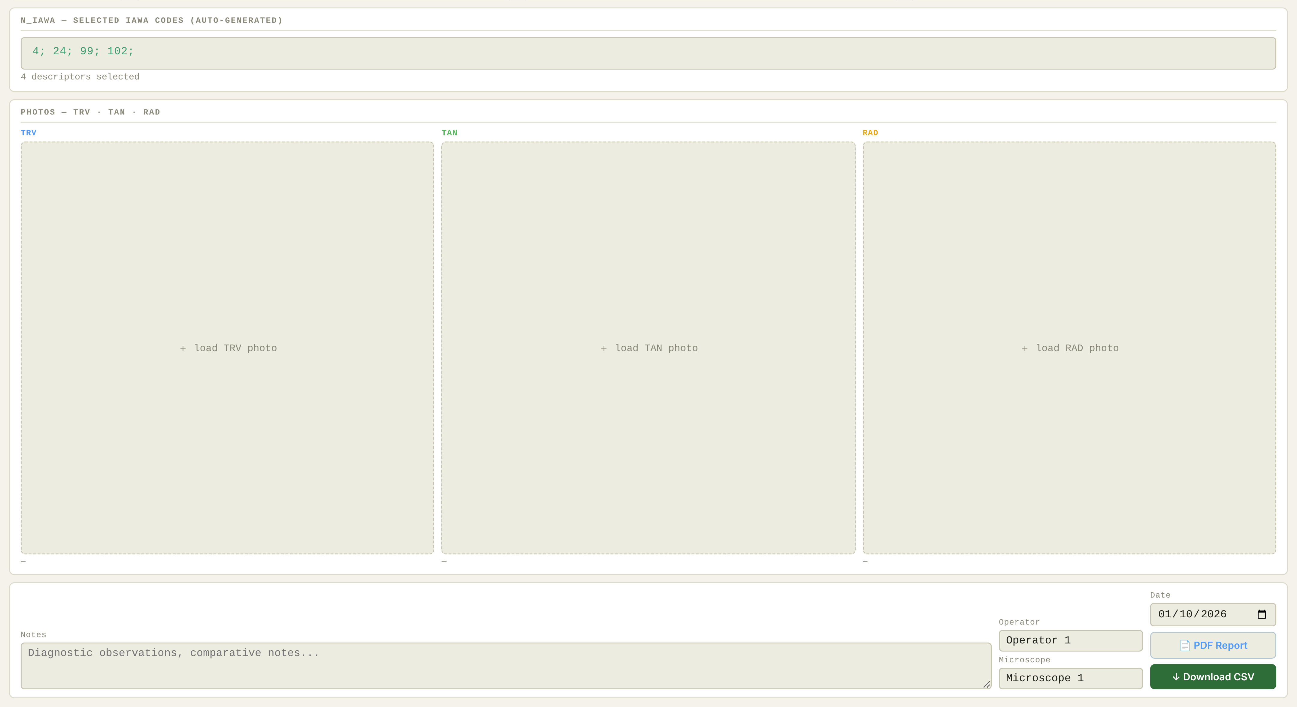
Figure 5. Lower part of the form: list of selected IAWA codes, one photograph per section, notes, operator, microscope, date, PDF record sheet and CSV download.
- N_iawa lists the codes ticked for the fragment.
- Photos: load one photograph per section. The CSV keeps only the file name; the image stays in your archive. Name your files so that they lead back to the record (for example site, SU, section, id_det and magnification).
- Notes (several lines are allowed), Operator, Microscope and Date (today's date by default; stored as YYYY-MM-DD).
- ✓ Save (or Ctrl+S) writes the record to the CSV file and opens a new empty form with the kept values already in place.

5. Finding and editing records
- Move through the records with ⇤ ← → ⇥ or Alt+←/Alt+→ (from any tab).
- FIND: type an SU and press Enter to jump to its first record; press Enter again to cycle through the records of that SU. Type an id_det and press Enter to jump to that record.
- While a record is open the badge shows EDIT and the save button becomes ✓ Update. Changes to an open record are saved automatically when you move to another record; a record you have not changed is never rewritten.
- ✕ Delete removes the current record after a confirmation. It cannot be undone.

Keys | Action
Ctrl+S | Save or update the current record
Alt+← / Alt+→ | Previous / next record
Enter in FIND | Jump to the SU or id_det typed
Esc | Close the welcome window
Table 2. Keyboard shortcuts.

6. Identification tools
The three tools use the reference data of the module: the taxa with their IAWA profiles and the dichotomous key. They rank and compare candidates; the determination is always entered by the operator.

6.1 IAWA Reverse Lookup
The lookup uses the features ticked on the current fragment (shown at the top; the number on the tab counts them). It lists the taxa of the module ordered by the share of their reference profile that you have observed (covered) and, in case of a tie, by the number of matching features. For each taxon it shows the features that match, the features you ticked that the taxon does not have (absent in taxon), and the features of the taxon you have not ticked. Set a minimum number of matching features to hide weak candidates. ✓ Apply to det copies the taxon into the determination field.
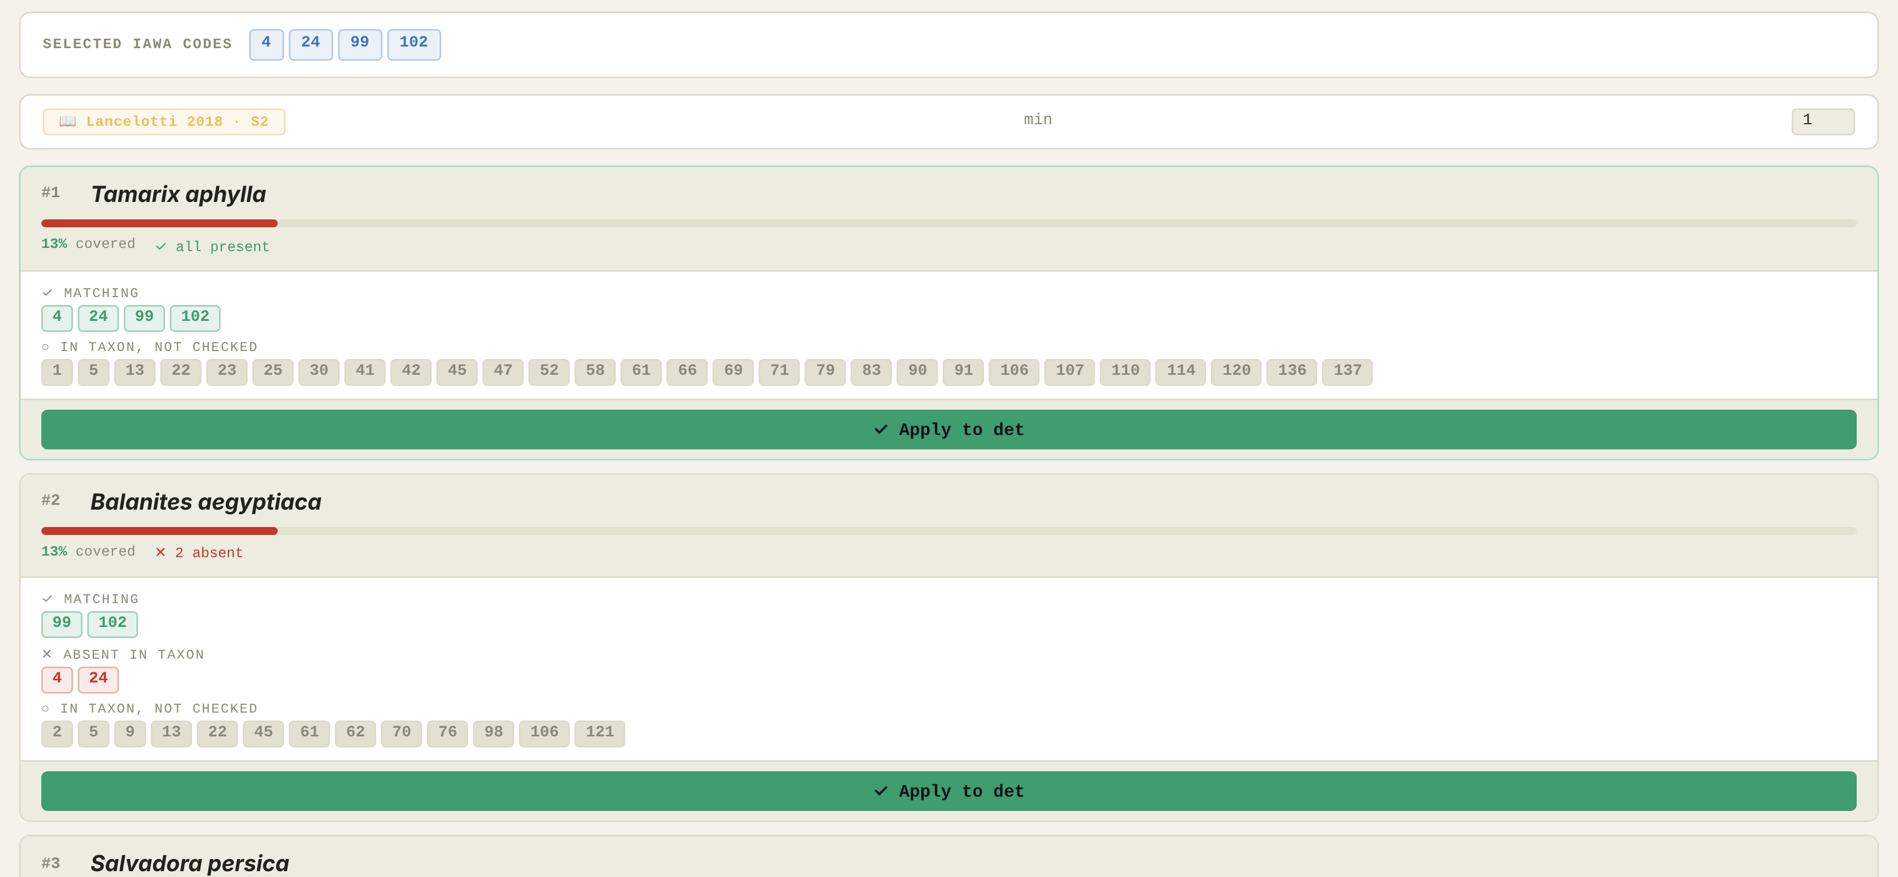
Figure 6. IAWA Reverse Lookup for a fragment with four features ticked.

6.2 Dichotomous Key
Follow the key one couplet at a time by clicking the statement that fits the fragment. The path taken is listed on the left; ← Back and ↺ Restart let you correct it. A result can be copied to the determination field. In the Saharo-Sindian (Sindh) module the key reproduces, couplet by couplet, the published key of Lancelotti (2018, Supplementary Material S2). In the Eastern Mediterranean (Lebanon) module it is the key to genera of Akkemik and Yaman (2012), and each result lists the species of that genus in the reference database; the transcription has been checked against the original pages (Akkemik and Yaman 2012: 293–296).
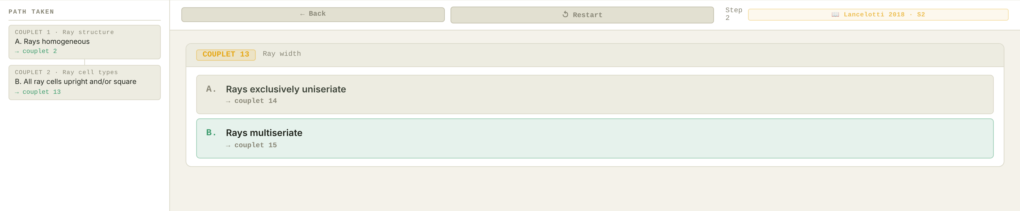
Figure 7. Dichotomous Key after two couplets.

6.3 Compare Taxa
Choose two or three taxa and click Compare →. The result lists the key distinguishing characters first, then, section by section, the features found only in one taxon and those shared.
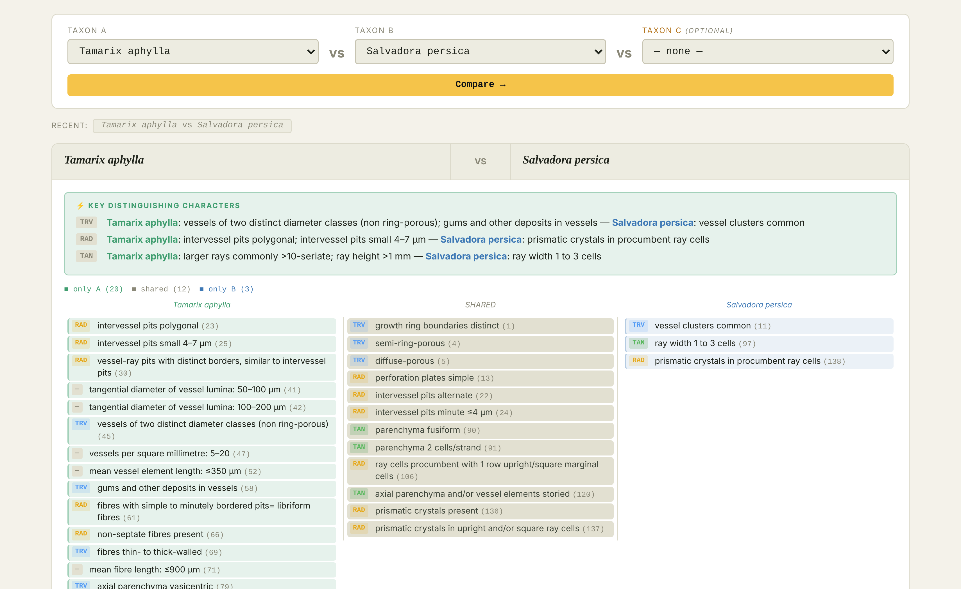
Figure 8. Compare Taxa: two taxa side by side.

7. Checking the sampling during the analysis

7.1 Saturation panel
The panel to the right of eco in the form is always visible and changes with every record (Figure 9). It has one row per curve: HF+LF (saturation curve of the SU), DS (conditional discovery curve of the SU) and HC (taxonomic discovery curve of the site). The heading gives the SU and the site it refers to; when the SU field is empty, it refers to the last record saved, marked (last record). The row of the channel selected in the form is highlighted.
Column | Content
taxa | Taxa on the curve. For DS, the count includes the taxa already found in HF and LF of the SU, as in the CDC.
frag. | Fragments on the curve (undetermined, cf. and slash determinations are not counted).
step | Next step for the fragments on the curve: 100, 200, 250, 300, 400 (e.g. →200); the last step reached is shown with a tick (✓100 …). The bar shows the way to the next step and turns from grey to yellow at 50 fragments and to green at 100.
Table 3. Columns of the saturation panel.
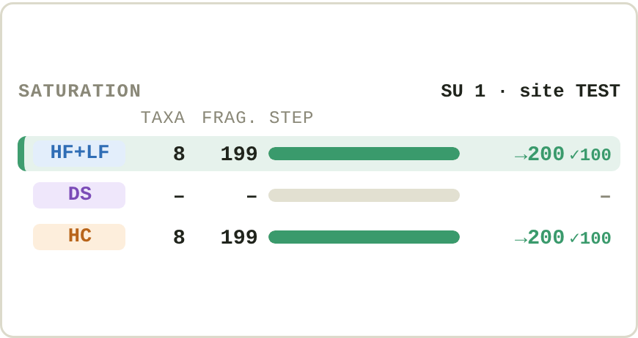
Figure 9. Saturation panel on a test file: the HF+LF curve of SU 1 and the HC curve of the site have 199 fragments on the curve, past the 100 step and one fragment short of the 200 step; SU 1 has no DS fragments. The HF+LF row is highlighted because the current fragment is LF.
The steps are reminders, not a stop rule. For assemblages from the arid zones of Sindh and Iranian Sistan, 100 identified fragments have proved to be a minimum; Kabukcu and Chabal (2021) give 200–300 identified fragments per layer for rich (e.g. tropical) assemblages and 250–400 for temperate ones. The plateau of a curve has no mathematically defined end point: the decision to stop belongs to the analyst, and AnthracoForm never stops the recording.

7.2 Saturation curve and SU summary
The field sat. curv. shows, for HF and LF fragments, how many taxa the SU has reached so far. The 📊 button next to it opens the summary of the current SU, or of the whole assemblage (Figure 10). Its seven tabs are:
Tab | Content
1 · Saturation | Cumulative number of taxa against the HF and LF fragments on the curve, in order of determination. The bar above the chart gives the fragments on the curve, those left out (undetermined, cf., slash) and the steps reached; dashed lines mark the steps on the chart.
2 · Richness | HF and LF fragments per taxon. Taxa found in the SU only through other channels (DS, HC, STR, C14) are listed above the chart.
3 · Simpson | Simpson diversity (1 − D) of every SU, on HF and LF fragments, for comparison.
4 · Ecology | Composition of HF and LF fragments by the ecological groups defined in the module.
5 · Taphonomy | Frequency of each alteration on the fragments where it was recorded (Figure 11).
6 · Fracture | Distribution of fracture types.
7 · HF/LF | HF and LF fragments per SU.
Table 4. Tabs of the SU summary.
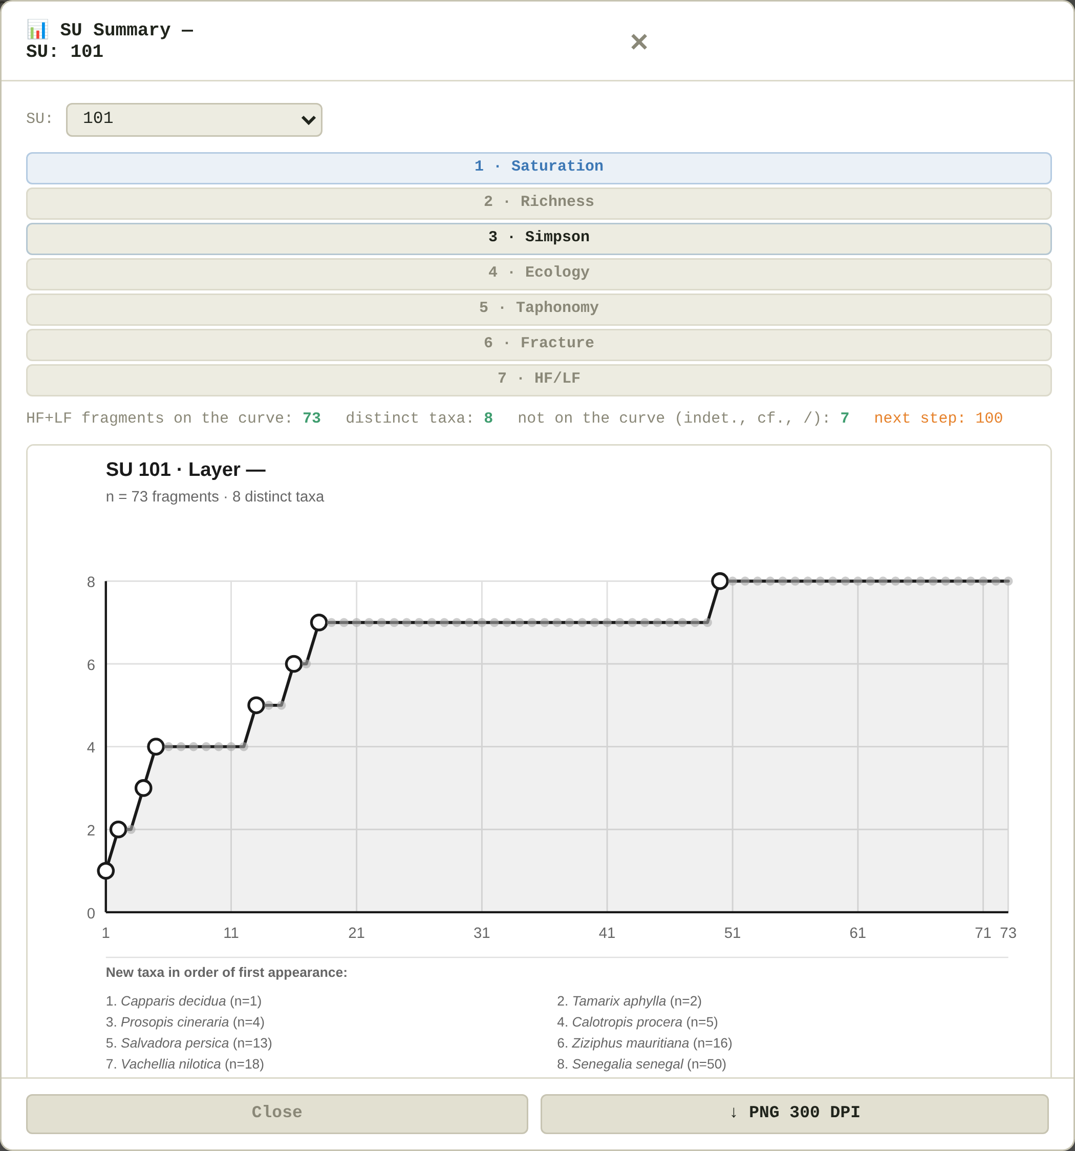
Figure 10. SU summary, Saturation tab. Open circles mark the first fragment of each new taxon; the list under the chart gives the order in which taxa appeared.
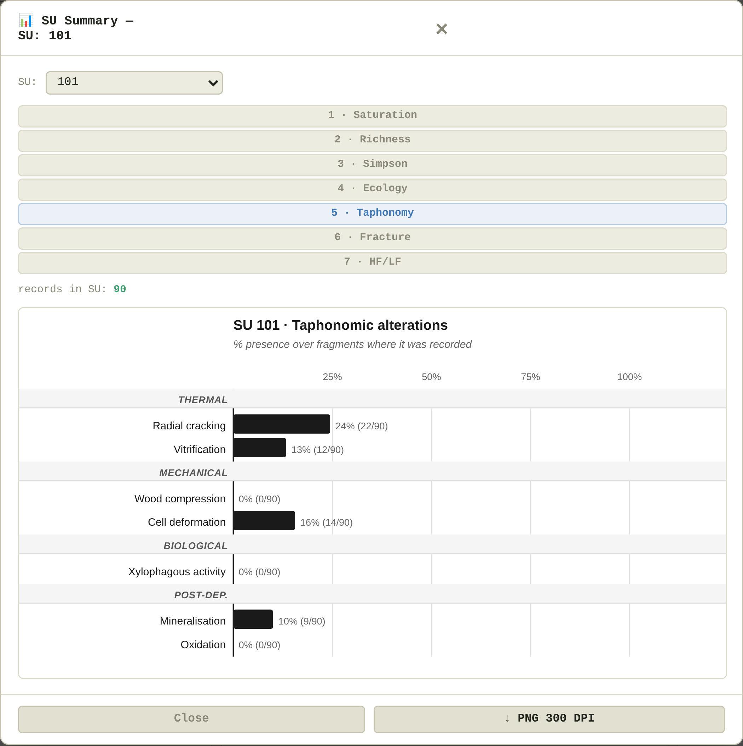
Figure 11. SU summary, Taphonomy tab.
Every chart can be exported with ↓ PNG 300 DPI: black and white, 170 mm wide, ready for print. These summaries are a check during the analysis; analyses for publication are run on the CSV file.

7.3 Curves for the other channels
- TDC (taxonomic discovery curve): one curve for the whole site, built on hand-collected (HC) fragments. It records how far the operator has learnt the local woods; it is not a saturation curve.
- CDC (conditional discovery curve): for each SU, built on dry-sieved (DS) fragments. It starts from the taxa already found in HF and LF and counts only the taxa that dry sieving adds; a flat curve means that DS adds nothing to flotation, which is itself a result.
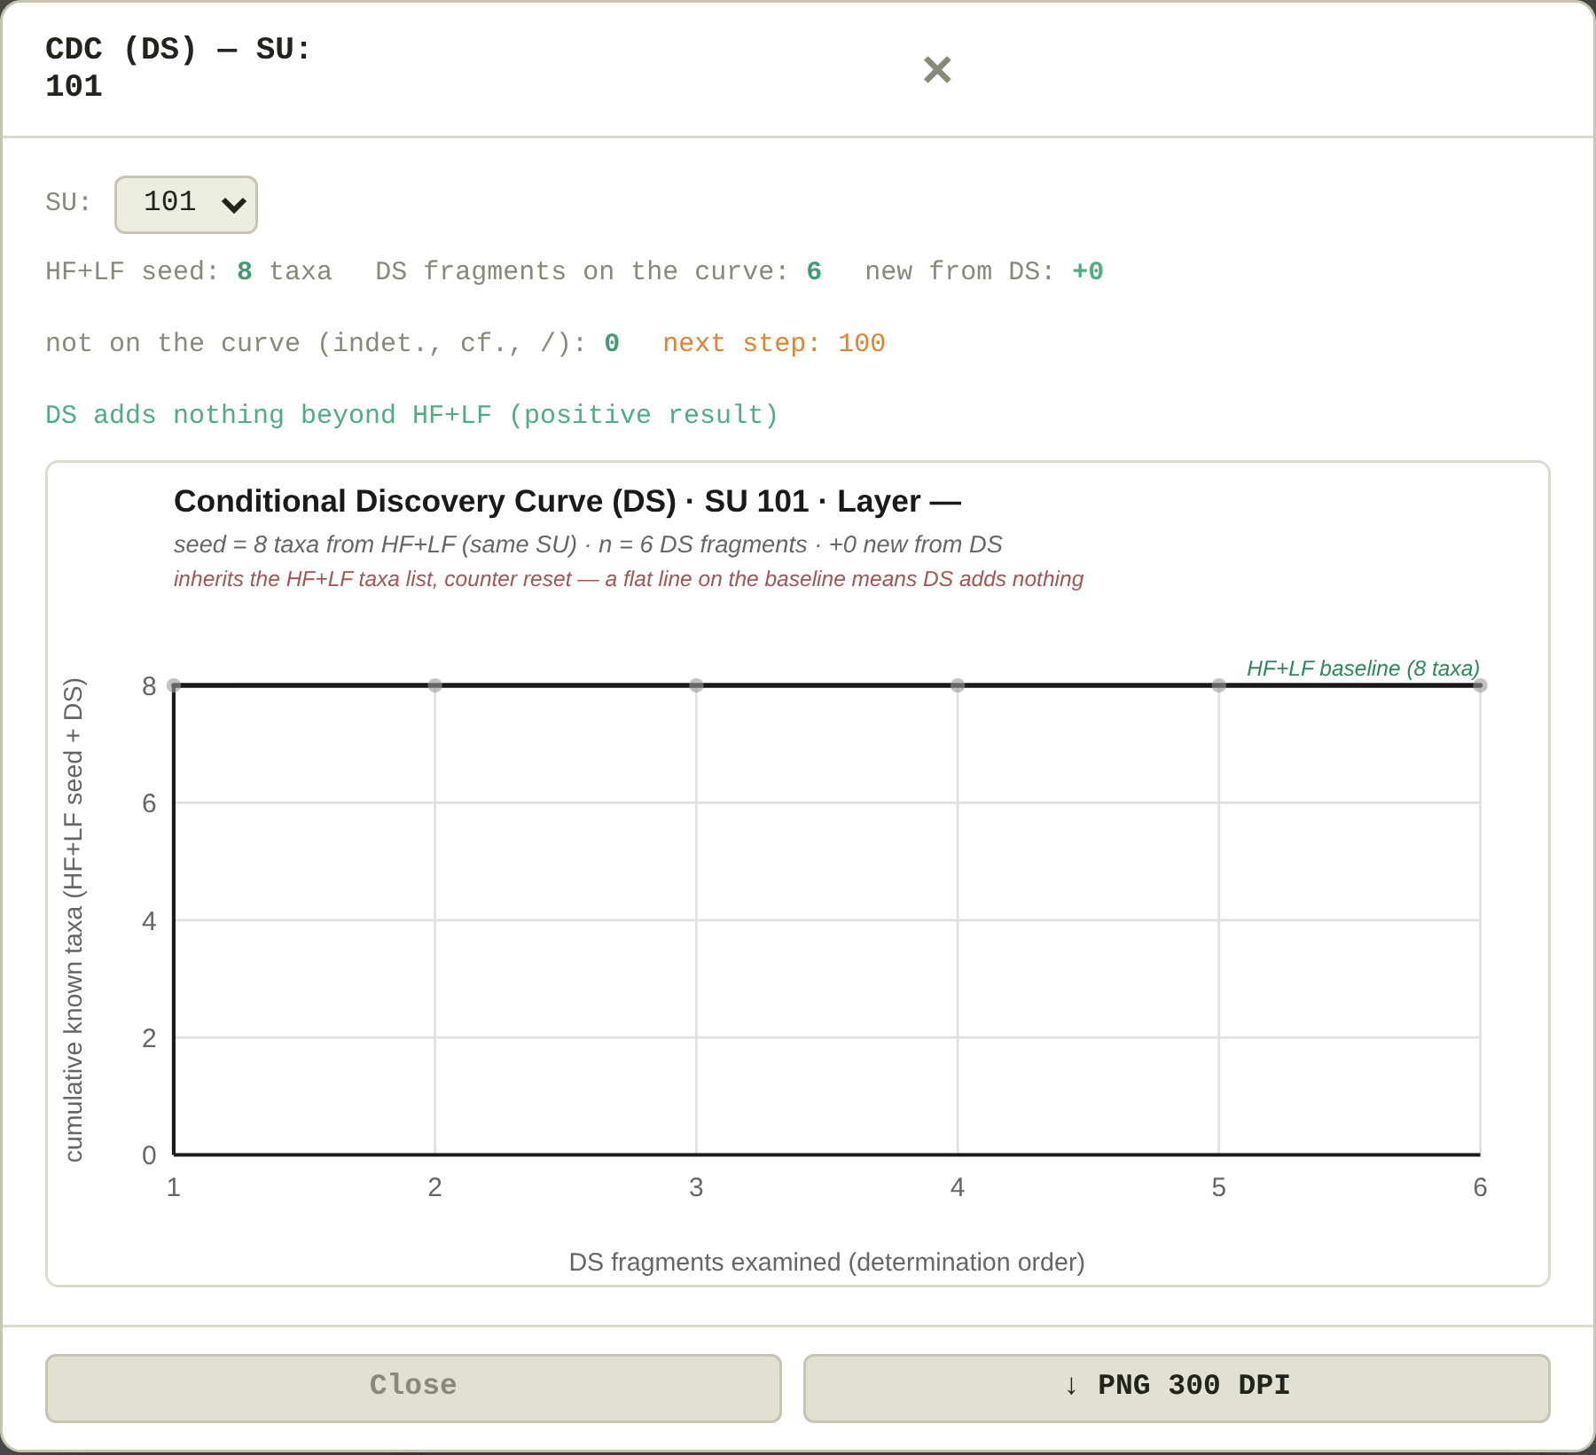
Figure 12. Conditional discovery curve (DS) of an SU.
Fragments from closed contexts (STR) and those selected for dating (C14) never enter the curves.

7.4 Using AnthracoForm with partial sampling
AnthracoForm was built on the complete sampling sequence used in the excavations of the ModAgrO and MeSAP projects: flotation of known volumes of sediment (HF and LF), dry sieving (DS), hand collection (HC), closed contexts (STR) and samples for dating (C14). Many assemblages have only some of these channels. The record is the same in every case; what changes is what the curves and the summary can tell (Table 5). Always record the channel the fragment really comes from.
Material available | Curves | SU summary (📊) | Read the data as
Complete sequence (HF, LF, DS, HC, STR, C14) | Saturation per SU (HF+LF); CDC per SU (DS); TDC per site (HC) | All tabs | Abundances and diversity from HF and LF; the CDC shows what dry sieving adds; the TDC records recognition
Flotation only (HF and/or LF) | Saturation per SU | All tabs | Abundances and diversity; with one fraction only, the curve is a curve of that fraction
Dry sieving only (DS) | CDC per SU, which without HF and LF is a plain saturation curve | Richness lists the taxa; Taphonomy and Fracture work; the abundance tabs stay empty | Relative frequencies calculated from the CSV file; no densities, because the volume is not recorded
Hand collection only (HC) | TDC per site only | Richness lists the taxa; Taphonomy and Fracture work; the abundance tabs stay empty | Presence of taxa and, with one id samp. per bag, ubiquity (share of bags in which each taxon occurs), calculated from the CSV file
Table 5. What AnthracoForm offers with different sampling strategies. STR and C14 never enter the curves.
Hand-collected charcoal is chosen by eye and is often concentrated: several fragments may come from one piece of wood, so a curve or a frequency counted on fragments says little about the vegetation or the fuel. Do not record hand-collected or dry-sieved fragments as HF or LF to obtain the curves: the file would no longer be comparable with those of other sites.

8. PDF record sheet
📄 PDF Report produces a printable sheet of the current fragment: context, determination, taphonomy, observed sections, the selected features with their IAWA labels, the photographs and the notes. It is meant for doubtful fragments: a second operator can check it, it can be discussed with a specialist or filed with the reference material. It works offline.

9. The data file
Each row of the CSV file is a fragment; the 220 columns are the same in every module. The complete description is in the data dictionary (S1). The essentials:
- UTF-8, comma-separated; 1 = present or yes, 0 = absent or no; an empty cell means "not recorded", never absent.
- Dates in ISO format (YYYY-MM-DD); fractions coded gt4, 4to2, 2to1, 1to05 so that spreadsheets cannot turn them into dates.
- One file per site. Merge the files of a region only when the analyses are finished; site_code + id_det identifies each fragment in the merged data.
- The file can be read directly in R or in any statistical program.
Avoid saving the file from Excel. Excel may change the separator to a semicolon, alter dates or drop leading zeros. AnthracoForm reads semicolon-separated files, but the safest course is to open the file in Excel only for reading and to make changes in AnthracoForm.

9.1 Converting existing data
- Start from the «Template» sheet of the data dictionary (S1), which has the 220 columns in the right order.
- Copy your data into the matching columns, recoding values to the controlled vocabularies of S1 (channel, fraction, fracture type, 0/1). Leave empty what was not recorded.
- Give each fragment a progressive id_det. If the original order of determination is known, follow it: the curves depend on it.
- Save as CSV (UTF-8), put the file in your data folder and open it with Select folder, typing its name. Check a few records on screen.
Files written with earlier versions of AnthracoForm (numeric IAWA columns without prefix, no wood_type, the column ossidation, no tipo_resolved) are converted automatically when opened and rewritten in the current schema at the first save.

10. Regional modules
Every module is the same program. The data that make it regional sit in one block at the top of the HTML file, between the lines REGIONAL MODULE DATA and END OF REGIONAL MODULE DATA. Everything outside that block is identical in all modules, so a correction to the program applies to every region. The block contains:
Element | Content
REGION | Module name and version; default wood type of a new record; the pair shown when Compare Taxa opens; the sources cited on screen and in the citation.
ECO_CATS | The ecological categories of the region, with the colour used in the charts and the rule that assigns an eco value to a category.
TAXA_DICT | Taxa dictionary: for each name, its family and ecological group (used to fill in family and eco).
TAXA_DB | Reference database: each taxon with the list of its IAWA codes (A or G prefix). Used by the Reverse Lookup and Compare Taxa.
KEY_DEF | The dichotomous key: each couplet with its statements, the next couplet or the result.
Table 6. Contents of the regional block.
Module names follow floristic regions (Loidi and Vynokurov 2024); the place in brackets is where the reference collection was made. Until v1.2 the modules were called Sindh and Lebanon.
To build a module for a new region, copy an existing HTML file, replace the content of the block with the data of the region, keeping the same structure, and leave the rest of the file untouched. Then open the file in a browser, walk the whole key and check a few taxa in the Reverse Lookup. The record structure, and therefore the CSV files, stay the same: data from different regions remain comparable.
Palms (Arecaceae) cannot be recorded with the current lists, because their stems have no secondary wood and are identified with features of their own. A third list of features, alongside those for gymnosperms and angiosperms, is in preparation.

11. Troubleshooting
Message or problem | What to do
"No folder access in this browser" in the file bar | The browser cannot write to a folder. Open and save the file with Open CSV and Download CSV (section 3.3), or open the HTML file in Chrome or Edge to save directly in the folder.
The browser asks again for permission to edit the folder | Normal at the start of each session: allow it.
"Data in memory — download CSV at end of session" | The file could not be written (for example because it is open in another program). Close the other program and save again, or download the CSV before closing the page.
"CSV with ";" detected" | The file was saved by a spreadsheet with European settings. It is read correctly and rewritten with commas at the next save.
The welcome window no longer appears | It was switched off with "don't show again on startup". Clearing the browser data brings it back.
Table 7. Common messages and problems.

References
Akkemik, Ü and Yaman, B. 2012. Wood Anatomy of Eastern Mediterranean Species. Remagen-Oberwinter: Kessel.
IAWA Committee. 1989. IAWA list of microscopic features for hardwood identification (Wheeler, EA, Baas, P and Gasson, PE, eds.). IAWA Bulletin, New Series, 10: 219–332.
IAWA Committee. 2004. IAWA list of microscopic features for softwood identification (Richter, HG, Grosser, D, Heinz, I and Gasson, PE, eds.). IAWA Journal, 25: 1–70.
Kabukcu, C and Chabal, L. 2021. Sampling and quantitative analysis methods in anthracology from archaeological contexts: achievements and prospects. Quaternary International, 593–594: 6–18. DOI: https://doi.org/10.1016/j.quaint.2020.11.004
Lancelotti, C. 2018. 'Not all that burns is wood'. A social perspective on fuel exploitation and use during the Indus urban period (2600–1900 BC). PLoS ONE, 13: e0192364. DOI: https://doi.org/10.1371/journal.pone.0192364
Loidi, J and Vynokurov, D. 2024. The biogeographical kingdoms and regions of the world. Mediterranean Botany, 45(2): e92333. DOI: https://doi.org/10.5209/mbot.92333

