CprE 381 – Computer Organization and

Assembly-Level Programming

Lab-02 Report

Student Name Taylor Burton

Section / Lab Time Wednesday at 10:00 AM

Submit a typeset pdf version of this on Canvas by the due date (i.e., the start of your next lab section). Refer to the highlighted language in the Lab-02 instructions for the context of the following questions.

- [Prelab] At the end of Chapter 3, answer questions 4b), 5a), and 6.
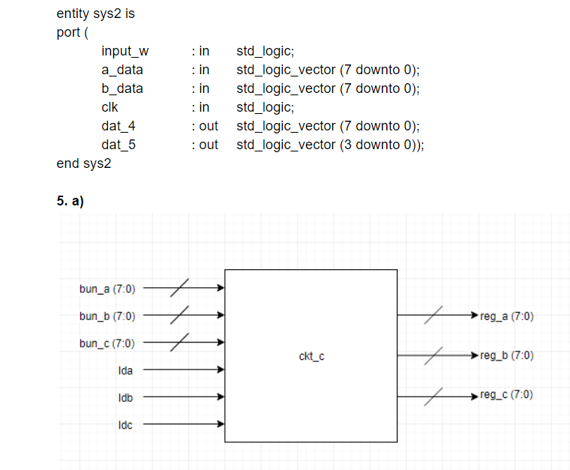
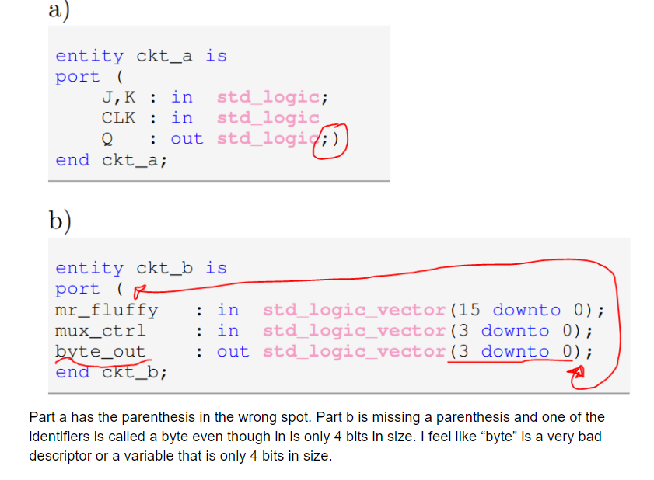

- [Part 1 (c)] Waveform.
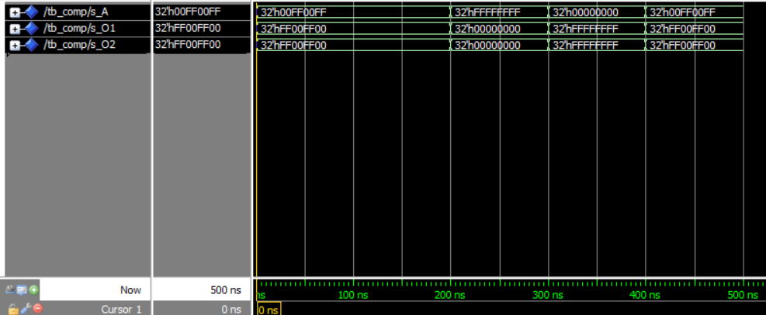

- [Part 2 (a)] Draw the truth table, Boolean equation, and Boolean circuit equivalent (using only two-input gates) that implements a 2:1 mux.
A | B | S | Out
0 | 0 | 0 | 0
0 | 0 | 1 | 0
0 | 1 | 0 | 0
0 | 1 | 1 | 1
1 | 0 | 0 | 1
1 | 0 | 1 | 0
1 | 1 | 0 | 1
1 | 1 | 1 | 1

Out = (A and not S) or (B and S)

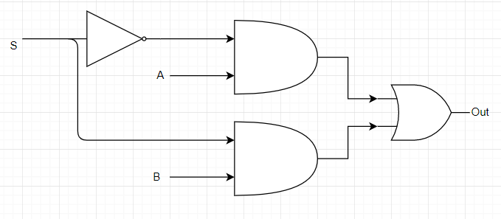
- [Part 2 (e)] Waveform.
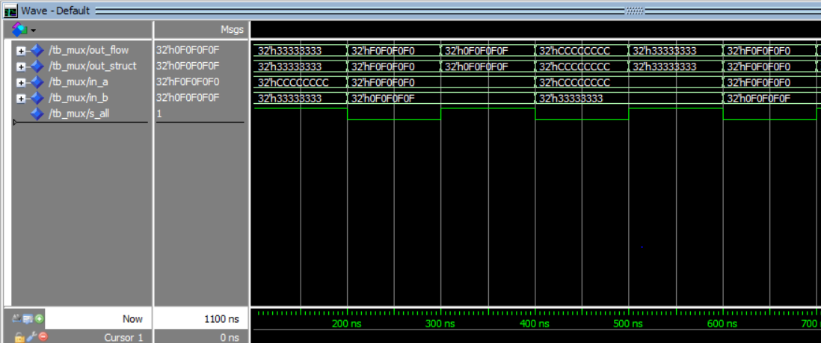
- [Part 3 (a)] Draw the truth table, Boolean equation, and Boolean circuit equivalent (using only two-input gates) that implements a full adder.

A | B | Cin | S | Cout
0 | 0 | 0 | 0 | 0
0 | 0 | 1 | 1 | 0
0 | 1 | 0 | 1 | 0
0 | 1 | 1 | 0 | 1
1 | 0 | 0 | 1 | 0
1 | 0 | 1 | 0 | 1
1 | 1 | 0 | 0 | 1
1 | 1 | 1 | 1 | 1

S <= (A xor B ) xor Cin;
Cout <= (A and B) or (A and Cin) or (B and Cin);

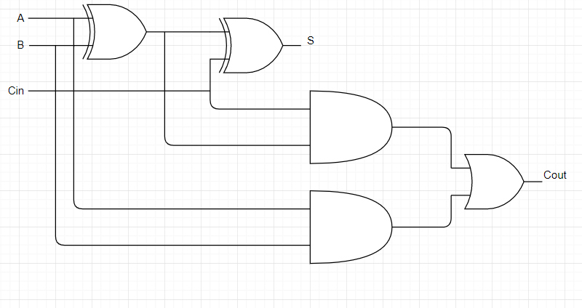

- [Part 3 (e)] Waveform.

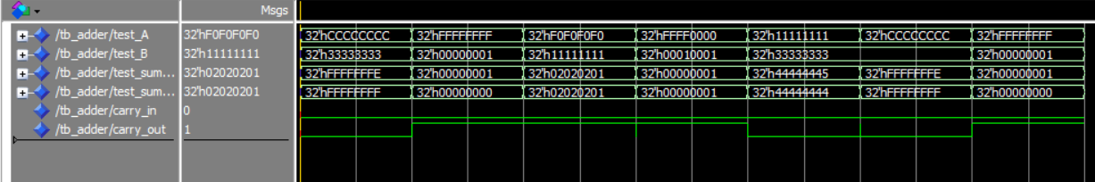

- [Part 4 (a)] Draw a schematic (don’t use a schematic capture tool) showing how an N-bit adder/subtractor with control can be implemented using only the three main components designed in problems 1), 2), and 3) (the N-bit inverter, N-bit 2:1 mux, and N-bit adder). How is the ‘nAdd_Sub’ bit used?

The nAdd_Sub is used to multiplex B. If a two’s complement result is desired instead, it can also be used as the carry in bit. Where you connect the signal depends on if you would like a two’s complement or a one’s complement implementation. For my setup, I decided to go with a one’s complement implementation.
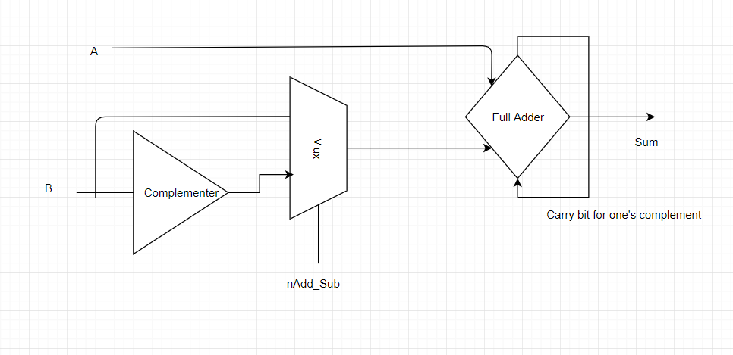

- [Part 4 (c)] Provide multiple waveform screenshots in your write-up to confirm that this component is working correctly. What test-cases did you include and why?

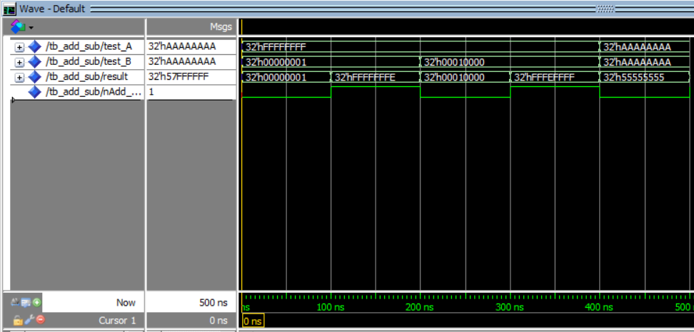

Well, I think this waveform is sufficeint. I tested the adders thouroughly and I also tested the muxes. So, I decided to focus on testing the carry bit from one end of the adder to the other. So, I thought the case of 0xFFFFFFFF + 0x1 and 0xFFFFFFFF – 0x1 would test it enough for me. I tried a few other cases as well, but the ripple is working as expected. I did my subtractor for ONE’S COMPELMENT. I was not sure if we were supposed to do ones complement or two’s complement. It would not be more difficult to do two’s complement. Would just have to switch a few signals around.

- [Feedback] You must complete this section for your lab to be graded. Write down the first response you think of; I expect it to take roughly 5 minutes (do not take more than 10 minutes).

I did not know that I needed a carry in bit for my N-bit adder in order to make subtraction in one’s complement work correctly. So, I had to go back and change all my vhdl files to accommodate for that. Other than that, the lab went very well. Sometimes my VHDL would crash in runtime, but I mostly fixed that. I am unsure what causes that and I would like to find out.

  - How many hours did you spend on this lab?

Task | During lab time | Outside of lab time
Reading lab | .25
Pencil/paper design
VHDL design | 1.5 | 1
Assembly coding
Simulation
Debugging | .25 | 4
Report writing |  | .5
Other:
Total | 2 | 5.5

  - If you could change one thing about the lab experience, what would it be? Why?
It would be nice to know that we needed a carry out bit and carry in bit for the n-bit full adder

  - What was the most interesting part of the lab?
It was very interesting to review CprE 281 material.

