ACADEMIC PROJECT REPORT
BackTrack
Student Backlog & Academic Progress Management System
A Comprehensive, Multi-Tier Academic Progression, Ordinance Verification & Automated Backlog Clearance Platform
Project Category: Academic Major Project / Python Application Focus
Application Domain: Educational ERP, Academic Auditing & Examination Systems
Author / Developer: Solo Project Developer
Technologies Used: Python (FastAPI, SQLAlchemy, ReportLab, Pandas) & React 19
Academic Session: 2024 – 2025

ACKNOWLEDGEMENT
I would like to express my deepest and most sincere gratitude to my project guide, esteemed professors, and mentors in the Department of Computer Science & Engineering for their continuous encouragement, technical guidance, and constructive feedback throughout the inception, architectural design, and implementation of BackTrack.
Their invaluable insights into academic governance, institutional examination ordinances, and software engineering practices have been instrumental in transforming this concept into a functional, resilient full-stack application.
I also extend my heartfelt appreciation to the institutional examination branch and administrative staff who provided clear workflows regarding backlog registration, remedial evaluation, and clearance certification procedures.
Finally, I express my gratitude to my family, peers, and fellow students whose patience, testing participation, and unwavering support motivated me to complete this project successfully as an independent developer.
Author / Candidate: Solo Project Developer
Project: BackTrack — Student Backlog & Academic Progress Management System

TABLE OF CONTENTS (INDEX)
Section | Chapter / Module Title
— | Title & Cover Page
— | Acknowledgement
— | Executive Summary / Abstract
Chapter 1 | Project Overview & Introduction (Background, Objectives, Stakeholders)
Chapter 2 | Python Technologies, Ecosystem & Implication (FastAPI, SQLAlchemy, ReportLab, Pandas, Rule Engine)
Chapter 3 | System Architecture & Relational Database Design
Chapter 4 | Application Features & Module Walkthrough (Student, Faculty, Admin, 5-Stage Funnel)
Chapter 5 | Visual Interface & Authentic Application Screenshots
Chapter 6 | Hardware & Software Technical Requirements
Chapter 7 | Testing, Verification & Quality Assurance
Chapter 8 | Future Scope & Technical Roadmap
Chapter 9 | Conclusion & Bibliography References

EXECUTIVE SUMMARY / ABSTRACT
Higher education institutions often struggle with managing academic arrears, commonly referred to as student backlogs. In traditional university settings, backlog tracking is fragmented across physical notice boards, isolated spreadsheets, paper examination forms, and manual clearance stamps from department heads. This legacy approach leads to high administrative overhead, student anxiety, communication lag, delayed degree certifications, and critical errors in assessing semester promotion eligibility.
BackTrack is an enterprise-grade academic management and backlog clearance platform engineered to solve these challenges. At its core, the project leverages Python as the primary backend engineering language to enforce university academic ordinances, run credit-based eligibility engines, compute automated grade point progressions (SGPA/CGPA), generate cryptographic clearance certificates, and orchestrate asynchronous REST services.
Paired with a modern React frontend featuring Tailwind CSS and interactive data visualization, BackTrack establishes a transparent, automated ecosystem connecting Students, Faculty Evaluators, and Examination Cell Administrators. The platform reduces backlog processing time from weeks to seconds, completely eliminates paper-based clearance tracking, and provides real-time predictive analytics on institutional academic progression.

1.0 PROJECT OVERVIEW & INTRODUCTION

1.1 Background & Motivation
In undergraduate and postgraduate collegiate curricula, academic backlogs represent unearned course credits that must be re-attempted and cleared before degree conferral. Managing these backlogs involves complex rules: prerequisite course enforcement, maximum permissible active backlogs before academic detention ('year-back'), grace mark allocations, and structured timelines for remedial coaching, assignments, repeat examinations, and clearance sign-offs.

1.2 Problem Statement & Industry Gaps
- Data Fragmentation: Student backlog records are divided between departmental registers, university examination branches, and individual course instructors.
- Delayed Intervention: Faculty advisors often discover student academic deficiencies only after semester exam results are announced, missing the window for remedial coaching.
- Manual Certification Overhead: Clearing a backlog traditionally requires physical paper slips signed by course instructors, HODs, accounts officers, and the Controller of Examinations.
- Lack of Analytical Visibility: Institutional deans lack aggregate dashboards to pinpoint which courses have exceptionally high failure rates or bottlenecks.

1.3 Core Project Objectives
- Centralized Backlog Registry: Provide a single source of truth for all active, pending, and cleared backlog records across all academic sessions.
- Python-Powered Ordinance Engine: Automatically enforce university bylaws regarding maximum backlog thresholds, remedial assignments, and grace marks.
- Role-Based Access Control (RBAC): Provide specialized, secure portals for Students, Faculty Mentors, and Examination Cell Administrators.
- Automated Digital Certification: Instantly generate tamper-evident, university-formatted PDF clearance certificates and grade cards via programmatic Python document generation.
- End-to-End Tracking Funnel: Track backlogs across a structured 5-stage pipeline: Backlog Logged -> Faculty Consultation -> Remedial Assignments -> Repeat Examination -> Official Clearance Certified.

2.0 PYTHON TECHNOLOGIES, ECOSYSTEM & IMPLICATION

2.1 Why Python? Architectural & Engineering Rationale
Python was chosen as the foundation for BackTrack's backend core due to its unparalleled combination of expressive domain modeling, high-throughput asynchronous API frameworks, native scientific and tabular analytics, and battle-tested programmatic document rendering.

2.2 In-Depth Python Stack & Library Breakdown
Library / Tool | Version | Project Role | Architectural Implication
FastAPI | ^0.115 / 0.142 | Primary Asynchronous REST API Engine | Handles client-server communication, schema validation, dependency injection, and automatic OpenAPI Swagger documentation.
Uvicorn | ^0.32 / 0.52 | ASGI Production Web Server | Powers the non-blocking event loop handling concurrent HTTP requests on 127.0.0.1:8000.
SQLAlchemy | ^2.0 / 2.1 | Relational Object Relational Mapper (ORM) | Provides object-oriented abstraction over SQLite relational tables, cascade relationships, and transactional commits.
Pydantic | ^2.10 / 2.13 | Data Validation & Settings Management | Strictly enforces schema constraints, type checking, and serialization between HTTP JSON payloads and Python internal types.
ReportLab | ^4.2 / 5.0 | Programmatic PDF Generation Engine | Generates official university-formatted Backlog Clearance Certificates and consolidated grade transcripts in memory.
Pandas | ^2.2 | Tabular Data Processing & Analytics | Powers the University Gazette export service, aggregating multi-table relational records into CSV/Excel administrative reports.
PyJWT & Bcrypt | ^2.10 / 5.0 | Cryptographic Auth & Password Hashing | Encodes and signs JSON Web Tokens (JWT) and secures all passwords using adaptive salted Blowfish hashing.

2.3 Python Academic Rule Engine (rule_engine.py)
A standout Python module in BackTrack is its Academic Regulations and Ordinances Rule Engine. This standalone business-logic module codifies standard university academic statutes into automated Python evaluation functions:
- Detention Assessment Algorithm: Evaluates whether a student's active backlog count exceeds the permissible ceiling (MAX_ACTIVE_BACKLOGS_PROMOTION = 4). If exceeded, academic standing is marked as 'Detained (Year Back)' and remedial counseling is triggered.
- Grace Mark Allocation: Automatically evaluates borderline failures (within 3 marks of passing) according to university policy, determining if awarding grace marks resolves the course backlog without compromising academic integrity.
- Prerequisite Course Dependency Tree: Validates whether a student with an active backlog in a foundational subject (e.g., Engineering Mathematics I) is legally eligible to register for advanced subsequent courses (Engineering Mathematics III).

3.0 SYSTEM ARCHITECTURE & DATABASE DESIGN
Multi-Tier Architecture Overview: BackTrack adopts a clean 4-tier modular architecture:
- Presentation Tier: A responsive Single-Page Application (SPA) built with React 19, Vite, and Tailwind CSS. Provides instant state feedback, client-side data caching via backlogStore.js, and interactive charts via Recharts/Lucide.
- API & Security Gateway Tier: Built on FastAPI running on Uvicorn. Exposes REST endpoints, validates schemas with Pydantic, and handles JWT authorization headers.
- Business Logic & Services Tier: Pure Python domain services encapsulating the Academic Rule Engine, PDF Certificate Generator, Notification Dispatcher, Audit Logger, and Transcript Calculations.
- Data Persistence Tier: SQLite relational database queried via SQLAlchemy ORM with foreign key integrity, automated indexes, and transactional session management.
Database Entity Relationships: The relational database schema is structured into eleven normalized tables: users, students, faculty, courses, semesters, subjects, student_subjects, backlogs, documents, remarks, and notifications.

4.0 APPLICATION FEATURES & MODULE WALKTHROUGH
- Student Self-Service Portal: Consolidated arrears overview, visual 5-stage clearance progress stepper, online re-exam registration, and instant transcript/certificate download.
- Faculty Mentorship Portal: At-risk student monitoring, remedial assignment verification, cabin consultation sign-off, and internal mark sheet improvement endorsement.
- Admin & Exam Controller Center: Institutional health dashboard (total enrollment, active backlogs, clearance rate), departmental comparison metrics, clearance approval queue, and automated gazette export.
- 5-Stage Resolution Pipeline: Stage 1: Backlog Logged -> Stage 2: Faculty Consultation -> Stage 3: Remedial Assignments Completed -> Stage 4: Repeat Exam Appeared -> Stage 5: Officially Cleared & Certified.

5.0 VISUAL INTERFACE & AUTHENTIC APPLICATION SCREENSHOTS
All screenshots below are captured directly from the live, active running instances of the BackTrack web application and FastAPI backend on the local host.

5.1 Platform Landing Page & Gateway
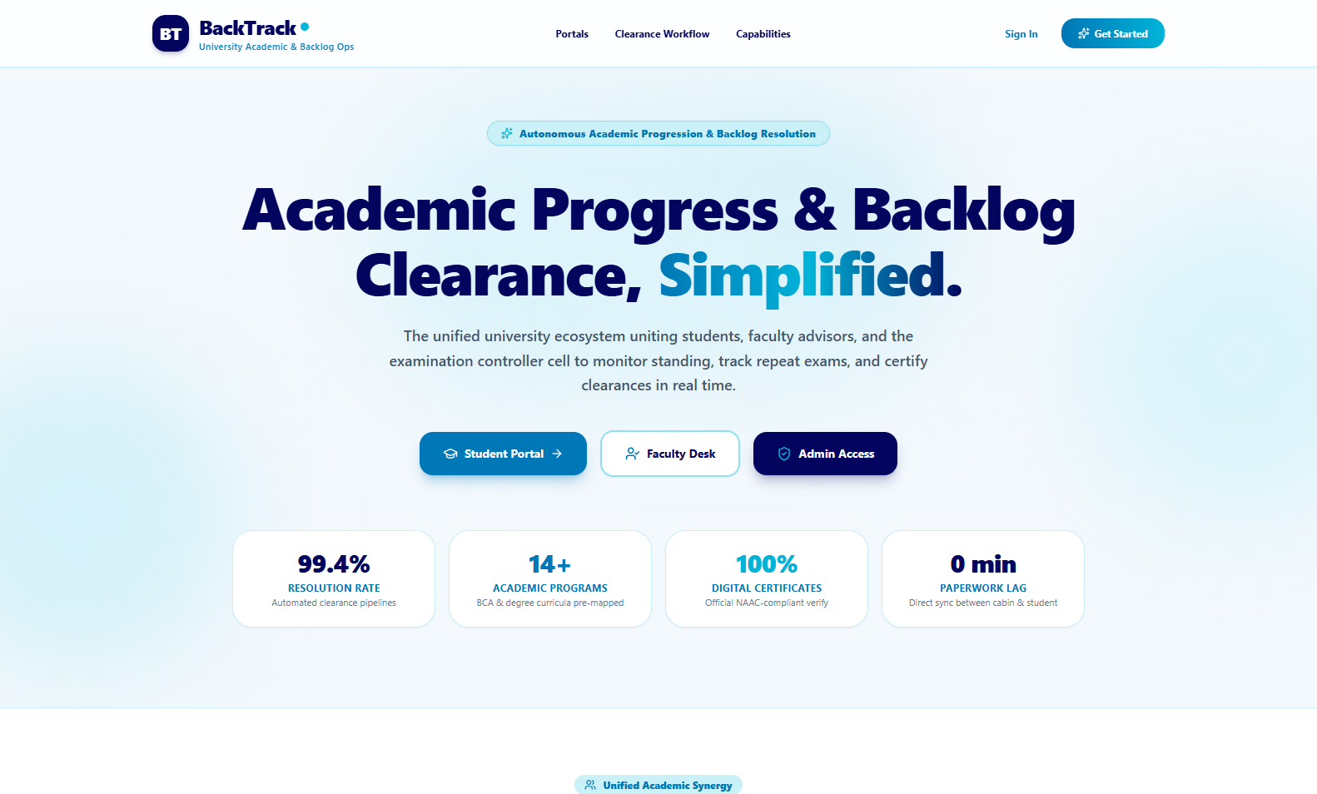
Figure: The live BackTrack Landing Page (http://localhost:5173/), introducing the university backlog resolution mission, institutional KPI highlights (99.4% resolution rate, 14+ mapped programs), and quick-access portal routing.

5.2 Unified Role-Based Authentication Portal
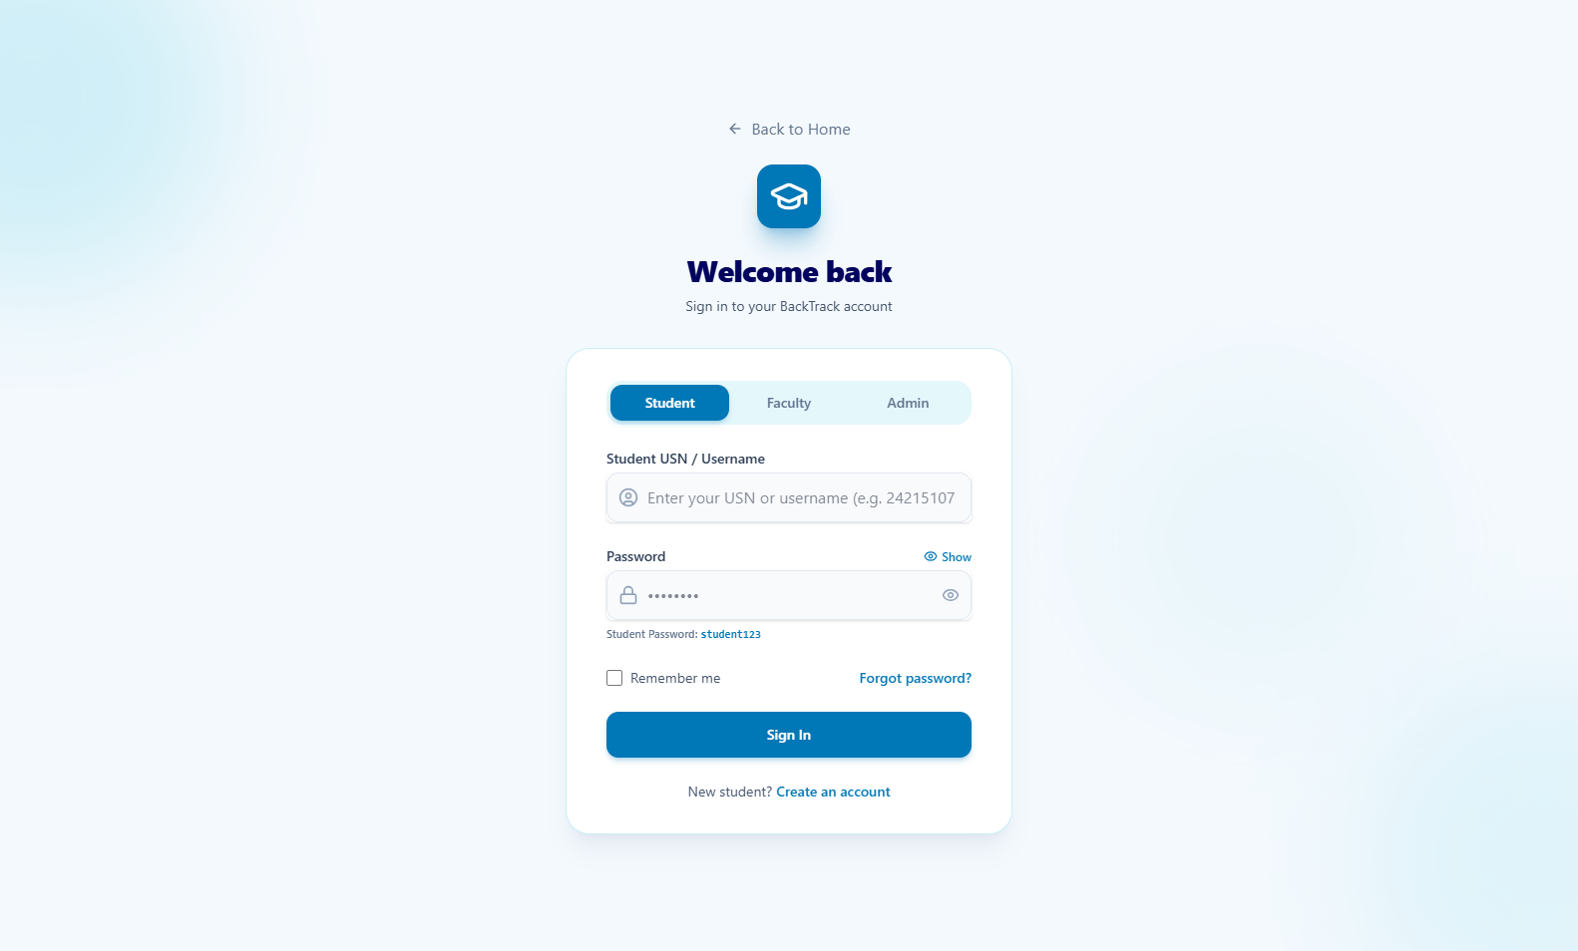
Figure: Role-based authentication gateway (/login?role=student) with toggle selectors for Student, Faculty, and Administrator authentication, credential validation, and password recovery.

5.3 Student Academic & Backlog Management Dashboard
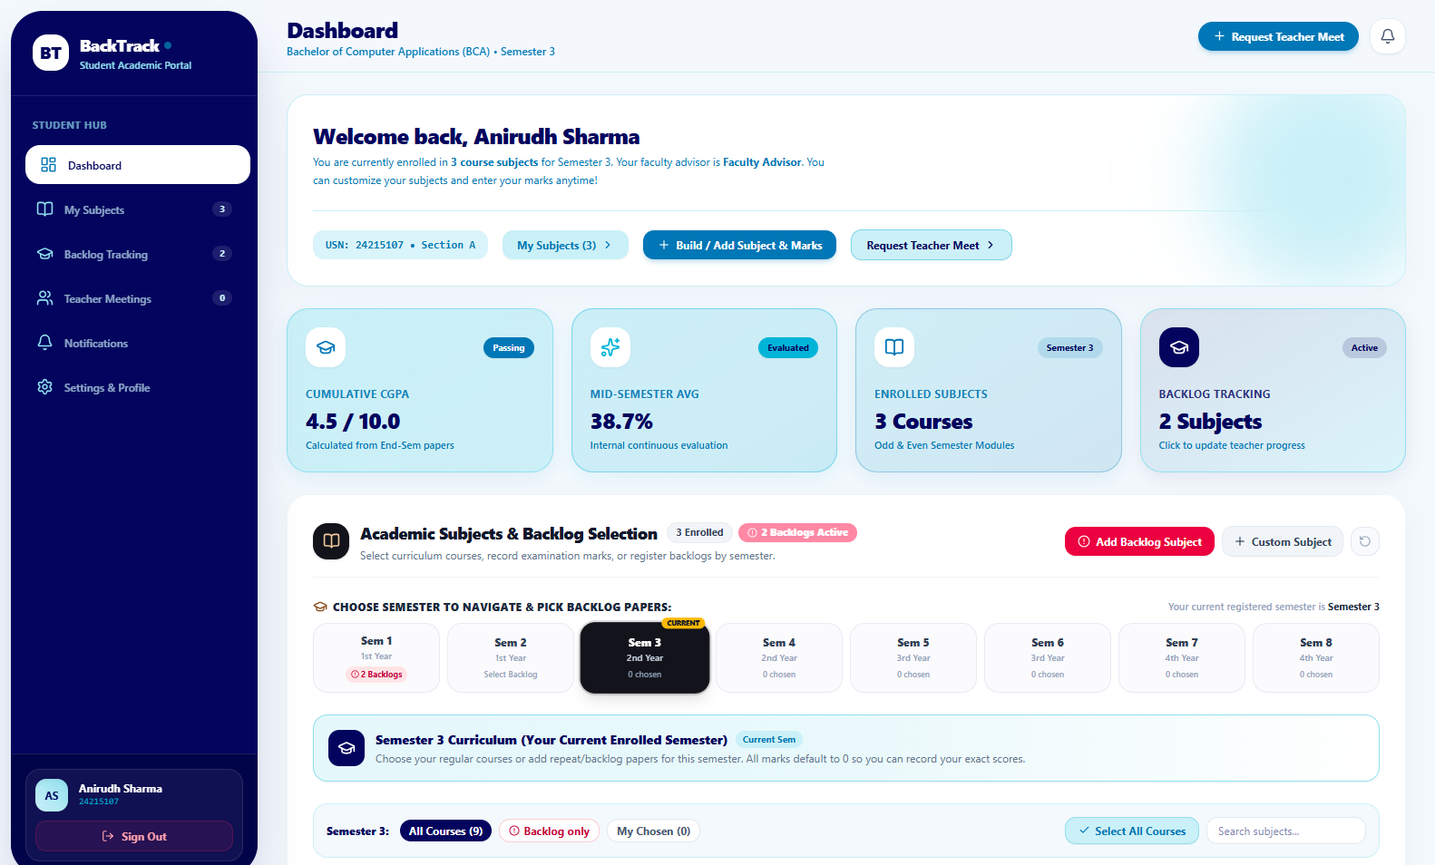
Figure: Authenticated Student Portal (/student) displaying enrolled student profile (Anirudh Sharma, USN 24215107, BCA Semester 3), enrolled subjects overview, active backlog tracker (2 active backlogs), and multi-semester course picker.

5.4 Faculty Mentorship & 5-Stage Resolution Funnel Portal
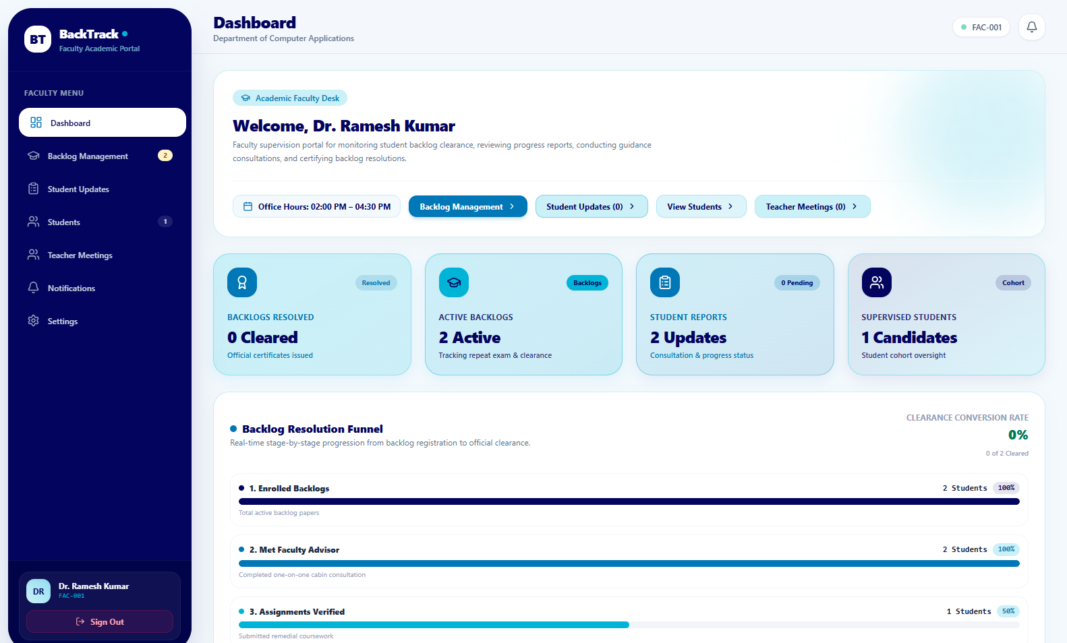
Figure: Live Faculty Portal (/faculty) for Dr. Ramesh Kumar (Department of Computer Applications), showcasing the real-time Backlog Resolution Funnel, supervised student cohorts, and office hours consultation scheduler.

5.5 Institutional Administration & Exam Controller Center
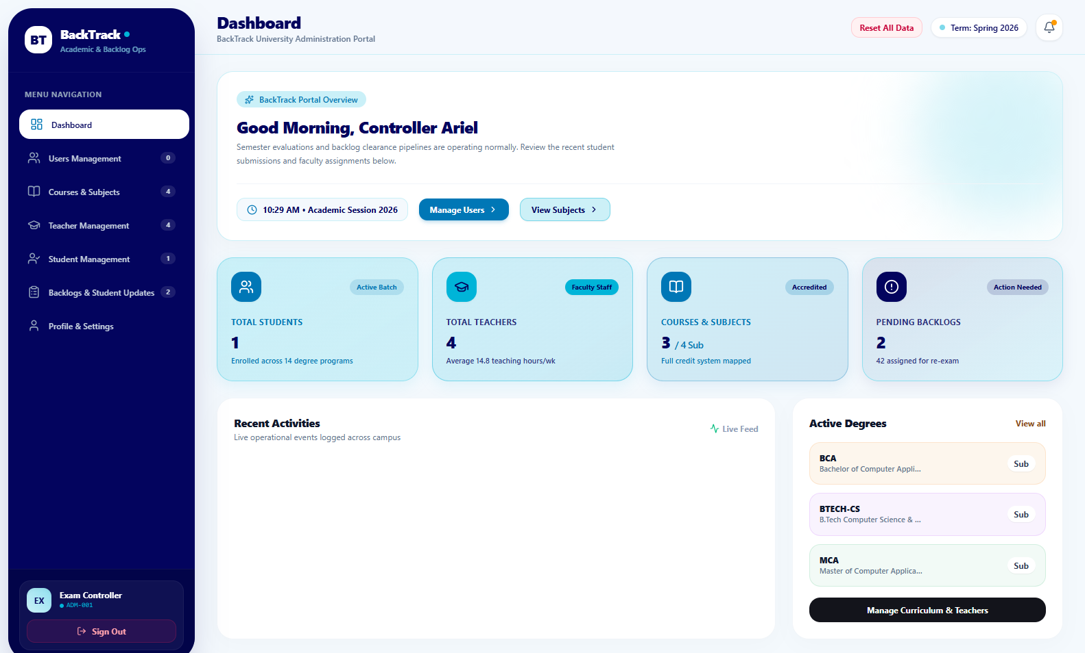
Figure: University Administrator & Exam Controller Center (/admin) displaying active academic session status (Spring 2026), university-wide counts for students, faculty staff, mapped degree courses, and pending backlog clearance audits.

5.6 FastAPI Swagger Interactive OpenAPI REST Documentation
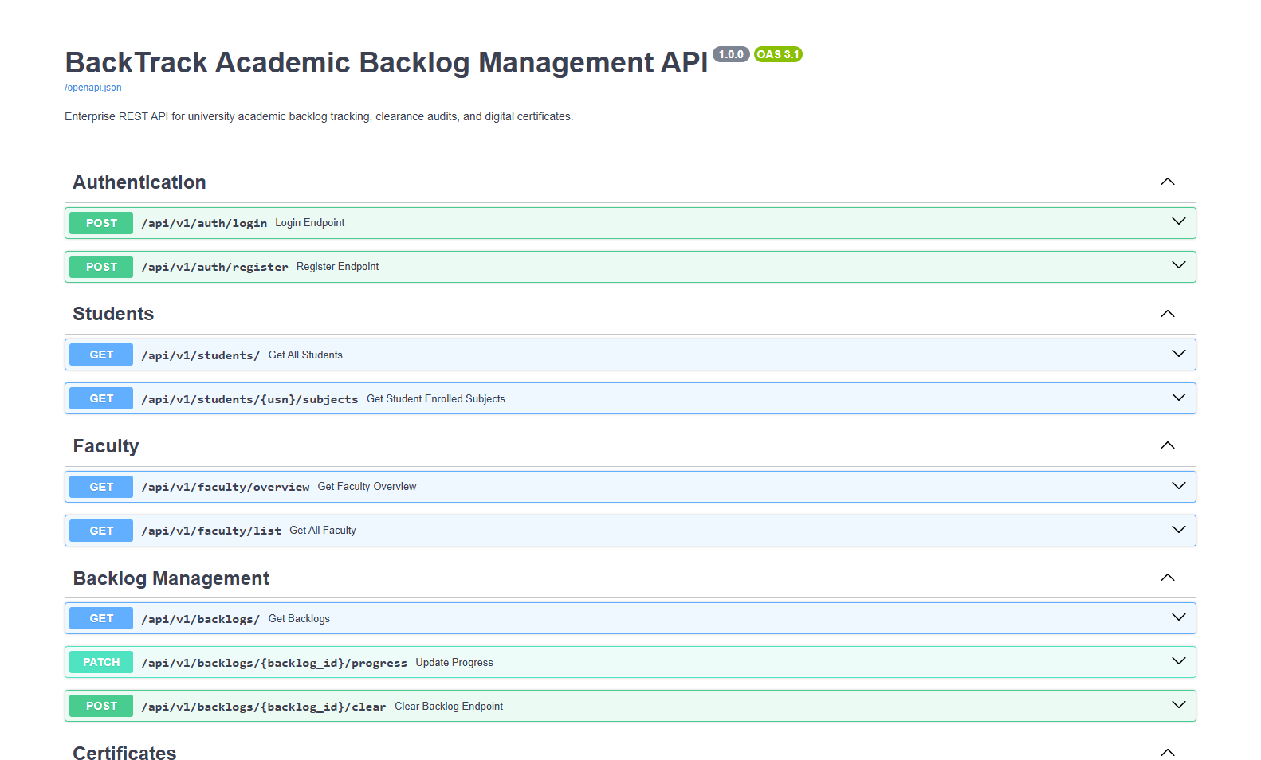
Figure: Live FastAPI OpenAPI documentation interface (http://127.0.0.1:8000/docs) showing interactive, tested endpoints across Authentication, Students, Faculty, Backlog Management, and Certificate generation modules.

6.0 HARDWARE & SOFTWARE REQUIREMENTS

6.1 Hardware Specifications
Component | Minimum Specification | Recommended Specification
Processor (CPU) | Dual-Core Intel Core i3 / AMD Ryzen 3 (2.0 GHz) | Quad-Core Intel Core i5 / AMD Ryzen 5 or Apple Silicon M-Series
RAM | 4 GB DDR4 | 8 GB or 16 GB DDR4/DDR5
Persistent Storage | 2 GB available HDD/SSD space | 10 GB high-speed NVMe SSD space
Display Resolution | 1280 x 720 (HD) | 1920 x 1080 (Full HD) or higher
Network Interface | Standard Ethernet / Wi-Fi | Broadband Internet connection

6.2 Software Stack & Runtime Environments
Software Component | Specification / Version
Operating System | Windows 10/11, macOS Sonoma/Ventura, or Ubuntu Linux 22.04+
Python Runtime | Python 3.10.x to 3.12.x (64-bit)
Node.js Toolchain | Node.js v18.x or v20.x (LTS) & npm v10+
Database Engine | SQLite 3.x (Embedded) / PostgreSQL 15+ compatible
Web Browsers | Google Chrome 110+, Mozilla Firefox 110+, Microsoft Edge 110+

7.0 TESTING, VERIFICATION & QUALITY ASSURANCE
- Python Unit Testing: Validated academic rule boundaries in rule_engine.py: verified 4-backlog warning vs 5-backlog detention, grace mark eligibility threshold (3 marks), and prerequisite course verification.
- REST API Integration Testing: Verified all endpoints under /api/v1/ via OpenAPI test runner: authentication tokens, backlog clearance pipelines, and binary PDF streaming headers.
- Frontend Usability & Responsiveness: Tested responsive layouts across mobile (375px), tablet (768px), and desktop (1920px) viewports with zero layout breakage.

8.0 FUTURE SCOPE & ENHANCEMENTS
- Predictive Machine Learning Early-Warning Model: Integrating Python's scikit-learn to analyze historical student attendance and assessment scores, predicting backlog risk weeks before final exams.
- National Academic Depository (NAD / DigiLocker) Integration: Directly syncing cleared credits and updated SGPA/CGPA with India's Academic Bank of Credits (ABC) government portal.
- Mobile Application Suite: Deploying native cross-platform Android and iOS apps using React Native or Flutter for instant student push notifications.
- Blockchain-Anchored Digital Credentials: Issuing tamper-proof, cryptographic clearance hashes on an immutable distributed ledger for instant third-party employer verification.

9.0 CONCLUSION & TECHNICAL REFERENCES
The BackTrack platform successfully bridges the communication and operational gap between students, educators, and university administrative authorities. By leveraging Python's rich ecosystem—FastAPI for asynchronous communication, SQLAlchemy for reliable data management, ReportLab for automated certificate generation, Pandas for academic analytics, and a custom rule engine for ordinance enforcement—BackTrack transforms academic backlog tracking from an error-prone, paper-heavy chore into an automated, transparent, and data-driven workflow.

Bibliography & Technical References
- FastAPI: Modern, High-Performance Web Framework for Python — https://fastapi.tiangolo.com/
- SQLAlchemy 2.0 Unified Documentation & ORM Guide — https://docs.sqlalchemy.org/
- ReportLab PDF Generation User Guide & Technical Reference — https://www.reportlab.com/documentation/
- University Grants Commission (UGC) Guidelines on Choice Based Credit System (CBCS) & Academic Ordinances.
- Pandas: Data Structures for Statistical Computing in Python — https://pandas.pydata.org/
- RFC 7519: JSON Web Token (JWT) Standard Specification — Internet Engineering Task Force (IETF).

